Table S1. Sequences of the primers used for sex genotyping in channel catfish
Primers |  | PCR product (bp) | Genome location
names | Sequence (5’ - 3’) | PCR product (bp) | HNU_Msal_1.0
Marker 1 | Forward: CTGGAGACGAGTTCAGCACGAT  Reverse: TCCAAATCGTAAGACAATAGCG | 893 bp in males  596 bp in females | LG4(Y): 17,847,495-17,848,945
Marker 2 | Forward: CTTCTGCCCAATGTCTTAACCA  Reverse: CTGGCACTACCATCAGATCCATAC | 922 bp in males  755 bp in females | LG4(Y): 24,650,445-24,651,895
Marker 3 | Forward: AAAATGGCACCTGTAAACTGAA  Reverse: GCTAACTGCCCTAACAACCTCA | 944 bp in males  611 bp in females | LG4(Y): 22242899-22244349
SNP 1 | Forward:  GCAGAGGTTAGCAGGCAGAGTC  Reverse:  AGAGTGTCACGCACAGATTTCG | 330 bp in males  and in females | LG4(Y): 24,736,909- 24,737,239
SNP 2 | Forward:  GCCTTATTTGGATGCTGCCTGTG  Reverse:  ACGTGATGCCTGTCGTCTTTGC | 403 bp in males  and in females | LG4(Y): 24,737,586- 24,737,989
Three primer pairs (marker 1 to 3) flanking a male- and Y-specific insertion and two primer pairs for surrounding a male-specific SNP (SNP 1 and 2) were designed based on our Pool-Seq analyses of the channel catfish SDR. Linkage groups (LGs) names and nucleotide position of each amplicons are given in the genome location column; Y = Y chromosome.

Table S2. Summary of sex-specific SNPs distribution in SDR in YY channel catfish
Category | Male SNPs |  | Female SNPs
Category | Male coding SNPs | Male non-coding SNPs | Female coding SNPs | Female non-coding SNPs
SNPs number | 239 | 9,952 | 0 | 18
Total SNPs | 10,191 |  | 18

Supplementary figures
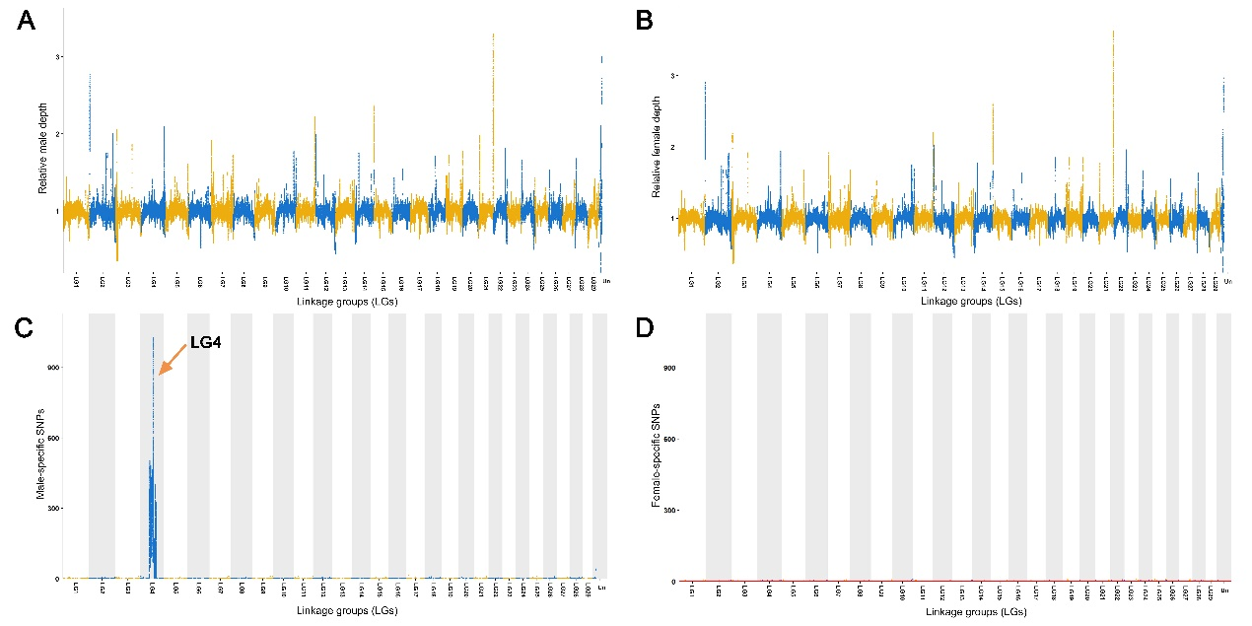
Figure S1
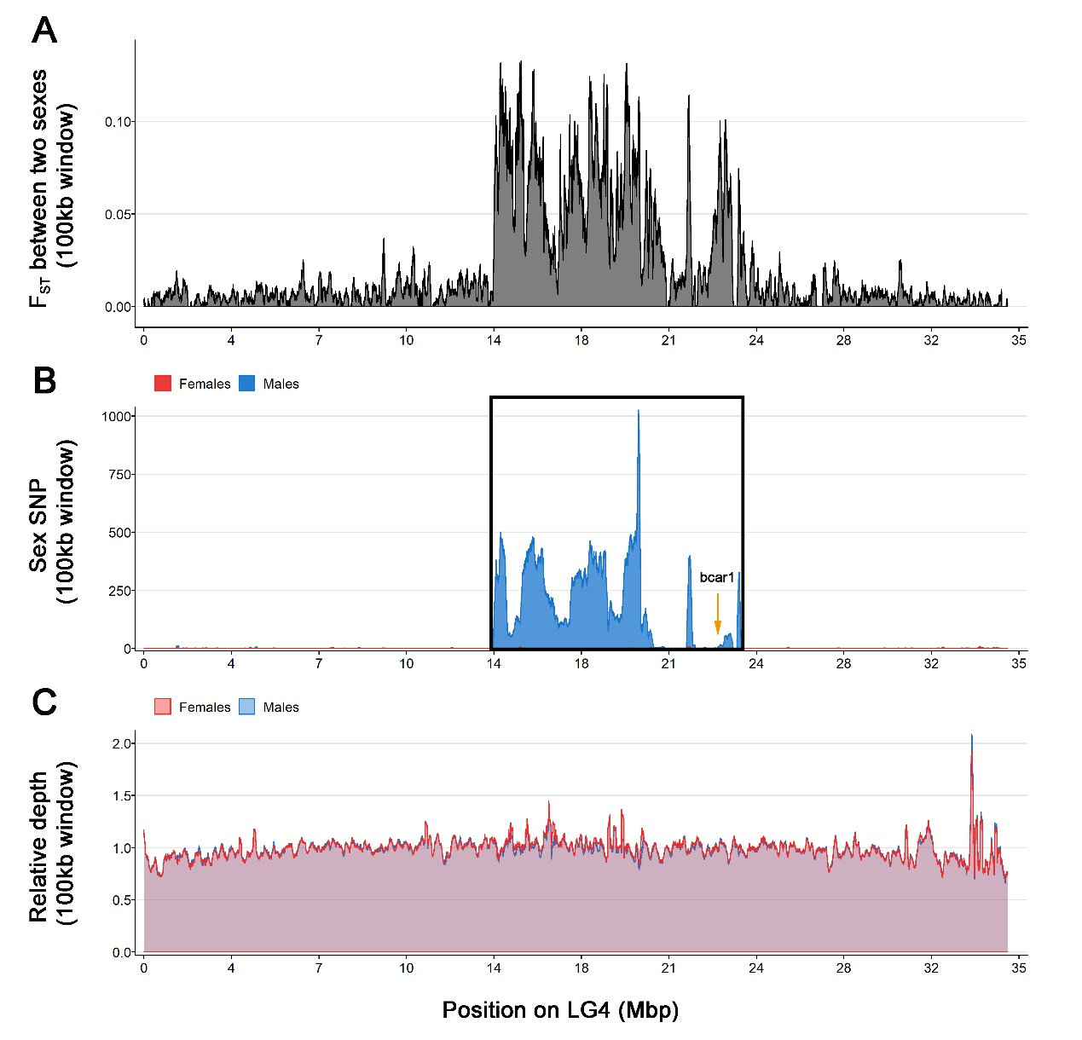
Figure S2

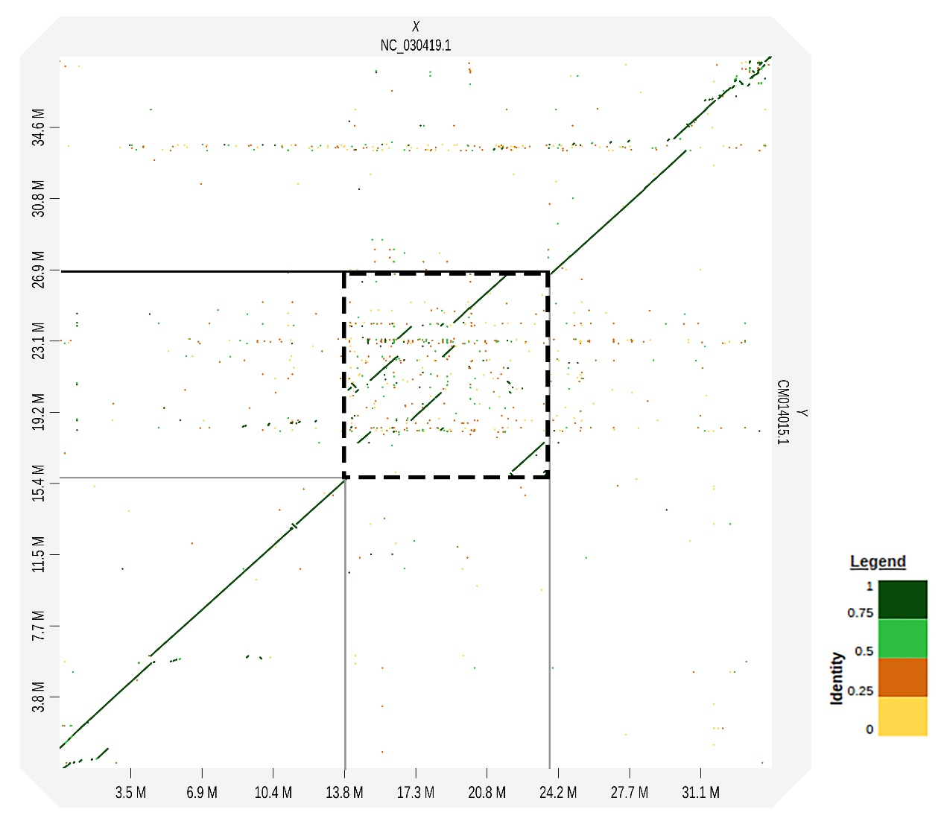
Figure S3

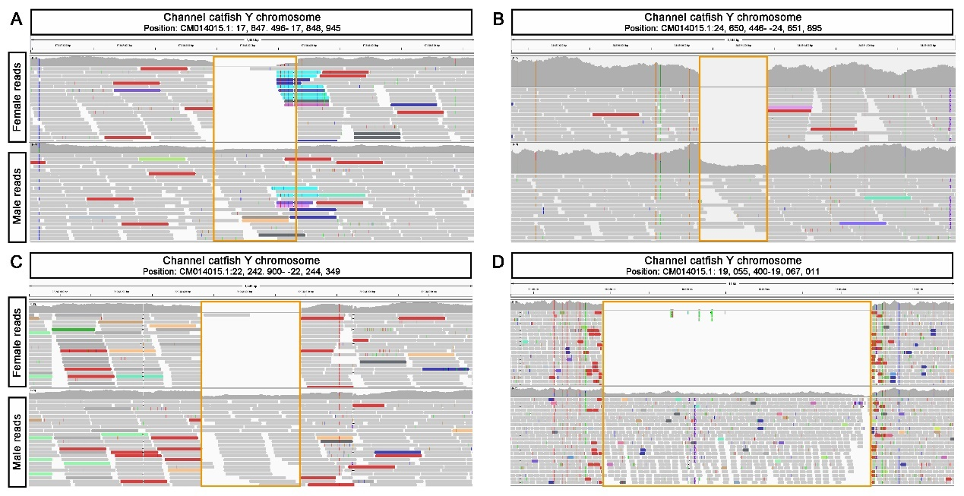
Figure S4
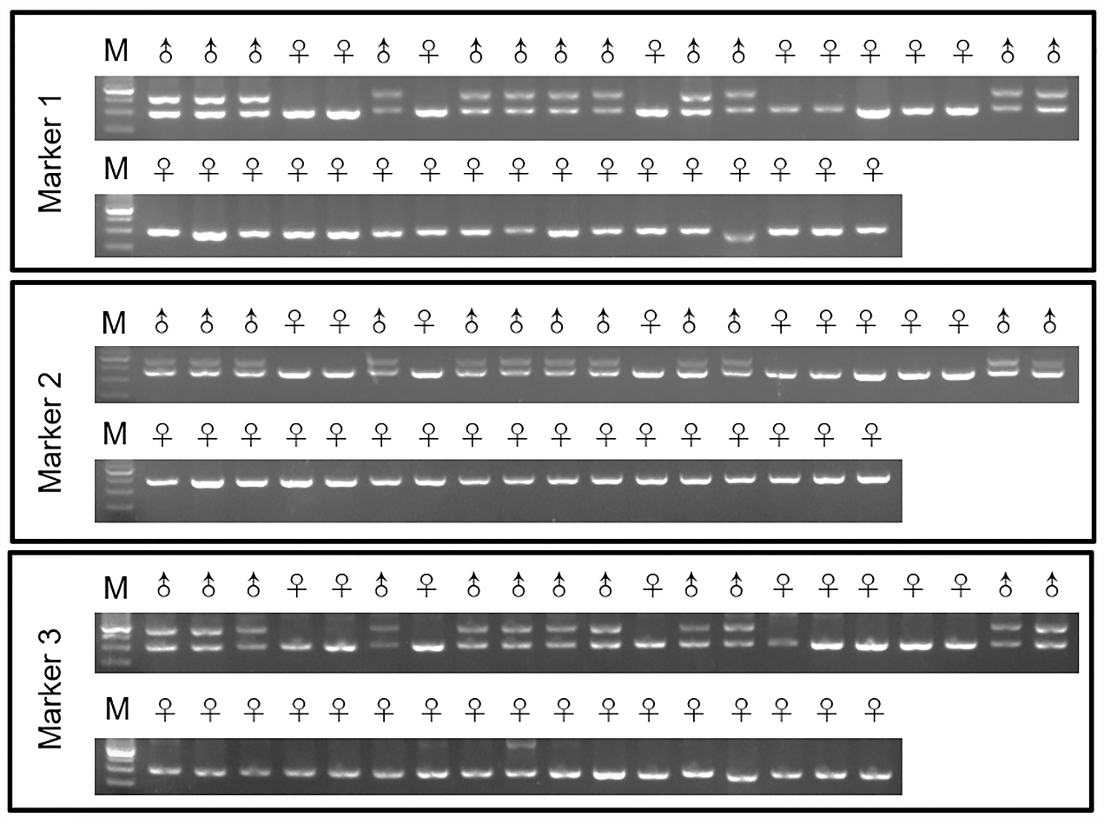
Figure S5
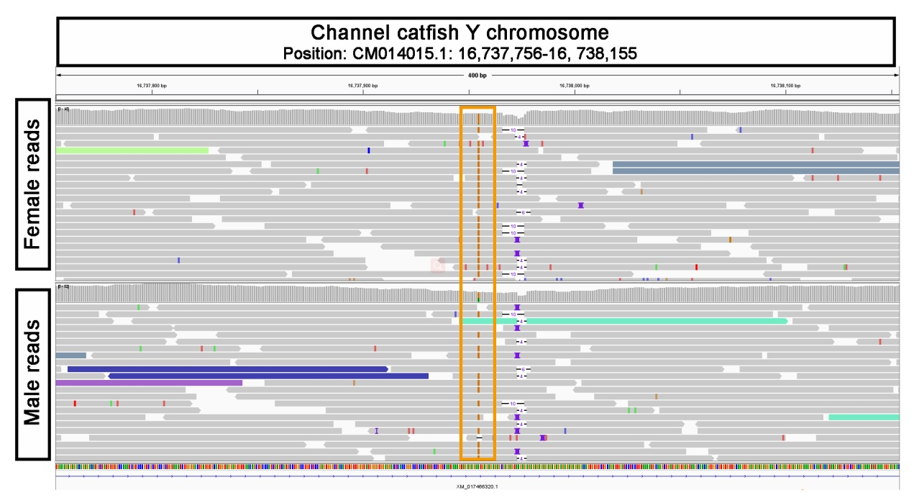
Figure S6
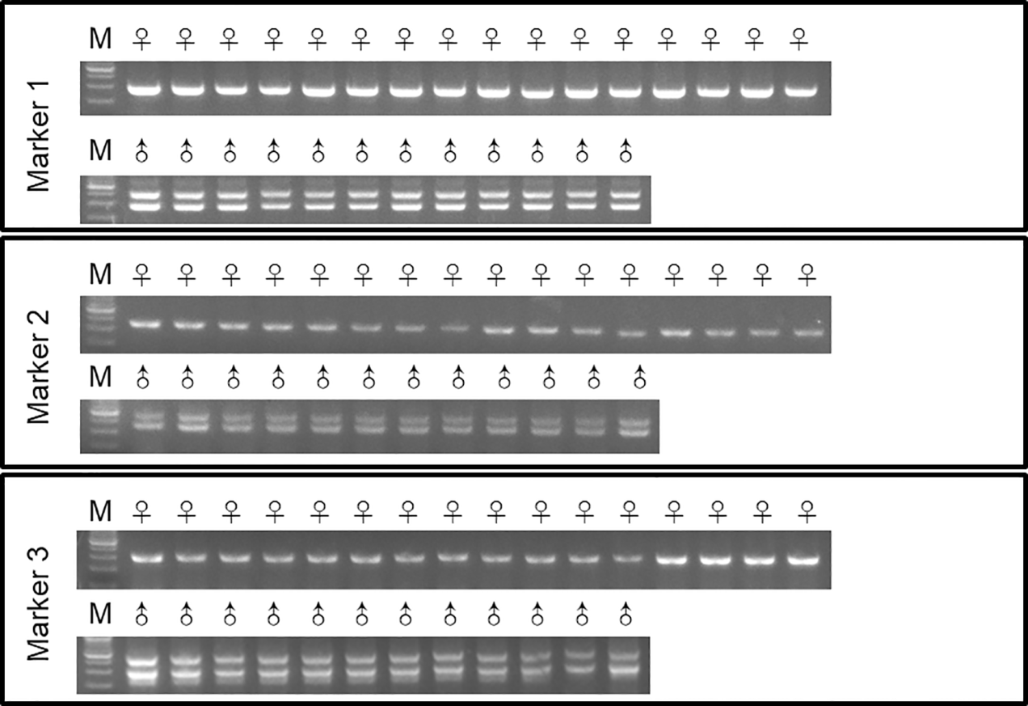
Figure S7

