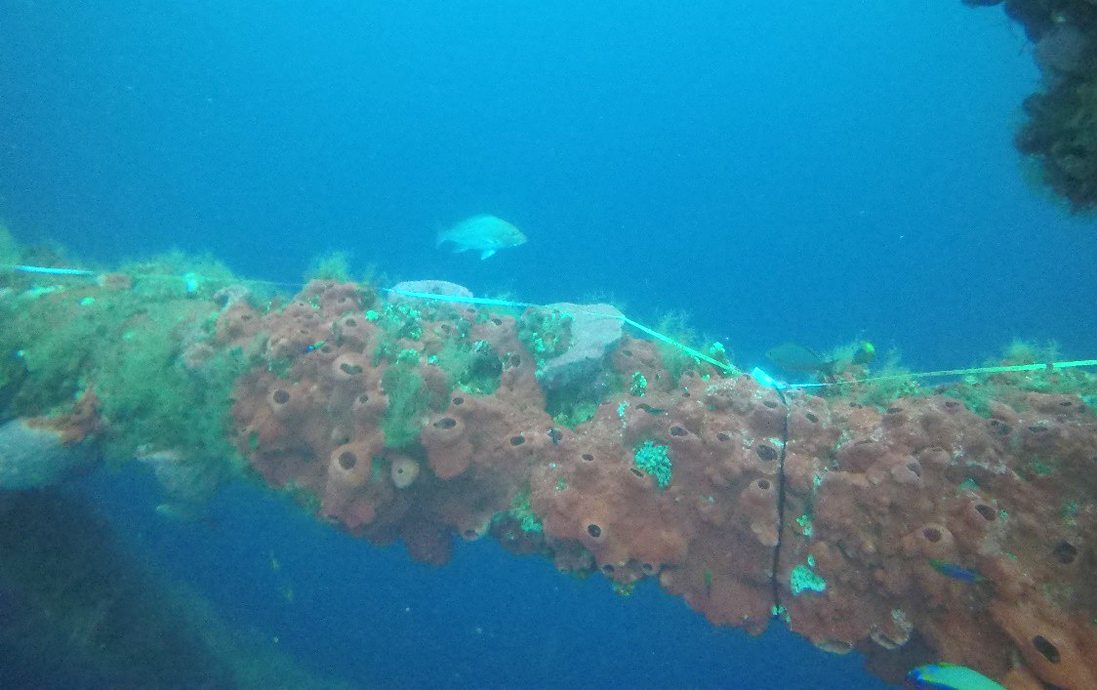
Supplementary Material:
Top

Side

Bottom

Fig. S1 Random transect tape tied on to horizontal support beam, with top, side, and bottom of beam labeled.

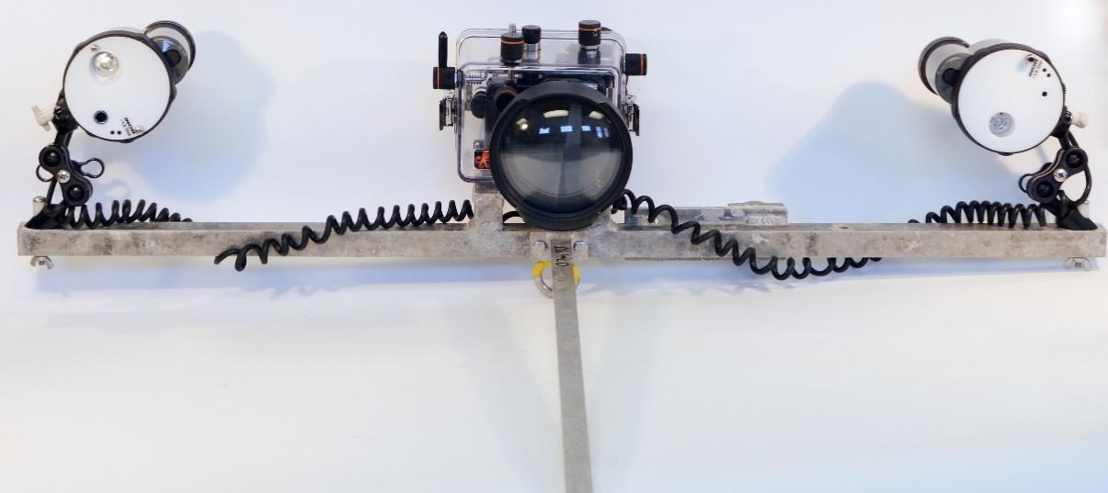
(a)

(b)

(b)

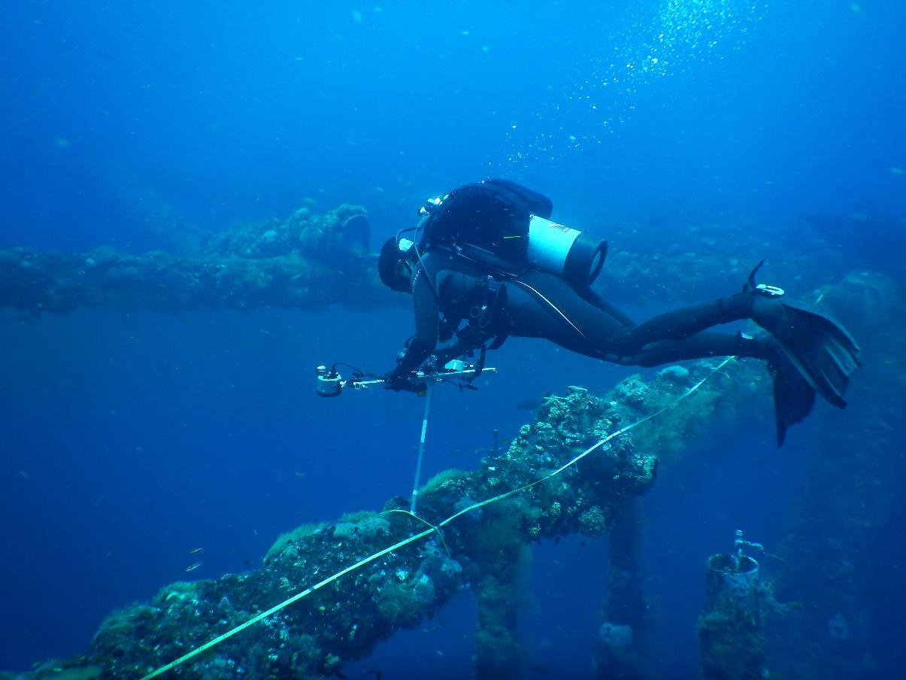
Fig. S2 Benthic transect T-frame camera setup (a) and diver taking transect photographs (b) along a horizontal support beam.

Table S1 Distribution of random photographic transects via scuba from H1to H3 during pre-removal and post-removal surveys.

Level (Horizontal Beam) | Direction/Platform Side | Beam Orientation:
Level (Horizontal Beam) | Direction/Platform Side | Top | Bottom | Inside | Outside
Pre-removal H1 | East | 1 | 1 | 1 | 1
 | North | 1 | 1 | 1 | 1
 | South | 1 | 1 | 1 | 1
 | West | 1 | 1 | 1 | 1
Pre-removal H2 | East | 1 | 1 | 1 | 1
 | North | 1 | 1 | 1 | 1
 | South | 2 | 1 | 2 | 2
 | West | 1 | 1 | 1 | 1
Pre-removal H3 | North | 1 | 1 | 1 | 1
Post-removal H2 | East | 2 | 2 | 2 | 2
 | North | 1 | 1 | 1 | 1
 | South | 1 | 1 | 1 | 1
 | West | 2 | 2 | 2 | 2
Post-removal H3 | East | 1 | 1 | 1 | 2
 | North | 1 | 1 | 1 | 1
 | West | 1 | 1 | 1 | 1

Table S2 Mean percent cover and change of groups identified in CPCe pre- and post-removal analysis on depth delineated horizontal beams from H1 to H8. No post-removal surveys were conducted on H8. Calculated change between pre- and post-removal surveys for each depth level is in italics. Shading separates platform depth levels.
