Supplemental materials

Changes in coral reef community structure along a sediment gradient in Fouha Bay, Guam
By Dwayne Minton, David Burdick, and Valerie Brown

Table S.1. Coral taxa by assemblage in Fouha Bay.

 | SS1 | SS2 | SS3 | NS1 | NS2 | NS3 | NS4 | SD1 | SD2 | ND1
Acanthastrea echinata |  |  | X |  |  | X |  | X | X | X
Acanthastrea sp. |  |  |  |  |  |  |  |  |  | X
Acropora abrotanoides |  |  |  |  |  | X | X
Acropora digitifera |  |  | X
Acropora globiceps |  |  |  |  |  | X
Acropora humilis |  |  |  |  |  |  |  | X | X
Acropora palmerae |  |  | X
Acropora sp. |  |  | X |  |  | X | X |  | X
Astrea curta |  |  | X |  |  | X | X
Astreopora listeri |  |  |  |  |  |  |  |  | X | X
Astreopora myriophthalma |  |  |  |  |  |  | X |  | X | X
Astreopora randalli |  |  |  |  |  |  |  | X | X | X
Astreopora sp. |  |  |  |  |  |  |  |  | X
Cyphastrea agassizi |  |  | X
Cyphastrea chalcidicum |  | X | X |  |  | X |  | X | X | X
Cyphastrea serailia |  |  |  |  |  |  |  | X | X | X
Cyphastrea sp. |  |  |  |  |  |  |  |  | X
Echinophyllia echinata |  |  |  |  |  |  |  |  | X | X
Favia danae |  |  |  |  |  |  |  | X | X | X
Favia favus |  |  | X |  |  |  |  | X | X | X
Favia maritima |  |  |  |  |  |  |  |  | X | X
Favia matthaii |  |  | X |  |  | X | X
Favia pallida |  |  | X |  |  | X | X
Favia sp. |  |  | X |  |  | X |  | X | X | X
Favia stelligera |  |  | X |  |  |  | X
Favites abdita |  |  | X
Favites flexuosa |  |  | X |  |  | X |  |  | X
Favites russelli |  |  | X |  |  | X |  | X | X | X
Favites sp. |  |  |  |  |  |  |  | X | X
Galaxea fascicularis |  | X | X |  |  | X | X |  |  | X
Goniastrea edwardsi |  |  | X |  |  | X |  | X | X | X
Goniastrea pectinata |  |  | X |  |  |  |  |  | X | X
Goniastrea retiformis |  | X | X |  |  | X | X
Goniopora fruticosa |  |  |  |  |  | X | X |  |  | X
Goniopora minor |  |  |  |  |  |  |  |  | X
Goniopora sp. |  |  |  |  |  |  |  |  |  | X
Hydnophora microconos |  |  |  |  |  | X | X
Leptastrea immersa |  | X | X |  |  |  |  |  |  | X
Leptastrea purpurea |  | X | X |  | X | X | X | X | X | X
Leptastrea sp. |  |  |  |  |  | X |  |  |  | X
Leptastrea transversa |  |  | X
Leptoria phrygia |  |  | X |  |  | X | X |  |  | X
Lobophyllia hemprichii |  |  |  |  |  |  |  |  |  | X
Micromussa pacifica |  |  |  |  |  |  |  |  |  | X
Millepora dichotoma |  |  |  |  |  | X
Millepora platyphylla |  |  | X |  |  | X | X
Montipora hoffmeisteri |  |  |  |  |  |  |  |  |  | X
Montipora sp. |  |  |  |  |  | X | X
Pavona chiriquiensis |  |  |  |  |  | X |  |  |  | X
Pavona explanulata |  |  |  |  |  |  |  | X
Pavona sp. |  |  |  |  |  | X | X |  | X | X
Pavona sp. “albomarginata” |  |  | X
Pavona varians |  | X |  |  |  |  |  |  | X | X
Pavona venosa |  |  | X |  |  | X
Platgyra daedalea |  |  |  |  |  | X |  |  | X
Platygyra pini |  |  |  |  |  |  | X | X
Pocillopora acuta |  |  |  |  |  |  |  |  | X
Pocillopora ankeli |  |  | X
Pocillopora damicornis |  |  | X |  |  | X |  |  | X
Pocillopora grandis |  |  |  |  |  | X | X
Pocillopora ligulata |  |  |  |  |  |  | X
Pocillopora setchelli |  |  |  |  |  |  | X
Pocillopora sp. |  |  | X |  |  | X | X | X | X | X
Pocillopora verrucosa |  |  |  |  |  |  |  |  | X | X
Porites annae |  |  |  |  |  | X
Porites deformis |  | X |  |  |  |  |  | X |  | X
Porites densa |  |  | X |  |  | X | X | X | X | X
Porites horizontalata |  |  |  |  |  |  |  | X |  | X
Porites lobata |  |  |  |  |  |  |  |  | X
Porites lutea |  |  |  |  |  |  |  |  | X
Porites sp. “mammalata” |  |  |  |  |  |  |  |  |  | X
Porites murrayensis |  |  |  |  |  |  |  |  | X | X
Porites rus |  | X | X |  |  | X |  | X | X | X
Porites solida |  |  |  |  |  |  |  | X
Porites sp. |  | X | X |  |  | X | X |  | X | X
Porites sp. (massive) |  | X | X |  |  | X | X | X | X | X
Porites stephensoni |  |  |  |  |  |  |  |  |  | X
Porites superfusa |  |  | X |  |  | X | X
Porites vaughani |  |  |  |  |  | X |  |  |  | X
Psammocora contigua |  | X | X |  |  | X | X
Psammocora haimeana |  |  |  |  |  |  |  |  | X | X
Psammocora haimiana |  |  | X
Psammocora nierstraszi |  |  |  |  |  |  |  |  |  | X
Psammocora profundacella |  |  |  |  |  |  |  | X | X | X
Psammocora sp. |  |  |  |  |  | X | X | X | X
Stylocoeniella armata |  | X | X |  |  | X |  | X | X | X
Stylophora mordax |  |  | X |  |  |  |  | X | X | X
TOTAL CORAL | 0 | 12 | 38 | 0 | 1 | 39 | 27 | 25 | 41 | 45

Table S.2. Non-coral taxa by assemblage in Fouha Bay.

 | SS1 | SS2 | SS3 | NS1 | NS2 | NS3 | NS4 | SD1 | SD2 | ND1
Acanthophora spicifera | X | X | X | X | X | X |  | X
Actinotrichia cf. fragilis | X | X | X | X | X | X | X
Amphiroa cf. fragilissima |  | X | X |  |  | X | X | X | X | X
Amphiroa sp. |  |  |  |  |  | X
Ascidian (Unidentified) |  |  |  |  |  |  |  |  | X
Boodlea sp. | X |  | X
Branching Coralline Algae |  | X | X |  |  | X | X |  |  | X
Caulerpa cf. webbiana |  | X
Caulerpa racemosa |  | X | X |  | X | X | X
Caulerpa racemosa hybrid |  |  |  |  |  | X
Caulerpa sp. |  |  | X |  |  |  |  | X | X | X
Caulerpa sp. (pickeringii/verticillata) |  |  |  |  | X |  |  |  | X | X
Chlorodesmis sp. |  |  | X |  |  | X | X
Chlorophyta (Unidentified) |  |  | X
Chrysocystis fragilis |  | X | X |  |  | X |  | X
Cinachyra sp. |  | X
Corallimorph (Unidentified) |  |  |  |  |  |  |  |  |  | X
Crustose Coralline Algae | X | X | X |  | X | X | X | X | X | X
Cyanobacteria |  | X | X | X |  | X | X | X | X | X
Dichotomaria marginata | X | X | X |  |  | X | X |  |  | X
Dictyosphaeria |  |  |  |  |  | X |  |  |  | X
Dictyota sp. 1 (thin blades) |  | X | X |  |  | X |  | X | X
Dictyota sp. 2 (thick blades) |  | X | X |  |  | X
Dictyota sp. 3 | X | X |  |  |  |  |  |  |  | X
Gracilaria canaliculata |  |  | X |  |  |  |  |  | X
Gracilaria salicornia |  | X |  |  | X | X |  | X | X
Halimeda opuntia |  |  |  |  | X | X |  |  | X
Halimeda sp. |  |  | X |  | X | X |  | X | X | X
Hydroclathrus clathratus |  |  | X |  | X | X
Hydroid (Unidentified) |  |  | X
Hydrolithon sp. |  | X |  | X | X | X |  | X
Hypnea cf. spinella |  |  | X |  |  | X |  |  | X
Jania sp. |  |  | X
Laurencia sp. |  |  |  |  |  | X
Mastophora cf. pacifica | X | X | X |  |  | X
Neomeris annulata | X | X |  |  |  |  |  | X | X | X
Padina sp. | X | X | X | X | X | X |  | X | X | X
Peyssonnelia sp. |  |  | X |  |  | X
Sargassum cristaefolium |  |  | X
Sargassum sp. |  |  |  |  | X | X |  |  |  | X
Sponge (Unidentified) |  |  | X |  |  |  |  |  | X
Tricleocarpa fragilis | X | X | X |  | X | X | X | X | X | X
Tridacna maxima |  |  | X
Turbinaria ornata |  | X | X |  | X | X | X
TURF | X | X | X | X | X | X | X | X | X | X
Udotea sp. |  |  |  |  |  | X |  | X | X | X
Zoanthid (Unidentified) |  |  | X
TOTAL NON-CORAL | 11 | 22 | 31 | 6 | 15 | 30 | 11 | 15 | 18 | 17

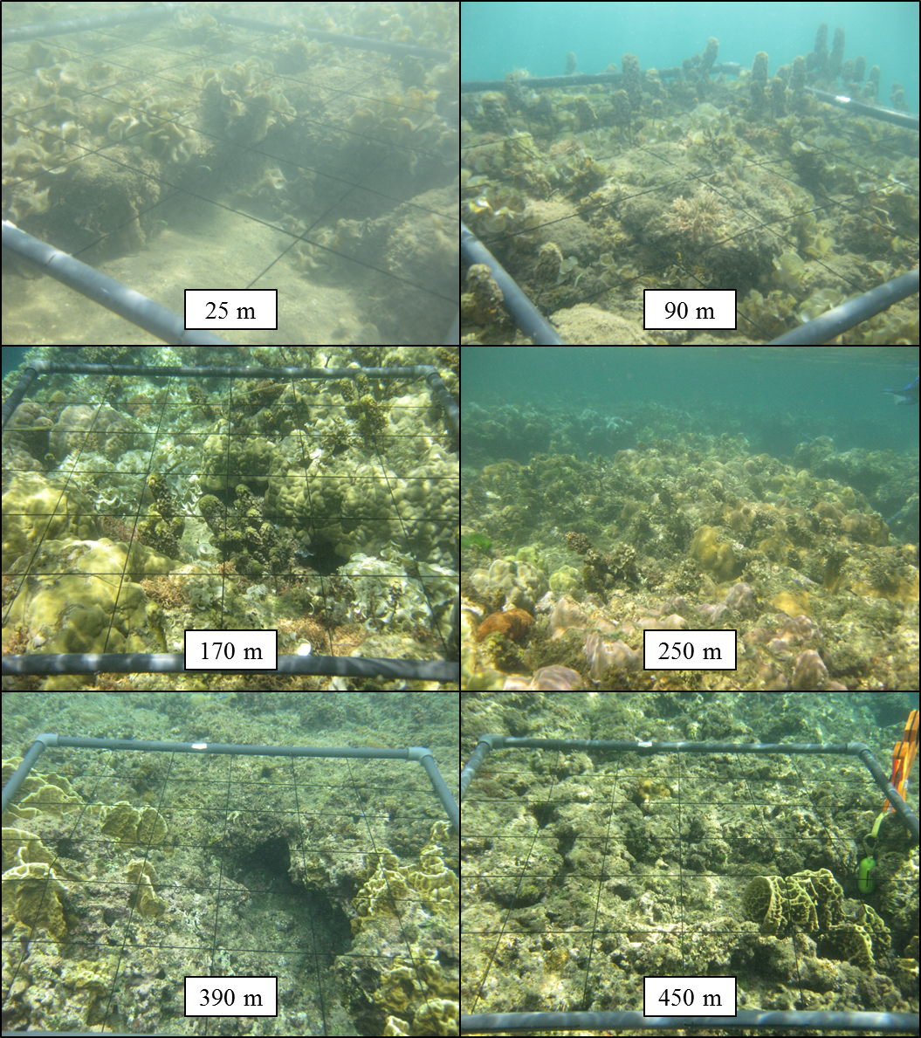

Plate 1. South Shallow (SS) Transect.

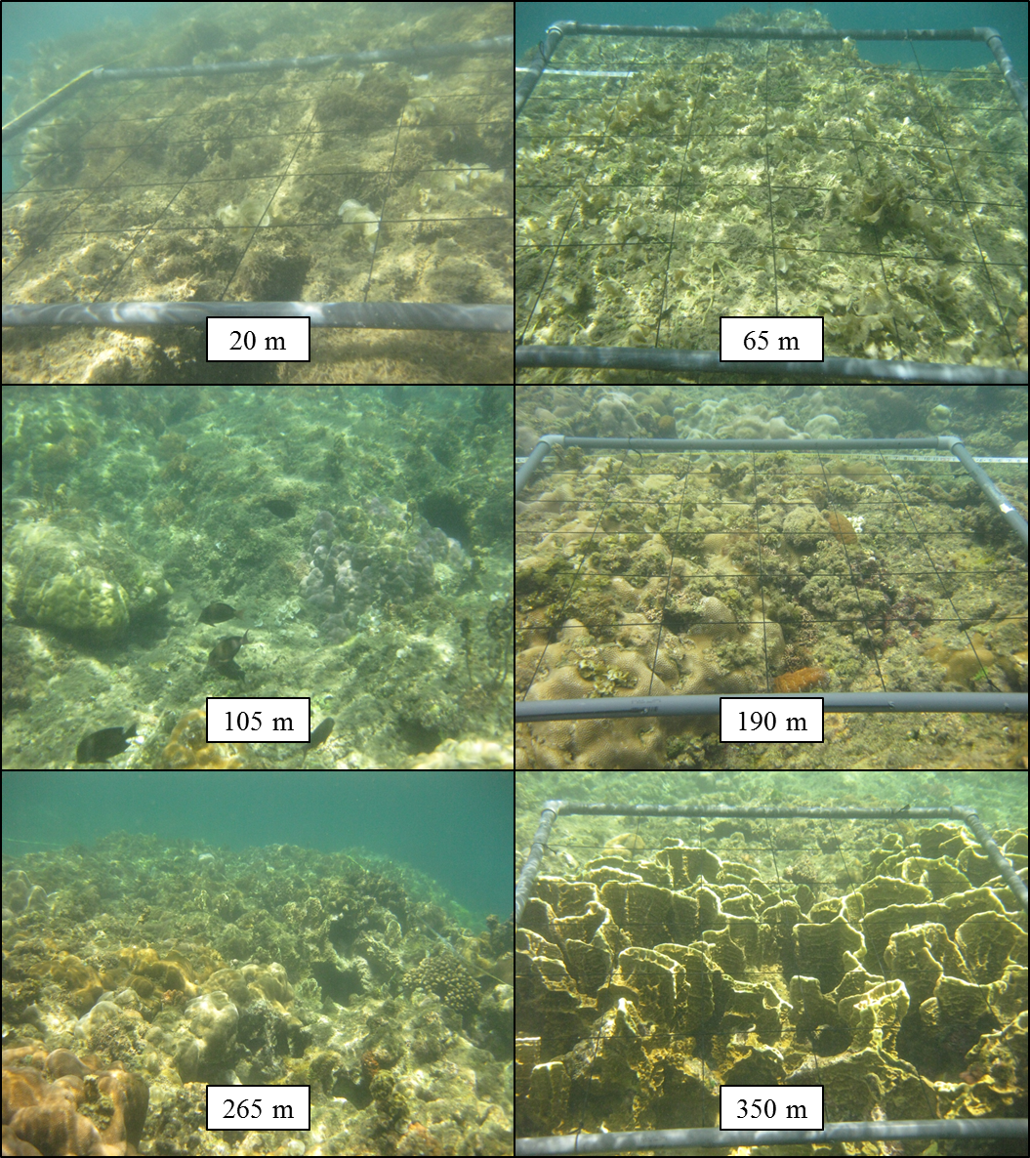

Plate 2. North Shallow (NS) Transect.

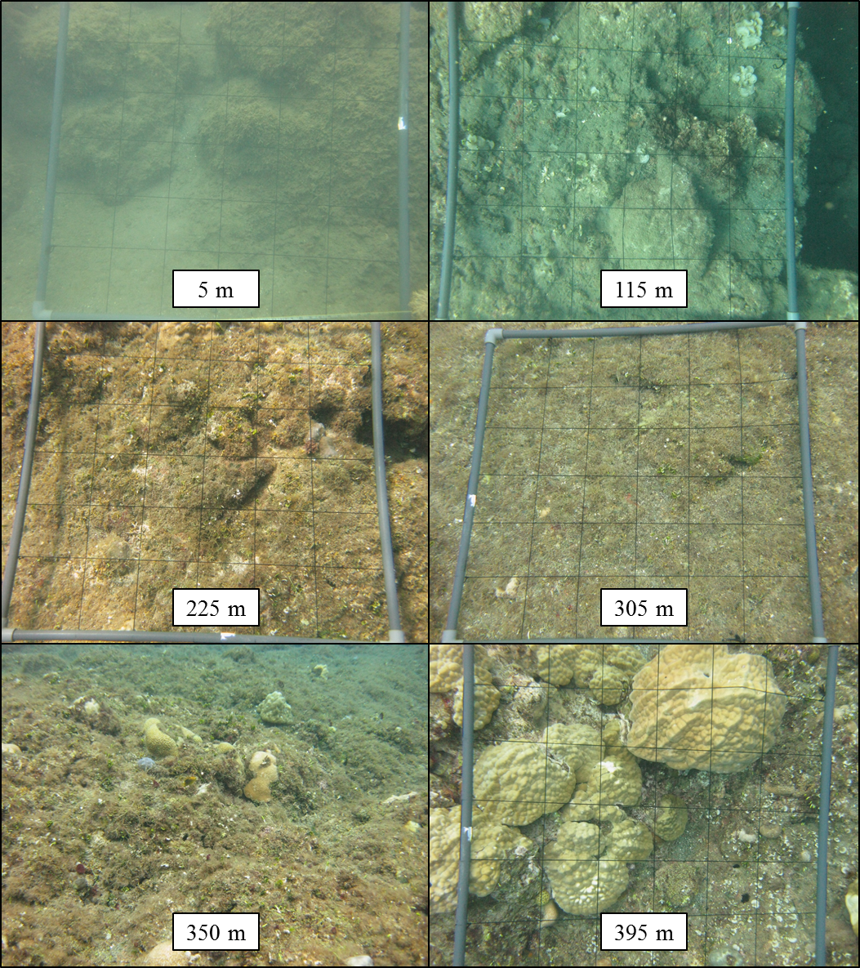

Plate 3. South Deep (SD) Transect.

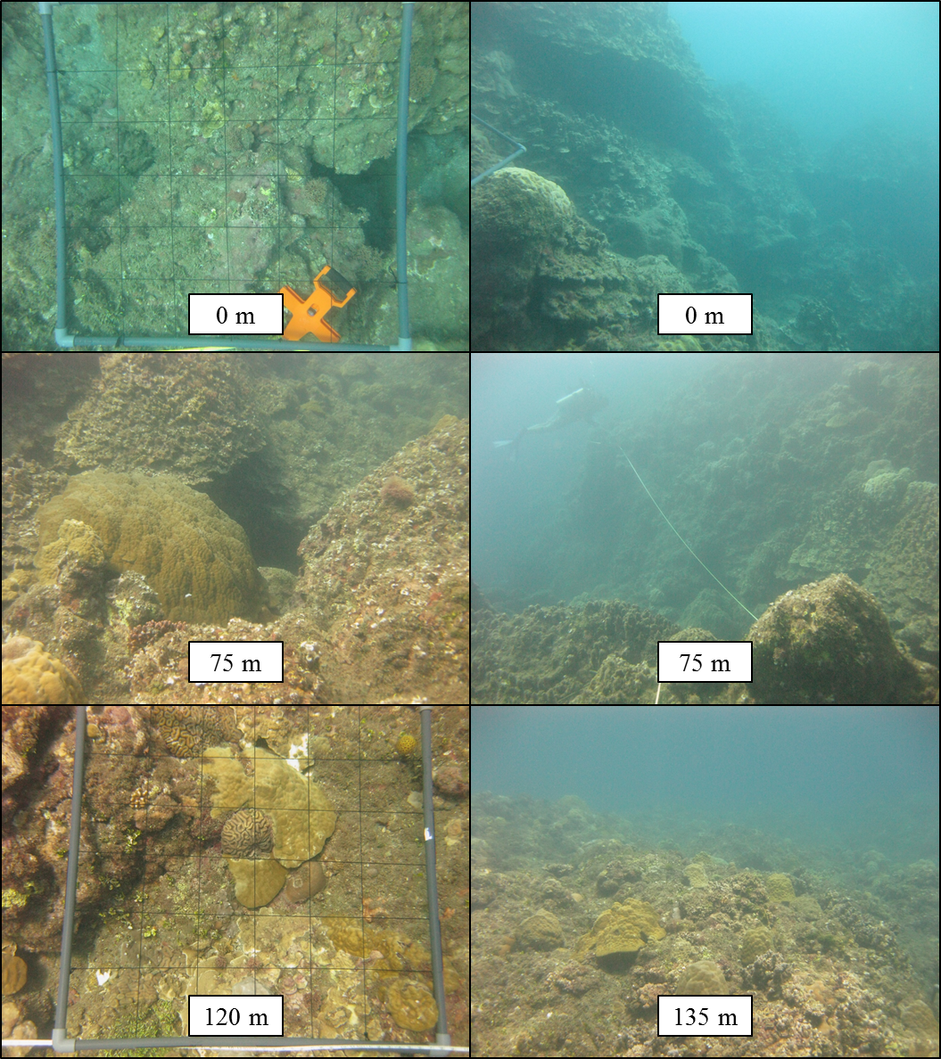

Plate 4. North deep transect.

