Appendices
Modeling the impacts of a changing and disturbed environment on an endangered beluga whale population

Elizabeth A. McHuron^{a*}, Manuel Castellote^{a,b}, Gina K. Himes Boor^{c}, Kim E.W. Shelden^{b}, Amanda J. Warlick^{d}, Tamara L. McGuire^{e}, Paul R. Wade^{b}, Kimberly T. Goetz^{b}

ª Cooperative Institute for Climate, Ocean, and Ecosystem Studies, University of Washington, Seattle, WA 98115, USA
^{b} ﻿Marine Mammal Laboratory, Alaska Fisheries Science Center, National Marine Fisheries Service, Seattle, WA 98115, USA
^{c} Ecology Department, Montana State University, Bozeman, MT 59717, USA
^{d} School of Aquatic and Fishery Sciences, University of Washington, Seattle, WA 98115, USA
^{e} The Cook Inlet Beluga Whale Photo-ID Project, Anchorage, AK 99515, USA

Appendix A. Fetal Energy Allocation SDP Submodel
Model overview
The purpose of this SDP submodel was to determine the optimal amount of energy to allocate to fetal reserves (blubber) across the 475-day gestation period, where the optimal amount was quantified relative to the predicted blubber reserves. This decision depended on three state variables: female blubber mass, fetal blubber mass, and energy gain. The optimal energy allocation was chosen from 31 potential options that ranged from 0 – 1 at intervals of 0.001 to 0.05. Much of the description of the state variables and state dynamics are similar to what is described in the main text, but we present it here as well for completeness. An overview of the notation and description of state variables and key parameters can be found in Table A1.

Time horizon and time steps
The model was run from conception (assumed to be April 16th) to birth (assumed to be August 4th in the year following conception), lasting a total of 475 days (Robeck et al., 2015). The date of birth was based on estimates from fetal and calf morphology (Shelden et al., 2020) and timing of neonate observations (McGuire et al., 2020). The date of conception was then assumed to occur 475 days prior. Neonates have been observed as early as July and as late as October in Cook Inlet (McGuire et al., 2020), but for model simplicity we assume fixed times for conception and birth.

The backward iteration was assessed at a time step of 1 day, although the physiological dynamics were assessed at a 6-hour time step to match the behavioral SDP model described in the main text.

Glossary of terms
Table A1. Key parameter values used in the SDP fetal submodel. For state variables, values represent the range of possible values across which decisions were assessed.
Parameter | Notation | Value | Units
Model output
Investment in fetal blubber | $$E_{BGestation}$$ | Variable based on state variables and time | MJ
State variables
Female blubber mass | $X(t)$ or $x$ | 80.0 – 543.0 | kg
Fetal blubber mass | $X_{f}(t)$ or $x_{f}$ | 0 – 52.0 | kg
Energy gain | $E(t)$ or $e$ or $E_{Gain}$ | 0 - 250.0 | MJ
Parameters
Digestive efficiency | $$DEF$$ | 95.0 | % GEI
Energy cost of metabolism | $$E_{Metab}$$ | see main text
Energy cost of urine production | $$E_{Urine}$$ | see main text
Energy cost of digestion | $$E_{HIF}$$ | see main text
Blubber energy density | $$ED_{Blubber}$$ | 34.32 | MJ kg⁻¹
Fetal blubber energy density | $$ED_{FetalBlubber}$$ | Variable through time | MJ kg⁻¹
Minimum fetal investment | $$E_{MGestation}$$ | Variable through time | MJ
Heat increment of gestation | $$HIG$$ | Variable through time | MJ

State variables
We used blubber mass,$X(t)$ at time $t$ with a particular value denoted by $x$, as the metric to describe a female’s energy reserves. Blubber mass was bounded by a critical ($x_{crit}$) and upper limit ($x_{max}$). Mortality was assumed to occur when blubber mass was below $x_{crit}$. We assumed that $x_{crit}$ and $x_{max}$ occurred at 80 kg and 543 kg, or when blubber mass was 12% or 45% of estimated body mass, respectively. Behavioral decisions were assessed at 10 kg intervals between $x_{crit}$ and $x_{max}$.

To estimate $x_{crit}$, we used data from (Cornick et al., 2016) to create a predictive equation for blubber mass (as a proportion of body mass) based on blubber depth at either the D2 or AX location. Each equation was based on only two data points (one in the spring and one in the fall) since individual blubber depth measurements were not presented. We then estimated the proportion of body mass that was blubber of three stranded Cook Inlet belugas where malnutrition was identified as the cause of death (Burek-Huntington et al., 2015). This resulted in values that ranged from 12 – 15%; we chose the lowest of these values for $x_{crit}$. The value for $x_{max}$ was chosen so that it was slightly higher than the mean blubber masses (as a proportion of body mass) of adult Bristol Bay belugas in the fall (42.9%), when animals are presumably in good condition (Burek-Huntington et al., 2015).

We used fetal blubber mass, $X_{f}(t)$ at time $t$ with a particular value denoted by $x_{f}$, to describe the energy reserves of the fetus. As above, this variable was bounded by $x_{fcrit}$, which was assumed to be 0 kg based on the findings that an aborted fetus had essentially no blubber layer (Burek-Huntington et al., 2015). The upper bound, $x_{fmax}$, was set at 60% of estimated body mass for that day and thus increased exponentially as the fetus grew. Behavioral decisions were assessed at 74 discrete fetal blubber masses, from 0 kg to 52 kg. Intervals were not constant because fetal growth is exponential and blubber masses are very small during early gestation. At very small blubber masses we assessed behavioral choices at fetal blubber masses that differed by 0.0001 kg - 0.1 kg, and from 1 kg in blubber mass onwards we used increments of 1 kg.

As mentioned above, the value for $x_{fcrit}$ was based on observations that an aborted Cook Inlet beluga fetus had virtually no blubber layer (Burek-Huntington et al., 2015). The value for $x_{fmax}$ was based on observations that blubber mass as a percent of body mass may be up to 60% in juvenile belugas (Burek-Huntington et al., 2015). We used this value since data from bottlenose dolphins (Tursiops truncatus) found that around birth, fetuses had similar body composition as juvenile animals. Since fetal mass changes with age, we made $x_{fmax}$ age-specific so that a fetus could not achieve a blubber mass that was greater than 60% of its estimated predicted body mass. Thus, $x_{fmax}$ increased exponentially with fetal age (Fig. A1).

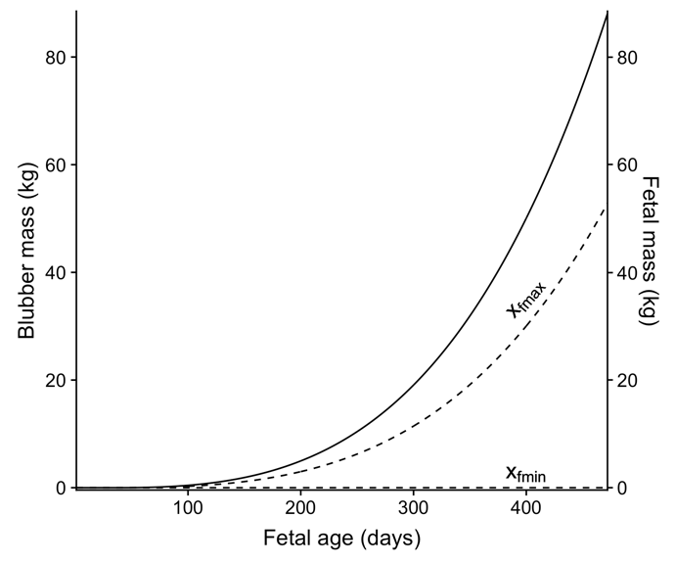
Figure A1. Estimated minimum and maximum blubber mass values for a beluga whale fetus (dashed lines) as a function of fetal age. The solid line indicates the estimated fetal mass based on fetal age.

We used $E(t)$ at time t with a particular value denoted by $e$ to describe the energy gain by a female. Behavioral decisions were assessed between 0 MJ and 250 MJ in 5 MJ increments, for a total of 51 discrete classes.

Physiological parameters
As described in the main text, the dynamics of female and fetal blubber mass depended on how much energy a female beluga expended, how much energy she gained (if any), and the energy density of blubber. Energy costs incurred by the female included her own maintenance, locomotion, pregnancy, digestion, and urine production, assuming that any thermoregulatory costs were negligible. We separated the energy costs of pregnancy into two categories: 1) the minimum cost a female must invest in the fetus (metabolic costs and energy stored in non-blubber tissues), and 2) additional energy that can be allocated to fetal blubber reserves. A complete description of all costs except those associated with gestation are described in the main text and so are largely not reiterated here. Locomotion costs were simplified in this model compared with the one described in the main text; when energy gain was 0, costs were calculated assuming belugas spent 50% of their time swimming and when it was not 0, time spent swimming was assumed to be 100%. Below we focus on how we calculated the minimum cost of gestation ($E_{MGestation}$) and the energy density of fetal blubber as a function of fetal age.

The minimum cost of gestation was assumed to be the sum of the energy invested in muscle and viscera growth (energy stored in fetal tissue) and the metabolic costs incurred by the female associated with supporting the fetus (Heat Increment of Gestation, HIG). Our general approach was to estimate the amount of new lipid and protein deposition in different tissues by estimating body mass, body composition, and tissue composition, assuming energy densities of 39.3 MJ kg⁻¹ (lipid) and 18.0 MJ kg⁻¹ (protein) and deposition costs of 0.17 MJ kg⁻¹ (lipid) and 1.38 MJ kg⁻¹ (protein). While we accounted for skeletal tissue in body composition estimates, we did not include it in the final cost estimate since the energy density of bone is largely unknown. We also estimated the expected energy invested in blubber deposition even though it was not included in the minimum cost of gestation. This was because we estimated predictions of optimal energy allocation to blubber reserves relative to this value (see State dynamics) and also because blubber energy density estimates were needed to convert energy surplus to blubber mass changes. We used the equations of Robeck et al. (2015) and Robeck et al. (2005) to estimate fetal length and mass as a function of age, respectively. Predicted lengths at < 40 days of age were set to the lowest predicted length since initial predictions from the equation resulted in negative lengths. A detailed description of body and tissue composition is described below.

Body composition was assumed to be largely comprised of blubber, muscle, bone, and viscera. Values for blubber composition were based off data from harbor porpoises (Phocoena phocoena) and bottlenose dolphins, which indicated the following: fetal blubber composition increases with age, about 50% of the blubber mass was reached about 60% of the way through gestation, and that fetal blubber values are about 74% of juvenile values (Lockyer, 1995; Struntz et al., 2004). From these data, and estimates of juvenile beluga blubber mass composition (Cornick et al., 2016), we fit a 2nd order polynomial curve assuming the proportion of blubber at fetal lengths of 1 cm, 87 cm, and 145 cm was 0, 22.5%, and 45%, respectively. Data on body composition of muscle (26%), bone (9.8%), and viscera (12.2%) were derived from harbor porpoise calves (McLellan et al., 2002). We assumed that the relative proportion of these three tissues did not change throughout gestation and that the total proportion of body mass comprised of blubber, muscle, bone, and viscera was 85%, with the remaining presumed to come from fluids. Thus, the absolute proportion of the fetus comprised of muscle, bone, and viscera decreased with fetal age due to presumed increases in blubber deposition (Fig. A2).
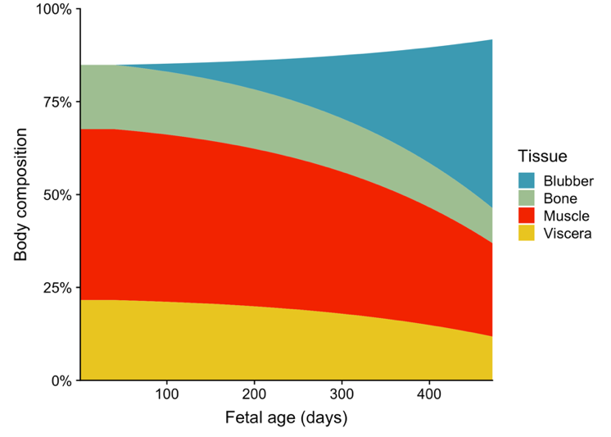
Figure A2. Estimated body composition of the fetus as a function of fetal age. Values represent the total percentage of body mass of each tissue. The remaining composition is assumed to come from fluids. While predicted blubber composition is shown here, it was not included in the costs of gestation since energy allocation or fetal blubber reserves is the behavior that is being modeled in this SDP model.

Tissue composition of blubber and muscle was estimated from limited measurements from other cetaceans. To estimate the lipid composition of blubber, we digitized the data on blubber lipid composition of pilot whale (Globicephala melas) fetuses as a function of fetal age from Lockyer (1993) to develop a predictive relationship. We adjusted the slope of this relationship by multiplying it by 0.68 to account for the fact that the highest mass used to generate the equation was considerably less the predicted birth mass of beluga whales; without this adjustment, predicted lipid composition was predicted to be > 1 at the time of birth. The resulting estimate of blubber lipid composition on the final day of gestation was 76.6%, which is similar to the 79.2% measured from a single neonate beluga whale fetus (Gauthier et al., 1998). The lipid composition of muscle was estimating using a similar approach, using the data on muscle lipid composition as a function of fetal age from pilot whale fetuses (Lockyer, 1993). The unadjusted estimate from the equation resulted in a value of 6.6% muscle lipid composition on the final day of gestation; however, belugas appear to have considerably less lipid in muscle than other cetaceans, around 1% (Kiceniuk et al., 1997; Metcalfe et al., 1999). Because of this, we adjusted the slope of the relationship between muscle lipid composition and fetal age until the end value aligned with the empirical estimates from belugas. There are little data protein composition of blubber and muscle and no indication on how composition might change with fetal age. For blubber, we assumed a value of 6% on the last day of gestation (Lockyer, 1993) and that it varied inversely with lipid content so that the protein composition of blubber declined with fetal age. For muscle, we used a value of 14.5% on the last day of gestation and assumed that the total contribution of lipid and protein was constant throughout gestation (Fig. A3). For viscera, we again used data from (Lockyer, 1993) and assumed a constant proportion of lipid (2.5%) and protein (14.5%) throughout gestation.

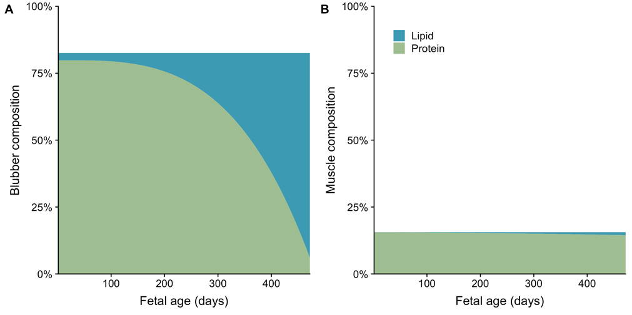
Figure A3. Lipid and protein composition of blubber (A) and muscle (B) as a function of fetal age. Values represent the total percent of blubber or muscle mass comprised of either lipid or protein. The remaining composition is assumed to come from water.

The energy stored in new tissue growth was calculated by summing the estimated cost of new lipid and protein deposition in muscle and viscera. As mentioned previously, we exclude the energy stored in blubber deposition because the purpose of the model was to estimate this value. We did use the estimated tissue composition of blubber to estimate the daily energy density of blubber. Energy storage costs were added to estimates of the HIG, which accounts for the metabolic costs of being pregnant and comprises the majority of pregnancy costs (Fig. A4). The total HIG was estimated based on Brody’s equation $HIG=18.41∙{M_{Birth}}^{1.2}$ (Brody, 1938) using a birth mass ($M_{Birth})$ of 90 kg. The fetal length at age curve was used to allocate this total cost to daily costs so that the daily HIG increased as the fetus grew. We assumed that daily energy costs stored in the placenta or other pregnancy tissues were negligible.

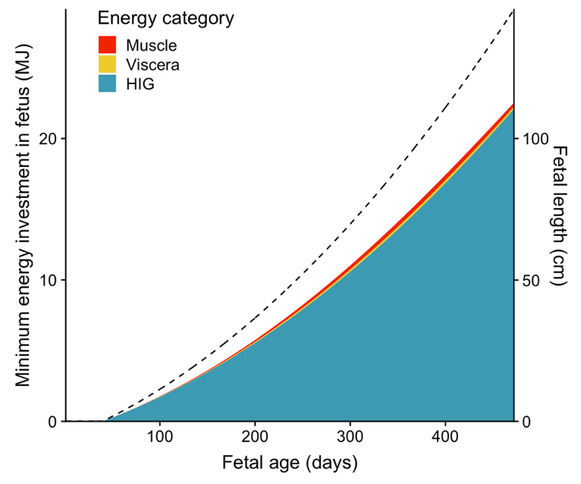
Figure A4. Minimum fetal energy investment by fetal age. The dashed line indicates changes in fetal length as a function of fetal age.

State dynamics
The blubber mass dynamics of a pregnant female beluga whale are
$$X\left(t+1\right)=\min\left[X\left(t\right)+\frac{E_{Gain}⋅DEF-E_{Metab}-E_{HIF}-E_{Urine}-E_{MGestation}-E_{BGestation}}{{ED}_{Blubber}},x_{max}\right]$$Eq. A1
where $E_{Metab}$ encompasses costs associated with resting metabolic rate and locomotion (the cost of swimming; $COS$, Table 1 in main text). As mentioned previously, $E_{Metab}$ costs were calculated assuming 50% of the time was spent swimming when energy gain was zero, and 100% when energy gain was > 0. When energy gain is 0, these dynamics are simplified to

$$X\left(t+1\right)=\min\left[X\left(t\right)-\frac{E_{Metab}-E_{MGestation}-E_{BGestation}}{{ED}_{Blubber}},x_{max}\right]$$Eq. A2

The blubber mass dynamics of the fetus are

$$X_{f}\left(t+1\right)= min\left[X_{f}\left(t\right)+\frac{E_{BGestation}}{{ED}_{FetalBlubber}},x_{fmax}\right]$$ Eq. A3

The costs associated with the fetus, the energy density of fetal blubber, and the maximum value of fetal blubber mass all vary with time, but notation is omitted for simplicity.

Because the goal of this model was to predict the optimal value of $E_{BGestation}$, female and fetal blubber dynamics differed depending on this value. The specific values for $E_{BGestation}$ at any given time were calculated as some proportion ($n$) of the predicted energy allocation for blubber reserves
$$E_{BGestation}=n∙E_{BPGestation}$$Eq. A4

where n was one of 31 value that ranged from 0 – 1 as described in the Model overview section.

SDP Equations
When solving the SDP equations, we assume that all individuals act in such a way to maximize their expected future reproductive success, which for this model is based on a single reproductive event and a female’s probability of survival. The fitness function, $F(x,x_{f},e)$, is defined as the expected total probability that a female will survive the year and her fetus, once born, will survive given that $X\left(t\right)=x, { X}_{f}\left(t\right)=x_{f}$, and $E\left(t\right)=e$, where the expectation is taken over the stochastic events of survival and food distribution.

At the last time step in the model, $T$, fitness was calculated as
$$F\left(x,x_{f},e,T\right)=ϕ\left(x\right)+ϕ\left(x\right)∙ϕ_{f}\left(x_{f}\right)≡Φ\left(x,x_{f}\right)$$Eq. A5

where $ϕ\left(x\right)$ is the probability that a female with blubber mass $x$ survives to the following year, and $ϕ_{f}\left(x_{f}\right)$ is the probability that a fetus with blubber mass $x_{f}$ at the time of birth ($t=T$; referred to as calf survival) survives to one year of age. Since the relationships between survival probability and female and calf blubber mass are unknown, we parameterized these functions using estimates of the annual probability of adult and young-of-the-year survival of CIBs and a sigmoidal function (Figs. A5 – A6). Survival estimates were derived from an earlier version of the model presented in Himes Boor et al. (2022).
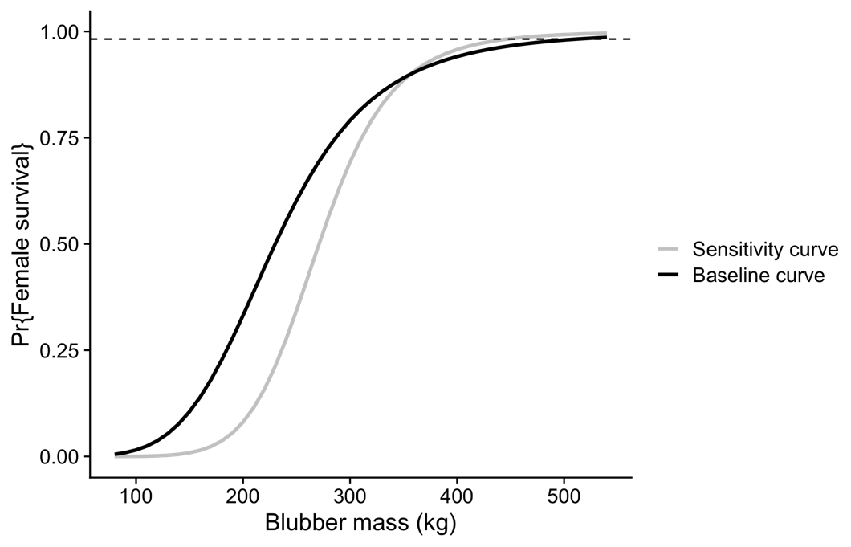
Figure A5. The probability of female survival as a function of female blubber mass. The dashed horizontal line is the estimate of annual adult survival for Cook Inlet belugas. Separate curves are shown for the baseline model and the one used in the sensitivity analysis as described in the main text.

Figure A6. The probability of calf survival as a function of blubber mass at birth and female blubber mass (from the baseline survival curve). The horizontal dashed line indicates the annual probability of young-of-the-year survival of Cook Inlet beluga whales, and the vertical dashed line indicates the blubber mass at which that value occurs.

Fitness at all other model time steps was calculated by iterating backwards through time, where fitness is the maximum future expected fitness across all 31 values of $n$

$$F\left(x_{f},x_{fe},e,t\right)=\max_{n over η(n)}{[V\left(x_{f},x_{fe},e,t\right)}]$$Eq. A6

The fitness value for an individual energy allocation value is

$$V_{n}=e^{-μ}*F(x_{f}^{'},x_{fe}^{'},e,t+1)$$Eq. A7

where $e^{-μ}$ is the probability a beluga whale survives the current time step (see Table 1 in main text), and $x_{f}^{'}$ and $x_{fe}^{'}$ are the predicted values of blubber mass of the female and fetus at the next time step, respectively, conditioned on the value of $n.$

When ties in fitness arose, we assumed that a female chose the lesser value of energy allocation to the fetus. If at any time a female’s blubber mass fell below $x_{crit}$ then her fitness went to zero.

Application
There is no forward simulation associated with this model because the goal was to use the optimal values in the behavioral SDP model described in the main text. Since we explored the sensitivity of the behavioral model to different terminal fitness functions (Fig. A5), we also ran the fetal energy allocation for each fitness function.

Appendix B. Prey energy landscape
Overview
To characterize the prey landscape, we would ideally use fisheries-independent data on spatial and temporal variation in abundance for all potential beluga prey species in Cook Inlet. Because we lacked such data, we instead used fisheries data from salmonids, general descriptions of the timing of eulachon runs, and basic assumptions about the relative amounts of prey available during late fall - spring. As mentioned in the main text, we acknowledge that while this approach has flaws, it allows us to capture the general features we believe represent their prey landscape, that it is characterized by seasonally abundant prey resources.

Salmonids
We used a combination of set-net harvest and escapement data from five salmonid species to parameterize the prey landscape of salmonids. We included data from sockeye (Oncorhynchus nerka) and pink (O. gorbuscha) salmon, along with coho (O. kisutch), chinook (O. tshawytscha), and chum (O. keta), even though these two species have not been detected in the limited stomach samples collected from CIBs (Quakenbush et al., 2015). Traditional ecological knowledge indicates that CIBs followed sockeye salmon up Kenai River, and belugas from other populations consume both species (Huntington, 2000; Quakenbush et al., 2015). Set nets are stationary nets anchored in the river or to shore, while escapement is the number of fish allowed to escape the harvest to spawn. Harvest data were available for 15 of the 27 cells, and escapement data for 6 of 27 cells (Fig. 1 in main text, Table B1). There were no cells with escapement data that did not also have harvest data, but within a cell there was not necessarily temporal overlap between the two datasets, both in the year range and day within the year. Harvest data were provided to us at the level of the statistical area, a management designation, whereas escapement data were presented per river. Both provided counts on a daily timescale by species. The earliest records within the year occurred on April 30 and the latest October 11. We linked each dataset with the associated SDP cell, and for each cell summed the number of salmon by species and by date. When both harvest and escapement data were available, the number of salmon was summed across the two data sources. We combined these species sums with estimates of species-specific energy density (Table B2) and then summed across all species in a cell for each date to obtain the total available energy from salmonids (Fig. B1). We also calculated the mean energy density of prey, weighted by the abundance of the different salmonid species, which was necessary so that we could track of the mass of prey consumed in the forward simulation since stomach fullness was a state variable. Since data did not cover the entire year, we inserted zeros at the start and end of each year. We used Generalized Additive Models with a log link function to estimate the total energy available throughout the entire year (Fig. B1). Because each cell had data from multiple years, the resulting output can be viewed as our best representation of the average salmonid energy landscape encountered by belugas, at least for cells with available data.

To convert energy availability to energy gained from foraging, we calculated the proportion of energy available relative to the maximum predicted value in Cell 6, which is a known Cook Inlet beluga hotspot. The resulting proportion was then multiplied by the maximum prey consumption in a single time step, 22 kg, and converted back to energy using the average cell-specific prey energy density.

Table B1. Year range for salmonid harvest and escapement datasets by cell. Harvest data were available back to 1990 but in almost all cases we used data from 2000 onwards because data had to be manually compiled.
Cell | Harvest | Escapement
Knik Arm (1) | 1990 - 1997 | 1993 - 2019
Fire Island (5) | 2000 - 2020
Susitna (6) | 2000 - 2020 | 1981 - 2019
Beluga River (7) | 2000 - 2020
N. Moose Point (8) | 2000 - 2020
N. Foreland (10) | 2000 - 2020
N. Boulder Point (11) | 2000 - 2020
Trading Bay (13) | 2000 - 2020
Big River (14) | 2000 - 2020
Kenai River (15) | 2000 - 2020 | 1960 - 2019
Kasilof River (16) | 2000 - 2020 | 2010 - 2020
Kalgin Island (18) | 2000 - 2020
Redoubt Bay (19) | 2000 - 2020 | 1979 - 2012
Tuxedni Bay (20) | 2000 - 2020
Ninilchik (22) | 2000 - 2020 | 1997 - 2020

Table B2. Energy density and average mass of five salmonid species and eulachon. Data from O’Neill et al. (2014) and Perez (1994).
Species | Energy density (MJ kg⁻¹) | Average mass (kg)
Chinook salmon | 7.21 | 3.81
Sockeye salmon | 7.51 | 2.40
Chum salmon | 4.78 | 4.20
Coho salmon | 5.80 | 3.56
Pink salmon | 4.29 | 1.86
Eulachon | 11.0 | 0.069

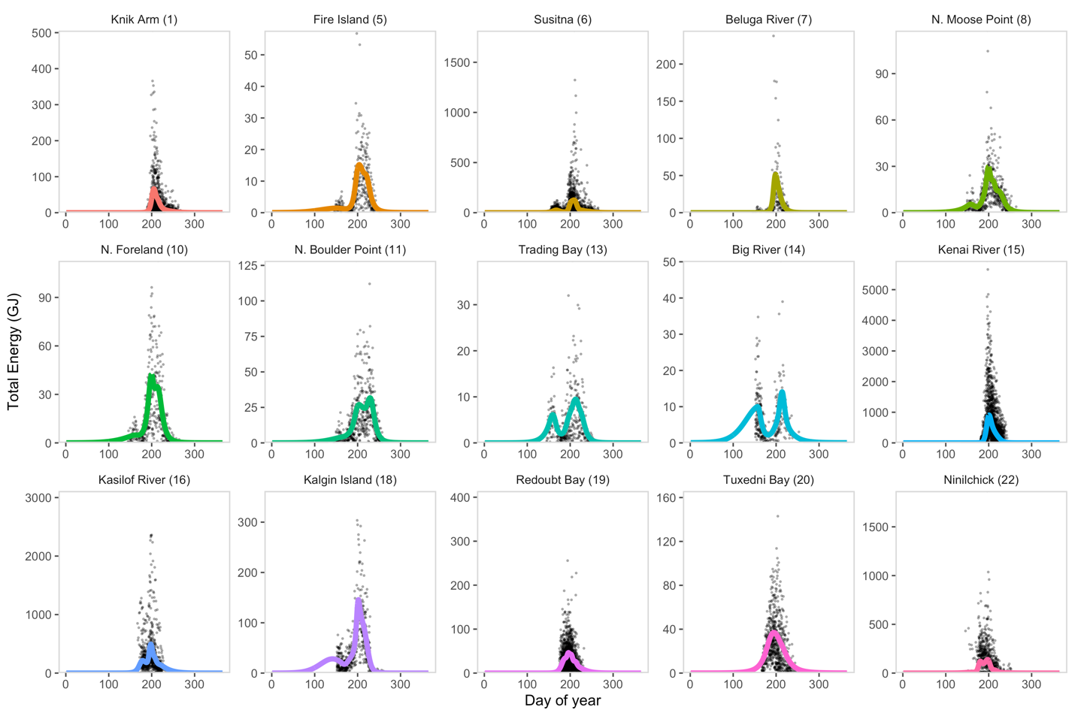
Figure B1. Estimates of total energy availability (GJ) of salmonids in Cook Inlet derived from set-net harvest and escapement data. The solid line in each subplot represents predictions from a generalized additive model and points represent the individual data across multiple years. Note the differences in axis scales among cells.

Eulachon
We found mention of three eulachon runs in Cook Inlet, specifically in the Kenai River, Turnagain Arm, and Susitna River. We were unable to find any data on the size of eulachon runs for any of these locations, other than brief mention of harvest and/or escapement data. Data from early reports seemed to indicate that the number of eulachon harvested in a subsistence fishery in the Kenai River was small compared with harvest and escapement estimates from the Susitna River. (Logan, 1970). Because of this, and the extremely limited information for the Kenai run, we did include it in the prey landscape. Descriptions of available information for the two runs considered in the model are presented below.

Twentymile River, Turnagain Arm: In 2000 and 2001, eulachon were detected between May 4th - June 21, 2000 (49 days) and April 17th - June 9, 2001 (54 days). Run times in the 1970s reported in Table 1.8 indicate a run from late April/early May - early to mid-June (18 - 46 days), although (Spangler, 2002) note that the shortened runs during the 1970s may be due to detection issues associated with the presence of ice. For the Turnagain Arm run, we assumed the run began on May 5 and ended on June 9, with a maximum consumption at the midpoint of 22 kg. Consumption estimates for each day of the run were converted to energy gain using the prey energy density estimate for eulachon (Table B2).

Susitna River: The eulachon run occurs as two migrations (Barrett et al., 1984). In the 1980s, the timing of these runs was May 16th - May 30th and June 1st - June 8th in 1982, and May 10th - May 17th and May 19th - June 6th in 1983. In the 1980s there was a small sport fishery in the range of several thousand fish. Estimated escapement in 1982 and 1983 of the first migration was several hundred thousand fish and several million fish for the second migration. For the Susitna runs, we assumed the first run occurred from May 13 – May 24 and the second from May 25 – June 7. We set the maximum consumption at 70% of the maximum allowed for the first run (15.4 kg), and at the maximum allowed (22 kg) for the second run. We assumed this maximum consumption occurred at the midpoint of each run and that values increased linearly up to this midpoint and thereafter decreased linearly to the end of the run.

Other prey
We also used rough approximations of beluga presence and absence derived from acoustic data (Castellote et al., 2020) to parameterize the prey landscape, which was primarily intended to fill in the late fall to early spring time periods and represent prey other than salmonids and eulachon (Fig. B2). The average prey energy density was assumed to be 6.2 MJ kg⁻¹. We assumed a fixed energy gain from foraging for each occurrence. For the baseline model this was 40 MJ per time step.
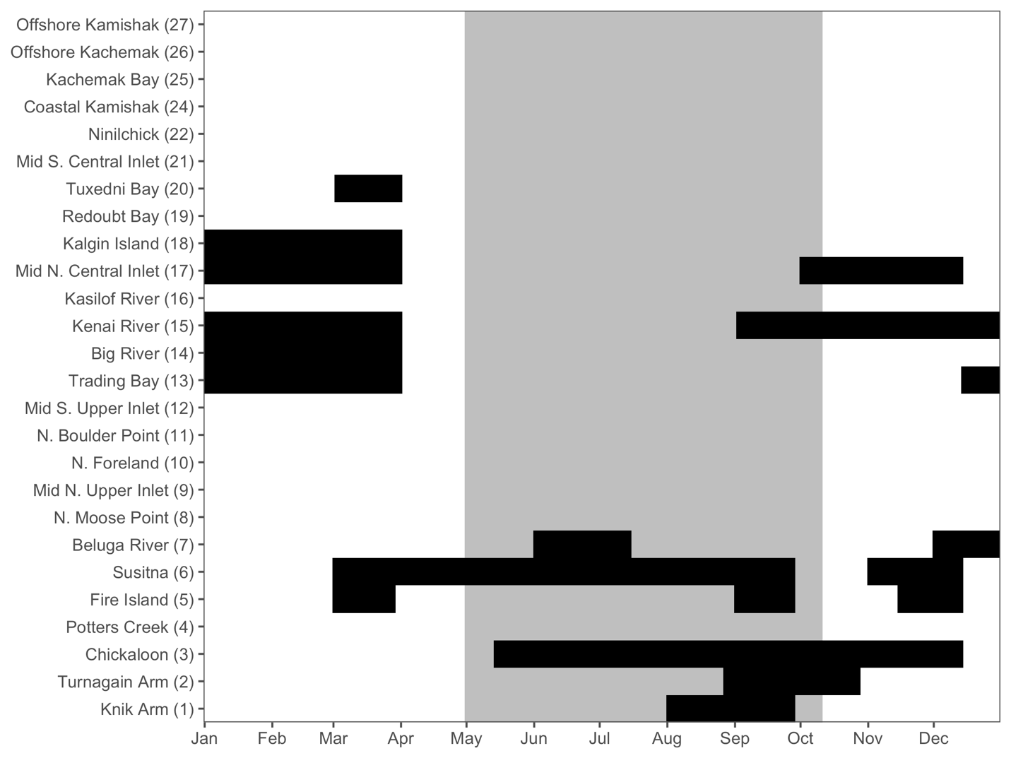
Figure B2. Approximations of beluga presence (black) in each cell to aid in characterizing the prey landscape experienced by Cook Inlet belugas. For all the black cells, an energy gain from foraging was assumed to be 40 MJ per time step. Presence data were roughly approximated from acoustic presence data (Castellote et al., 2020). The gray box represents the minimum and maximum dates from the salmonid prey landscape.

Final prey landscape
All three prey landscapes were summed per day and cell to create a single prey landscape. Prey energy density per cell and day were averaged across all three landscapes. The resulting energy gain from foraging was then multiplied by the proportion of the cell with exposed mudflats to quantify the landscape when the tide was below slack (Fig. B3). As mentioned in the main text, while it is known that some cells may be partially or fully inaccessible during certain tidal phases, it is unknown how tidal phase affects energy gain. This was simply a first attempt to produce some variation in the prey landscape associated with tidal phase, which was a state variable in the model. The resulting landscape represented the amount of energy gained from foraging in a given cell and time.

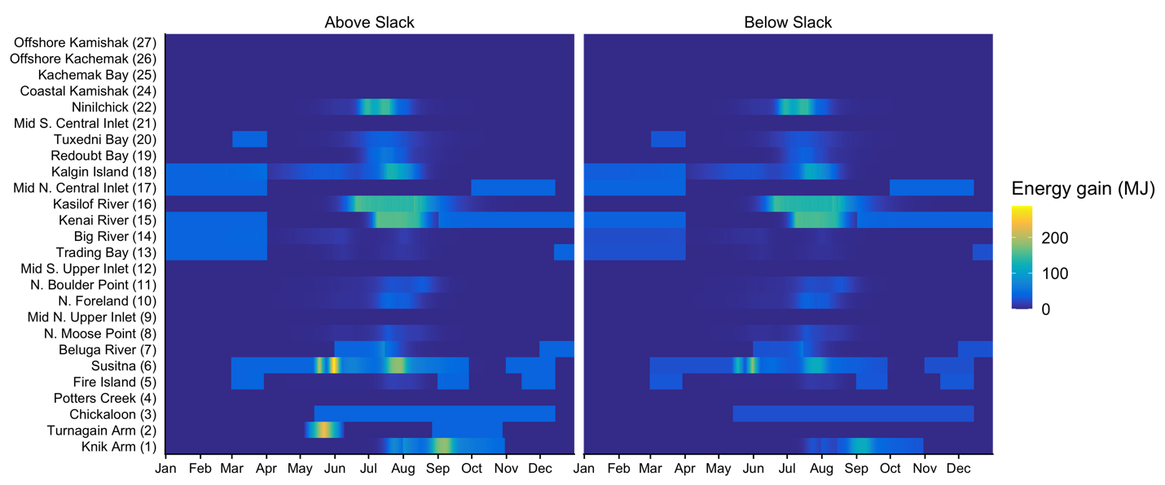
Figure B3. Prey energy landscape used in the Stochastic Dynamic Programming model for predicting behavioral decisions by pregnant Cook Inlet belugas. Colors represent the amount of energy gained from foraging depending on tidal state. The landscape shown here is the one that was used in baseline model described in the main text.

We created several variations on the original prey landscape. Specifically, we assumed that the prey availability in Knik Arm (Cell 1) from August 15 – October 31 was equivalent to what was in Susitna (Cell 6) from July 5 – September 20. As described in the main text, this prey landscape ended up being our baseline prey landscape for the model. We also varied the amount of energy gained in the prey landscape based on beluga presence data from 40 MJ to either 30 MJ or 55 MJ to explore how changes in winter prey availability affected model output.

Appendix C. Probability distribution of behavior
The optimal behavioral decision at any given time is based on the behavior that maximizes the future expected reproductive success. There may be some instances, however, where two behaviors have the same fitness value (a tie in fitness), necessitating a method for selecting behavior in the presence of fitness ties. By selecting the optimal value, we also ignore suboptimal behaviors that may have very similar fitness values as the optimal one and assume that animals never make any errors in selecting a behavior (i.e., they never choose a suboptimal behavior). In nature this is unlikely to be the case. To deal with these issues in a more natural way, we calculated the probability of selecting each behavior as the output of the backward iteration.

To compute a probability distribution of behavior, we let $V^{*}(x, x_{f}, c, p, s, t)$ denote the optimal value of fitness given $X(t)=x$, $X_{f}(t)= x_{f}$, $C(t)=c$, $P(t)=p$, and $S(t)=s$. That is,
$$V^{*}\left(x, x_{f}, c, p, s, t\right)=\max_{}\left[V_{Forage}\left(x,x_{f},c,p,s,t\right),V_{Travel}(x,x_{f},c,p,s,t),V_{Rest}(x,x_{f},c,p,s,t)\right]$$ Eq. C1
and the fitness cost of different behaviors are
$$Δ_{Forage}=V^{*}\left(x, x_{f}, c, p, s, t\right)-V_{Forage}\left(x,x_{f},c,p,s,t\right)$$
$$Δ_{Travel}=V^{*}\left(x, x_{f}, c, p, s, t\right)-V_{Travel}\left(x,x_{f},c,p,s,t\right)$$
$$Δ_{Rest}=V^{*}\left(x, x_{f}, c, p, s, t\right)-V_{Rest}\left(x,x_{f},c,p,s,t\right)$$Eq. C2
These are all ≥ 0 and only 0 when the optimal behavior is followed.

We let $p_{Forage}\left(x,x_{f},c,p,s,t\right)$, $p_{Travel}\left(x,x_{f},c,p,s,t\right)$, $p_{Rest}\left(x,x_{f},c,p,s,t\right)$ denote the probability of foraging, traveling, and resting, respectively given that a pregnant beluga whale is in cell $c$at time $t$ and that $X(t)=x$, $X_{f}(t)= x_{f}$, $P(t)=p$, and $S(t)=s$. We then set
$$p_{Forage}(x, x_{f},c,p,s,t)=\frac{e^{-Δ_{Forage}(x, x_{f},c,p,s,t)/ς}}{e^{-Δ_{Forage}(x, x_{f},c,p,s,t)/ς}+e^{-Δ_{Travel}(x, x_{f},c,p,s,t)/ς}e^{-Δ_{Rest}(x, x_{f},c,p,s,t)/ς}}$$
$$p_{Travel}(x, x_{f},c,p,s,t)=\frac{e^{-Δ_{Travel}(x, x_{f},c,p,s,t)/ς}}{e^{-Δ_{Forage}(x, x_{f},c,p,s,t)/ς}+e^{-Δ_{Travel}(x, x_{f},c,p,s,t)/ς}e^{-Δ_{Rest}(x, x_{f},c,p,s,t)/ς}}$$
$$p_{Rest}(x, x_{f},c,p,s,t)=\frac{e^{-Δ_{Rest}(x, x_{f},c,p,s,t)/ς}}{e^{-Δ_{Forage}(x, x_{f},c,p,s,t)/ς}+e^{-Δ_{Travel}(x, x_{f},c,p,s,t)/ς}e^{-Δ_{Rest}(x, x_{f},c,p,s,t)/ς}}$$Eq. C3

In these equations the denominator is a normalization constant that ensures that the sum over all the probabilities is 1 (i.e., the whale must do something) and $ς$ is a tuning parameter on the errors in decisions. When $ς$ is much bigger than any of the costs, then the probabilities in Eq. C3 are essentially a uniform distribution and behavior is random. Alternatively, when $ς$ is much smaller than the smallest cost in Eq. C2, then Eq. C3 will pick out the optimal behavior with a very high probability (or fitness ties with equal probability). We chose a value of $ς$ that resulted in minimum blubber mass values in the forward simulation that best approximated the blubber mass estimates of adult belugas in the spring from (Cornick et al., 2016).

We found $F\left(x, x_{f}, c, p, s, t\right)$ by averaging across the fitness values of different behaviors
$$F\left(x, x_{f}, c, p, s, t\right)=p_{Forage}\left(x, x_{f},c,p,s,t\right)∙V_{Forage}\left(x, x_{f},c,p,s,t\right)+p_{Travel}\left(x, x_{f},c,p,s,t∙V_{Travel}\left(x, x_{f},c,p,s,t\right)\right)+p_{Rest}(x, x_{f},c,p,s,t)∙V_{Rest}\left(x, x_{f},c,p,s,t\right)$$Eq. C4
We determined probability distributions for both behavior (forage, travel, and rest) as above and travel decisions (not shown), so that the $V_{Travel}$ in Eqs. C1 – C2 was first calculated across all potential travel cells using equations similar to C1 – C4, replacing the behaviors of forage, travel, and rest by the available travel cells.

Appendix D. Results
In the forward simulation where foraging is allowed in these cells, the model predicts beluga whales should almost exclusively be found in Cell 16 if whales are allowed to forage there (Fig. D1). While the output of the backward iteration predicts a high probability of traveling to Cell 15 and foraging during July and August, simulated whales do not occur in Cell 15. Similarly, there is a high probability of foraging in Cell 6 during these months, but again, whales are not predicted to occur in these cells. The reason for this is because high prey abundance occurs first in Cell 16 in mid-June (Fig. B3), so whales are predicted to travel there, and then stay because there is abundant food.

Figure D1. Comparisons of spatial habitat use predictions between a model run allowing Cook Inlet belugas to forage in Cell 15 (Kenai) and Cell 16 (Kasilof) in July and August (red dots) and one that does not allow it (blue dots). All of the results presented in the main text are based off a model that does not allow it.

Figure D2. The percentage of time that simulated pregnant beluga whales spent in each behavior, separated by month. Results are shown for the baseline scenario under undisturbed conditions.
Figure D3. Spatial use of mid and upper Cook Inlet cells by simulated pregnant beluga whales by month. Each blue dot corresponds to an occurrence in that cell so that individual dots in high use areas are indistinguishable. Within-cell locations were generated by randomly sampling locations within the cell polygon since model output simply returned what cell an animal was in at any given time.

Table D1. Mean estimates of survival probability (female/calf) of 50 simulated belugas during gestation from the baseline scenario and four sensitivity scenarios. See Table 2 in the main text for a description of disturbance scenarios.
Scenario names (s) | Baseline | Optimality | Survival | Reduced winter | Increased winter
None | 0.987/0.974 | 0.987/0.974 | 0.987/0.974 | 0.980/0.967 | 0.987/0.974
Disturbance | 0.986/0.974 | 0.986/0.974 | 0.986/0.974 | 0 | 0.987/0.974
No eulachon | 0.970/0.957 | 0.961/0.948 | 0.970/0.958 | 0 | 0.987/0.974
75% salmon | 0.979/0.967 | 0.976/0.963 | 0.980/0.968 | 0.913/0.896 | 0.987/0.974
50% salmon | 0.821/0.793 | 0.761/0.725 | 0.818/0.763 | 0 | 0.983/0.971
75% salmon/eulachon | 0.954/0.941 | 0.946/0.934 | 0.956/0.944 | 0.803/0.769 | 0.987/0.974
50% salmon/eulachon | 0.147/0.124 | 0.051/0.043 | 0.137/0.105 | 0 | 0.626/0.579
Disturbance + 75% salmon/eulachon | 0.844/0.816 | 0.851/0.824 | 0.858/0.812 | 0 | 0.987/0.974

References
Barrett, B.M., Thompson, F.M., Wick, S.N., 1984. Adult anadromous fish investigations: May - October 1983. Alaska Department of Fish and Game. Susitna Hydro Aquatic Studies Report No. 1. Anchorage.
Brody, S., 1938. Growth and development with special reference to domestic animals. XLVI. Relation between heat increment of gestation and birth weight. Agricultural Experiment Station Research Bulletin 283.
Burek-Huntington, K.A., Dushane, J.L., Goertz, C.E.C., Measures, L.N., Romero, C.H., Raverty, S.A., 2015. Morbidity and mortality in stranded Cook Inlet beluga whales Delphinapterus leucas. Dis Aquat Organ 114, 45–60. https://doi.org/10.3354/dao02839
Castellote, M., Small, R.J., Lammers, M.O., Jenniges, J., Mondragon, J., Garner, C.D., Atkinson, S., Delevaux, J.M.S., Graham, R., Westerholt, D., 2020. Seasonal distribution and foraging occurrence of Cook Inlet beluga whales based on passive acoustic monitoring. Endanger Species Res 41, 225–243. https://doi.org/10.3354/ESR01023
Cornick, L.A., Quakenbush, L.T., Norman, S.A., Pasi, C., Maslyk, P., Burek, K.A., Goertz, C.E.C., Hobbs, R.C., 2016. Seasonal and developmental differences in blubber stores of beluga whales in Bristol Bay, Alaska using high-resolution ultrasound. J Mammal 97, 1238–1248. https://doi.org/10.1093/jmammal/gyw074
Gauthier, J.M.I., Brochu, C., Moore, S., Metcalfe, C.D., Beland, P., 1998. Environmental contaminants in tissues of a neonate St Lawrence beluga whale (Delphinapterus leucas). Mar Pollut Bull 36, 102–108.
Himes Boor, G.K., McGuire, T.L., Warlick, A.J., Taylor, R.L., Converse, S.J., McClung, J.R., Stephens, A.D., 2022. Estimating reproductive and juvenile survival rates when offspring ages are uncertain: A novel multievent mark-resight model with beluga whale case study. Methods Ecol Evol 2022, 1–12. https://doi.org/10.1111/2041-210X.14032
Huntington, H.P., 2000. Traditional knowledge of the ecology of belugas, Delphinapterus leucas, in Cook Inlet, Alaska. Marine Fisheries Review 62, 134–140.
Kiceniuk, J.W., Holzbecher, J., Chatt, A., 1997. Extractable organohalogens in tissues of beluga whales from the Canadian Arctic and the St. Lawrence Estuary. Environmental Pollution 97, 205–211.
Lockyer, C., 1995. Aspects of the biology of the harbour porpoise, Phocoena phocoena, from British waters, in: Blix, A.S., Walløe, L., Ulltang, O. (Eds.), Whales, Seals, Fish and Man. Elsevier Science, pp. 443–464.
Lockyer, C., 1993. Seasonal changes in body fat condition of northeast Atlantic pilot whales, and their biological significance. Report of the International Whaling Commission Special Issue 14, 325–350.
Logan, S., 1970. Inventory and cataloging of Kenai Peninsula-Cook Inlet-Prince William Sound drainages and fish stocks. Alaska Department of Fish and Game. Federal Aid in Fish Restoration, Annual Performance Report, 1969-1970, Project F-9-2(11)7-A, Juneau.
McGuire, T.L., Stephens, A.D., McClung, J.R., Garner, C.D., Shelden, K.E.W., Boor, G.K.H., Wright, B., 2020. Reproductive natural history of endangered Cook Inlet beluga whales: insights from a long-term photo-identification study. Polar Biol 43, 1851–1871. https://doi.org/10.1007/s00300-020-02750-y
McLellan, W.A., Koopman, H.N., Rommel, S.A., Read, A.J., Potter, C.W., Nicolas, J.R., Westgate, A.J., Pabst, D.A., 2002. Ontogenetic allometry and body composition of harbour porpoises (Phocoena phocoena, L .) from the western North Atlantic. J Zool 257, 457–471. https://doi.org/10.1017/S0952836902001061
Metcalfe, C., Metcalfe, T., Ray, S., Paterson, G., 1999. Polychlorinated biphenyls and organochlorine compounds in brain, liver and muscle of beluga whales (Delphinapterus leucas) from the Arctic and St. Lawrence estuary. Mar Environ Res 47, 1–15.
O’Neill, S.M., Ylitalo, G.M., West, J.E., 2014. Energy content of Pacific salmon as prey of northern and southern resident killer whales. Endanger Species Res 25, 265–281. https://doi.org/10.3354/esr00631
Perez, M.A., 1994. Calorimetry measurements of energy value of some Alaskan fishes and squids. U.S. Dep. Commer., NOAA Tech. Memo., NMFS-AFSC-32, 32 p.
Quakenbush, L.T., Suydam, R.S., Bryan, A.L., Lowry, L.F., Frost, K.J., Mahoney, B.A., 2015. Diet of beluga whales, Delphinapterus leucas, in Alaska from stomach contents, March-November. Marine Fisheries Review 77, 70–84. https://doi.org/10.7755/MFR.77.1.7
Robeck, T.R., Monfort, S.L., Calle, P.P., Dunn, J.L., Jensen, E., Boehm, J.R., Young, S., Clark, S.T., 2005. Reproduction, growth and development in captive beluga (Delphinapterus leucas). Zoo Biol 24, 29–49. https://doi.org/10.1002/zoo.20037
Robeck, T.R., Schmitt, T.L., Osborn, S., 2015. Development of predictive models for determining fetal age-at-length in belugas (Delphinapterus leucas) and their application toward in situ and ex situ population management. Mar Mamm Sci 31, 591–611. https://doi.org/10.1111/mms.12180
Shelden, K.E.W., Robeck, T.R., Goertz, C.E.C., Mcguire, T.L., Burek-Huntington, K.A., Vos, D.J., Mahoney, B.A., 2020. Breeding and calving seasonality in the endangered Cook Inlet beluga whale population: Application of captive fetal growth curves to fetuses and newborns in the wild. Mar Mamm Sci 36, 700–708. https://doi.org/10.1111/mms.12653
Spangler, E.A.K., 2002. The ecology of eulachon (Thaleichthys pacificus) in Twentymile River, Alaska. University of Alaska Fairbanks.
Struntz, D.J., Mclellan, W.A., Dillaman, R.M., Blum, J.E., Kucklick, J.R., Pabst, D.A., 2004. Blubber development in bottlenose dolphins (Tursiops truncatus). J Morphol 259, 7–20. https://doi.org/10.1002/jmor.10154

