Supplementary Material
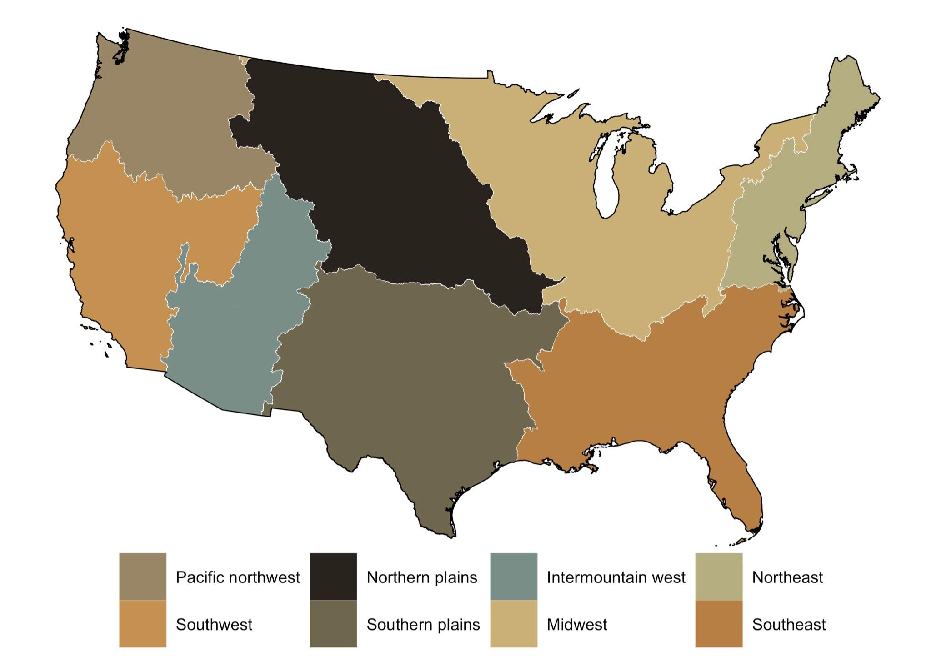
Figure S1: Physical drought regions defined in this study.

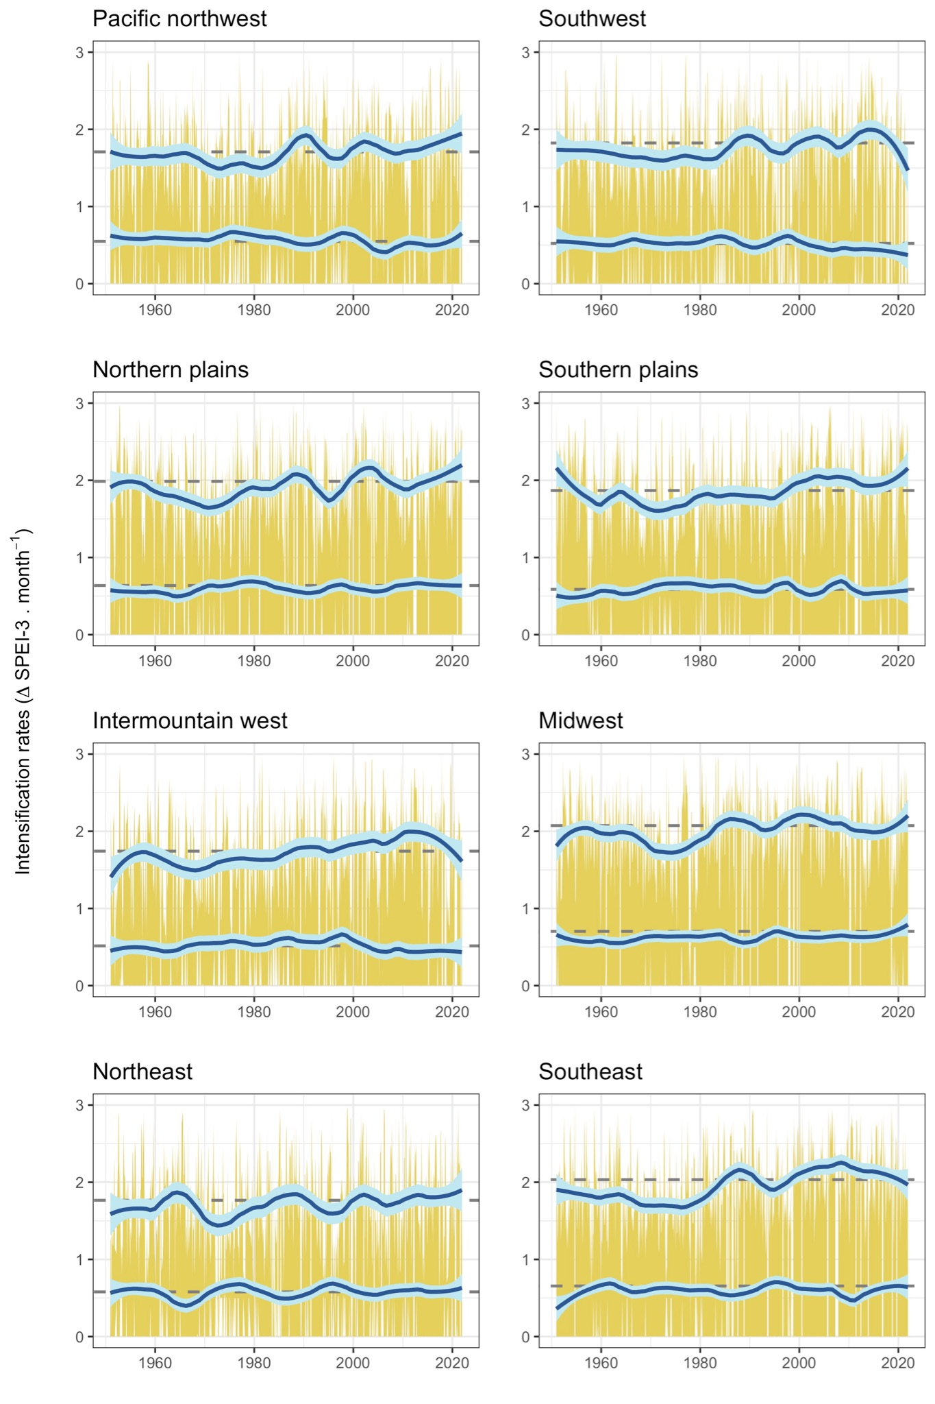
Figure S2: Drought intensification rates based on changes in SPEI-3 for the regions defined in this study (Fig. S1). The blue lines show trends in the median (bottom line) and 95th percentile (top line) of drought intensification rates smoothed with Locally Weighted Scatterplot Smoothing (LOWESS, smoothing parameter = 0.25). The light blue shading represents the 95% confidence intervals for the smoothers. The dashed lines depict the median and 95th percentile drought intensification rates for 1951-2021. Departures from these baselines are statistically significant (0.05 alpha-level).
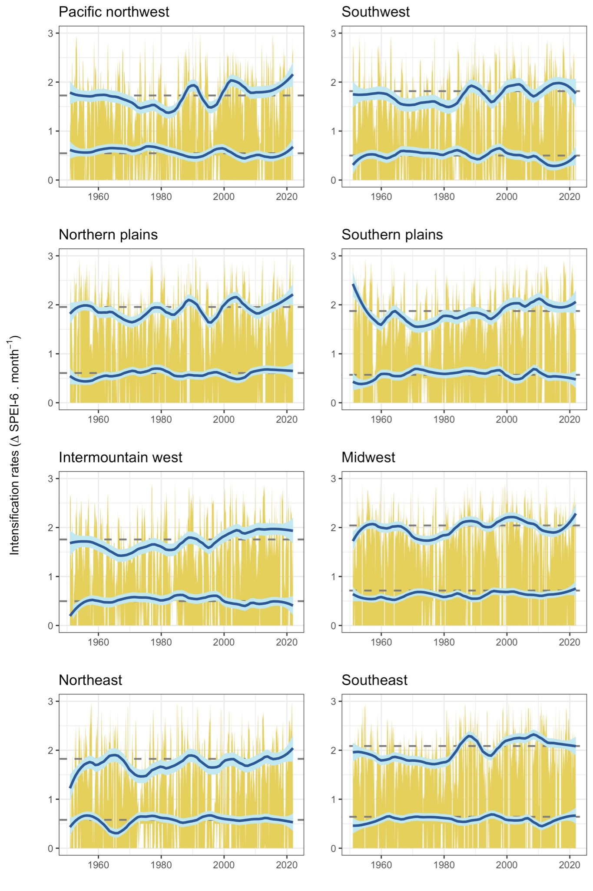
Figure S3: Drought intensification rates based on changes in SPEI-6 for the regions defined in this study (Fig. S1). The blue lines show trends in the median (bottom line) and 95th percentile (top line) of drought intensification rates smoothed with Locally Weighted Scatterplot Smoothing (LOWESS, smoothing parameter = 0.25). The light blue shading represents the 95% confidence intervals for the smoothers. The dashed lines depict the median and 95th percentile drought intensification rates for 1951-2021. Departures from these baselines are statistically significant (0.05 alpha-level).
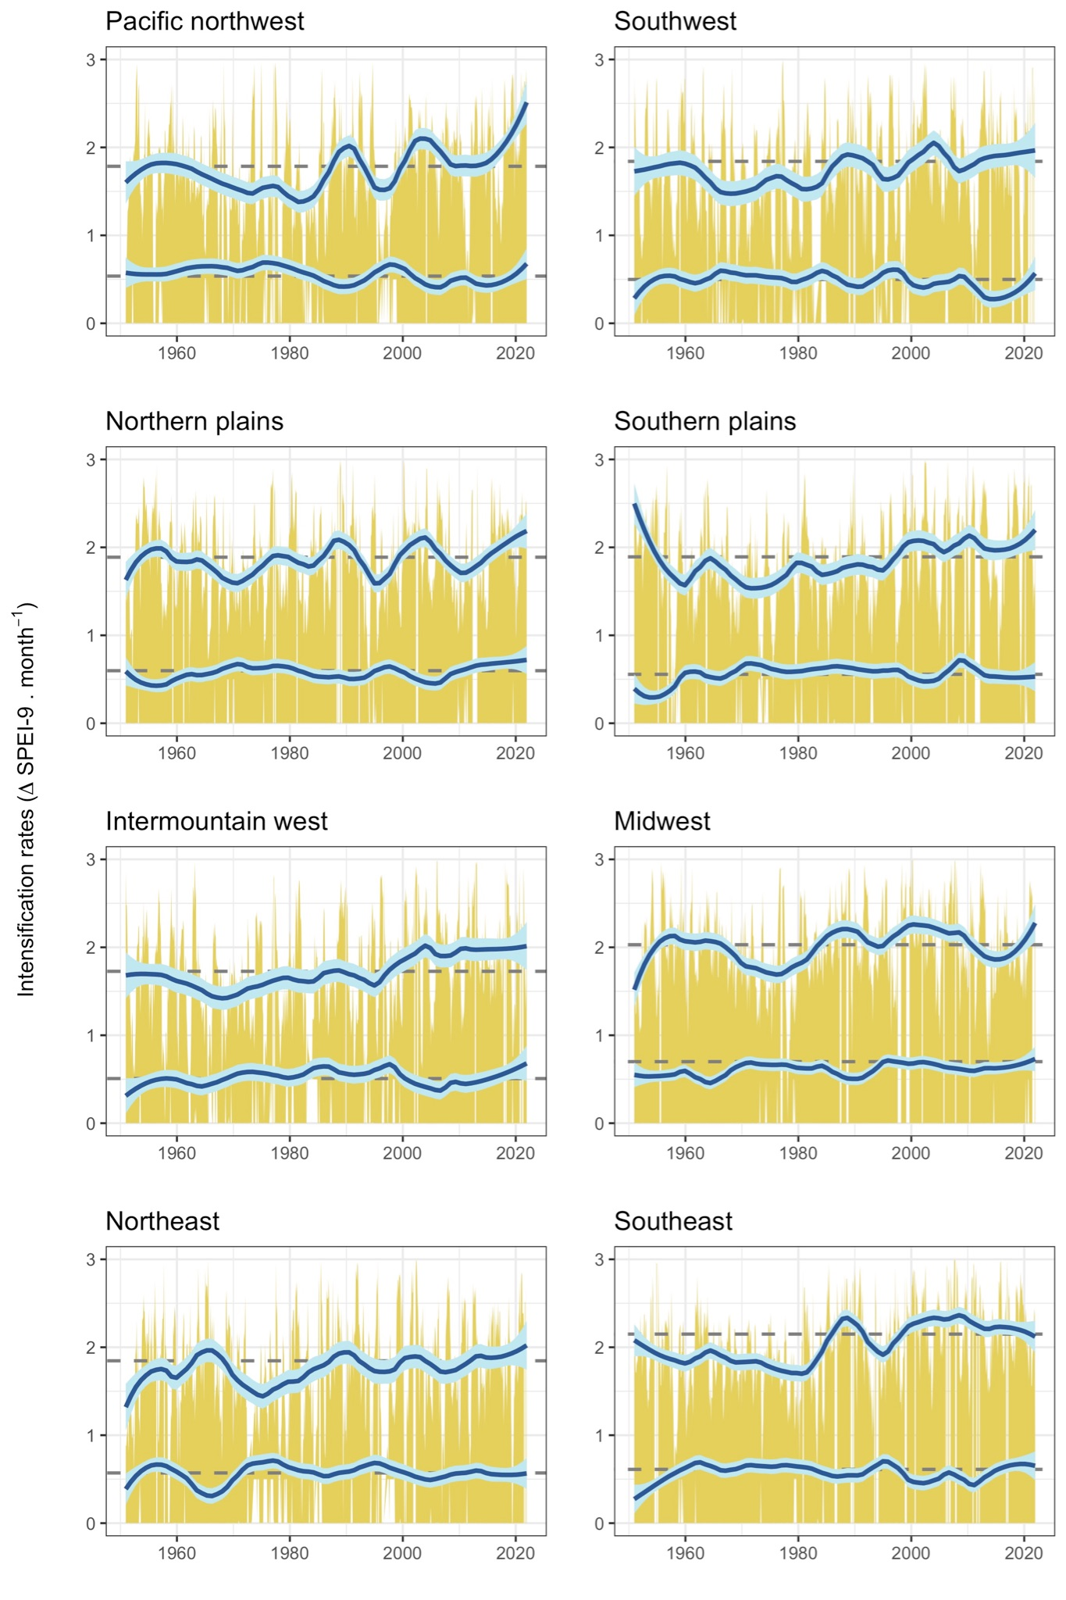
Figure S4: Drought intensification rates based on changes in SPEI-9 for the regions defined in this study (Fig. S1). The blue lines show trends in the median (bottom line) and 95th percentile (top line) of drought intensification rates smoothed with Locally Weighted Scatterplot Smoothing (LOWESS, smoothing parameter = 0.25). The light blue shading represents the 95% confidence intervals for the smoothers. The dashed lines depict the median and 95th percentile drought intensification rates for 1951-2021. Departures from these baselines are statistically significant (0.05 alpha-level).
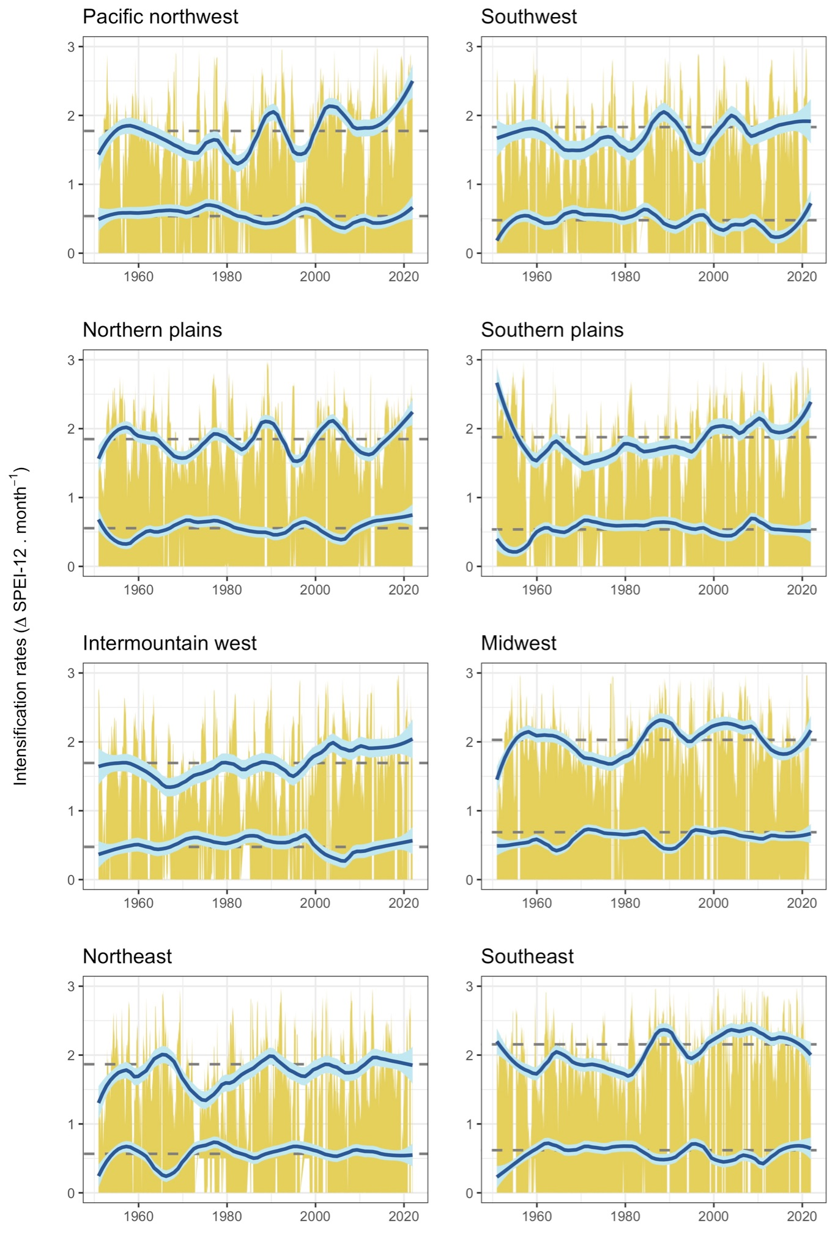
Figure S5: Drought intensification rates based on changes in SPEI-12 for the regions defined in this study (Fig. S1). The blue lines show trends in the median (bottom line) and 95th percentile (top line) of drought intensification rates smoothed with Locally Weighted Scatterplot Smoothing (LOWESS, smoothing parameter = 0.25). The light blue shading represents the 95% confidence intervals for the smoothers. The dashed lines depict the median and 95th percentile drought intensification rates for 1951-2021. Departures from these baselines are statistically significant (0.05 alpha-level).
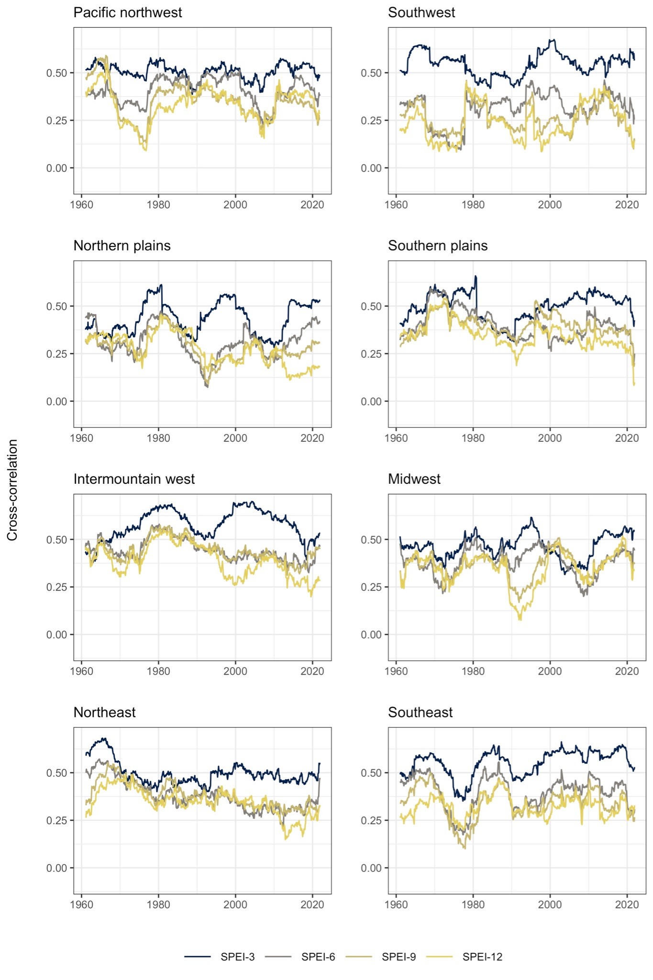
Figure S6: Dynamic cross-correlation between drought intensification rates derived from SPEI-1 and SPEI-3, SPEI-6, SPEI-9, and SPEI-12 for the regions defined in this study (Fig. S1).

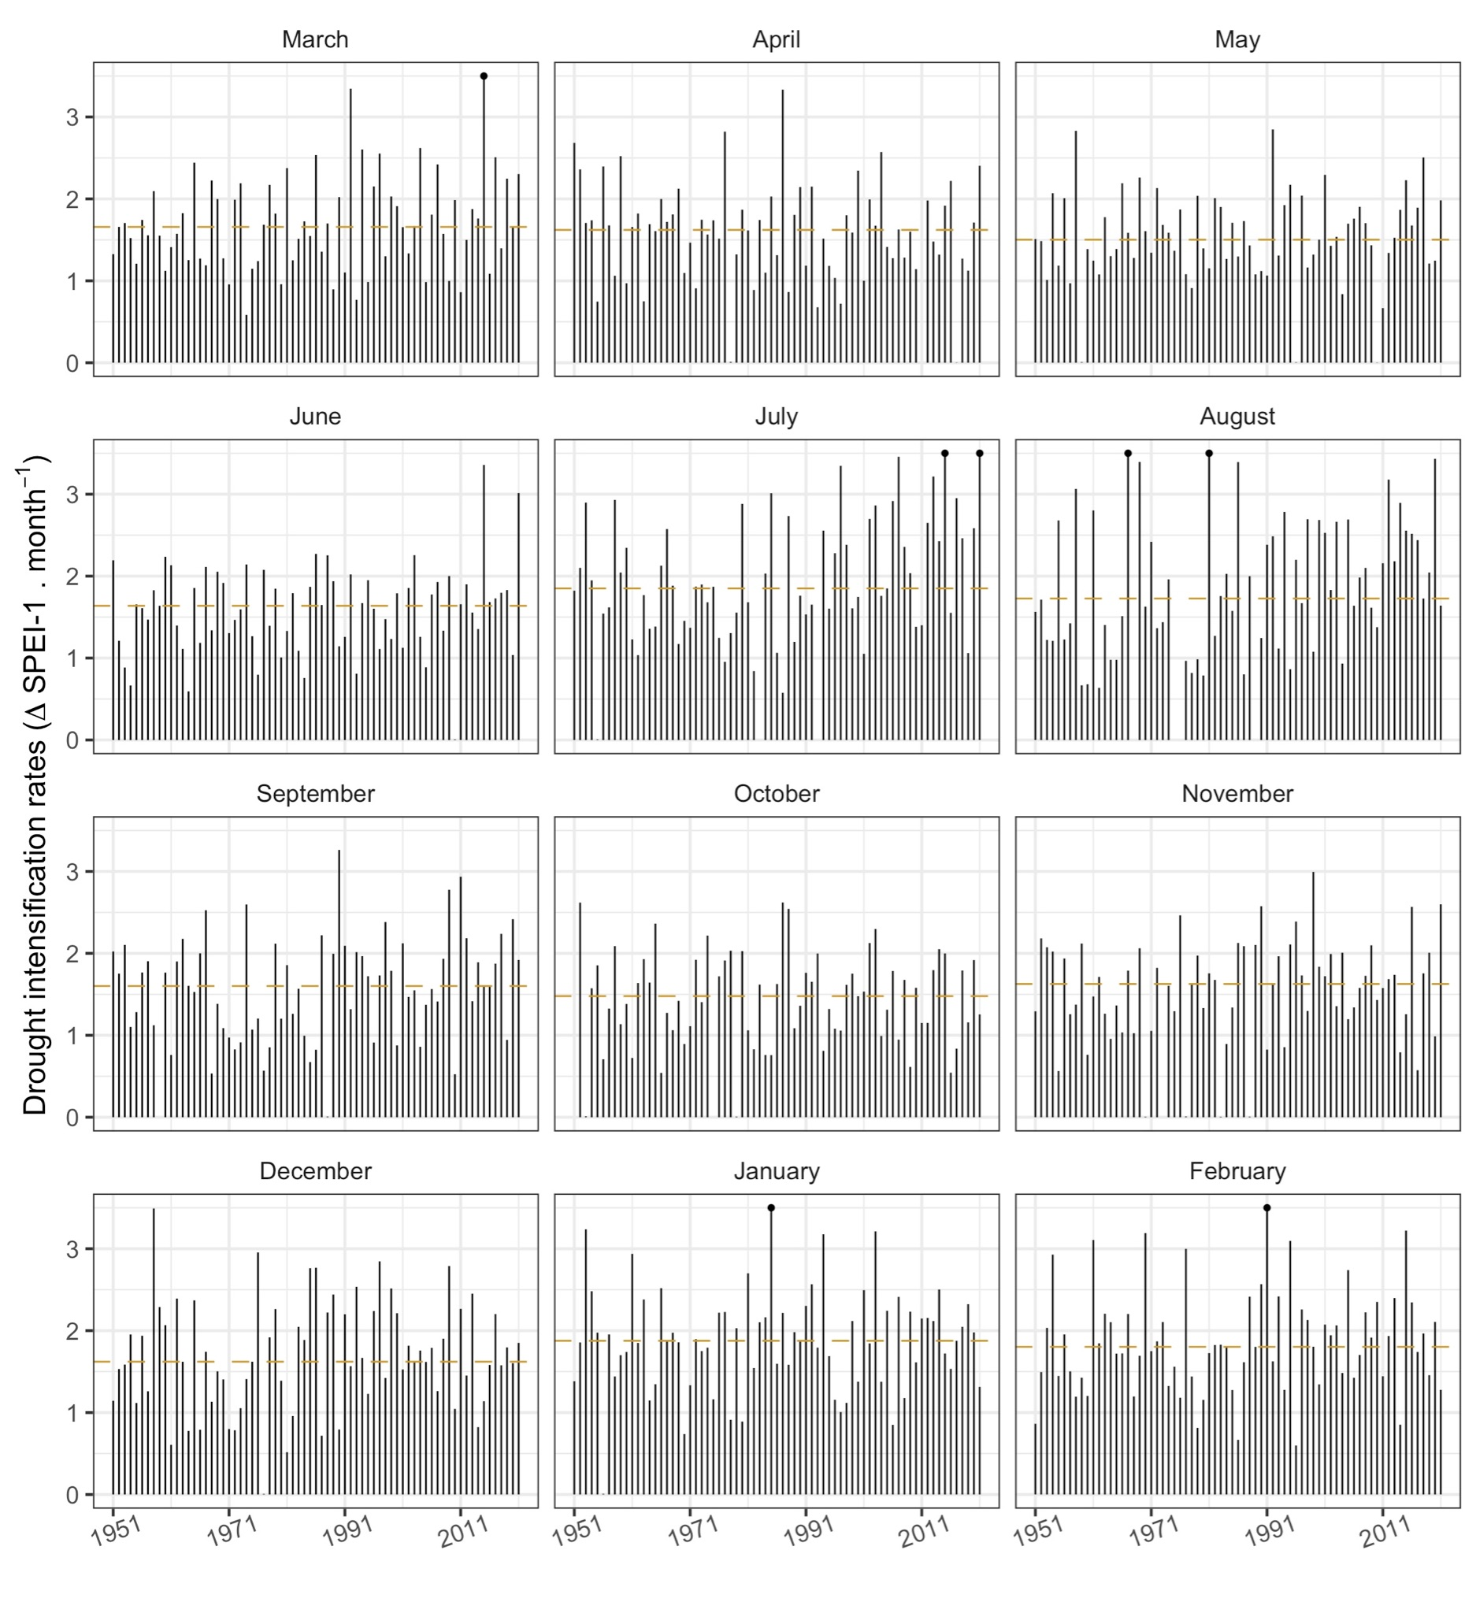
Figure S7: Monthly maximum 95th percentiles of drought intensification rates based on changes in SPEI-1 for the Pacific northwest. For reference, the dashed line shows the median 95th percentile intensification rates for each month in 1951-2021. The black dots indicate the presence of values exceeding the limits of the y axis.

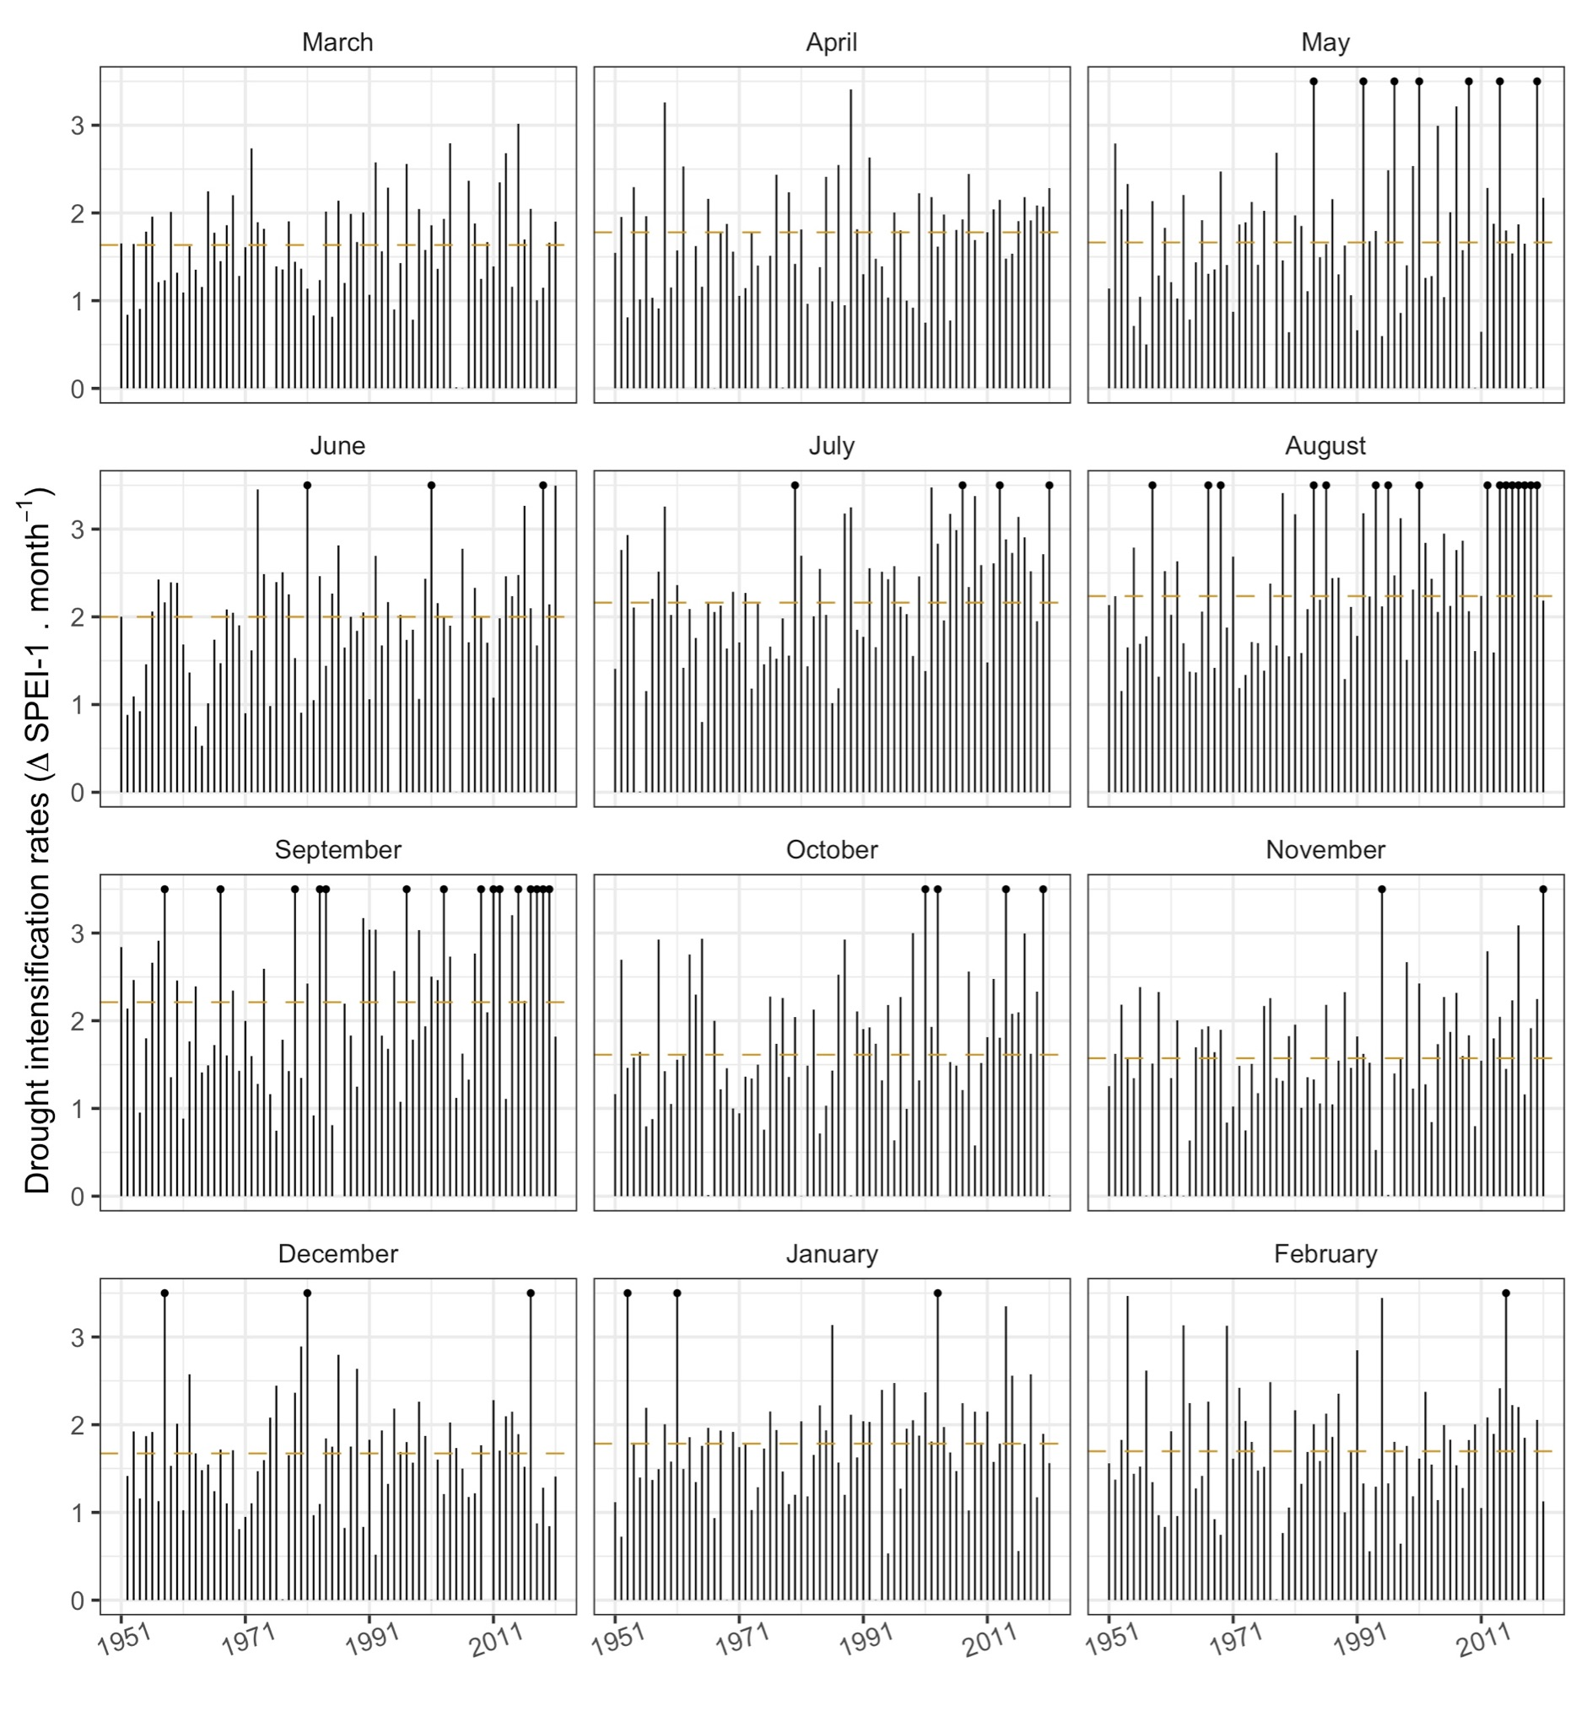
Figure S8: Monthly maximum 95th percentiles of drought intensification rates based on changes in SPEI-1 for the Southwest. For reference, the dashed line shows the median 95th percentile intensification rates for each month in 1951-2021. The black dots indicate the presence of values exceeding the limits of the y axis.

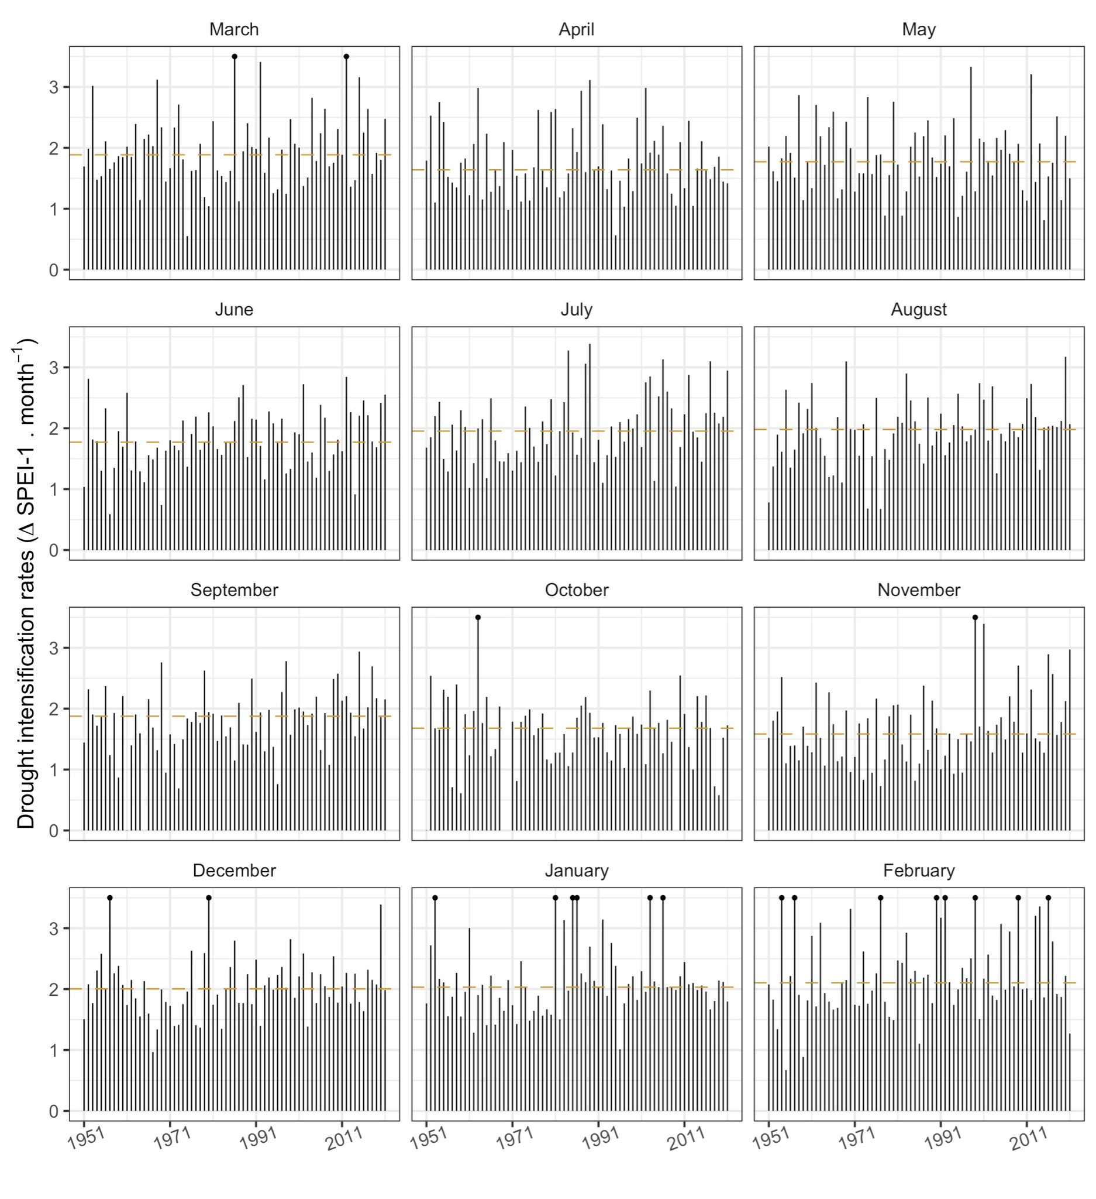
Figure S9: Monthly maximum 95th percentiles of drought intensification rates based on changes in SPEI-1 for the Northern plains. For reference, the dashed line shows the median 95th percentile rates for each month in 1951-2021. The black dots indicate the presence of values exceeding the limits of the y axis.
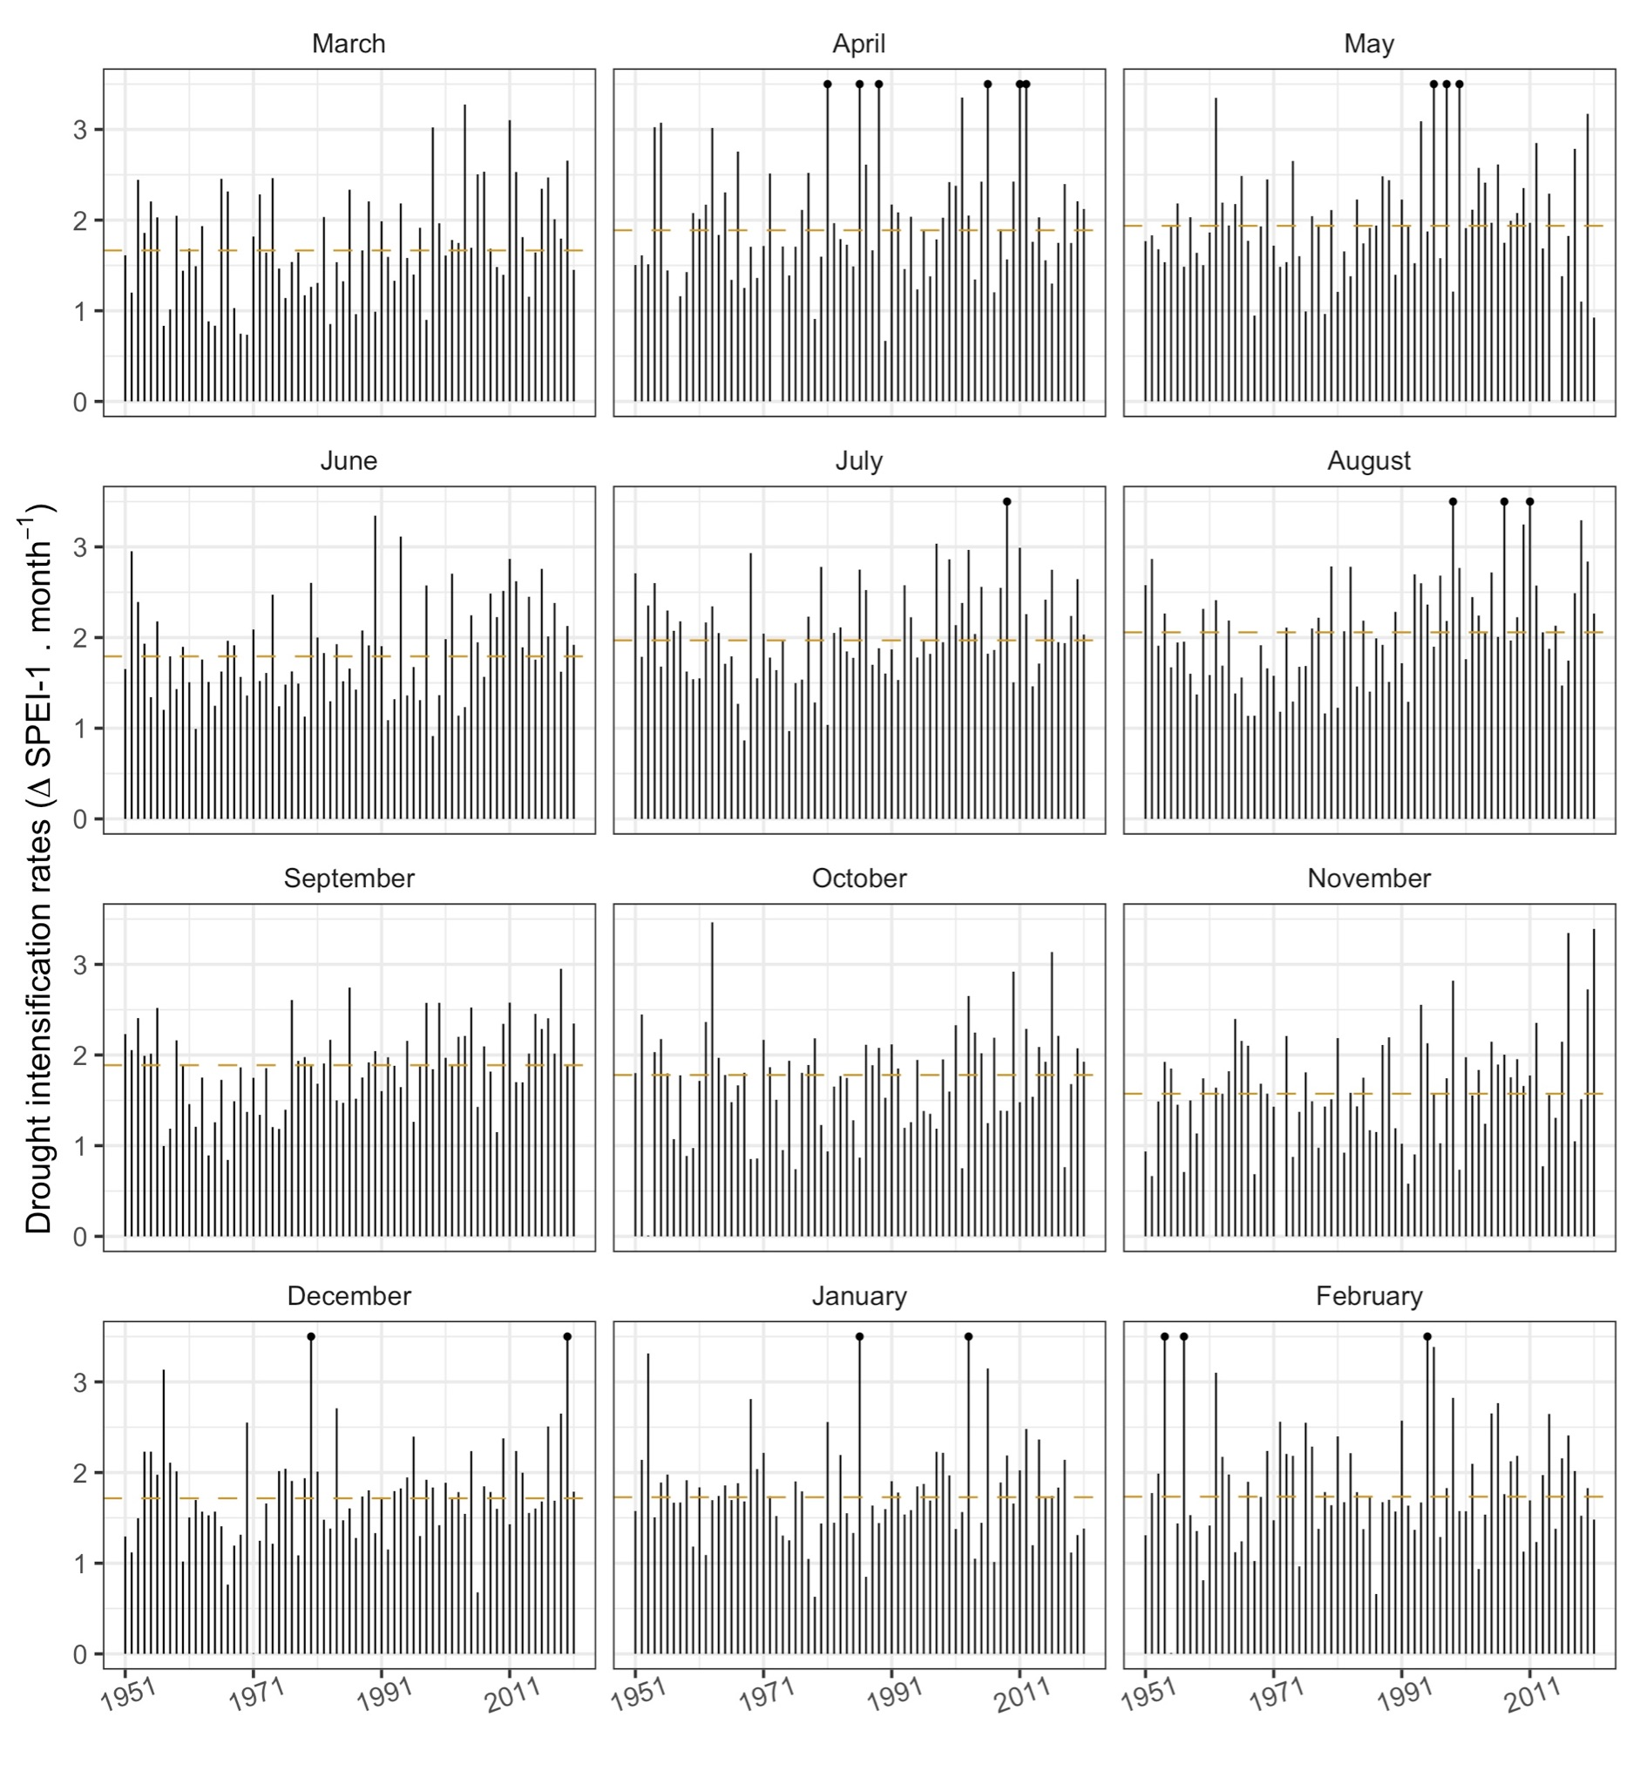
Figure S10: Monthly maximum 95th percentiles of drought intensification rates based on changes in SPEI-1 for the Southern plains. For reference, the dashed line shows the median 95th percentile intensification rates for each month in 1951-2021. The black dots indicate the presence of values exceeding the limits of the y axis.

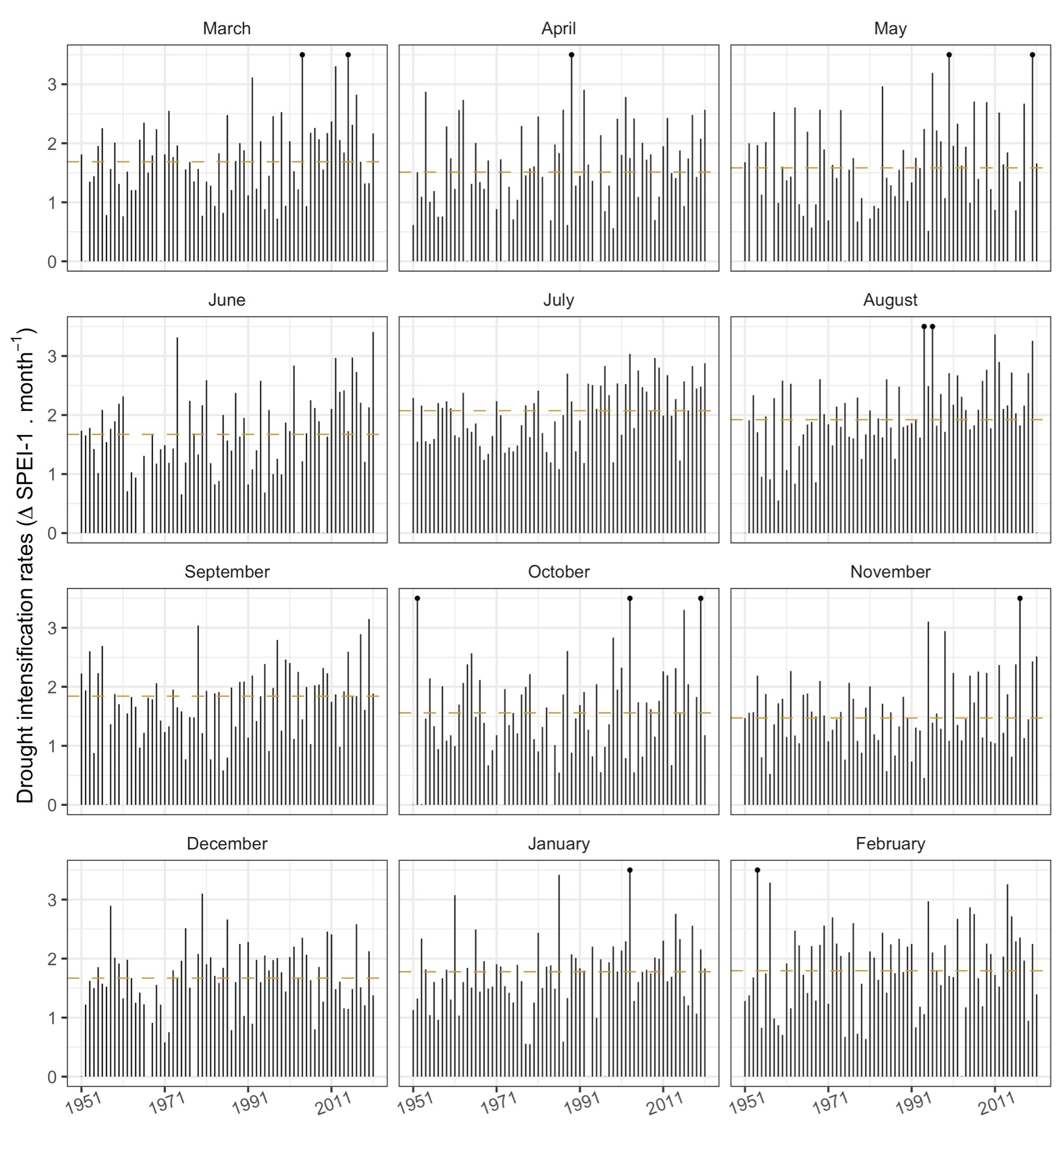
Figure S11: Monthly maximum 95th percentiles of drought intensification rates based on changes in SPEI-1 for the Intermountain west. For reference, the dashed line shows the median 95th percentile intensification rates for each month in 1951-2021.

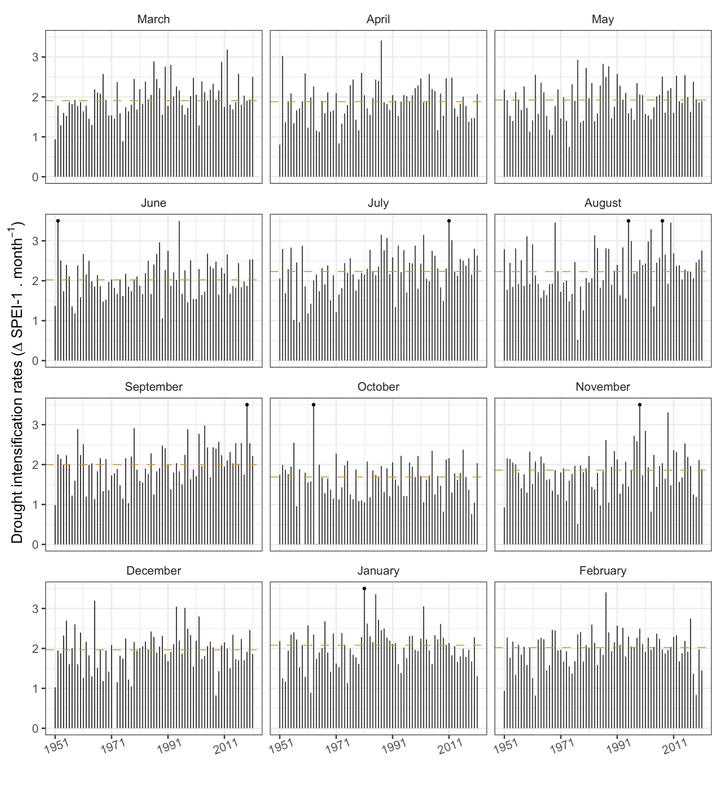
Figure S12: Monthly maximum 95th percentiles of drought intensification rates based on changes in SPEI-1 for the Midwest. For reference, the dashed line shows the median 95th percentile intensification rates for each month in 1951-2021. The black dots indicate the presence of values exceeding the limits of the y axis.

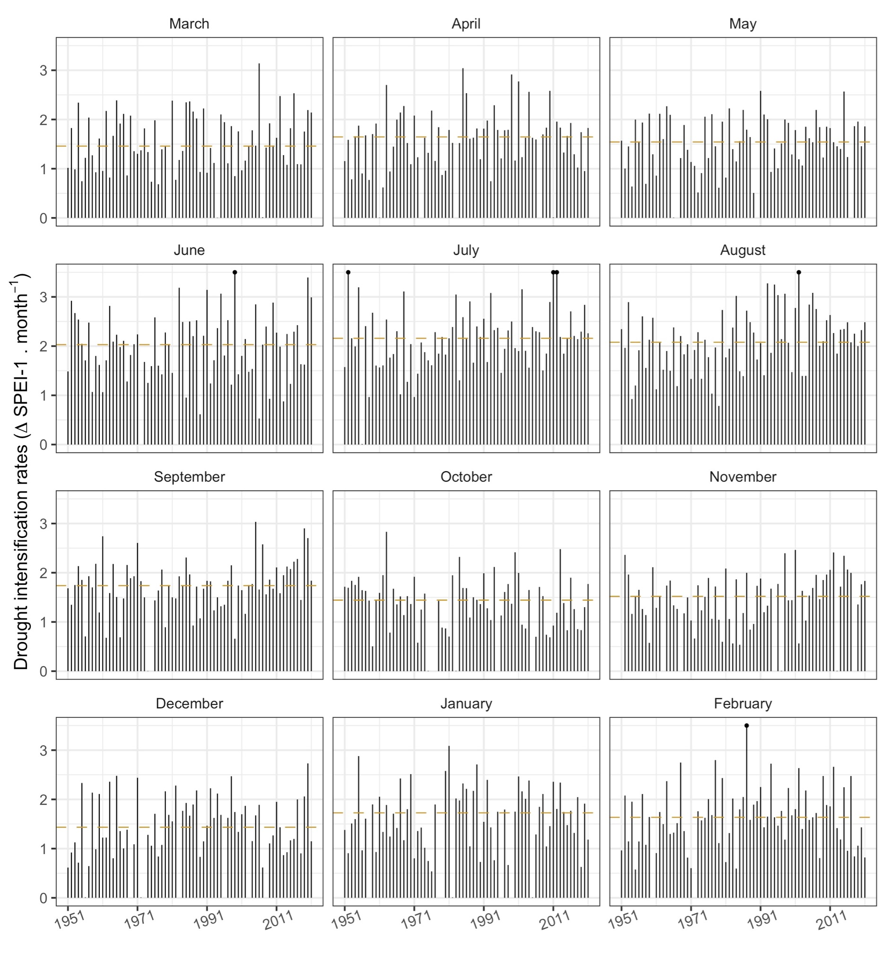
Figure S13: Monthly maximum 95th percentiles of drought intensification rates based on changes in SPEI-1 for the Northeast. For reference, the dashed line shows the median 95th percentile intensification rates for each month in 1951-2021. The black dot indicates the presence of values exceeding the limits of the y axis.

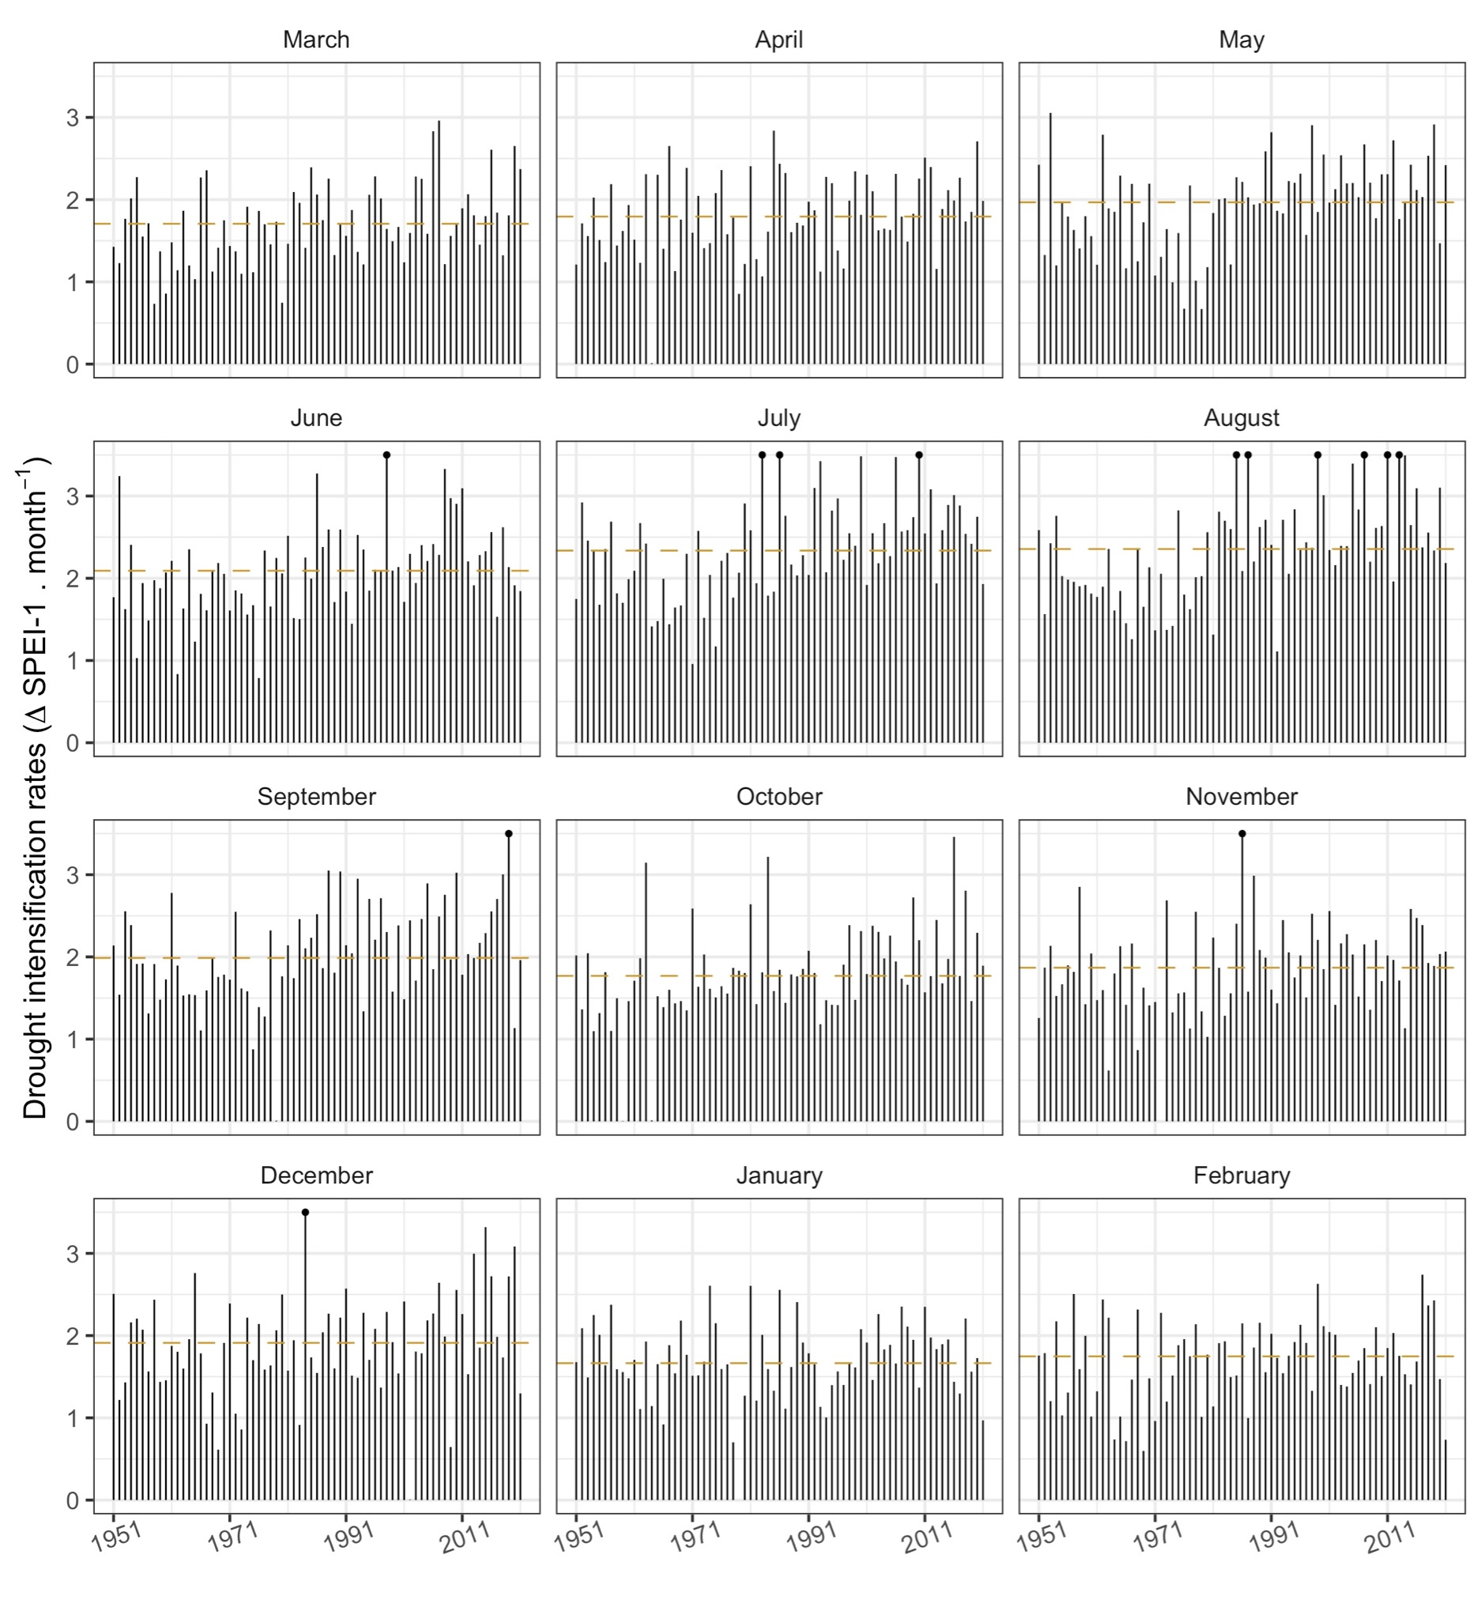
Figure S14: Monthly maximum 95th percentiles of drought intensification rates based on changes in SPEI-1 for the Southeast. For reference, the dashed line shows the median 95th percentile intensification rates for each month in 1951-2021. The black dots indicate the presence of values exceeding the limits of the y axis.

