Supplementary Table 1. Comparison of mean curved fork length across gear for the otolith samples used in this study and for ICCAT catch data (https://www.iccat.int/en/accesingdb.htm).

 | Otolith |  |  | ICCAT
 | 1970s | 1990s | 2010s | 1970s | 1990s | 2010s
Overall | 190.7 | 165.9 | 158.8 | 106.7 | 163.5 | 177.4
RR | 165.8 | 166.1 | 142.1 | 101.9 | 146.6 | 163.8
LL | 256.7 | — | 251.8 | 172.8 | 174.5 | 197.9
PS | 101.8 | — | — | 89.5 | 221.9 | 198.8
HL | 248.9 | 130.4 | — | 259.7 | 226.1 | 208.8
HP | 260.1 | — | 225.7 | 249.2 | 220.1 | 209.2

Supplementary Table 2. (Left) Relative contribution of gear types to total western stock landings (%) for years included in the otolith dataset (1970s: 1974-1978; 1990s: 1996-2002; 2010s: 2009-2014). (Right) Relative contribution of gear types to total US landings (%) for years included in the otolith dataset (1970s: 1974-1978; 1990s: 1996-2002; 2010s: 2009-2014). BB=baitboat, GN=gillnet, HL=handline, HP=harpoon, LL=longline, PS=purse seine, RR=rod-and-reel, TL=tended line, TP=trap, TR=troll, TW=trawl, UN=unclassified. Data from ICCAT (https://www.iccat.int/en/accesingdb.htm).

 | Western Stock Landings |  |  | US Landings
Gear | 1970s | 1990s | 2010s | 1970s | 1990s | 2010s
BB | 0 | 0 | 0 | — | — | —
GN | 0 | 0 | 0 | 0 | 0 | 0
HL | 3 | 1 | 0 | 7 | 1 | 0
HP | 2 | 5 | 4 | 6 | 7 | 6
LL | 44 | 31 | 39 | 0 | 13 | 28
PS | 26 | 9 | 1 | 52 | 16 | 2
RR | 20 | 48 | 52 | 34 | 63 | 64
TL | 0 | 5 | 2 | — | — | —
TP | 4 | 2 | 1 | 0 | 0 | 0
TR | 0 | 0 | 0 | — | — | —
TW | 0 | 0 | 0 | 0 | 0 | 0
UN | 1 | 0 | 0 | 1 | 0 | 0

Supplementary Figure 1. Catch of ABFT (number of fish) at capture locations (latitude, longitude) for years that overlap with otolith samples (1974-1978, 1996-2002, and 2009-2014). North America resides in the top left half of the figure; the northwest Atlantic Ocean resides in the bottom left half of the figure (Florida is outlined by catch cells at ~ 82 degrees by 27 degrees). White boxes correspond to catch of 0 fish, while darker boxes correspond to incrementally higher catch. ICCAT data from: https://www.iccat.int/en/accesingdb.HTM
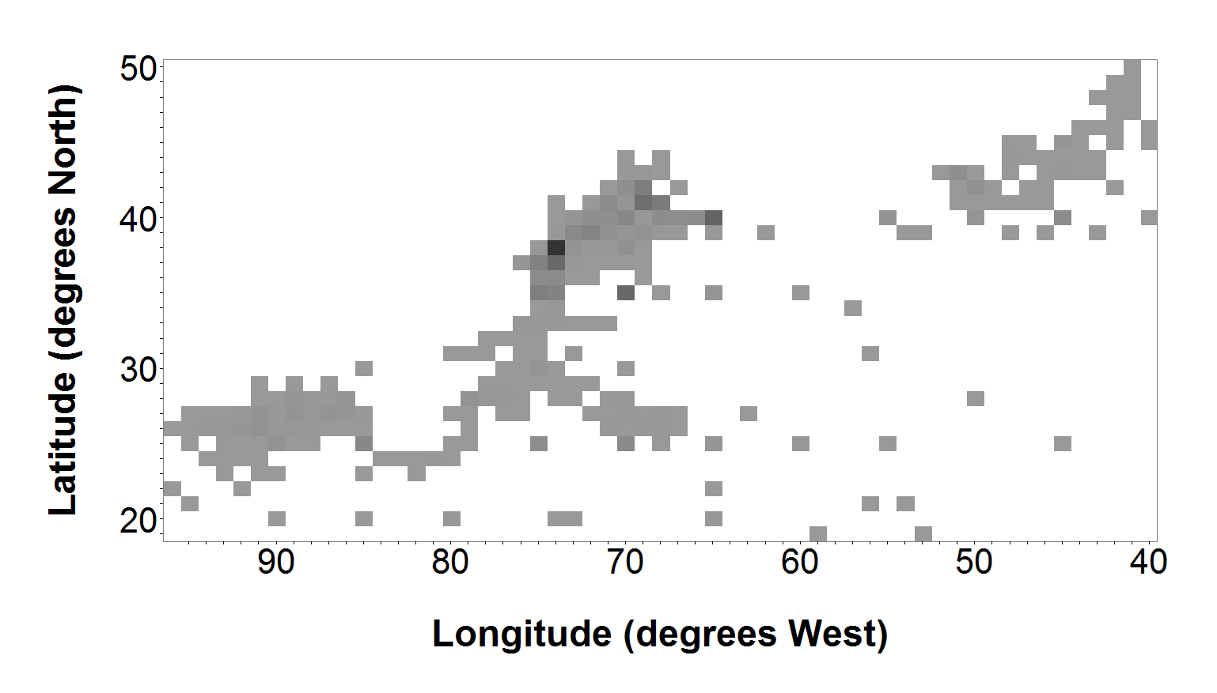
Supplementary Figure 2. Catch of ABFT (number of fish) by month for years that overlap with otolith samples (1974-1978, 1996-2002, and 2009-2014). (Left) Data from ICCAT, (right) data from this study. ICCAT data from: https://www.iccat.int/en/accesingdb.HTM
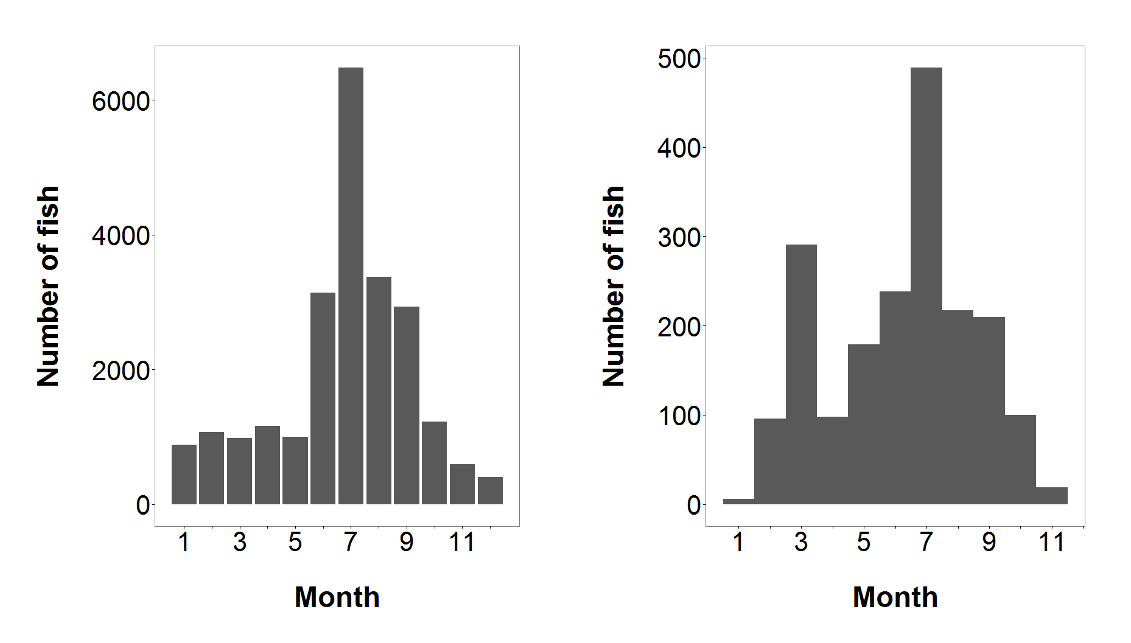
Supplementary Figure 3. (Left) Relative frequency of ABFT (number of fish) caught by gear in the otolith sample. (Right) Relative landings of ABFT (tonnes) caught by gear in catch data from ICCAT. Data from ICCAT queried to only include years that overlap with otolith samples (1974-1978, 1996-2002, and 2009-2014). Harp = Harpoon, LL = Longline, PS = Purse Seine, RR = rod-and-reel; ICCAT data from: https://www.iccat.int/en/accesingdb.HTM
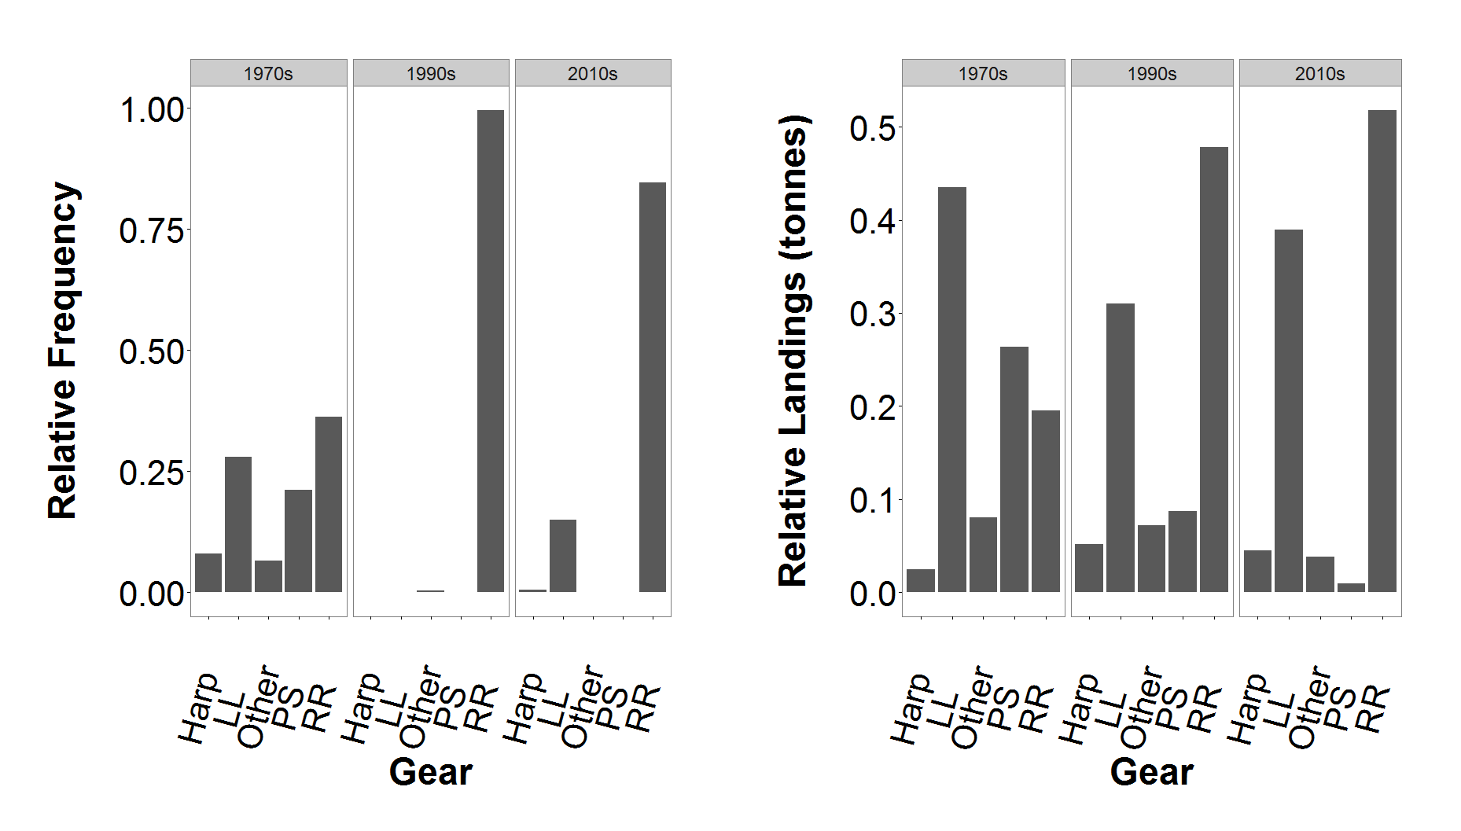
Supplementary Figure 4. Catch-at-size data for Atlantic bluefin tuna (Thunnus thynnus) from fisheries operating in the 1970s (1974-1978), 1990s (1996-2000, 2002), and 2010s (2009-2013). Data was obtained from the ICCAT database (https://www.iccat.int/en/accesingdb.htm) and censored for fish sizes (50-310 cm) and years included in this study.
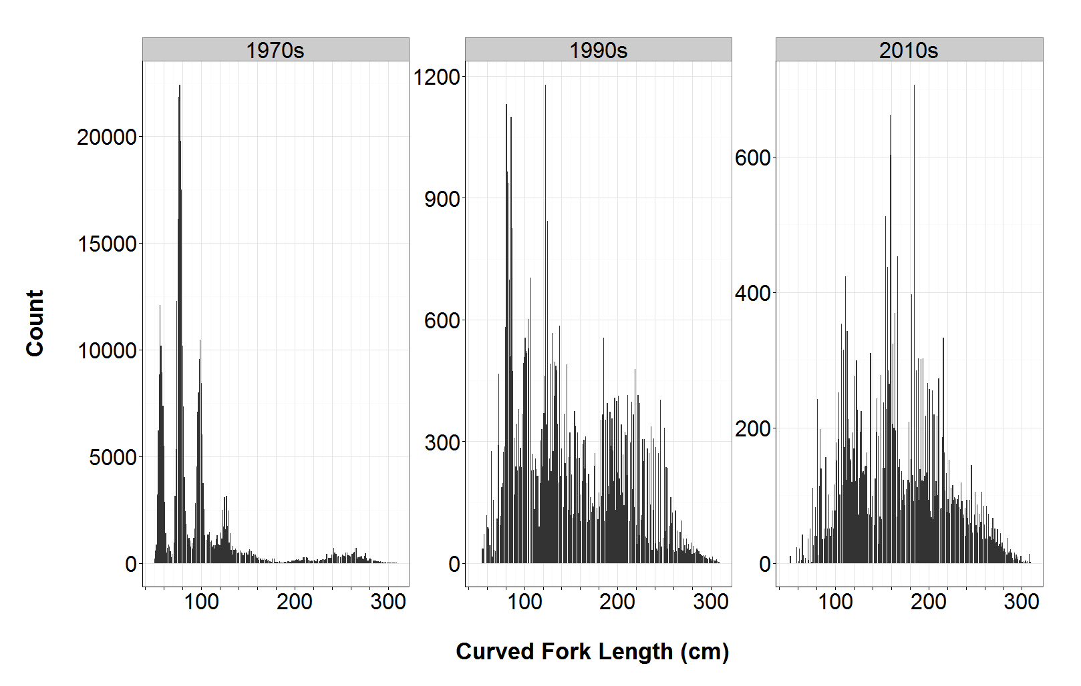

Supplementary Figure 5. Size frequency data for Atlantic bluefin tuna (Thunnus thynnus) individuals included in the 1970s (1974-1978), 1990s (1996-2000, 2002), and 2010s (2009-2014) samples obtained from the National Marine Fisheries Service.

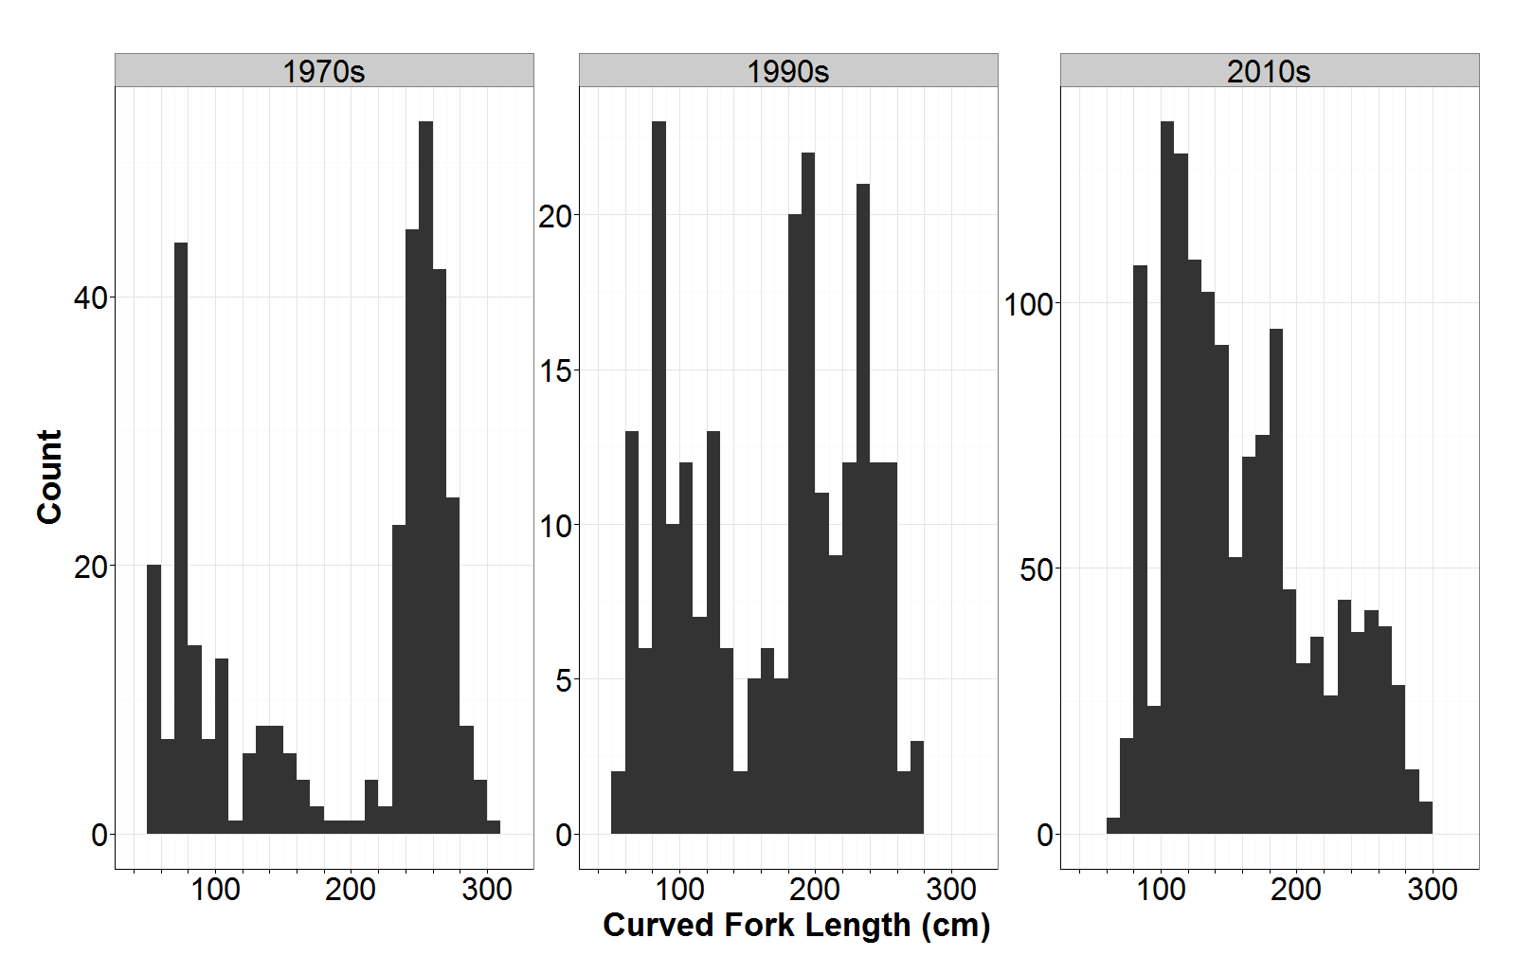

Supplementary Figure 6. Annotated Atlantic bluefin tuna (Thunnus thynnus) otolith image showing 21 annuli (opaque bands; white dots), correct section type (“Y” section), measurement scale marker used for interpreting the first annulus.

