Supplementary Material

Synchrony among regions

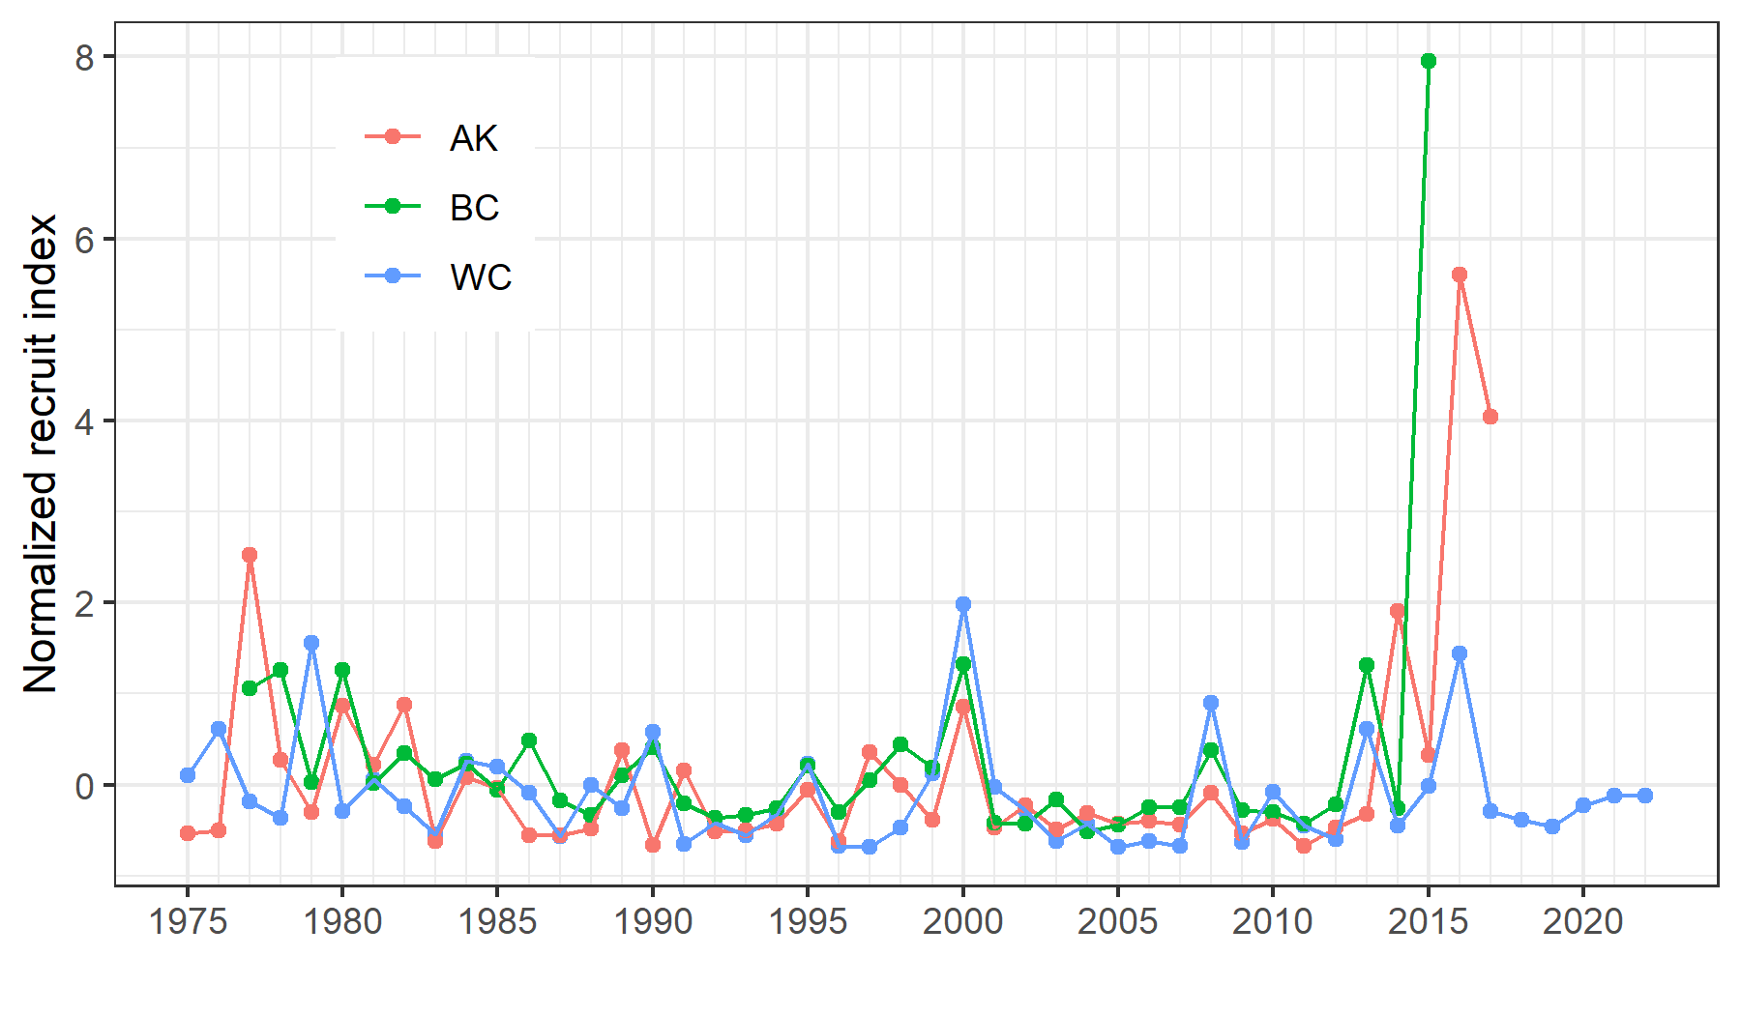
Fig. S1. Normalized recruitment indices from the Alaskan, British Columbia, and West Coast stock assessments. Data from Goethel et al. (2020) & Kapur et al. (2021).

Sea level time series
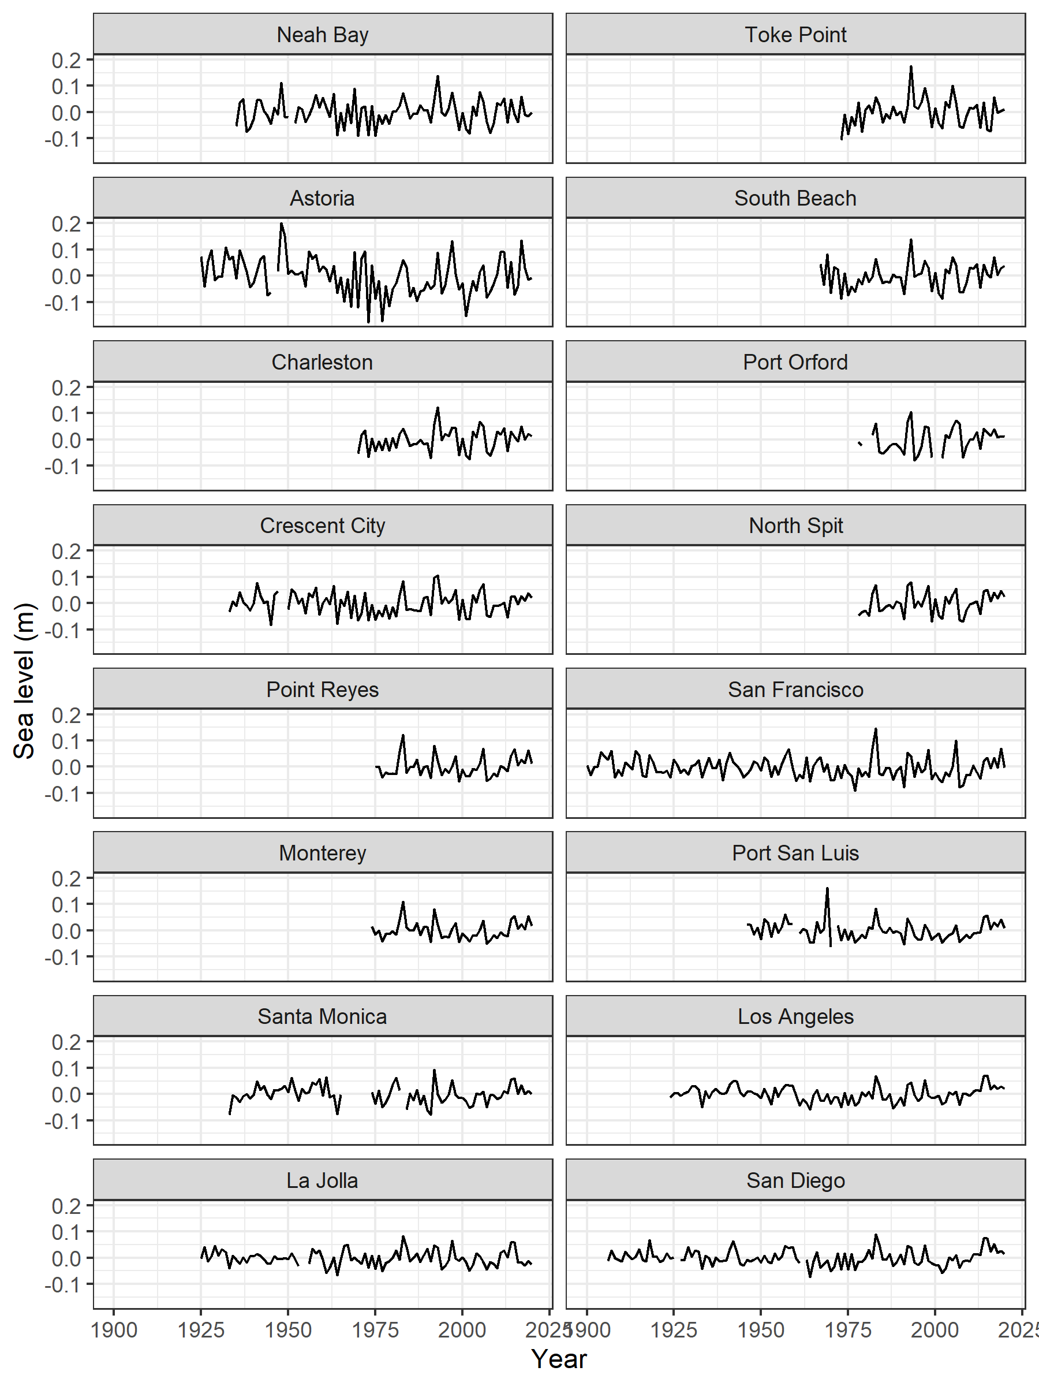
Fig. S2. Mean monthly sea level in the second quarter (April-June) at 16 stations along the US west coast from 1900 to 2019. Average seasonal cycle and linear trend have been removed.

Model fit to the data
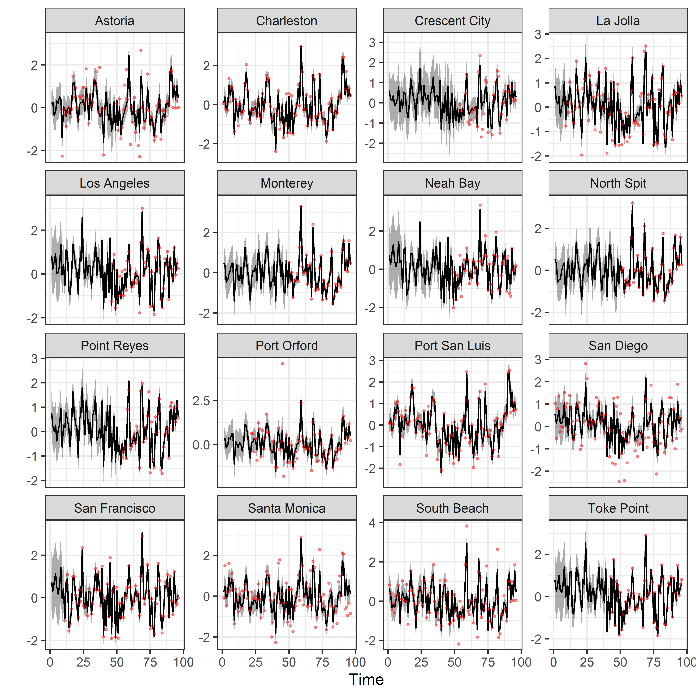
Fig. S3. Fit of the DFA model (black line) to the observed data (red points) for 16 tide gauge locations along the West Coast of the U.S.A.

Model testing and validation
We ran an array of additional tests to validate the best-fit model (Model 1). Some model validation actions are described in the main text. Here, we describe three additional validation tests:
The recruitment deviations used in the main analysis were assessment-based estimates and have error. Therefore, we determined whether the precision of recruitment deviations from the assessment model affected the recruitment-environment relationship. We resampled recruitment deviations from a normal distribution for each year using the recruitment deviation and its standard error from the 2019 assessment. We then refit the model 1000 times and compared the r² values. Median r² was r² = 0.16 (CI_{95%} = 0.6 – 0.28).
To determine whether individual years had a strong influence on which terms (DFs) were included in the best-fit model, we jackknifed years and re-ran the entire model selection exercise 1000 times for each of the 45 years. We then compared what terms were included in the model from each iteration that had the lowest AICc. The first dynamic factor (DF1) was included in all 45 models. DF2 and DF4 each occurred in one model each.
Finally, we combined the two preceding analyses. We re-ran the entire model fitting exercise 1000 times using the re-sampled sablefish recruitment deviations. We then compared the best-fit (in this case lowest AICc) models from each run and determined the number of times each DF appeared in the model with the lowest AICc. DF1 was included in over 95% of all best-fit models, while other terms appear more sporadically. Note these results are for the model from each iteration with the lowest AICc not the lowest AICc and fewest parameters. When the best-fit model was chosen based on delta AICc < 2.0 and the fewest parameters, over 90% of models contained only DF1 (Table S1).

Table S1. Results of jackknife-refit analysis showing the number of times the predictor was included in the best-fit model (lowest AICc) out of 1000 iterations.
Predictor | Number of models  lowest AICc | Number of models lowest AICc &  fewest parameters
DF1 | 957 | 906
DF12 | 30 | 2
DF2 | 217 | 39
DF22 | 5 | 0
DF3 | 23 | 5
Df32 | 12 | 2
DF4 | 243 | 54
DF42 | 115 | 16
DF5 | 191 | 50
DF5 | 51 | 16

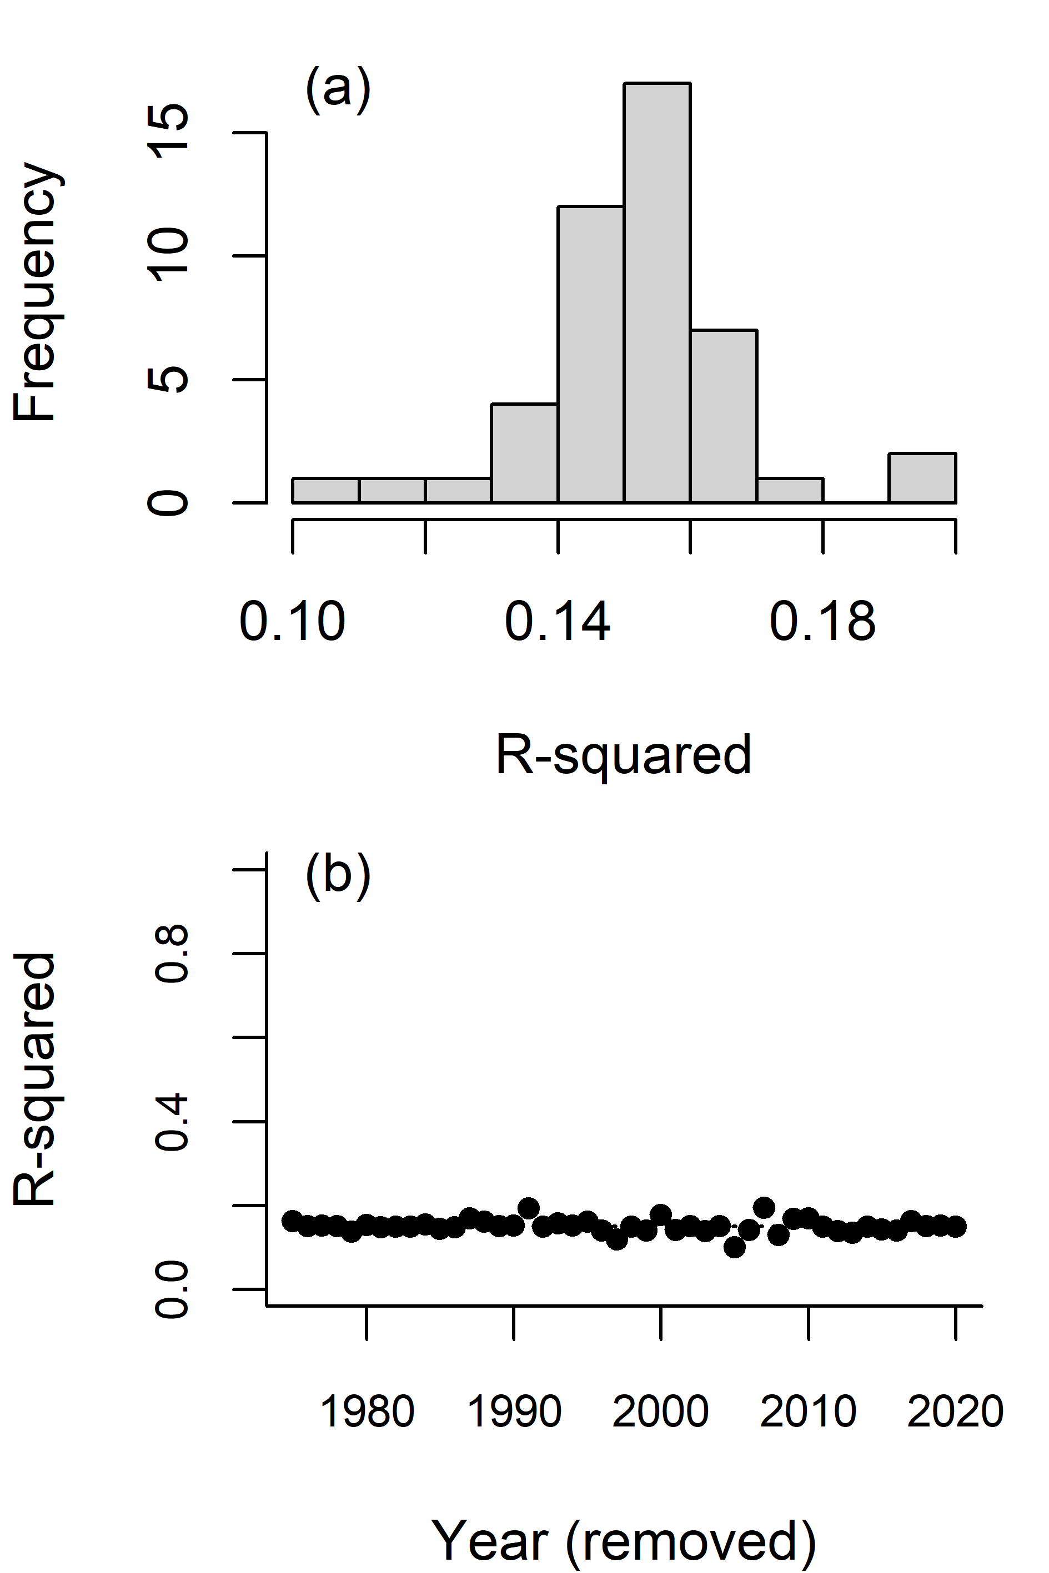
Fig. S4. Results of jackknife refitting of the best-fit model for 1975-2020.

Standard model diagnostics for the sea level recruitment model
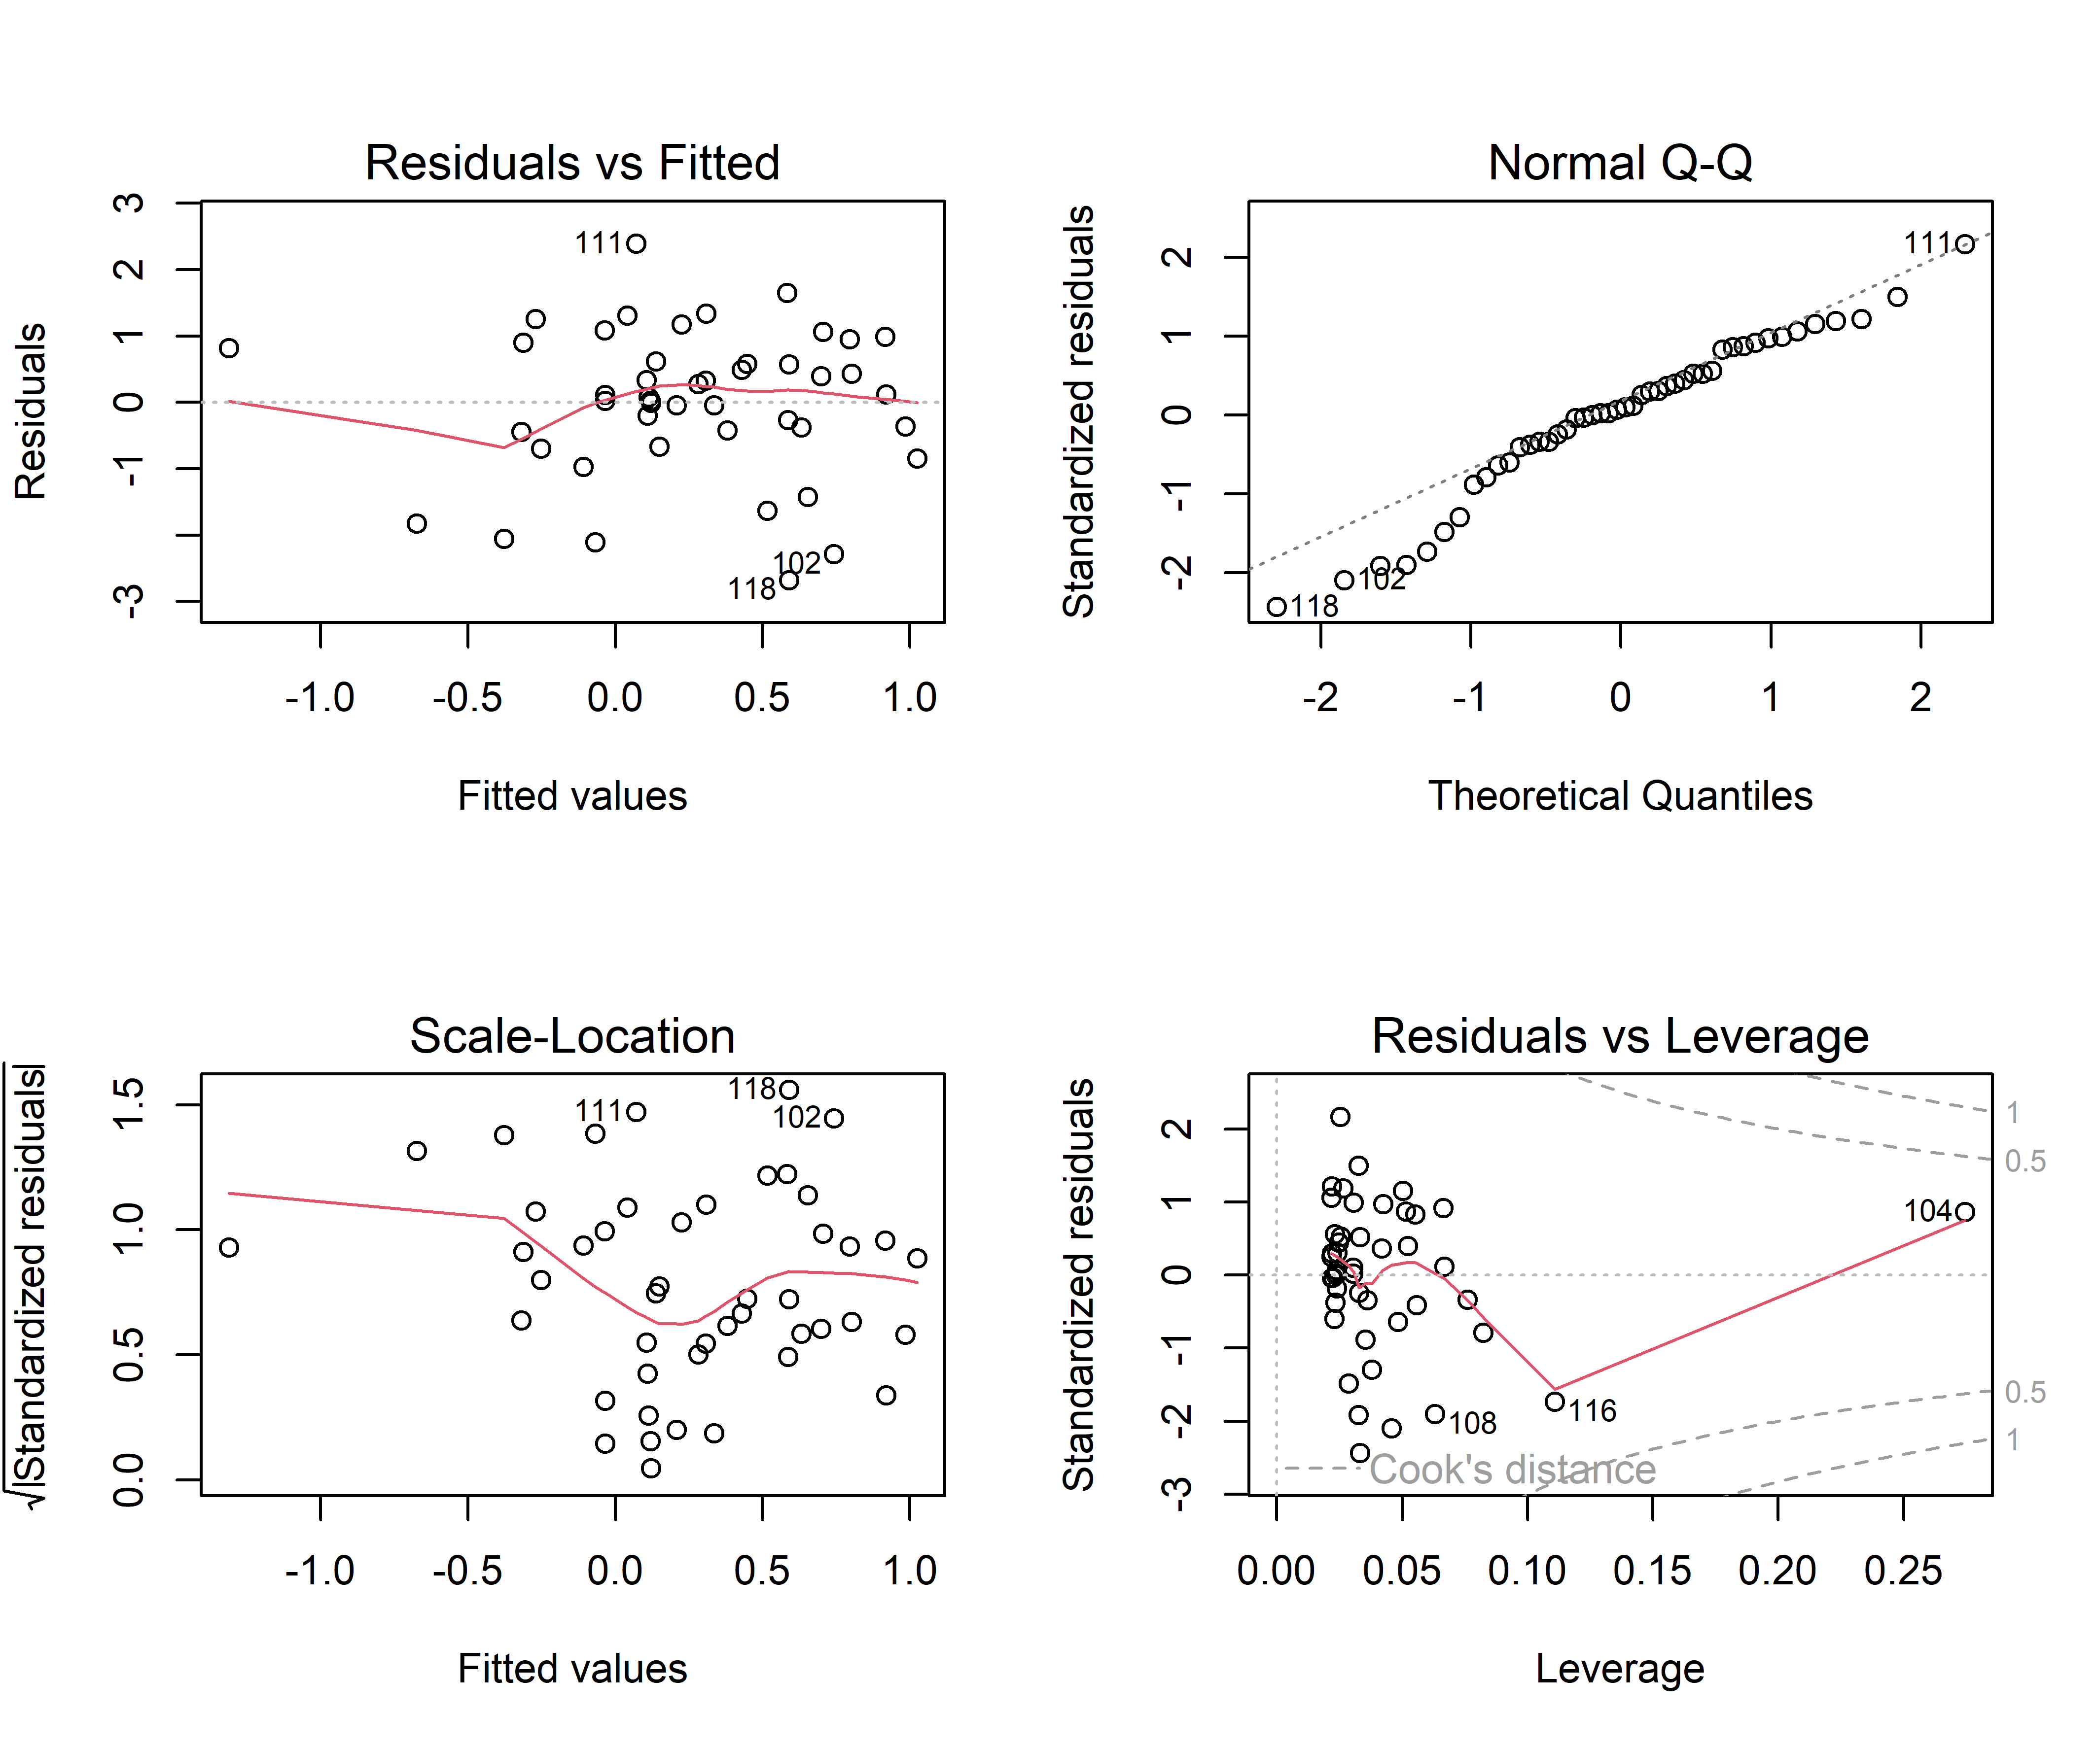
Fig. S5. Plots of model diagnostics for the best-fit model: recruitment deviations = DF1.
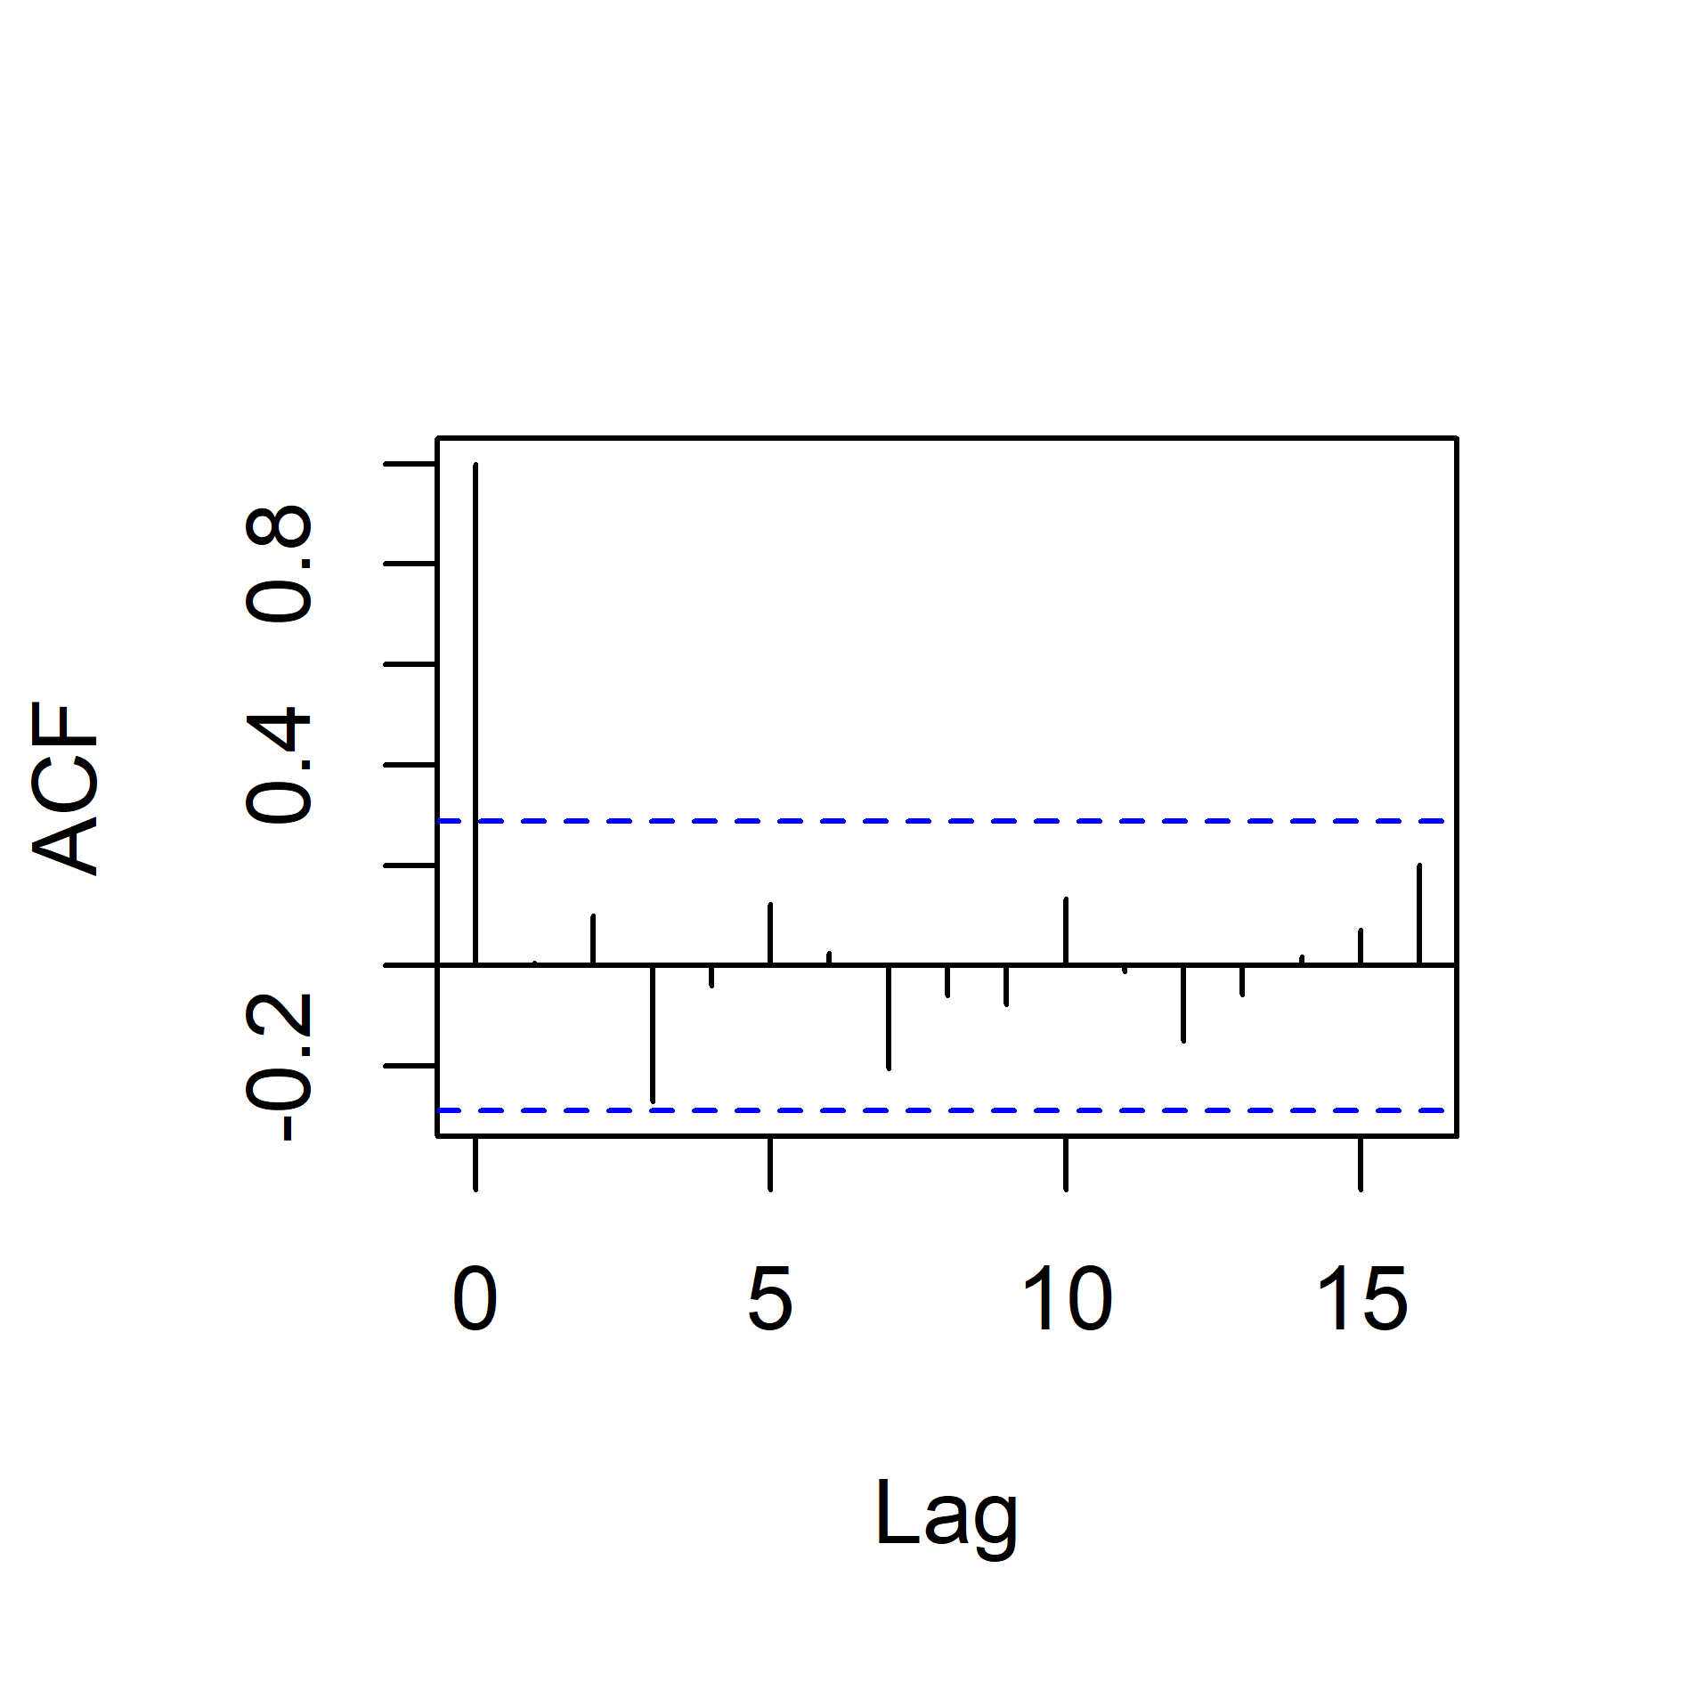
Fig. S6. Autocorrelations factors for the best-fit model.

Stock assessment output
Removing the sea-level index from the 2021 assessment had little impact on model estimates of natural mortality and growth parameters, but did suggest slightly lower recruitments during 2011-2019 (Table S2). In 2020, when there were no survey data, the model with the sea-level index showed slightly lower recruitment than the model without (Table S3). As the time series of fishery-independent and -dependent data available to the model decreased, model estimates of natural mortality increased, while estimates for the Von Bertalanffy k parameters increased (Table 2), resulting in decreases in estimated unfished spawning biomass and stock status (Table S3). The standard deviations for natural mortality and growth parameters generally increased as the time series of available data declined (Table S2).

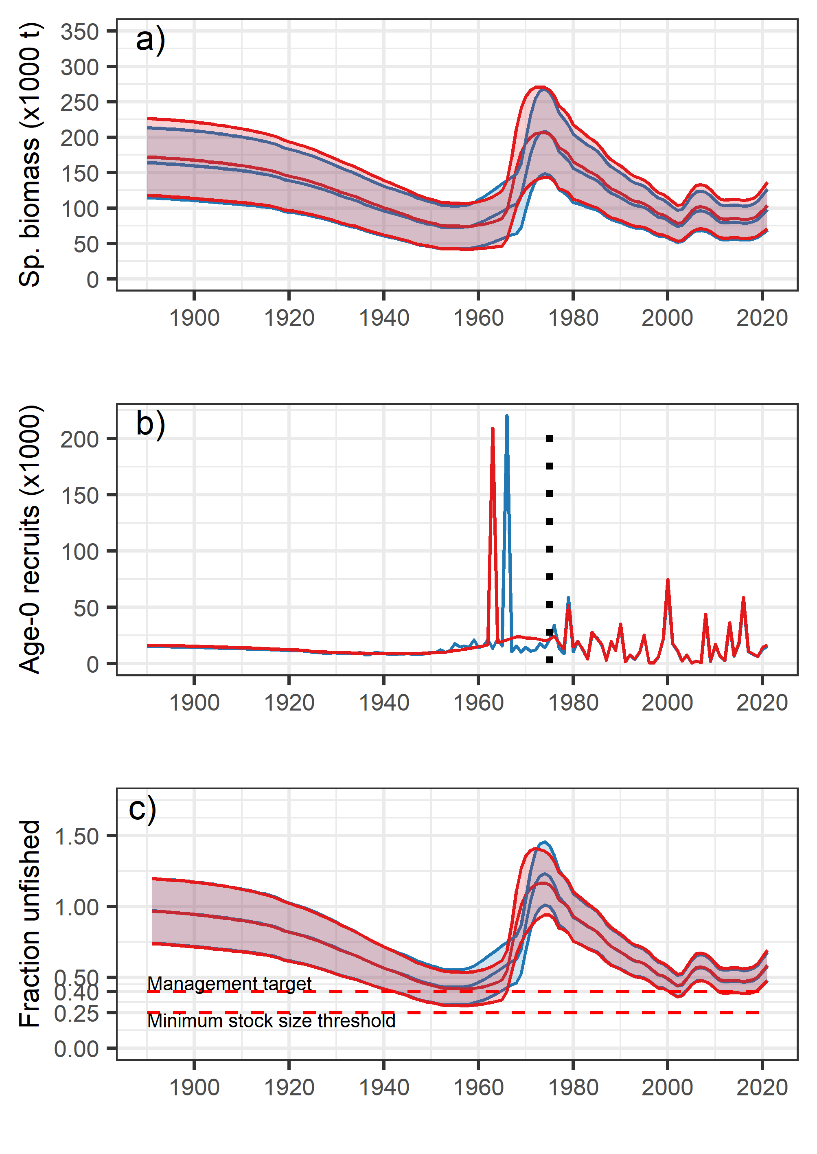

Fig. S7. Comparisons of the time series of spawning biomass (top row), age-0 recruits (middle row), and stock depletion (bottom row) between the 2021 stock assessment model used for management advice that includes sea level (blue lines) and a model sensitivity run with the sea-level index removed (red lines) (Kapur et al. 2021). Dotted black line in (b) indicates first year of recruitment deviations used in the analyses.

Table S2. Select parameter estimates from the 2021 and 2011 stock assessment model runs. Bold values represent years with reduced survey effort (2019) and no survey (2020).
 | 2021 Assessment | 2021 Assessment, No DF1 sea level | 2011 Catch and DF1 sea level hindcast | 2011 Catch only hindcast | 2021 Assessment | 2021 Assessment, No DF1 sea level | 2011 Catch and DF1 sea level hindcast | 2011 Catch only hindcast
 | Estimates |  |  |  | Standard Deviations
Female Natural Morality | 0.073 | 0.072 | 0.098 | 0.095 | 0.008 | 0.008 | 0.010 | 0.010
Female growth at minimum age | 25.7 | 25.7 | 24.9 | 24.9 | 0.456 | 0.455 | 0.515 | 0.515
Female growth at maximum age | 62.5 | 62.5 | 63.2 | 63.2 | 0.633 | 0.633 | 0.625 | 0.625
Female VonBertlanffy k | 0.343 | 0.343 | 0.380 | 0.380 | 0.015 | 0.015 | 0.016 | 0.016
Male Natural Morality | 0.060 | 0.060 | 0.082 | 0.079 | 0.006 | 0.006 | 0.008 | 0.008
Male growth at minimum age | 26.9 | 26.9 | 26.0 | 26.0 | 0.514 | 0.515 | 0.704 | 0.703
Male growth at maximum age | 56.6 | 56.6 | 56.9 | 56.9 | 0.322 | 0.323 | 0.325 | 0.325
Male VonBertlanffy k | 0.371 | 0.371 | 0.419 | 0.420 | 0.014 | 0.014 | 0.017 | 0.017
SR_LN(R0) | 9.705 | 9.700 | 9.979 | 9.846 | 0.305 | 0.304 | 0.313 | 0.303
2011 Recruitment Deviation | 0.09 | 0.09 | -0.33 | -0.019 | 0.221 | 0.221 | 1.196 | 1.393
2012 Recruitment Deviation | -0.76 | -0.75 | -0.36 | -0.019 | 0.363 | 0.362 | 1.193 | 1.393
2013 Recruitment Deviation | 1.76 | 1.76 | 1.85 | -0.019 | 0.130 | 0.130 | 0.866 | 1.393
2014 Recruitment Deviation | 0.13 | 0.13 | -0.09 | -0.019 | 0.226 | 0.226 | 1.322 | 1.393
2015 Recruitment Deviation | 1.12 | 1.11 | 0.69 | -0.019 | 0.167 | 0.167 | 1.972 | 1.393
2016 Recruitment Deviation | 2.25 | 2.24 | 1.28 | -0.019 | 0.137 | 0.138 | 1.171 | 1.393
2017 Recruitment Deviation | 0.60 | 0.60 | -0.27 | -0.019 | 0.264 | 0.263 | 1.237 | 1.393
2018 Recruitment Deviation | 0.32 | 0.31 | 0.19 | -0.019 | 0.397 | 0.398 | 1.374 | 1.393
2019 Recruitment Deviation | 0.05 | -0.04 | 0.15 | -0.019 | 1.255 | 1.235 | 1.440 | 1.393
2020 Recruitment Deviation | -0.19 | -0.10 | -0.19 | -0.019 | 1.316 | 1.392 | 1.251 | 1.393

Table S3. Select derived estimates from the 2021 and 2011 stock assessment model runs. Bold values represent years with reduced survey effort (2019) and no survey (2020).
 | 2021 Assessment | 2021 Assessment, No DF1 sea level | 2011 Catch and DF1 sea level hindcast | 2011 Catch only hindcast | 2021 Assessment | 2021 Assessment, No DF1 sea level | 2011 Catch and DF1 sea level hindcast | 2011 Catch only hindcast
 | Estimates |  |  |  | Standard Deviations
Unfished Spawning Biomass (mt) | 168,875 | 168,484 | 158,521 | 145,676 | 31,187 | 30,956 | 31,820 | 28,653
Unfished Recruitment (mt) | 16,392 | 16,316 | 21,571 | 18,889 | 5,003 | 4,956 | 6,758 | 5,726
Recruitment
2011 | 6,446 | 6,427 | 4,951 | 6,042 | 2,147 | 2,130 | 6,133 | 8,698
2012 | 2,759 | 2,767 | 4,735 | 5,967 | 1,227 | 1,225 | 5,854 | 8,592
2013 | 34,308 | 33,934 | 42,799 | 5,934 | 9,685 | 9,521 | 38,892 | 8,546
2014 | 6,709 | 6,685 | 6,126 | 5,944 | 2,281 | 2,262 | 8,395 | 8,561
2015 | 18,011 | 17,774 | 13,334 | 5,929 | 5,450 | 5,351 | 27,181 | 8,544
2016 | 55,595 | 55,061 | 24,165 | 5,867 | 15,803 | 15,574 | 29,572 | 8,460
2017 | 10,689 | 10,689 | 5,277 | 5,775 | 3,906 | 3,885 | 6,786 | 8,336
2018 | 8,151 | 7,966 | 8,492 | 5,669 | 3,894 | 3,805 | 12,144 | 8,195
2019 | 6,274 | 5,674 | 8,282 | 5,560 | 8,224 | 7,319 | 12,410 | 8,050
2020 | 12,455 | 13,563 | 14,761 | 13,539 | 17,074 | 19,633 | 19,264 | 19,642
Fraction of unfished spawning biomass
2011 | 0.476 | 0.473 | 0.292 | 0.315 | 0.081 | 0.081 | 0.064 | 0.071
2012 | 0.469 | 0.467 | 0.279 | 0.301 | 0.081 | 0.081 | 0.065 | 0.072
2013 | 0.471 | 0.469 | 0.272 | 0.296 | 0.082 | 0.081 | 0.067 | 0.074
2014 | 0.475 | 0.472 | 0.272 | 0.297 | 0.082 | 0.081 | 0.069 | 0.077
2015 | 0.472 | 0.469 | 0.266 | 0.295 | 0.081 | 0.081 | 0.071 | 0.080
2016 | 0.466 | 0.463 | 0.270 | 0.284 | 0.081 | 0.081 | 0.075 | 0.081
2017 | 0.470 | 0.467 | 0.293 | 0.270 | 0.082 | 0.082 | 0.094 | 0.083
2018 | 0.478 | 0.475 | 0.312 | 0.254 | 0.084 | 0.084 | 0.115 | 0.084
2019 | 0.497 | 0.494 | 0.328 | 0.240 | 0.088 | 0.087 | 0.131 | 0.084
2020 | 0.537 | 0.534 | 0.343 | 0.225 | 0.094 | 0.094 | 0.148 | 0.085

Female Condition
The best-fit model did a poor job of predicting recruitment in 2005-2007 and in 2009. A previous analysis of condition of female sablefish noted that female condition was low in these years (Haltuch et al., 2019). Since evaluating condition requires individual length-weight data, it has some limitations for hindcasting to data-poor years, so we do not evaluate it in the main manuscript. However, incorporating condition may help to elucidate the model failures above, and we examine its effects on model fit here.
Female sablefish mature at approximately seven years (50% mature at 6.86 years; Head et al., 2014). Therefore, we evaluated whether adding condition for age-7+ females improved the model fit for the years 2003-2019—the years for which condition data (length and individual biomass) were available from the West Coast Groundfish Bottom Trawl Survey (WCGBTS, Keller et al., 2017). We used relationships for females north of Cape Mendocino (40° N) because the sea-level index in the best-fit model was northern sea level, because growth rates differ north and south of Cape Mendocino (Head et al. 2014), and because the majority of the length-age data are from the northern portion of the range (generally May – September for data north of Cape Mendocino) (Haltuch et al., 2019; Kapur et al., 2021). The condition index (CI) is a relative measure of the overall health of the fish quantified as the observed weight of an individual relative to the expected weight from the length-weight relationship for the species (Ricker 1973, Ricker 1975, Stevenson and Woods 2006). We used data from the WCGBTS to calculate the condition index for female sablefish. We calculated condition for age-7+ females. First, we calculated the length-weight relationship as:
log(W_{i}) = log(a) + b*log(L_{i})

Where W = weight in kg, L = length in cm, a and b are estimated parameters, and i indicates the individual fish. There was a strong relationship on the log-scale (r² = 0.98, Fig. S5).
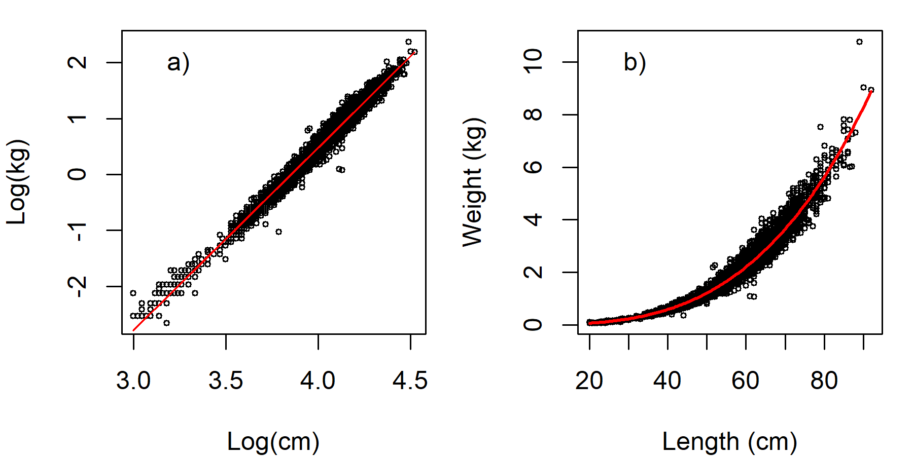
Fig. S8. Length-weight relationships for female sablefish, coast-wide. a) log-scale relationships and b) untransformed data.
Next, we back-transformed the resulting relationship (equation) to the original data scale to obtain the length-weight relationship as W = aL^{b}, where a = 3.30 x 10⁻⁶, and b = 3.27. We then calculated condition for each individual as:
CI = W_{obsserved}/W_{expected} * 100
Finally, we averaged the Individual Condition Index by year to obtain an annual index of female condition for age 7+ females north of approximately Cape Mendocino.
We added female condition to the base model (DF1) in several forms and selected the best-fit model based on the lowest AICc. We add female condition as a continuous variable and as a categorical predictor in which years with condition exceeding the upper and lower 1.0 s.d. bound were classified as “good” or “poor” and other years were classified as “normal” (Fig. S6). We also fit each as lagged one year or estimated recruitment and condition in the same year.
Three models had AICc less than 2.0 (Table S4), including the base DF1 only model (r² 0.27, ranked third). Including current year condition as a continuous variable produced the lowest AICc and r² = 0.37 (Table S5). Condition as a factor produced the highest r² (0.48), and closer examination of the model parameters (Table S6) suggests that years with low condition were important to the model fish (coefficient was different from zero).

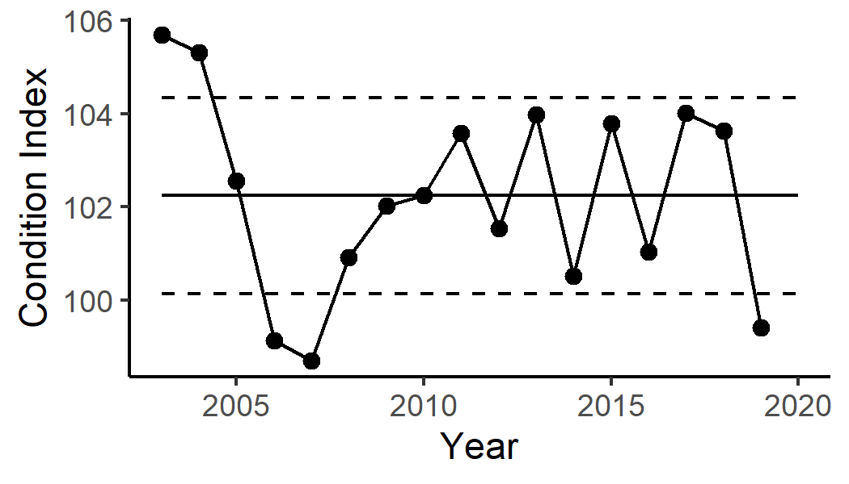
Fig. S9. Condition of age-7+ females north of Cape Mendocino for 2003-2019. See Haltuch et al. (2019b) for details on calculation. Index is the percentage of expected weight for that year. Values below 100 indicate poor condition. Solid line is the average condition across the time series. Dotted lines are +/- 1.0 s.d.

Table S4. Comparison of model fits evaluating predictors of recruitment for 2003-2018 for the base model plus condition as a factor, continuous variable, and lagged or within the same year.
Model | AICc | ΔAICc | R² | Parameters
DF1 + condition | 60.58 | - | 0.37 | 3
DF1 + condition, factor | 61.30 | 0.72 | 0.49 | 4
DF1 | 61.48 | 0.90 | 0.27 | 2
DF1 + condition, lagged | 62.75 | 2.17 | 0.26 | 3
Condition, lagged | 64.04 | 3.46 | 0.02 | 2
Condition | 64.37 | 3.79 | 0.04 | 2
DF1 + condition, lagged, factor | 64.67 | 4.09 | 0.35 | 4
Condition, factor | 64.94 | 4.36 | 0.19 | 3
Condition, factor, lagged | 65.30 | 4.72 | 0.14 | 3

Table S5. Results of adding condition (continuous variable) of age 7+ females north of 40° N to the base model predicting recruitment deviations from the stock assessment model.
Parameter | Estimate (SE) | t value | P-value
Intercept | -20.87 (14.11) | -1.479 | 0.161
Northern sea level (DF1) | -0.93 (0.24) | -2.735 | 0.016
Condition | 0.21 (0.14) | 1.491 | 0.158

Table S6. Results of adding condition (factor = good, average, poor) of age 7+ females north of 40° N to the base model predicting recruitment deviations from the stock assessment model.
Parameter | Estimate (SE) |  | t value | P-value
Intercept | 0.4867 (0.310) | 1.572 |  |  | -0.1400
Northern sea level (DF1) | -8.8761 (0.319) | -2.744 |  |  | 0.0167
Condition - good | 0.3418 (0.829) | -0.412 |  |  | 0.6867
Condition - poor | -1.6030 (0.690) | -2.323 |  |  | 0.0370

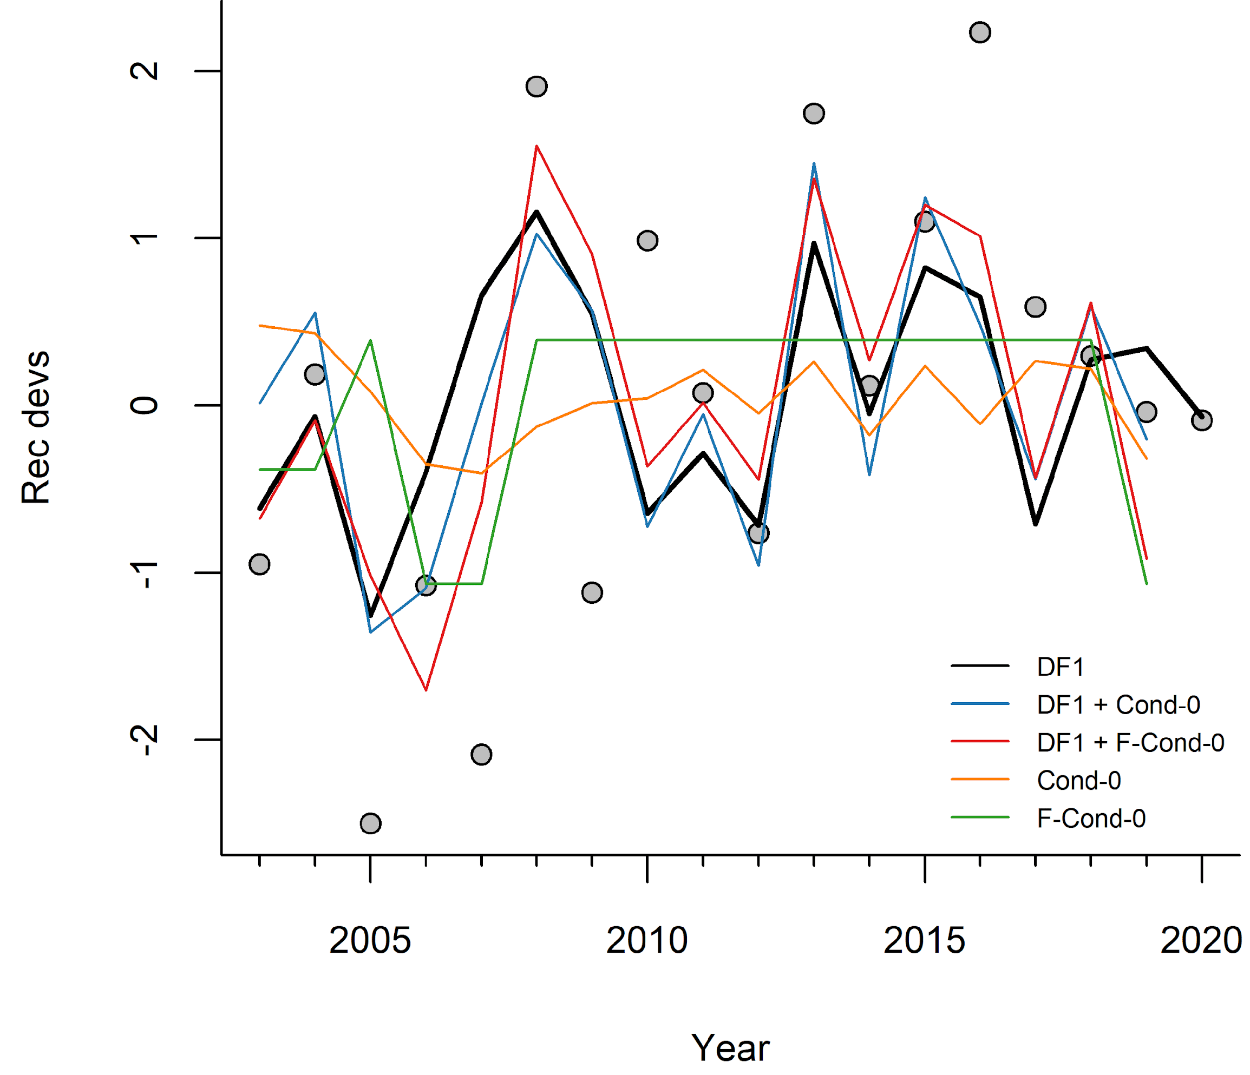
Fig. S10. Results of model fitting using female condition as a categorical variable. ‘DF1 Index’ are the predicted recruitment deviations for the best-fit model in the main analysis. ‘DF1 & F_Cond’ are the results when condition is included as a two-level factor in the model. “C_Cond” shows standardized female condition for age-7+ individuals (north of Cape Mendocino), and DF1 is the first dynamic factor from the primary analysis. Dotted lines are the 95% confidence limits for DF1 & F_Cond index.

