Appendix S1 Recording schedule for deployments from all sites.

Deployment | Sampling Frequency (kHz) | Duty Cycle  (minutes on/ total minutes) | Latitude, Longitude  (decimal degrees) | Instrument Depth  (nearest 10 meters) | Start Date | End Date
Hawaiʻi05 | 200 | 5/5 | 19.578, -156.014 | 550 | 2009-02-10 | 2009-04-01
Hawaiʻi06 | 200 | 5/15 | 19.583, -156.016 | 750 | 2009-04-23 | 2009-08-18
Hawaiʻi07 | 200 | none | 19.582, -156.015 | 720 | 2009-10-25 | 2009-12-15
Hawaiʻi08 | 200 | 5/12 | 19.581, -156.015 | 750 | 2009-12-20 | 2010-03-05
Hawaiʻi09 | 200 | none | 19.581, -156.016 | 750 | 2010-05-01 | 2010-06-16
Hawaiʻi10 | 200 | 5/8 | 19.582, -156.015 | 720 | 2010-09-30 | 2011-03-12
Hawaiʻi11 | 200 | 5/8 | 19.582, -156.015 | 720 | 2011-05-12 | 2011-10-22
Hawaiʻi16 | 200 | 5/15 | 19.583, -156.015 | 720 | 2013-10-23 | 2014-04-03
Hawaiʻi17 | 200 | none | 19.583, -156.016 | 720 | 2014-03-25 | 2014-07-14
Hawaiʻi18 | 320 | none | 19.583, -156.016 | 720 | 2014-07-28 | 2014-10-12
Hawaiʻi19 | 320 | none | 19.583, -156.016 | 720 | 2014-12-06 | 2015-03-06
Hawaiʻi20 | 320 | none | 19.583, -156.016 | 720 | 2015-04-25 | 2015-08-18
Hawaiʻi22 | 200 | none | 19.583, -156.016 | 720 | 2015-11-07 | 2016-03-19
Hawaiʻi23 | 200 | none | 19.583, -156.016 | 720 | 2016-07-04 | 2016-09-14
Hawaiʻi26 | 200 | none | 19.582, -156.015 | 740 | 2017-07-12 | 2017-10-25
Hawaiʻi27 | 200 | none | 19.583, -156.016 | 750 | 2017-10-26 | 2018-04-25
Hawaiʻi28 | 200 | none | 19.583, -156.016 | 730 | 2018-04-29 | 2018-11-19
Hawaiʻi29 | 200 | none | 19.583, -156.016 | 740 | 2018-11-23 | 2019-03-31
Hawaiʻi30 | 200 | none | 19.583, -156.015 | 700 | 2019-04-04 | 2019-09-29
Kauaʻi01 | 200 | 5/20 | 21.953, -159.887 | 720 | 2009-10-08 | 2010-05-13
Kauaʻi02 | 200 | none | 21.954, -159.890 | 730 | 2010-06-04 | 2010-08-20
Kauaʻi05 | 200 | 5/7 | 21.949, -159.888 | 730 | 2016-07-09 | 2017-08-09
Manawai01 | 200 | 5/20 | 27.725, -175.638 | 770 | 2009-10-20 | 2010-05-24
Manawai02 | 200 | none | 27.727, -175.632 | 750 | 2010-06-01 | 2010-09-17
Manawai04 | 200 | none | 27.725, -175.638 | 770 | 2011-04-12 | 2011-07-29
Manawai05 | 200 | 5/8 | 27.725, -175.638 | 770 | 2011-08-15 | 2012-01-07
Manawai08 | 200 | 5/20 | 27.742, -175.559 | 970 | 2014-09-12 | 2015-07-16
Manawai09 | 200 | 5/30 | 27.742, -175.560 | 960 | 2015-10-15 | 2016-08-14
Manawai10 | 200 | 5/30 | 27.741, -175.560 | 960 | 2016-08-20 | 2017-03-14
Table S1.1. Recording schedule. Recording schedule for deployments from all sites, adapted from Ziegenhorn et al. (2022). Deployments with a 25 kHz crossover between the low and high frequency hydrophones have been bolded. Lines in-between rows represent different sites, including Manawai subsites 1-2.

Appendix S2 Seasonal species composition for each site

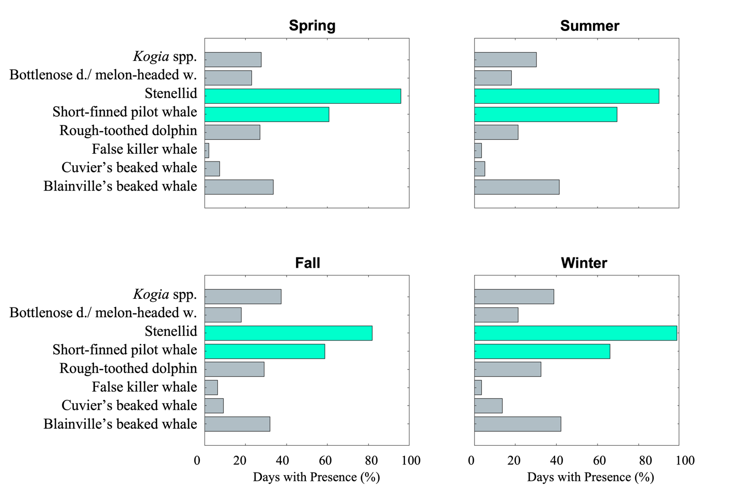
Figure S2.1. Percentage days with presence-Hawaiʻi. Percent days out of total recording days at Hawaiʻi with presence of each type for each season. Values greater than 50% are shown in green.

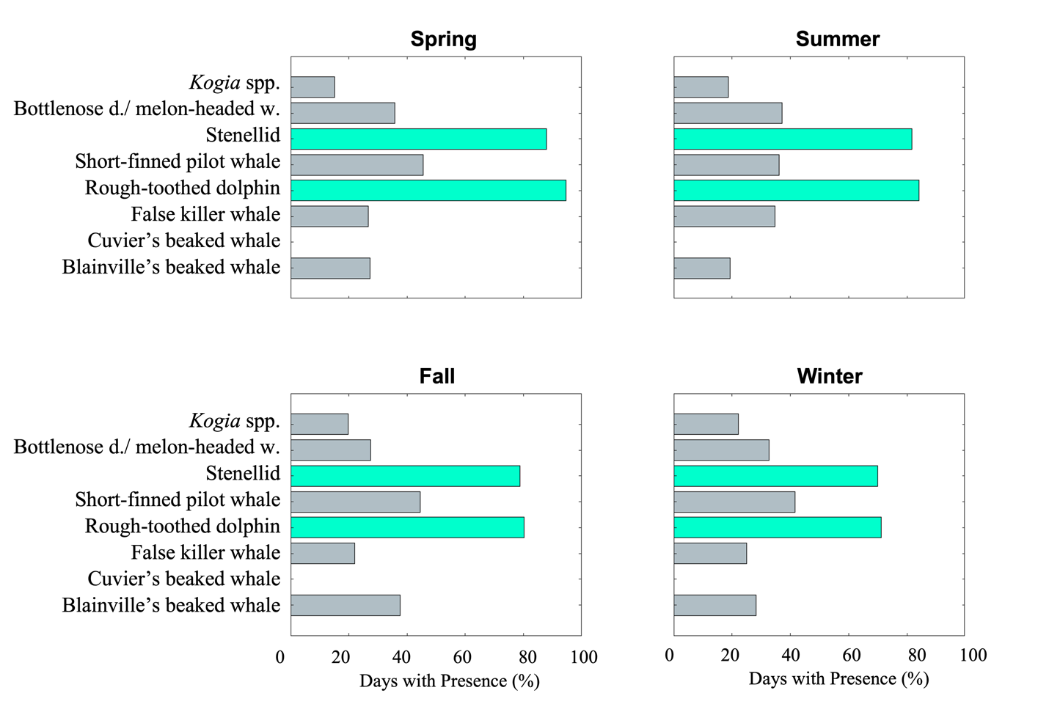

Figure S2.2. Percentage days with presence-Kauaʻi. Percent days out of total recording days at Kauaʻi with presence of each type for each season. Values greater than 50% are shown in green.

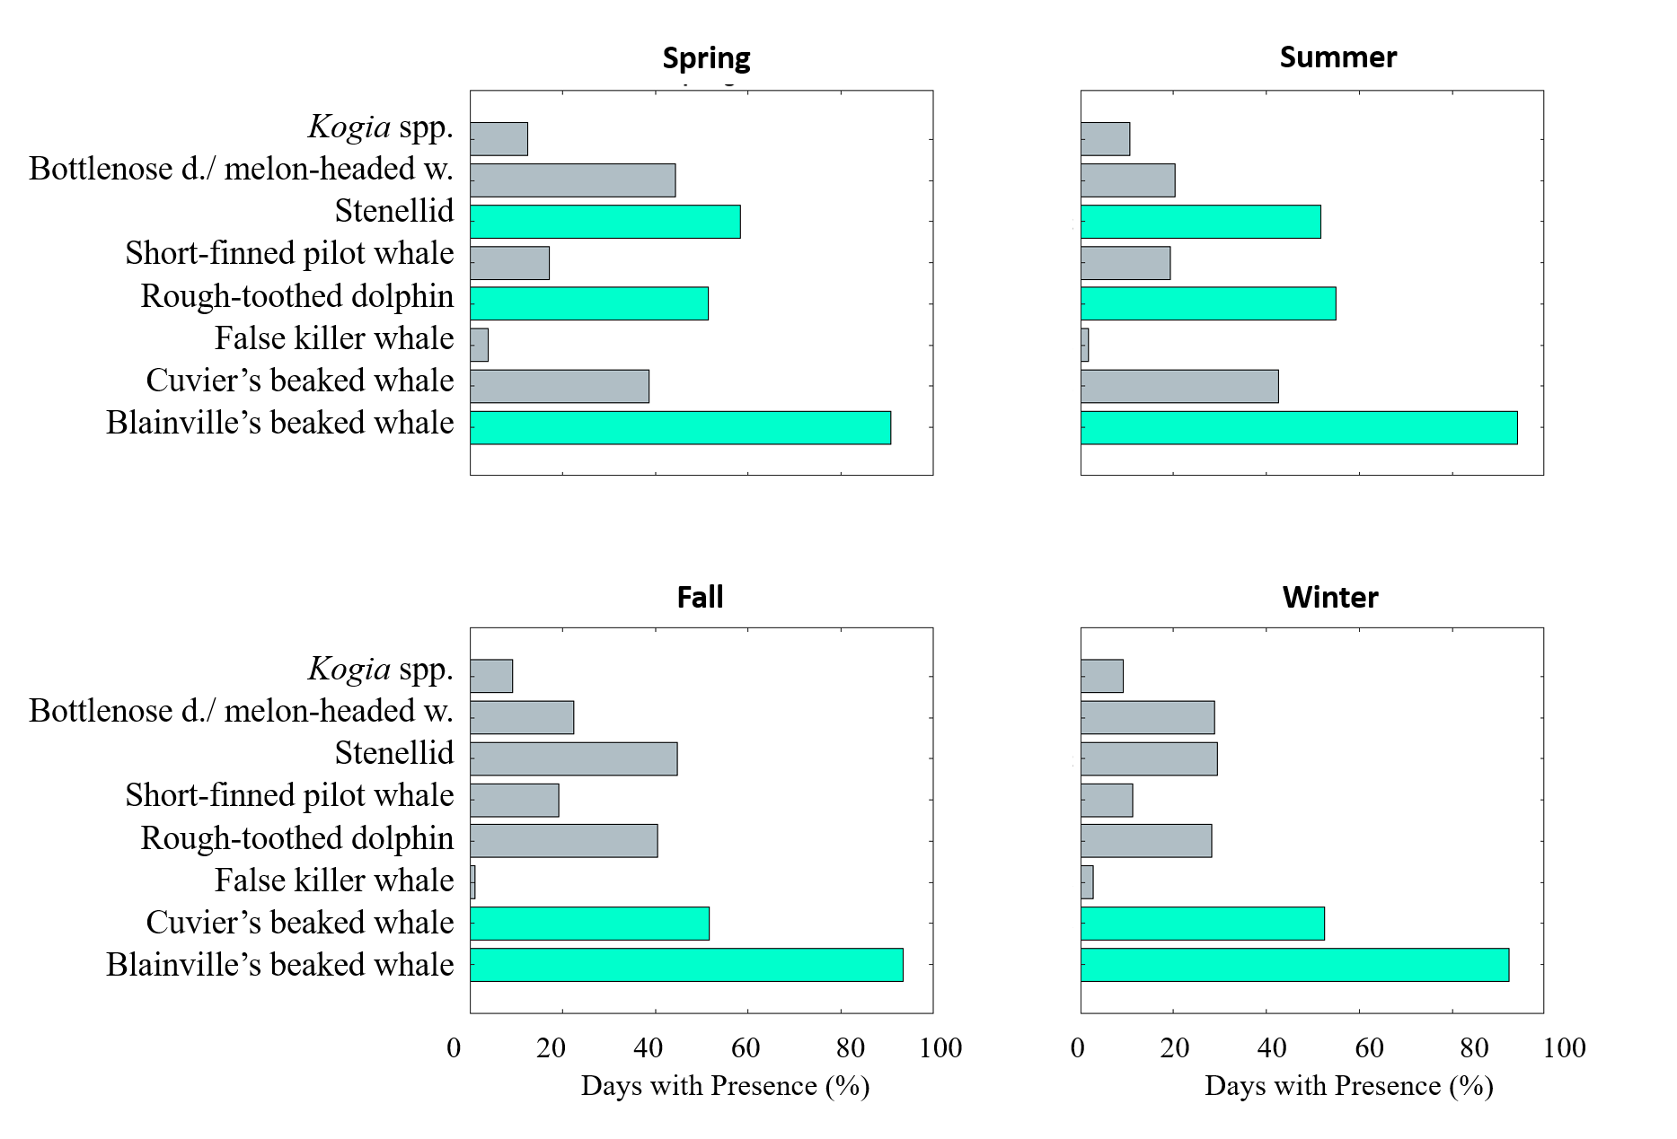

Figure S2.3. Percentage days with presence-Manawai. Percent days out of total recording days at Manawai with presence of each type for each season. Values greater than 50% are shown in green.

Appendix S3 Full timeseries of species presence

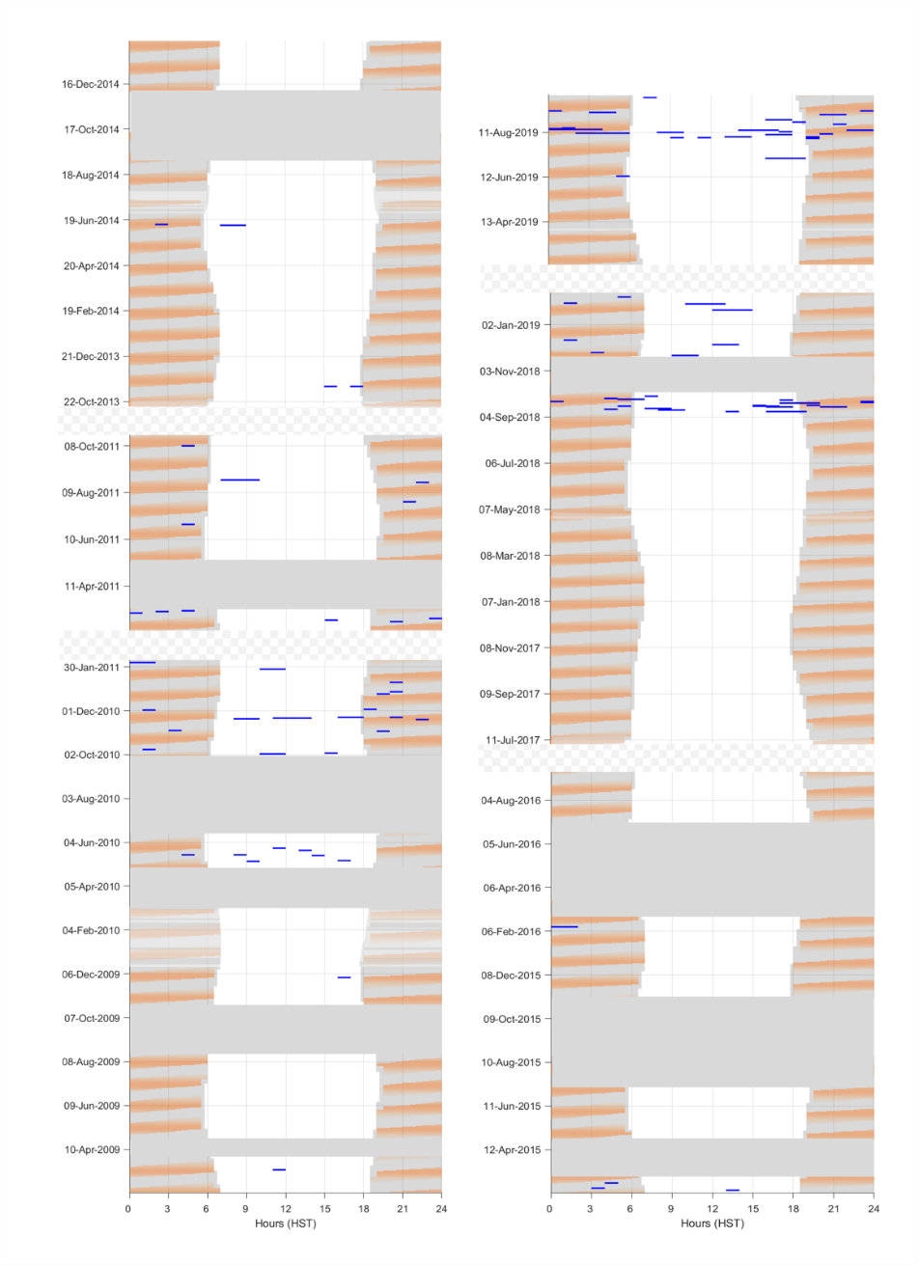
Figure S3.1. Diel and lunar timeseries for false killer whales at Hawaiʻi. Hours of presence for false killer whales at Hawaiʻi (blue). Date is shown on the y-axis, and hour of day on the x-axis. Lunar illumination (orange shading), nighttime hours (grey shading), times of no effort (dark gray boxes), and large time gaps (hashed gray boxes) are drawn.

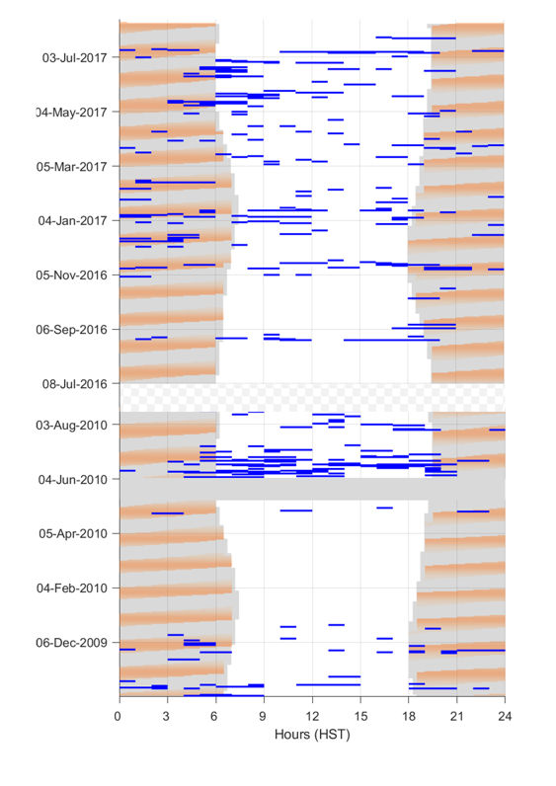
Figure S3.2. Diel/lunar timeseries- false killer whales at Kauaʻi. Hours of presence for false killer whales at Kauaʻi (blue). Date is shown on the y-axis, and hour of day on the x-axis. Lunar illumination (orange shading), nighttime hours (grey shading), times of no effort (dark gray boxes), and large time gaps (hashed gray boxes) are drawn.

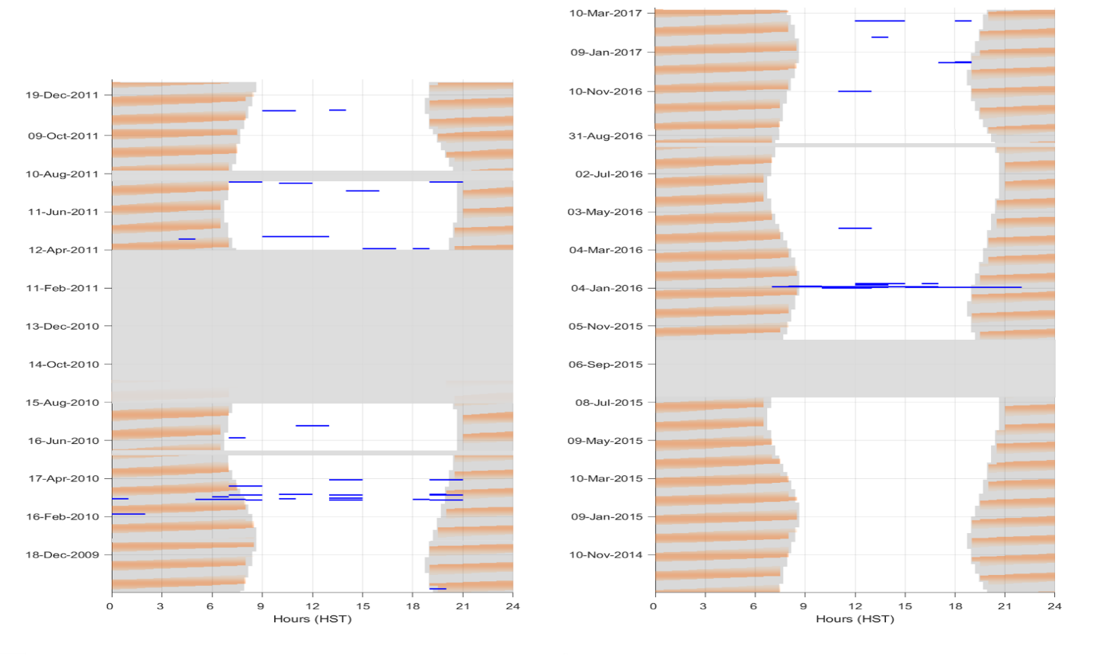
Figure S3.3. Diel/lunar timeseries- false killer whales at Manawai. Hours of presence for false killer whales (blue) at Manawai. Date is shown on the y-axis, and hour of day on the x-axis. Lunar illumination (orange shading), nighttime hours (grey shading), times of no effort (dark gray boxes), and large time gaps (hashed gray boxes) are drawn.

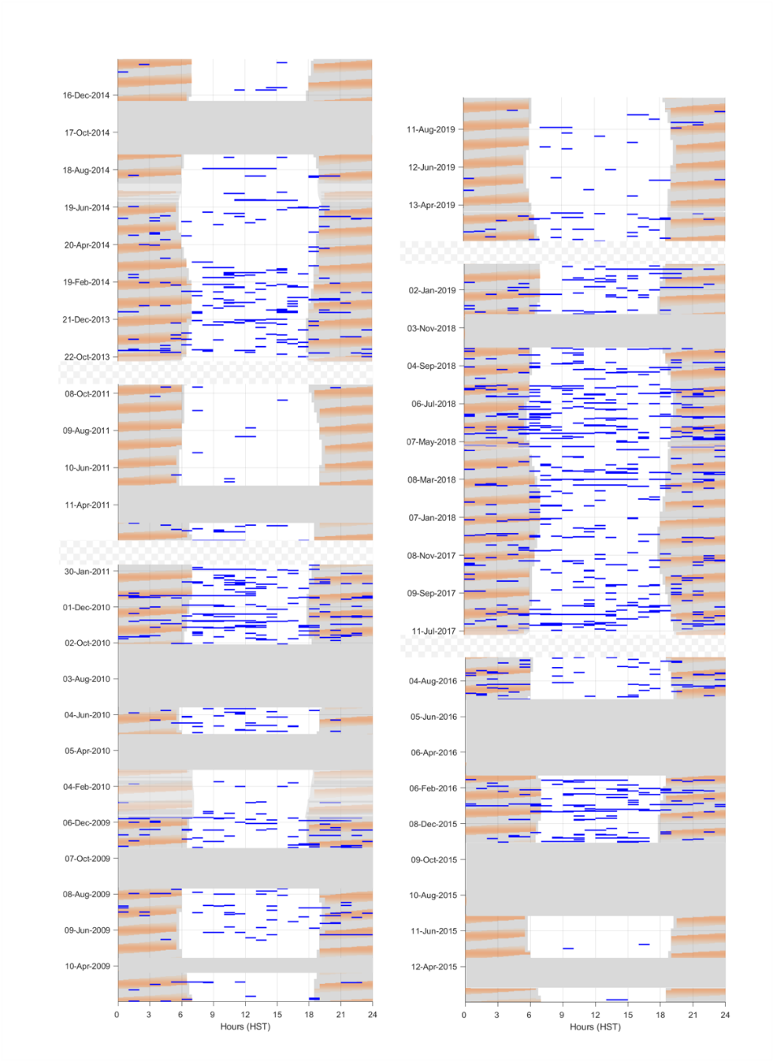
Figure S3.4. Diel/lunar timeseries- Kogia spp. at Hawaiʻi. Hours of presence for Kogia spp. at Hawaiʻi (blue). Date is shown on the y-axis, and hour of day on the x-axis. Lunar illumination (orange shading), nighttime hours (grey shading), times of no effort (dark gray boxes), and large time gaps (hashed gray boxes) are drawn.

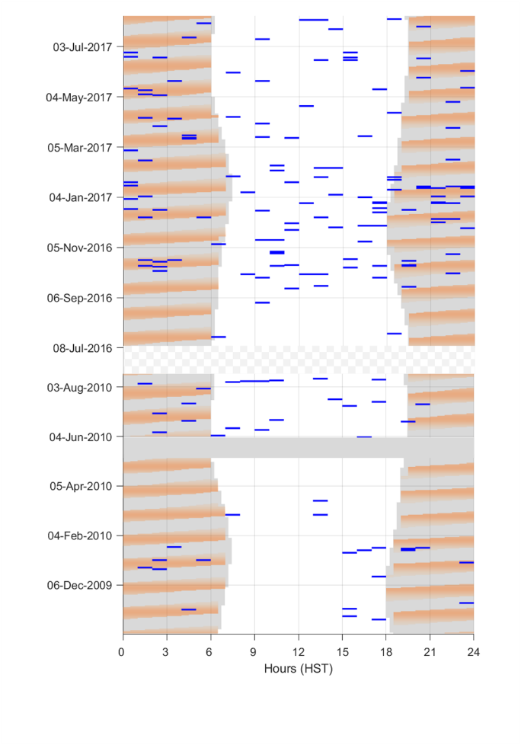
Figure S3.5. Diel/lunar timeseries- Kogia spp. at Kauaʻi. Hours of presence for Kogia spp. at Kauaʻi (blue). Date is shown on the y-axis, and hour of day on the x-axis. Lunar illumination (orange shading), nighttime hours (grey shading), times of no effort (dark gray boxes), and large time gaps (hashed gray boxes) are drawn.

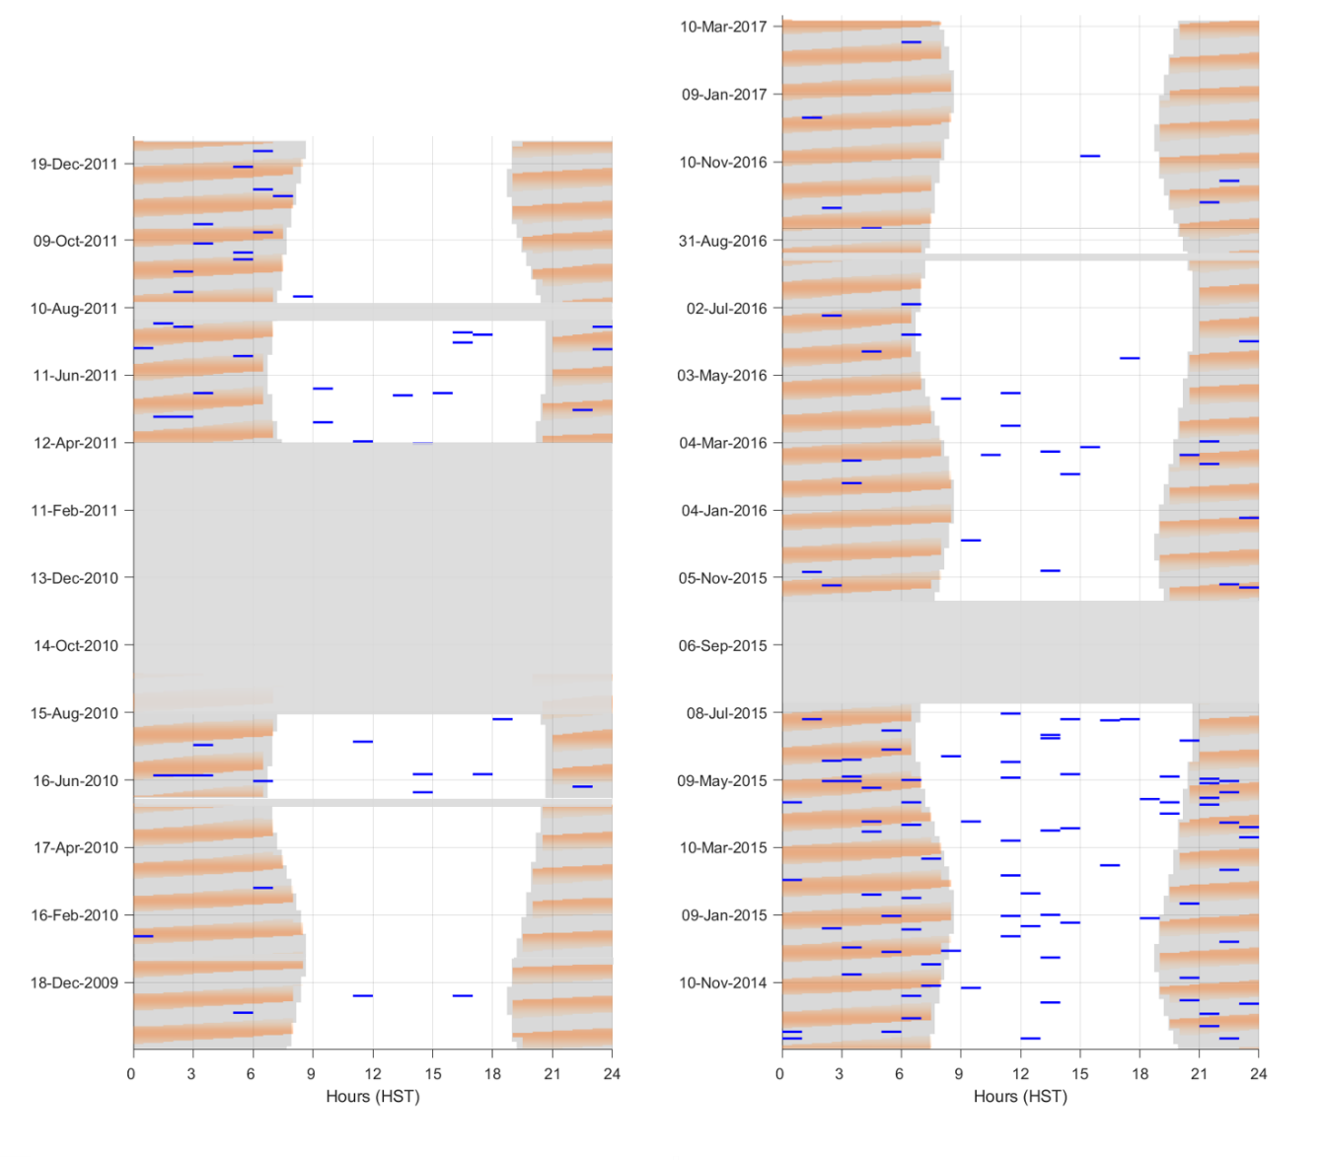
Figure S3.6. Diel/lunar timeseries- Kogia spp. at Manawai. Hours of presence for Kogia spp. (blue) at Manawai. Date is shown on the y-axis, and hour of day on the x-axis. Lunar illumination (orange shading), nighttime hours (grey shading), times of no effort (dark gray boxes), and large time gaps (hashed gray boxes) are drawn.

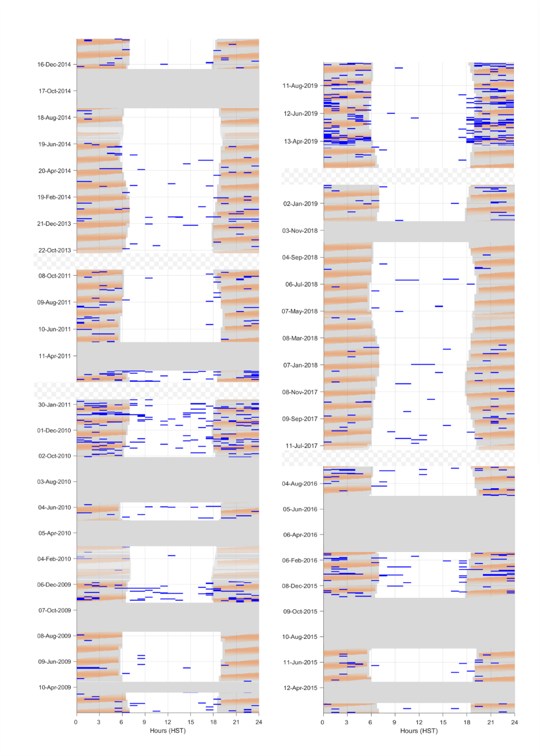
Figure S3.7. Diel/lunar timeseries- rough-toothed dolphin at Hawaiʻi. Hours of presence for rough-toothed dolphin at Hawaiʻi (blue). Date is shown on the y-axis, and hour of day on the x-axis. Lunar illumination (orange shading), nighttime hours (grey shading), times of no effort (dark gray boxes), and large time gaps (hashed gray boxes) are drawn.

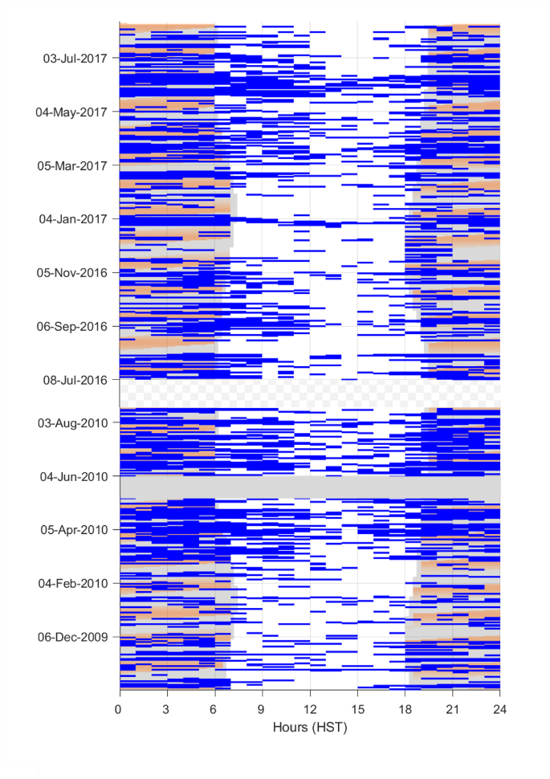
Figure S3.8. Diel/lunar timeseries- rough-toothed dolphin at Kauaʻi. Hours of presence for rough-toothed dolphin at Kauaʻi (blue). Date is shown on the y-axis, and hour of day on the x-axis. Lunar illumination (orange shading), nighttime hours (grey shading), times of no effort (dark gray boxes), and large time gaps (hashed gray boxes) are drawn.

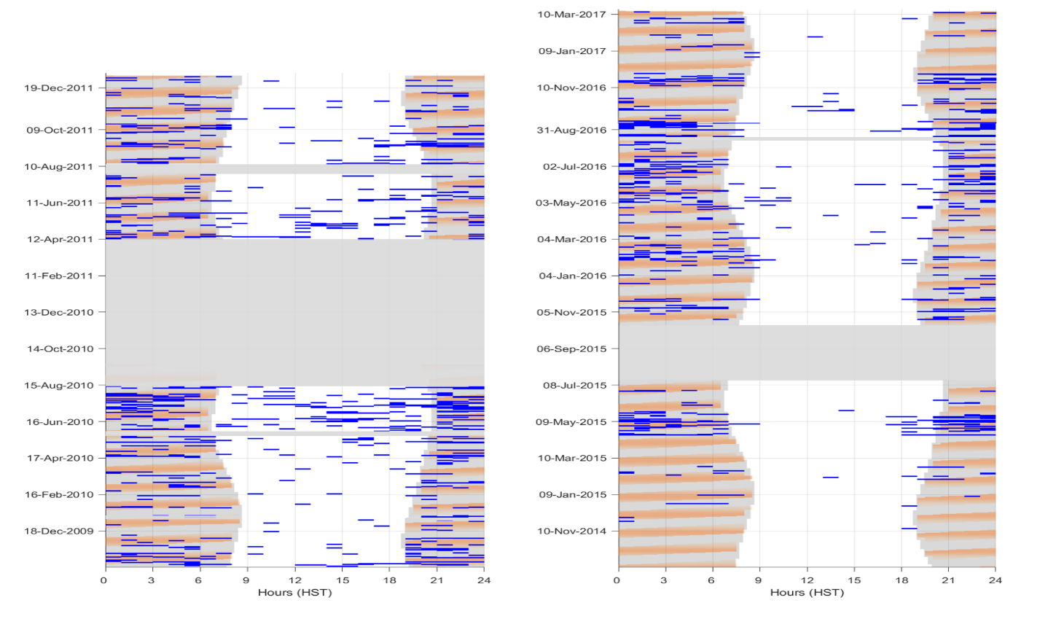
Figure S3.9. Diel/lunar timeseries- rough-toothed dolphin at Manawai. Hours of presence for rough-toothed dolphin (blue) at Manawai. Date is shown on the y-axis, and hour of day on the x-axis. Lunar illumination (orange shading), nighttime hours (grey shading), times of no effort (dark gray boxes), and large time gaps (hashed gray boxes) are drawn.

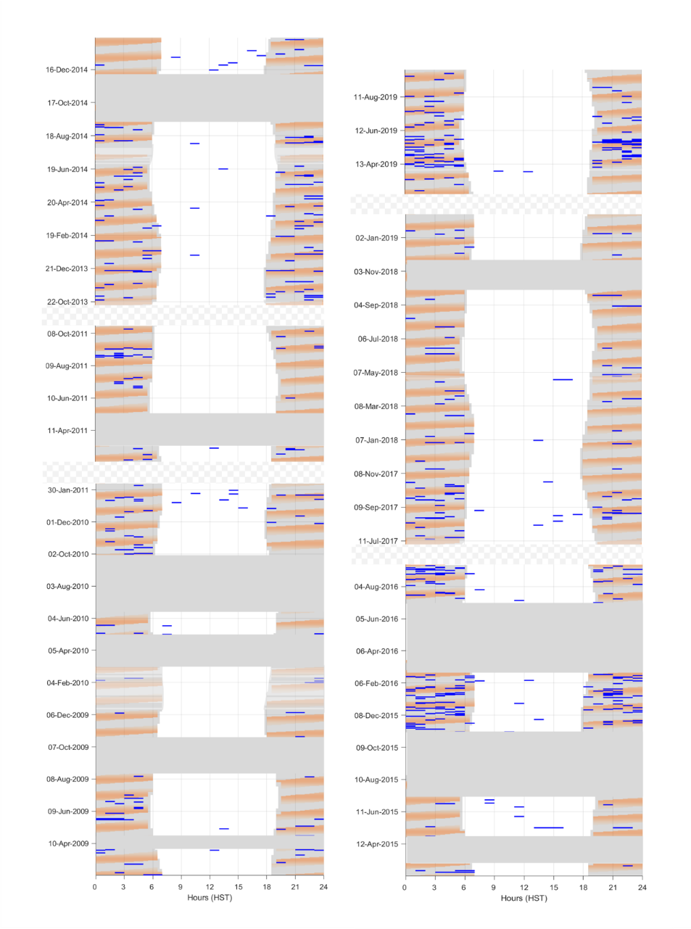
Figure S3.10. Diel/lunar timeseries- bottlenose dolphin and melon-headed whale at Hawaiʻi. Hours of presence for bottlenose dolphin/melon-headed whale at Hawaiʻi (blue). Date is shown on the y-axis, and hour of day on the x-axis. Lunar illumination (orange shading), nighttime hours (grey shading), times of no effort (dark gray boxes), and large time gaps (hashed gray boxes) are drawn.

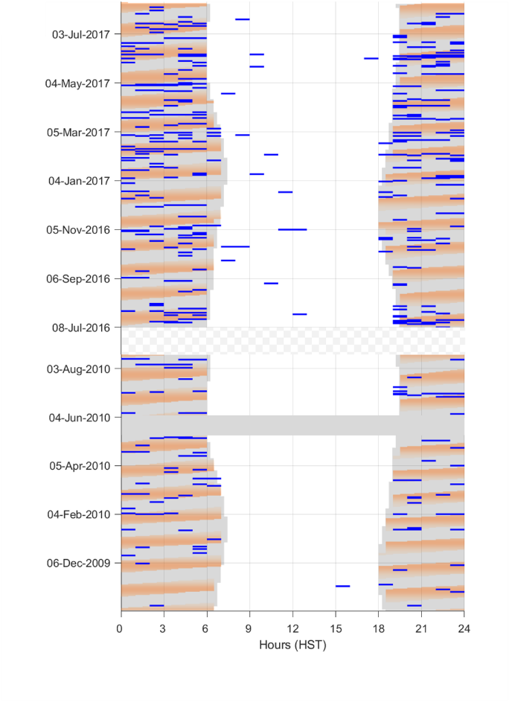
Figure S3.11. Diel/lunar timeseries- bottlenose dolphin and melon-headed whale at Kauaʻi. Hours of presence for bottlenose dolphin/melon-headed whale at Kauaʻi (blue). Date is shown on the y-axis, and hour of day on the x-axis. Lunar illumination (orange shading), nighttime hours (grey shading), times of no effort (dark gray boxes), and large time gaps (hashed gray boxes) are drawn.

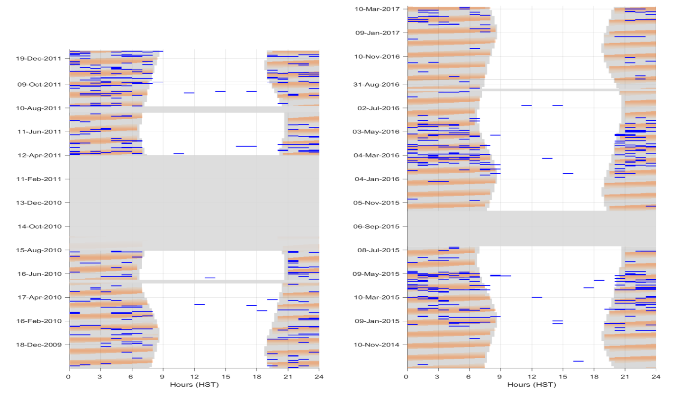
Figure S3.12. Diel/lunar timeseries- bottlenose dolphin and melon-headed whale at Manawai. Hours of presence for bottlenose dolphin/melon-headed whale (blue) at Manawai. Date is shown on the y-axis, and hour of day on the x-axis. Lunar illumination (orange shading), nighttime hours (grey shading), times of no effort (dark gray boxes), and large time gaps (hashed gray boxes) are drawn.

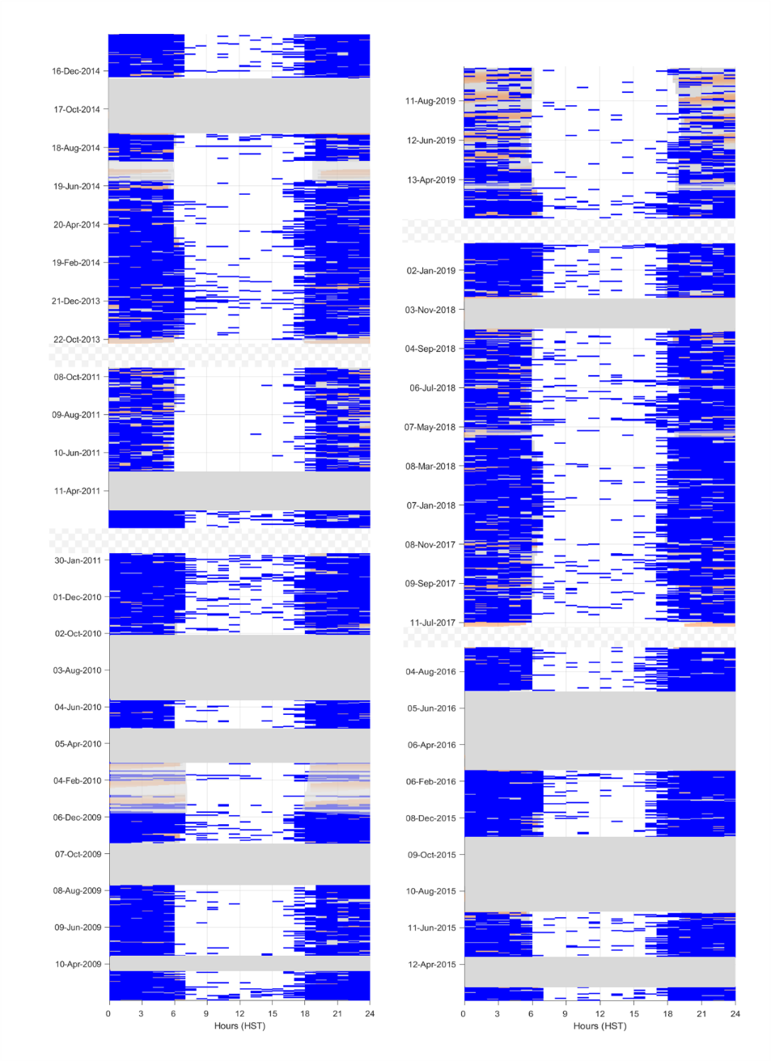
Figure S3.13. Diel/lunar timeseries- stenellid dolphins at Hawaiʻi. Hours of presence for stenellid dolphins at Hawaiʻi (blue). Date is shown on the y-axis, and hour of day on the x-axis. Lunar illumination (orange shading), nighttime hours (grey shading), times of no effort (dark gray boxes), and large time gaps (hashed gray boxes) are drawn.

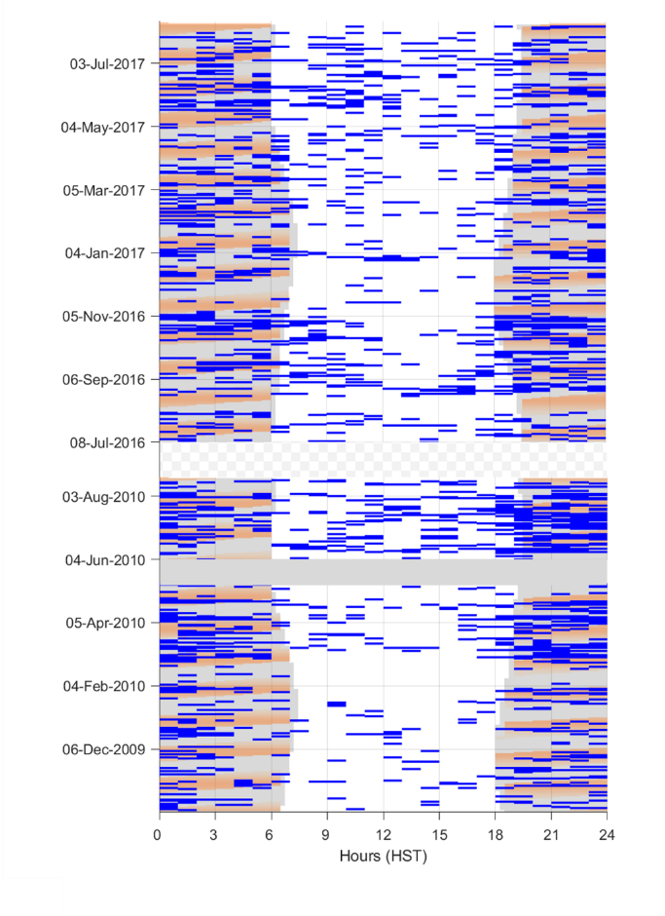
Figure S3.14. Diel/lunar timeseries- stenellid dolphins at Kauaʻi. Hours of presence for stenellid dolphins at Kauaʻi (blue). Date is shown on the y-axis, and hour of day on the x-axis. Lunar illumination (orange shading), nighttime hours (grey shading), times of no effort (dark gray boxes), and large time gaps (hashed gray boxes) are drawn.

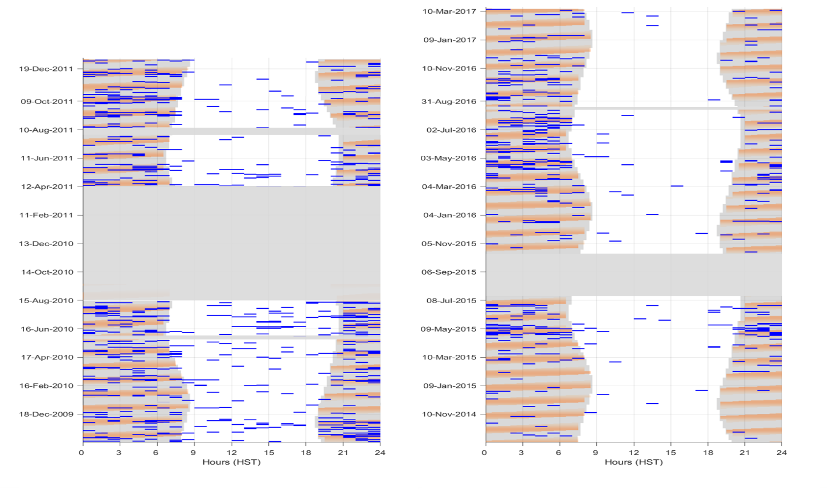
Figure S3.15. Diel/lunar timeseries- stenellid dolphins at Manawai. Hours of presence for stenellid dolphins (blue) at Manawai. Date is shown on the y-axis, and hour of day on the x-axis. Lunar illumination (orange shading), nighttime hours (grey shading), times of no effort (dark gray boxes), and large time gaps (hashed gray boxes) are drawn.

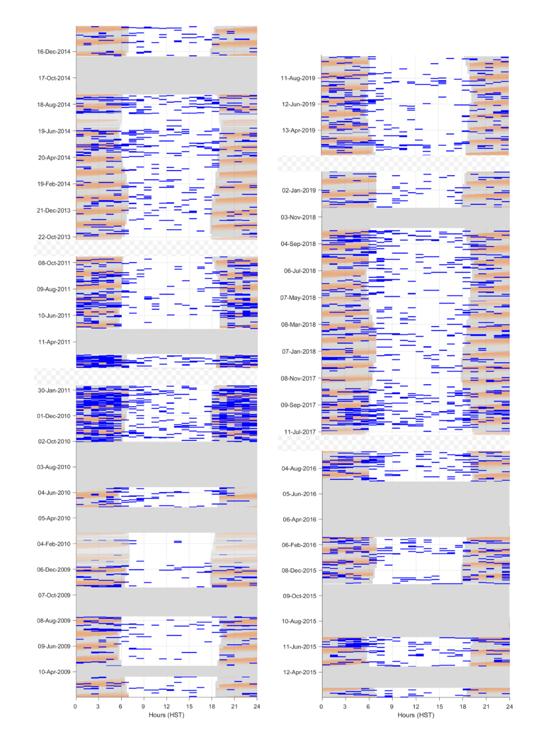
Figure S3.16. Diel/lunar timeseries- short-finned pilot whales at Hawaiʻi. Hours of presence for short-finned pilot whales at Hawaiʻi (blue). Date is shown on the y-axis, and hour of day on the x-axis. Lunar illumination (orange shading), nighttime hours (grey shading), times of no effort (dark gray boxes), and large time gaps (hashed gray boxes) are drawn.

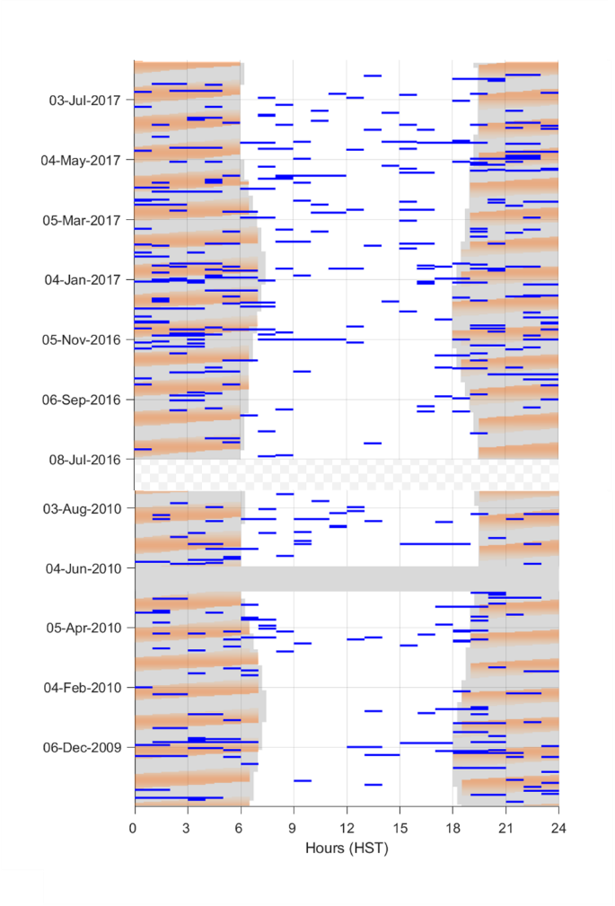
F
Figure S3.17. Diel/lunar timeseries- short-finned pilot whales at Kauaʻi. Hours of presence for short-finned pilot whales at Kauaʻi (blue). Date is shown on the y-axis, and hour of day on the x-axis. Lunar illumination (orange shading), nighttime hours (grey shading), times of no effort (dark gray boxes), and large time gaps (hashed gray boxes) are drawn.

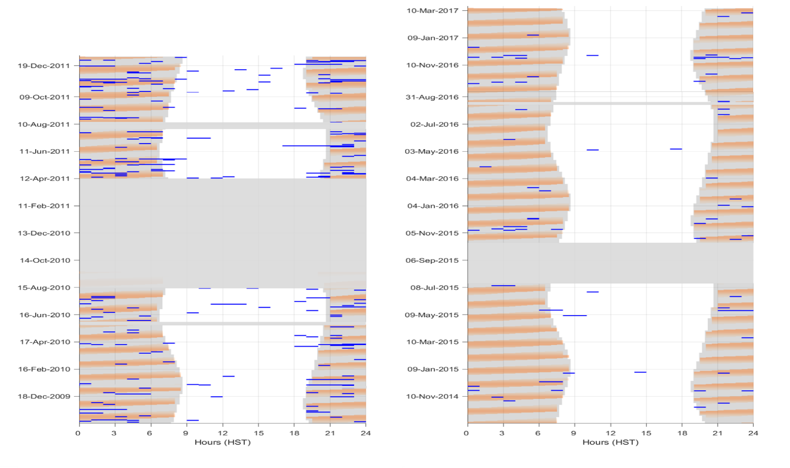
Figure S3.18. Diel/lunar timeseries- short-finned pilot whales at Manawai. Hours of presence for short-finned pilot whales (blue) at Manawai. Date is shown on the y-axis, and hour of day on the x-axis. Lunar illumination (orange shading), nighttime hours (grey shading), times of no effort (dark gray boxes), and large time gaps (hashed gray boxes) are drawn.

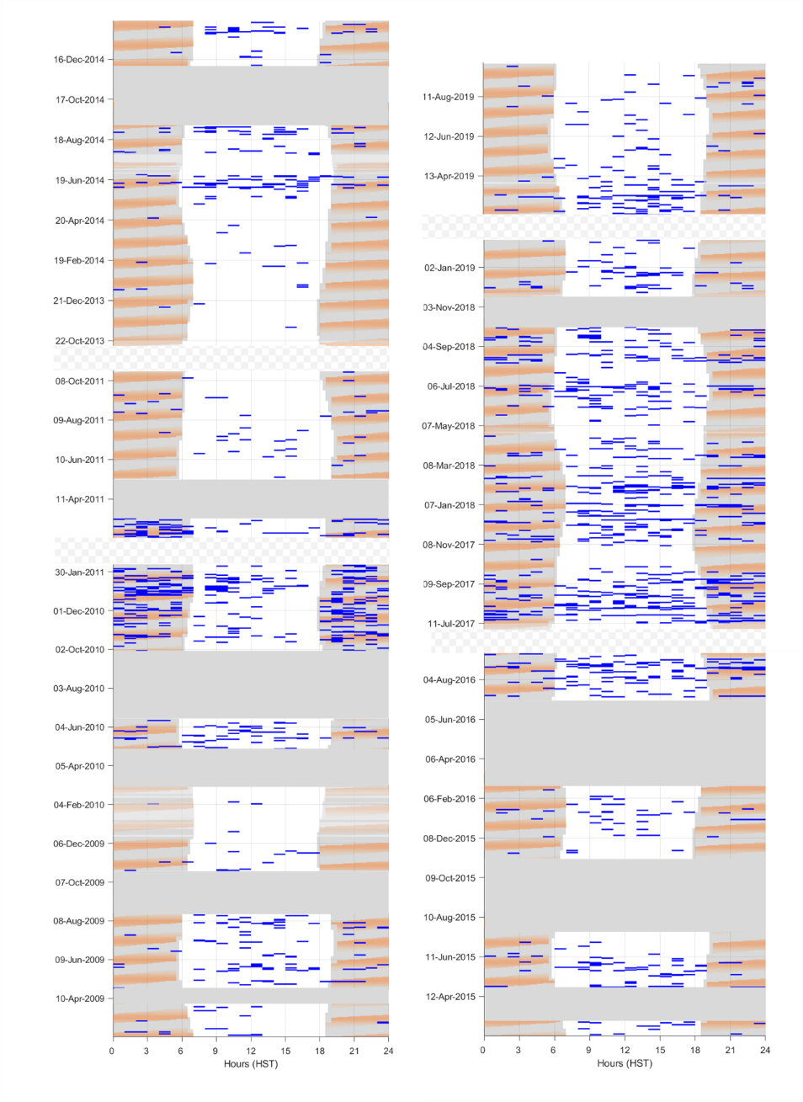
Figure S3.19. Diel/lunar timeseries- Blainville’s beaked whales at Hawaiʻi. Hours of presence for Blainville’s beaked whales at Hawaiʻi (blue). Date is shown on the y-axis, and hour of day on the x-axis. Lunar illumination (orange shading), nighttime hours (grey shading), times of no effort (dark gray boxes), and large time gaps (hashed gray boxes) are drawn.

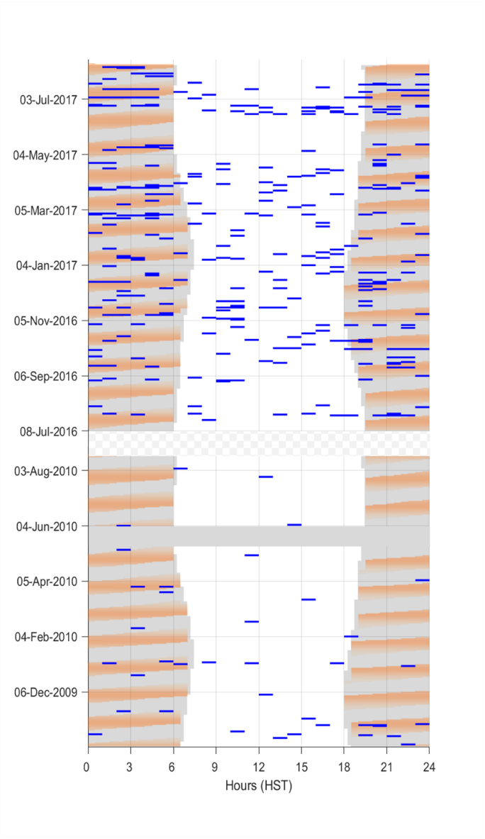
Figure S3.20. Diel/lunar timeseries- Blainville’s beaked whales at Kauaʻi. Hours of presence for Blainville’s beaked whales at Kauaʻi (blue). Date is shown on the y-axis, and hour of day on the x-axis. Lunar illumination (orange shading), nighttime hours (grey shading), times of no effort (dark gray boxes), and large time gaps (hashed gray boxes) are drawn.

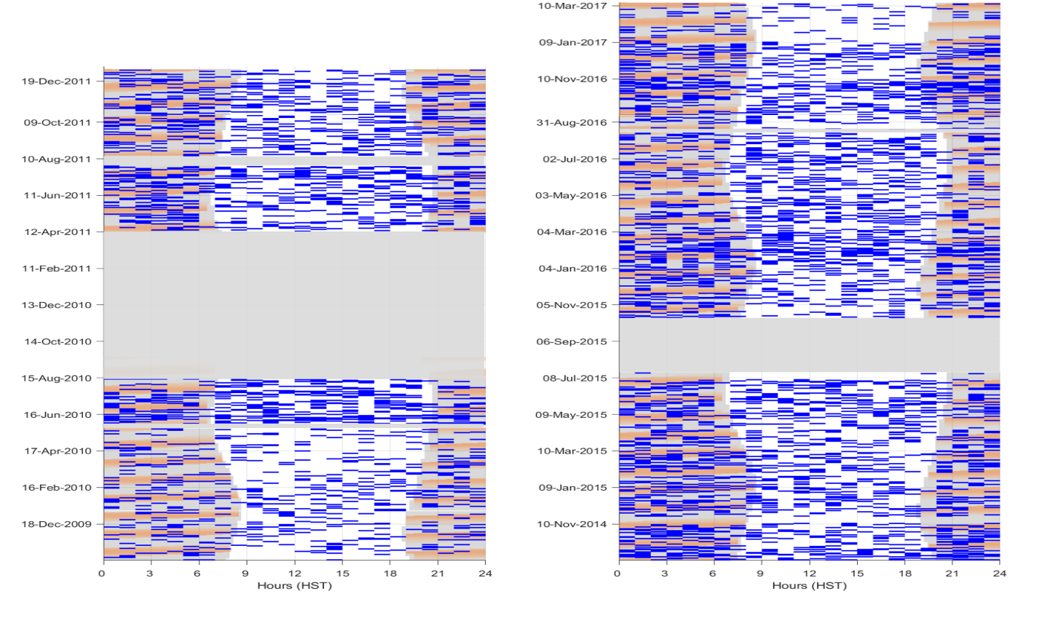
Figure S3.21. Diel/lunar timeseries- Blainville’s beaked whales at Manawai. Hours of presence for Blainville’s beaked whales (blue) at Manawai. Date is shown on the y-axis, and hour of day on the x-axis. Lunar illumination (orange shading), nighttime hours (grey shading), times of no effort (dark gray boxes), and large time gaps (hashed gray boxes) are drawn.

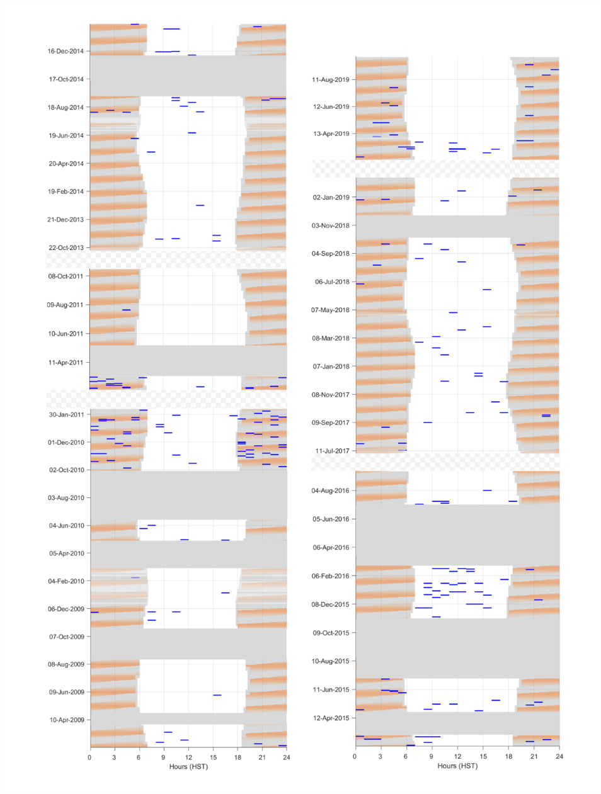
Figure S3.22. Diel/lunar timeseries- Cuvier’s beaked whales at Hawaiʻi. Hours of presence for Cuvier’s beaked whales at Hawaiʻi (blue). Date is shown on the y-axis, and hour of day on the x-axis. Lunar illumination (orange shading), nighttime hours (grey shading), times of no effort (dark gray boxes), and large time gaps (hashed gray boxes) are drawn.

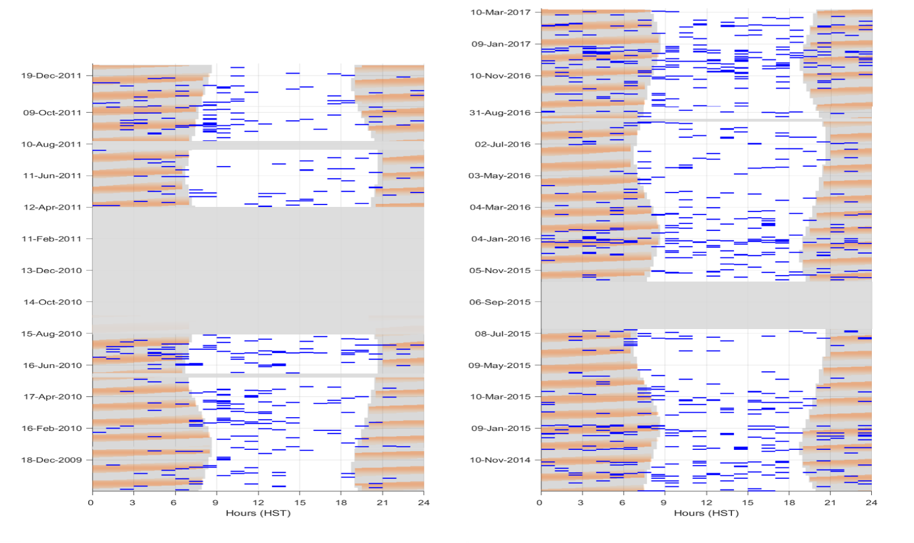
Figure S3.23. Diel/lunar timeseries- Cuvier’s beaked whales at Manawai. Hours of presence for Cuvier’s beaked whales (blue) at Manawai. Date is shown on the y-axis, and hour of day on the x-axis. Lunar illumination (orange shading), nighttime hours (grey shading), times of no effort (dark gray boxes), and large time gaps (hashed gray boxes) are drawn.

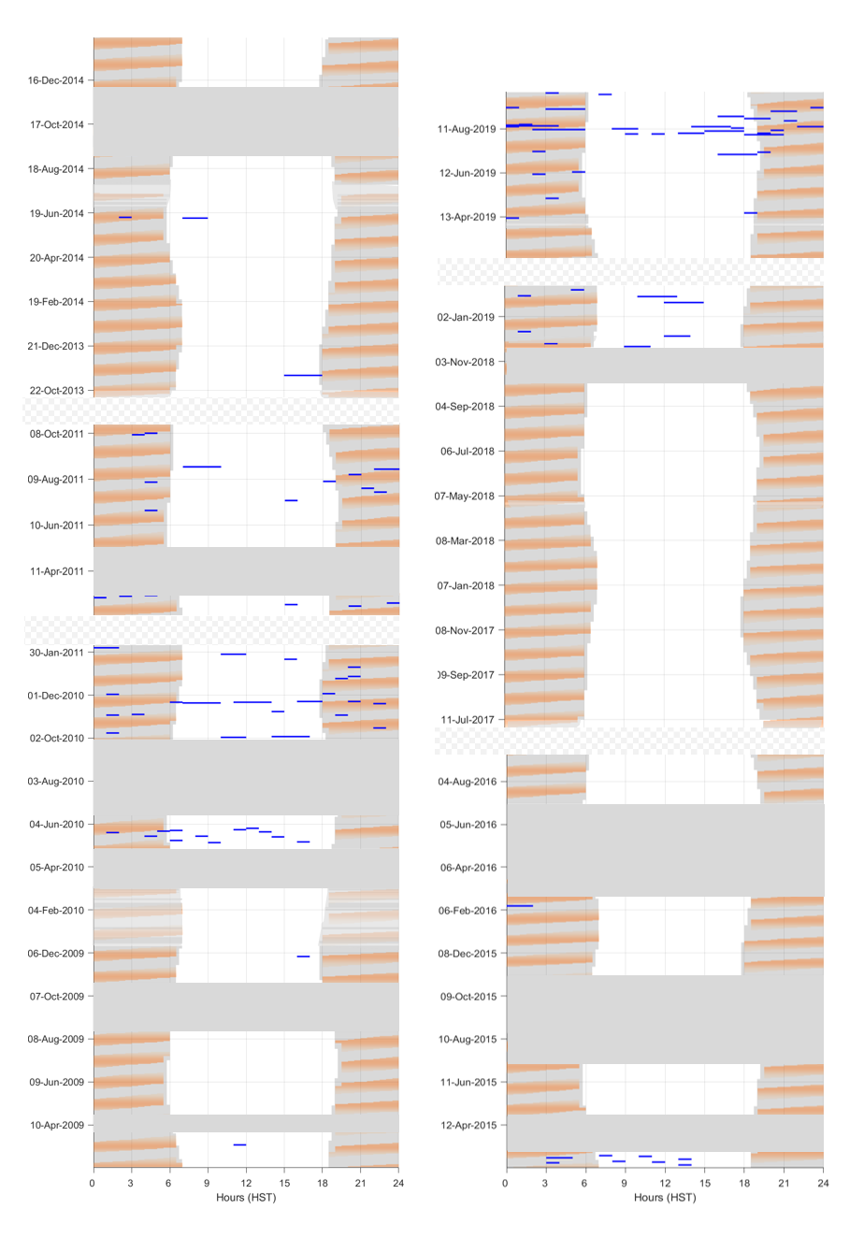
Figure S3.24. Diel/lunar timeseries- False killer whale (alternate) at Hawaiʻi. Hours of presence for false killer whales at Hawaiʻi (blue) for the precision-modified timeseries instead of the manually-edited timeseries. Date is shown on the y-axis, and hour of day on the x-axis. Lunar illumination (orange shading), nighttime hours (grey shading), times of no effort (dark gray boxes), and large time gaps (hashed gray boxes) are drawn.

