Overlap between bowhead whales (Balaena mysticetus) and vessel traffic in the North American Arctic during July to October and implications for conservation and management

Supplementary Material - Supplemental Figures
Figure Legends
Figure S1. Aerial survey transects in Nunavut for the Eastern Canada-West Greenland bowhead whales flown during August 2013.
Figure S2. Bering-Chukchi-Beaufort bowhead whale density by month from satellite telemetry based on kernel density estimation. Values are normalized between zero and one by dividing each cell value by the maximum cell value across months.
Figure S3. Bering-Chukchi-Beaufort bowhead whale density by month from aerial surveys. Values are normalized between zero and one by dividing each cell value by the maximum cell value across months.
Figure S4. Eastern Canada-West Greenland bowhead whale density in summer by month from satellite telemetry based on kernel density estimation Values are normalized between zero and one by dividing each cell value by the maximum cell value across months.
Figure S5. Eastern Canada-West Greenland bowhead whale density from aerial surveys in August 2013. Values are normalized between zero and one by dividing each cell value by the maximum cell value.
Figure S6. Automatic identification system (AIS) vessel density by month in Bering-Chukchi-Beaufort bowhead whale areas, averaged across 2012-2018. Areas where only a single vessel occurred show up as a single dark blue line. White are areas where no vessels occurred.
Figure S7. Average vessel density within the Bering-Chukchi-Beaufort range (the sum of all cells) by vessel class in four months, averaged across the years 2012-2018.
Figure S8. Boxplot of vessel speed by vessel class in four months in Bering-Chukchi-Beaufort range, with data from 2012-2018 pooled together. The underlying data are the average speed per vessel class per month per year in individual 10 × 10 km grid cells.
Figure S9. Average vessel density from automatic identification system (AIS) data within the Eastern Canada-West Greenland range (the sum of all cells) by vessel class in four months, averaged across the years 2012-2018. Areas where only a single vessel occurred show up as a single dark blue line. White are areas where no vessels occurred.
Figure S10. Sum of vessel density cell values by vessel class in four months in Eastern Canada-West Greenland bowhead whale areas, averaged across the years 2012-2018.
Figure S11. Boxplot of vessel speed by vessel class in four months in Eastern Canada-West Greenland bowhead whale areas, with data from 2012-2018 pooled together. The underlying data are the average speed per vessel class per month per year in individual 10 × 10 km grid cells.
Figure S12. Overlap between vessels and Bering-Chukchi-Beaufort bowhead whales based on telemetry data in July, August, September, and October.
Figure S13. Overlap between vessels and Bering-Chukchi-Beaufort bowhead whales based on aerial survey data in July, August, September, and October.
Figure S14. Overlap between vessels and Eastern Canada-West Greenland bowhead whales based on telemetry data in July, August, September, and October.
Figure S15. Overlap between vessels and Eastern Canada-West Greenland bowhead whales based on aerial survey data in August.
Figure S16. Hypothetical vessel strike risk for Bering-Chukchi-Beaufort bowhead whales based on telemetry data in July, August, September, and October for all vessel classes combined (left), all vessel classes excluding pleasure craft (middle), and for only bulk carriers, container ships, and tanker ships (right).
Figure S17. Hypothetical vessel strike risk for Eastern Canada-West Greenland bowhead whales based on telemetry data in July, August, September, and October for all vessel classes combined (left), all vessel classes excluding pleasure craft (middle), and for bulk carriers, container ships, and tanker ships combined (right).

Figure S1. Aerial survey transects in Nunavut for the Eastern Canada-West Greenland bowhead whales flown during August 2013.

Figure S2. Bering-Chukchi-Beaufort bowhead whale density by month from satellite telemetry based on kernel density estimation. Values are normalized between zero and one by dividing each cell value by the maximum cell value across months.
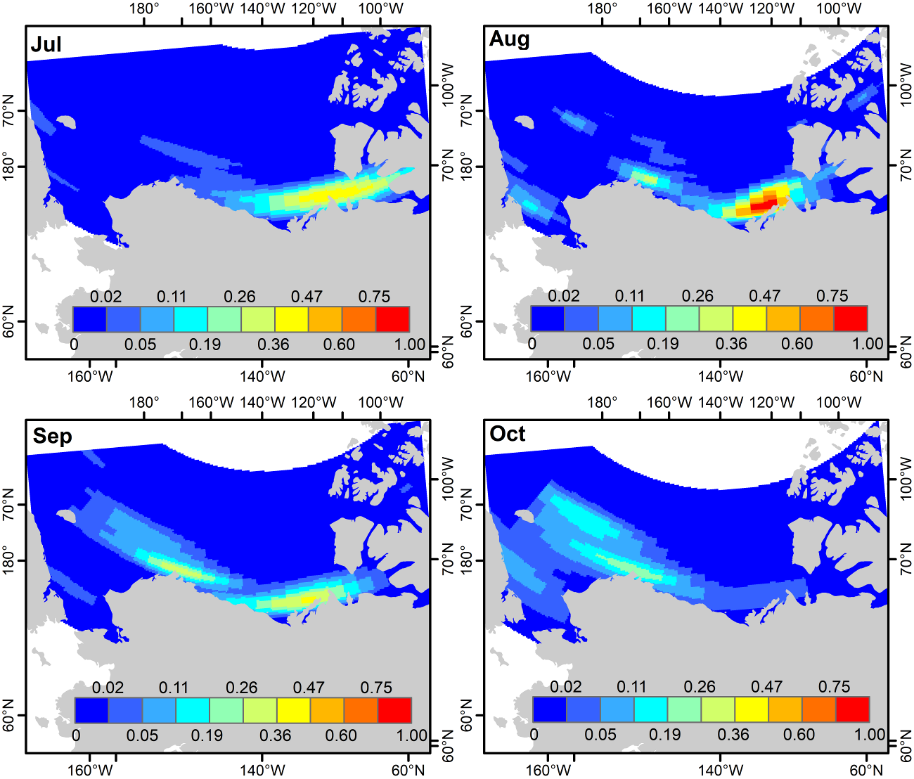

Figure S3. Bering-Chukchi-Beaufort bowhead whale density by month from aerial surveys. Values are normalized between zero and one by dividing each cell value by the maximum cell value across months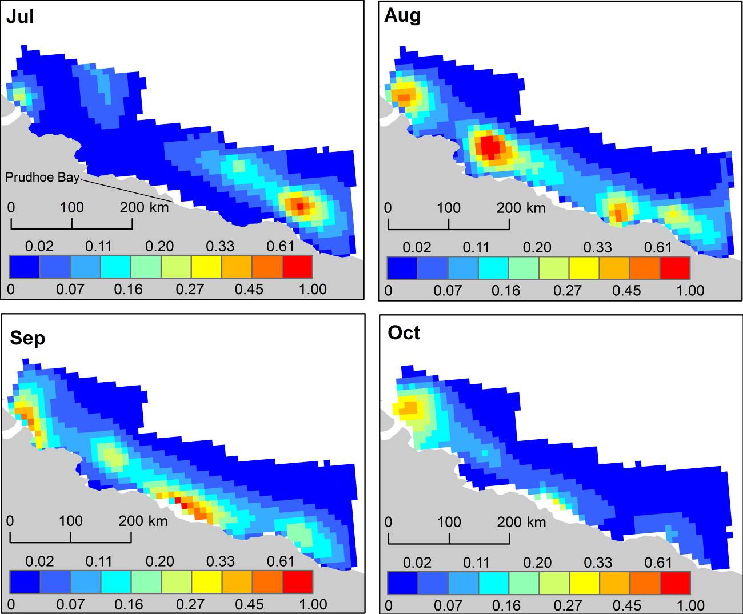.

Figure S4. Eastern Canada-West Greenland bowhead whale density in summer by month from satellite telemetry based on kernel density estimation. Values are normalized between zero and one by dividing each cell value by the maximum cell value across months.
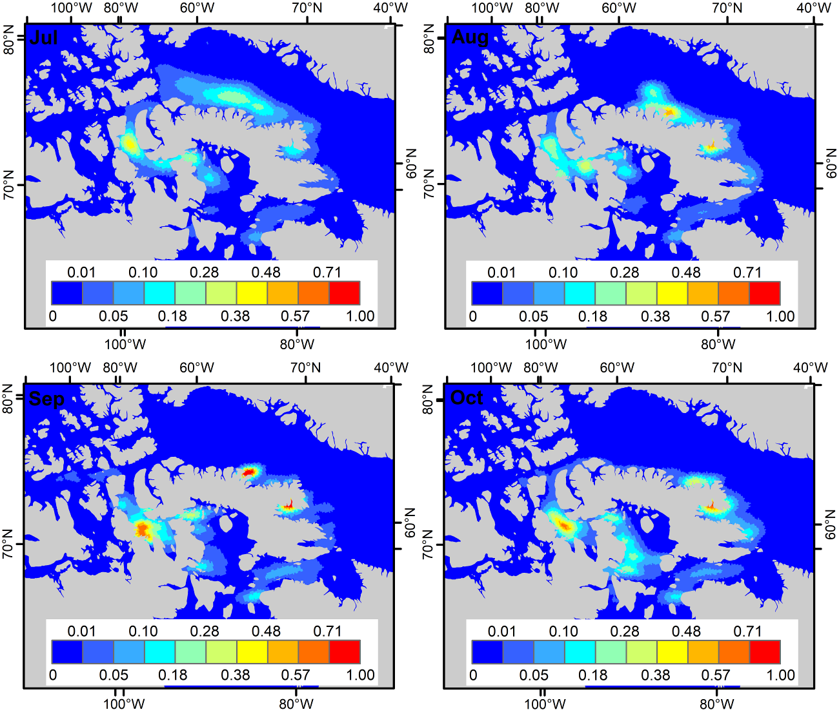

Figure S5. Eastern Canada-West Greenland bowhead whale density from aerial surveys in August 2013. Values are normalized between zero and one by dividing each cell value by the maximum cell value.
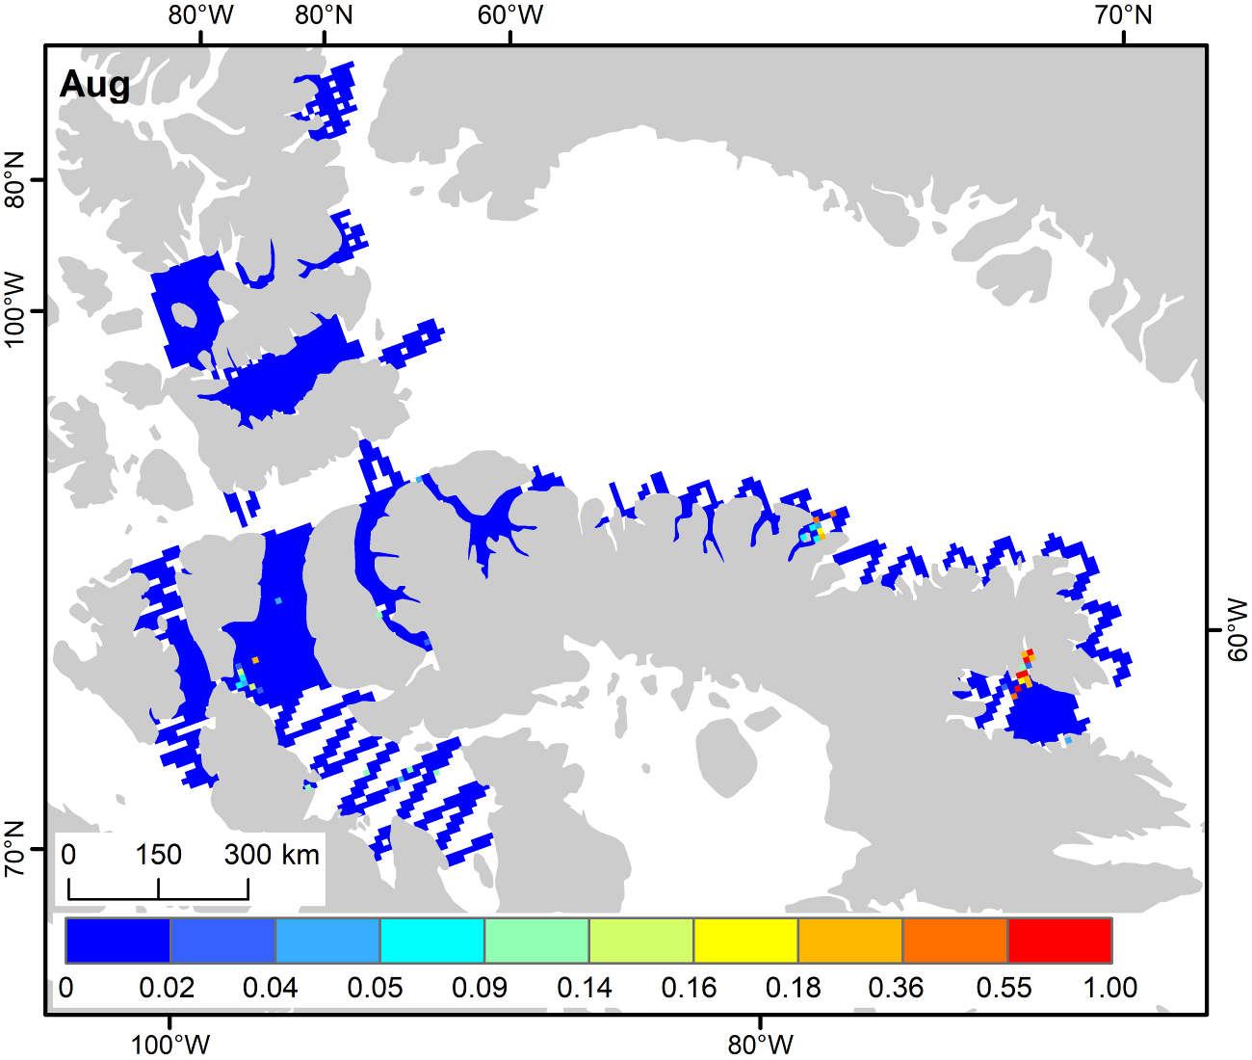

Figure S6. Automatic identification system (AIS) vessel density by month in Bering-Chukchi-Beaufort bowhead whale areas, averaged across 2012-2018. Areas where only a single vessel occurred show up as a single dark blue line. White are areas where no vessels occurred.
Figure S7. Average vessel density within the Bering-Chukchi-Beaufort bowhead whale range (the sum of all cells) by vessel class in four months, averaged across the years 2012-2018.
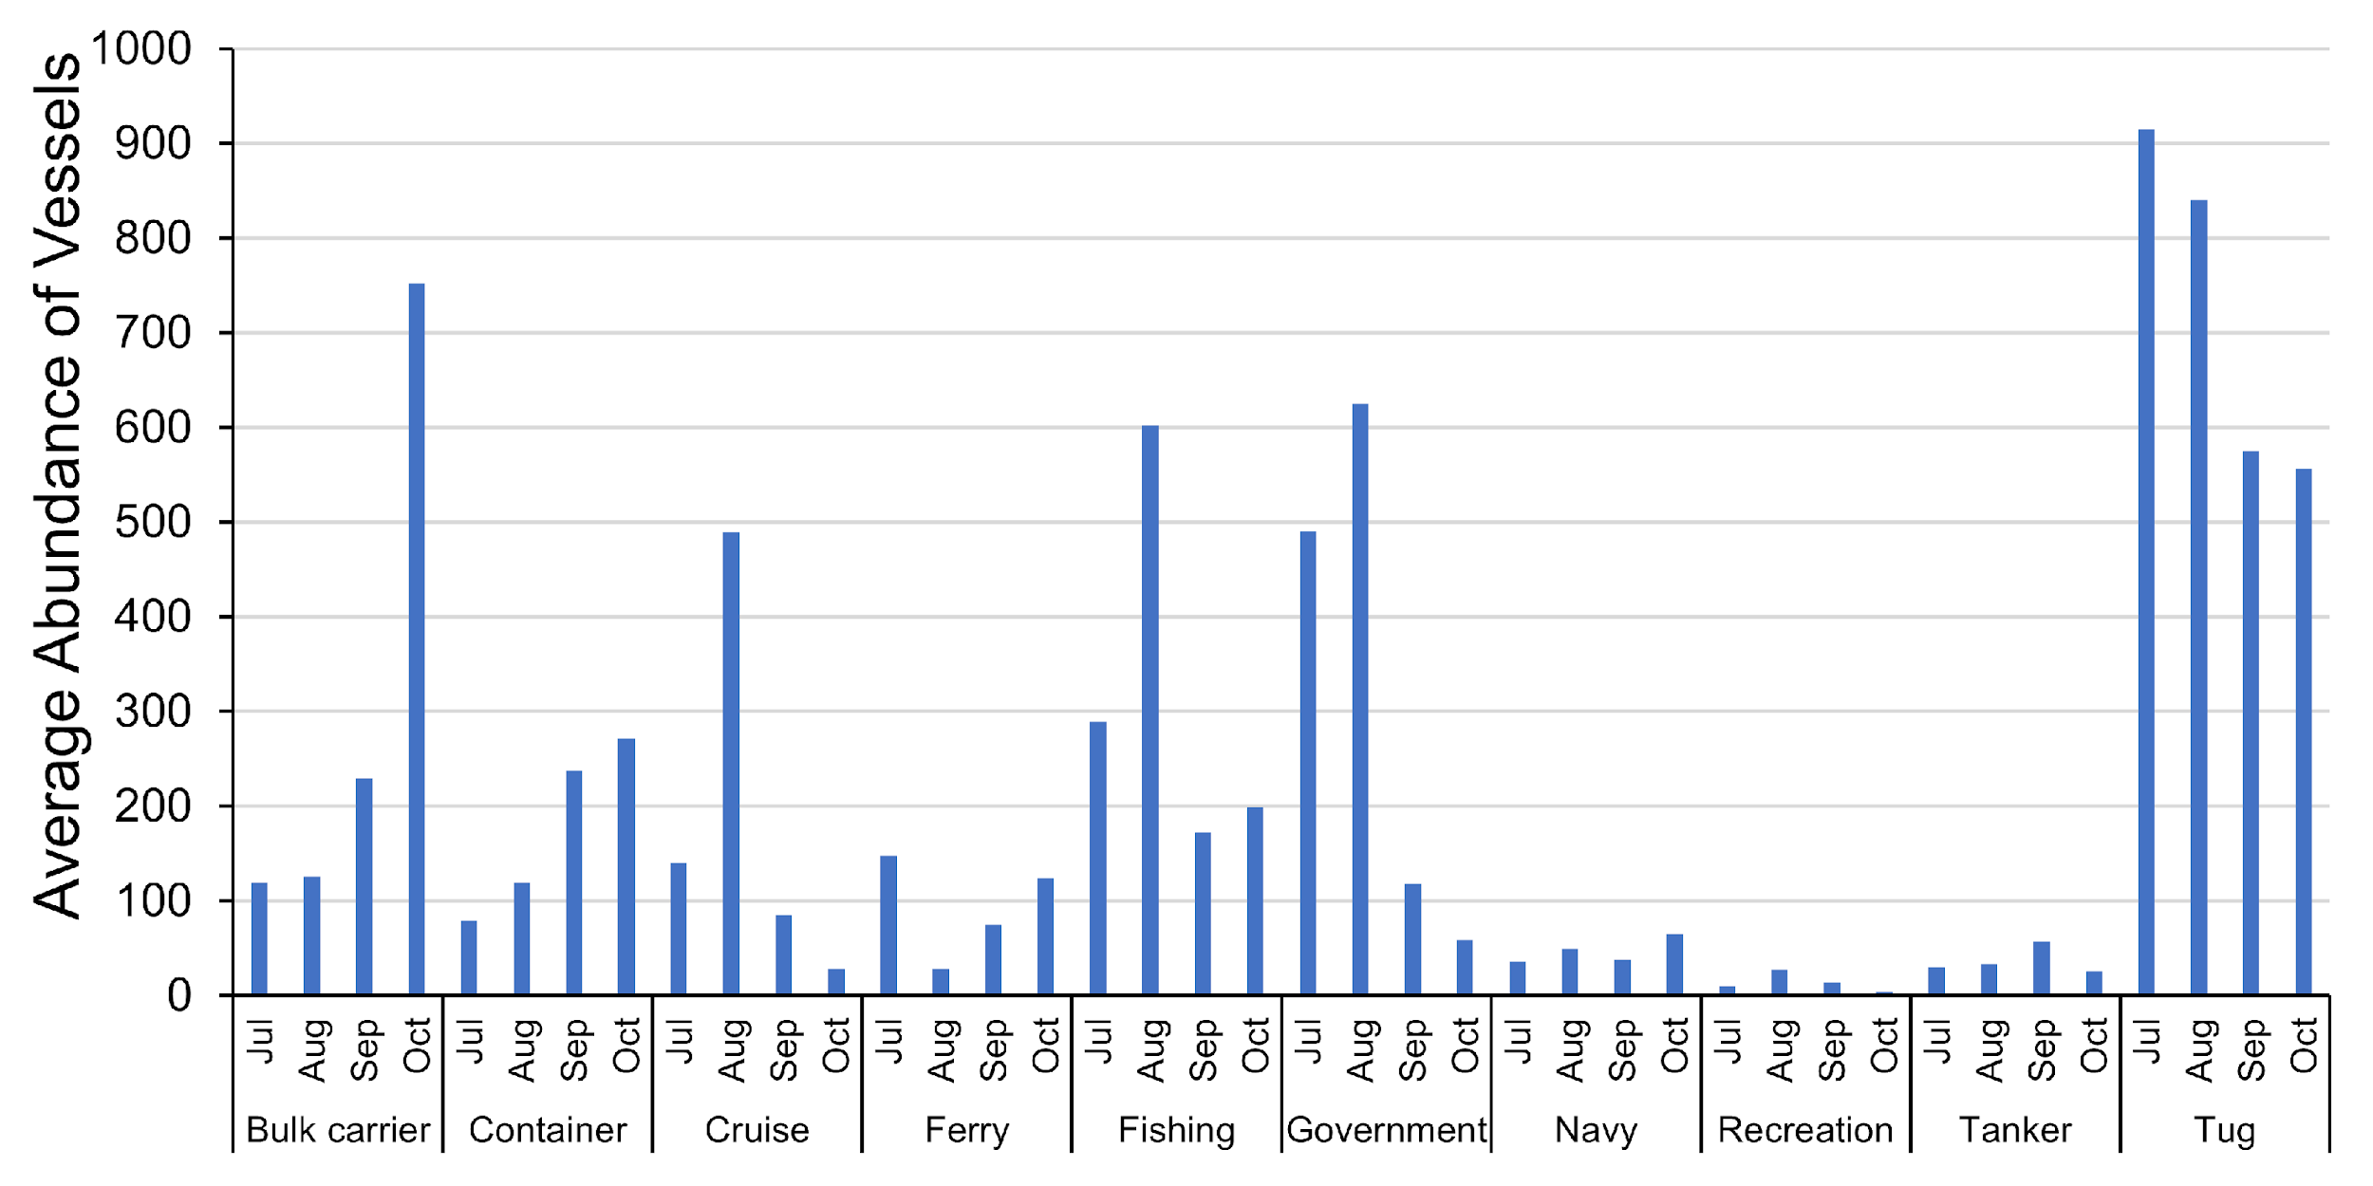

Figure S8. Boxplot of vessel speed by vessel class in four months in Bering-Chukchi-Beaufort bowhead whale range, with data from 2012-2018 pooled together. The underlying data are the average speed per vessel class per month per year in individual 10 × 10 km grid cells.
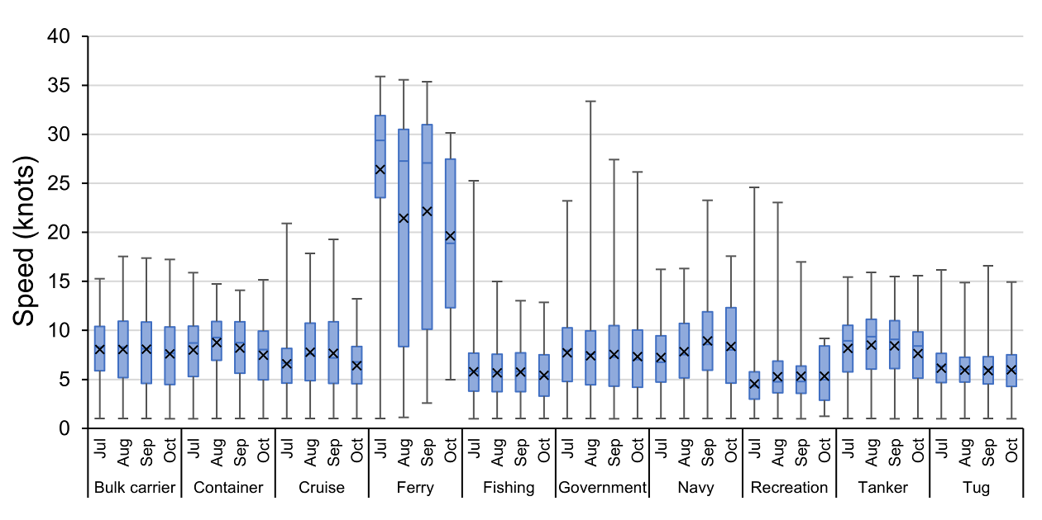

Figure S9. Average vessel density from automatic identification system (AIS) data within the Eastern Canada-West Greenland range (the sum of all cells) by vessel class in four months, averaged across the years 2012-2018. Areas where only a single vessel occurred show up as a single dark blue line. White are areas where no vessels occurred.
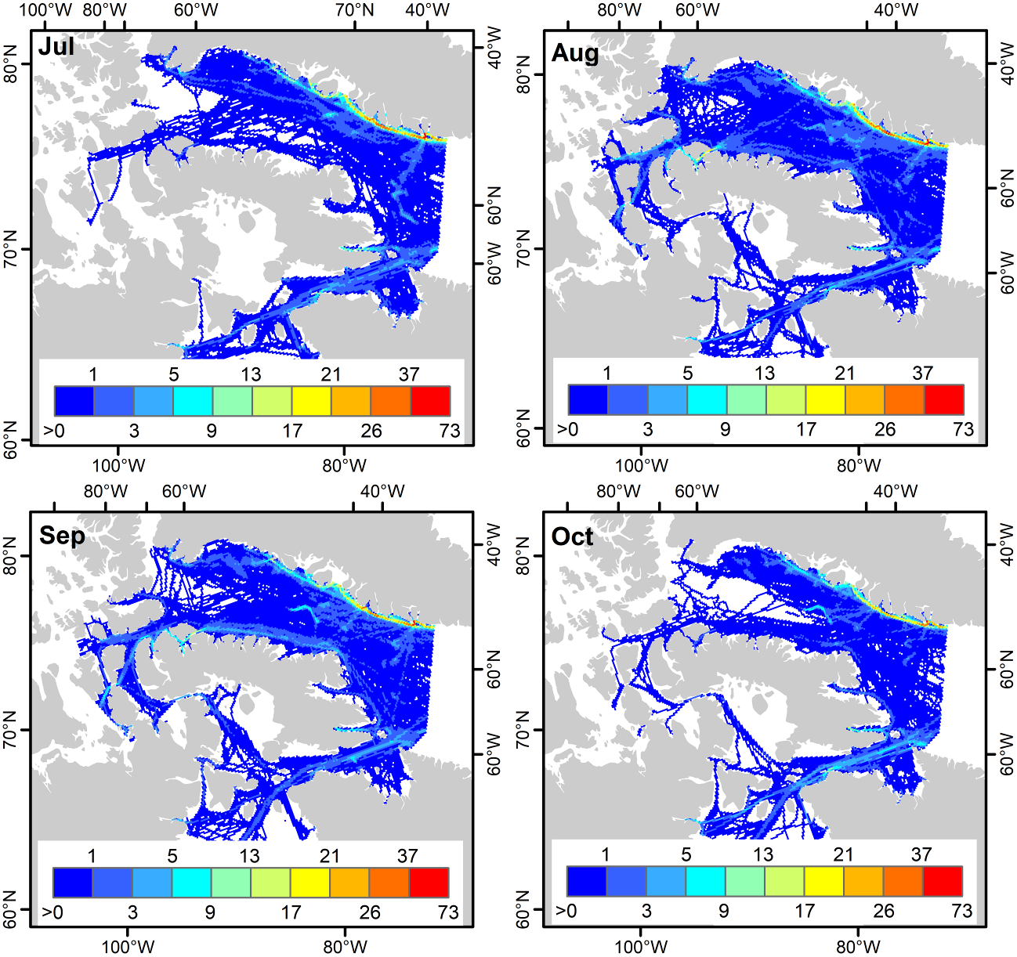

Figure S10. Average vessel density within the range of the Eastern Canada-West Greenland bowhead whale stock in summer (the sum of all cells) by vessel class in four months, averaged across the years 2012-2018.
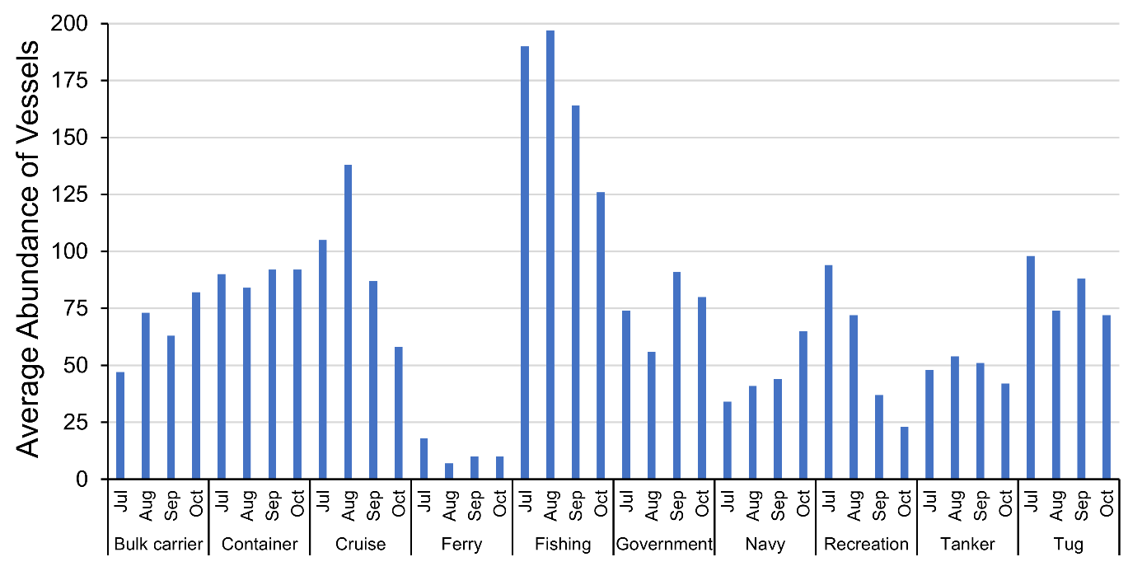

Figure S11. Boxplot of vessel speed by vessel class in four months in Eastern Canada-West Greenland bowhead whale range, with data from 2012-2018 pooled together. The underlying data are the average speed per vessel class per month per year in individual 10 × 10 km grid cells.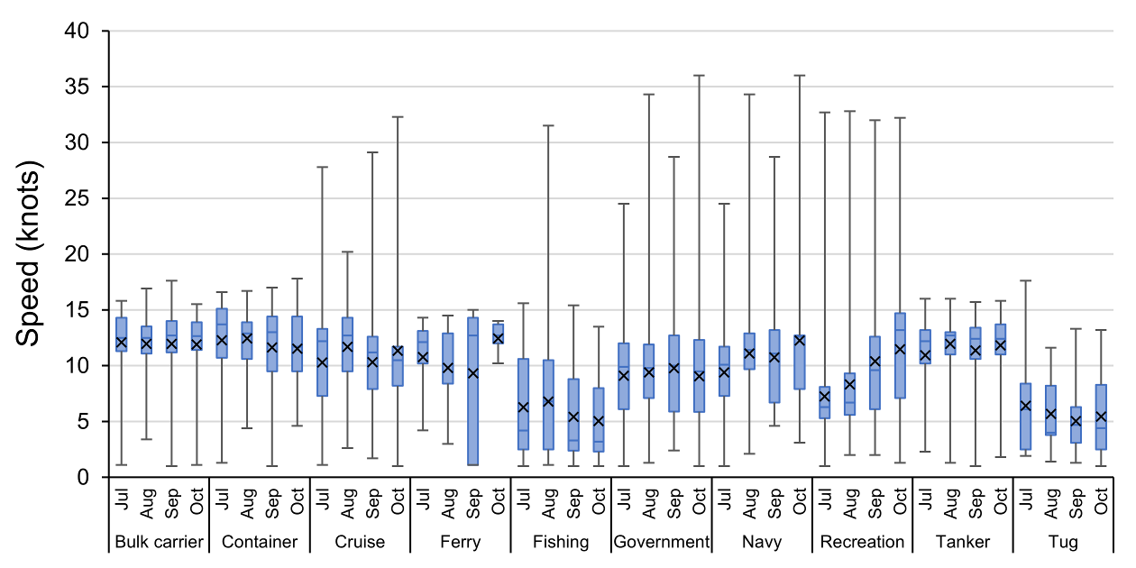

Figure S12. Overlap between vessels and Bering-Chukchi-Beaufort bowhead whales based on telemetry data in July, August, September, and October.

Figure S13. Overlap between vessels and Bering-Chukchi-Beaufort bowhead whales based on aerial survey data in July, August, September, and October.

Figure S14. Overlap between vessels and Eastern Canada-West Greenland bowhead whales based on telemetry data in July, August, September, and October.
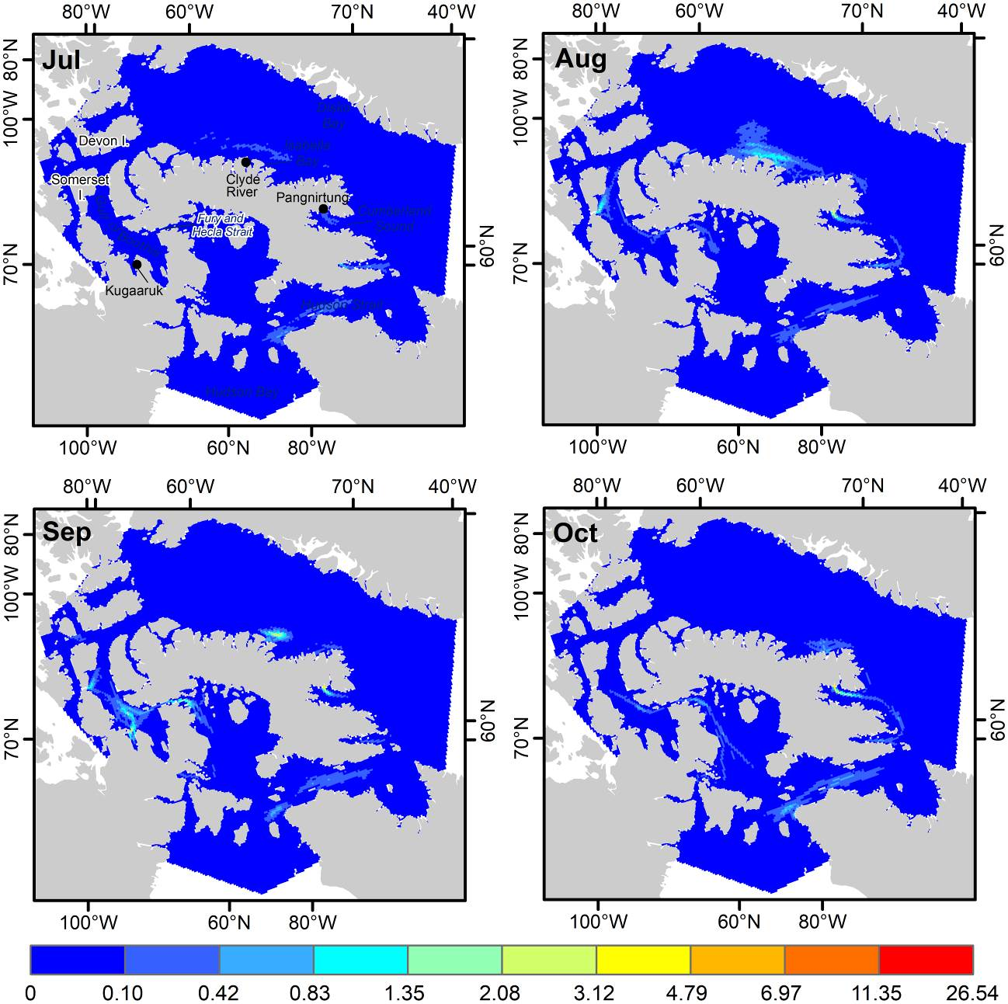

Figure S15. Overlap between vessels and Eastern Canada-West Greenland bowhead whales based on aerial survey data in August.
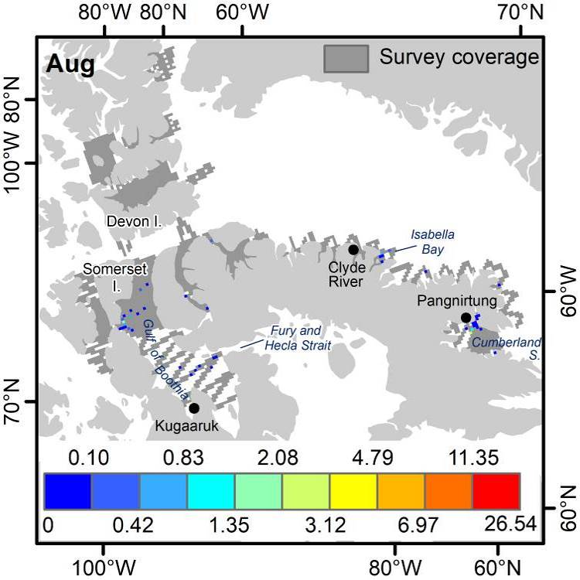

Figure S16. Hypothetical vessel strike risk for Bering-Chukchi-Beaufort bowhead whales based on telemetry data in July, August, September, and October for all vessel classes combined (left), all vessel classes excluding pleasure craft (middle), and for only bulk carriers, container ships, and tanker ships (right).

Figure S17. Hypothetical vessel strike risk for Eastern Canada-West Greenland bowhead whales based on telemetry data in July, August, September, and October for all vessel classes combined (left), all vessel classes excluding pleasure craft (middle), and for bulk carriers, container ships, and tanker ships combined (right).

