Quantifying ecosystem responses to environmental and human pressures in the marine ecosystem off the west coast of Vancouver Island
Authors: Jennifer L. Boldt^{1*}, Elliott L. Hazen², Mary E. Hunsicker³, Caihong Fu¹, R. Ian Perry¹, Xiujuan Shan⁴
^{1*} Corresponding author; Jennifer.Boldt@dfo-mpo.gc.ca; Fisheries and Oceans Canada, Pacific Biological Station, 3190 Hammond Bay Road, Nanaimo, BC, V9T 6N7, Canada
¹Fisheries and Oceans Canada, Pacific Biological Station, 3190 Hammond Bay Road, Nanaimo, BC, V9T 6N7, Canada
²Southwest Fisheries Science Center, NMFS, NOAA, 99 Pacific St., Suite 255A, Monterey, CA, U.S.A. 93940
³Northwest Fisheries Science Center, NMFS, NOAA, Hatfield Marine Science Center, 2032 S. OSU Dr., Newport, OR, U.S.A. 97365
⁴Yellow Sea Fisheries Research Institute, CAFS, 106 Nanjing Rd., Shinan District, Qingdao, Shandong, People's Republic of China 266071

Appendix A
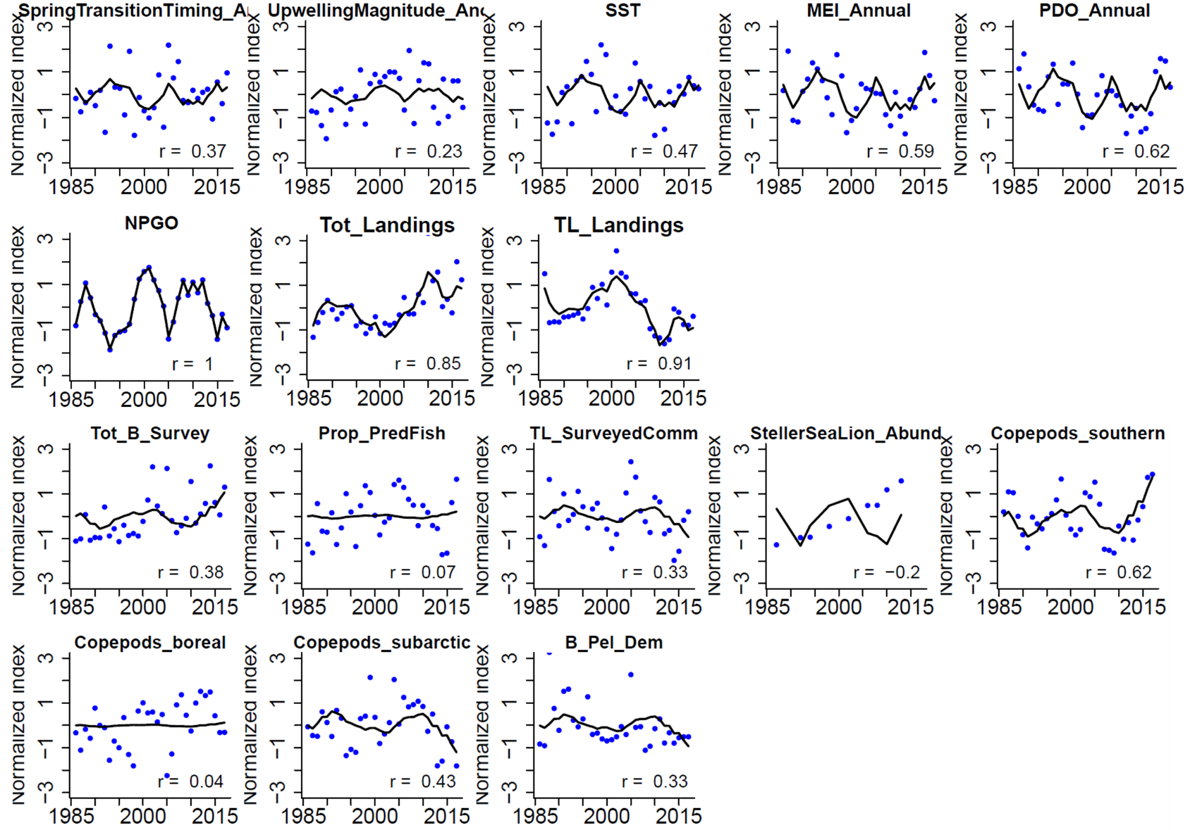
Figure A1. Model fits to the three separate DFA analyses on environment pressures (top row and left panel of second row), human pressures (second row; Tot_Landings and TL_Landings), ecosystem responses (bottom two rows). R-values are shown for model fits to observations. See Table 1 for definitions.

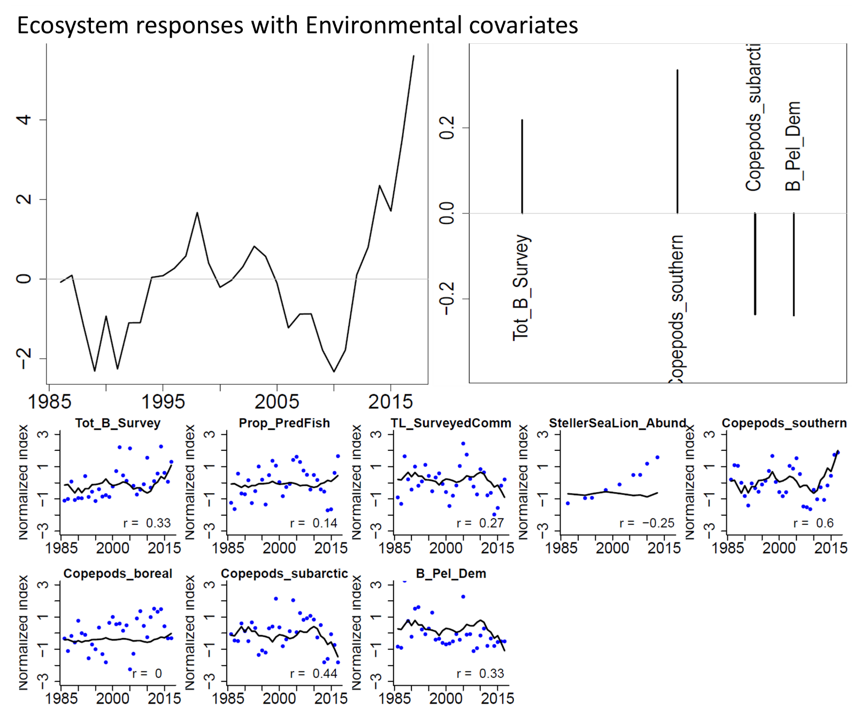
Figure A2. Results from a DFA on ecosystem responses with environment pressure covariates. The trend (top left), factor loadings on the trends (top right), and model fits (bottom two rows) are shown. R-values are shown for model fits to observations. See Table 1 for definitions.
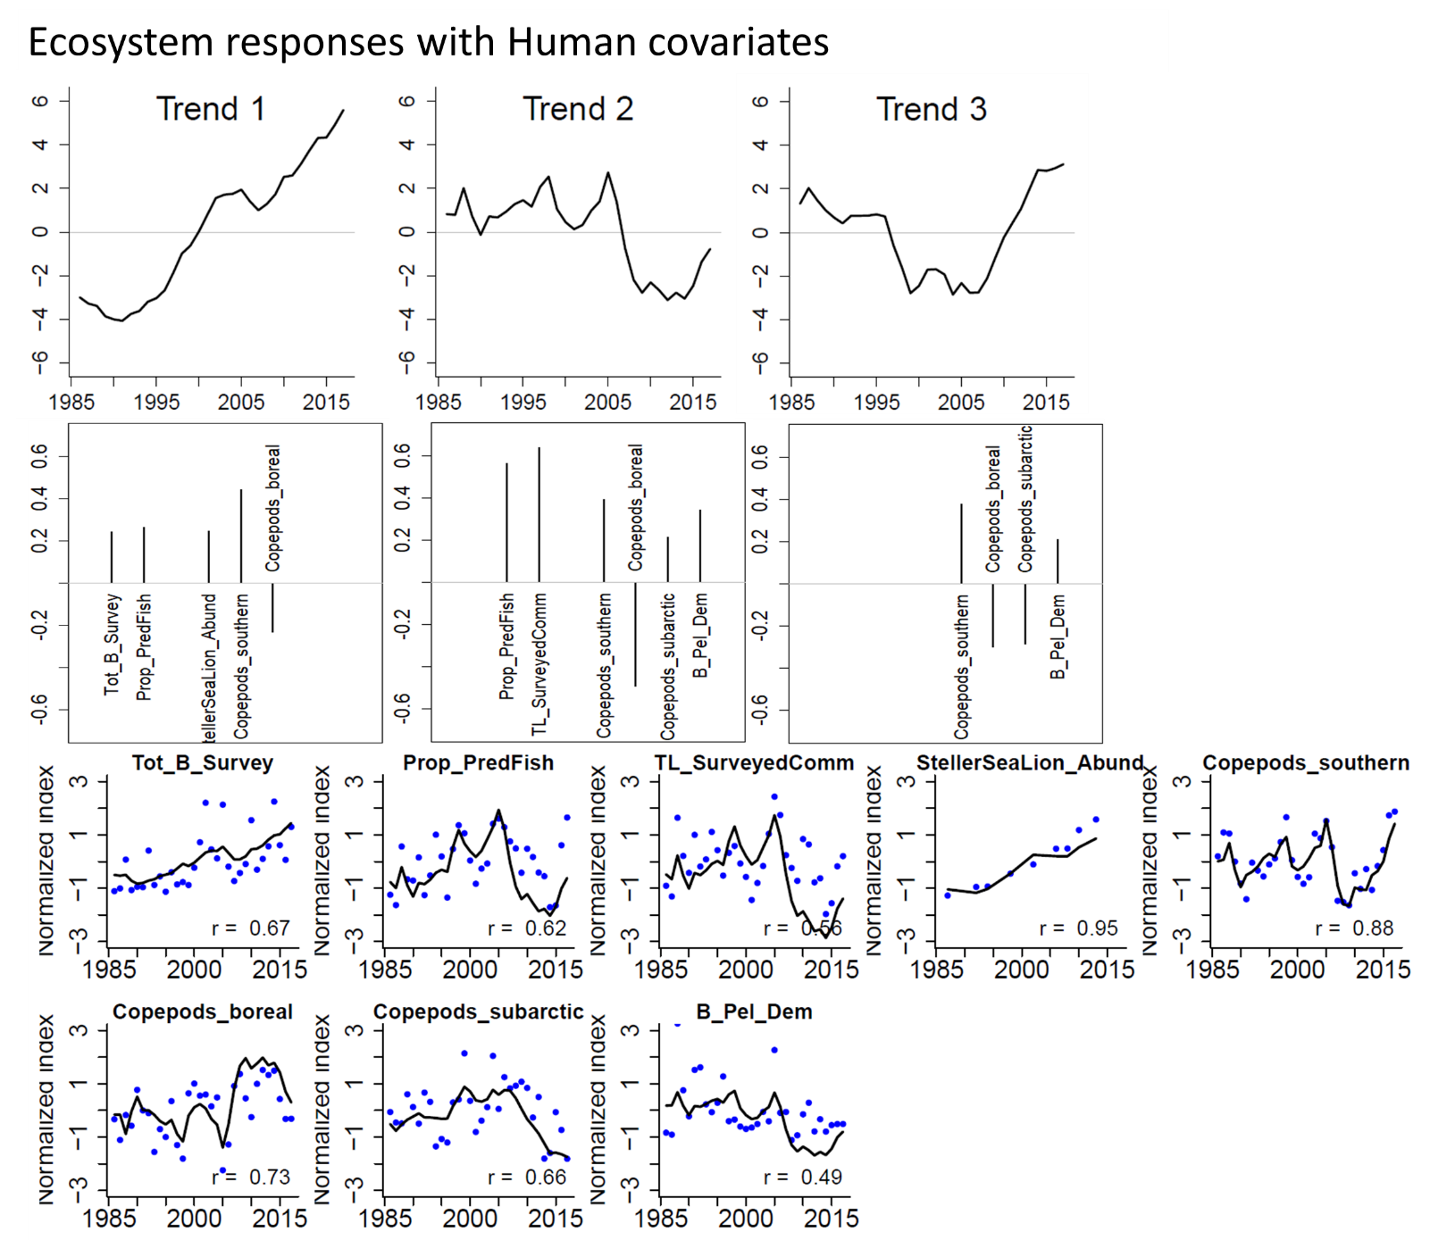
Figure A3. Results from a DFA on ecosystem responses with human pressure covariates. The trends (top row), factor loadings on those trends (second row), and model fits (bottom two rows) are shown. R-values are shown for model fits to observations. See Table 1 for definitions.
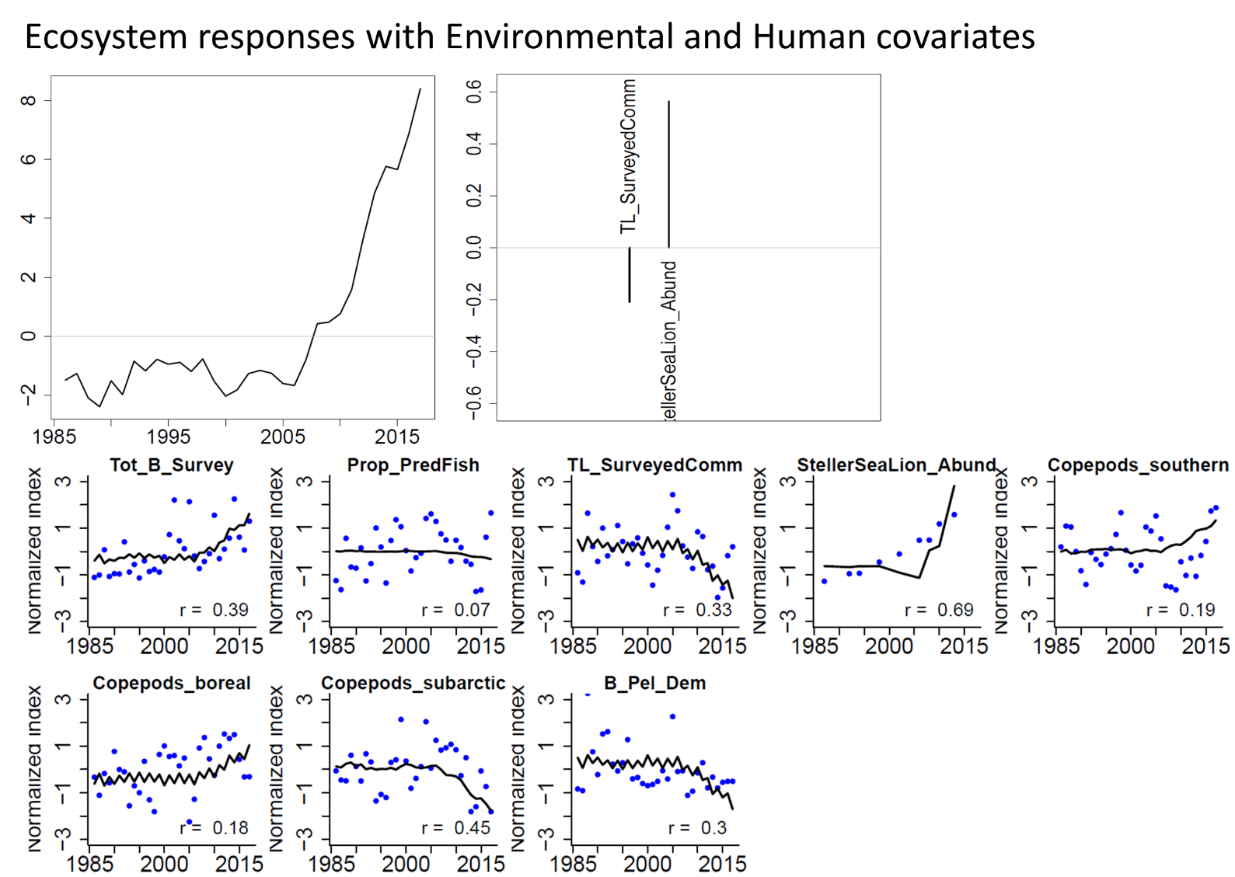
Figure A4. Results from a DFA on ecosystem responses with both environment and human pressure covariates. The trend (top left), factor loadings on the trends (top right), and model fits (bottom two rows) are shown. R-values are shown for model fits to observations. See Table 1 for definitions.

Table A1. All single pressure-response models (see Table 1 for acronyms). GAMM = general additive mixed models; LMAC = linear with autocorrelation; GAM = general additive model (GAM); AICc = Akaike’s Information Criterion (corrected for small sample size); logLik = log-likelihood ratio test to compare GAMMs (with autocorrelated error structure) vs GAMs (with normal error structure) with a p.ac value < 0.05 indicating temporal autocorrelation existed and model evaluation was carried out on GAMM vs LMAC; dev.expl = deviance explained, edf = estimated degrees of freedom; GCV = generalized cross validation score; diff.dev.expl = difference in deviance explained between GAMM and LMAC or between GAM and linear models. As in Samhouri et al. (2017), supportive evidence for nonlinear models (vs. linear models) was based on these criteria: i) edf ≥2 (Zuur et al. 2009), ii) delta.AICc values ≥2 (Burnham and Anderson 2002), and iii) for GAMs vs. linear models, a lower GCV (Wood 2004). Models in bold font were significant (p < 0.05) with R² > 0.2.
Model | Response | Pressure | AICc | logLik | dev.expl | edf | Pvalue | R² | GCV | p.ac | diff.dev.expl
GAMM | B_Pel_Dem | PDO_Annual | 67.977 | -28.989 | 0.211 | 2.189 | 0.127 | 0.151 | NA | 0.838 | 0.205
LMAC | B_Pel_Dem | PDO_Annual | 69.638 | -29.819 | 0.006 | 30.000 | 0.814 | -0.027 | NA | NA | NA
GAM | B_Pel_Dem | PDO_Annual | 63.312 | -26.747 | 0.201 | 1.756 | 0.043 | 0.153 | 0.373 | NA | 0.193
Linear | B_Pel_Dem | PDO_Annual | 66.845 | -30.215 | 0.007 | 30.000 | 0.642 | -0.026 | 0.440 | NA | NA
GAMM | log(B_Pel_Dem+1) | log(MEI_Annual+1) | 18.946 | -4.473 | -0.022 | 1.000 | 0.214 | -0.056 | NA | 0.373 | 0.000
LMAC | log(B_Pel_Dem+1) | log(MEI_Annual+1) | 18.946 | -4.473 | -0.022 | 30.000 | 0.221 | -0.056 | NA | NA | NA
GAM | log(B_Pel_Dem+1) | log(MEI_Annual+1) | 18.538 | -6.115 | 0.000 | 0.000 | 0.838 | 0.000 | 0.091 | NA | -0.004
Linear | log(B_Pel_Dem+1) | log(MEI_Annual+1) | 18.529 | -6.057 | 0.004 | 30.000 | 0.744 | -0.030 | 0.097 | NA | NA
GAMM | log(B_Pel_Dem+1) | log(NPGO+1) | 15.102 | -2.551 | 0.053 | 1.000 | 0.261 | 0.013 | NA | 0.824 | 0.000
LMAC | log(B_Pel_Dem+1) | log(NPGO+1) | 15.102 | -2.551 | 0.053 | 24.000 | 0.270 | 0.013 | NA | NA | NA
GAM | log(B_Pel_Dem+1) | log(NPGO+1) | 13.756 | -3.124 | 0.023 | 0.254 | 0.258 | 0.013 | 0.082 | NA | -0.029
Linear | log(B_Pel_Dem+1) | log(NPGO+1) | 11.974 | -2.726 | 0.053 | 24.000 | 0.258 | 0.013 | 0.085 | NA | NA
GAMM | log(B_Pel_Dem+1) | log(SpringTransitionTiming_Anom+1) | 19.413 | -4.707 | 0.028 | 1.000 | 0.370 | -0.004 | NA | 0.380 | 0.000
LMAC | log(B_Pel_Dem+1) | log(SpringTransitionTiming_Anom+1) | 19.413 | -4.707 | 0.028 | 30.000 | 0.378 | -0.004 | NA | NA | NA
GAM | log(B_Pel_Dem+1) | log(SpringTransitionTiming_Anom+1) | 18.491 | -5.852 | 0.016 | 0.239 | 0.324 | 0.009 | 0.091 | NA | -0.013
Linear | log(B_Pel_Dem+1) | log(SpringTransitionTiming_Anom+1) | 17.682 | -5.634 | 0.030 | 30.000 | 0.346 | -0.003 | 0.095 | NA | NA
GAMM | log(B_Pel_Dem+1) | log(SST+1) | 20.252 | -5.126 | 0.001 | 1.000 | 0.947 | -0.032 | NA | 0.373 | 0.000
LMAC | log(B_Pel_Dem+1) | log(SST+1) | 20.252 | -5.126 | 0.001 | 30.000 | 0.948 | -0.032 | NA | NA | NA
GAM | log(B_Pel_Dem+1) | log(SST+1) | 18.538 | -6.115 | 0.000 | 0.000 | 0.684 | 0.000 | 0.091 | NA | -0.006
Linear | log(B_Pel_Dem+1) | log(SST+1) | 18.463 | -6.025 | 0.006 | 30.000 | 0.683 | -0.028 | 0.097 | NA | NA
GAMM | log(B_Pel_Dem+1) | log(TL_Landings+1) | 20.252 | -5.126 | -0.002 | 1.000 | 0.947 | -0.035 | NA | 0.373 | 0.000
Model | Response | Pressure | AICc | logLik | dev.expl | edf | Pvalue | R2 | GCV | p.ac | diff.dev.expl
LMAC | log(B_Pel_Dem+1) | log(TL_Landings+1) | 20.252 | -5.126 | -0.002 | 30.000 | 0.948 | -0.035 | NA | NA | NA
GAM | log(B_Pel_Dem+1) | log(TL_Landings+1) | 18.538 | -6.115 | 0.000 | 0.000 | 0.510 | 0.000 | 0.091 | NA | -0.002
Linear | log(B_Pel_Dem+1) | log(TL_Landings+1) | 18.572 | -6.079 | 0.002 | 30.000 | 0.797 | -0.031 | 0.097 | NA | NA
GAMM | log(B_Pel_Dem+1) | log(Tot_Landings+1) | 20.252 | -5.126 | -0.002 | 1.000 | 0.947 | -0.035 | NA | 0.373 | 0.000
LMAC | log(B_Pel_Dem+1) | log(Tot_Landings+1) | 20.252 | -5.126 | -0.002 | 30.000 | 0.948 | -0.035 | NA | NA | NA
GAM | log(B_Pel_Dem+1) | log(Tot_Landings+1) | 18.538 | -6.115 | 0.000 | 0.000 | 0.510 | 0.000 | 0.091 | NA | -0.002
Linear | log(B_Pel_Dem+1) | log(Tot_Landings+1) | 18.572 | -6.079 | 0.002 | 30.000 | 0.797 | -0.031 | 0.097 | NA | NA
GAMM | log(B_Pel_Dem+1) | log(UpwellingMagnitude_Anom+1) | 10.783 | -0.392 | -0.001 | 1.000 | 0.904 | -0.042 | NA | 0.447 | 0.000
LMAC | log(B_Pel_Dem+1) | log(UpwellingMagnitude_Anom+1) | 10.783 | -0.392 | -0.001 | 24.000 | 0.906 | -0.042 | NA | NA | NA
GAM | log(B_Pel_Dem+1) | log(UpwellingMagnitude_Anom+1) | 11.875 | 0.167 | 0.204 | 2.604 | 0.159 | 0.111 | 0.078 | NA | 0.204
Linear | log(B_Pel_Dem+1) | log(UpwellingMagnitude_Anom+1) | 12.104 | -2.791 | 0.000 | 24.000 | 0.984 | -0.042 | 0.085 | NA | NA
Linear | Copepods_boreal | MEI_Annual | -1.443 | 3.928 | 0.203 | 30.000 | 0.010 | 0.176 | 0.052 | NA | NA
GAMM | Copepods_boreal | MEI_Annual | -2.679 | 6.340 | 0.201 | 1.000 | 0.012 | 0.174 | NA | 0.084 | 0.000
LMAC | Copepods_boreal | MEI_Annual | -2.679 | 6.340 | 0.201 | 30.000 | 0.014 | 0.174 | NA | NA | NA
GAM | Copepods_boreal | MEI_Annual | 0.328 | 3.859 | 0.199 | 0.869 | 0.010 | 0.176 | 0.052 | NA | -0.003
Linear | Copepods_boreal | NPGO | -4.495 | 5.455 | 0.275 | 30.000 | 0.002 | 0.251 | 0.047 | NA | NA
GAMM | Copepods_boreal | NPGO | -3.980 | 6.990 | 0.275 | 1.000 | 0.005 | 0.251 | NA | 0.217 | 0.000
LMAC | Copepods_boreal | NPGO | -3.980 | 6.990 | 0.275 | 30.000 | 0.006 | 0.251 | NA | NA | NA
GAM | Copepods_boreal | NPGO | -2.683 | 5.408 | 0.273 | 0.912 | 0.002 | 0.251 | 0.047 | NA | -0.002
Linear | Copepods_boreal | PDO_Annual | -3.518 | 4.966 | 0.253 | 30.000 | 0.003 | 0.228 | 0.049 | NA | NA
GAMM | Copepods_boreal | PDO_Annual | -4.203 | 7.101 | 0.253 | 1.000 | 0.005 | 0.228 | NA | 0.534 | 0.000
LMAC | Copepods_boreal | PDO_Annual | -4.203 | 7.101 | 0.253 | 30.000 | 0.006 | 0.228 | NA | NA | NA
GAM | Copepods_boreal | PDO_Annual | -4.410 | 8.835 | 0.413 | 3.476 | 0.003 | 0.339 | 0.046 | NA | 0.160
GAM | Copepods_boreal | SpringTransitionTiming_Anom | -4.971 | 8.294 | 0.393 | 2.654 | 0.002 | 0.336 | 0.044 | NA | 0.262
GAMM | Copepods_boreal | SpringTransitionTiming_Anom | -2.033 | 6.017 | 0.319 | 2.318 | 0.018 | 0.264 | NA | 0.070 | 0.194
LMAC | Copepods_boreal | SpringTransitionTiming_Anom | -0.978 | 5.489 | 0.125 | 30.000 | 0.035 | 0.096 | NA | NA | NA
Linear | Copepods_boreal | SpringTransitionTiming_Anom | 1.310 | 2.552 | 0.131 | 30.000 | 0.042 | 0.102 | 0.057 | NA | NA
GAMM | Copepods_boreal | SST | 1.853 | 4.073 | 0.098 | 1.000 | 0.159 | 0.068 | NA | 0.320 | 0.000
LMAC | Copepods_boreal | SST | 1.853 | 4.073 | 0.098 | 30.000 | 0.166 | 0.068 | NA | NA | NA
GAM | Copepods_boreal | SST | 0.647 | 4.522 | 0.232 | 1.691 | 0.020 | 0.188 | 0.053 | NA | 0.126
Linear | Copepods_boreal | SST | 2.231 | 2.091 | 0.106 | 30.000 | 0.069 | 0.076 | 0.058 | NA | NA
GAMM | Copepods_boreal | TL_Landings | 3.776 | 3.112 | 0.009 | 1.000 | 0.777 | -0.023 | NA | 0.229 | 0.000
LMAC | Copepods_boreal | TL_Landings | 3.776 | 3.112 | 0.009 | 30.000 | 0.781 | -0.023 | NA | NA | NA
GAM | Copepods_boreal | TL_Landings | 4.757 | 2.151 | 0.109 | 1.376 | 0.169 | 0.068 | 0.060 | NA | 0.097
Linear | Copepods_boreal | TL_Landings | 5.424 | 0.495 | 0.012 | 30.000 | 0.550 | -0.021 | 0.065 | NA | NA
GAMM | Copepods_boreal | Tot_Landings | 3.807 | 3.096 | -0.015 | 1.000 | 0.809 | -0.049 | NA | 0.063 | 0.000
LMAC | Copepods_boreal | Tot_Landings | 3.807 | 3.096 | -0.015 | 30.000 | 0.812 | -0.049 | NA | NA | NA
GAM | Copepods_boreal | Tot_Landings | 5.705 | 0.301 | 0.000 | 0.000 | 0.402 | 0.000 | 0.061 | NA | -0.020
Linear | Copepods_boreal | Tot_Landings | 5.181 | 0.616 | 0.020 | 30.000 | 0.446 | -0.013 | 0.064 | NA | NA
GAMM | Copepods_boreal | UpwellingMagnitude_Anom | 3.513 | 3.243 | 0.019 | 1.000 | 0.565 | -0.014 | NA | 0.064 | 0.000
Model | Response | Pressure | AICc | logLik | dev.expl | edf | Pvalue | R2 | GCV | p.ac | diff.dev.expl
LMAC | Copepods_boreal | UpwellingMagnitude_Anom | 3.513 | 3.243 | 0.019 | 30.000 | 0.571 | -0.014 | NA | NA | NA
GAM | Copepods_boreal | UpwellingMagnitude_Anom | 5.687 | 0.420 | 0.007 | 0.110 | 0.313 | 0.004 | 0.061 | NA | -0.014
Linear | Copepods_boreal | UpwellingMagnitude_Anom | 5.106 | 0.654 | 0.022 | 30.000 | 0.420 | -0.011 | 0.064 | NA | NA
GAMM | Copepods_southern | MEI_Annual | -25.588 | 17.794 | 0.089 | 1.000 | 0.168 | 0.067 | NA | 0.003 | 0.000
LMAC | Copepods_southern | MEI_Annual | -25.588 | 17.794 | 0.089 | 30.000 | 0.174 | 0.067 | NA | NA | NA
GAM | Copepods_southern | MEI_Annual | -15.912 | 11.867 | 0.114 | 0.757 | 0.051 | 0.092 | 0.031 | NA | -0.007
Linear | Copepods_southern | MEI_Annual | -17.579 | 11.996 | 0.121 | 30.000 | 0.051 | 0.092 | 0.031 | NA | NA
GAMM | Copepods_southern | NPGO | -24.140 | 17.070 | 0.056 | 1.000 | 0.456 | 0.030 | NA | 0.002 | 0.000
LMAC | Copepods_southern | NPGO | -24.140 | 17.070 | 0.056 | 30.000 | 0.464 | 0.030 | NA | NA | NA
GAM | Copepods_southern | NPGO | -14.506 | 11.008 | 0.065 | 0.601 | 0.124 | 0.046 | 0.033 | NA | -0.012
Linear | Copepods_southern | NPGO | -16.024 | 11.219 | 0.077 | 30.000 | 0.124 | 0.046 | 0.033 | NA | NA
GAM | Copepods_southern | PDO_Annual | -35.409 | 23.736 | 0.578 | 2.877 | 0.000 | 0.535 | 0.017 | NA | 0.197
GAMM | Copepods_southern | PDO_Annual | -31.464 | 20.732 | 0.475 | 2.776 | 0.006 | 0.425 | NA | 0.069 | 0.111
LMAC | Copepods_southern | PDO_Annual | -32.235 | 21.118 | 0.364 | 30.000 | 0.003 | 0.344 | NA | NA | NA
Linear | Copepods_southern | PDO_Annual | -28.781 | 17.597 | 0.381 | 30.000 | 0.000 | 0.360 | 0.022 | NA | NA
GAMM | Copepods_southern | SpringTransitionTiming_Anom | -23.671 | 16.835 | -0.013 | 1.000 | 0.798 | -0.037 | NA | 0.001 | 0.000
LMAC | Copepods_southern | SpringTransitionTiming_Anom | -23.671 | 16.835 | -0.013 | 30.000 | 0.802 | -0.037 | NA | NA | NA
GAM | Copepods_southern | SpringTransitionTiming_Anom | -14.214 | 11.338 | 0.084 | 1.077 | 0.203 | 0.051 | 0.033 | NA | 0.082
Linear | Copepods_southern | SpringTransitionTiming_Anom | -13.530 | 9.972 | 0.002 | 30.000 | 0.796 | -0.031 | 0.036 | NA | NA
GAMM | Copepods_southern | SST | -24.751 | 17.376 | 0.039 | 1.000 | 0.529 | 0.015 | NA | 0.005 | 0.000
LMAC | Copepods_southern | SST | -24.751 | 17.376 | 0.039 | 30.000 | 0.536 | 0.015 | NA | NA | NA
GAM | Copepods_southern | SST | -16.057 | 11.843 | 0.079 | 0.660 | 0.096 | 0.059 | 0.031 | NA | -0.010
Linear | Copepods_southern | SST | -17.632 | 12.023 | 0.089 | 30.000 | 0.096 | 0.059 | 0.031 | NA | NA
GAMM | Copepods_southern | TL_Landings | -23.700 | 16.850 | -0.036 | 1.000 | 0.750 | -0.059 | NA | 0.006 | 0.000
LMAC | Copepods_southern | TL_Landings | -23.700 | 16.850 | -0.036 | 30.000 | 0.754 | -0.059 | NA | NA | NA
GAM | Copepods_southern | TL_Landings | -14.448 | 11.596 | 0.099 | 1.218 | 0.170 | 0.062 | 0.033 | NA | 0.074
Linear | Copepods_southern | TL_Landings | -14.239 | 10.326 | 0.024 | 30.000 | 0.396 | -0.008 | 0.035 | NA | NA
LMAC | Copepods_southern | Tot_Landings | -27.618 | 18.809 | -0.126 | 30.000 | 0.044 | -0.144 | NA | NA | NA
GAMM | Copepods_southern | Tot_Landings | -27.618 | 18.809 | -0.126 | 1.000 | 0.040 | -0.144 | NA | 0.001 | 0.000
GAM | Copepods_southern | Tot_Landings | -13.563 | 9.936 | 0.000 | 0.000 | 0.794 | 0.000 | 0.034 | NA | 0.000
Linear | Copepods_southern | Tot_Landings | -13.457 | 9.936 | 0.000 | 30.000 | 0.990 | -0.033 | 0.036 | NA | NA
GAMM | Copepods_southern | UpwellingMagnitude_Anom | -23.603 | 16.802 | -0.009 | 1.000 | 0.995 | -0.033 | NA | 0.001 | 0.000
LMAC | Copepods_southern | UpwellingMagnitude_Anom | -23.603 | 16.802 | -0.009 | 30.000 | 0.995 | -0.033 | NA | NA | NA
GAM | Copepods_southern | UpwellingMagnitude_Anom | -13.563 | 9.936 | 0.000 | 0.000 | 0.777 | 0.000 | 0.034 | NA | -0.006
Linear | Copepods_southern | UpwellingMagnitude_Anom | -13.659 | 10.036 | 0.006 | 30.000 | 0.667 | -0.027 | 0.036 | NA | NA
GAMM | Copepods_subarctic | MEI_Annual | -35.337 | 22.668 | -0.015 | 1.000 | 0.798 | -0.047 | NA | 0.104 | 0.000
LMAC | Copepods_subarctic | MEI_Annual | -35.337 | 22.668 | -0.015 | 30.000 | 0.801 | -0.047 | NA | NA | NA
GAM | Copepods_subarctic | MEI_Annual | -34.447 | 20.378 | 0.000 | 0.000 | 0.526 | 0.000 | 0.017 | NA | -0.016
Linear | Copepods_subarctic | MEI_Annual | -34.872 | 20.643 | 0.016 | 30.000 | 0.484 | -0.016 | 0.018 | NA | NA
GAMM | Copepods_subarctic | NPGO | -36.756 | 23.378 | 0.079 | 1.000 | 0.221 | 0.049 | NA | 0.180 | 0.000
Model | Response | Pressure | AICc | logLik | dev.expl | edf | Pvalue | R2 | GCV | p.ac | diff.dev.expl
LMAC | Copepods_subarctic | NPGO | -36.756 | 23.378 | 0.079 | 30.000 | 0.228 | 0.049 | NA | NA | NA
GAM | Copepods_subarctic | NPGO | -35.778 | 21.805 | 0.085 | 0.762 | 0.101 | 0.062 | 0.017 | NA | 0.005
Linear | Copepods_subarctic | NPGO | -37.022 | 21.718 | 0.080 | 30.000 | 0.116 | 0.050 | 0.017 | NA | NA
GAMM | Copepods_subarctic | PDO_Annual | -35.625 | 22.812 | 0.052 | 1.000 | 0.505 | 0.021 | NA | 0.226 | 0.000
LMAC | Copepods_subarctic | PDO_Annual | -35.625 | 22.812 | 0.052 | 30.000 | 0.512 | 0.021 | NA | NA | NA
GAM | Copepods_subarctic | PDO_Annual | -35.210 | 21.322 | 0.057 | 0.563 | 0.141 | 0.040 | 0.017 | NA | -0.014
Linear | Copepods_subarctic | PDO_Annual | -36.692 | 21.553 | 0.071 | 30.000 | 0.141 | 0.040 | 0.017 | NA | NA
GAMM | Copepods_subarctic | SpringTransitionTiming_Anom | -35.358 | 22.679 | -0.002 | 1.000 | 0.782 | -0.034 | NA | 0.104 | 0.000
LMAC | Copepods_subarctic | SpringTransitionTiming_Anom | -35.358 | 22.679 | -0.002 | 30.000 | 0.786 | -0.034 | NA | NA | NA
GAM | Copepods_subarctic | SpringTransitionTiming_Anom | -34.447 | 20.378 | 0.000 | 0.000 | 0.769 | 0.000 | 0.017 | NA | 0.000
Linear | Copepods_subarctic | SpringTransitionTiming_Anom | -34.348 | 20.381 | 0.000 | 30.000 | 0.938 | -0.033 | 0.019 | NA | NA
GAMM | Copepods_subarctic | SST | -35.388 | 22.694 | -0.005 | 1.000 | 0.744 | -0.038 | NA | 0.104 | 0.000
LMAC | Copepods_subarctic | SST | -35.388 | 22.694 | -0.005 | 30.000 | 0.748 | -0.038 | NA | NA | NA
GAM | Copepods_subarctic | SST | -34.447 | 20.378 | 0.000 | 0.000 | 0.935 | 0.000 | 0.017 | NA | 0.000
Linear | Copepods_subarctic | SST | -34.343 | 20.378 | 0.000 | 30.000 | 0.969 | -0.033 | 0.019 | NA | NA
GAMM | Copepods_subarctic | TL_Landings | -37.435 | 23.718 | -0.124 | 1.000 | 0.082 | -0.159 | NA | 0.104 | 0.000
LMAC | Copepods_subarctic | TL_Landings | -37.435 | 23.718 | -0.124 | 30.000 | 0.087 | -0.159 | NA | NA | NA
GAM | Copepods_subarctic | TL_Landings | -34.447 | 20.378 | 0.000 | 0.000 | 1.000 | 0.000 | 0.017 | NA | -0.003
Linear | Copepods_subarctic | TL_Landings | -34.423 | 20.418 | 0.003 | 30.000 | 0.784 | -0.031 | 0.019 | NA | NA
GAMM | Copepods_subarctic | Tot_Landings | -35.310 | 22.655 | -0.003 | 1.000 | 0.862 | -0.036 | NA | 0.104 | 0.000
LMAC | Copepods_subarctic | Tot_Landings | -35.310 | 22.655 | -0.003 | 30.000 | 0.864 | -0.036 | NA | NA | NA
GAM | Copepods_subarctic | Tot_Landings | -34.447 | 20.378 | 0.000 | 0.000 | 0.820 | 0.000 | 0.017 | NA | 0.000
Linear | Copepods_subarctic | Tot_Landings | -34.349 | 20.382 | 0.000 | 30.000 | 0.932 | -0.033 | 0.019 | NA | NA
GAMM | Copepods_subarctic | UpwellingMagnitude_Anom | -35.984 | 22.992 | 0.137 | 1.754 | 0.274 | 0.086 | NA | 0.156 | 0.102
LMAC | Copepods_subarctic | UpwellingMagnitude_Anom | -35.857 | 22.929 | 0.036 | 30.000 | 0.456 | 0.004 | NA | NA | NA
GAM | Copepods_subarctic | UpwellingMagnitude_Anom | -37.301 | 23.456 | 0.175 | 1.652 | 0.062 | 0.129 | 0.016 | NA | 0.131
Linear | Copepods_subarctic | UpwellingMagnitude_Anom | -35.775 | 21.094 | 0.044 | 30.000 | 0.250 | 0.012 | 0.018 | NA | NA
GAMM | log(Tot_B_Survey+1) | log(MEI_Annual+1) | 66.918 | -28.459 | 0.002 | 1.000 | 0.686 | -0.031 | NA | 0.028 | 0.000
LMAC | log(Tot_B_Survey+1) | log(MEI_Annual+1) | 66.918 | -28.459 | 0.002 | 30.000 | 0.691 | -0.031 | NA | NA | NA
GAM | log(Tot_B_Survey+1) | log(MEI_Annual+1) | 70.522 | -32.107 | 0.000 | 0.000 | 0.558 | 0.000 | 0.464 | NA | -0.003
Linear | log(Tot_B_Survey+1) | log(MEI_Annual+1) | 70.542 | -32.064 | 0.003 | 30.000 | 0.778 | -0.031 | 0.494 | NA | NA
GAMM | log(Tot_B_Survey+1) | log(NPGO+1) | 51.208 | -20.604 | -0.009 | 1.000 | 0.919 | -0.049 | NA | 0.011 | 0.000
LMAC | log(Tot_B_Survey+1) | log(NPGO+1) | 51.208 | -20.604 | -0.009 | 24.000 | 0.921 | -0.049 | NA | NA | NA
GAM | log(Tot_B_Survey+1) | log(NPGO+1) | 57.182 | -25.091 | 0.000 | 0.000 | 0.403 | 0.000 | 0.436 | NA | -0.027
Linear | log(Tot_B_Survey+1) | log(NPGO+1) | 55.993 | -24.736 | 0.027 | 24.000 | 0.423 | -0.014 | 0.461 | NA | NA
GAMM | log(Tot_B_Survey+1) | log(PDO_Annual+1) | 62.887 | -26.444 | 0.013 | 1.433 | 0.670 | -0.042 | NA | 0.050 | 0.015
LMAC | log(Tot_B_Survey+1) | log(PDO_Annual+1) | 62.889 | -26.444 | -0.002 | 26.000 | 0.955 | -0.040 | NA | NA | NA
GAM | log(Tot_B_Survey+1) | log(PDO_Annual+1) | 65.592 | -29.432 | 0.000 | 0.000 | 1.000 | 0.000 | 0.515 | NA | -0.003
Linear | log(Tot_B_Survey+1) | log(PDO_Annual+1) | 65.249 | -29.385 | 0.003 | 26.000 | 0.768 | -0.035 | 0.554 | NA | NA
GAMM | log(Tot_B_Survey+1) | log(SpringTransitionTiming_Anom+1) | 57.824 | -23.912 | -0.031 | 1.000 | 0.484 | -0.071 | NA | 0.058 | 0.000
Model | Response | Pressure | AICc | logLik | dev.expl | edf | Pvalue | R2 | GCV | p.ac | diff.dev.expl
LMAC | log(Tot_B_Survey+1) | log(SpringTransitionTiming_Anom+1) | 57.824 | -23.912 | -0.031 | 25.000 | 0.493 | -0.071 | NA | NA | NA
GAM | log(Tot_B_Survey+1) | log(SpringTransitionTiming_Anom+1) | 60.853 | -26.998 | 0.000 | 0.000 | 0.940 | 0.000 | 0.466 | NA | -0.008
Linear | log(Tot_B_Survey+1) | log(SpringTransitionTiming_Anom+1) | 60.286 | -26.893 | 0.008 | 25.000 | 0.662 | -0.032 | 0.501 | NA | NA
GAMM | log(Tot_B_Survey+1) | log(SST+1) | 66.493 | -28.247 | -0.006 | 1.000 | 0.441 | -0.040 | NA | 0.028 | 0.000
LMAC | log(Tot_B_Survey+1) | log(SST+1) | 66.493 | -28.247 | -0.006 | 30.000 | 0.448 | -0.040 | NA | NA | NA
GAM | log(Tot_B_Survey+1) | log(SST+1) | 70.522 | -32.107 | 0.000 | 0.000 | 0.438 | 0.000 | 0.464 | NA | -0.001
Linear | log(Tot_B_Survey+1) | log(SST+1) | 70.581 | -32.083 | 0.001 | 30.000 | 0.835 | -0.032 | 0.495 | NA | NA
GAMM | log(Tot_B_Survey+1) | log(TL_Landings+1) | 66.881 | -28.440 | 0.000 | 1.000 | 0.652 | -0.034 | NA | 0.028 | 0.000
LMAC | log(Tot_B_Survey+1) | log(TL_Landings+1) | 66.881 | -28.440 | 0.000 | 30.000 | 0.658 | -0.034 | NA | NA | NA
GAM | log(Tot_B_Survey+1) | log(TL_Landings+1) | 70.522 | -32.107 | 0.000 | 0.000 | 0.558 | 0.000 | 0.464 | NA | -0.002
Linear | log(Tot_B_Survey+1) | log(TL_Landings+1) | 70.553 | -32.070 | 0.002 | 30.000 | 0.793 | -0.031 | 0.494 | NA | NA
Linear | log(Tot_B_Survey+1) | log(Tot_Landings+1) | 64.247 | -28.917 | 0.181 | 30.000 | 0.015 | 0.153 | 0.406 | NA | NA
GAMM | log(Tot_B_Survey+1) | log(Tot_Landings+1) | 62.146 | -26.073 | 0.181 | 1.000 | 0.028 | 0.153 | NA | 0.056 | 0.000
LMAC | log(Tot_B_Survey+1) | log(Tot_Landings+1) | 62.146 | -26.073 | 0.181 | 30.000 | 0.030 | 0.153 | NA | NA | NA
GAM | log(Tot_B_Survey+1) | log(Tot_Landings+1) | 65.999 | -28.997 | 0.177 | 0.849 | 0.015 | 0.153 | 0.404 | NA | -0.004
GAMM | log(Tot_B_Survey+1) | log(UpwellingMagnitude_Anom+1) | 55.713 | -22.856 | -0.056 | 1.000 | 0.476 | -0.086 | NA | 0.128 | 0.000
LMAC | log(Tot_B_Survey+1) | log(UpwellingMagnitude_Anom+1) | 55.713 | -22.856 | -0.056 | 24.000 | 0.485 | -0.086 | NA | NA | NA
GAM | log(Tot_B_Survey+1) | log(UpwellingMagnitude_Anom+1) | 59.195 | -24.729 | 0.123 | 1.369 | 0.190 | 0.073 | 0.475 | NA | 0.105
Linear | log(Tot_B_Survey+1) | log(UpwellingMagnitude_Anom+1) | 58.926 | -26.202 | 0.018 | 24.000 | 0.510 | -0.023 | 0.516 | NA | NA
GAMM | Prop_PredFish | MEI_Annual | -22.005 | 16.002 | 0.065 | 1.000 | 0.164 | 0.034 | NA | 0.056 | 0.000
LMAC | Prop_PredFish | MEI_Annual | -22.005 | 16.002 | 0.065 | 30.000 | 0.171 | 0.034 | NA | NA | NA
GAM | Prop_PredFish | MEI_Annual | -18.522 | 12.944 | 0.051 | 0.529 | 0.155 | 0.035 | 0.029 | NA | -0.015
Linear | Prop_PredFish | MEI_Annual | -19.972 | 13.193 | 0.066 | 30.000 | 0.155 | 0.035 | 0.029 | NA | NA
GAMM | Prop_PredFish | NPGO | -20.414 | 15.207 | -0.002 | 1.000 | 0.511 | -0.035 | NA | 0.056 | 0.000
LMAC | Prop_PredFish | NPGO | -20.414 | 15.207 | -0.002 | 30.000 | 0.518 | -0.035 | NA | NA | NA
GAM | Prop_PredFish | NPGO | -17.890 | 12.099 | 0.000 | 0.000 | 0.899 | 0.000 | 0.029 | NA | -0.004
Linear | Prop_PredFish | NPGO | -17.923 | 12.168 | 0.004 | 30.000 | 0.720 | -0.029 | 0.031 | NA | NA
GAM | Prop_PredFish | PDO_Annual | -27.431 | 19.743 | 0.380 | 2.874 | 0.004 | 0.316 | 0.022 | NA | 0.293
GAMM | Prop_PredFish | PDO_Annual | -23.812 | 16.906 | 0.081 | 1.000 | 0.054 | 0.051 | NA | 0.675 | 0.000
LMAC | Prop_PredFish | PDO_Annual | -23.812 | 16.906 | 0.081 | 30.000 | 0.058 | 0.051 | NA | NA | NA
Linear | Prop_PredFish | PDO_Annual | -20.706 | 13.560 | 0.087 | 30.000 | 0.101 | 0.057 | 0.029 | NA | NA
GAMM | Prop_PredFish | SpringTransitionTiming_Anom | -21.231 | 15.616 | 0.066 | 1.000 | 0.265 | 0.035 | NA | 0.138 | 0.000
LMAC | Prop_PredFish | SpringTransitionTiming_Anom | -21.231 | 15.616 | 0.066 | 30.000 | 0.273 | 0.035 | NA | NA | NA
GAM | Prop_PredFish | SpringTransitionTiming_Anom | -19.569 | 13.928 | 0.108 | 0.989 | 0.094 | 0.079 | 0.028 | NA | 0.023
Linear | Prop_PredFish | SpringTransitionTiming_Anom | -20.631 | 13.522 | 0.085 | 30.000 | 0.105 | 0.055 | 0.029 | NA | NA
GAMM | Prop_PredFish | SST | -21.332 | 15.666 | 0.078 | 1.000 | 0.242 | 0.047 | NA | 0.101 | 0.000
LMAC | Prop_PredFish | SST | -21.332 | 15.666 | 0.078 | 30.000 | 0.249 | 0.047 | NA | NA | NA
GAM | Prop_PredFish | SST | -19.131 | 13.369 | 0.076 | 0.650 | 0.101 | 0.057 | 0.028 | NA | -0.011
Linear | Prop_PredFish | SST | -20.696 | 13.555 | 0.087 | 30.000 | 0.101 | 0.057 | 0.029 | NA | NA
GAMM | Prop_PredFish | TL_Landings | -20.460 | 15.230 | -0.026 | 1.000 | 0.477 | -0.060 | NA | 0.056 | 0.000
Model | Response | Pressure | AICc | logLik | dev.expl | edf | Pvalue | R2 | GCV | p.ac | diff.dev.expl
LMAC | Prop_PredFish | TL_Landings | -20.460 | 15.230 | -0.026 | 30.000 | 0.484 | -0.060 | NA | NA | NA
GAM | Prop_PredFish | TL_Landings | -17.890 | 12.099 | 0.000 | 0.000 | 0.632 | 0.000 | 0.029 | NA | 0.000
Linear | Prop_PredFish | TL_Landings | -17.784 | 12.099 | 0.000 | 30.000 | 0.982 | -0.033 | 0.031 | NA | NA
GAMM | Prop_PredFish | Tot_Landings | -22.212 | 16.106 | 0.033 | 1.000 | 0.142 | 0.001 | NA | 0.053 | 0.000
LMAC | Prop_PredFish | Tot_Landings | -22.212 | 16.106 | 0.033 | 30.000 | 0.149 | 0.001 | NA | NA | NA
GAM | Prop_PredFish | Tot_Landings | -17.945 | 12.312 | 0.013 | 0.186 | 0.276 | 0.007 | 0.029 | NA | -0.026
Linear | Prop_PredFish | Tot_Landings | -19.067 | 12.740 | 0.039 | 30.000 | 0.277 | 0.007 | 0.030 | NA | NA
GAMM | Prop_PredFish | UpwellingMagnitude_Anom | -20.000 | 15.000 | -0.007 | 1.000 | 0.864 | -0.040 | NA | 0.056 | 0.000
LMAC | Prop_PredFish | UpwellingMagnitude_Anom | -20.000 | 15.000 | -0.007 | 30.000 | 0.866 | -0.040 | NA | NA | NA
GAM | Prop_PredFish | UpwellingMagnitude_Anom | -17.890 | 12.099 | 0.000 | 0.000 | 0.856 | 0.000 | 0.029 | NA | -0.012
Linear | Prop_PredFish | UpwellingMagnitude_Anom | -18.179 | 12.296 | 0.012 | 30.000 | 0.546 | -0.021 | 0.031 | NA | NA
GAMM | StellerSeaLion_Abund | NPGO | 12.358 | -1.179 | -0.083 | 1.000 | 0.676 | -0.207 | NA | 0.122 | 0.000
LMAC | StellerSeaLion_Abund | NPGO | 12.358 | -1.179 | -0.083 | 5.000 | 0.702 | -0.207 | NA | NA | NA
GAM | StellerSeaLion_Abund | NPGO | 70.796 | -3.398 | 0.000 | 0.000 | 0.707 | 0.000 | 0.210 | NA | 0.000
Linear | StellerSeaLion_Abund | NPGO | 15.796 | -3.398 | 0.000 | 5.000 | 0.999 | -0.200 | 0.303 | NA | NA
Linear | StellerSeaLion_Abund | PDO_Annual | 167.765 | -79.882 | 0.488 | 7.000 | 0.036 | 0.414 | 4957391.208 | NA | NA
GAMM | StellerSeaLion_Abund | PDO_Annual | 169.765 | -79.882 | 0.488 | 1.000 | 0.028 | 0.414 | NA | 1.000 | 0.000
LMAC | StellerSeaLion_Abund | PDO_Annual | 169.765 | -79.882 | 0.488 | 7.000 | 0.036 | 0.414 | NA | NA | NA
GAM | StellerSeaLion_Abund | PDO_Annual | 185.680 | -79.441 | 0.535 | 1.399 | 0.063 | 0.437 | 5054036.880 | NA | 0.048
GAMM | StellerSeaLion_Abund | TL_Landings | 175.284 | -82.642 | 0.018 | 1.000 | 0.711 | -0.121 | NA | 1.000 | -0.001
LMAC | StellerSeaLion_Abund | TL_Landings | 175.608 | -82.804 | 0.019 | 7.000 | 0.723 | -0.121 | NA | NA | NA
GAM | StellerSeaLion_Abund | TL_Landings | 189.782 | -82.891 | 0.000 | 0.000 | 0.983 | 0.000 | 7406779.500 | NA | -0.019
Linear | StellerSeaLion_Abund | TL_Landings | 173.608 | -82.804 | 0.019 | 7.000 | 0.723 | -0.121 | 9489471.543 | NA | NA
GAMM | StellerSeaLion_Abund | Tot_Landings | 172.541 | -81.270 | 0.302 | 1.000 | 0.104 | 0.203 | NA | 1.000 | 0.000
LMAC | StellerSeaLion_Abund | Tot_Landings | 172.541 | -81.270 | 0.302 | 7.000 | 0.125 | 0.203 | NA | NA | NA
GAM | StellerSeaLion_Abund | Tot_Landings | 188.296 | -81.477 | 0.270 | 0.670 | 0.123 | 0.203 | 6445061.654 | NA | -0.033
Linear | StellerSeaLion_Abund | Tot_Landings | 170.541 | -81.270 | 0.302 | 7.000 | 0.125 | 0.203 | 6748453.869 | NA | NA
Linear | log(StellerSeaLion_Abund+1) | log(MEI_Annual+1) | 9.441 | -0.721 | 0.594 | 7.000 | 0.015 | 0.536 | 0.114 | NA | NA
GAMM | log(StellerSeaLion_Abund+1) | log(MEI_Annual+1) | 5.213 | 2.393 | 0.926 | 2.887 | 0.001 | 0.885 | NA | 1.000 | 0.332
LMAC | log(StellerSeaLion_Abund+1) | log(MEI_Annual+1) | 11.441 | -0.721 | 0.594 | 7.000 | 0.015 | 0.536 | NA | NA | NA
GAM | log(StellerSeaLion_Abund+1) | log(MEI_Annual+1) | 15.366 | 6.554 | 0.919 | 2.237 | 0.000 | 0.888 | 0.033 | NA | 0.325
GAMM | log(StellerSeaLion_Abund+1) | log(SST+1) | 18.937 | -4.469 | 0.031 | 1.000 | 0.776 | -0.107 | NA | 1.000 | -0.008
LMAC | log(StellerSeaLion_Abund+1) | log(SST+1) | 19.198 | -4.599 | 0.040 | 7.000 | 0.608 | -0.098 | NA | NA | NA
GAM | log(StellerSeaLion_Abund+1) | log(SST+1) | 33.561 | -4.780 | 0.000 | 0.000 | 0.596 | 0.000 | 0.214 | NA | -0.040
Linear | log(StellerSeaLion_Abund+1) | log(SST+1) | 17.198 | -4.599 | 0.040 | 7.000 | 0.608 | -0.098 | 0.269 | NA | NA
Linear | log(StellerSeaLion_Abund+1) | log(UpwellingMagnitude_Anom+1) | 8.163 | -0.082 | 0.648 | 7.000 | 0.009 | 0.598 | 0.099 | NA | NA
GAMM | log(StellerSeaLion_Abund+1) | log(UpwellingMagnitude_Anom+1) | 10.163 | -0.082 | 0.648 | 1.000 | 0.006 | 0.598 | NA | 1.000 | 0.000
LMAC | log(StellerSeaLion_Abund+1) | log(UpwellingMagnitude_Anom+1) | 10.163 | -0.082 | 0.648 | 7.000 | 0.009 | 0.598 | NA | NA | NA
GAM | log(StellerSeaLion_Abund+1) | log(UpwellingMagnitude_Anom+1) | 26.107 | -0.131 | 0.644 | 0.922 | 0.008 | 0.598 | 0.097 | NA | -0.004
GAMM | log(StellerSeaLion_Abund+1) | SpringTransitionTiming_Anom | 6.271 | 1.865 | -0.011 | 1.000 | 0.989 | -0.141 | NA | 1.000 | -0.288
Model | Response | Pressure | AICc | logLik | dev.expl | edf | Pvalue | R2 | GCV | p.ac | diff.dev.expl
LMAC | log(StellerSeaLion_Abund+1) | SpringTransitionTiming_Anom | 16.492 | -3.246 | 0.278 | 7.000 | 0.164 | 0.175 | NA | NA | NA
GAM | log(StellerSeaLion_Abund+1) | SpringTransitionTiming_Anom | 32.320 | -3.363 | 0.270 | 0.797 | 0.175 | 0.189 | 0.193 | NA | -0.010
Linear | log(StellerSeaLion_Abund+1) | SpringTransitionTiming_Anom | 14.604 | -3.302 | 0.280 | 7.000 | 0.143 | 0.177 | 0.202 | NA | NA
GAMM | TL_SurveyedComm | MEI_Annual | -10.123 | 10.062 | 0.027 | 1.000 | 0.155 | -0.005 | NA | 0.051 | 0.000
LMAC | TL_SurveyedComm | MEI_Annual | -10.123 | 10.062 | 0.027 | 30.000 | 0.162 | -0.005 | NA | NA | NA
GAM | TL_SurveyedComm | MEI_Annual | -5.772 | 6.040 | 0.000 | 0.000 | 0.562 | 0.000 | 0.043 | NA | -0.031
Linear | TL_SurveyedComm | MEI_Annual | -6.679 | 6.546 | 0.031 | 30.000 | 0.334 | -0.001 | 0.044 | NA | NA
GAMM | TL_SurveyedComm | NPGO | -8.393 | 9.196 | 0.033 | 1.000 | 0.556 | 0.001 | NA | 0.056 | 0.000
LMAC | TL_SurveyedComm | NPGO | -8.393 | 9.196 | 0.033 | 30.000 | 0.562 | 0.001 | NA | NA | NA
GAM | TL_SurveyedComm | NPGO | -5.812 | 6.218 | 0.011 | 0.158 | 0.284 | 0.006 | 0.043 | NA | -0.027
Linear | TL_SurveyedComm | NPGO | -6.908 | 6.661 | 0.038 | 30.000 | 0.284 | 0.006 | 0.044 | NA | NA
GAM | TL_SurveyedComm | PDO_Annual | -15.462 | 13.726 | 0.381 | 2.841 | 0.003 | 0.319 | 0.032 | NA | 0.358
GAMM | TL_SurveyedComm | PDO_Annual | -10.138 | 10.069 | 0.169 | 1.829 | 0.166 | 0.117 | NA | 0.777 | 0.151
LMAC | TL_SurveyedComm | PDO_Annual | -9.460 | 9.730 | 0.018 | 30.000 | 0.251 | -0.015 | NA | NA | NA
Linear | TL_SurveyedComm | PDO_Annual | -6.433 | 6.423 | 0.024 | 30.000 | 0.400 | -0.009 | 0.045 | NA | NA
Linear | TL_SurveyedComm | SpringTransitionTiming_Anom | -10.228 | 8.321 | 0.133 | 30.000 | 0.040 | 0.104 | 0.040 | NA | NA
GAMM | TL_SurveyedComm | SpringTransitionTiming_Anom | -10.416 | 10.208 | 0.109 | 1.000 | 0.127 | 0.079 | NA | 0.386 | 0.000
LMAC | TL_SurveyedComm | SpringTransitionTiming_Anom | -10.416 | 10.208 | 0.109 | 30.000 | 0.133 | 0.079 | NA | NA | NA
GAM | TL_SurveyedComm | SpringTransitionTiming_Anom | -11.579 | 11.714 | 0.299 | 2.770 | 0.017 | 0.230 | 0.036 | NA | 0.166
GAMM | TL_SurveyedComm | SST | -8.593 | 9.296 | 0.039 | 1.000 | 0.461 | 0.008 | NA | 0.063 | 0.000
LMAC | TL_SurveyedComm | SST | -8.593 | 9.296 | 0.039 | 30.000 | 0.468 | 0.008 | NA | NA | NA
GAM | TL_SurveyedComm | SST | -5.982 | 6.492 | 0.028 | 0.347 | 0.225 | 0.017 | 0.043 | NA | -0.021
Linear | TL_SurveyedComm | SST | -7.259 | 6.837 | 0.049 | 30.000 | 0.225 | 0.017 | 0.043 | NA | NA
GAMM | TL_SurveyedComm | TL_Landings | -8.583 | 9.291 | 0.015 | 1.000 | 0.476 | -0.018 | NA | 0.243 | 0.000
LMAC | TL_SurveyedComm | TL_Landings | -8.583 | 9.291 | 0.015 | 30.000 | 0.483 | -0.018 | NA | NA | NA
GAM | TL_SurveyedComm | TL_Landings | -7.357 | 9.721 | 0.206 | 2.889 | 0.117 | 0.124 | 0.041 | NA | 0.190
Linear | TL_SurveyedComm | TL_Landings | -6.164 | 6.289 | 0.015 | 30.000 | 0.498 | -0.017 | 0.045 | NA | NA
GAMM | TL_SurveyedComm | Tot_Landings | -9.597 | 9.799 | 0.017 | 1.000 | 0.221 | -0.015 | NA | 0.051 | 0.000
LMAC | TL_SurveyedComm | Tot_Landings | -9.597 | 9.799 | 0.017 | 30.000 | 0.228 | -0.015 | NA | NA | NA
GAM | TL_SurveyedComm | Tot_Landings | -5.772 | 6.040 | 0.000 | 0.000 | 0.714 | 0.000 | 0.043 | NA | -0.023
Linear | TL_SurveyedComm | Tot_Landings | -6.423 | 6.419 | 0.023 | 30.000 | 0.403 | -0.009 | 0.045 | NA | NA
GAMM | TL_SurveyedComm | UpwellingMagnitude_Anom | -8.057 | 9.028 | 0.001 | 1.000 | 0.930 | -0.032 | NA | 0.051 | 0.000
LMAC | TL_SurveyedComm | UpwellingMagnitude_Anom | -8.057 | 9.028 | 0.001 | 30.000 | 0.931 | -0.032 | NA | NA | NA
GAM | TL_SurveyedComm | UpwellingMagnitude_Anom | -5.772 | 6.040 | 0.000 | 0.000 | 0.641 | 0.000 | 0.043 | NA | -0.003
Linear | TL_SurveyedComm | UpwellingMagnitude_Anom | -5.747 | 6.080 | 0.003 | 30.000 | 0.784 | -0.031 | 0.046 | NA | NA
GAMM | Ecosystem response DFA trend | Environment pressure DFA trend | 92.740 | -41.370 | -0.744 | 1.000 | 0.458 | -0.045 | NA | 0.000 | 0.000
LMAC | Ecosystem response DFA trend | Environment pressure DFA trend | 92.740 | -41.370 | -0.744 | 30.000 | 0.465 | -0.045 | NA | NA | NA
GAM | Ecosystem response DFA trend | Environment pressure DFA trend | 134.897 | -64.295 | 0.000 | 0.000 | 0.923 | 0.000 | 3.470 | NA | 0.000
Linear | Ecosystem response DFA trend | Environment pressure DFA trend | 134.996 | -64.291 | 0.000 | 30.000 | 0.936 | -0.033 | 3.704 | NA | NA
GAMM | Ecosystem response DFA trend | Human pressure DFA trend | 92.592 | -41.296 | -0.722 | 1.000 | 0.398 | -0.017 | NA | 0.003 | 0.000
Model | Response | Pressure | AICc | logLik | dev.expl | edf | Pvalue | R2 | GCV | p.ac | diff.dev.expl
LMAC | Ecosystem response DFA trend | Human pressure DFA trend | 92.592 | -41.296 | -0.722 | 30.000 | 0.406 | -0.017 | NA | NA | NA
GAM | Ecosystem response DFA trend | Human pressure DFA trend | 124.854 | -55.523 | 0.422 | 3.750 | 0.004 | 0.342 | 2.595 | NA | 0.404
Linear | Ecosystem response DFA trend | Human pressure DFA trend | 134.436 | -64.011 | 0.018 | 30.000 | 0.470 | -0.015 | 3.640 | NA | NA

