
Water resources Research
Supporting Information for
The Benefits of Using State-of-the-Art Digital Soil Properties Maps to Improve the Modeling of Soil Moisture in Land Surface Models
Chengcheng Xu¹, Laura Torres-Rojas¹, Noemi Vergopolan^{2,3}, and Nathaniel W Chaney¹
¹ Department of Civil and Environmental Engineering, Duke University, Durham, NC, USA
² Program in Atmospheric and Oceanic Sciences, Princeton University, Princeton, NJ, USA
³ NOAA Geophysical Fluid Dynamics Laboratory, Princeton, NJ, USA

Contents of this file

Figures S1 to S14

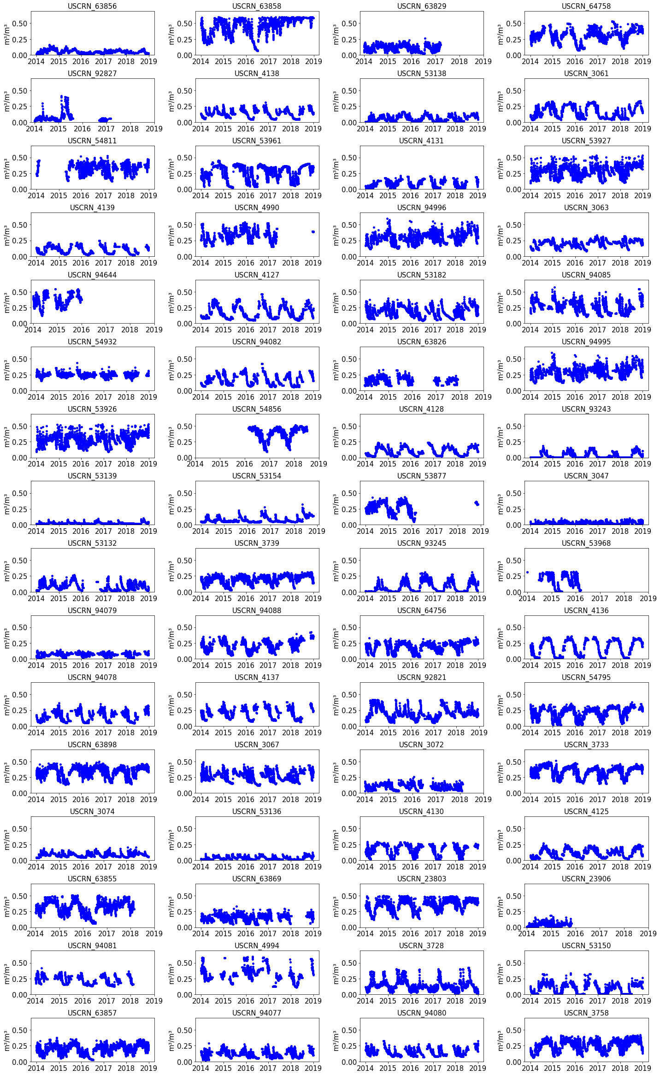
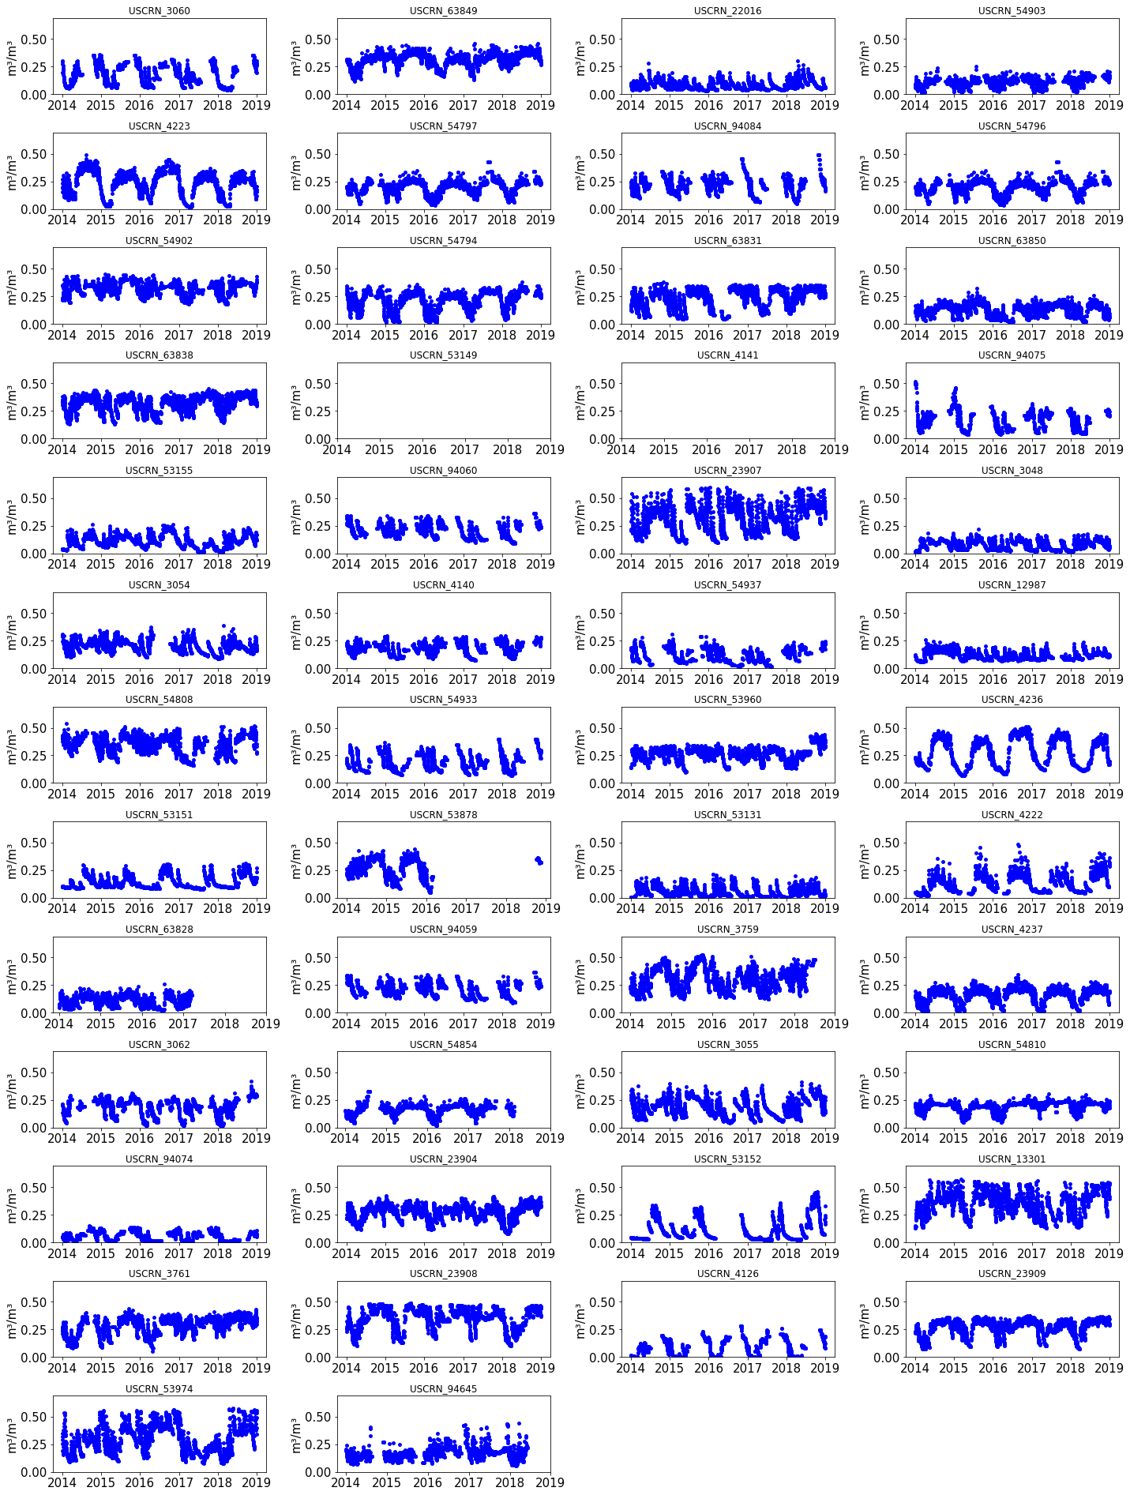
Figure S1. Time series measurements of top-5cm soil moisture (${m^{3}}/{m^{3}}$) for the quality check from 2014–Winter to 2019–Fall over 114 USCRN sites. Each subplot represents a USCRM site. Each blue dot represents a daily averaged measurement. Each subplot title contains the USCRN site ID. Y-axis is the measured daily averaged soil moisture.

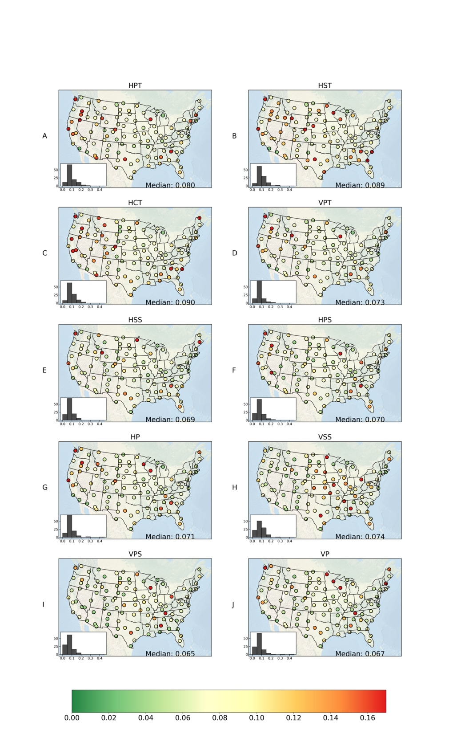
Figure S2. Spatial distribution of RMSE from (A) HPT (30–60cm representing 0–200cm soil), (B) HST (30–60cm representing 0–200cm soil), (C) HCT (30–60cm representing 0–200cm soil), (D) VPT, (E) HSS (30–60cm representing 0–200cm soil), (F) HPS (30–60cm representing 0–200cm soil), (G) HP (30–60cm representing 0–200cm soil), (H) VSS, (I) VPS, (J) VP HydroBlocks simulation of soil moisture (2014–2019) compared to the USCRN in-situ surface 5-cm soil moisture measurements. In each subplot, the left corner displays the frequency of RMSE.
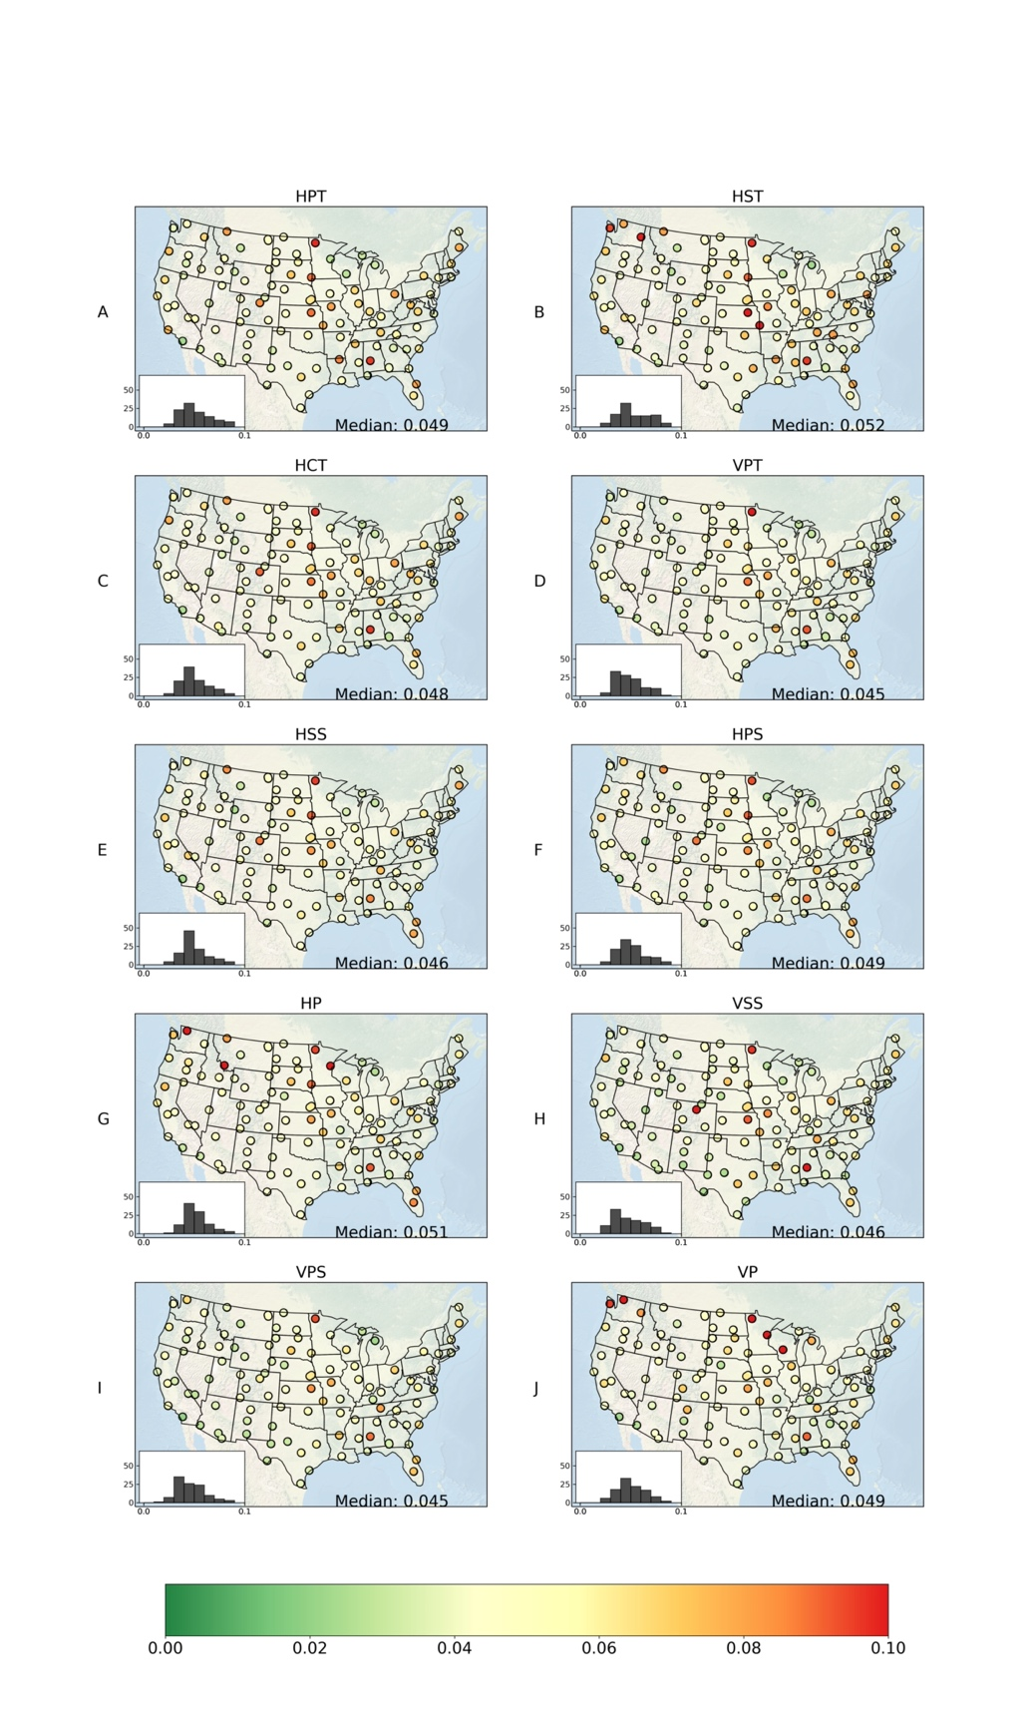
Figure S3. Spatial distribution of ubRMSE from (A) HPT (30–60cm representing 0–200cm soil), (B) HST (30–60cm representing 0–200cm soil), (C) HCT (30–60cm representing 0–200cm soil), (D) VPT, (E) HSS (30–60cm representing 0–200cm soil), (F) HPS (30–60cm representing 0–200cm soil), (G) HP (30–60cm representing 0–200cm soil), (H) VSS, (I) VPS, (J) VP HydroBlocks simulation (2014–2019) of soil moisture compared to the USCRN in-situ surface 5-cm soil moisture measurements. In each subplot, the left corner displays the frequency of ubRMSE.
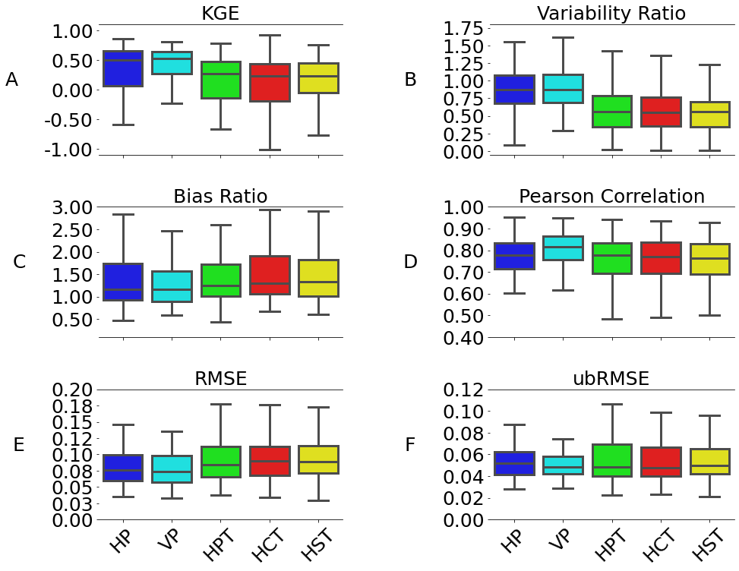
Figure S4. Box plots of (A) KGE scores, (B) variability ratios, (C) bias ratios, (D) Pearson correlation coefficients, (E) RMSE (${m^{3}}/{m^{3}}$), and (F) ubRMSE (${m^{3}}/{m^{3}}$) for (i) HP (blue), (ii) VP (cyan), (iii) HPT (green), (iv) HCT (red), (v) HST (yellow) soil datasets over the CONUS from 2014 to 2019. HP: vertically homogeneous POLARIS (0–5cm representing 0–200cm soil); VP: vertically heterogeneous POLARIS; HPT: vertically homogeneous POLARIS texture (0–5cm representing 0–200cm soil); HCT: vertically homogeneous CONUS-Soil texture (0–5cm representing 0–200cm soil); HST: vertically homogeneous SoilGrids250m texture (0–5cm representing 0–200cm soil). Textured soils mean the soil hydraulic properties were derived from lookup tables.

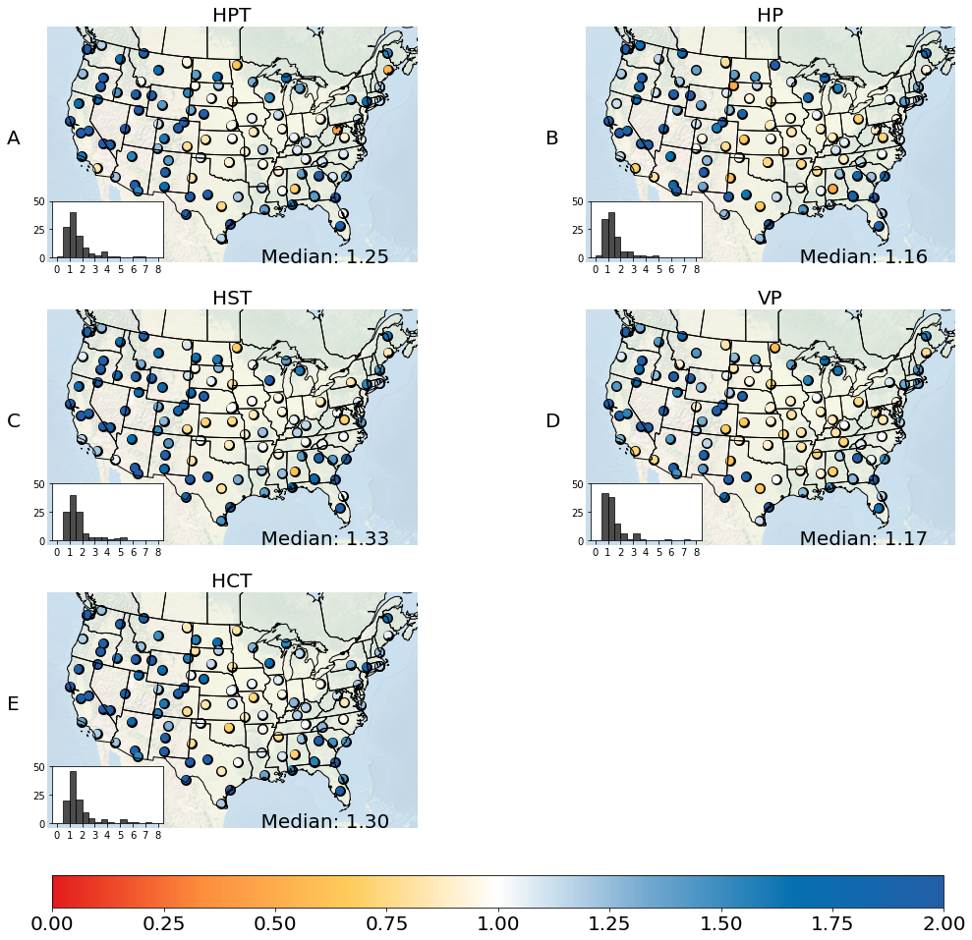
Figure S5. Spatial distribution of bias ratios from (A) HPT (0–5cm representing 0–200cm soil), (B) HP (0–5cm representing 0–200cm soil), (C) HST (0–5cm representing 0–200cm soil), (D) VP, (E) HCT (0–5cm representing 0–200cm soil) HydroBlocks simulation (2014–2019) of soil moisture compared to the USCRN in-situ surface 5-cm soil moisture contents. Histogram in the left corner displays the occurrence of bias ratios. HPT: vertically homogeneous POLARIS texture (0–5cm representing 0–200cm soil); HP: vertically homogeneous POLARIS (0–5cm representing 0–200cm soil); HST: vertically homogeneous SoilGrids250m texture (0–5cm representing 0–200cm soil); VP: vertically heterogeneous POLARIS; HCT: vertically homogeneous CONUS-Soil texture (0–5cm representing 0–200cm soil). Textured soils mean the soil hydraulic properties were derived from lookup tables.
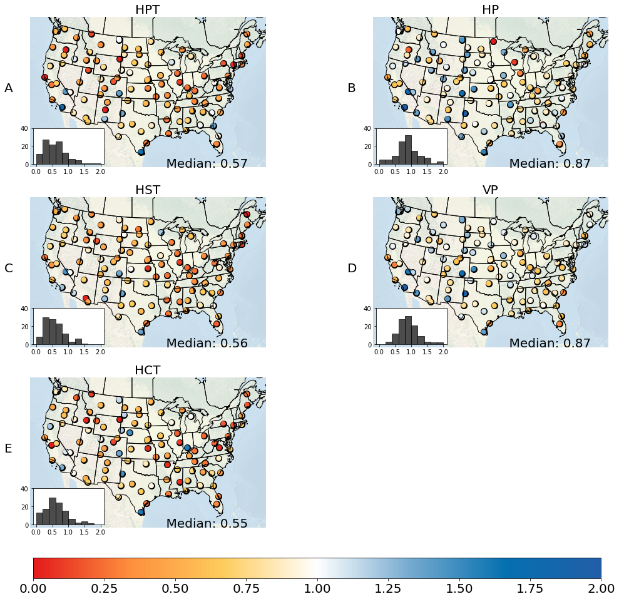
Figure S6. Spatial distribution of variability ratios from (A) HPT (0–5cm representing 0–200cm soil), (B) HP (0–5cm representing 0–200cm soil), (C) HST (0–5cm representing 0–200cm soil), (D) VP, (E) HCT (0–5cm representing 0–200cm soil) HydroBlocks simulation (2014–2019) of soil moisture compared to the USCRN in-situ surface 5-cm soil moisture contents. Histogram in the left corner displays the occurrence of variability ratios. HPT: vertically homogeneous POLARIS texture (0–5cm representing 0–200cm soil); HP: vertically homogeneous POLARIS (0–5cm representing 0–200cm soil); HST: vertically homogeneous SoilGrids250m texture (0–5cm representing 0–200cm soil); VP: vertically heterogeneous POLARIS; HCT: vertically homogeneous CONUS-Soil texture (0–5cm representing 0–200cm soil). Textured soils mean the soil hydraulic properties were derived from lookup tables.

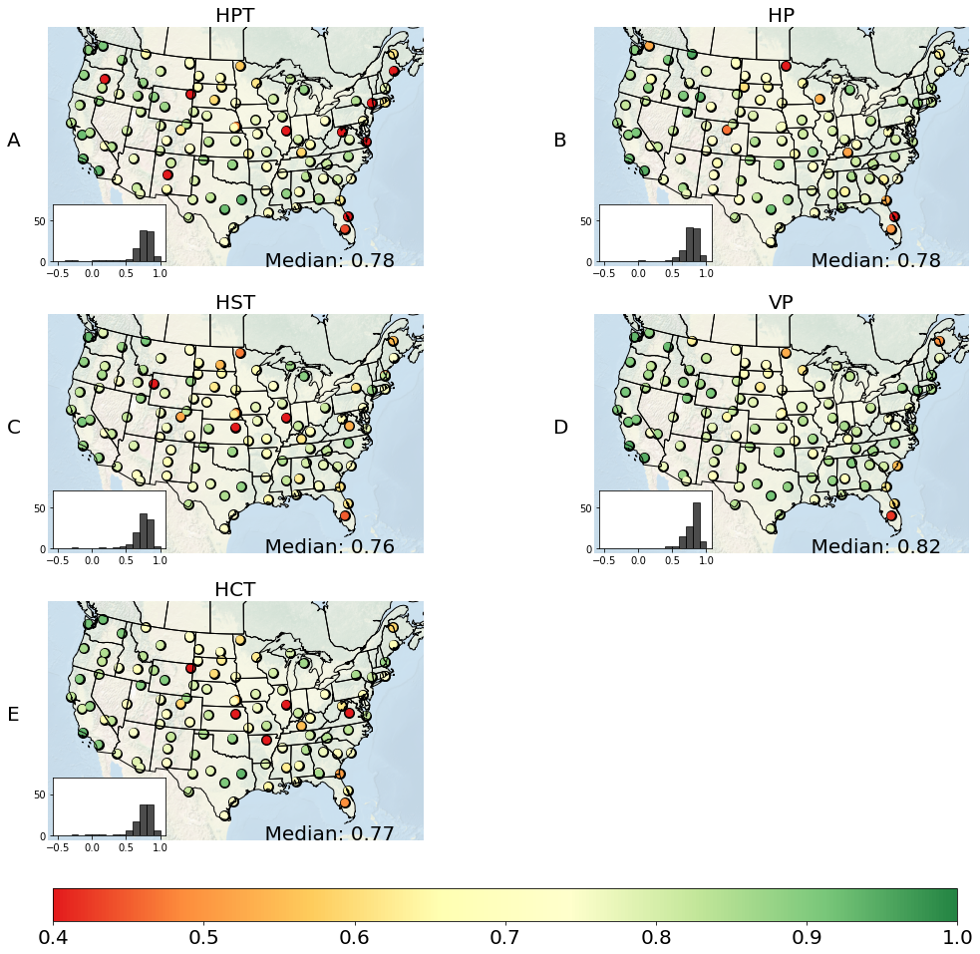
Figure S7. Spatial distribution of Pearson correlation coefficients from (A) HPT (0–5cm representing 0–200cm soil), (B) HP (0–5cm representing 0–200cm soil), (C) HST (0–5cm representing 0–200cm soil), (D) VP, (E) HCT (0–5cm representing 0–200cm soil) soil moisture HydroBlocks simulation (2014–2019) compared to the USCRN in-situ surface 5-cm soil moisture contents. Histogram in the left corner displays the frequency of Pearson correlation coefficients. HPT: vertically homogeneous POLARIS texture (0–5cm representing 0–200cm soil); HP: vertically homogeneous POLARIS (0–5cm representing 0–200cm soil); HST: vertically homogeneous SoilGrids250m texture (0–5cm representing 0–200cm soil); VP: vertically heterogeneous POLARIS; HCT: vertically homogeneous CONUS-Soil texture (0–5cm representing 0–200cm soil). Textured soils mean the soil hydraulic properties were derived from lookup tables.
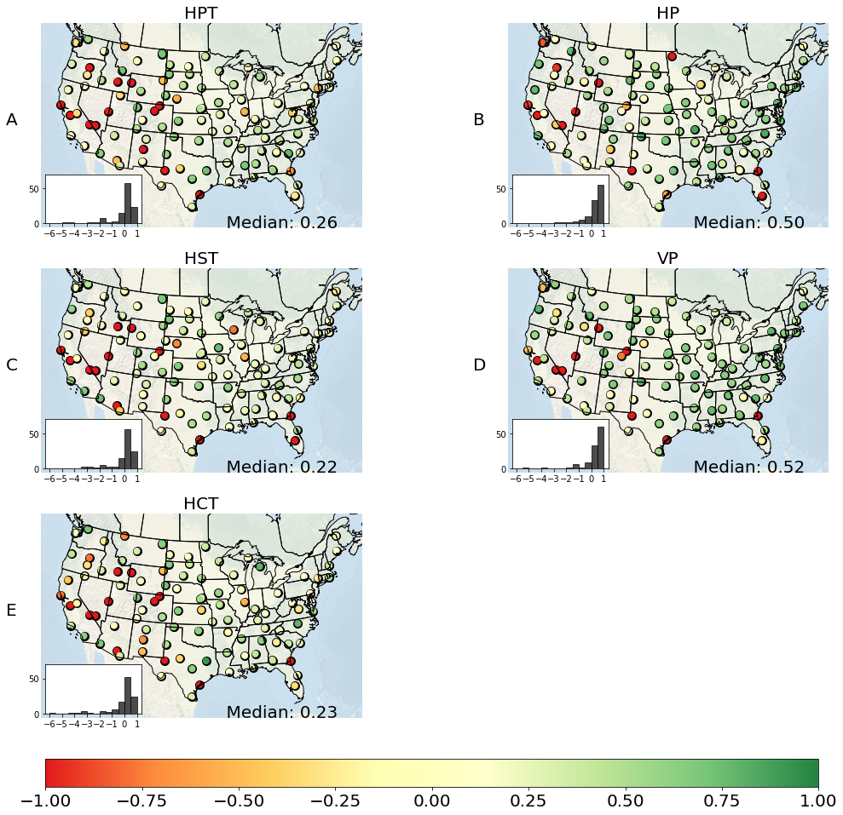
Figure S8. Spatial distribution of KGE scores from (A) HPT (0–5cm representing 0–200cm soil), (B) HP (0–5cm representing 0–200cm soil), (C) HST (0–5cm representing 0–200cm soil), (D) VP, (E) HCT (0–5cm representing 0–200cm soil) soil moisture HydroBlocks simulation (2014–2019) compared to the USCRN in-situ surface 5-cm soil moisture contents. Histogram in the left corner displays the frequency of KGE scores. HPT: vertically homogeneous POLARIS texture (0–5cm representing 0–200cm soil); HP: vertically homogeneous POLARIS (0–5cm representing 0–200cm soil); HST: vertically homogeneous SoilGrids250m texture (0–5cm representing 0–200cm soil); VP: vertically heterogeneous POLARIS; HCT: vertically homogeneous CONUS-Soil texture (0–5cm representing 0–200cm soil). Textured soils mean the soil hydraulic properties were derived from lookup tables.

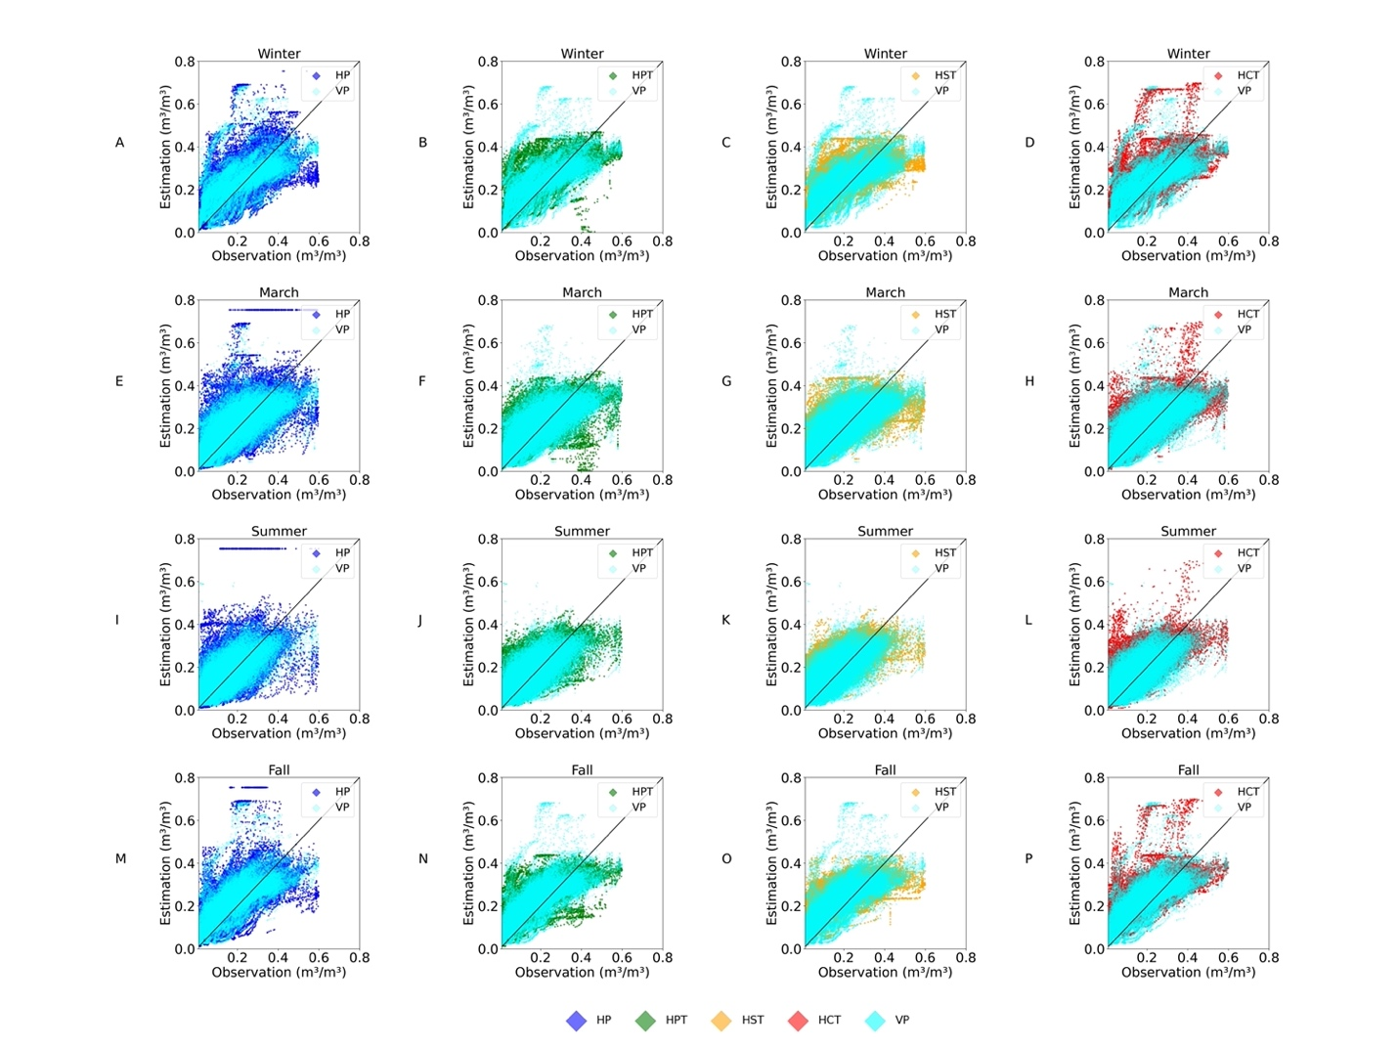
Figure S9. Seasonal comparison of the HydroBlocks simulated daily average using the HP, HPT, HST, HCT, and VP datasets and observed 5-cm volumetric soil moisture content (${m^{3}}/{m^{3}}$) from 2014 to 2019. Each subplot is superimposed with the VP soil dataset as a comparison since VP is a top-performed soil dataset. HP: vertically homogeneous POLARIS (0–5cm representing 0–200cm soil); HPT: vertically homogeneous POLARIS texture (0–5cm representing 0–200cm soil); HST: vertically homogeneous SoilGrids250m texture (0–5cm representing 0–200cm soil); HCT: vertically homogeneous CONUS-Soil texture (0–5cm representing 0–200cm soil); VP: vertically heterogeneous POLARIS. Textured soils mean the soil hydraulic properties were derived from lookup tables.
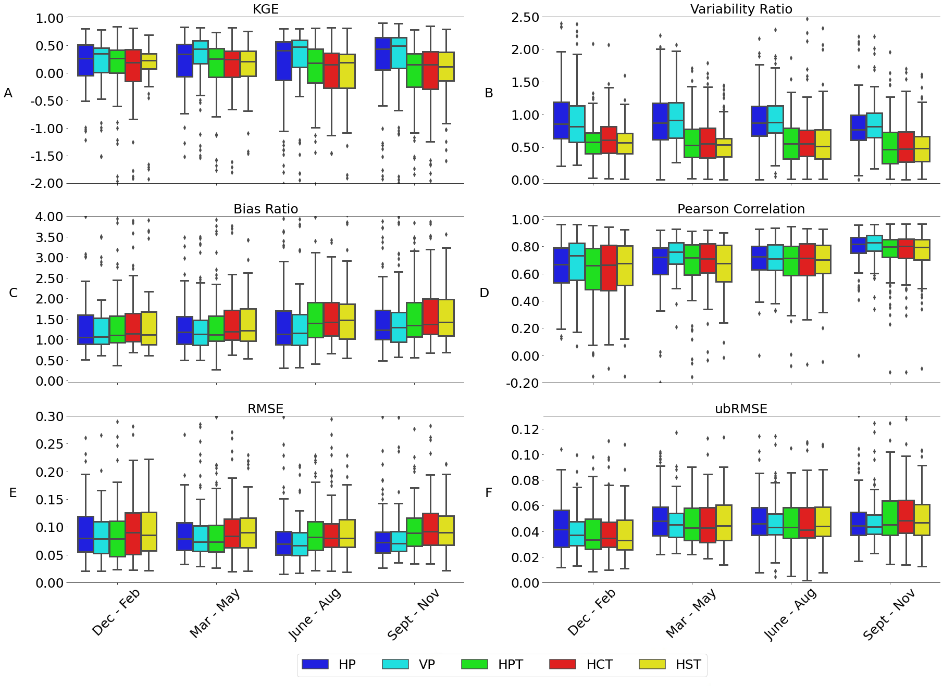
Figure S10. Box plots of (A) KGE scores, (B) variability ratios, (C) bias ratios, (D) Pearson correlation coefficients, (E) RMSE (${m^{3}}/{m^{3}}$), and (F) ubRMSE (${m^{3}}/{m^{3}}$)) for (i) HP (blue), (ii) VP (cyan), (iii) HPT (green), (iv) HST (yellow), (v) HCT (red) soil datasets over the CONUS. The first, second, third, and fourth group are seasonal metrics from December to February, from March to May, from June and August, and from September to November. Some outliers were removed to show the variations of interquartile range. HP: vertically homogeneous POLARIS (0–5cm representing 0–200cm soil); VP: vertically heterogeneous POLARIS; HPT: vertically homogeneous POLARIS texture (0–5cm representing 0–200cm soil); HCT: vertically homogeneous CONUS-Soil texture (0–5cm representing 0–200cm soil); HST: vertically homogeneous SoilGrids250m texture (0–5cm representing 0–200cm soil). Textured soils mean the soil hydraulic properties were derived from lookup tables.
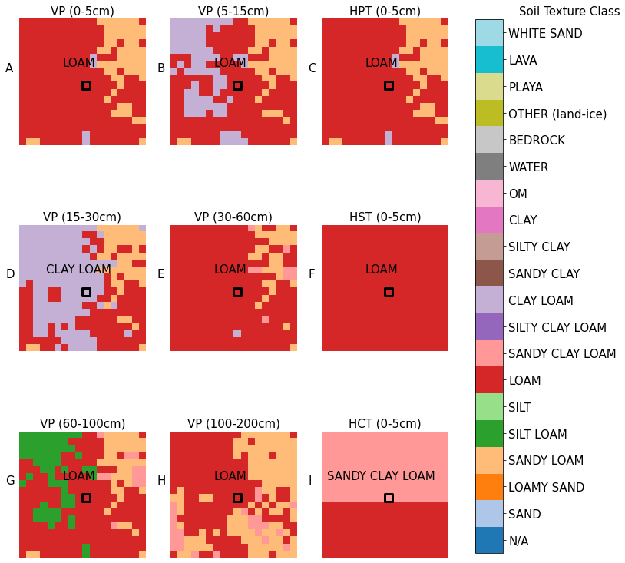
Figure S11. Spatial distribution of soil texture categories at Blackville, South Carolina from (A) POLARIS 0–5cm, (B) POLARIS 5–15cm, (C) POLARIS Texture 0–5cm (representing 0–200cm), (D) POLARIS 15–30cm, (E) POLARIS 30–60cm, (F) SoilGrids250m Texture 0–5cm (representing 0–200cm), (G) POLARIS 60–100cm, (H) POLARIS 100–200cm, (I) CONUS-SOIL Texture 0–5cm (representing 0–200cm) depth. The size of each map is about 540m by 540m. The central square covers the USCRN site (Blackville) with a size of 30m by 30m. The soil category at the Blackville site is shown in the upper center. Textured soils mean the soil hydraulic properties were derived from lookup tables.

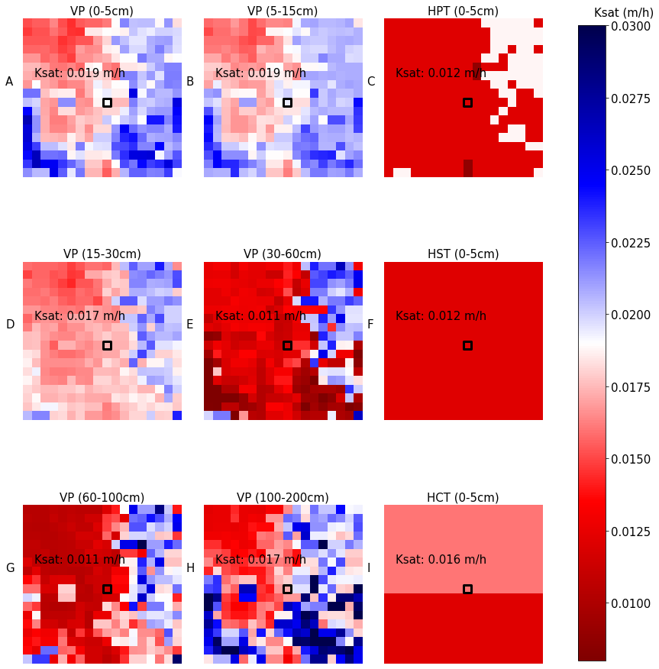
Figure S12. Spatial distribution of saturated hydraulic conductivity for (A) POLARIS 0–5cm, (B) POLARIS 5–15cm, (C) POLARIS Texture 0–5cm (representing 0–200cm), (D) POLARIS 15–30cm, (E) POLARIS 30–60cm, (F) SoilGrids250m Texture 0–5cm (representing 0–200cm), (G) POLARIS 60–100cm, (H) POLARIS 100–200cm, (I) CONUS-SOIL Texture 0–5cm (representing 0–200cm) depth. The size of each map is about 540m by 540m. The central square covers the USCRN site (Blackville) with a size of 30m by 30m. The values of saturated hydraulic conductivity (unit: m/h) at the Blackville site are shown in the upper center. Textured soils mean the soil hydraulic properties were derived from lookup tables.
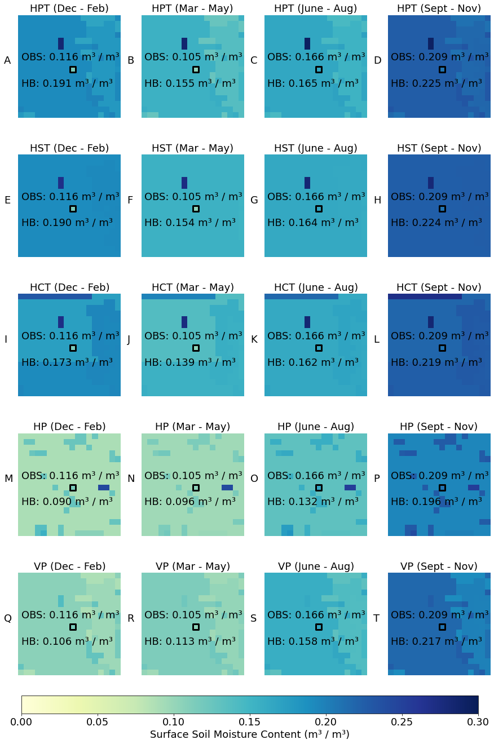
Figure S13. Spatial patterns of HydroBlocks simulated near-surface 5-cm volumetric soil moisture content (${m^{3}}/{m^{3}}$) using HPT (0–5cm representing 0–200cm soil), HST (0–5cm representing 0–200cm soil), HCT (0–5cm representing 0–200cm soil), HP (0–5cm representing 0–200cm soil), and VP soil datasets per season from Dec–2017 to November–2018. The size of each map is about 540m by 540m. The central square indicates the USCRN site at Blackville with a size of about 30m by 30m. USCRN observed surface 5-cm volumetric soil moisture content (${m^{3}}/{m^{3}}$) are superimposed per map. Values of HydroBlocks simulated (HB) and USCRN site observed (USCRN) surface soil moisture content at the Blackville site are presented in the lower center.

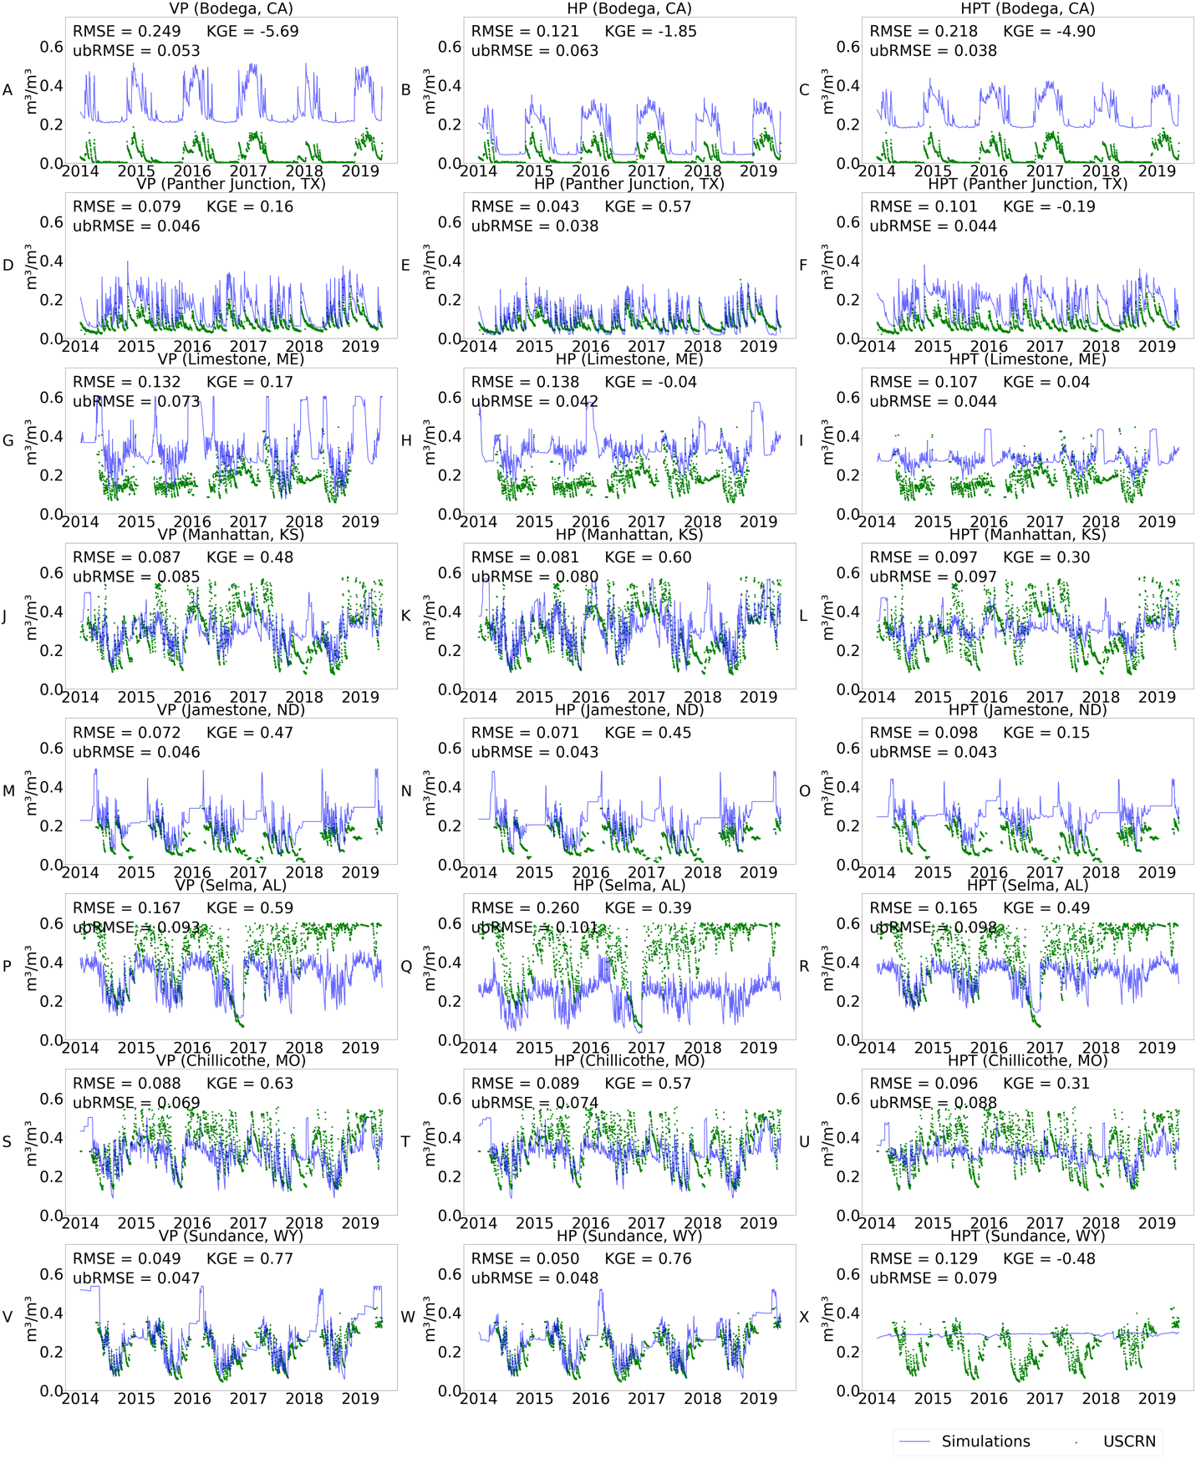
Figure S14. Time series of HydroBlocks simulated surface 5-cm volumetric soil moisture content (${m^{3}}/{m^{3}}$) using POLARIS relevant datasets (VP, HP, and HPT datasets) against USCRN observations from 2014 to 2019 over the (A, B, C) Bodega site, California; (D, E, F) Panther Junction site, Texas; (G, H, I) Limestone site, Maine; (J, K, L) Manhattan site, Kansas; (M, N, O) Jamestone, North Dakota;(P, Q, R) Selma site, Alabama; (S, T, U) Chillicothe site, Missouri; (V, W, X) Sundance site, Wyoming. Blue lines represent simulated surface 5-cm soil moisture content. Green dots are USCRN observed surface 5cm soil moisture content. KGE, ubRMSE, and RMSE computed during the study period per site are shown in the top. VP: vertically heterogeneous POLARIS; HP: vertically homogeneous POLARIS (0–5cm representing 0–200cm soil); HPT: vertically homogeneous POLARIS texture (0–5cm representing 0–200cm soil). Textured soils mean the soil hydraulic properties were derived from lookup tables.

