Geophysical Research Letters
Supporting Information for

On the Lateral Entrainment Instability in the Inner Core Region of Tropical Cyclones
Ping Zhu¹, Jun A. Zhang^{2,3}, and Frank D. Marks³
¹Department of Earth and Environment, Florida International University
²Cooperative Institute for Marine and Atmospheric Studies, University of Miami
³Hurricane Research Division, Atlantic Oceanographic and Meteorological Laboratory, NOAA

Corresponding author: Ping Zhu (zhup@fiu.edu), 11200 SW 8th ST, Miami, FL, 33199.

Contents of this file
S1: Flight-level in-situ data
S2: Numerical simulations of Hurricanes Michael (2018) and Patricia (2015)
S3: Possible reasons for lateral entrainment not to meet the instability criterion
Introduction
This document provides Supporting Information regarding the in-situ aircraft flight-level data (Section S1), numerical simulations of Hurricanes Michael (2018) and Patricia (2015) (Section S2), and possible reasons for lateral entrainment not to meet the instability criterion (Section S3).

S1: Flight-level in-situ data
In this study, we analyzed flight-level data to study the lateral entrainment process and instability in the inner core of tropical cyclones. The flight-level data provides measurements of three-dimensional wind velocities, pressure, temperature, and humidity with a sampling rate of 1 Hz (Lenschow 1986; Marks et al. 2008; Zhang et al. 2011). Information for the detailed instrumentation and accuracy can be found in Khelif et al. (1999) and French et al. (2007). Here, we use post-processed quality-controlled the fight-level data from 4 tropical cyclones at different intensity stages. These storms include Rita (2005), Patricia (2015), Harvey (2017), and Michael (2018). Radial legs were determined using the storm center positions that were derived based on the flight-level center fixes through an algorithm developed by Willoughby and Chelmow (1982). Data from 50 radial legs from Rita (2005), 7 legs from Patricia (2015), 22 legs from Harvey (2017), and 34 legs from Michael (2018) in total of 113 radial legs were analyzed in this study.
S2: Numerical simulations of Hurricanes Michael (2018) and Patricia (2015)
Hurricane Michael (2018) was simulated by a global-nested version of HAFS (HAFS-globalnest) that does not feature ocean coupling. It uses Geophysical Fluid Dynamics Laboratory (GFDL) finite-volume dynamic core (FV3, e.g., Lin 2004; Harris and Lin 2013) with a static nest covering most of the Atlantic basin. The grid spacing of the global domain is ~13 km and the grid spacing of the nest is ~3 km for the Atlantic grid layout (Hazelton et al. 2021). There is a 2-way feedback between the parent and nested domains. There are 64 levels in the vertical, the same as that in the operational Global Forecast System (GFS). The model is initialized with the GFS analysis. The physics used in HAFS-globalnest includes the GFDL microphysics scheme (Chen and Lin 2013), RRTMG radiation (Iacono et al. 2008), and the scale-aware convective parameterization (Han et al. 2017), which is turned on for the global domain but not the nested domain. The default planetary boundary layer (PBL) scheme used in the HAFS-globalnest is the hybrid Eddy-Diffusivity-Mass-Flux (EDMF) scheme (Han et al. 2016), which is a first-order K-closure scheme originally formulated by Hong and Pan (1996). For the simulation of Michael (2018) presented in this study, a stability correction to account for the buoyancy generated by eyewall and rainband clouds is added in the PBL scheme. Details of numerical simulation of Michael (2018) can be found in Zhu et al. (2021).
Hurricane Patricia (2015) was simulated by the Hurricane Weather Research & Forecasting (HWRF) model version v3.9a without ocean coupling. It consists of triple-nested domains on an E-grid. The grid-spacing of the three domains is 0.099⁰, 0.033⁰, and 0.011⁰ degree, corresponding approximately to 10.98 km, 3.66 km, and 1.22 km, respectively. The horizontal grid-meshes for the three domains are 390X750, 268X538, and 268X538, respectively. There are 75 levels in the vertical. HWRF provides multiple choices for treating the sub-grid-scale physics. In this simulation, we used the physics package for operational forecasts except for the PBL scheme. These include: the Ferrier-Aligo microphysical scheme (Aligo et al. 2018), the modified GFDL longwave/shortwave radiation scheme, the simplified Arakawa-Schubert cumulus scheme for the outmost low-resolution domain, and the modified GFDL surface layer scheme. The details of HWRFv3.9a may be accessed at https://dtcenter.org/HurrWRF/users/docs/index.php. The PBL scheme used for this simulation is a modified hybrid EDMF scheme (Han et al. 2016) with the stability correction (Zhu et al. 2021). The initial and boundary conditions were supplied by the Global Forecast System (GFS) data.
S3: Possible reasons for lateral entrainment not to meet the instability criterion
S3.1 Aircraft observations
As shown in Fig.3, there are a few lateral entrainment cases falling in the stable regime. To understand the underlying reasons, we analyzed the radial profiles associated with these cases. As an illustration, we take the solid black triangle in the stable regime in Fig. 3 as an example. This case was recorded in one of the flight legs into Hurricane Patricia (2015). The radial profiles of relative humidity, equivalent potential temperature $θ_{e}$, mixing ratio $q$, and potential temperature $θ$ of this leg are shown in Fig. S1. The stable lateral entrainment occurs at the outer edge of the eyewall indicated by the red *. As shown clearly in Fig. S1d, the reason to cause the stable entrainment is mainly due to the drop of $θ$ just inside of the eyewall clouds, which causes $∆θ_{e}$ across the edge of clouds to be less negative than $\frac{\overline{θ}}{α}∆q_{t}$, so that the entrained moat air into the eyewall cannot sink unstably. This case is different from the normal situation in which the temperature inside the clouds is usually higher than its surroundings due to the latent heat release. An example of the normal situation is shown in Fig. 2d where $θ_{e}$ increases inside the eyewall clouds. The reason for the temperature dropping just inside the clouds of this atypical case is not totally clear. One of the likely causes is the precipitation at the cloud edge, the evaporative cooling results in the temperature dropping just inside the clouds. Further investigation is needed to clarify this issue. However, as indicated by Fig. 3, majority of the lateral entrainments in the TC inner core meet the instability criterion. Stable lateral entrainment is rare and atypical, which may be caused by various reasons related to the perturbations in moist thermodynamics of TCs.
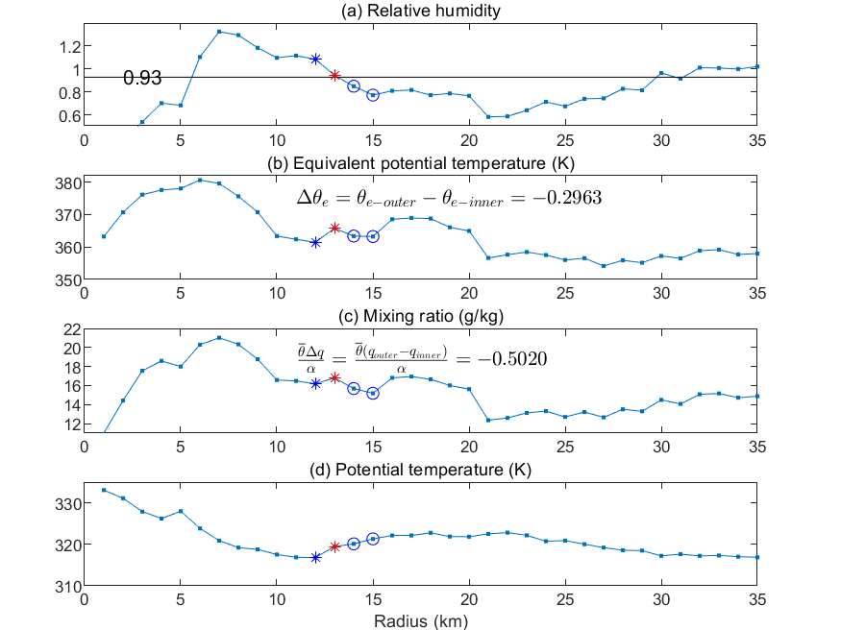
Fig. S1: Radial profiles of relative humidity, equivalent potential temperature, mixing ratio, and potential temperature from one of the legs into Hurricane Patricia (2015) that recorded a stable lateral entrainment at the outer edge of the eyewall indicated by the solid black triangle in Fig. 3.
S3.2 Numerical simulations
As shown in Figs. 4c and 4d, most of the vertical column at the outer edge of eyewall clouds satisfies the lateral entrainment instability criterion except a shallow layer in-between 1 and 2 km. To understand what causes the stable lateral entrainment in this shallow layer, we examined the vertical profiles of various thermodynamic and dynamic variables at the three grid points in the vicinity of the outer edge of the eyewall indicated in Fig. 4a and 4b. As an example, Fig. S2 shows the vertical profiles of total water mixing ratio $q_{t}$, $θ_{e}$, $θ$, and vertical velocity $w$ at the three grid points from the HWRF simulation of Hurricane Patricia (2015). Outside the clouds, the profiles of $q_{t}$ and $θ$ (red) show a slight discontinuity with a decrease of $q_{t}$ and increase of $θ$ just below 2 km. This discontinuity in $q_{t}$ and $θ$ may be analogous to the cap that tops the typical convective boundary layer, which forms mainly through the adiabatic warming and drying process caused by subsidence. As indicated by Fig. S2d, outside the clouds there is a downdraft (red) that peaks between 2 and 3 km. It is this downdraft that causes the subsidence warming, leading to the temperature increase near 2 km in altitude. The resultant discontinuity in temperature and moisture serves a role in separating the convective boundary layer from the free atmosphere above. No such discontinuity, however, is seen inside the clouds since the turbulence generated by the boundary layer processes and cloud processes is intimately connected. The subsidence warming outside the clouds reduces the difference of $θ_{e}$ across the cloud boundaries, leading to $∆θ_{e}>\frac{\overline{θ}}{α}∆q_{t}$ (i.e., stable lateral entrainment). Similar process also occurs the HAFS simulation of Hurricane Michael (2018).
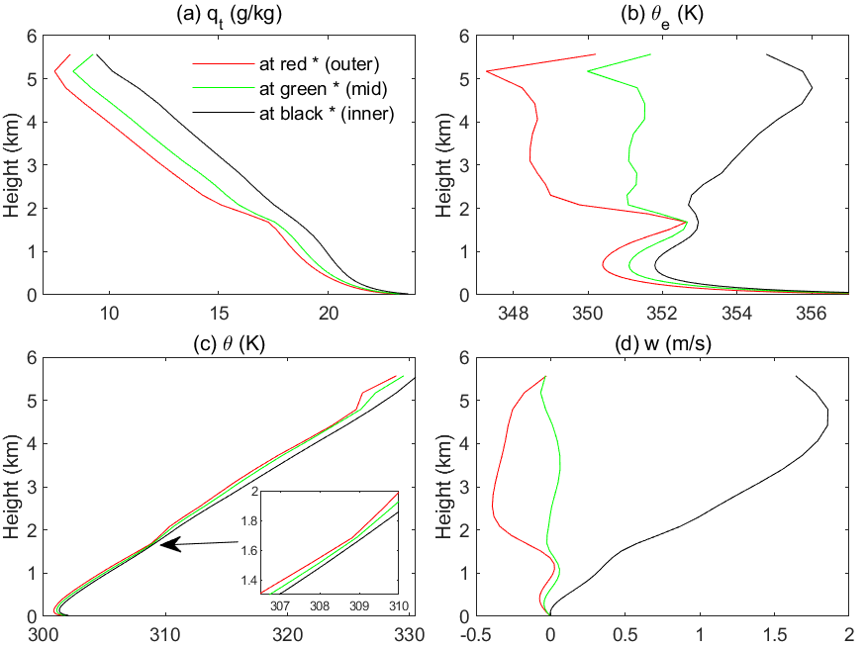
Fig. S2: Vertical profiles of total water mixing ratio $q_{t}$, equivalent potential temperature $θ_{e}$, potential temperature $θ$, and vertical velocity $w$ at the three grid points indicated in Fig. 4b from the HWRF simulation of Hurricane Patricia (2015).

