Supporting Information 1: Additional figures and Tables
Fig. S1: Value of the “decadal trends” spline, generated as a first-order I-spline (i.e., an integral of an M-spline) with four degrees of freedom, generated in R using `splines2::iSpline( 1982:2019, df=4, degree=0, intercept=TRUE)`. We then estimate a spatially varying response to generate the decadal trends results (Fig. 2 of main text).
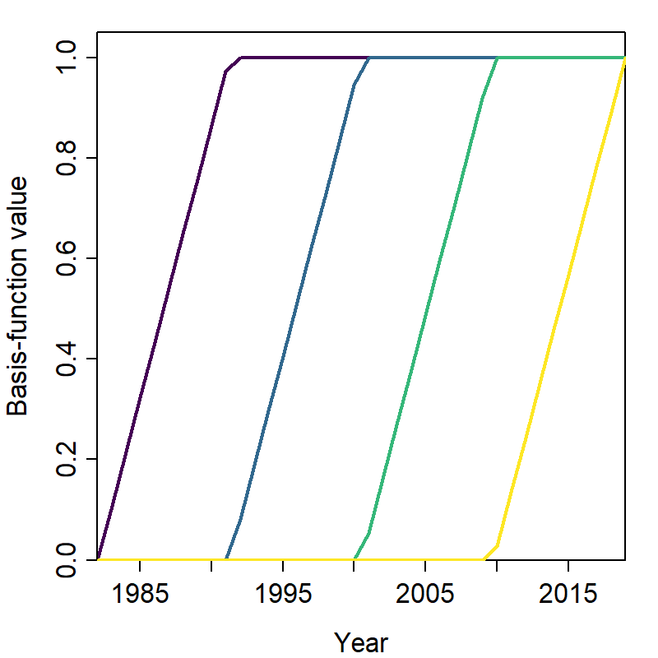

Fig. S2: Total abundance (y-axis) for arrowtooth flounder in each year 1982-2018 (x-axis), estimated by summing density estimates across the spatial domain of the bottom trawl survey.
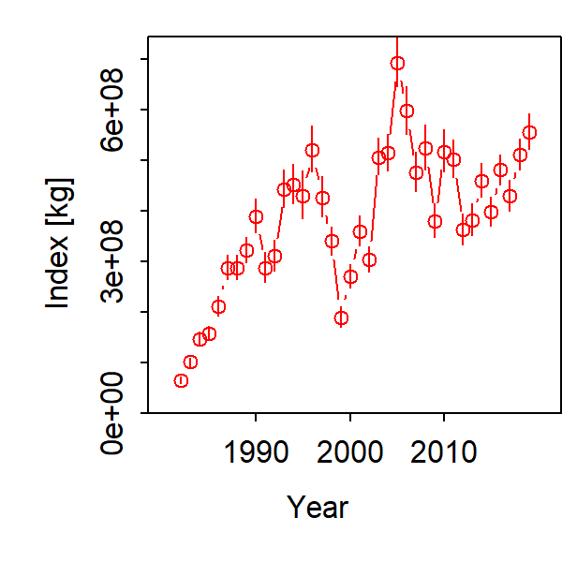

Fig. S3: The covariate-response function resulting from the product of the I-spline covariates (Fig. S1) and the covariate-response maps (Fig. 2)
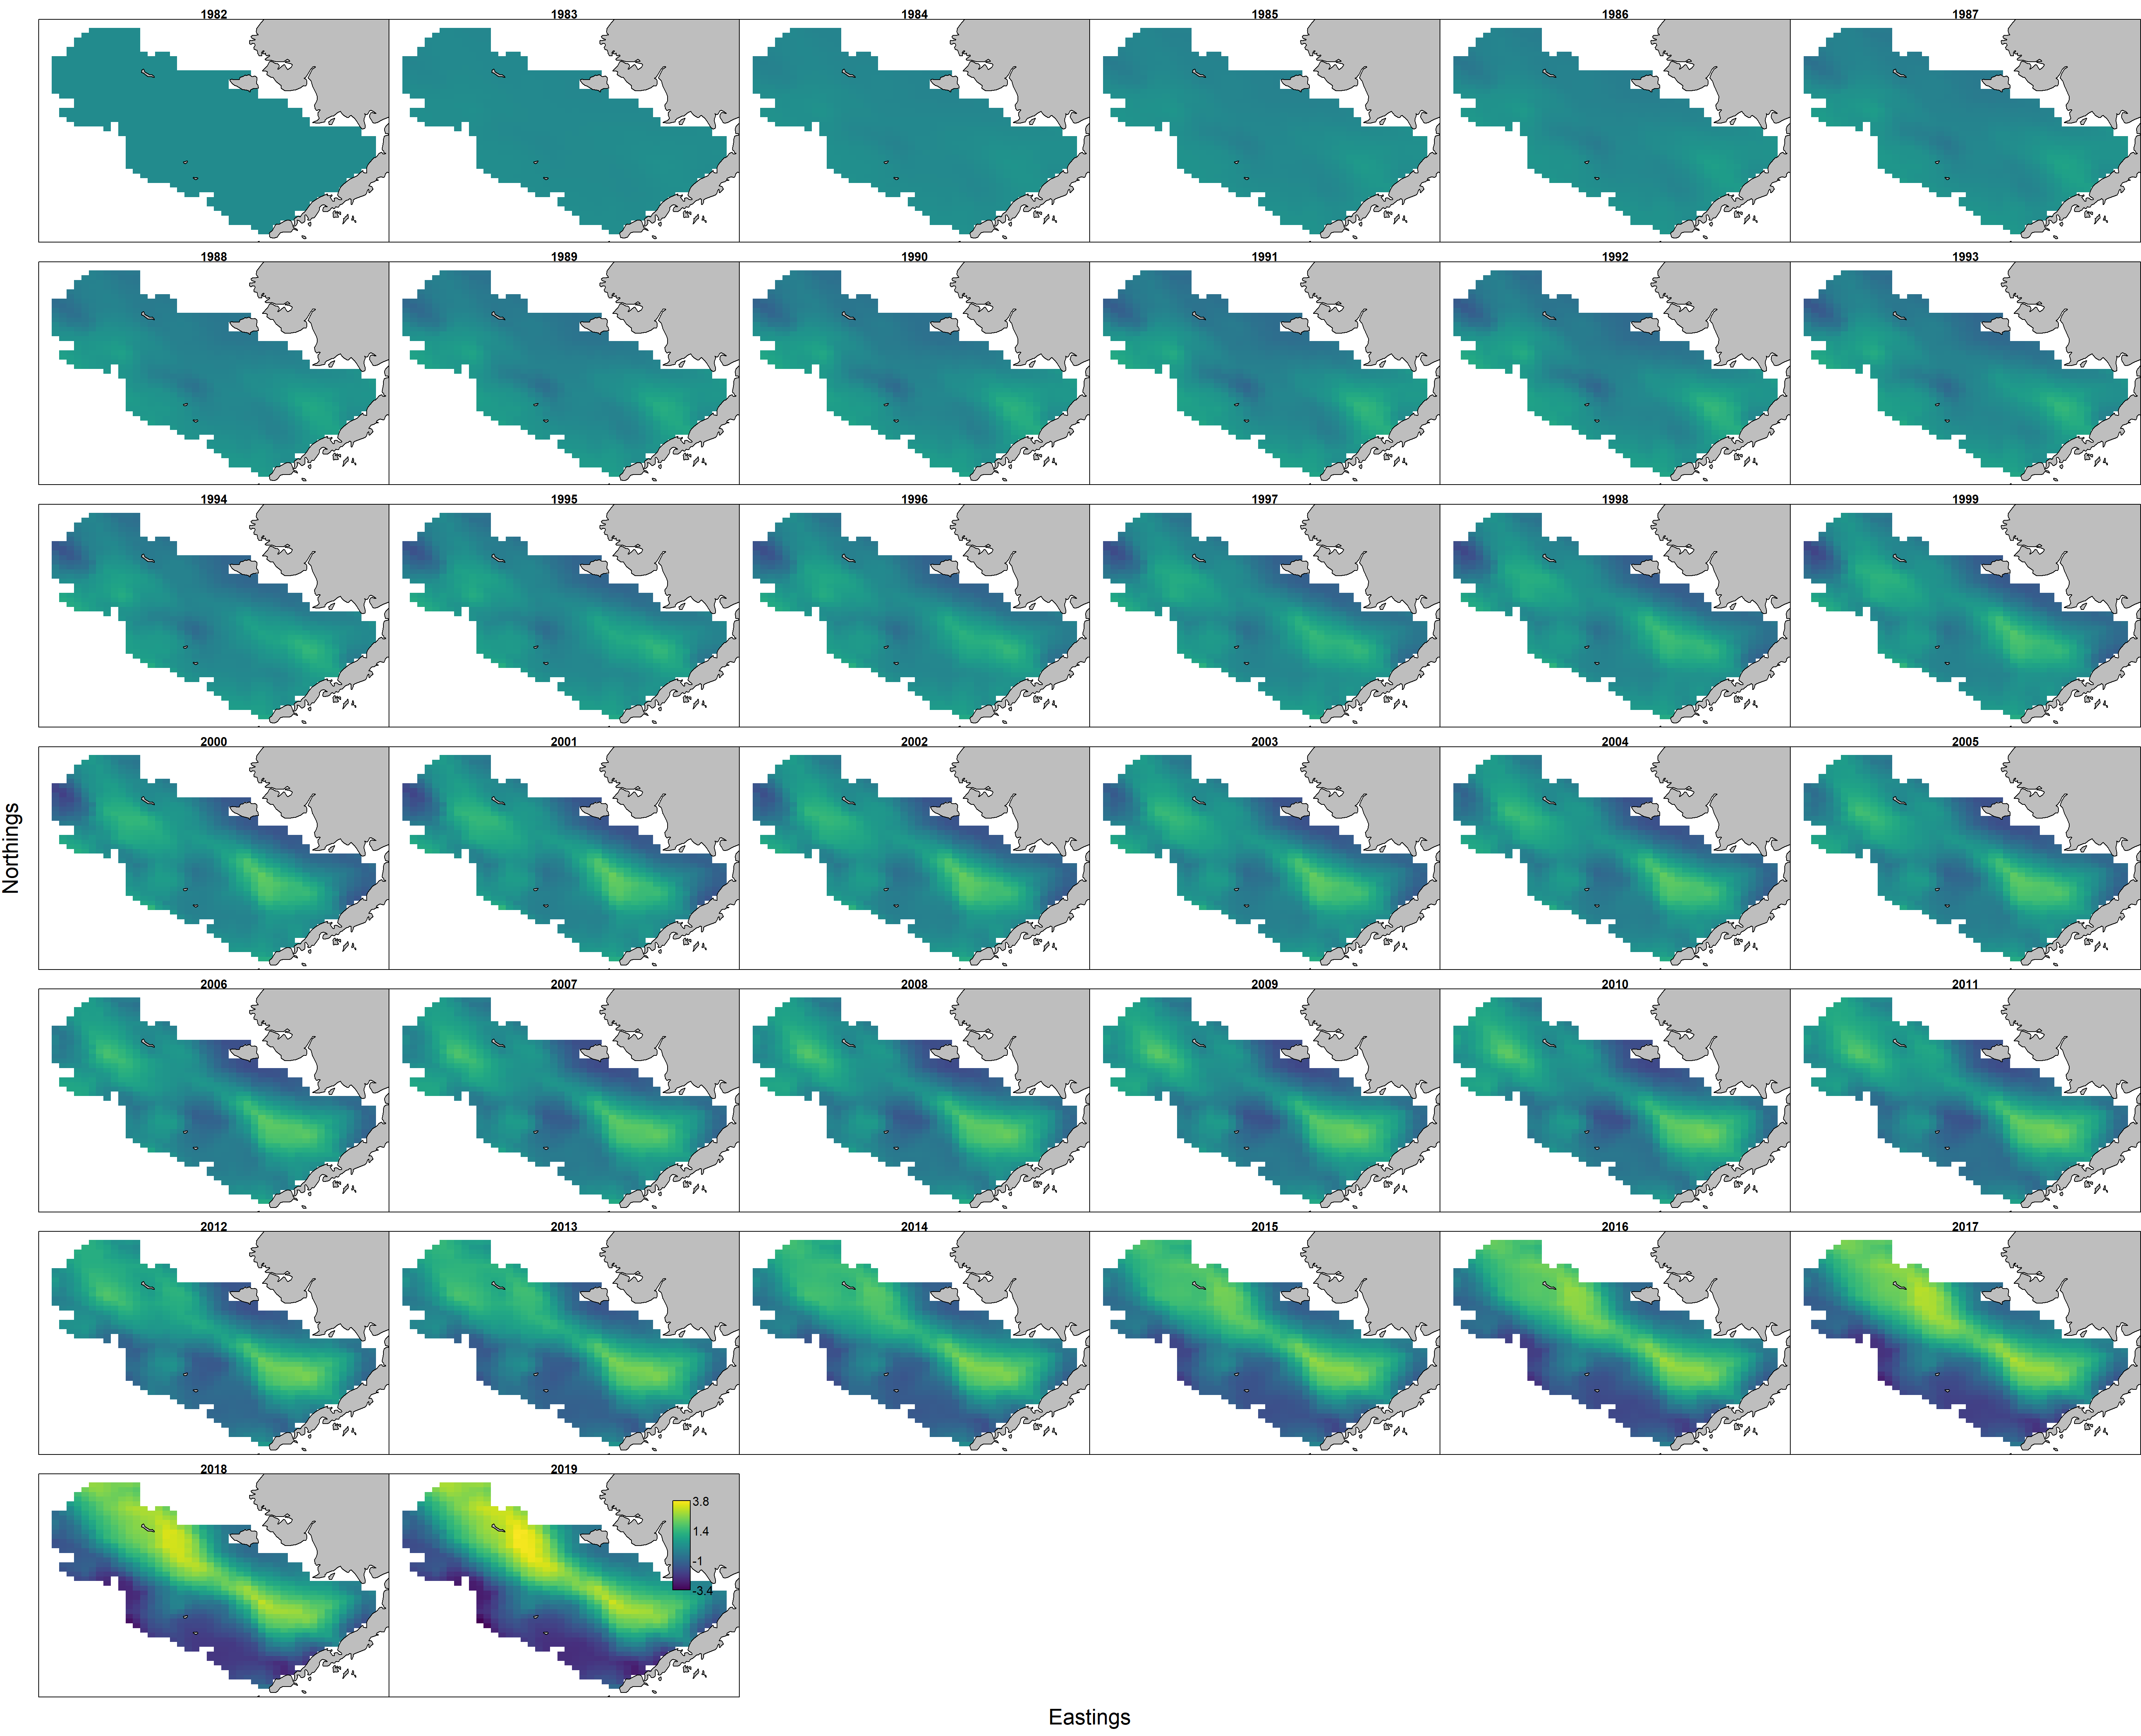
Fig. S4: Spatial response $ξ^{*}\left(c,t\right)$, transposed to show ages $c$ (columns) and years $t$ (rows) for 2007-2019, where cohorts are tracked along the diagonal from top-left to bottom-right. The color bar legend is omitted due to small panel size, but ranges from -2.2 (blue) to +2.2 (yellow).
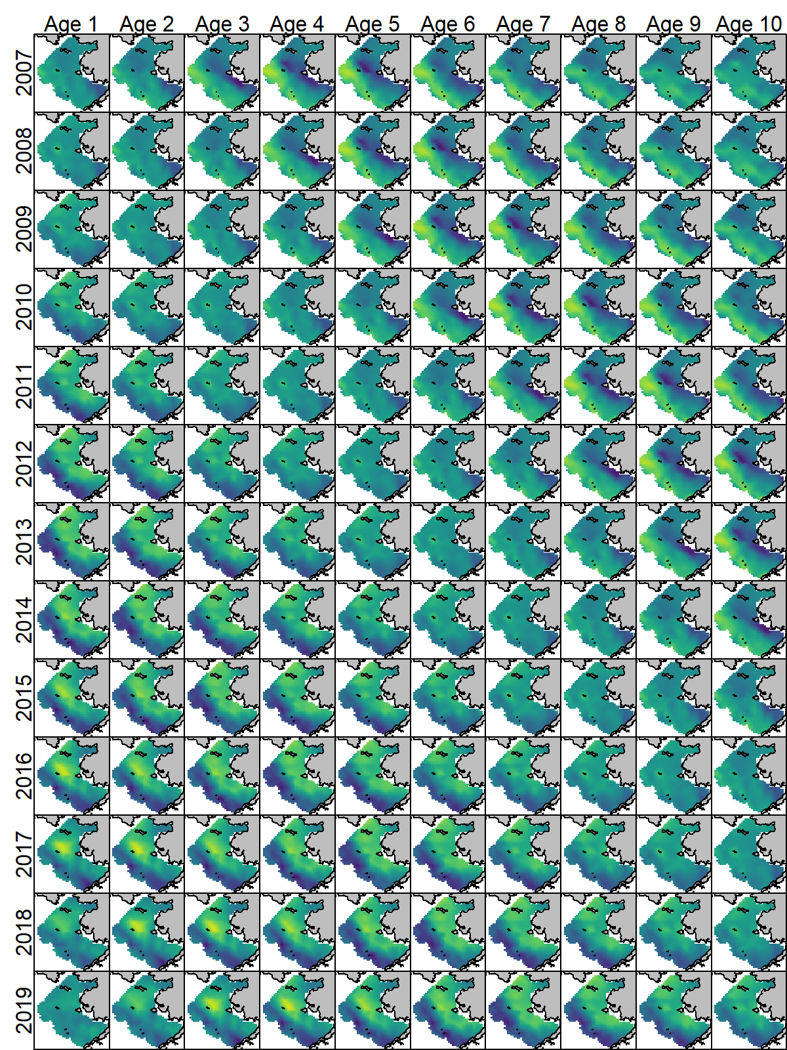

Table S1 – List of species (rows) and trait values (columns) used in the “trait-based habitat suitability” model, where traits are drawn from an updated fit of FishLife (Thorson et al., 2017), which includes trophic level. Note that traits are centered and scaled prior to analysis.
Common Name | Species | log max age | temperature | trophic level | log max length
Arrowtooth Flounder | Atheresthes stomias | 3.14 | 10.69 | 4.17 | 3.78
Pacific Halibut | Hippoglossus stenolepis | 4.01 | 9.75 | 4.14 | 5.39
Walleye Pollock | Gadus chalcogrammus | 3.33 | 11.07 | 3.57 | 4.16
Rex Sole | Glyptocephalus zachirus | 3.30 | 8.89 | 3.25 | 4.07
Pacific Cod | Gadus macrocephalus | 3.22 | 10.18 | 3.78 | 4.62
Flathead Sole | Hippoglossoides elassodon | 3.30 | 5.93 | 3.67 | 3.87
Pacific Dover Sole | Microstomus pacificus | 4.02 | 14.00 | 3.22 | 3.86
Sablefish | Anoplopoma fimbria | 4.54 | 8.50 | 3.84 | 3.15
Pacific Ocean Perch | Sebastes alutus | 4.63 | 5.40 | 3.48 | 3.84
Eulachon | Thaleichthys pacificus | 1.61 | 6.96 | 3.09 | 2.91
Southern Rock Sole | Lepidopsetta bilineata | 3.26 | 5.40 | 3.18 | 3.97
Shortspine Thornyhead | Sebastolobus alascanus | 4.60 | 14.63 | 3.62 | 3.53
Yellow Irish Lord | Hemilepidotus jordani | 2.32 | 10.85 | 3.62 | 3.35
Northern Rock Sole | Lepidopsetta polyxystra | 2.89 | 5.40 | 3.30 | 3.94
Longnose Skate | Raja rhina | 2.81 | 12.10 | 3.76 | 4.34
Pacific Spiny Dogfish | Squalus suckleyi | 4.03 | 5.40 | 4.19 | 4.34

Table S2 – Covariance (upper triangle, including variances on diagonal) and correlation (lower-triangle with grey background) among four life history traits across the 16 groundfishes included in the community-trait model (see Table S1).
 | log max age | temperature | trophic level | log max length
log max age | 0.7 | 0.32 | 0.1 | 0.11
temperature | 0.12 | 9.63 | 0.12 | 0.06
trophic level | 0.33 | 0.11 | 0.13 | 0.09
log max length | 0.23 | 0.03 | 0.45 | 0.35

