Supplementary files:

Supplementary figures to support the main manuscript.

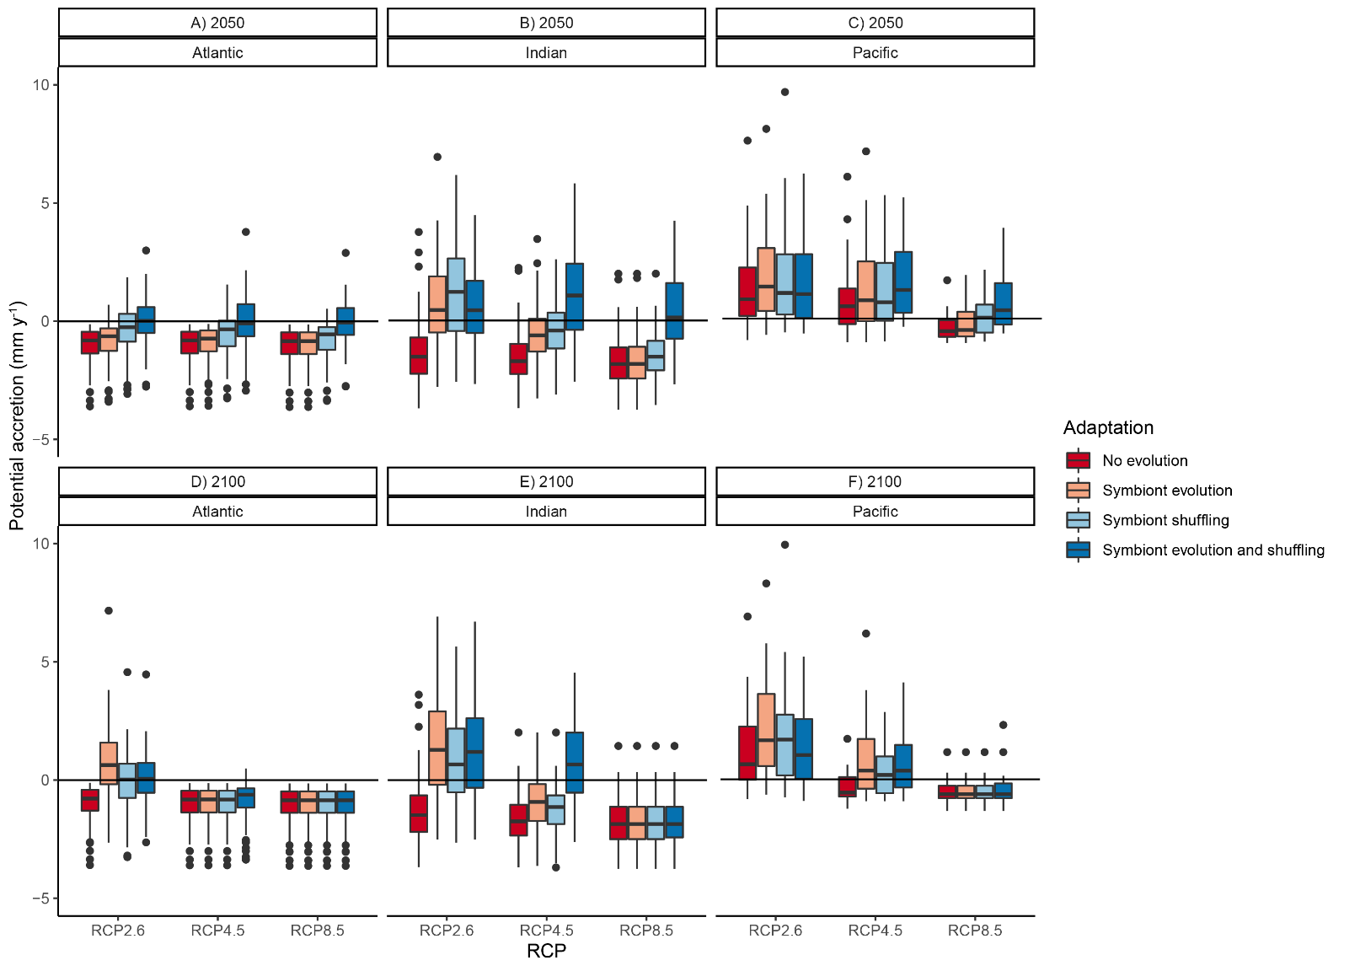

Figure S1: Projected potential vertical accretion rates (mm y-1) in the Atlantic (a, d), Indian (b, e), and Pacific (c, f) Oceans by 2050 (a, b, c) and 2100 (d, e, f), allowing for four levels of adaptive capacity: no evolution, symbiont evolution only, symbiont shuffling only, and symbiont evolution and shuffling combined under RCP2.6, 4.5 ad 8.5. Medians, quartiles and 95% whiskers displayed.

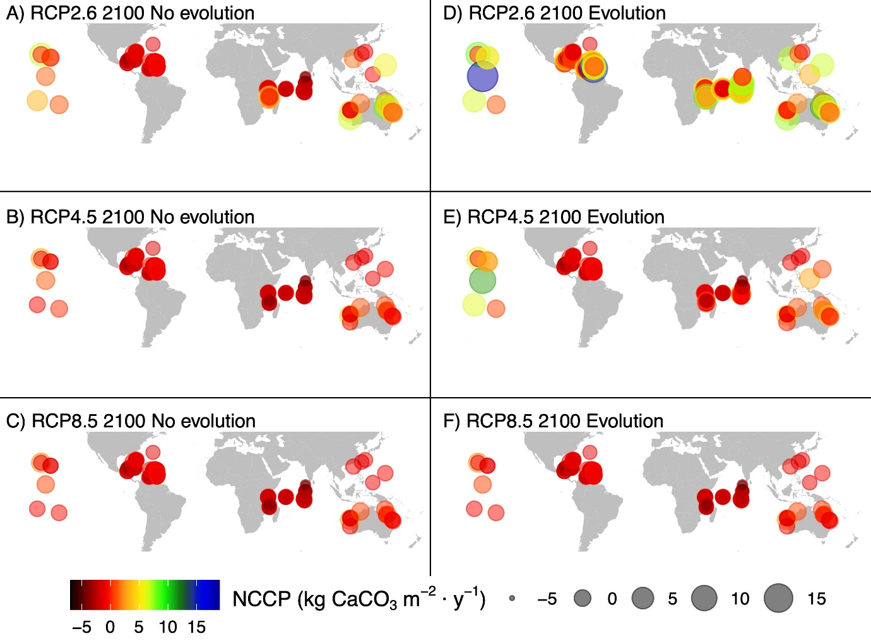

Figure S2: Locations of study reefs and their net carbonate production (kg CaCO3 m-2 y-1) under scenarios of no evolution (A, B, C) and evolution (D, E, F) at RCP2.6 (A, D), RCP4.5 (B, E) and RCP8.5 (C, F) by 2100.