Aquatic Geochemistry
Supplementary Material for
Predicting coral reef carbonate chemistry through statistical modeling: constraining nearshore residence time around Guam
Heidi K. Hirsh^{1,2}, Thomas Oliver³, Hannah Barkley³, Johanna L. K. Wren³, Stephen G. Monismith⁴, Derek P. Manzello⁵, and Ian C. Enochs¹
¹NOAA, Atlantic Oceanographic and Meteorological Laboratory, Ocean Chemistry and Ecosystem Division, 4301 Rickenbacker Cswy., Miami, FL 33149, USA
²University of Miami, Cooperative Institute for Marine and Atmospheric Studies, 4600 Rickenbacker Cswy., Miami, FL 33149, USA
³NOAA Pacific Islands Fisheries Science Center, 1845 Wasp Blvd, Building 176, Honolulu, HI 96818
⁴Environmental Fluid Mechanics Laboratory, Stanford University, 473 Via Ortega, Stanford, CA 94305
⁵Coral Reef Watch, Center for Satellite Applications and Research, Satellite Oceanography & Climatology Division, U.S. National Oceanic and Atmospheric Administration, College Park, MD 20740

Introduction

This document expands upon the method details provided in the main text and provides more detailed results for each estimation of residence time. The figures and tables provided here supplement the main text.
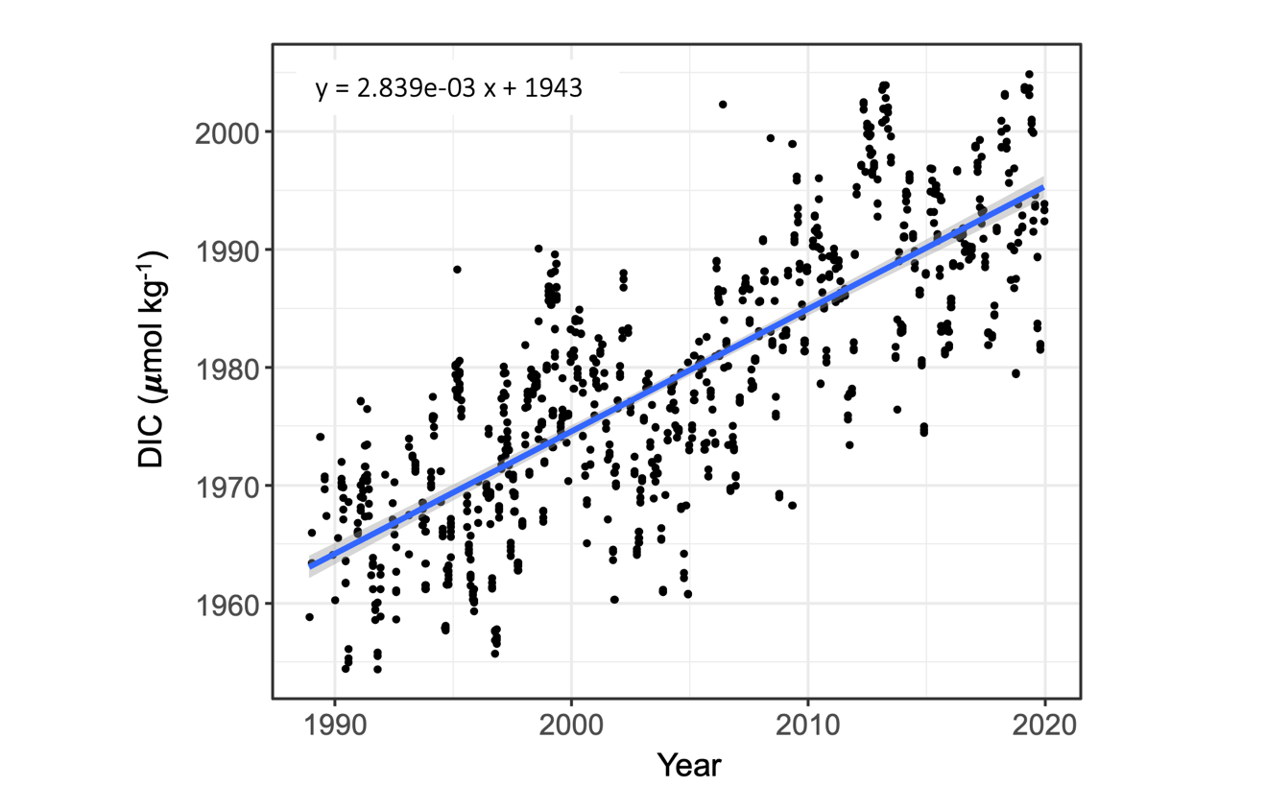

Figure S1. Dissolved inorganic carbon (DIC) measured over time as part of the Hawaii Ocean Time-series (HOT, https://hahana.soest.hawaii.edu/hot/methods/dicalk.html). The blue line shows the linear regression describing the change in DIC over time. This regression was used to correct our offshore reference values to account for the global progression of DIC over time. The gray shading indicates the 95% confidence interval.

Text S1. Land Masking
In the time periods of interest from 2015 to 2021, we identified three unique land masks (cells with NA value) for the island of Guam. These were later explained as adjustments made by Brian Powell’s team at the University of Hawai’i at Manoa to correct the location of the island in the interpolated grid. For our calculations, we required a single shared land mask so that we could compare residence time for the same sectors over time. To accomplish this, we shifted the definition of land cells prior to 2021 (the land mask was shifted by Brian on 8/9/2020) to match the 2021 mask (shifted East). This allowed us to compare the coastal current fields across years.

Prior to 2018, we also noticed additional cells masked in the northern and southern areas of the island. We considered these an “uncertainty mask” since they were not consistently part of the land mask, but there is obviously no data available in those cells for the years where they are NA. As such they lead to NA residence time estimates for the sectors they belong to (Sector 1 and Sector 3) and decrease the number of residence times ultimately used to calculate the Julian day climatological residence time for those sectors.

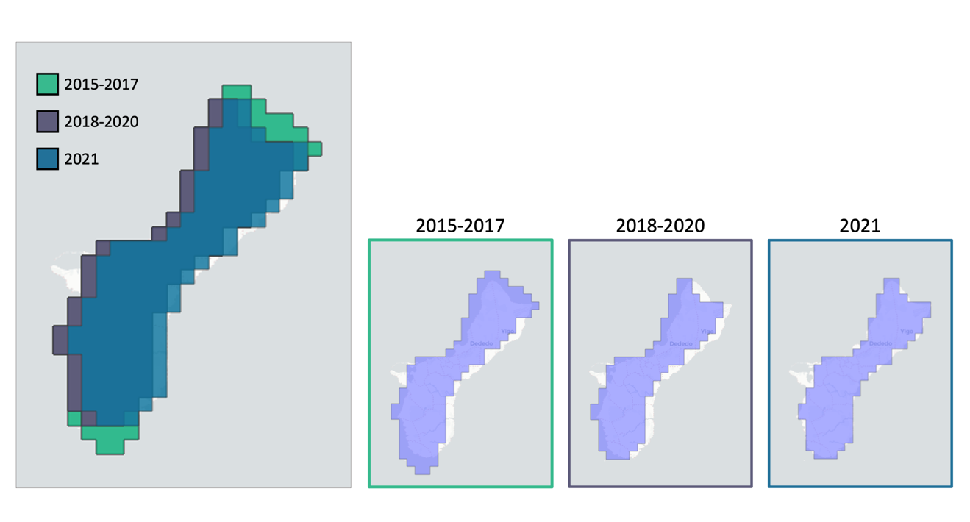

Figure S2. Illustration of the shifting Guam land mask through time. The 2021 land mask is the correct mask so prior fields were shifted East to compare residence time across years and calculate the appropriate climatological residence time.
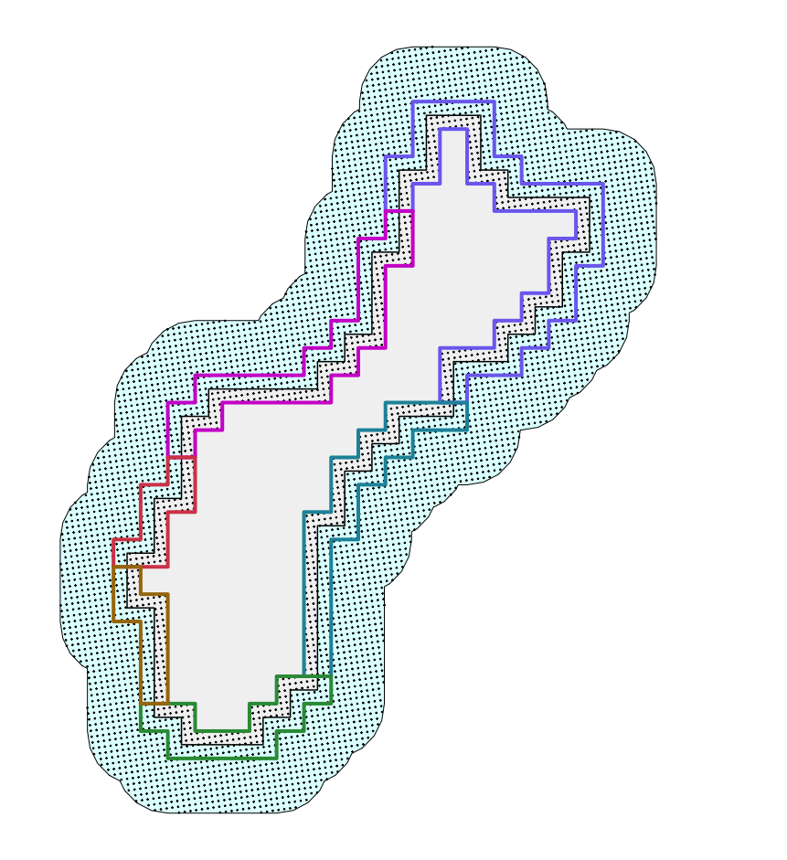
Figure S3. Designated seed sites (black points) for particle tracking in Ocean Parcels. Particles were seeded 500 m apart in each nearshore sectors as well as a 2-cell buffer beyond the sector boundaries (blue shading indicates seeding area). Gray polygon indicates the land mask for Guam (note, trajectories were not modeled for particles that were seeded inside the land mask boundary). Colored lines indicate the boundaries of the six nearshore sectors.

Text S2. Longshore Currents
We recalculated the velocity vectors in the cells nearest to land to better simulate longshore current flow, especially on the windward eastern side of the island. This was done because when we used the native velocity field, particles repeatedly beached onto the land mask and did not continue flowing along the coast. We defined a “land adjacency” identity for each nearshore cell (indicating the cardinal direction of any NA cells relative to the focal (coastal) cell), then based on the direction of land we redirected currents so that the velocity component that was not going directly toward land was favored in the total velocity vector, thus allowing water to flow parallel to land. This new velocity field (only changed in those nearshore cells) was used in the Ocean Parcels script if a particle became beached by the original velocity field.

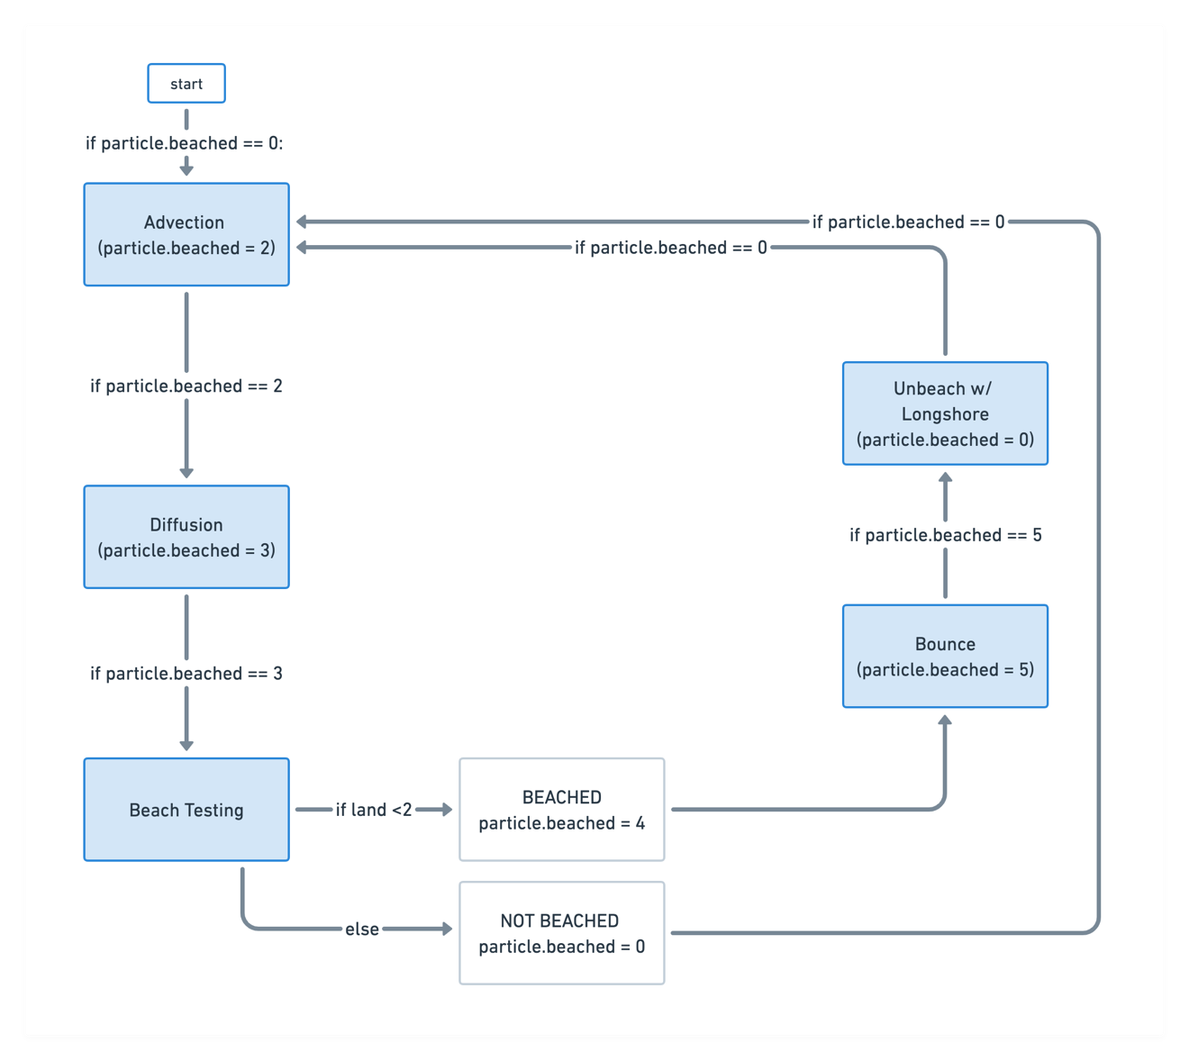Figure S4. Overview of the workflow used to advect particles using Ocean Parcels. The particle.beached value changes with each step and directs the next step taken. If a particle never leaves the nonzero velocity field then it will follow a simple progression of advection, diffusion, and beach testing (determining if it is on land or not) for each time step. If advection delivers a particle onto land then it is labeled as “beached” (particle.beached = 4) indicating that it should be returned to its previous location (“bounced” back) and re-advected using the longshore velocity field.
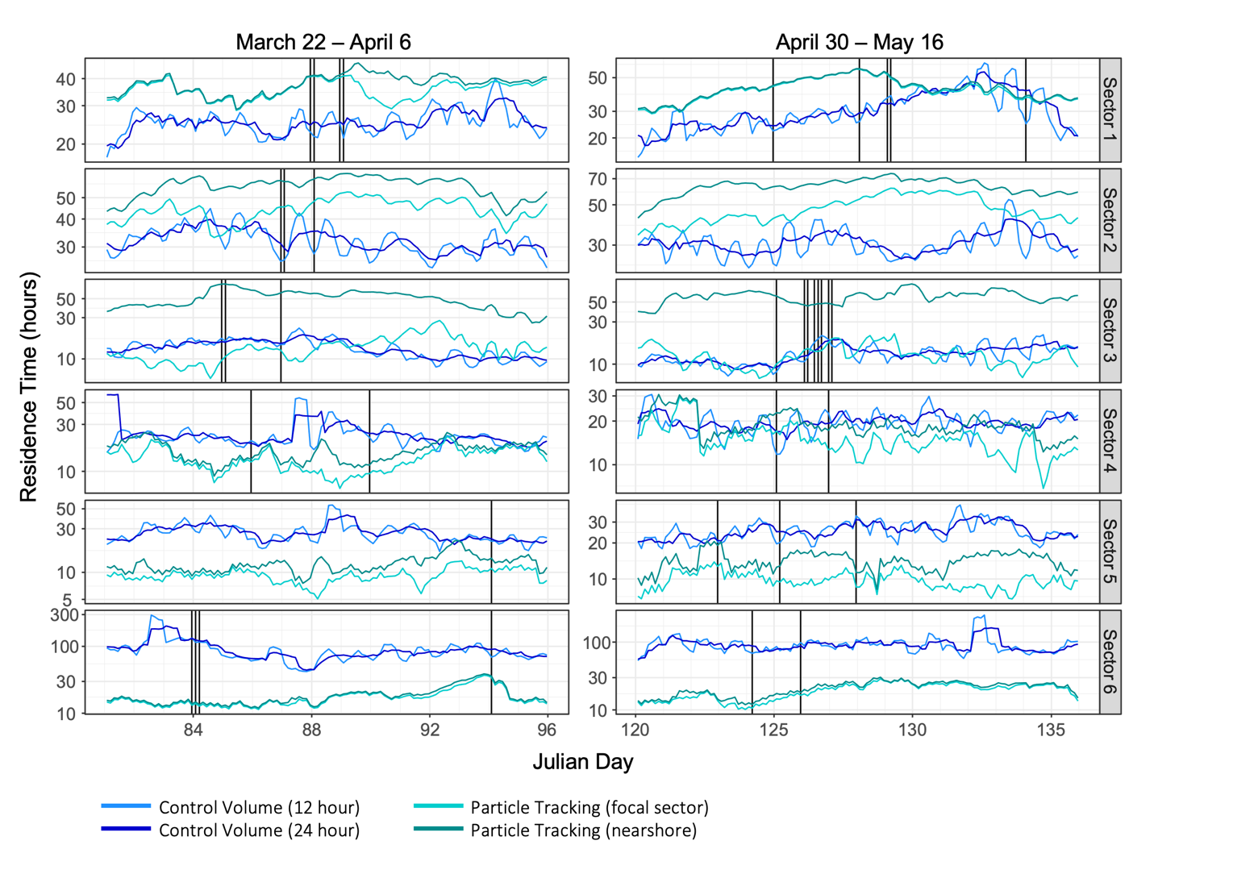

Figure S5. Time series comparing estimates of climatological residence time (in hours) from each estimation method. Control volume estimates are plotted in blue colors and particle tracking estimates are plotted in green colors. Residence time was calculated during the periods encompassing all the discrete sampling dates (black vertical lines): from March 22 to April 6 (Julian days 81 to 96) and from April 30 to May 16 (Julian days 120 to 136). Note, the y axis is a log scale, and the y axes may differ between time periods depending on the sector (for instance, control volume estimates of residence times were higher in Sector 6 (bottom) during the first period).

Table S1. Model performance comparison for statistical models predicting nearshore changes in dissolved inorganic carbon (ΔDIC). Models were evaluated based on the adjusted R-squared (Adj.Rsq) value and the difference in Akaike’s Information Criterion (ΔAIC). The model factors column indicates which parameters were included in each model (Benthos = benthic composition, HR = hour of the day, PAR = satellite-derived Photosynthetically Active Radiation, RT_CV12 = control volume (12 hour) residence time estimate, RT_CV24 = control volume (24 hour) residence time estimate, RT_PTsector = particle tracking (focal sector) residence time estimate, RT_PTnear = particle tracking (nearshore) residence time estimate, RT:Benthos = residence time as an interaction with benthic composition).

Model Factors | Adj.Rsq | ∆AIC | Residence Time? | RT Interaction?
Benthos | 0.145 | -11.22 | no | no
Benthos + HR | 0.151 | -11.69 | no | no
Benthos + HR + PAR | 0.136 | -13.68 | no | no
Benthos + HR + PAR + RT_CV12 | 0.144 | -14.01 | yes | no
Benthos + HR + PAR + RT_CV24 | 0.121 | -15.58 | yes | no
Benthos + HR + PAR + RT_PTsector | 0.146 | -13.90 | yes | no
Benthos + HR + PAR + RT_PTnear | 0.193 | -10.47 | yes | no
Benthos + HR + PAR + RT_CV12 + RT:Benthos | 0.342 | 0.00 | yes | yes
Benthos + HR + PAR + RT_CV24 + RT:Benthos | 0.285 | -4.97 | yes | yes
Benthos + HR + PAR + RT_PTsector + RT:Benthos | 0.121 | -17.37 | yes | yes
Benthos + HR + PAR + RT_PTnear + RT:Benthos | 0.168 | -14.06 | yes | yes

Table S2. Model performance comparison for statistical models predicting nearshore changes in total alkalinity (ΔTA). Models were evaluated based on the adjusted R-squared (Adj.Rsq) value and the difference in Akaike’s Information Criterion (ΔAIC). The model factors column indicates which parameters were included in each model (Benthos = benthic composition, HR = hour of the day, PAR = satellite-derived Photosynthetically Active Radiation, RT_CV12 = control volume (12 hour) residence time estimate, RT_CV24 = control volume (24 hour) residence time estimate, RT_PTsector = particle tracking (focal sector) residence time estimate, RT_PTnear = particle tracking (nearshore) residence time estimate, RT:Benthos = residence time as an interaction with benthic composition).

Model Factors | Adj.Rsq | ∆AIC | Residence Time? | RT Interaction?
Benthos | 0.020 | -4.20 | no | no
Benthos + HR | 0.009 | -5.83 | no | no
Benthos + HR + PAR | 0.003 | -7.13 | no | no
Benthos + HR + PAR + RT_CV12 | -0.005 | -8.49 | yes | no
Benthos + HR + PAR + RT_CV24 | -0.015 | -9.12 | yes | no
Benthos + HR + PAR + RT_PTsector | 0.024 | -6.72 | yes | no
Benthos + HR + PAR + RT_PTnear | 0.126 | 0.00 | yes | no
Benthos + HR + PAR + RT_CV12 + RT:Benthos | 0.112 | -2.66 | yes | yes
Benthos + HR + PAR + RT_CV24 + RT:Benthos | 0.145 | -0.35 | yes | yes
Benthos + HR + PAR + RT_PTsector + RT:Benthos | -0.010 | -10.56 | yes | yes
Benthos + HR + PAR + RT_PTnear + RT:Benthos | 0.094 | -3.93 | yes | yes

Text S3. Data Archival Details

Carbonate chemistry:
Guam 2017: https://www.ncei.noaa.gov/data/oceans/ncei/ocads/metadata/0175228.html
Oliver, Thomas A.; Barkley, Hannah C.; Young, Charles W.; Pomeroy, Noah; Halperin, Ariel A.; Smith, Joy N. (2018). National Coral Reef Monitoring Program: Dissolved inorganic carbon, total alkalinity, pH and other variables collected from surface discrete measurements using Coulometer, alkalinity titrator and other instruments from Guam and the Commonwealth of the Northern Marianas Islands from 2017-05-02 to 2017-06-20 (NCEI Accession 0175228). NOAA National Centers for Environmental Information. Dataset. https://doi.org/10.25921/8n1z-pm97.

Guam 2014: https://www.ncei.noaa.gov/data/oceans/ncei/ocads/metadata/0157715.html
Barkley, Hannah C.; Oliver, Thomas A.; Young, Charles W.; Pomeroy, Noah; Halperin, Ariel A.; Smith, Joy N.; Trick, Kevin (2017). National Coral Reef Monitoring Program: Dissolved inorganic carbon, total alkalinity, pH and other variables collected from surface discrete measurements using Coulometer, alkalinity titrator and other instruments from Guam and the Commonwealth of the Northern Marianas Islands from 2014-03-24 to 2014-05-05 (NCEI Accession 0157715). NOAA National Centers for Environmental Information. Dataset. https://www.ncei.noaa.gov/archive/accession/0157715.

Guam 2011: https://www.ncei.noaa.gov/data/oceans/ncei/ocads/metadata/0232262.html
Barkley, Hannah C.; Oliver, Thomas A.; Young, Charles W.; Pomeroy, Noah; Halperin, Ariel A.; Smith, Joy N.; Trick, Kevin (2021). Pacific Reef Assessment and Monitoring Program: Dissolved inorganic carbon, total alkalinity, pH and other variables collected from surface discrete measurements using Coulometer, alkalinity titrator and other instruments from the US Pacific Islands from 2006-02-12 to 2012-05-18 (NCEI Accession 0232262). NOAA National Centers for Environmental Information. Dataset. https://www.ncei.noaa.gov/archive/accession/0232262.

Benthic composition:
Guam 2011 (RAMP): https://www.fisheries.noaa.gov/inport/item/34515
Pacific Islands Fisheries Science Center, 2022: Pacific Reef Assessment and Monitoring Program: Stratified Random Surveys (StRS) of Reef Fish, including Benthic Estimate Data at Coral Reef Sites across the Pacific Ocean from 2007 to 2012, https://www.fisheries.noaa.gov/inport/item/34515.

Guam 2014 & 2017 (NCRMP): https://www.fisheries.noaa.gov/inport/item/36156
Pacific Islands Fisheries Science Center, 2022: National Coral Reef Monitoring Program: Benthic Cover Derived from Analysis of Benthic Images Collected during Stratified Random Surveys (StRS) across the Mariana Archipelago since 2014, https://www.fisheries.noaa.gov/inport/item/36156.
(2014) http://accession.nodc.noaa.gov/0159148
(2017) http://accession.nodc.noaa.gov/0176574

