Supplementary Table 1. Summary of covariates at sites sampled in the lower Sacramento-San Joaquin Delta during the spring of 2017. See Figure 1 in main text for map of site locations.

Site | Region | Sampling Date(s) | Channel Type | Site Area (${km}^{2}$) | Mean Depth (m) | Sinuosity | Channel width (m)
1 | Lower San Joaquin | 4/4/2017  4/10/2017  4/19/2017  5/1/2017  4/26/2017  5/10/2017 | Mainstem | 0.33 | 9.11 | 1.24 | 730
3 | Lower Old River | 4/6/2017 | Mainstem | 0.12 | 3.15 | 1.12 | 98
6 | Mildred Island and Cuts | 4/7/2017 | Distributary | 0.12 | 4.22 | 1.00 | 105
8 | Lower Old River | 4/8/2017 | Distributary | 0.18 | 3.93 | 1.33 | 160
10 | Middle River and Cuts | 4/13/2017 | Distributary | 0.83 | 3.29 | 1.00 | 76
11 | Mildred Island and Cuts | 4/14/2017 | Mainstem | 0.19 | 5.02 | 1.52 | 126
12 | Lower San Joaquin | 4/15/2017 | Mainstem | 0.13 | 3.97 | 1.07 | 260
13 | Upper San Joaquin | 4/20/2017 | Mainstem | 0.83 | 2.90 | 1.65 | 75
14 | Upper Old River and Cuts | 4/21/2017 | Distributary | 0.70 | 2.26 | 1.00 | 71
16 | Mid San Joaquin | 4/22/2017 | Mainstem | 0.70 | 6.16 | 1.01 | 168
19 | Lower Old River | 4/28/2017 | Mainstem | 0.19 | 3.13 | 1.29 | 146
22 | Lower Old River | 4/29/2017 | Mainstem | 0.14 | 3.81 | 1.35 | 106
23 | Upper San Joaquin | 5/4/2017 | Mainstem | 0.15 | 2.13 | 2.08 | 130
24 | Lower San Joaquin | 5/5/2017 | Mainstem | 0.22 | 2.36 | 1.02 | 238
25 | Upper San Joaquin | 4/5/2017  4/11/2017  4/17/2017  4/27/2017  5/2/2017  5/8/2017 | Mainstem | 0.71 | 2.01 | 1.49 | 82
27 | Mildred Island and Cuts | 5/6/2017 | Mainstem | 0.17 | 5.68 | 1.43 | 185
28 | Mildred Island and Cuts | 4/3/2017  4/12/2017  4/18/2017  4/25/2017  5/3/2017  5/9/2017 | Distributary | 0.15 | 3.78 | 1.06 | 98
33 | Lower San Joaquin | 5/11/2017 | Distributary | 0.21 | 4.74 | 1.00 | 189
34 | Upper Old River and Cuts | 5/12/2017 | Mainstem | 0.87 | 1.24 | 1.38 | 72
37 | Franks Tract | 5/13/2017 | Distributary | 0.11 | 4.30 | 1.23 | 91

Supplementary Table 2. Summary of fish catches during electrofishing sampling at the three repeat sites in the lower Sacramento-San Joaquin Delta on two different occasions each, at the beginning and end of the season.

Site | Date | Species | Common Name | Count
1 | 11 April 2017 | Micropterus salmoides | Largemouth Bass | 52
 |  | Morone saxatilis | Striped Bass | 13
 |  | Ameiurus catus | White Catfish | 1
 |  | Lepomis microlophus | Redear Sunfish | 4
 |  | Lepomis gulosus | Warmouth | 1
1 | 11 May 2017 | Lepomis macrochirus | Bluegill Sunfish | 1
 |  | Cyprinus carpio | Common Carp | 1
 |  | Micropterus salmoides | Largemouth Bass | 13
 |  | Ptychocheilus grandis | Sacramento Pikeminnow | 1
 |  | Lepomis microlophus | Redear Sunfish | 4
 |  | Notemigonus crysoleucas | Golden Shiner | 3
 |  | Morone saxatilis | Striped Bass | 30
 |  | Hysterocarpus traskii | Tule Perch | 1
 |  | Ameiurus catus | White Catfish | 1
25 | 12 April 2017 | Lepomis macrochirus | Bluegill Sunfish | 9
 |  | Micropterus salmoides | Largemouth Bass | 36
 |  | Lepomis microlophus | Redear Sunfish | 23
 |  | Morone saxatilis | Striped Bass | 23
 |  | Ameiurus catus | White Catfish | 1
25 | 9 May 2017 | Micropterus salmoides | Largemouth Bass | 29
 |  | Ptychocheilus grandis | Sacramento Pikeminnow | 1
 |  | Lepomis microlophus | Redear Sunfish | 3
 |  | Morone saxatilis | Striped Bass | 26
 |  | Lepomis macrochirus | Bluegill Sunfish | 1
 |  | Carassius auratus | Goldfish | 1
 |  | Ptychocheilus grandis | Sacramento Pikeminnow | 2
 |  | Lepomis microlophus | Redear Sunfish | 4
 |  | Ameiurus catus | White Catfish | 5
28 | 13 April 2017 | Ameiurus nebulosus | Brown Bullhead | 3
 |  | Lepomis macrochirus | Bluegill Sunfish | 6
 |  | Carassius auratus | Goldfish | 1
 |  | Micropterus salmoides | Largemouth Bass | 111
 |  | Lepomis microlophus | Redear Sunfish | 27
 |  | Ameiurus catus | White Catfish | 10
 |  | Lepomis gulosus | Warmouth | 1
 |  | Cyprinus carpio | Common Carp | 6
28 | 10 May 2017 | Lepomis macrochirus | Bluegill Sunfish | 11
 |  | Pomoxis nigromaculatus | Black Crappie | 1
 |  | Cyprinus carpio | Common Carp | 3
 |  | Lepomis cyanellus | Green Sunfish | 1
 |  | Micropterus salmoides | Largemouth Bass | 115
 |  | Lepomis microlophus | Redear Sunfish | 29
 |  | Ameiurus catus | White Catfish | 4
 |  | Lepomis gulosus | Warmouth | 5

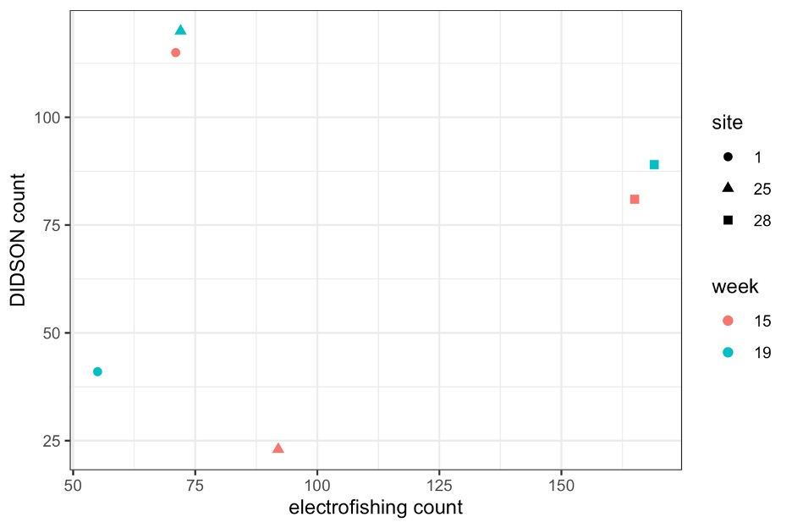
Supplemental Figure 1. Relationship between the number of fish captured with electrofishing and observed with the dual-frequency identification sonar (DIDSON) at three sites on two different dates.

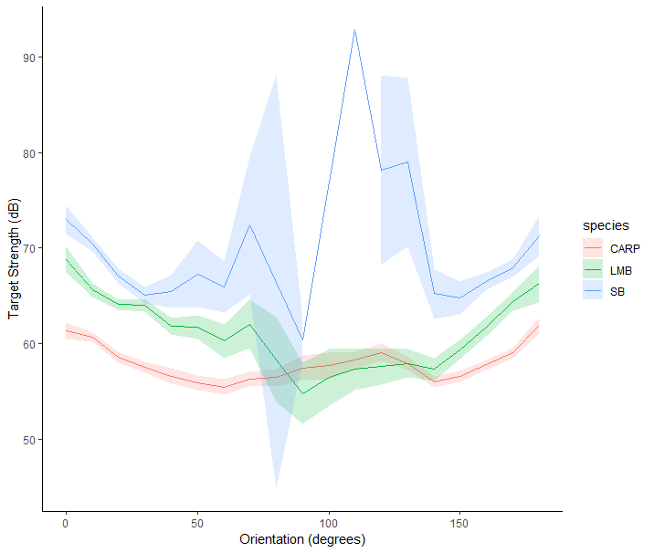
Supplementary Figure 2. Target strength versus orientation for three species of fish observed in the Delta: Common Carp (CARP); Largemouth Bass (LMB); and Striped Bass (SB). Target Strength is the magnitude of sound reflected by the fish measured in decibels (dB). Orientation is the direction a fish is facing relative to the DIDSON camera. 95% confidence intervals are presented as shaded ribbons around each line.

