Appendix A

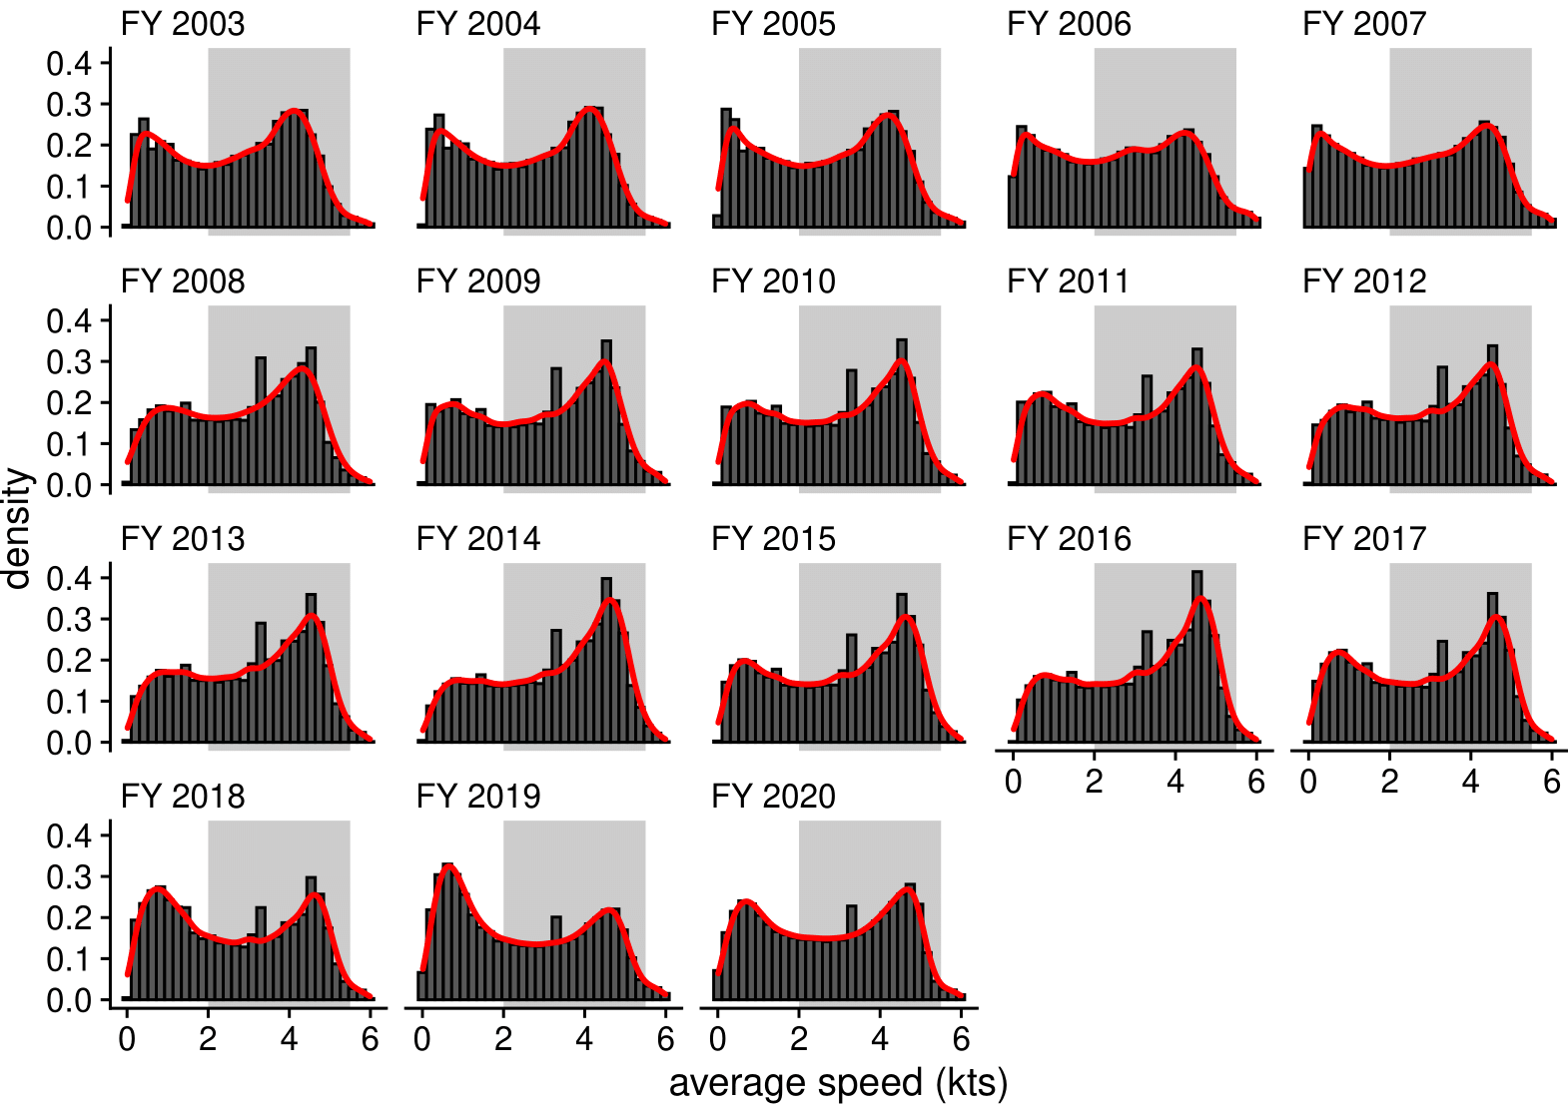
Figure A1: Histograms and density plots (red lines) of the average vessel speed monitored by the Vessel Monitoring System for vessels participating in the U.S. Atlantic sea scallop fishery by fishing year (FY). The grey rectangles indicate the average speed used to define fishing in this study. Roughly 19% of average vessel speeds were greater than 6 kts across fishing years, but are not shown.

Appendix B
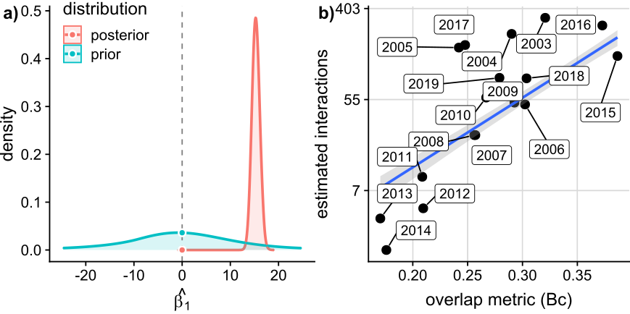
Figure B1: a) density plots of the posterior and prior distributions for ${\hat{β_{1}}}_{}$from the Bayesian regression model and b) scatter plot of estimated interactions, averaged overlap values by calendar year, and the fitted line from the Bayesian regression model with 95% credible intervals.

Appendix C
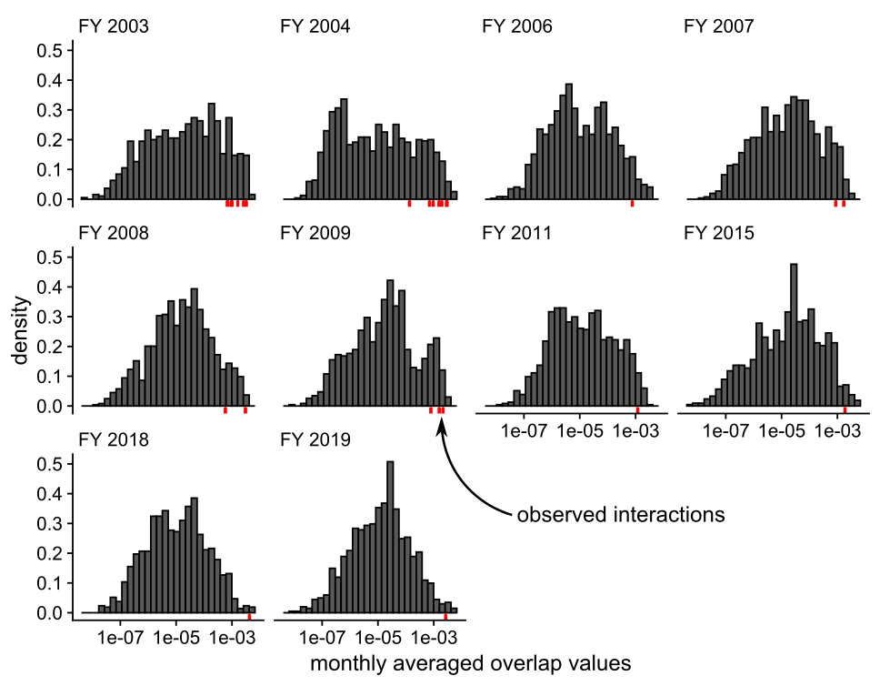
Figure C1: Histograms of the monthly averaged overlap values for fishing years (FY) with observed interactions on the log₁₀ scale. The rug plots (red lines beneath the histograms) indicate values associated with an observed interaction.

