Supporting Information

DNA metabarcoding marker choice skews perception of marine eukaryotic biodiversity

Jordan M. Casey, Emma Ransome, Allen G. Collins, Angka Mahardini, Eka M. Kurniasih, Andrianus Sembiring, Nina M. D. Schiettekatte, Ni Kadek Dita Cahyani, Aji Wahyu Anggoro, Mikaela Moore, Abby Uehling, Mahdi Belcaid, Paul H. Barber, Jonathan B. Geller, Christopher P. Meyer

Supporting Tables

Primer Label | Primer Sequence (5'-3')
m1COIintF_Tag1 | AGACGCGGWACWGGWTGAACWGTWTAYCCYCC
m1COIintF_Tag2 | AGTGTAGGWACWGGWTGAACWGTWTAYCCYCC
m1COIintF_Tag3 | ACTAGCGGWACWGGWTGAACWGTWTAYCCYCC
m1COIintF_Tag4 | ACAGTCGGWACWGGWTGAACWGTWTAYCCYCC
m1COIintF_Tag5 | ATCGACGGWACWGGWTGAACWGTWTAYCCYCC
m1COIintF_Tag6 | ATGTCGGGWACWGGWTGAACWGTWTAYCCYCC
m1COIintF_Tag7 | ATAGCAGGWACWGGWTGAACWGTWTAYCCYCC
jgHCO_Tag1 | AGACGCTAIACYTCIGGRTGICCRAARAAYCA
jgHCO_Tag2 | AGTGTATAIACYTCIGGRTGICCRAARAAYCA
jgHCO_Tag3 | ACTAGCTAIACYTCIGGRTGICCRAARAAYCA
jgHCO_Tag4 | ACAGTCTAIACYTCIGGRTGICCRAARAAYCA
jgHCO_Tag5 | ATCGACTAIACYTCIGGRTGICCRAARAAYCA
jgHCO_Tag6 | ATGTCGTAIACYTCIGGRTGICCRAARAAYCA
jgHCO_Tag7 | ATAGCATAIACYTCIGGRTGICCRAARAAYCA

Table S1. Seven-tailed primer pairs of MICOIintF and jgHCO2190. Six base pair tags are bolded within the primer sequence.

Rank | COI | 18S
11 | Sipuncula | Ochrophyta
12 | Nemertea | Entoprocta
13 | Ascomycota | Nematoda
14 | Amoebozoa | Miozoa
15 | Nematoda | Xenacoelomorpha
16 | Chlorophyta | Nemertea
17 | Chaetognatha | Retaria
18 | Platyhelminthes | Ciliophora
19 | Pseudofungi | Sipuncula
20 | Choanozoa | Chlorophyta
21 | Entoprocta | Bigyra
22 | Kinorhyncha | Cercozoa
23 | Sulcozoa | Kinorhyncha
24 | Haptophyta | Gastrotricha
25 | Rotifera | Brachiopoda
26 | Cercozoa | Pseudofungi
27 | Hemichordata | Charophyta
28 | Basidiomycota | Ctenophora
29 | Xenacoelomorpha | Ascomycota
30 | Bigyra | Choanozoa
31 | Picozoa | Amoebozoa
32 | Miozoa | Hemichordata
33 | Gastrotricha | Haptophyta
34 | Rhizaria | Sulcuzoa
35 | Placozoa | Basidiomycota
36 | Retaria | Heliozoa
37 | Proteobacteria | Loukozoa
38 | Chytridiomycota | Tardigrada
39 |  | Metamonada
40 |  | Zygomycota
41 |  | Acanthocephala
42 |  | Rotifera
43 |  | Sulcozoa
44 |  | Placozoa
45 |  | Cryptista
46 |  | Chytridiomycota
47 |  | Chaetognatha
48 |  | Orthonectida
49 |  | Glomeromycota
50 |  | Loricifera
51 |  | Hermichordata

Table S2. List of phyla beyond the ten phyla with the highest average relative abundances across the ARMS for the COI and 18S datasets, ranked by average relative abundance. These phyla are summarized as the “Other” category in Figure 4.

Phylum | COI | 18S
Amoebozoa | 0.04% [0.02, 0.07] | <0.01% [<0.01, 0.01]
Annelida | 13.73% [7.68, 24.56] | 14.7% [8.47, 24.81]
Arthropoda | 14.41% [8.12, 25.37] | 17.6% [10.04, 30.71]
Ascomycota | 0.09% [0.05, 0.16] | 0.01% [0.01, 0.02]
Bryozoa | 12.67% [7.25, 22.59] | 2.73% [1.51, 4.97]
Chlorophyta | 0.03% [0.02, 0.06] | 0.2% [0.11, 0.34]
Choanozoa | 0.01% [<0.01, 0.01] | 0.01% [<0.01, 0.01]
Chordata | 2.85% [1.55, 5.25] | 15.44% [8.68, 27.4]
Cnidaria | 6.95% [3.91, 12.18] | 9.22% [5.2, 16.59]
Echinodermata | 1.83% [0.99, 3.33] | 1.73% [0.91, 3.2]
Entoprocta | 0.01% [<0.01, 0.01] | 0.39% [0.2, 0.75]
Haptophyta | <0.01% [<0.01, <0.01] | <0.01% [<0.01, <0.01]
Mollusca | 2.94% [1.65, 5.28] | 3.18% [1.82, 5.63]
Nematoda | 0.03% [0.02, 0.06] | 0.7% [0.39, 1.23]
Nemertea | 0.15% [0.08, 0.31] | 0.31% [0.16, 0.6]
Ochrophyta | 1.61% [0.9, 2.83] | 1.43% [0.82, 2.53]
Porifera | 15.14% [8.72, 26.37] | 7.54% [4.26, 13.2]
Pseudofungi | 0.01% [0.01, 0.03] | 0.02% [0.01, 0.03]
Rhodophyta | 14.86% [8.31, 26.12] | 9.69% [5.49, 16.79]
Sipuncula | 0.5% [0.27, 0.96] | 0.19% [0.1, 0.34]

Table S3. Means ± 95% credible intervals from a Bayesian mixed model that assesses the effect of COI versus 18S marker choice on the relative abundances of 20 co-occurring phyla (see Figure 5).

Phylum | COI | 18S | CoralNet
Annelida | 1.36% [0.62, 3.06] | 2.77% [1.32, 5.88] | 2.52% [1.24, 5.14]
Bryozoa | 22.33% [10.98, 46.59] | 5.15% [2.4, 11.05] | 27.54% [13.48, 57.21]
Chlorophyta | 0.04% [0.02, 0.08] | 0.38% [0.18, 0.77] | 1.55% [0.72, 3.21]
Chordata | 4.44% [2.06, 9.33] | 35.95% [16.66, 72.78] | 3.19% [1.54, 6.57]
Mollusca | 2.35% [1.08, 5.2] | 2.95% [1.37, 6.47] | 2.4% [1.09, 5.28]
Porifera | 32.87% [15.76, 66.71] | 12.86% [5.83, 26.6] | 38.56% [18.47, 77.73]
Rhodophyta | 19.07% [9.34, 38.93] | 18.32% [8.8, 36.47] | 21.11% [10.28, 42.99]

Table S4. Means ± 95% credible intervals from a Bayesian mixed model that assesses the effect of COI marker choice, 18S marker choice, and visual image analysis of ARMS plates (CoralNet) on the relative abundances of seven co-occurring phyla (see Figure 6).

Supporting Figures

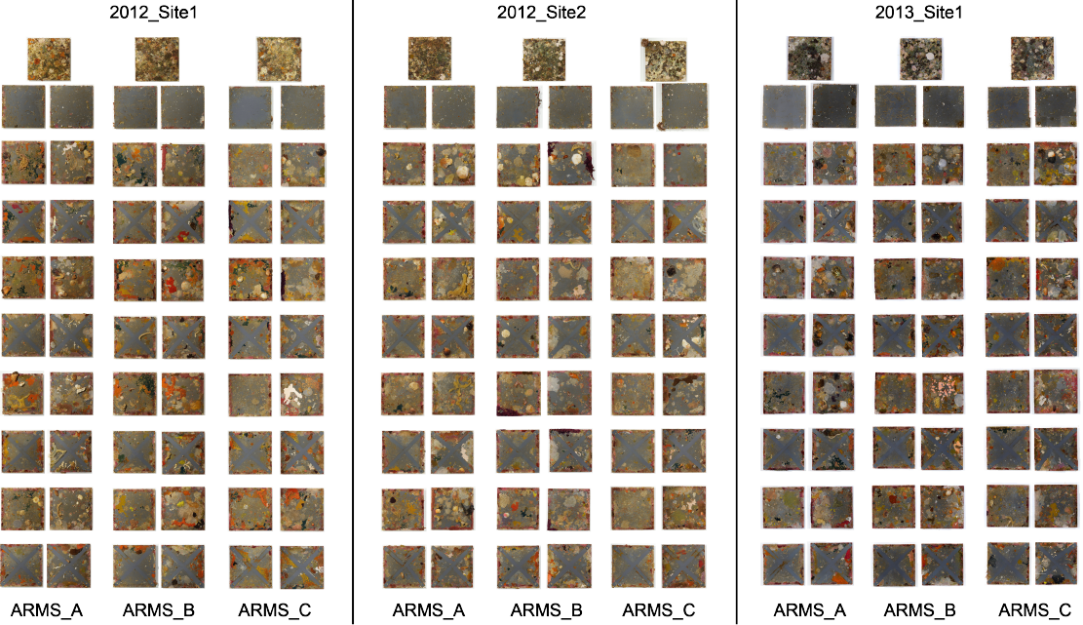

Figure S1. Compilation of high quality plate images from the nine autonomous reef monitoring structures (ARMS) across the sampling years and sites (Site 1 in 2012, Site 2 in 2012, and Site 1 in 2013). For each ARMS, the images on the left-hand side are the tops of the plates, and the photos on the right-hand side are the bottoms of the plates. High quality images of each individual plate are also available on the California Digital Library (https://n2t.net/ark:/21547/DXy2).

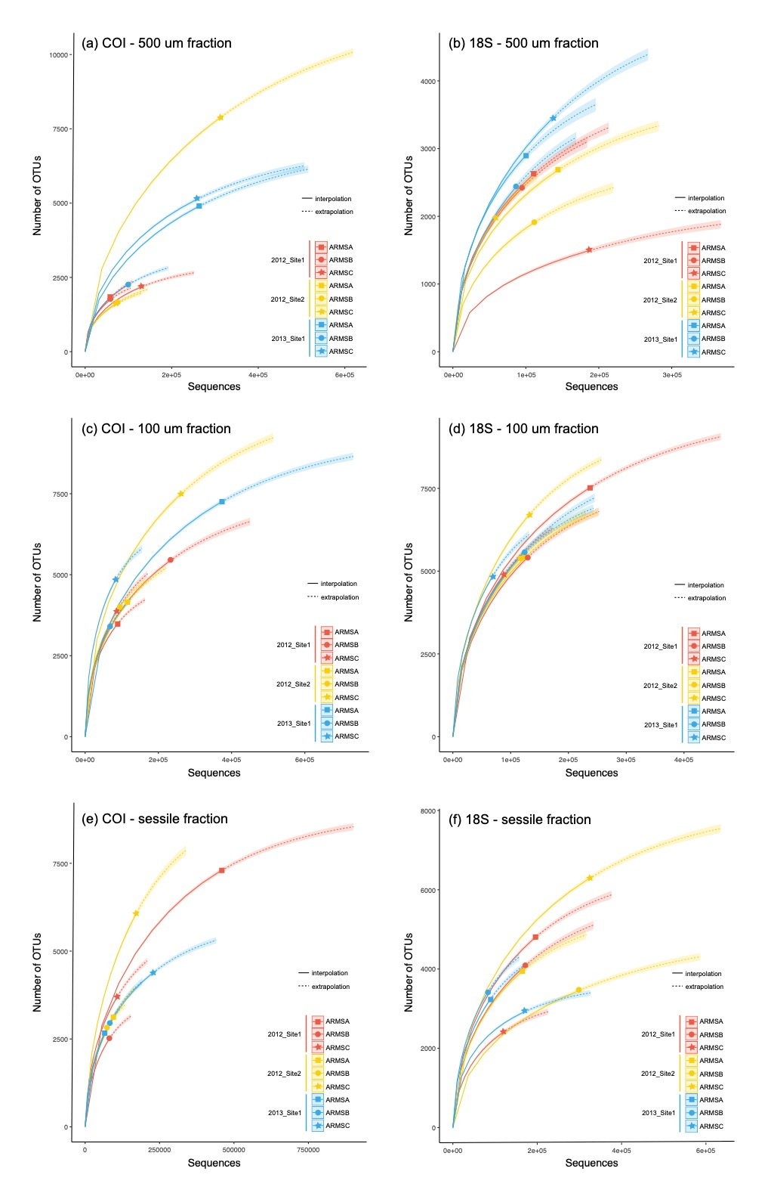
Figure S2. Rarefaction curves for the (a,c,e) COI and (b,d,f) 18S markers showing operational taxonomic unit (OTU) richness by total number of sequences for each fraction of each autonomous reef monitoring structure (ARMS) in each year and site. Fractions include the 500 μm – 2 mm fraction (a,b; 500 μm fraction), the 500 μm – 106 μm fraction (c,d; 100 μm fraction), and the sessile fraction (e,f). Solid lines indicate interpolated values, and dotted lines indicate predicted extrapolated values.

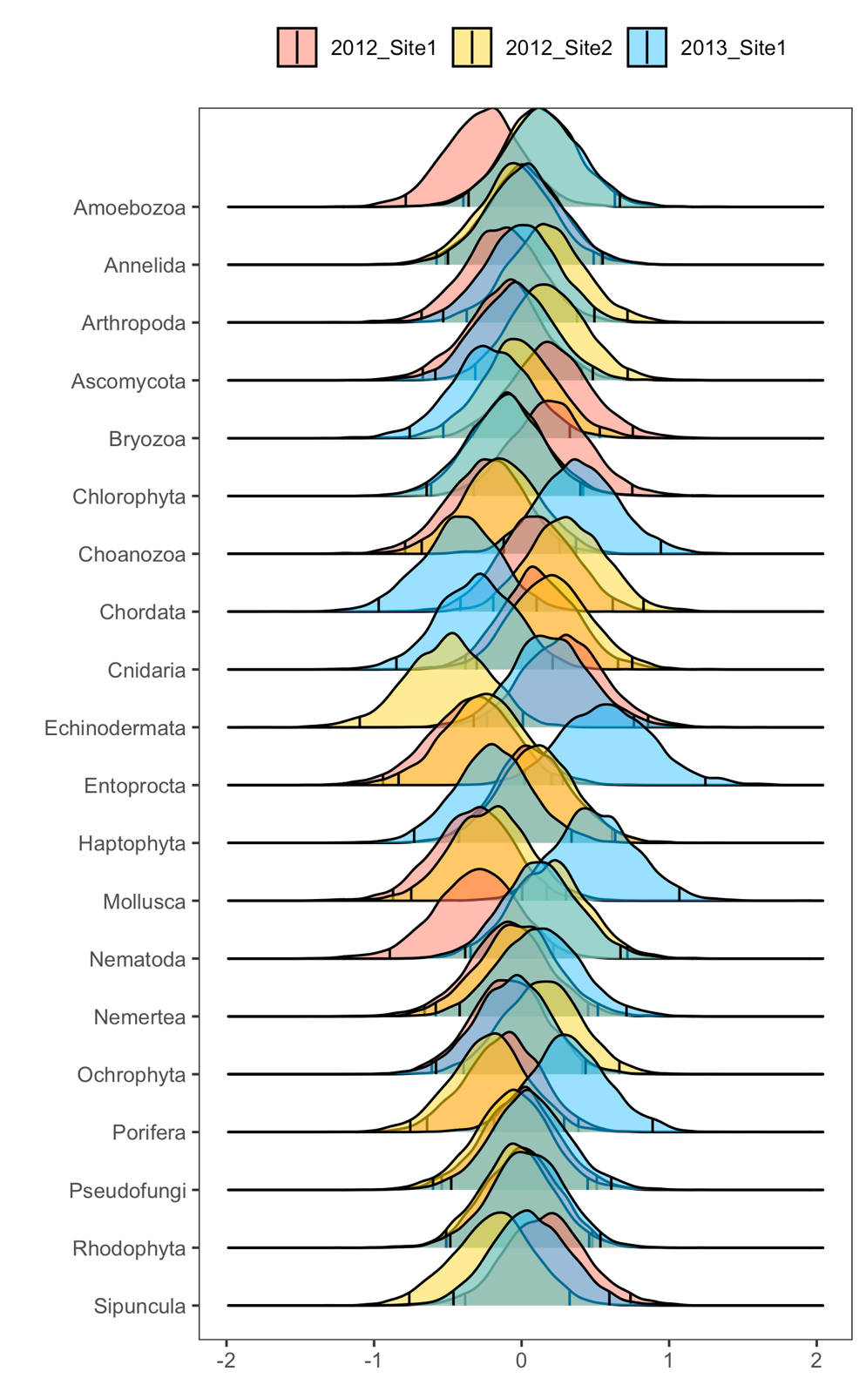

Figure S3. The relative effect of the spatio-temporal variables (year and site) on the predicted relative abundances of the 20 co-occurring phyla across the COI and 18S datasets. The mean posterior distributions (±95% highest density intervals (HDIs) are designated by vertical black bars within each curve) from a Bayesian mixed model. When the HDIs between the two curves do not overlap, this indicates strong differences among quantification techniques.

