Supplementary Material
Tracking Performance of Fish Detection and Classification Models on Real-World Unlabeled Datasets
Jack Prior*, Matthew D. Campbell, Matthew Dawkins, Paul F. Mickle, Robert J. Moorhead, Simegnew Y. Alaba, Chiranjibi Shah, Joseph R. Salisbury, Kevin R. Rademacher, A. Paul Felts, Farron Wallace
* Correspondence: Corresponding Author: jack.prior@noaa.gov

Supplementary Figures

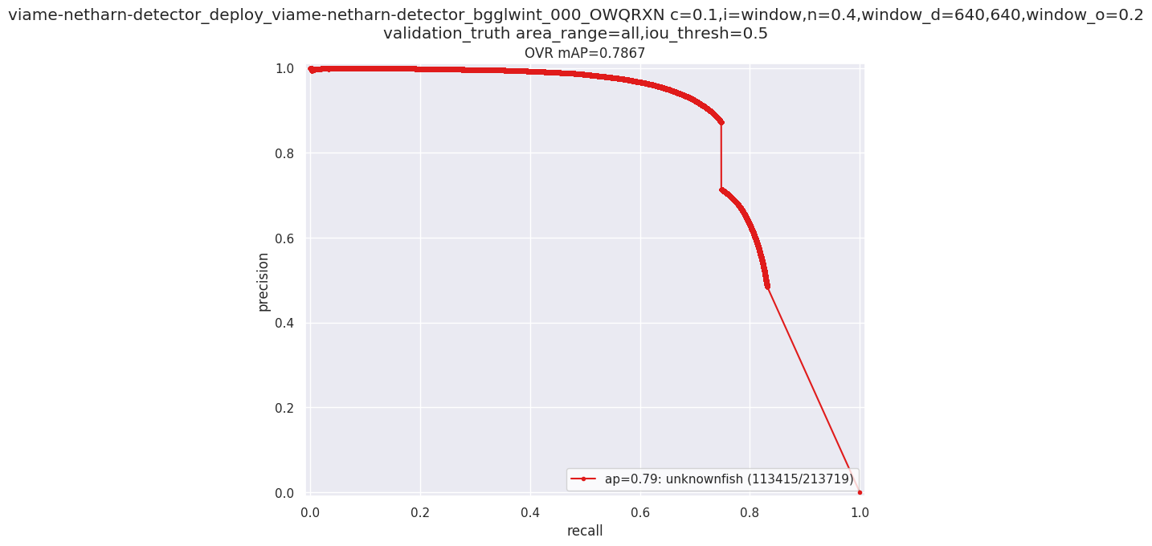
Supplementary Figure 1. Raw output from VIAME training of model 2.4s, showing a precision and recall relationship with the mAP₅₀ value of 0.7867
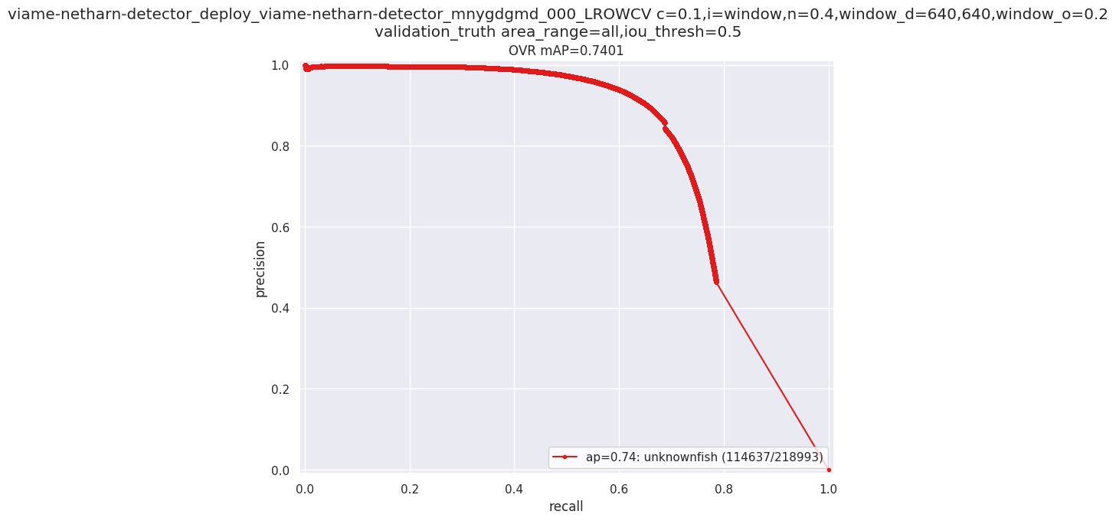
Supplementary Figure 2. Raw output from VIAME training of model 2.4m, showing a precision and recall relationship with the mAP₅₀ value of 0.7401

