Supplementary Information

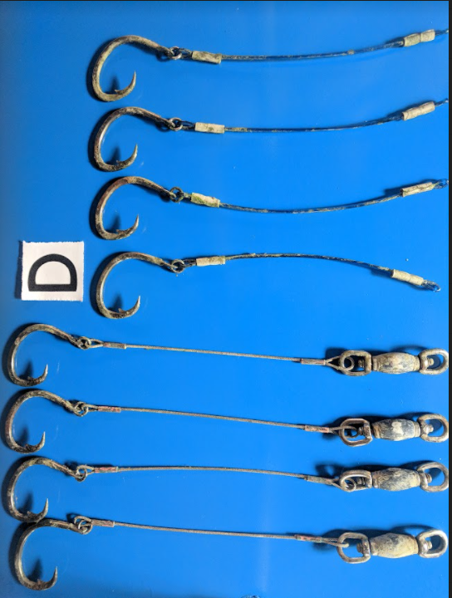

Figure S1: An example of one treatment ‘D’ demonstrating the differences in wire and monofilament leader material. In this case, for both leader materials, hook characteristics were: 15/0, flat, ring, stainless steel. Monofilament leader configurations are shown in the top four hooks, and wire leader configuations with the weighted swivel in the bottom four hooks.

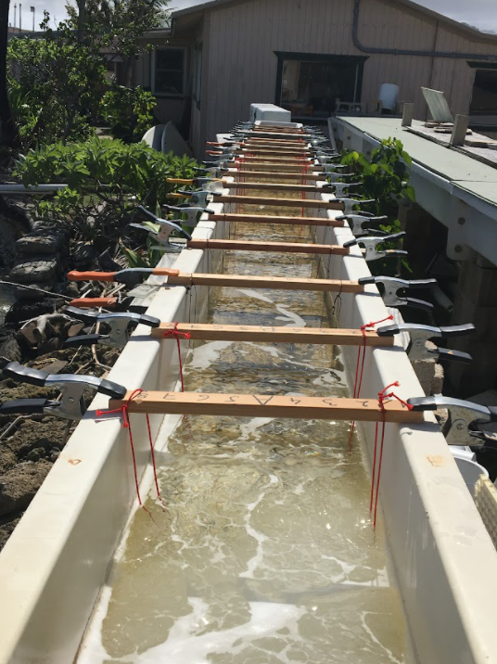
Figure S2: Image of the gear configuration set up in the flume at HIMB. Each strut contains two treatments (i.e., eight hooks). The flume dimensions were: 24 ft long, 14 in wide and 14 in deep, and the wooden cross struts holding the treatments were 17.5 in wide. The ballistic gel cut-offs holding the control hooks were 12 in wide.

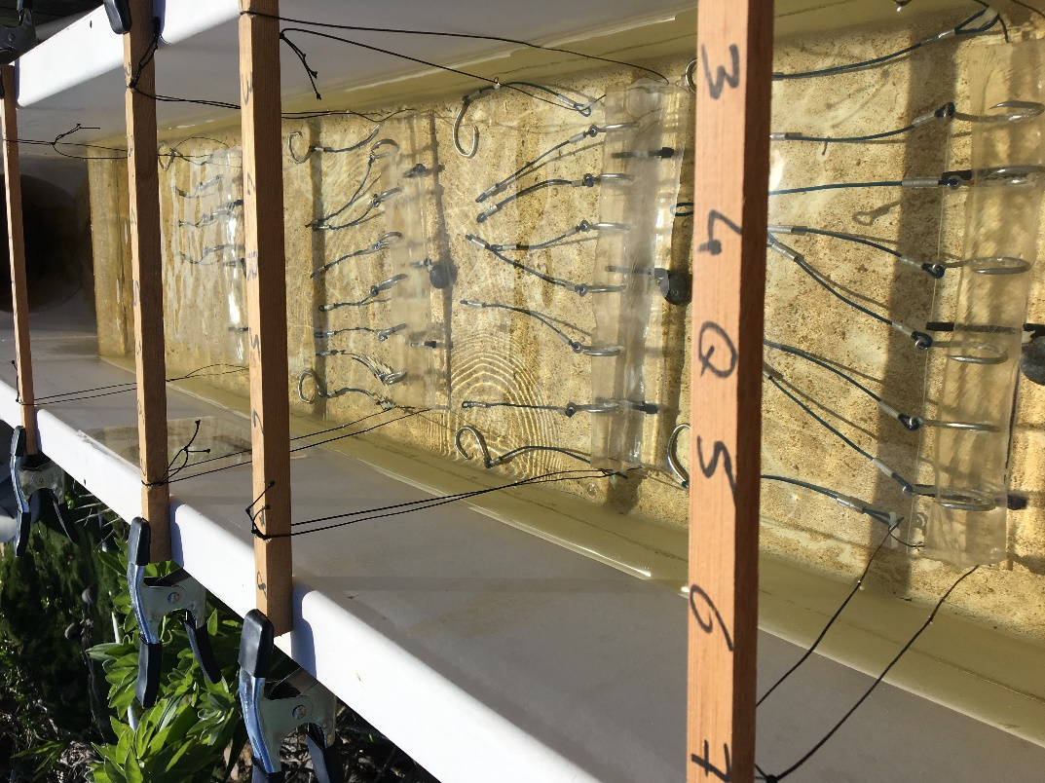
Figure S3: Depiction of two treatments (i.e. 8 hooks from two different gear configurations) attached to wooden struts and a plexiglass base suspended above the bottom of the flow-through flume with hooks embedded in balistic gel to mimic being embedded in tissue (of a marine mammal). One hook from each configuration was left out of the gel as a control.
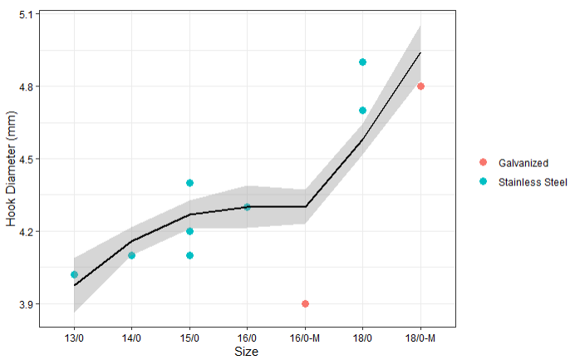Figure S4: Positive correlation between hook diameter and size. Hook sizes with ‘-M’ are Mustad, galvanized hooks.

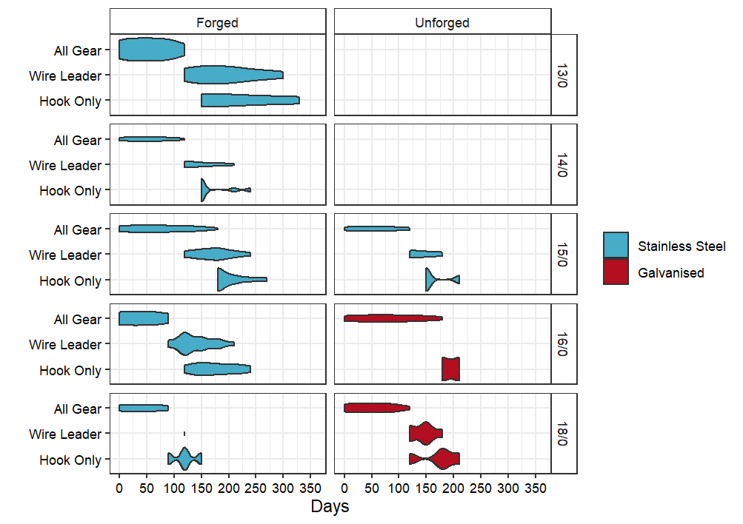
Figure S5: Amount of time (days) taken for All Gear, Wire Leaders, and Hook Only (y-axis) to remain components of trailing gear to break apart from hooks rigged with wire leaders only.

