Supplement of
Source appointment of volatile organic compounds and evaluation of anthropogenic monoterpene emission estimates in Atlanta, Georgia
Yuyang Peng et al.

Correspondence to: Jennifer Kaiser (Jennifer.kaiser@ce.gatech.edu)
S1. Instrumentation and theoretic sensitivity calculation
The PTR-ToF-MS instrument excludes most alkanes and some alkenes in its measurements due to their low proton affinity comparing to that of water, and our analysis additionally excludes species with high uncertainties due to humidity dependence (e.g. formaldehyde and methanol), and species with known strong interference from fragmentation of larger VOC species at their corresponding m/z. Certain exceptions are made, e.g., in the case of m/z 81 (C₆H₈)H⁺. m/z 81 is a known fragment peak of monoterpenes under stronger electric fields (e.g., E/N = 120 Td). We specifically include this and several other similar fragment peaks in our NNMF to evaluate the source apportionment of monoterpenes.
For species without a calibration standard, we estimate their PTR-ToF-MS instrument sensitivities using a theoretical method outlined in in Sekimoto et al. (2017) that is based on the reactivity of species in the instrument. This method uses a linear regression method of corrected sensitivity vs. kinetic reaction rate constants. To estimate the slope of this regression, we convert measured sensitivity of species we have (Isoprene, toluene, benzene, α-pinene, acetone, acetonitrile, and methyl acetate) using Eqn. S1.1 adapted from Equation 6 in Sekimoto et al. (2017):
$Sens_{corr}[\frac{ncps}{ppbv}]=Sens_{meas}[\frac{ncps}{ppbv}]×\frac{100}{F_{VOC·H^{+}}[\%]}×\frac{T_{H_{3}O^{+}}}{T_{VOC·H^{+}}}$ [S1.1]
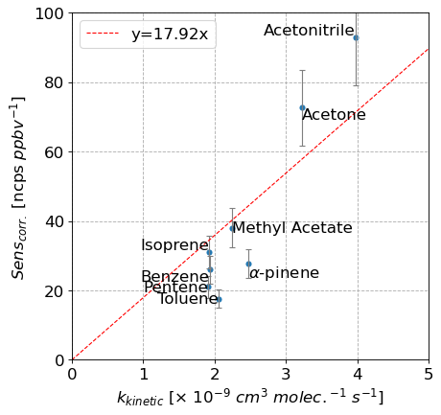
for example, for isoprene:
Figure S1 – sensitivity correlation between corrected sensitivity vs. kinetic reaction rate constants. Slope of regression line is 17.92 for our study.
$Sens_{corr,isop}=108.1 ×\frac{100}{100}×\frac{0.17}{0.50}=36.8\frac{ncps}{ppbv}$ [S1.2]
The transmission value is interpolated from the transmission curve (determined by acetone, isoprene, toluene, and α-pinene), based on m/z. Using these values, we plot a sensitivity vs. $k_{kinetic}$ in Fig. S1 and obtain a slope of 17.92. Here, we included pentene from the second tank to evaluate the calculated sensitivity correlation.
Once we have the slope, we then calculate a corrected sensitivity of other compounds, by multiplying the slope with $k_{kinetic}$, as shown in the following equation:
$Sens_{theo.}\left[\frac{ncps}{ppbv}\right]=\frac{T_{VOC·H^{+}}}{T_{H_{3}O^{+}}} × \frac{F_{VOC·H^{+}} [\%]}{100} ×a×k_{kinetic}$ [S1.3]
Where the theoretical sensitivity ($Sens_{theo.}\left[\frac{ncps}{ppbv}\right]$) is the product of the transmission efficiency of the VOC species ( $\frac{T_{VOC·H^{+}}}{T_{H_{3}O^{+}}}$), fraction of ion at measured m/z ( $\frac{F_{VOC·H^{+}} [\%]}{100}$), correlation slope ($a=17.92$) and kinetic reaction rate constant ($k_{kinetic}$). From there, we convert our instrument data in ncps to ppbv for each individual species, then from ppbv to ppbC based on the number of C atoms each species has. This value is our best estimate of how sensitive the PTR is to each species, taking into account fraction of parent ion at this mass (i.e., fragmentation) and transmission of the instrument under these specific settings. Calculated sensitivities that are used to derive concentration data are listed in Table S2.
We also correct for baseline shifts in our data. For species in the calibration standards, the y-intercept on the ncps-ppbv regression from the calibration is used for this baseline correction. For other species calculated using the theoretical method, we use instrument readings at the corresponding m/z peak during our “zero” points in calibration, averaged to generate baseline values for each species. The baseline correction values are subtracted from signals for the entire dataset.
In addition, certain species are known to deviate from the calculated slope by a large margin using this method. In particular, ethanol is expected to have a much lower actual sensitivity than its calculated theoretical values. We attempt to correct for this known overestimation of ethanol sensitivity by applying an arbitrary scaling factor of 0.33 to the calculated theoretical sensitivity. However, such factor is a conservative estimate, and may not be sufficient to correct for this overestimation of sensitivity, especially when considering the specific conditions of our dataset (e.g., temperature and humidity, instrument setups). As a result, we expect the concentration of ethanol to be underestimated in our actual dataset and its uncertainty would be larger than most other species. This would affect the fraction of ethanol in each factor, but its fingerprint and temporal patterns are unaffected. Therefore, we still find that our NNMF is representative of the source estimates of ethanol and other species.

S2. Supplemental information on NNMF analysis
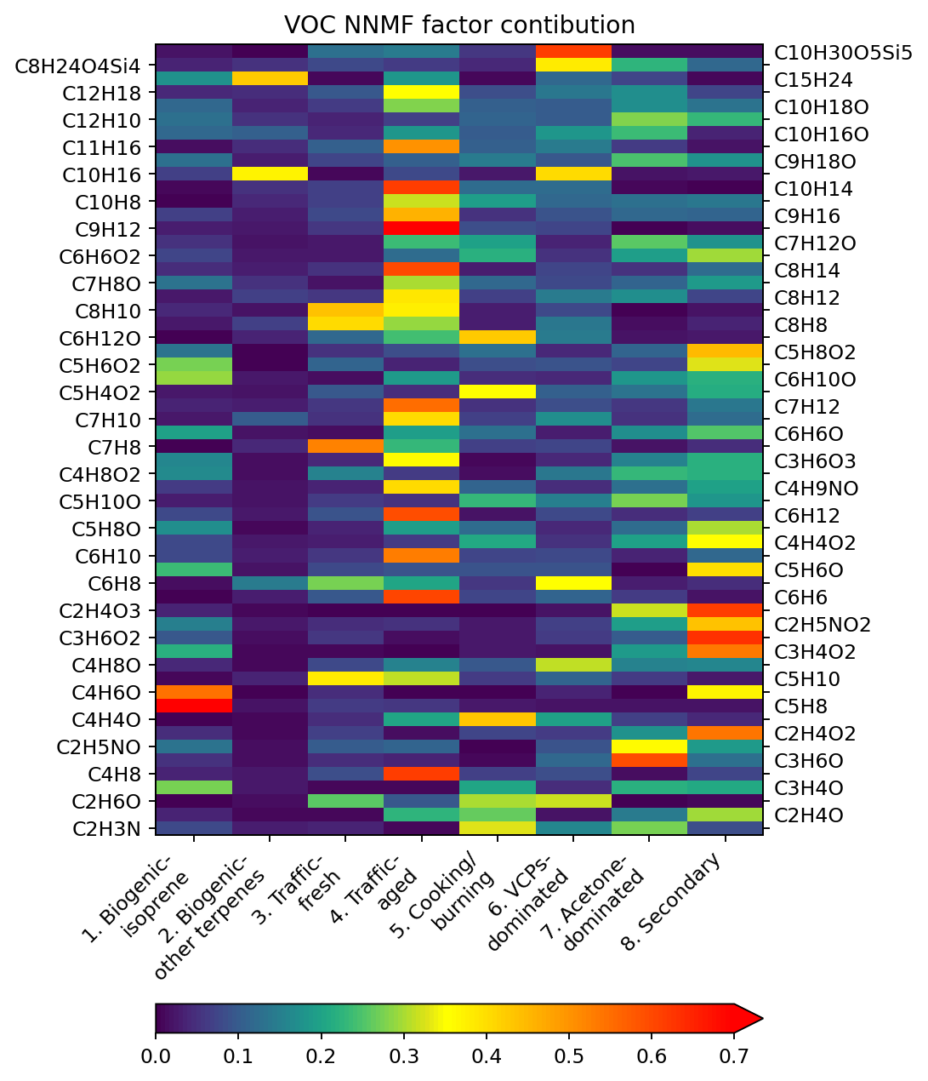
S2.1 NNMF results with all species
Figure S2.1 – Full NNMF factor speciation results, including all 58 species used in the factorization analysis. Figure 2 is an abbreviated version of this factor speciation with major contributing species in each factor shown.

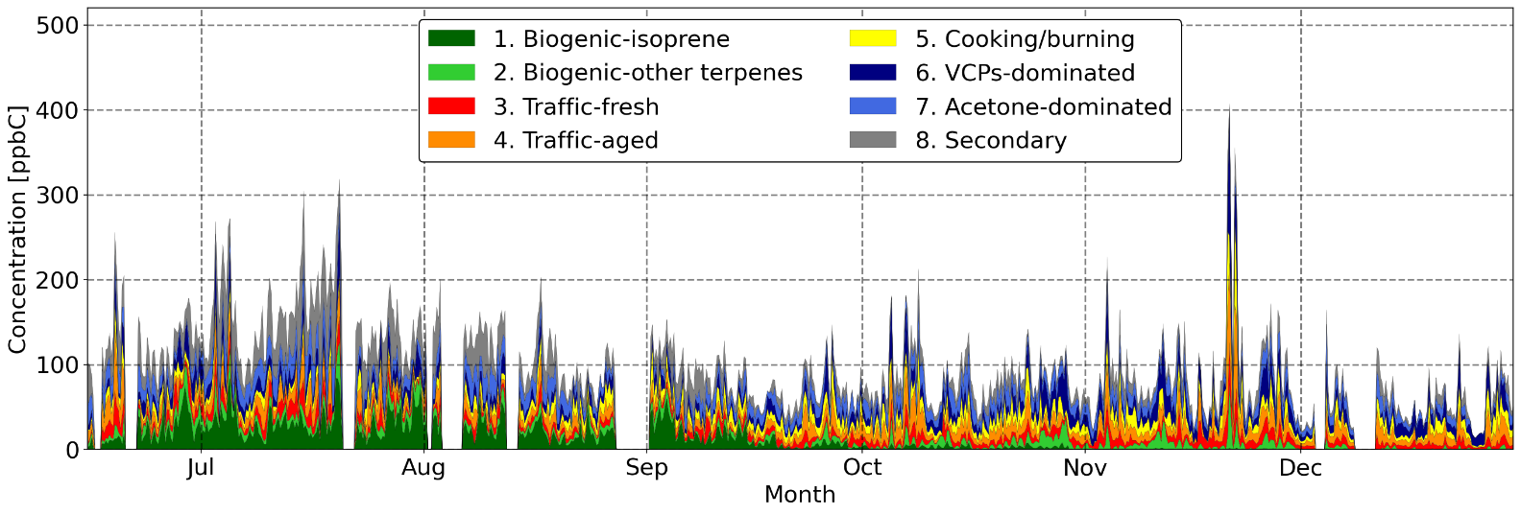
Figure S2.2 – Time series of VOCs measured by the PTR-ToF-MS in each NNMF factor over the entire 7-month span. Figure 4 shows the same time series zoomed into the summer (Jul-Aug) and winter (Nov-Dec) months.

Table S1. NNMF Factor Identification
Factor | Source sector | Contributing species | References
1 | Biogenic – isoprene | Isoprene (m/z 69 C₅H₈·H⁺)  MVK/MACR (m/z 71 C₄H₆O·H⁺)  Monoterpenes (m/z 137 C₁₀H₁₆·H⁺) | (Seinfeld and Pandis, 2016)  (Guenther et al., 2012)
2 | Biogenic –  other terpenes | Monoterpenes (m/z 137 C₁₀H₁₆·H⁺)  Sesquiterpenes (m/z 205 C₁₅H₂₄·H⁺) | (Guenther et al., 2012)
3 | Traffic - fresh | Toluene (m/z 93 C₇H₈·H⁺)  Xylene (m/z 107 C₈H₁₀·H⁺)  Ethanol (m/z 47 C₂H₆O·H⁺)  C3-benzene (m/z 121 C₉H₁₂·H⁺) | (Seinfeld and Pandis, 2016)  (Miller et al., 2011)  (Ilgen et al., 2001)
4 | Traffic - aged | Benzene (m/z 79 C₆H₆·H⁺)  Pentene (m/z 71 C₅H₁₀·H⁺) | (Miller et al., 2011)  (Gelencsér et al., 1997)
5 | Cooking / Biomass Burning | Furan (m/z 69 C₄H₄O·H⁺)  Furfural (m/z 97 C₅H₄O₂·H⁺)  Butanal (m/z 73 C₄H₈O·H⁺)  Hexanal (m/z 101 C₆H₁₂O·H⁺)  Acetonitrile (m/z 42 C₂H₃N·H⁺) | (Müller et al., 2016)  (Simoneit, 2002)  (Klein et al., 2016)  (Abdullahi et al., 2013)
6 | VCPs-  dominated | Ethanol (m/z 47 C₂H₆O·H⁺)  Monoterpenes (m/z 137 C₁₀H₁₆·H⁺)  D5-siloxane (m/z 371 C₁₀H₃₀O₅Si₅·H⁺)  Toluene (m/z 93 C₇H₈·H⁺) | (Gkatzelis et al., 2021)  (Coggon et al., 2018)  (Coggon et al., 2021)  (Yuan et al., 2010)  (De Gouw et al., 2012)
7 | Acetone-dominated | Acetone (m/z 59 C₃H₆O·H⁺)  MBO (m/z 87 C₅H₁₀O·H⁺) | (Brewer et al., 2017)  (Jacob et al., 2002)  (Steiner et al., 2007)
8 | Secondary | MVK/MACR (m/z 71 C₄H₆O·H⁺)  Methyl acetate (m/z 75 C₃H₆O₂·H⁺)  Acetic acid (m/z 61 C₂H₄O₂·H⁺)  Glycolic acid (m/z 77 C₂H₄O₃·H⁺) | (Guenther et al., 2012)  (Paulot et al., 2011)  (Fu et al., 2008)  (Link et al., 2021)

Table S2. List of m/z peaks used in NNMF, ion composition, likely corresponding species, and sensitivity; bold species are calibrated using a standard, the rest with method outlined in Sect. S1.
m/z | Ion composition | Likely species | Sensitivity [ncps/ppb]
42 | (C2H3N)H+ | Acetonitrile | 218.6
45 | (C2H4O)H+ | Acetaldehyde | 88.2
47 | (C2H6O)H+ | Ethanol | 17.0✝
57 | (C3H4O)H+ | Acrolein | 52.8
57 | (C4H8)H+ | Butene; Alkane, alkene, and aromatic fragments | 59.8
59 | (C3H6O)H+ | Acetone; Propanal | 205.2
60 | (C2H5NO)H+ | Acetamide | 129.0
61 | (C2H4O2)H+ | Acetic acid | 77.7
69 | (C4H4O)H+ | Furan | 65.7
69 | (C5H8)H+ | Isoprene | 108.1
71 | (C4H6O)H+ | MVK/MACR | 126.5
71 | (C5H10)H+ | Pentene; Fragments | 75.5
73 | (C4H8O)H+ | Butanal; Butanone (MEK); Tetrahydrofuran | 127.9
73 | (C3H4O2)H+ | Acrylic acid; Methyl glyoxal | 100.9
75 | (C3H6O2)H+ | Methyl acetate; Propionic acid | 138.5
76 | (C2H5NO2)H+ | Nitroethane; Ethyl nitrite | 151.1
77* | (C2H4O3)H+/  (C3H8O2)H+ | Glycolic acid; Peracetic acid;  Propanediol/propylene glycol | 126.1
79 | (C6H6)H+ | Benzene | 100.8
81 | (C6H8)H+ | Cyclohexadiene; Monoterpenes fragment | 88.1
83 | (C5H6O)H+ | Methyl furan | 85.9
83 | (C6H10)H+ | Cyclohexene | 88.6
85 | (C4H4O2)H+ | Furanone | 92.7
85 | (C5H8O)H+ | Pentenal; Methyl butenal; Methyl butenone | 139.1
85 | (C6H12)H+ | Cyclohexane | 95.0
87 | (C5H10O)H+ | Pentanal; Pentanone; MBO; Methyl butanone | 152.0
88* | (C4H9NO)H+/  (C5H13N)H+ | Butyramide;  Pentylamine | 101.0
89 | (C4H8O2)H+ | Butyric acid; Methyl propanoate | 114.8
91 | (C3H6O3)H+ | Lactic acid | 119.6
93 | (C7H8)H+ | Toluene | 79.8
95 | (C6H6O)H+ | Phenol | 111.6
95 | (C7H10)H+ | Monoterpenes fragment; Large HC fragments | 103.4
m/z | Ion composition | Likely species | Sensitivity [ncps/ppb]
97 | (C7H12)H+ | Cycloheptene; HC fragments | 110.0
97 | (C5H4O2)H+ | Furfural | 131.0
99 | (C6H10O)H+ | Hexenal; Cyclohexanone | 175.3
99 | (C5H6O2)H+ | Ethyl propiolate; Furfuryl alcohol | 100.9
101 | (C5H8O2)H+ | Pentanedial; Methyl methacrylate | 113.1
101 | (C6H12O)H+ | Hexanal; Hexanone; Hexenol | 150.7
105 | (C8H8)H+ | Styrene | 123.8
107 | (C8H10)H+ | Xylene; Ethyl benzene | 128.8
109 | (C8H12)H+ | Cyclooctadiene; Cyclooctyne; HC fragments | 113.4
109 | (C7H8O)H+ | Methylphenol | 132.7
111 | (C8H14)H+ | Cyclooctenes; Octynes; Fragments | 114.9
111 | (C6H6O2)H+ | Methyl furfural; Benzenediol; Hydroxyphenol | 120.6
113 | (C7H12O)H+ | Heptenal; Cycloheptanone | 203.5
121 | (C9H12)H+ | C3-benzenes | 139.3
125 | (C9H16)H+ | Cyclononene; Nonyne; Trimethylcyclohexene | 142.1
129 | (C10H8)H+ | Naphthalene; Fragments | 138.6
135 | (C10H14)H+ | C4-benzenes | 149.1
137 | (C10H16)H+ | Monoterpenes (α-pinene) | 34.1
143 | (C9H18O)H+ | Nonanal; Trimethylhexanal; Nonanones | 235.5
149 | (C11H16)H+ | C5-benzenes | 150.5
153 | (C10H16O)H+ | Camphor; Fenchone | 268.2
155 | (C12H10)H+ | Biphenyl; Heptalene; Acenaphthene | 172.1
155 | (C10H18O)H+ | Linalool; Menthone; Monoterpenenoids | 176.6
163* | (C12H18)H+/  (C10H14N2)H+ | C6-benzenes;  Nicotine | 150.5
205 | (C15H24)H+ | Sesquiterpenes | 163.6
297 | (C8H24O4Si4)H+ | D4-siloxane | 196.3
371 | (C10H30O5Si5)H+ | D5-siloxane | 222.4

✝Sensitivity of ethanol adjusted by a factor of 0.33.
*m/z 77, m/z 88, and m/z 163 peaks are not entirely resolved at all times; although total signals are consistently above the limit of detection to be considered in the NNMF

S2.2: Bayesian information criterion (BIC) analysis results
The Bayesian information criterion defined by Stoica and Selen (2004) and adapted by Karl et al. (2018) takes on the following form:
$BIC=\log\left({\left\|\overset{⃡}{W}×\overset{⃡}{H}-\overset{⃡}{F}\right\|}^{2}\right)+k\frac{s+t}{st}\log\left(\frac{st}{s+t}\right)$ [S2.1]
Minimizing the BIC value would give a NNMF matrix that’s representative of the original dataset while separating source factors in an efficient way. We performed NNMF analysis for number of factors k between 3 and 25, then calculate the BIC value using the above equation.
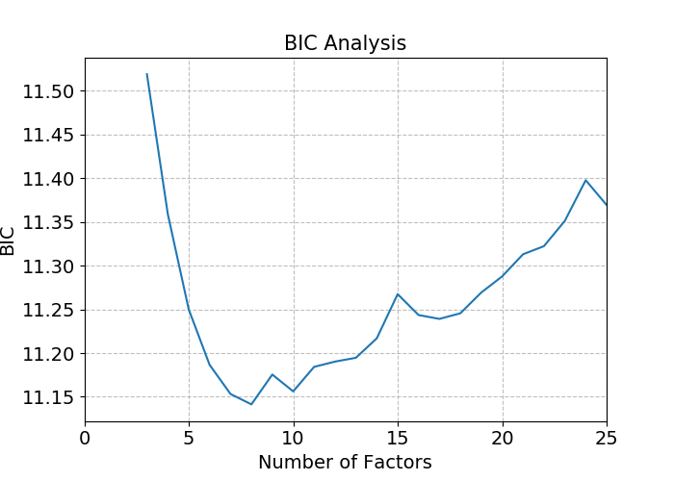
Based on the results, the optimal number of factors are likely 7 or 8 (where BIC is the lowest). We select the number of factors to be 8 in our final analysis with the additional information provided in species fingerprint (Sect. S2.1) and NNMF residual values (SI Sect. S2.3).
Figure S2.2 – Results of BIC analysis showing minimum values at 7 or 8 factors.
S2.3: NNMF bias – residual matrix
Biases of the NNMF method in each species make up the residual matrix $\overset{⃡}{r}$ in Eqn. 1. The bias for each species $s$ at time step $t_{i}$ can be evaluated using the following equation:
$Bias_{s,t_{i}}=\overset{⃡}{r_{s,t_{i}}} \left[ppbC\right]=\overset{⃡}{F_{s,t_{i}}}-\sum_{k=1}^{8}{\overset{⃡}{W_{s,k}} ×\overset{⃡}{H_{k,t_{i}}}}$ [S2.2]
We then calculate bias for all species to obtain absolute bias time series (Fig. S2.3a), and divide that by original mixing ratios to get relative bias (Fig. S2.3b). Figure S2.3c shows the scatter plot of PTR-ToF-MS measured total mixing ratio vs. NNMF calculated ratio. The slope (1.014 > 1) and intercept (3.884 > 0) of the regression suggest a slight overestimation of VOCs in the NNMF analysis, especially at lower total concentrations. The overall correlation is high with an R value of 0.987, indicating that the NNMF represents our dataset well. The larger relative biases in the winter months are due to the lower total VOCs on average, and possibly also the higher variation as observed in winter (Figs. 3, 4). Bias does not follow any diurnal trends.
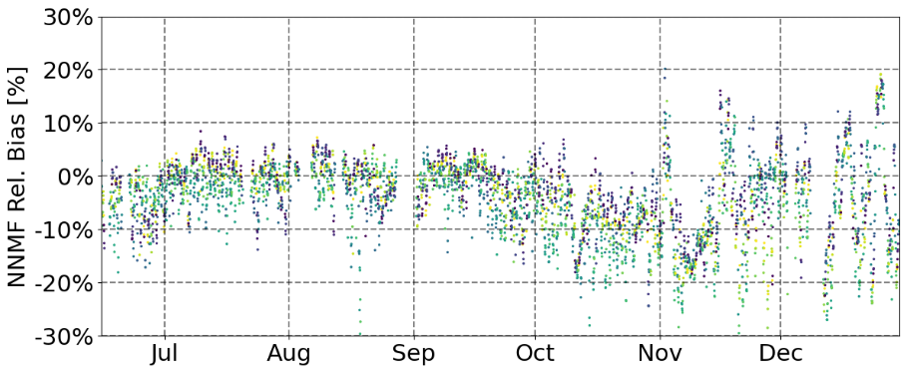
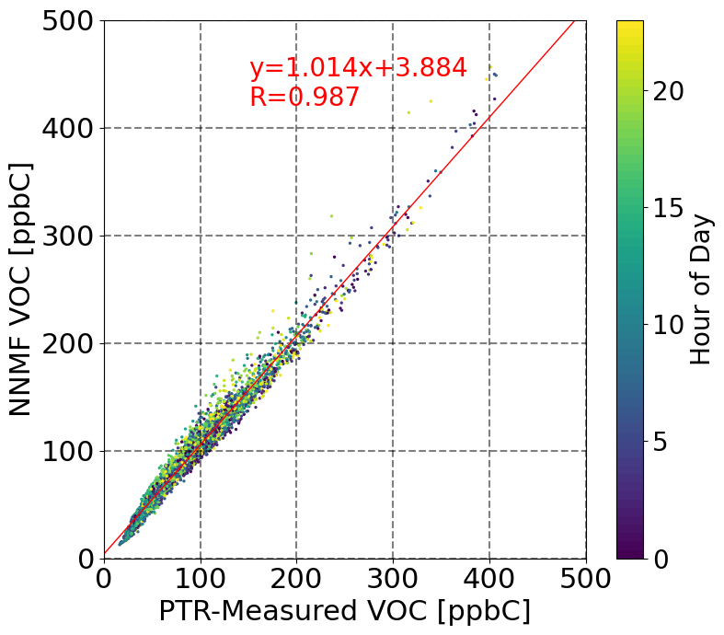
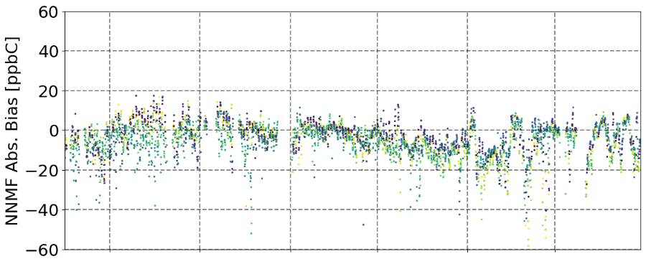
Speciated NNMF vs. original mixing ratios also correlate well for most species; for example, isoprene has an R value of 0.992, monoterpenes 0.992, benzene 0.917, and toluene 0.954.
Figure S2.3 – Absolute and relative total NNMF bias for all species, and scatter plots of measured and NNMF speciated total VOC.
S2.4: NNMF variability and uncertainty analysis
We evaluate the variability and reproducibility of our NNMF analysis through an iterative application of the algorithm in MATLAB. For each variability test run, we use the species fingerprint $\overset{⃡}{W}$ and time series $\overset{⃡}{H}$ matrices as initial values ($\overset{⃡}{W_{0}}$ and $\overset{⃡}{H_{0}}$) of the algorithm, and perform the factorization analysis under identical settings (i.e., 8 factors, 50 maximum iterations per run, multiplicative algorithm), with the exception of a single replicate for each run to allow the fully-resolved matrices to be saved each time (rather than the algorithm choosing the smallest RMSE and saving that run only). We perform a total of 10 variability test runs, and compare the species and time matrices of each run with the original results.
We found that all 10 variability runs agree excellently with the original results. Figure S2.4 show the daily average concentration of VOCs in each factor, separated by season. The bar graphs represent our original NNMF result. Each of the x’s represent concentration in that factor from one variability run, in the same order from left to right, i.e., the left-most x’s for each factor are from the same run. Error bars represent ranges of these x’s. We see that for most factors, each variability run agrees with the original factorization within ±10%, with a couple of exceptions that reach ±12%. The average standard deviation of the variability of all factors is ~6%. In addition, these 10 runs show slight differences in species fingerprints that also vary within ±10% on average, although in very rare cases, the differences in individual species to each factor can reach 30% for a single data point. This is most-likely due to the inability of the algorithm to fully account for every species and/or data point at all times, and that the bias in the original NNMF can reach >30% for single points as well (Fig. S2.3).
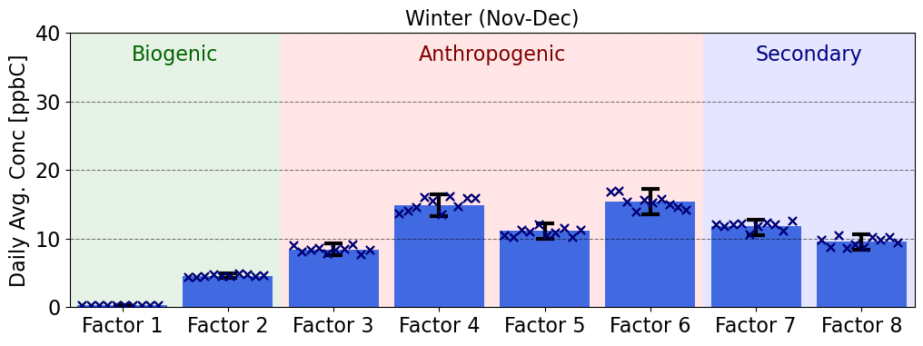
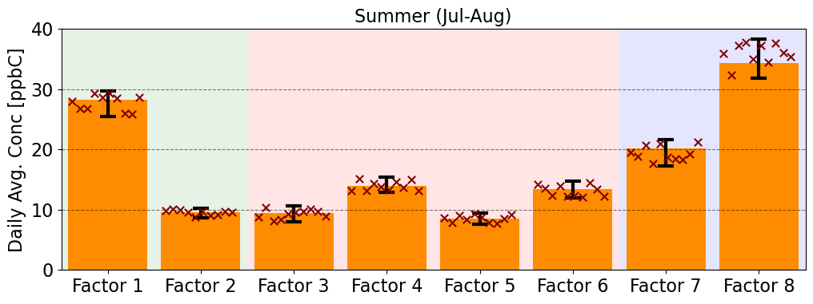
Considering the large dataset, we are still able to consistently recreate the same factorization with this method, and we conclude that an estimated uncertainty of 10% is adequate for our NNMF analysis.
Figure S2.4 – Variability and reproducibility test results. Bar graphs represent daily average concentrations of VOCs in each factor in the original NNMF results, in summer (top) and winter (bottom). Each x represents summed VOCs in that factor from one variability run, error bars show range of these values.

S3. Meteorological and traffic data
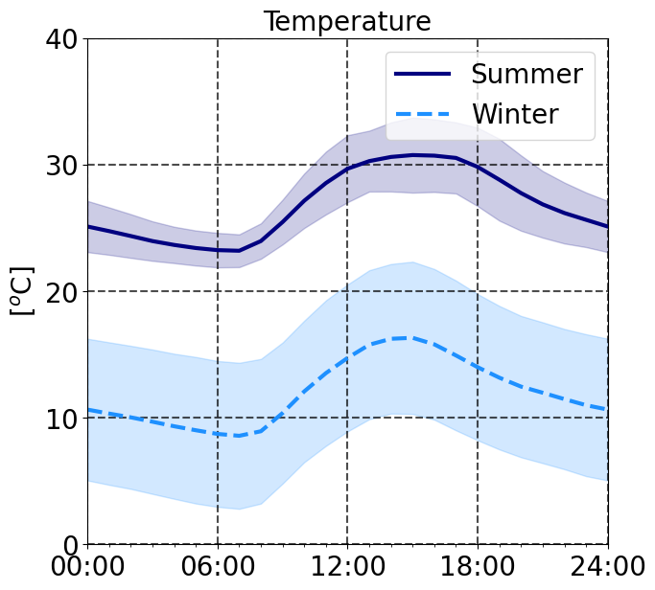
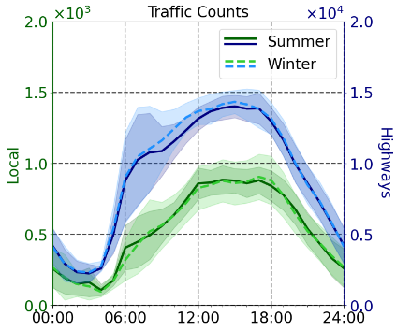
We compare supporting meteorological and traffic data in 2020 in this following section. Figure S3.1 compares temperature and traffic volume between the two seasons. Traffic data includes the highway station (Fig. 1, blue square) and another site next to a local road with less traffic, ~1km NW of the measurement site (not pictured). Traffic trends show minimum variation between the seasons, suggesting minimum impact of the COVID-19 pandemic on anthropogenic activities by July 2020.
Figure S3.1 – Seasonal comparison of a) temperature and b) traffic data in 2020. Traffic data show comparison of local (green) and highway (blue) stations between 2 seasons.
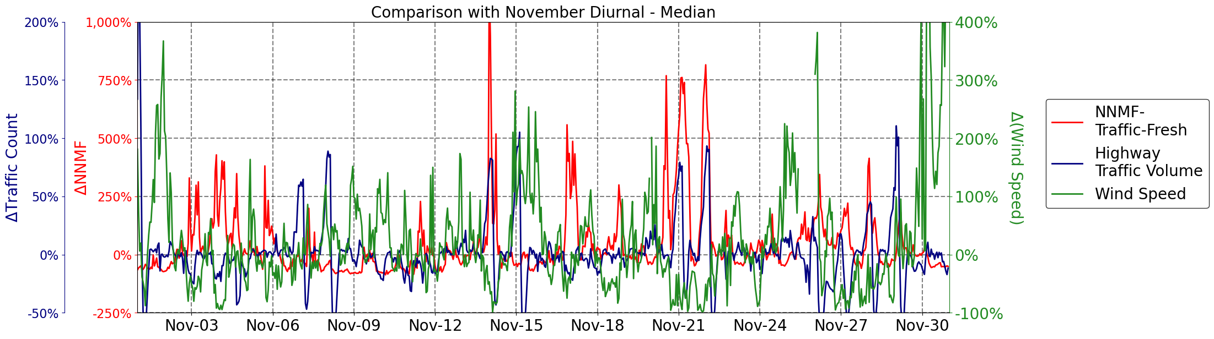
Figure S3.2 compares the relative difference in November, calculated using median values of the entire month at each given hour of day, for traffic count (emission trends), the “traffic – fresh” factor in NNMF results (VOC measurements), and wind speed (met./transport effects). We use the hour of day diurnal averages to minimize the effects of photochemistry on our data, as nighttime and mid-day median values can vary greatly based on the species and chemistry. This plot shows that change in VOC measurements attributed to the traffic – fresh factor is largely driven by wind speed, i.e., vertical mixing and transport effects, at our site, although there are some correlations between measured VOC in this factor and emission trends.
References:
Figure S3.2 – Relative difference in November compared against median hourly values of the entire month of November at the same time of day, showing NNMF fresh traffic factor (red), traffic volume on the highways (blue), and wind speed (green).
Abdullahi, K. L., Delgado-Saborit, J. M., and Harrison, R. M.: Emissions and indoor concentrations of particulate matter and its specific chemical components from cooking: A review, Atmospheric Environment, 71, 260-294, 10.1016/j.atmosenv.2013.01.061, 2013.
Brewer, J. F., Bishop, M., Kelp, M., Keller, C. A., Ravishankara, A. R., and Fischer, E. V.: A sensitivity analysis of key natural factors in the modeled global acetone budget, Journal of Geophysical Research: Atmospheres, 122, 2043-2058, 10.1002/2016jd025935, 2017.
Coggon, M. M., McDonald, B. C., Vlasenko, A., Veres, P. R., Bernard, F., Koss, A. R., Yuan, B., Gilman, J. B., Peischl, J., Aikin, K. C., DuRant, J., Warneke, C., Li, S. M., and de Gouw, J. A.: Diurnal Variability and Emission Pattern of Decamethylcyclopentasiloxane (D5) from the Application of Personal Care Products in Two North American Cities, Environ Sci Technol, 52, 5610-5618, 10.1021/acs.est.8b00506, 2018.
Coggon, M. M., Gkatzelis, G. I., McDonald, B. C., Gilman, J. B., Schwantes, R. H., Abuhassan, N., Aikin, K. C., Arend, M. F., Berkoff, T. A., Brown, S. S., Campos, T. L., Dickerson, R. R., Gronoff, G., Hurley, J. F., Isaacman-VanWertz, G., Koss, A. R., Li, M., McKeen, S. A., Moshary, F., Peischl, J., Pospisilova, V., Ren, X., Wilson, A., Wu, Y., Trainer, M., and Warneke, C.: Volatile chemical product emissions enhance ozone and modulate urban chemistry, Proc Natl Acad Sci U S A, 118, 10.1073/pnas.2026653118, 2021.
de Gouw, J. A., Gilman, J. B., Borbon, A., Warneke, C., Kuster, W. C., Goldan, P. D., Holloway, J. S., Peischl, J., Ryerson, T. B., Parrish, D. D., Gentner, D. R., Goldstein, A. H., and Harley, R. A.: Increasing atmospheric burden of ethanol in the United States, Geophysical Research Letters, 39, 10.1029/2012gl052109, 2012.
Fu, T.-M., Jacob, D. J., Wittrock, F., Burrows, J. P., Vrekoussis, M., and Henze, D. K.: Global budgets of atmospheric glyoxal and methylglyoxal, and implications for formation of secondary organic aerosols, Journal of Geophysical Research: Atmospheres, 113, https://doi.org/10.1029/2007JD009505, 2008.
Gelencsér, A., Siszler, K., and Hlavay, J.: Toluene−Benzene Concentration Ratio as a Tool for Characterizing the Distance from Vehicular Emission Sources, Environmental Science & Technology, 31, 2869-2872, 10.1021/es970004c, 1997.
Gkatzelis, G. I., Coggon, M. M., McDonald, B. C., Peischl, J., Aikin, K. C., Gilman, J. B., Trainer, M., and Warneke, C.: Identifying Volatile Chemical Product Tracer Compounds in U.S. Cities, Environ Sci Technol, 55, 188-199, 10.1021/acs.est.0c05467, 2021.
Guenther, A. B., Jiang, X., Heald, C. L., Sakulyanontvittaya, T., Duhl, T., Emmons, L. K., and Wang, X.: The Model of Emissions of Gases and Aerosols from Nature version 2.1 (MEGAN2.1): an extended and updated framework for modeling biogenic emissions, Geoscientific Model Development, 5, 1471-1492, 10.5194/gmd-5-1471-2012, 2012.
Ilgen, E., Karfich, N., Levsen, K., Angerer, J., Schneider, P., Heinrich, J., Wichmann, H. E., Dunemann, L., and Begerow, J.: Aromatic hydrocarbons in the atmospheric environment: Part I. Indoor versus outdoor sources, the influence of traffic, Atmospheric Environment, 35, 1235-1252, https://doi.org/10.1016/S1352-2310(00)00388-5, 2001.
Jacob, D. J., Field, B. D., Jin, E. M., Bey, I., Li, Q., Logan, J. A., Yantosca, R. M., and Singh, H. B.: Atmospheric budget of acetone, Journal of Geophysical Research: Atmospheres, 107, ACH 5-1-ACH 5-17, 10.1029/2001jd000694, 2002.
Karl, T., Striednig, M., Graus, M., Hammerle, A., and Wohlfahrt, G.: Urban flux measurements reveal a large pool of oxygenated volatile organic compound emissions, Proc Natl Acad Sci U S A, 115, 1186-1191, 10.1073/pnas.1714715115, 2018.
Klein, F., Platt, S. M., Farren, N. J., Detournay, A., Bruns, E. A., Bozzetti, C., Daellenbach, K. R., Kilic, D., Kumar, N. K., Pieber, S. M., Slowik, J. G., Temime-Roussel, B., Marchand, N., Hamilton, J. F., Baltensperger, U., Prevot, A. S., and El Haddad, I.: Characterization of Gas-Phase Organics Using Proton Transfer Reaction Time-of-Flight Mass Spectrometry: Cooking Emissions, Environ Sci Technol, 50, 1243-1250, 10.1021/acs.est.5b04618, 2016.
Link, M. F., Brophy, P., Fulgham, S. R., Murschell, T., and Farmer, D. K.: Isoprene versus Monoterpenes as Gas-Phase Organic Acid Precursors in the Atmosphere, ACS Earth and Space Chemistry, 5, 1600-1612, 10.1021/acsearthspacechem.1c00093, 2021.
Miller, L., Xu, X., Wheeler, A., Atari, D. O., Grgicak-Mannion, A., and Luginaah, I.: Spatial variability and application of ratios between BTEX in two Canadian cities, ScientificWorldJournal, 11, 2536-2549, 10.1100/2011/167973, 2011.
Müller, M., Anderson, B. E., Beyersdorf, A. J., Crawford, J. H., Diskin, G. S., Eichler, P., Fried, A., Keutsch, F. N., Mikoviny, T., Thornhill, K. L., Walega, J. G., Weinheimer, A. J., Yang, M., Yokelson, R. J., and Wisthaler, A.: In situ measurements and modeling of reactive trace gases in a small biomass burning plume, Atmos. Chem. Phys., 16, 3813-3824, 10.5194/acp-16-3813-2016, 2016.
Paulot, F., Wunch, D., Crounse, J. D., Toon, G. C., Millet, D. B., DeCarlo, P. F., Vigouroux, C., Deutscher, N. M., Gonzalez Abad, G., Notholt, J., Warneke, T., Hannigan, J. W., Warneke, C., de Gouw, J. A., Dunlea, E. J., De Maziere, M., Griffith, D. W. T., Bernath, P., Jimenez, J. L., and Wennberg, P. O.: Importance of secondary sources in the atmospheric budgets of formic and acetic acids, Atmos Chem Phys, 11, 1989-2013, 10.5194/acp-11-1989-2011, 2011.
Seinfeld, J. H. and Pandis, S. N.: Atmospheric chemistry and physics: from air pollution to climate change, John Wiley & Sons2016.
Sekimoto, K., Li, S.-M., Yuan, B., Koss, A., Coggon, M., Warneke, C., and de Gouw, J.: Calculation of the sensitivity of proton-transfer-reaction mass spectrometry (PTR-MS) for organic trace gases using molecular properties, International Journal of Mass Spectrometry, 421, 71-94, 10.1016/j.ijms.2017.04.006, 2017.
Simoneit, B. R. T.: Biomass burning — a review of organic tracers for smoke from incomplete combustion, Applied Geochemistry, 17, 129-162, https://doi.org/10.1016/S0883-2927(01)00061-0, 2002.
Steiner, A. L., Tonse, S., Cohen, R. C., Goldstein, A. H., and Harley, R. A.: Biogenic 2-methyl-3-buten-2-ol increases regional ozone and HOx sources, Geophysical Research Letters, 34, https://doi.org/10.1029/2007GL030802, 2007.
Stoica, P. and Selen, Y.: Model-order selection: a review of information criterion rules, IEEE Signal Processing Magazine, 21, 36-47, 10.1109/MSP.2004.1311138, 2004.
Yuan, B., Shao, M., Lu, S., and Wang, B.: Source profiles of volatile organic compounds associated with solvent use in Beijing, China, Atmospheric Environment, 44, 1919-1926, 10.1016/j.atmosenv.2010.02.014, 2010.

