Supplement 1. River name, town, state, and Universal Transverse Mercator (UTM) easting and northing coordinates of sites where commercial American Eel Anguilla rostrata harvest took place and data were collected. See Figure 1 for mapped location sites.
River Name | Town | State | Easting | Northing
Millinocket Stream | Millinocket | Maine | 521732 | 5053338
Piscataquis River | Milo | Maine | 502866 | 5008474
Ferguson Stream | Cambridge | Maine | 463040 | 4985887
Sebasticook River | Cambridge | Maine | 464039 | 4983976
Higgans Brook | Harmony | Maine | 456820 | 4980225
Indian Stream | St. Albans | Maine | 467860 | 4972907
Withee Brook | Hartland | Maine | 458307 | 4971674
Mill Stream | Madison | Maine | 440035 | 4966234
East Branch Sebasticook River | Newport | Maine | 478373 | 4964888
Martin Stream | Plymouth | Maine | 483326 | 4957089
Carrabassett Stream | Canaan | Maine | 455687 | 4956863
Souadabscook Stream | Hampden | Maine | 510429 | 4956809
Sedgeunkedunk Stream | Orrington | Maine | 518540 | 4953514
25 Mile Stream | Unity | Maine | 471613 | 4941512
Narramissic River | Orland | Maine | 521827 | 4937833
Sherman Lake | Newcastle | Maine | 452054 | 4873246
Upper Delaware River | Narrowsburg | New York | 494041 | 4605735

Supplement 2. Year, start and end harvest dates, number of fishing days, and total American eel catch (number of eels) for a commercial fishing weir operated on the Upper Delaware River, New York.
Year | Start date | End date | Number of  fishing days | Total  Catch
1977 | 7/26/1977 | 9/24/1977 | 58 | 7299
1978 | 8/1/1978 | 11/2/1978 | 87 | 5358
1979 | 7/16/1979 | 10/22/1979 | 94 | 5300
1980 | 7/13/1980 | 11/7/1980 | 113 | 7121
1981 | 7/6/1981 | 11/1/1981 | 112 | 7036
1982 | 7/12/1982 | 10/29/1982 | 107 | 4324
1983 | 8/1/1983 | 11/8/1983 | 100 | 6275
1984 | 7/24/1984 | 11/15/1984 | 112 | 5002
1985 | 7/27/1985 | 9/8/1985 | 44 | 3362
1986 | 7/22/1986 | 10/16/1986 | 83 | 9046
1987 | 7/21/1987 | 9/27/1987 | 66 | 2326
1988 | 7/18/1988 | 11/12/1988 | 112 | 7986
1989 | 7/31/1989 | 10/19/1989 | 77 | 8938
1990 | 8/5/1990 | 10/23/1990 | 77 | 9694
1991 | 8/4/1991 | 11/1/1991 | 90 | 9389
1992 | 7/13/1992 | 10/29/1992 | 99 | 12012
1993 | 7/12/1993 | 10/29/1993 | 110 | 12394
1994 | 7/4/1994 | 11/1/1994 | 109 | 6592
1995 | 7/20/1995 | 10/20/1995 | 93 | 12922
1996 | 8/6/1996 | 10/20/1996 | 76 | 8685
1997 | 7/21/1997 | 11/1/1997 | 67 | 7058
1998 | 7/26/1998 | 10/19/1998 | 83 | 8765
1999 | 7/25/1999 | 10/8/1999 | 74 | 5133
2000 | 7/30/2000 | 10/6/2000 | 69 | 3341
2001 | 7/20/2001 | 10/27/2001 | 99 | 12107
2002 | 7/6/2002 | 10/11/2002 | 98 | 12383
2003 | 7/19/2003 | 9/1/2003 | 30 | 513
2004 | 7/11/2004 | 9/8/2004 | 36 | 205
2005 | 7/24/2005 | 10/11/2005 | 79 | 12488
2006 | 7/30/2006 | 10/18/2006 | 33 | 1120
2007 | 7/9/2007 | 10/23/2007 | 106 | 8553

Supplement 3. Stream name, year, start and end harvest dates, number of fishing days, and total American eel catch (number of eels) among commercial fishing weirs operated on tributaries to the Penobscot River, Maine.
River | Year | Start Date | End Data | Number of Fishing Days | Total Catch
25 Mile Stream | 1998 | 9/8/1998 | 10/17/1998 | 38 | 3508
 | 1999 | 8/9/1999 | 10/1/1999 | 25 | 3572
Carrabassett Stream | 1998 | 9/18/1998 | 10/17/1998 | 10 | 794
 | 1999 | 8/14/1999 | 9/16/1999 | 8 | 558
E. Branch Sebasticook River | 1997 | 8/22/1997 | 9/11/1997 | 20 | 654
 | 1999 | 7/17/1999 | 9/14/1999 | 55 | 1830
Ferguson Stream | 1997 | 8/23/1997 | 10/6/1997 | 23 | 22
 | 1998 | 8/11/1998 | 10/14/1998 | 7 | 13
Indian Stream | 1998 | 7/28/1998 | 10/20/1998 | 14 | 289
 | 1999 | 7/23/1999 | 9/23/1999 | 14 | 815
Martin Stream | 1998 | 9/8/1998 | 10/17/1998 | 34 | 189
 | 1999 | 9/17/1999 | 9/17/1999 | 1 | 230
Higgans Brook | 1997 | 8/23/1997 | 10/6/1997 | 23 | 16
Mill Stream | 1999 | 8/30/1999 | 9/20/1999 | 11 | 795
Millinocket Stream | 1997 | 8/18/1997 | 10/1/1997 | 41 | 785
 | 1998 | 8/8/1998 | 10/1/1998 | 55 | 1211
 | 1999 | 8/4/1999 | 9/12/1999 | 40 | 1362
Narramissic River | 1998 | 8/28/1998 | 11/15/1998 | 73 | 5383
 | 1999 | 8/18/1999 | 10/24/1999 | 68 | 1361
Piscataquis River | 1997 | 9/10/1997 | 10/19/1997 | 40 | 215
 | 1998 | 8/27/1998 | 10/15/1998 | 48 | 107
 | 1999 | 8/31/1999 | 9/13/1999 | 14 | 126
Sebasticook River | 1997 | 9/4/1997 | 10/29/1997 | 29 | 14
Sedgeunkedunk Stream | 1998 | 8/26/1998 | 11/3/1998 | 67 | 992
 | 1999 | 7/15/1999 | 10/14/1999 | 92 | 688
Sherman Lake | 1998 | 8/26/1998 | 10/11/1998 | 21 | 3717
Whithe Stream | 1998 | 10/2/1998 | 11/12/1998 | 11 | 19
 | 1999 | 9/13/1999 | 9/20/1999 | 8 | 11

Supplement 4. Year, start and end harvest dates, number of fishing days, total American eel catch (number of eels) for a commercial fishing weir operated on the Souadabscook River, Maine.
Year | Start Date | End Data | Number of Fishing Days | Total  Catch
1988 | 9/11/1988 | 11/3/1988 | 53 | 2254
1989 | 8/20/1989 | 10/30/1989 | 66 | 2441
1991 | 8/1/1991 | 10/5/1991 | 36 | 240
1992 | 8/30/1992 | 11/16/1992 | 73 | 1811
1993 | 9/10/1993 | 11/15/1993 | 63 | 1998
1994 | 9/7/1994 | 11/13/1994 | 59 | 3069
1995 | 8/31/1995 | 11/4/1995 | 58 | 2268
1997 | 8/21/1997 | 11/7/1997 | 64 | 1944
1998 | 9/18/1998 | 10/22/1998 | 28 | 2328
1999 | 9/11/1999 | 10/8/1999 | 15 | 156

Supplement 5. River discharge (cfs) regression with U.S. Geological Survey Eddington gauge (y-axis) and West Enfield gauge (x-axis).
Supplement 6. Water temperature (Celsius) regression with U.S. Geological Survey Eddington gauge (y-axis) and Jay (top) and Milltown (bottom) gauges (x-axis).
Supplement 7: Example of posterior predictions
Methods
In this supplement, we demonstrate the use of posterior simulation to forecast events and summarize outputs in terms of probabilities. We make 1000 simulated draws and calculate the probability that predicted daily eel catch exceeds the average catch. Next, we average this probability over a seven-day moving window. We graphically compare this probability to observed daily eel catch. We chose the Soudabscook 1988 because this was a year when both mean daily and weekly predictions did not correlate well with observed catch. The simulation process can be summarized in the following steps:
1. Simulate daily eel catch for every day in the time series based on environmental covariate for that day and year.
2. Calculate the average predicted catch across all eel catches.
3. For each predicted daily eel catch from step 1 assign a 1 if it is greater than the average eel catch from step 2 and a 0 if it is below the average catch.
4. From all simulated draws from the posterior predictive distribution calculate the percentage of simulated draws that are above the average catch.
5. Calculate the seven-day moving average for posterior probabilities and graphically compare it to observed daily eel catch.
Results and Discussion
Overall, we found that weekly forecast of the probability of above average catch correlated well with peaks in daily catch (Figure S1). Early in the time series the probability was relatively low, which corresponded to low daily eel catches. The predicted probability rises in the middle of the time series and then declines following the trend in observed catch. This positive correlation diverges towards the end of the time series where the model predicts a high probability of above average catch where observed catch declines. One biological explanation for this pattern is that the environmental conditions were conducive for migration but the majority of sexually mature eels had already migrated out of the system. Future model effort may want to consider a cumulative distribution approach to account for the fact that there is some finite number that can leave the system.
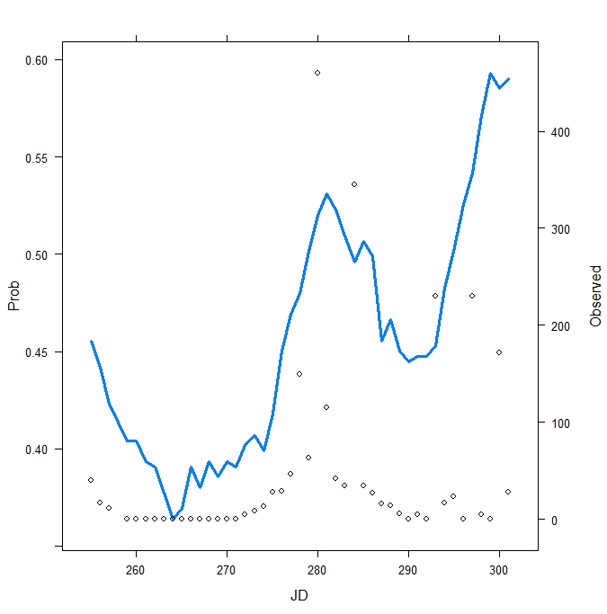
Figure S1: Plot of the seven-day moving average of the posterior probabilities of greater than average eel catch (blue line) vs the daily observed eel catch (open diamonds; Julian Day, JD) for the Souadabscook river in 1988.

