Tables
Table S1. NMFS Survey strata used for each geographic sub-area (see Figure 3).
SUBAREA | SURVEY STRATA
North | 1130 1140 1150 1160 1170 1180 1190 1200 1210 1220 1230 1240 1250 1260 1270 1280 1290 1300 1310 1320 1330 1340 1351 1360 1370 1380 1390 1400 3640 3650 3660
Middle | 1010 1020 1030 1040 1050 1060 1070 1080 1090 1100 1110 1120 3010 3020 3030 3040 3050 3060 3070 3080 3090 3100 3110 3120 3130 3140 3450 3460 3480 3510 3520 3540 3550 3560 3580 3590 3600 3610 3920
South | 0755 1610 1620 1630 1640 1650 1660 1670 1680 1690 1700 1710 1720 1730 1740 1750 1760 3150 3160 3170 3180 3190 3200 3220 3230 3240 3250 3260 3270 3280 3290 3300 3310 3320 3330 3340 3350 3360 3370 3380 3390 3400 3410 3420 3430 3440 7500 7510 7520 7540 8999

Figures

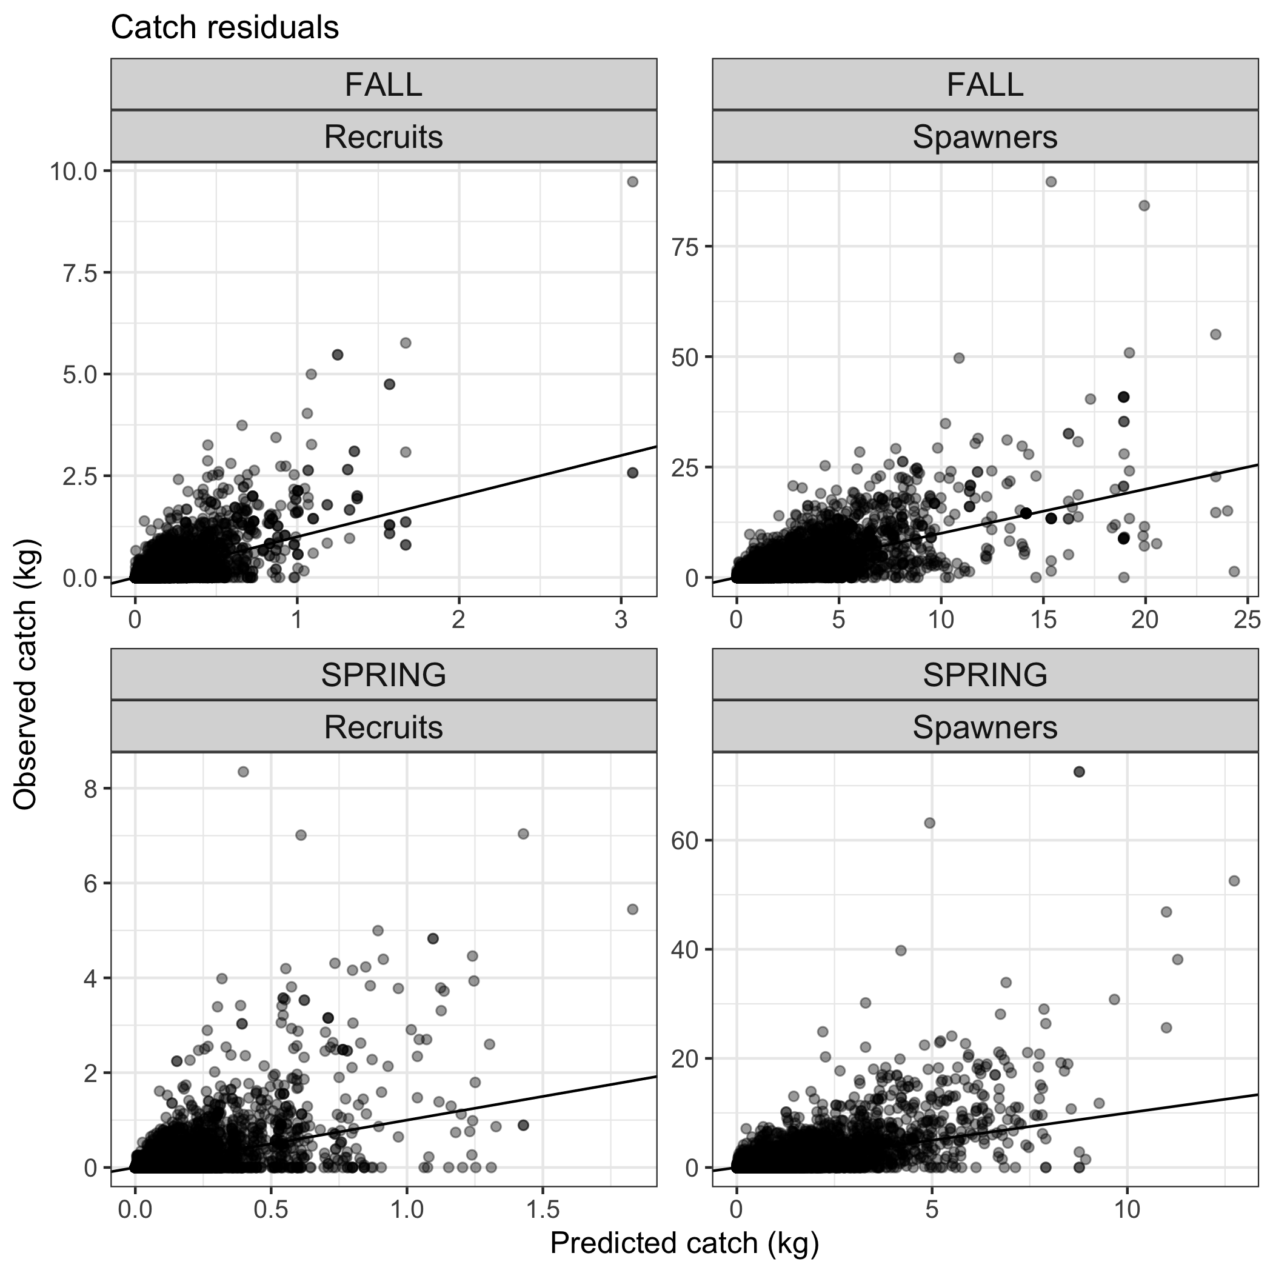
Figure S1. Predicted vs. observed catch.

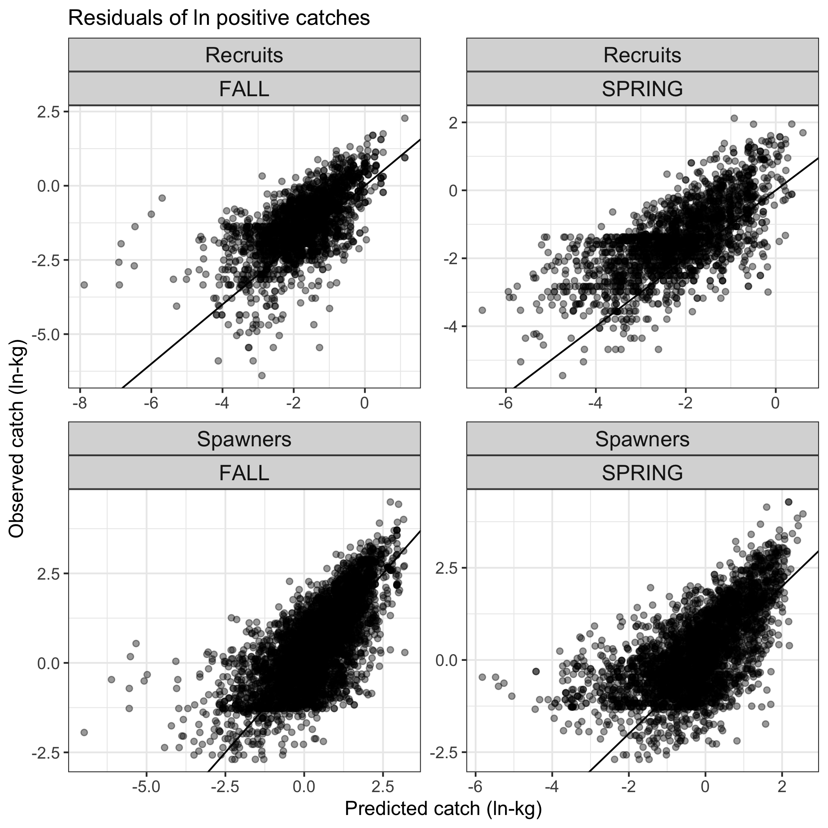
Figure S2. Predicted vs. observed catch for natural logged positive catches.
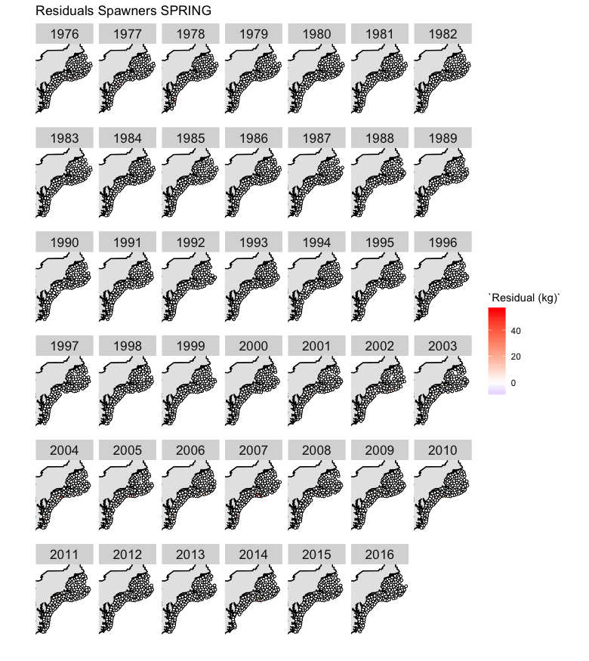
Figure S3. Model residuals for spawners in the spring.
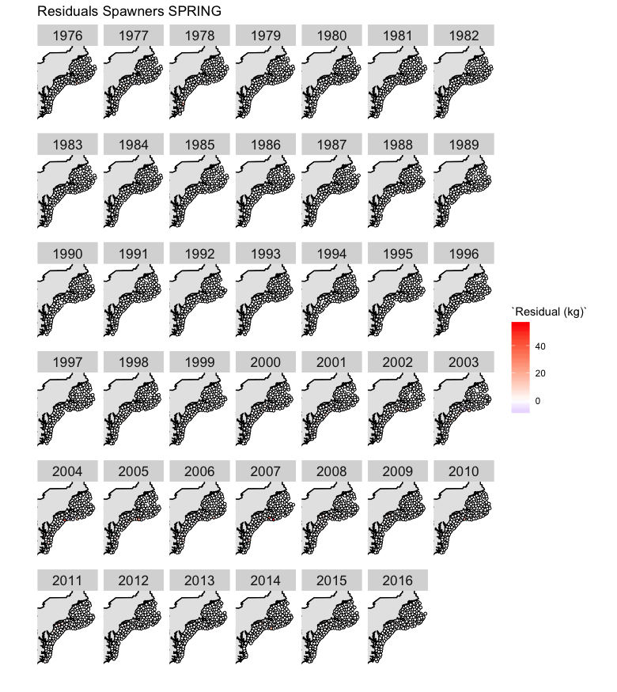
Figure S4. Model residuals for recruits in the spring.

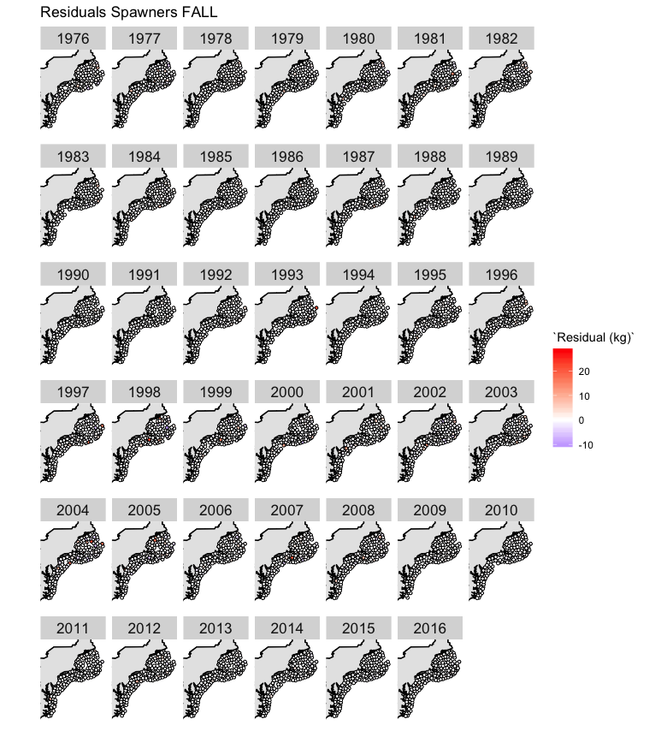
Figure S5. Model residuals for spawners in the fall.
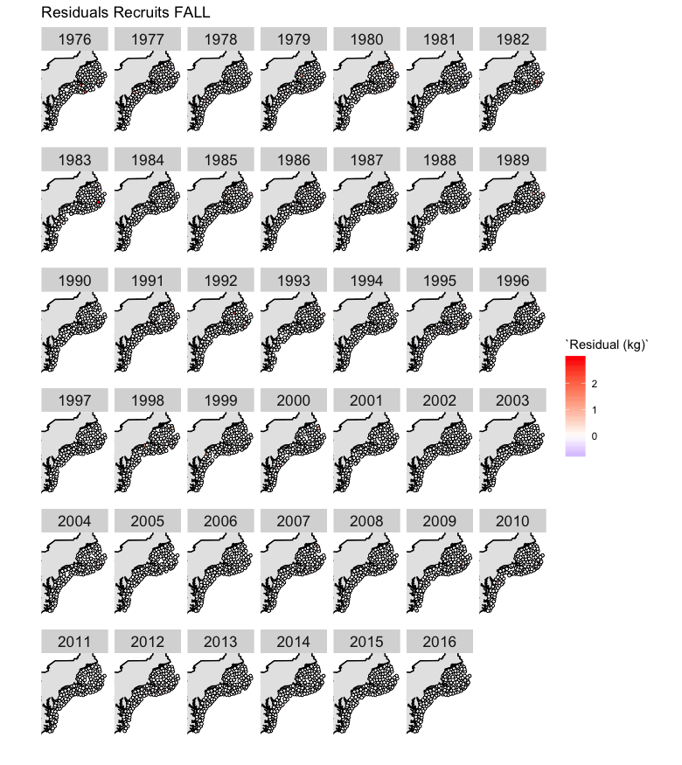
Figure S6. Model residuals for recruits in the fall.

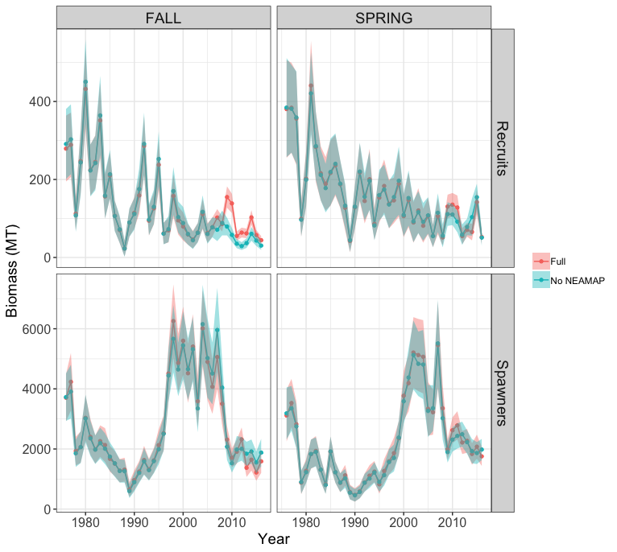
Figure S7. Biomass time series with and without NEAMAP data included in the model. Biomass is unadjusted for catchability.

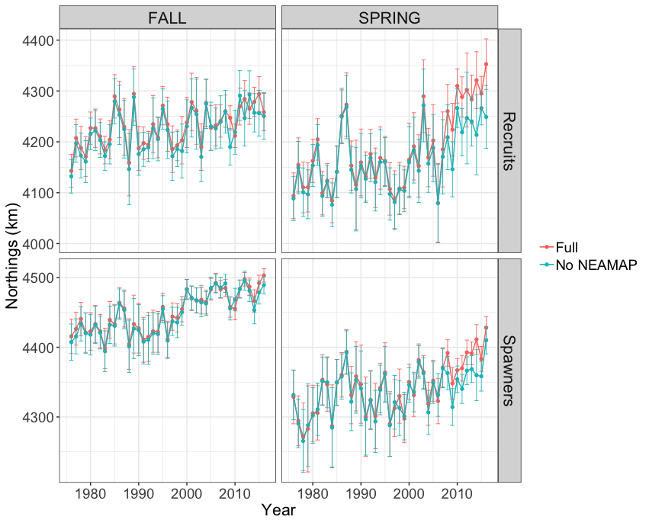
Figure S8. Center-of-gravity of northings for model with (Full) and without NEAMAP data.

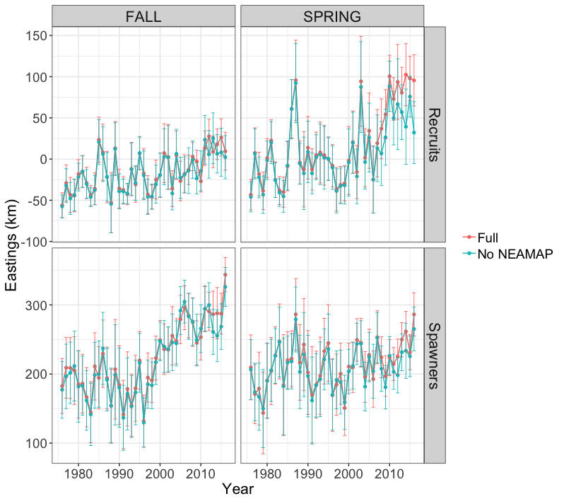
Figure S9. Center-of-gravity of eastings for model with (Full) and without NEAMAP data.

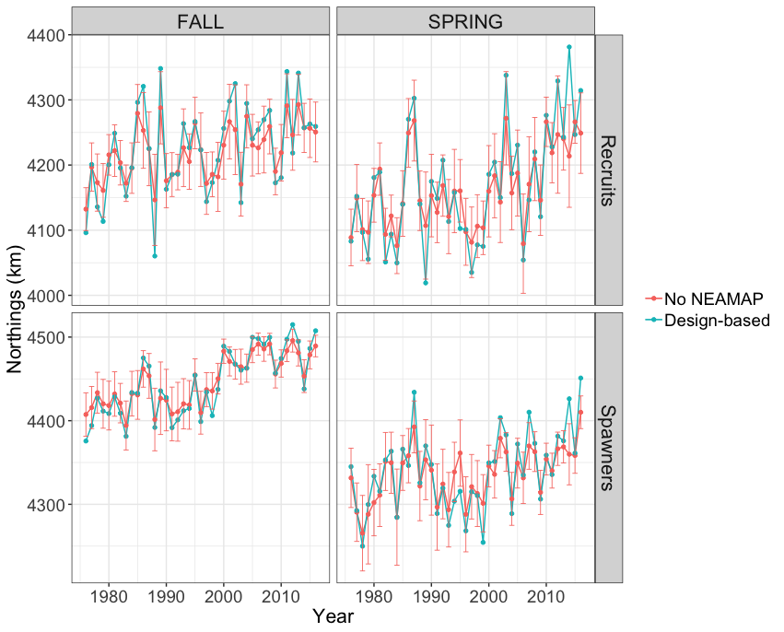
Figure S10. Comparison of northings center of gravity non-NEAMAP VAST model and non-NEAMAP design-based estimate.

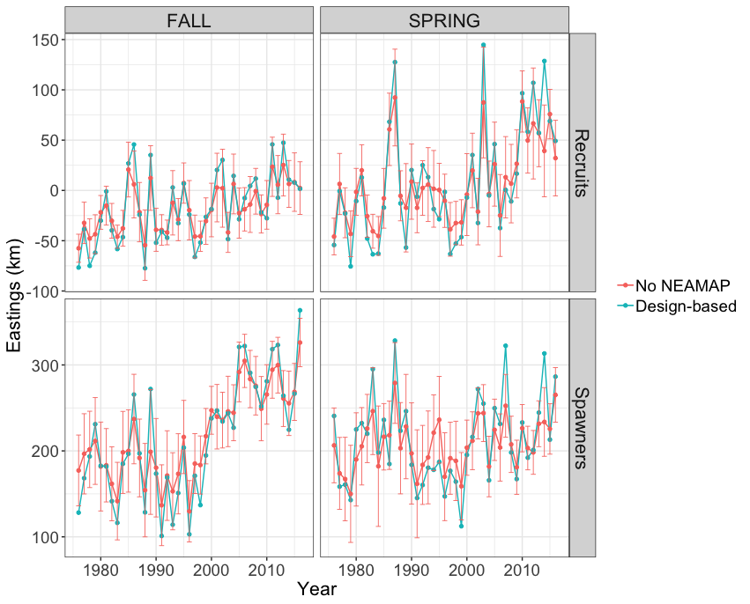
Figure S11. Comparison of eastings center of gravity of non-NEAMAP VAST model and non-NEAMAP design-based estimate.

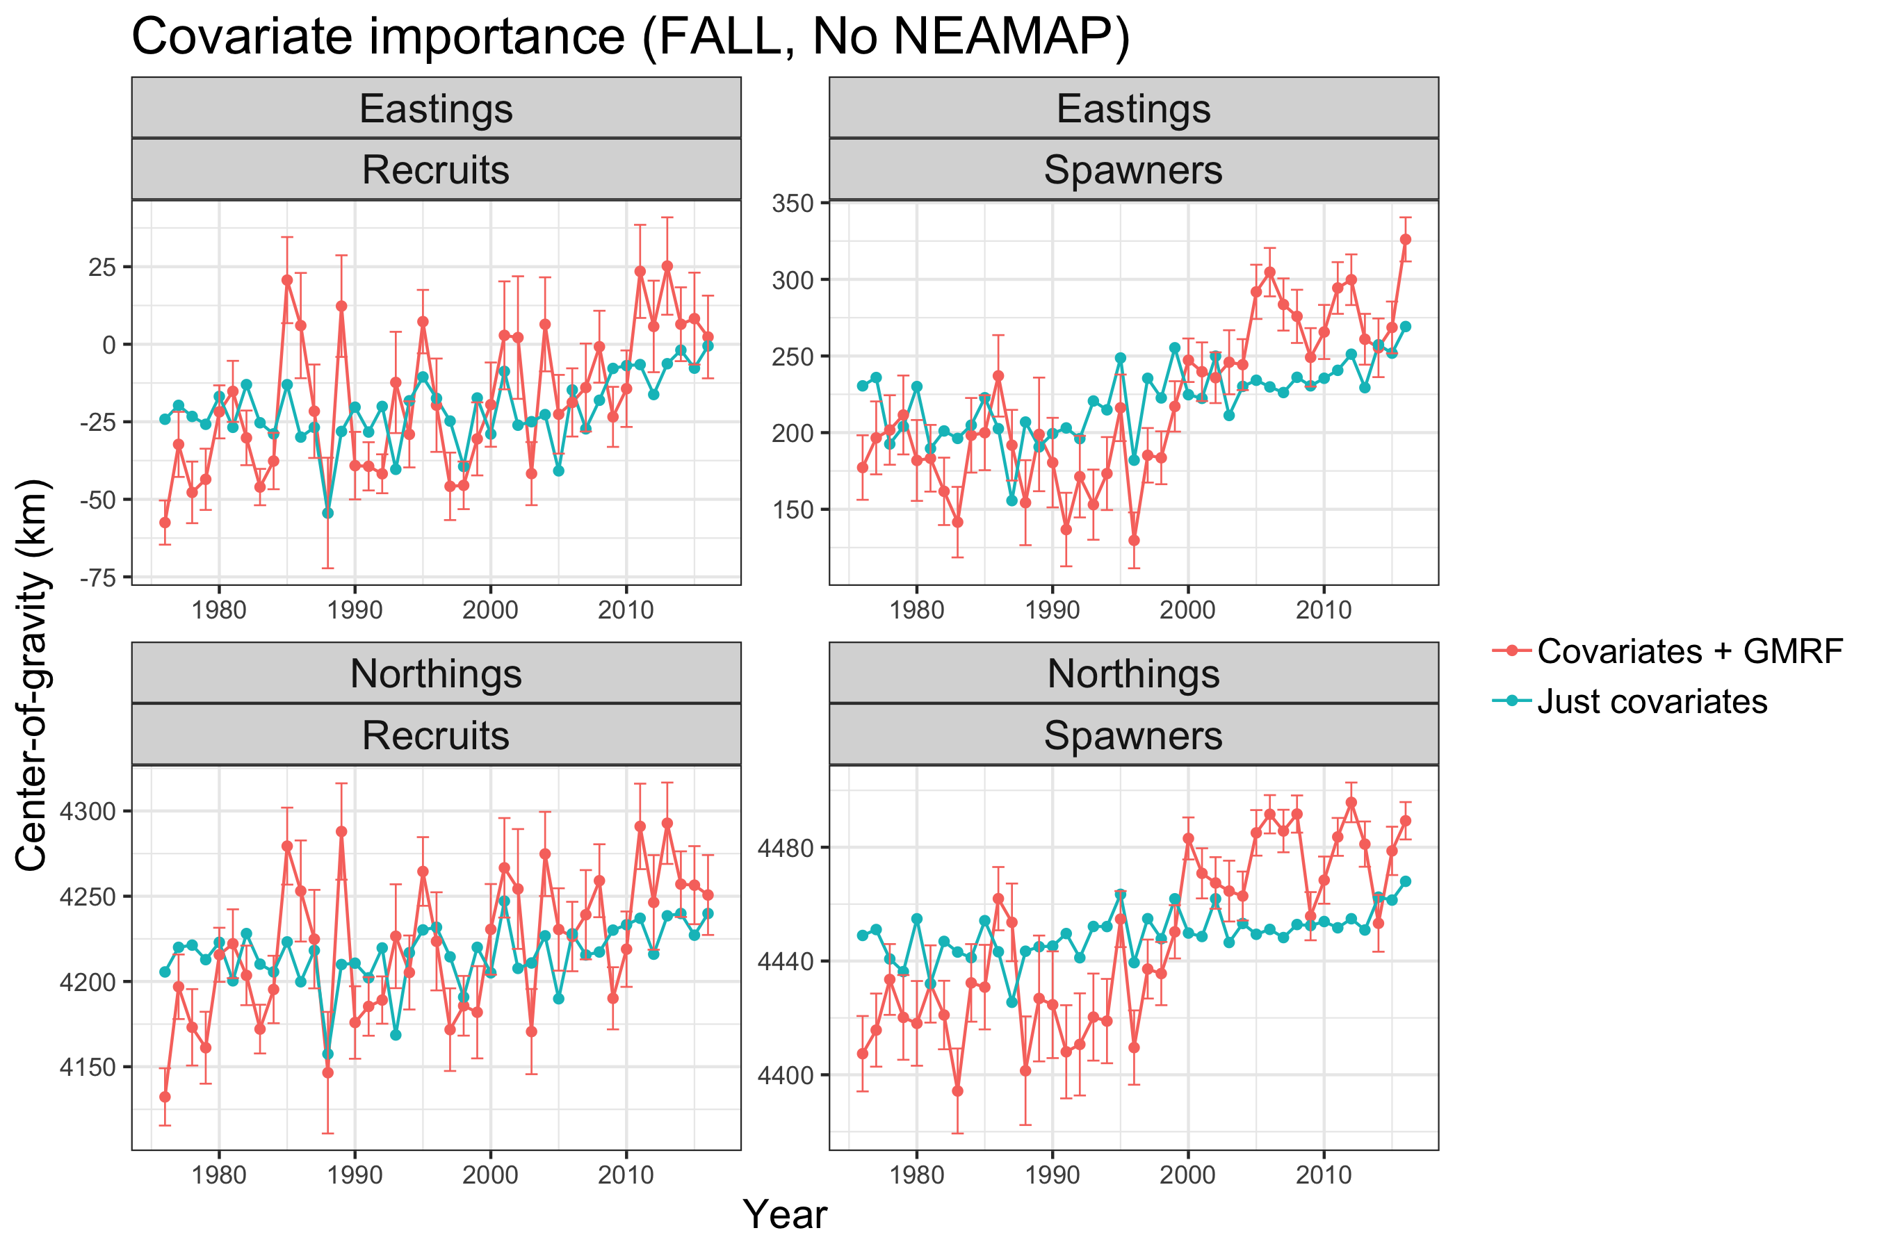
Figure S12. Counterfactual plots showing the ability of covariates to explain variability in the center-of-gravity (Fall, no NEAMAP data in model).

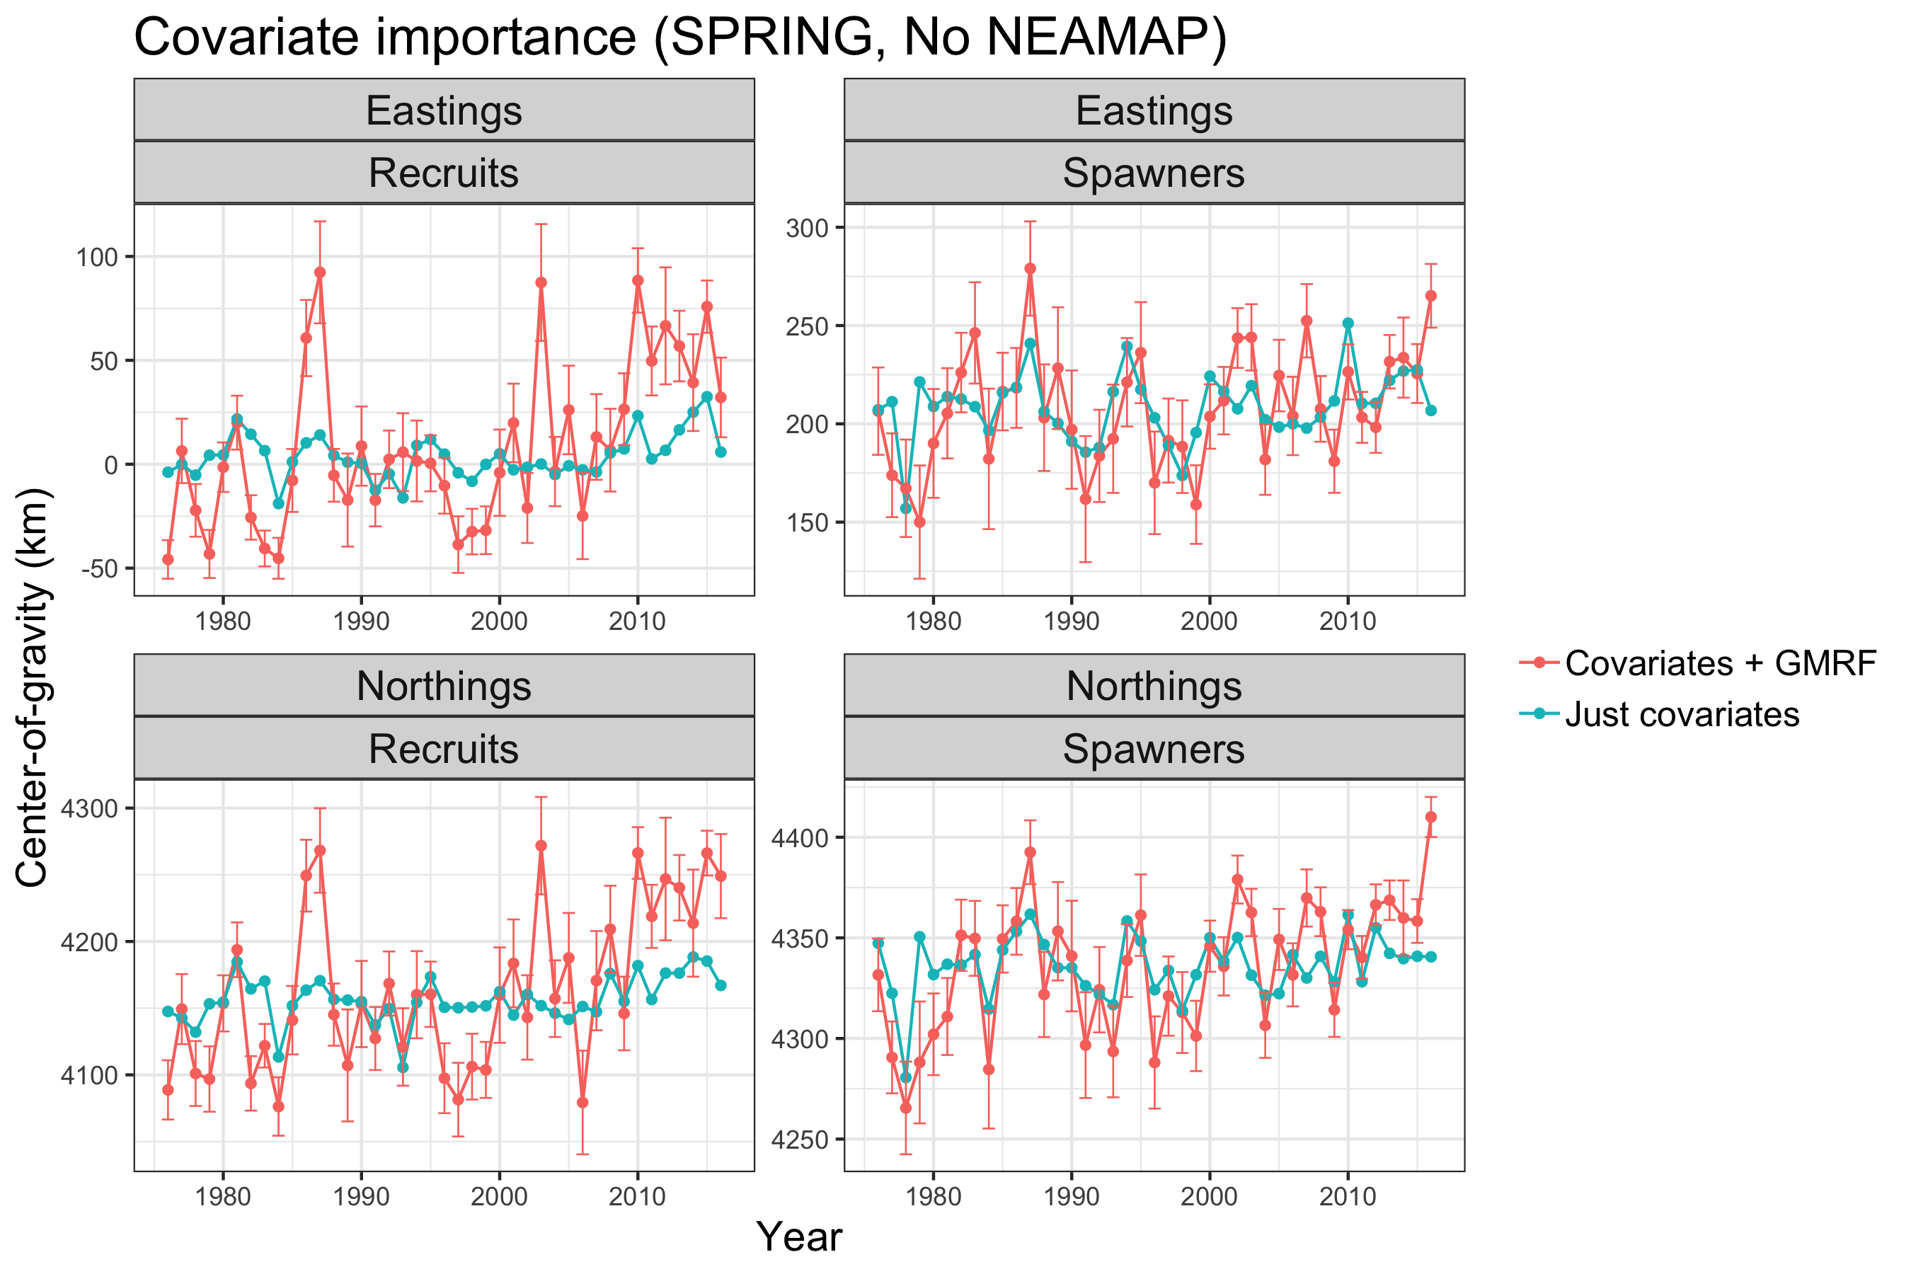
Figure S13. Counterfactual plots showing the ability of covariates to explain variability in the center-of-gravity (Spring, no NEAMAP data in model).

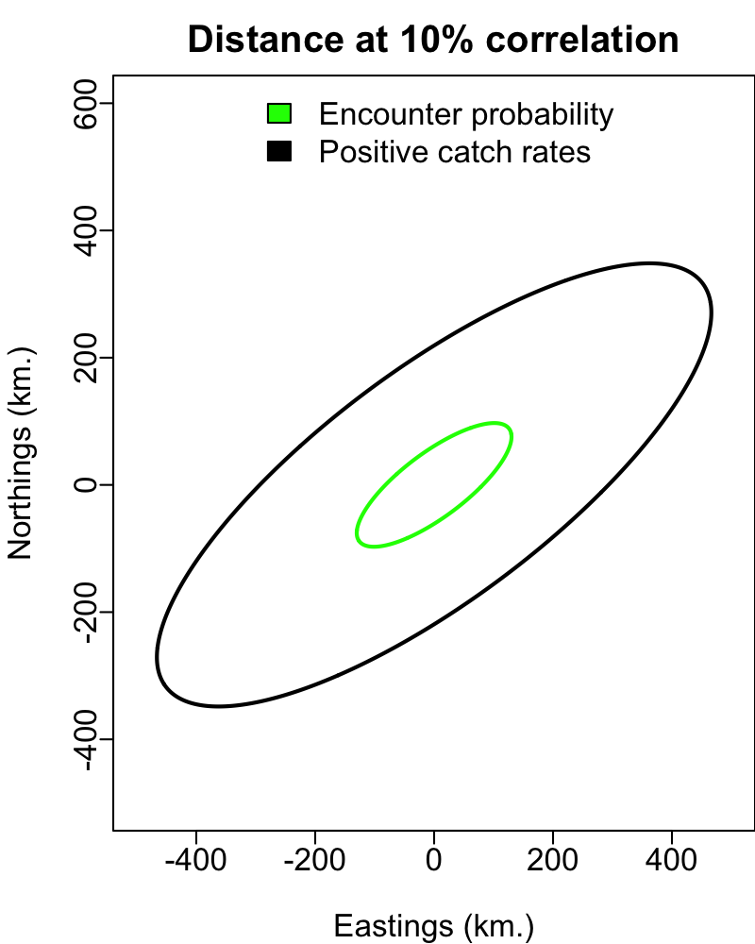
Figure S14. Distance at 10% correlation for each component of the spring model.
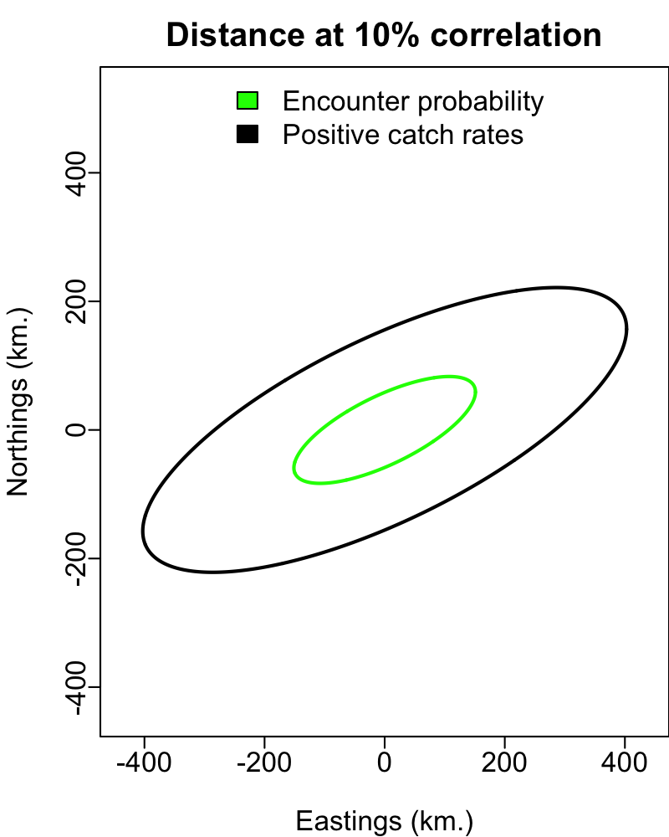
Figure S15. Distance at 10% correlation for each component of the fall model.

