Appendix S1 for

Diverse patterns of larval coral reef fish vertical distribution and consequences for dispersal and connectivity

Christina M. Hernández*, Claire B. Paris, Ana C. Vaz, Benjamin T. Jones, Julie B. Kellner, David E. Richardson, Su Sponaugle, Robert K. Cowen, Joel K. Llopiz
* Corresponding author: Christina M. Hernández Email: cmh352@cornell.edu

Submitted for consideration at Coral Reefs

This PDF file includes:

Supplementary text
Figures S1 to S13
Tables S1 to S3
SI References

Supplementary Information Text
Identifying and accounting for outliers in the larval length data. There were some particularly large larvae that were outliers in the size distribution, which were 2.86-13.09 mm longer than the next longest larva of that taxon. To have a reasonable sample size in each size class, we adjusted the length range using the second-longest larva in Scorpaenidae, Acanthuridae, Chaetodontidae, Scaridae, Gobiidae, and Pomacanthidae, and the third-longest larva in Pomacentridae. For taxa at lower taxonomic levels, we adjusted the size range using the second-longest larva in Anthiinae and Sparisoma, and the third-longest larva in Serraninae. These particularly large larvae were still included in size class 3 for the purpose of calculating proportions at depth. More details of the size class cutoffs are provided in Table S1.
Construction of the generalized OVM behavior. We calculated a generalized OVM distribution by averaging the observed proportions at depth from the five taxa that demonstrated OVM and then smoothing that distribution to 9 depths (Fig. S4). First, we took the average value across taxa of the proportion in each of the 4 observed depth bins, and re-normalized the average proportions to sum to 1. We then used the “density” function in R to estimate a kernel density curve from the 4-depth average proportions, and used the “integrate.xy” function in the R package “sfsmisc” to estimate the area under the kernel density curve for 9 depth bins, centered on the depths listed above.
Connectivity Modeling System modules and parameters used. A main focus of this study is the use of the depth assignment module of the Connectivity Modeling System (CMS; Paris et al. 2013), which forces particle depth distribution to conform to a user-provided matrix of the proportions at depth at various ages throughout the PLD. This study utilizes three vertical behaviors: (1) surface-dwelling larvae, held at 1 m depth; (2) larvae that are uniformly distributed across 9 depth bins in the upper 100 m; and (3) a generalized 9-depth OVM (Fig. S2) behavior based on five taxa (two families: Pomacanthidae and Pomacentridae; one subfamily and one tribe: Anthiinae and Grammistini, both in the family Serranidae; one genus: Xyrichtys in the family Labridae). For the uniformly-distributed and OVM larvae, the 9 depths we used were 4, 12.5, 21, 31.25, 43.75, 56.25, 68.75, 81.25, and 93.75 m. For the OVM behavior, we set the simulation time (larval ages) for each distribution as 25, 25, and 50% of the pre-competency pelagic larval duration. The distribution of older larvae also applied through the competency period.
To simulate settlement and calculate connectivity, we used the seascape module in CMS. When this module is in use, particles that pass into one of the user-defined polygons during a specified competency period are considered settled and stop moving. We used the same 261 polygons used in a previous Caribbean-wide study (Cowen et al. 2006) based on the Coral Reef Millennium Mapping dataset (Andréfouët 2008), with a 9 km buffer (Fig. S1). This buffer is used to incorporate a wide range of near-shore processes that are not present in models of this scale, including physical and behavioral phenomena.
Because we used shallow-water coral reefs as our target settlement habitat while focusing on particle behaviors down to 100 m, some polygons would be more accessible to simulated competent larvae in the surface simulations than to simulated competent larvae in the uniformly-distributed or OVM simulations. To account for this, we specified that all particles in the uniformly-distributed and OVM simulations would use a shallow water distribution at locations where HyCOM data were unavailable at 100 m. The shallow water distribution moves particles to a uniform distribution across 3 depths in the upper 25 m (4, 12.5, and 21 m).
We also used the turbulence module in the CMS, which adds a random kick to particle velocities and is integral to the probabilistic framework of the model. These simulations used horizontal diffusivity components of 10 and 20 m² s⁻¹ for the Global and GoM HyCOM grids, respectively (Table S2). We did not use a vertical diffusivity coefficient because we used vertical behaviors in all simulations. The timesteps used for integration of the CMS model are given in Table S2.
Spawning was simulated by releasing 1000 particles from each polygon at midnight of each day between January 1, 2004 through December 31, 2008. In general, release points are at the centroid of the polygon, except when this would place the particle on “land” according to the HyCOM landmask. For these release sites that cannot coincide with the polygon centroid, they were manually moved into the “ocean,” either within or close to the polygon. Geographic locations for particle releases corresponding to each polygon are available through Figshare (https://doi.org/10.6084/m9.figshare.16959460).
We do not include mortality in our model simulations, because it is insufficiently constrained and it is unlikely to change our main conclusions. Daily larval mortality rates should vary spatially (horizontally and vertically), with larval ontogeny, and across taxa, but these nuances are extremely difficult to estimate and are essentially unknown for reef fish larvae. Thus, models tend to use a constant daily mortality rate, which, if done so here, should not affect the conclusions we draw when comparing how traits influence connectivity and dispersal.

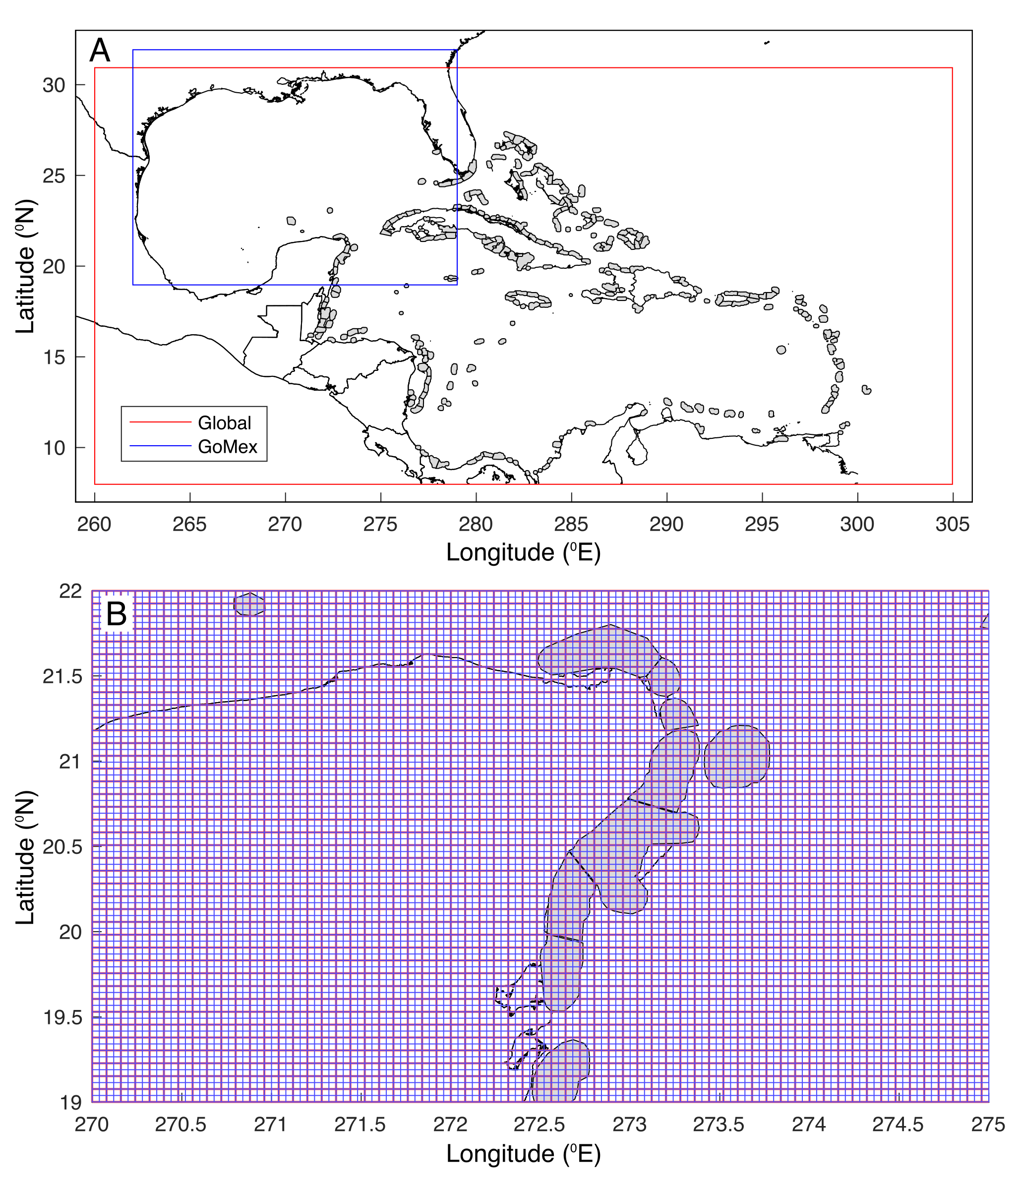
Fig. S1. Map of model domains and overlap with habitat polygons. The Global HyCOM and regional Gulf of Mexico HyCOM model domain edges are shown (A), along with Caribbean coastlines and habitat patches (with 9 km buffer). Habitat patches are shown as filled grey polygons. Note that the Global HyCOM extends globally, and the red polygon shows the edges of the downloaded data used for offline particle tracking simulations. To show how the model resolution relates to the habitat polygons, we also plot the hydrodynamic output grid overlaid with coastline and habitat polygons in the Yucatan peninsula (B). Note that blue lines overlap red lines, so the Gulf of Mexico model has twice the spatial resolution of the global model.

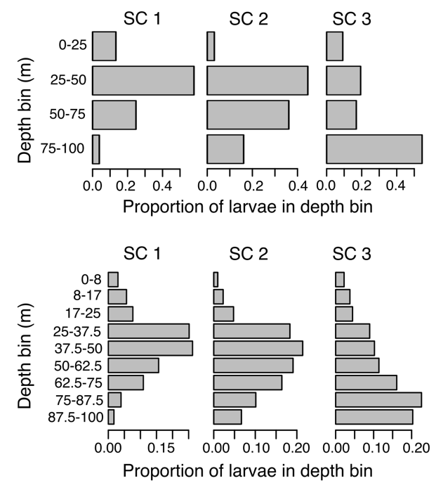

Fig. S2. Combined observations of OVM and Simulated OVM. The upper panel shows the field observations of proportions at depth, averaged across the 5 taxa showing OVM behavior: Pomacentridae, Pomacanthidae, Grammistini, Anthiinae, and Xyrichtys. The lower panel shows the OVM behavior used in model simulations, which was generated by smoothing the 4-depth distribution to a 9-depth distribution by fitting a density kernel to the 4-depth distributions and then integrating that kernel within the depth bins shown in the lower panel.

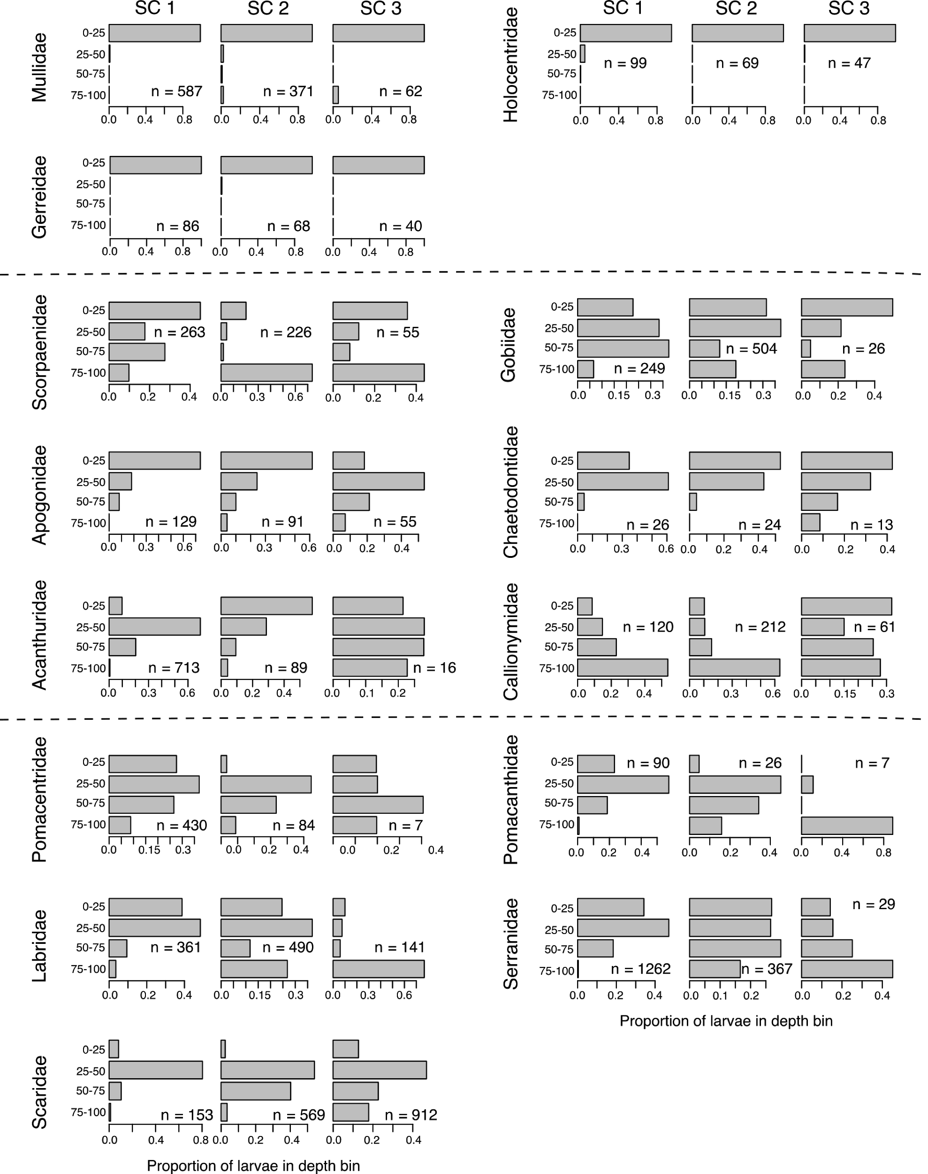

Fig. S3. The full set of family-level larval fish vertical distributions. Each set of 3 panels represents a taxon, with the name given on the left. The columns of sub-panels refer to size classes 1 through 3 that represent respectively 25, 25, and 50% of the observed size range, excluding a small number of outliers. Each sub-panel shows the proportional abundance in 4 depth bins in the upper 100 m, and each sub-panel lists the sample size in that taxon and size class.

Fig. S4. The full set of subfamily-, tribe-, and genus-level larval fish vertical distributions. Each set of 3 panels represents a taxon, with the name given on the left. The upper three rows are genera in the family Labridae; the middle three rows are genera in the family Scaridae; the bottom three rows are two subfamilies and one tribe in the family Serranidae. The columns of sub-panels refer to size classes 1 through 3 that represent respectively 25, 25, and 50% of the observed size range, excluding a small number of outliers. Each sub-panel shows the proportional abundance in 4 depth bins in the upper 100 m, and each sub-panel lists the sample size in that taxon and size class.

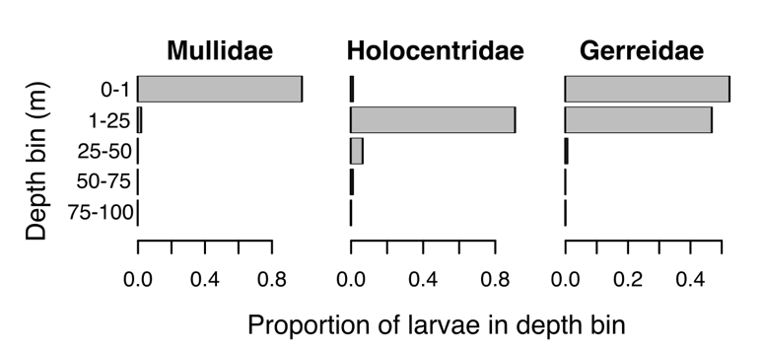
Fig. S5. Surface associated taxa and their depth in the water column. In order to show the importance of the neuston net sampling (0-1 m depth bin), we use proportional concentration (N per m³) instead of abundance (N per m²).

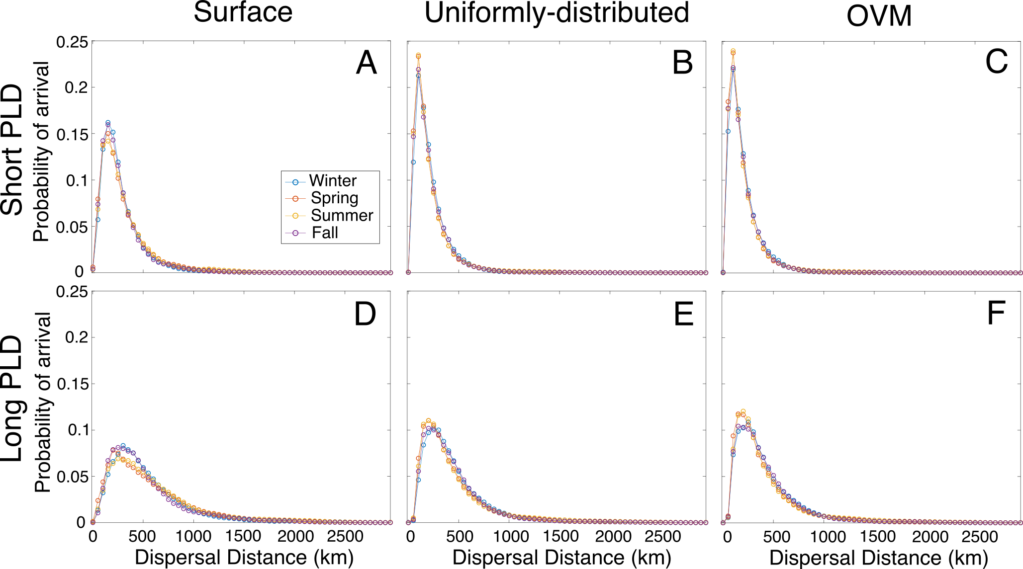
Fig. S6. Seasonal dispersal kernels. Shown for short PLD (first row) and long PLD (second row) for surface-dwelling (first column), uniformly-distributed (middle column) and OVM (third column) simulations. Seasons are defined by release dates with winter covering Jan-March, spring April-June, summer July-Sept, and fall Oct-Dec. All kernels are displayed on the same axes, and the sum of probabilities in each kernel (each colored curve) is equal to 1.

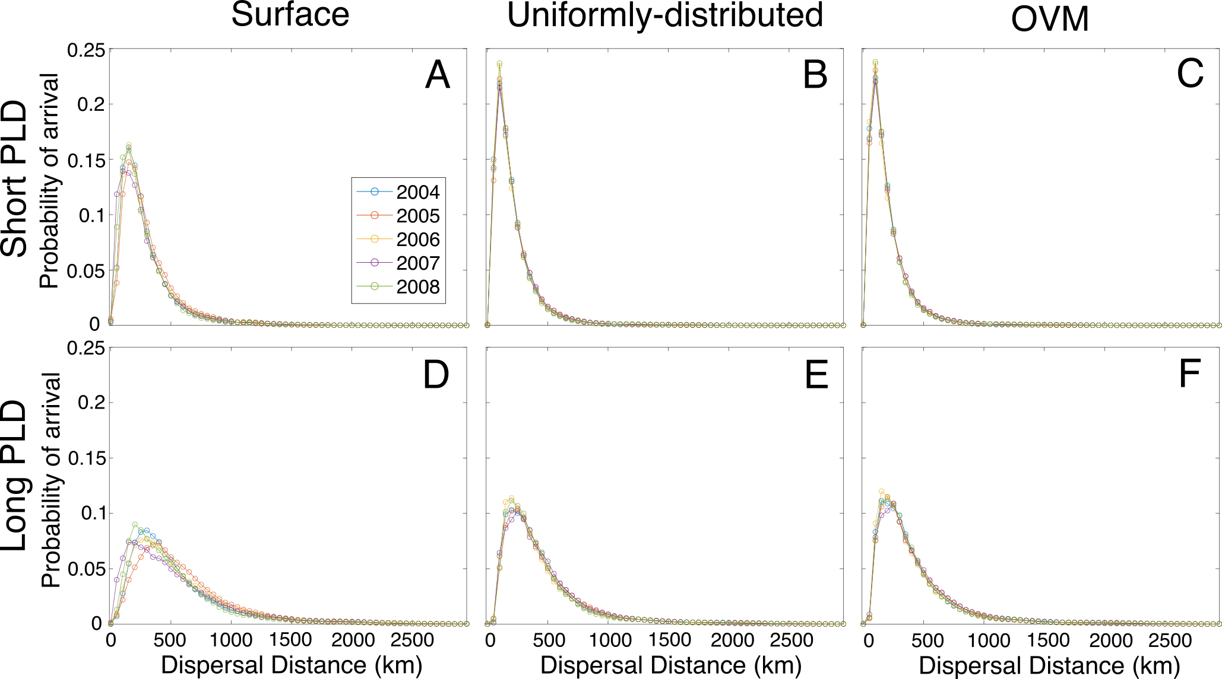

Fig. S7. Annual dispersal kernels. Dispersal kernels of successfully settled larvae for combinations of larval behaviors and pelagic larval durations (PLD). (Columns) Three larval behavior simulations were conducted: surface-dwelling, uniformly-distributed, and ontogenetic vertical migration (OVM). (Rows) Short and long PLD simulations correspond to 20-30 days and 40-50 days, respectively. Larvae are assigned to a year based on their release date between January 1 2004 and December 31 2008. Axis limits are the same across all panels, and the sum of probabilities in each kernel (each colored curve) is equal to 1.

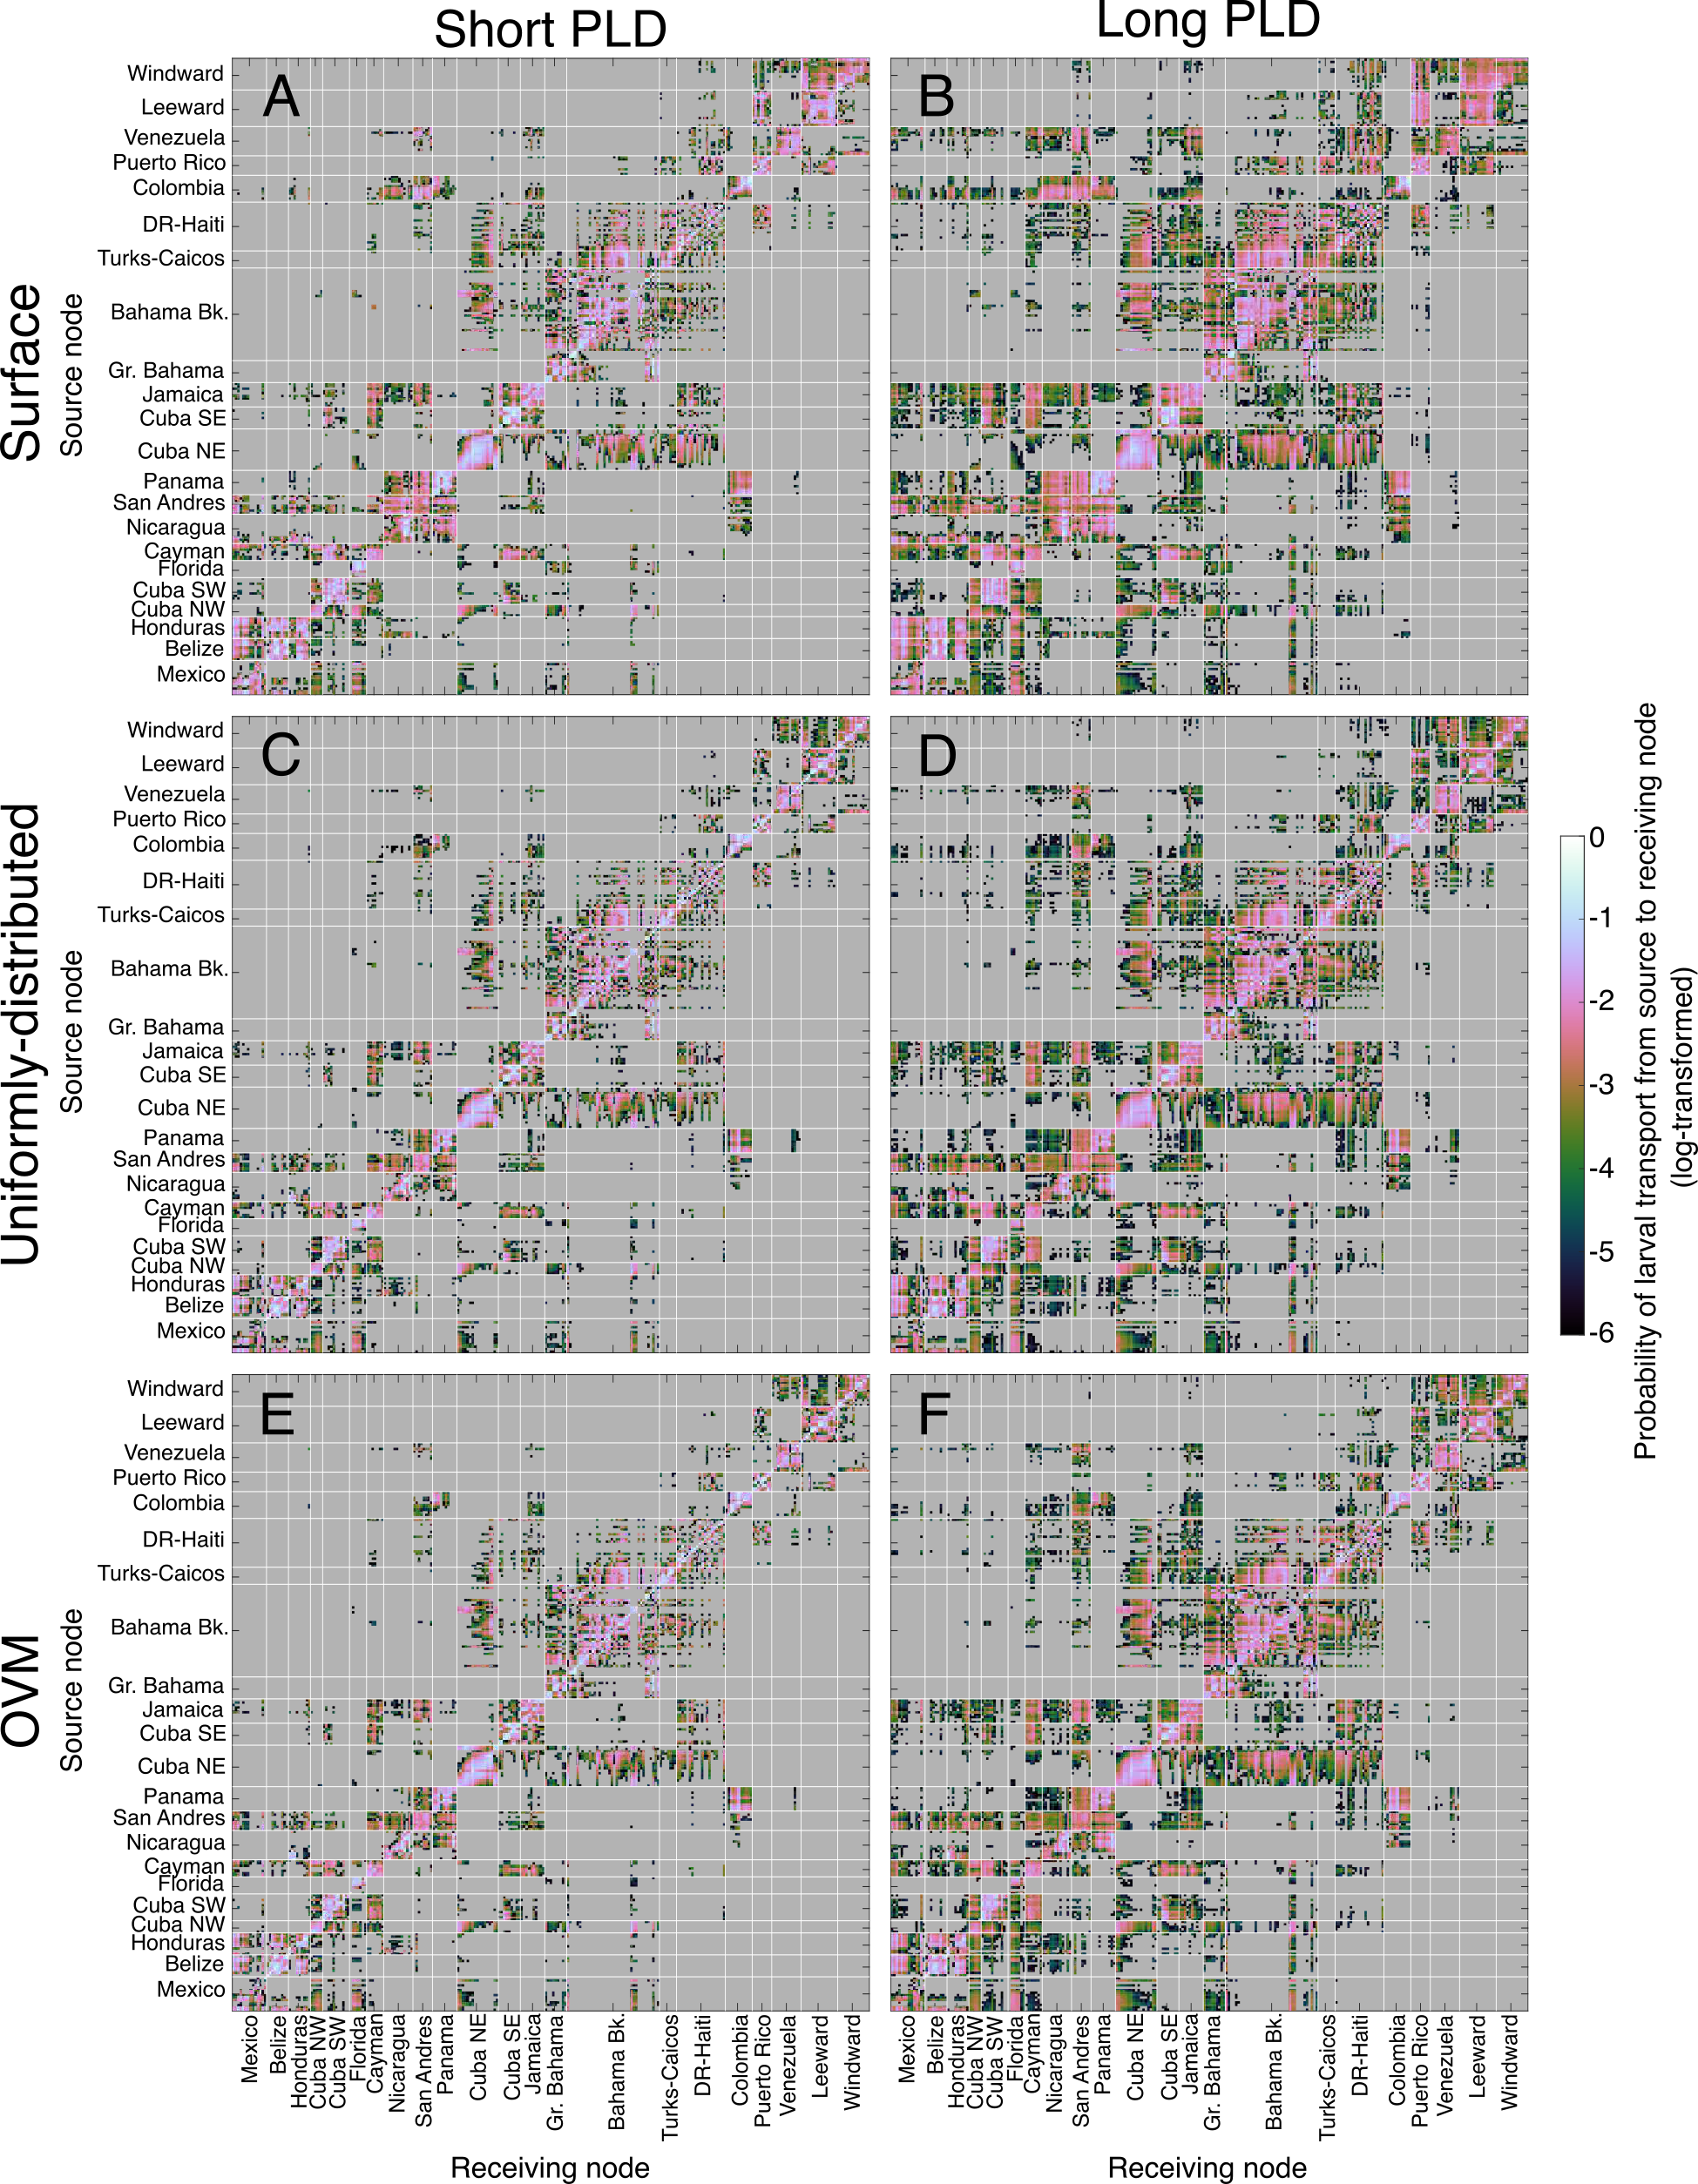
Figure S8. Connectivity matrices. Connectivity is defined as the probability of larval transport from the source nodes (rows) to receiving nodes (columns) of the matrix. This probability is taken across all released particles, so rows do not sum to one. Source and receiving nodes are organized into geographic regions, from west to east. A map of regions is available in Fig. S1. Note that the colorbar is log-scaled. (Rows) Three larval behavior simulations were conducted: surface-dwelling, uniformly-distributed, and ontogenetic vertical migration (OVM). (Columns) Short and long PLD simulations correspond to 20-30 days and 40-50 days, respectively.
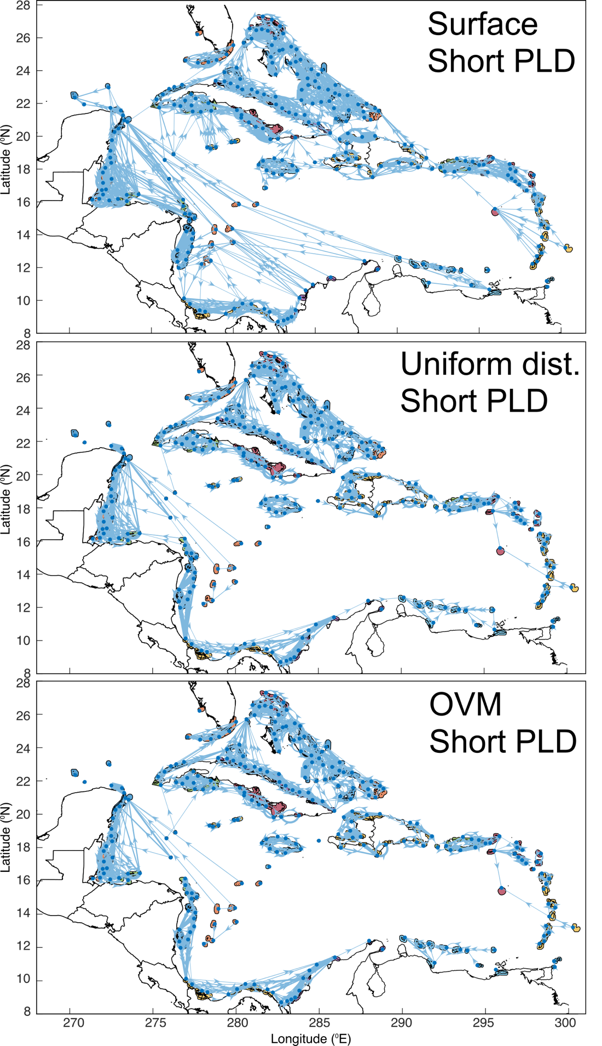
Fig. S9. Maps of larval connectivity under different vertical behaviors for short PLD simulations. The edges from a directed graph of the connectivity matrix are plotted on geographic axes, together with the habitat polygons. Line widths are scaled by the edge weight (i.e., the connectivity value). To aid in visibility of this figure and focus on the most important exchange pathways, only edges with a weight of at least 0.02 (2% probability of connectivity) are shown, and self loops are also omitted.

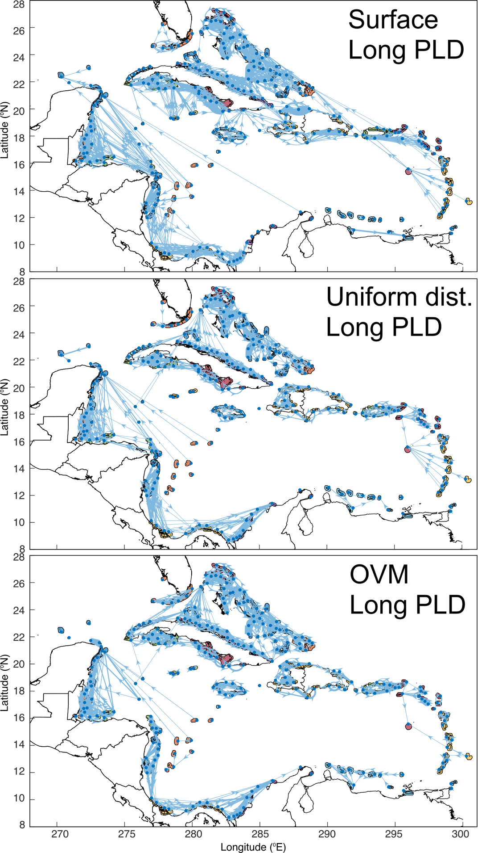
Fig. S10. Maps of larval connectivity under different vertical behaviors for long PLD simulations. Same as for Fig. S9, but for long PLD simulations. Edges with ≥2% probability of connectivity are shown, and self loops are not depicted.

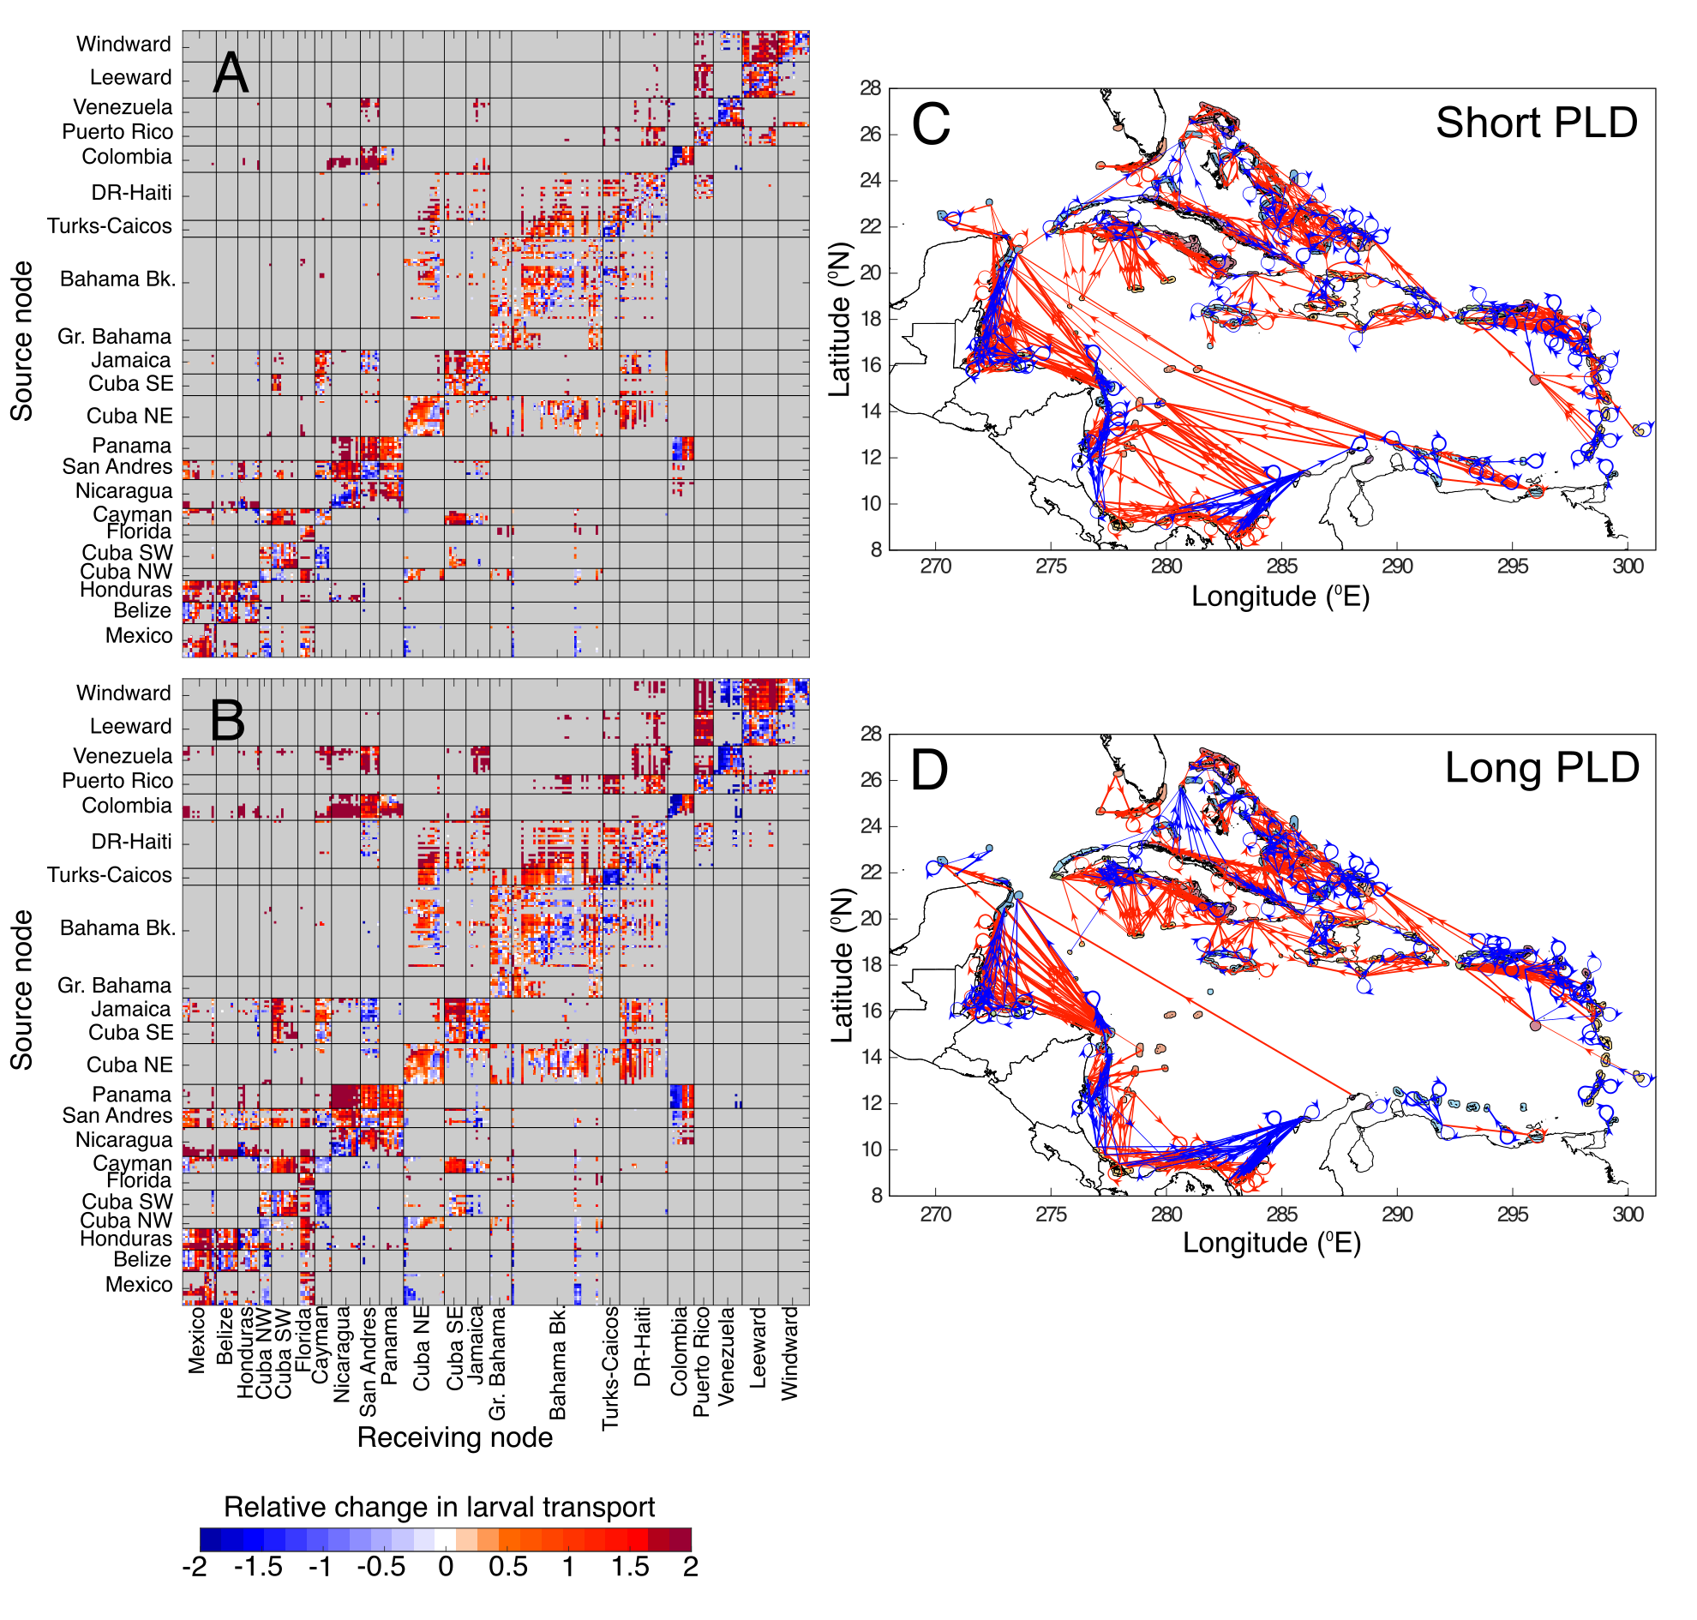
Fig. S11. Relative change in larval transport between the surface-dwelling and ontogenetic vertical migration simulations. Relative change in connectivity for (A) short (20-30 d) PLD and (B) long (40-50 d) PLD. Rows are release sites (source nodes) and columns settlement sites (receiving nodes). The colorbar indicates the relative change in larval transport as given by the equation for the matrix C: $c_{ij}=\frac{a_{ij}-b_{ij}}{\frac{1}{2}\left(a_{ij}+b_{ij}\right)}$ where A is the larval transport matrix for surface-dwelling simulations and B is the larval transport matrix for OVM simulations. Red colors indicate more larvae transported in the surface-dwelling simulations, and blue colors indicate more larvae transported in the OVM simulations. Source and receiving nodes are grouped within regions, and regions are arranged roughly west to east. For a map of regions, see Fig. S1.

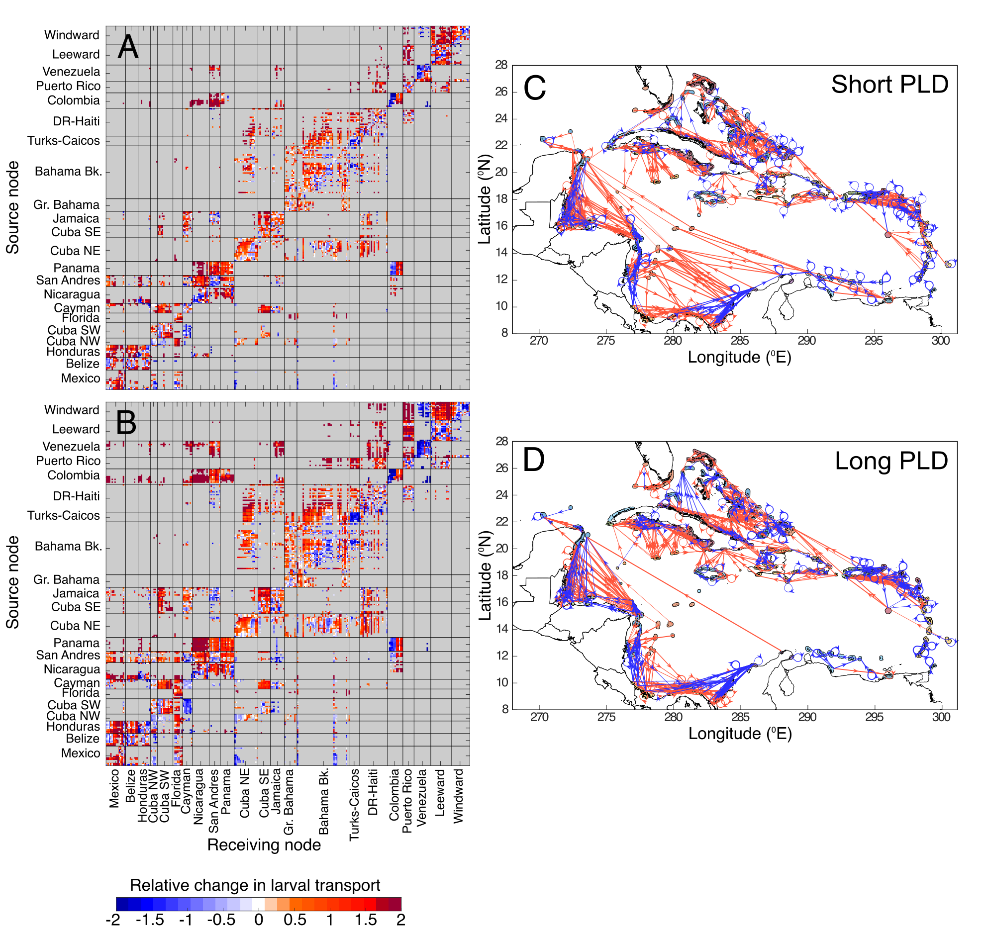
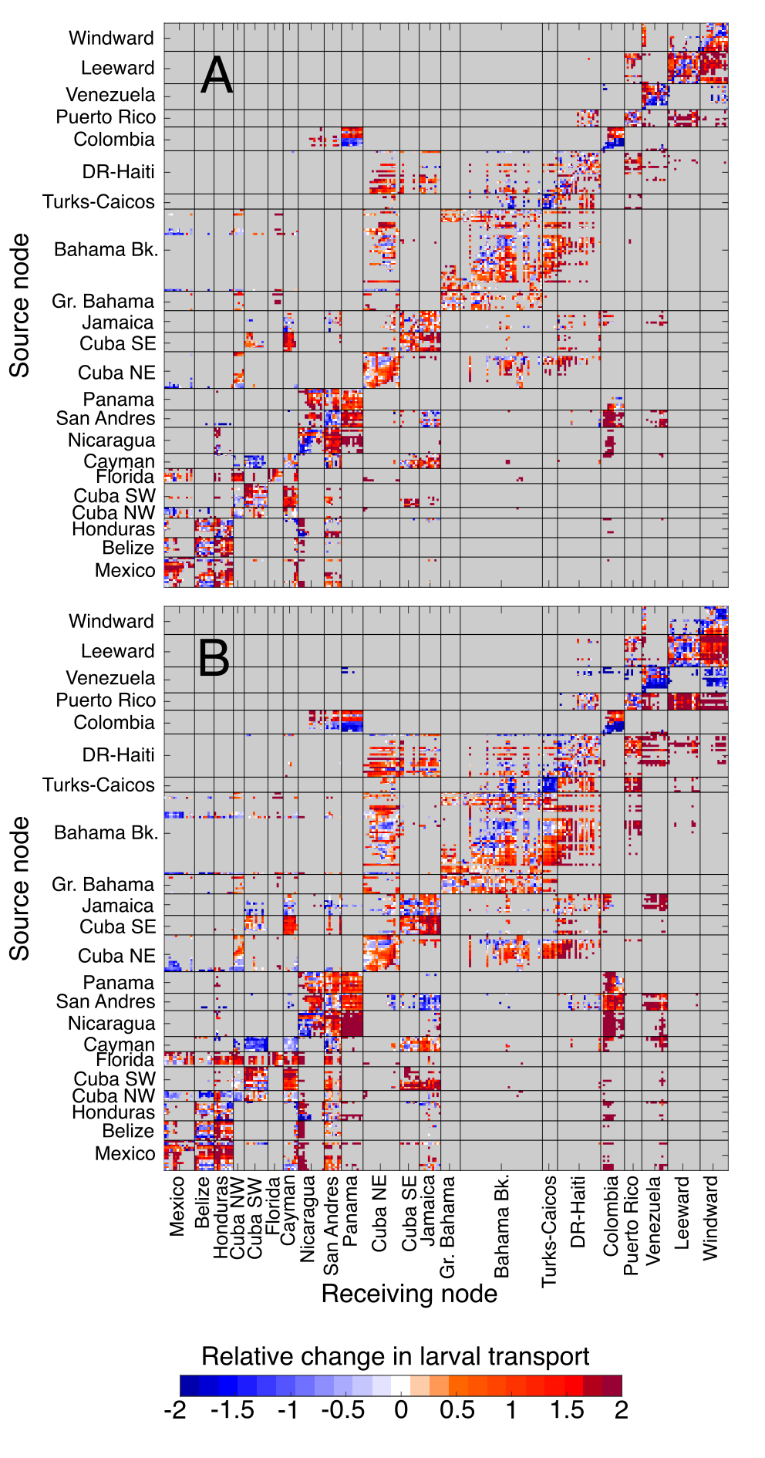
Fig. S12. Relative change in larval transport between the surface-dwelling and uniformly-distributed simulations. Relative change in connectivity for (A) short (20-30 d) PLD and (B) long (40-50 d) PLD. This figure follows the same design as Fig. S11. Red colors indicate more larvae transported in the surface-dwelling simulations, and blue colors indicate more larvae transported in the uniformly-distributed simulations.

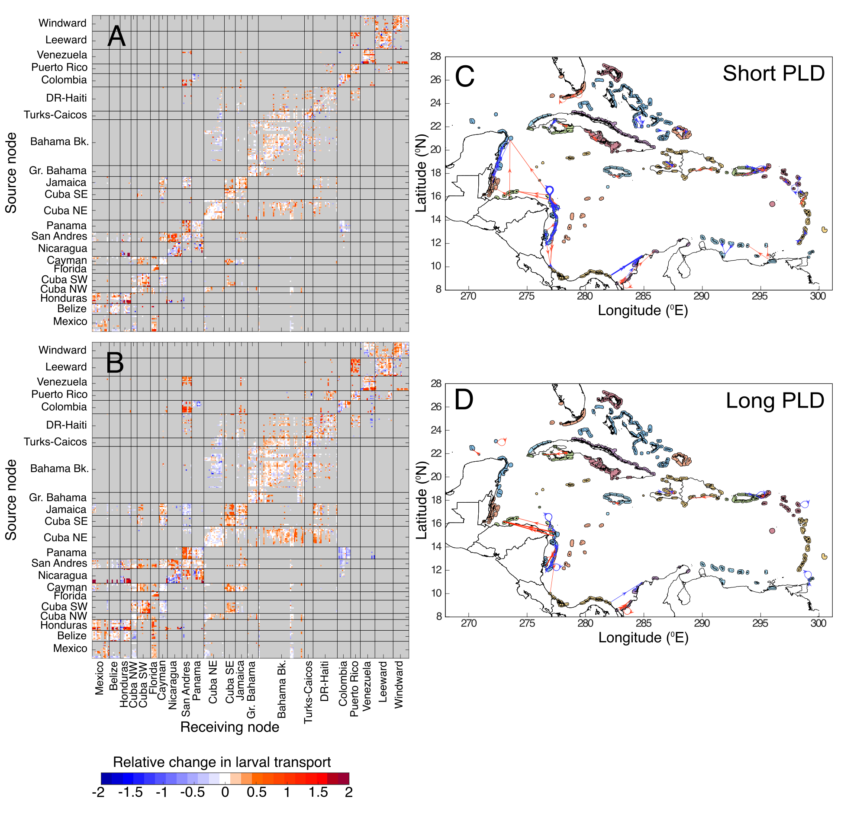Fig. S13. Relative change in larval transport between the uniformly-distributed and OVM simulations. Relative change in connectivity for (A) short (20-30 d) PLD and (B) long (40-50 d) PLD. This figure follows the same design as Fig. S11. Red colors indicate more larvae transported in the uniformly-distributed simulations, and blue colors indicate more larvae transported in the OVM simulations.

Table S1. Detailed length information for proportions at depth calculations. We provide the minimum size observed; the upper cutoffs for size classes 1, 2, and 3; and the maximum size observed. All lengths are in millimeters. If the maximum size observed is larger than the cutoff for size class 3, the number of outliers is indicated. Note that these outliers were still included in size class 3 for calculating proportions at depth.

Family | Genus, Subfamily, or Tribe | Minimum Size | Size Class 1 | Size Class 2 | Size Class 3 | Maximum Size
Acanthuridae | - | 1.75 | 4.4175 | 7.085 | 12.42 | 15.71 (1)
Apogonidae | - | 2.46 | 4.345 | 6.23 | 10.00 | 10.00
Callionymidae | - | 2.65 | 4.0875 | 5.525 | 8.40 | 8.40
Chaetodontidae | - | 3.00 | 4.275 | 5.55 | 8.10 | 12.42 (1)
Gerreidae | - | 2.80 | 4.92 | 7.04 | 11.28 | 11.28
Gobiidae | - | 1.76 | 5.7475 | 9.735 | 17.71 | 21.42 (1)
Holocentridae | - | 2.15 | 3.8375 | 5.525 | 8.90 | 8.90
Labridae | - | 2.15 | 5.005 | 7.86 | 13.57 | 13.57
Mullidae | - | 1.50 | 7.2675 | 13.035 | 24.57 | 24.57
Pomacanthidae | - | 2.20 | 4.65 | 7.10 | 12.00 | 19.00 (1)
Pomacentridae | - | 2.13 | 4.6675 | 7.205 | 12.28 | 15.57 (2)
Scaridae | - | 2.60 | 4.45 | 6.30 | 10.00 | 13.14 (1)
Scorpaenidae | - | 1.90 | 3.8175 | 5.735 | 9.57 | 22.66 (1)
Serranidae | - | 1.80 | 5.635 | 9.47 | 17.14 | 17.14
Labridae | Xyrichtys | 2.60 | 5.3425 | 8.085 | 13.57 | 13.57
Labridae | Halichoeres | 2.15 | 4.3975 | 6.645 | 11.14 | 11.14
Labridae | Thalassoma | 2.608 | 4.7385 | 6.869 | 11.13 | 11.13
Serranidae | Serraninae | 2.00 | 4.10 | 6.20 | 10.40 | 17.14 (2)
Serranidae | Anthiinae | 1.80 | 4.025 | 6.25 | 10.7 | 14.85 (1)
Serranidae | Grammistini | 2.50 | 4.73 | 6.96 | 11.42 | 11.42
Scaridae | Sparisoma | 2.60 | 4.45 | 6.30 | 10.00 | 13.14 (1)
Scaridae | Scarus | 3.06 | 4.1275 | 5.195 | 7.33 | 7.33
Scaridae | Cryptotomus | 2.85 | 4.4125 | 5.975 | 9.10 | 9.10

Table S2. Timesteps and diffusivity parameters used for integration of Connectivity Modeling System simulations.

 | Timestep (seconds)
Update location of particles | 1200
Add sub-gridscale turbulence | 2400
Update particle depths to match desired vertical distribution | 2400
 | Diffusivity (m² s⁻¹)
HyCOM Global grid | 10
Gulf of Mexico grid | 20

Table S3. Median dispersal distance by season. The median dispersal distance (km) of all larvae that reach settlement habitat under each behavior and duration combination, separated by the larval release season. Seasons are defined by release dates with winter covering Jan-March, spring April-June, summer July-Sept, and fall Oct-Dec. Distances are rounded to the nearest integer.

 | Short Duration |  |  | Long Duration
 | Surface | Uniform | OVM | Surface | Uniform | OVM
Winter | 223 | 173 | 165 | 443 | 364 | 342
Spring | 225 | 155 | 151 | 449 | 334 | 317
Summer | 234 | 157 | 152 | 479 | 335 | 321
Fall | 217 | 165 | 158 | 421 | 355 | 341

Appendix S1 References
Andréfouët, S. 2008. Coral reef habitat mapping using remote sensing: A user vs producer perspective. implications for research, management and capacity building. Journal of Spatial Science 53:113–129.
Cowen, R. K., C. B. Paris, and A. Srinivasan. 2006. Scaling of connectivity in marine populations. Science 311:522–527.
Paris, C. B., J. Helgers, E. van Sebille, and A. Srinivasan. 2013. Connectivity Modeling System: A probabilistic modeling tool for the multi-scale tracking of biotic and abiotic variability in the ocean. Environmental Modelling & Software 42:47–54.

