Supplementary Material
Supplementary Tables
Table S1. U.S. Virgin Islands water quality criteria. Class A waters should not exceed Class B water quality standards in any case. Listed are Class B and Class C water quality parameters that are evaluated by DPNR when determining if a water body meets the water quality criteria (USVI DPNR 2019).
Criterion Evaluated | Class B | Class C
Dissolved Oxygen | ≥ 5.5 mg/l | ≥ 5.0 mg/l
pH | ≤ 8.3 to ≥ 7.0 | ≤ 8.5 to ≥ 6.7
Temperature | ≤ 32° C; ≤ 29° C in coral reef ecosystems | Same as Class B
Total Phosphorus | Not to exceed 50 µg/L | Same as Class B
Total Nitrogen | Not to exceed 207 µg/L in > 10 % of samples over a three-year period | Same as Class B
Turbidity | A maximum NTU reading of 3 shall be permissible; should not exceed 1 NTU in coral reef ecosystems | Same as Class B
Secchi Depth | Visible at a minimum depth of 1 meter | Same as Class B
Bacteria | Enterococci shall not exceed 30 CFU/100 mL for the 30-day geometric mean; enterococci shall not exceed 110 CFU/100 mL in more than 10 % of samples collected within the same 30 days. | Same as Class B
Chlorine | The 4-day average concentration of Chlorine shall not exceed 7.5 µg/l. The 1-hour average concentration of Chlorine shall not exceed 13 µg/l | Same as Class B

Table S2. GPS coordinates of coral and sediment samples.
Coral Sites | Latitude (DDM) | Longitude (DDM)
SARI 1 | N 17°46.873 | W 64°44.707
SARI 2 | N 17°47.003 | W 64°45.180
SARI 3 | N 17°46.824 | W 64°45.268
BUIS 1 | N 17°46.994 | W 64°36.989
BUIS 2 | N 17°47.241 | W 64°36.576
BUIS 4 | N 17°47.553 | W 64°36.371
BUIS 6 | N 17°47.767 | W 64°36.639
Sediment Sites | Latitude (DDM) | Longitude (DDM)
SARI 1 | N 17°46.873 | W 64°44.707
SARI 2 | N 17°47.003 | W 64°45.180
SARI 3 | N 17°46.824 | W 64°45.268
SARI 4 | N 17°46.521 | W 64°45.260
SARI 5 | N 17°46.682 | W 64°45.237
SARI 6 | N 17°46.358 | W 64°45.180
SARI 7 | N 17°46.490 | W 64°45.234
SARI 8 | N 17°46.054 | W 64°45.584
SARI 9 | N 17°46.356 | W 64°45.608
SARI 10 | N 17°46.564 | W 64°45.557
SARI 11 | N 17°46.499 | W 64°45.666
SARI 12 | N 17°46.852 | W 64°45.893
BUIS 1 | N 17°46.994 | W 64°36.989
BUIS 2 | N 17°47.241 | W 64°36.576
BUIS 4 | N 17°47.553 | W 64°36.371

Table S3. Coral colony size and colony percent tissue mortality by site. Colony size (cm) is mean length in its longest dimension (SE = standard error).
Site | Colony length (cm) | ± SE | Mortality (%) | ± SE
SARI 1 | 87.2 | 7.9 | 25.0 | 7.1
SARI 2 | 132.0 | 25.3 | 31.0 | 6.1
SARI 3 | 128.5 | 18.6 | 20.5 | 4.4
BUIS 1 | 150.0 | 13.0 | 7.0 | 0.8
BUIS 2 | 155.5 | 8.7 | 19.5 | 3.9
BUIS 4 | 157.5 | 19.3 | 42.5 | 11.6

Table S4. 2017 water quality data compiled from the Water Quality Portal (https://www.waterqualitydata.us/portal/). Highlighted values exceed the class B water quality criteria for coral reef ecosystems shown in Table S1.
Table S5. Measured and assigned values for AIST Certified Geochemical Reference Material JCp-1 Coral (Porites sp.). Li, Al, and Zn are listed here but are not pictured in Figure S4 because the mass fraction ratio exceeds visibility on the chart. Highlighted values are non-certified informational values, and these comparisons do not account for any method biases in either the measured or assigned values. The uncertainty for the assigned value represents the 95 % confidence interval.
Element and Mode | Measured Value (µg/g) | ± SE (µg/g) | Assigned Value (µg/g) | ± Uncertainty (µg/g)
7 -> 7 Li [ No Gas ] | 0.39 | 0.02 | 1.3 | NA
11 -> 11 B [ No Gas ] | 50.83 | 0.34 | 47.7 | NA
23 -> 23 Na [ He ] | 4038.53 | 62.0 | 4350 | 30
24 -> 24 Mg [ He ] | 985.59 | 13.1 | 972 | 8
27 -> 27 Al [ He ] | 30.64 | 1.45 | 480 - 490 | NA
31 -> 47 P [ O₂ ] | 4.14 | 0.41 | 4.1 | 0.9
44 -> 44 Ca [ He ] | 387081 | 10905 | 380000 | NA
55 -> 55 Mn [ He ] | 0.61 | 0.03 | 1 | 0.1
57 -> 57 Fe [ He ] | 11.95 | 0.16 | 29 | 2
64 -> 64 Zn [ He ] | 0.87 | 0.62 | 0.5 | NA
88 -> 88 Sr [ He ] | 7207.06 | 53.8 | 7240 | 70
114 -> 114 Cd [ He ] | 0.026 | 0.004 | 0.028 - 0.032 | NA
138 -> 138 Ba [ He ] | 8.79 | 0.13 | 10.3 | 0.5

Table S6. Sediment trace element mass fractions by site. Mass fractions (µg/g dry mass fraction) are the mean from three replicates [± standard error]. Mg, Al, and Fe are listed as percentages [± standard error].
Table S7. Mercury (Hg) mass fractions (ng/g dry mass fraction) in the sediment. Three sediment sample replicates were measured from each site with the mean mass fraction [± standard error] displayed for each site.
Site | Hg (ng/g) | ± SE (ng/g)
SARI 1 | 5.50 | 0.48
SARI 2 | 1.67 | 0.49
SARI 3 | 2.45 | 0.02
SARI 4 | 4.20 | 0.83
SARI 5 | 9.70 | 0.63
SARI 6 | 43.64 | 2.80
SARI 7 | 3.30 | 0.59
SARI 8 | 56.00 | 1.79
SARI 9 | 28.81 | 9.93
SARI 10 | 5.77 | 0.05
SARI 11 | 28.62 | 1.40
SARI 12 | 0.71 | 0.01
BUIS 1 | 0.68 | 0.04
BUIS 2 | 0.97 | 0.08
BUIS 4 | 0.89 | 0.05

Table S8. Coral skeleton trace element mass fractions by site. Mass fractions (µg/g dry mass fraction) in the skeleton are shown as means from ten colonies at each site [± standard error]. Calcium is displayed as a percentage [± standard error].
Table S9. Coral skeleton ratios of trace elements to calcium (X/Ca). Ratios are shown as means from ten colonies at each site (µmol/mol ± standard error).
Table S10. Methodology used for coral skeleton trace element analysis associated with results shown in Table 4 (SRM/RM = standard reference material/reference material; NS = not specified; NA = not any; AAS = atomic absorption spectroscopy; ICP-AES = inductively coupled plasma – atomic emission spectroscopy; ICP-MS = inductively coupled plasma – mass spectrometry).
Sources: ¹Guzman and Jimenez, 1992; ²Bastidas and Garcia, 1999; ³Reichelt-Brushett and McOrist, 2003; ⁴Mokhtar et al., 2012; ⁵Jiang et al., 2020; ⁶Current Study. *It is unclear whether these are procedural or instrument blanks. **Study cited extensive cleaning procedure but only mentioned crushing the skeleton.

Supplementary Figures

Figure S1. Sieved sediment sample images. Sediment samples are representative of the three replicates of sieved sediment (≤ 1 mm) from each site.
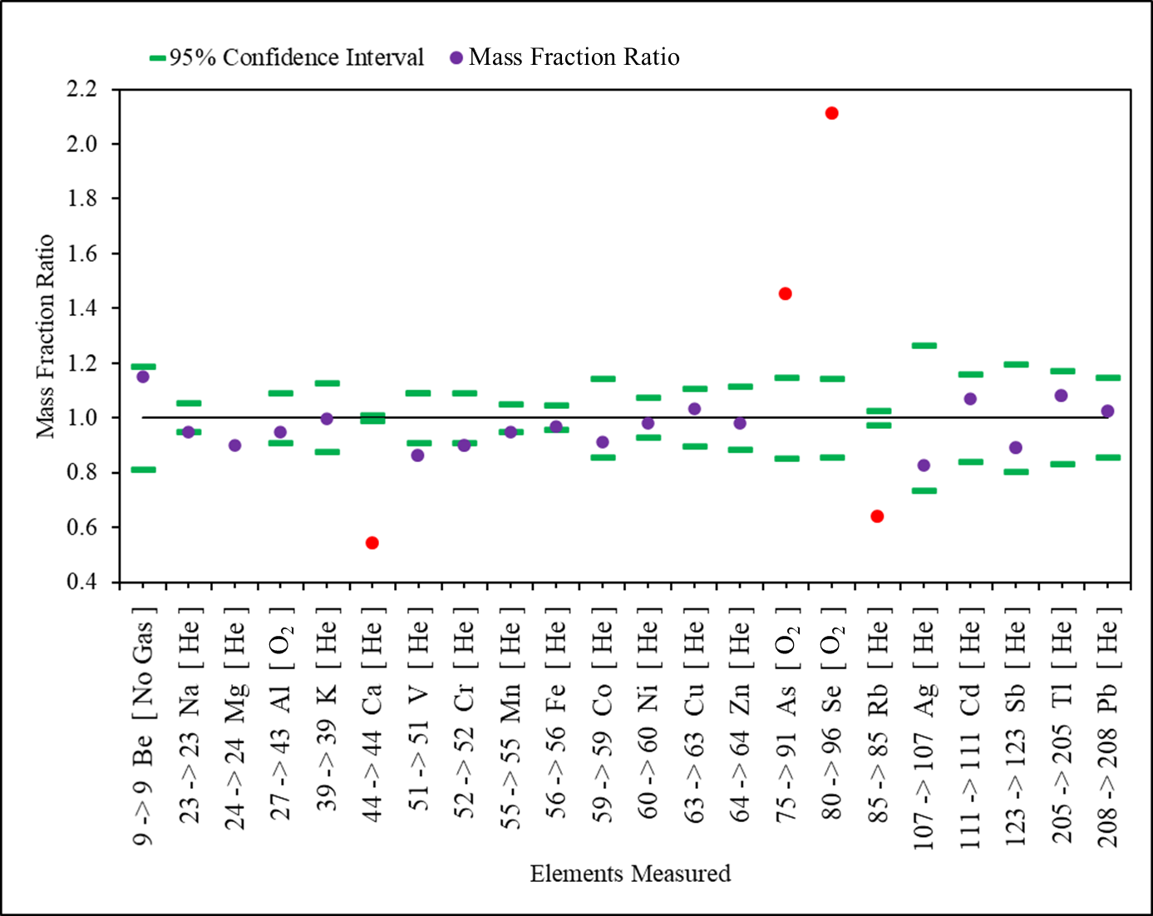
Figure S2. NIST SRM 1944. Measurements were made on NIST Standard Reference Material 1944 New York/New Jersey Waterway Sediment and compared to the assigned values. The assigned values include certified (Al, Cr, Mn, Fe, Ni, Zn, As, Cd, Pb), reference (Be, Na, K, Ca, V, Co, Cu, Se, Rb, Ag, Sb, Tl) and information values (Mg). Mass fraction ratios (measured value/assigned value) are shown in purple where the data fall within ± 20 % of the assigned values, or ratios are shown in red if outside of this range. The mass transitions and gas mode are given for QQQ-ICP-MS.
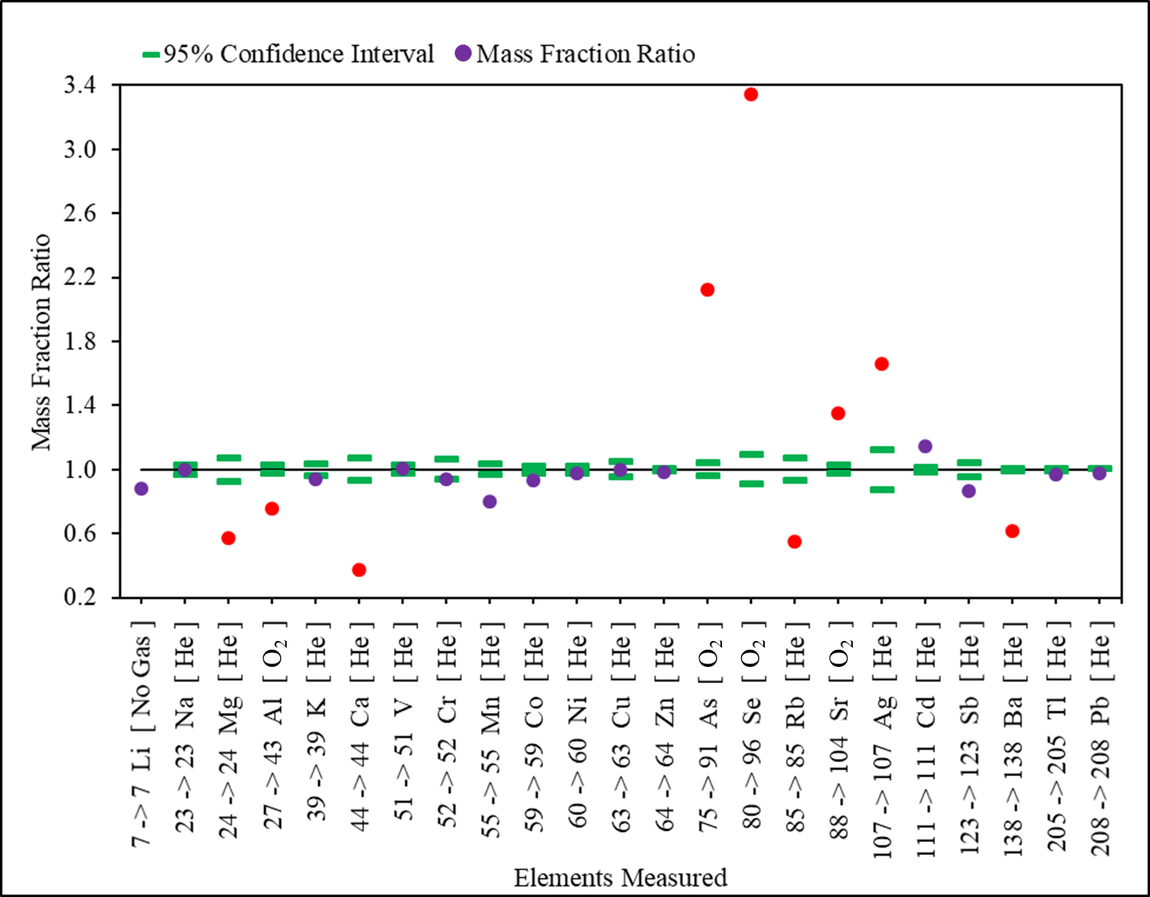
Figure S3. NIST SRM 2702. Measurements were made on NIST Standard Reference Material 2702 Inorganics in Marine Sediment and compared to the assigned values. The assigned values include certified (Na, Al, K, V, Cr, Mn, Co, Ni, Zn, As, Se, Rb, Sr, Cd, Sb, Ba, Tl, Pb), reference (Mg, Ca, Cu, Se, Ag) and information values (Li). Mass fraction ratios (measured value/assigned value) are shown in purple where the data fall within ± 20 % of the assigned values, or ratios are shown in red if outside of this range. The mass transitions and gas mode are given for QQQ-ICP-MS.
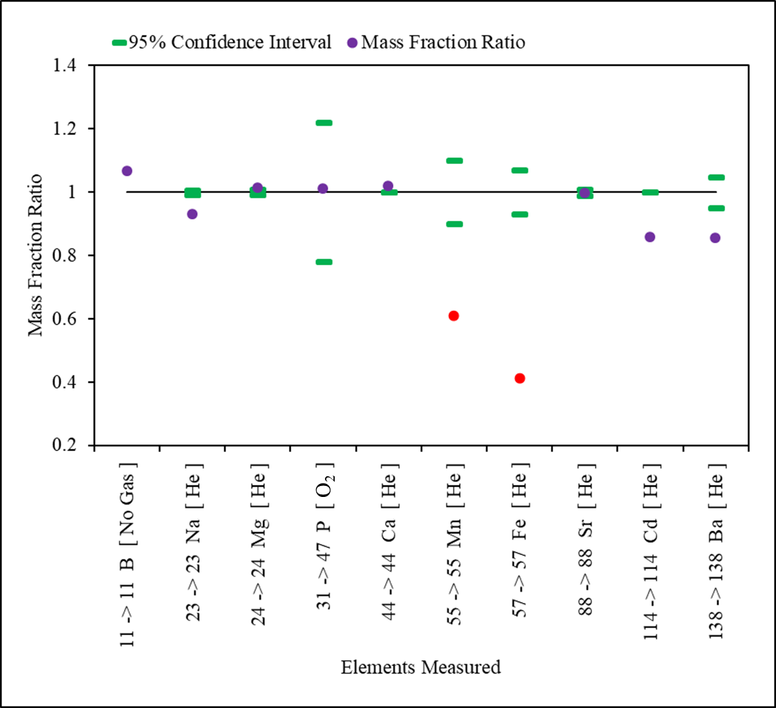
Figure S4. AIST SRM JCp-1. Measurements were made on AIST Certified Geochemical Reference Material JCp-1 Coral (Porites sp.) and compared to the assigned values. The assigned values include certified (Na, Mg, P, Ca, Mn, Fe, Sr, Ba) and information values (B, Cd) (See certificate: https://gbank.gsj.jp/geostandards/Certificate/PDF/eJCp1.pdf). Mass fraction ratios (measured value/assigned value) are shown in purple where the data fall within ± 20 % of the assigned values, or ratios are shown in red if outside of this range. The mass transitions and gas mode are given for QQQ-ICP-MS.

