Supplementary materials
- Supplementary tables and figures
Table S1. Equations for the stochastic juvenile survival (z_{t}) as a function of river flow at time t (cfs, w_{t}). The relationship represents a linear interpolation of the step function presented in Michel et al. (2021). Linear interpolation was accomplished by increasing the lower threshold and decreasing the upper threshold of each step by 5% of the original upper threshold presented in Michel et al. (2021), then implementing a linear function between new threshold values.
(1) | $\left(μ, σ\right)=\left\{\begin{matrix}\text{0.03, 0.276} \\ 0.0002(w_{t})-0.8275, 0.37 \\ \begin{matrix}0.189, 0.094 \\ 0.0002\left(w_{t}\right)-1.7419, 0.176 \\ \begin{matrix}0.508, 0.082 \\ -6e^{-5}\left(w_{t}\right)+1.9792, 0.17 \\ 0.353, 0.088\end{matrix}\end{matrix}\end{matrix}\right.$ | if  if  if  if  if  if  if | $\begin{matrix}0≤w_{t}<4045 \\ 4045≤w_{t}<4795 \\ \begin{matrix}4795≤w_{t}<10175 \\ 10175≤w_{t}<11856 \\ \begin{matrix}11856≤w_{t}<21727 \\ 21727≤w_{t}<24016 \\ 24016≤w_{t}\end{matrix}\end{matrix}\end{matrix}$
(2) | $ψ\sim Normal\left(logit\left(μ\right),σ\right)$
(3) | $z_{t}=Inv.Logit\left(ψ\right)$

Table S2. Equations for the harvest control rule (HCR) used for Sacramento River fall-run Chinook salmon. More detailed information on the HCR can be found in section 3.3.6.1 (p. 32) in PFMC (2021b). Values used to calculate the abundance breakpoints are the minimum stock size threshold (MSST; 91,500), adult spawners that achieve maximum sustainable yield (S_{MSY}; 122,000), and the annual exploitation rate associated with the acceptable biological catch (F_{ABC}; 0.7). The pre-fishery ocean abundance in spawner equivalent units (N) is used to calculate the maximum allowable exploitation rate (F).
Abundance breakpoints
(1) | $A=MSST/2$
(2) | $B=\left(MSST+S_{MSY}\right)/2$
(3) | $C=S_{MSY}/\left(1-0.25\right)$
(4) | $D=S_{MSY}/\left(1-F_{ABC}\right)$
Maximum allowable exploitation rates
(5) | $F=\left\{\begin{matrix}\begin{matrix}0.10*(N/A) \\ 0.10\end{matrix} \\ 0.10+(0.15*((N-MSST)/(B-MSST))) \\ \begin{matrix}0.25 \\ (N-S_{MSY})/N \\ F_{ABC}\end{matrix}\end{matrix}\right.$ | if  if  if  if  if  if |  | $\begin{matrix}0≤N≤A \\ A<N≤MSST \\ \begin{matrix}MSST<N≤B \\ B<N≤C \\ \begin{matrix}C<N≤D \\ D<N\end{matrix}\end{matrix}\end{matrix}$

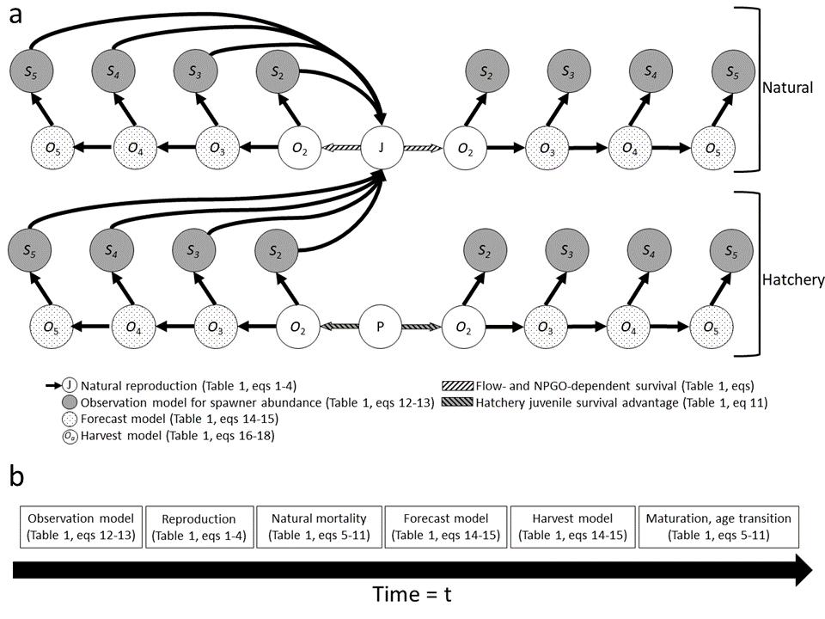
Figure S1. Life cycle diagram of Sacramento River fall Chinook. Circles represent state variables structured by origin (natural in the top row and hatchery in the bottom row), sex (females on the left and males on the right), maturation stage (O represents immature ocean fish and S represents mature spawners), and age (subscripts). The first life stages are represented by J and P, which indicate natural-origin fry and hatchery-origin smolts, respectively. Patterns and shading indicate which variables and processes in submodels (a). Also, the timing of submodel implementation for a single timestep is shown and related to equations in the Table 1 (b).
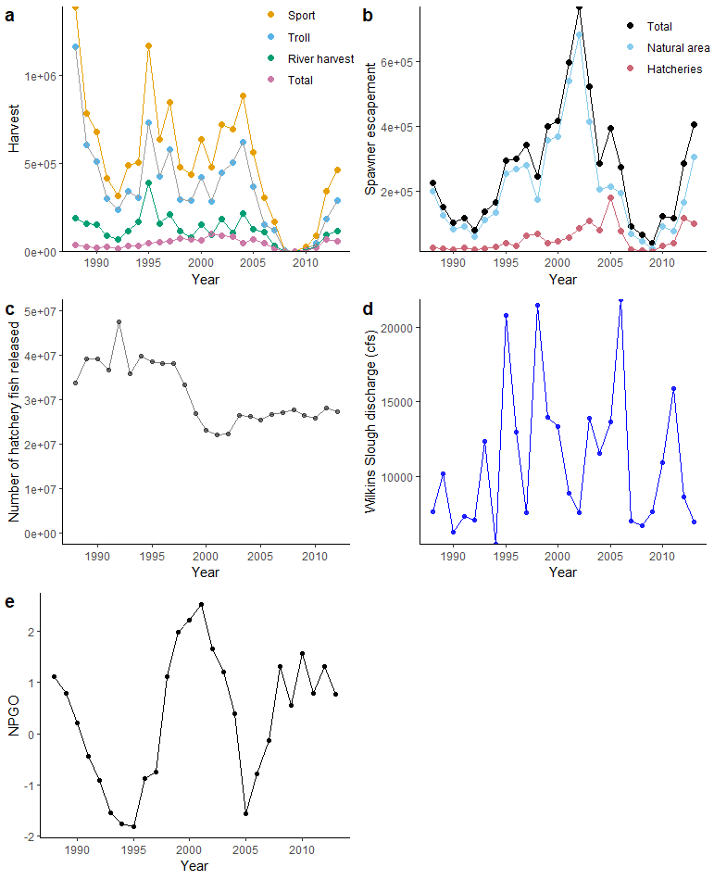
Figure S2. Empirical values for fisheries harvest (a; PFMC 2021), estimated spawner escapement (b; PFMC, 2021), number of hatchery fish released (c; Huber and Carlson 2015), flow (cfs) at Wilkins Slough (d; USGS station number 11390500), and North Pacific Gyre Oscillation (e; Di Lorenzo et al. 2008).
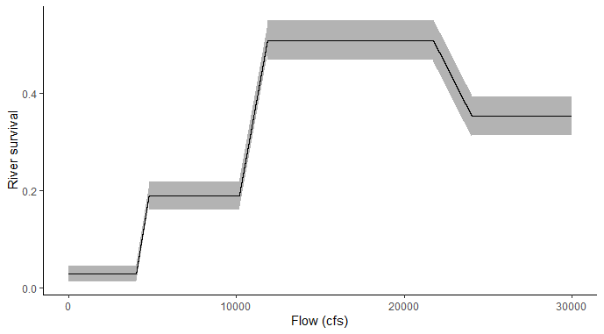
Figure S3. Juvenile survival during freshwater outmigration to the ocean as a function of flow at Wilkins Slough gauge (USGS station number 11390500). The shaded regions represent 95% confidence intervals. See Table S1 for equations that generate this interpolated step function.
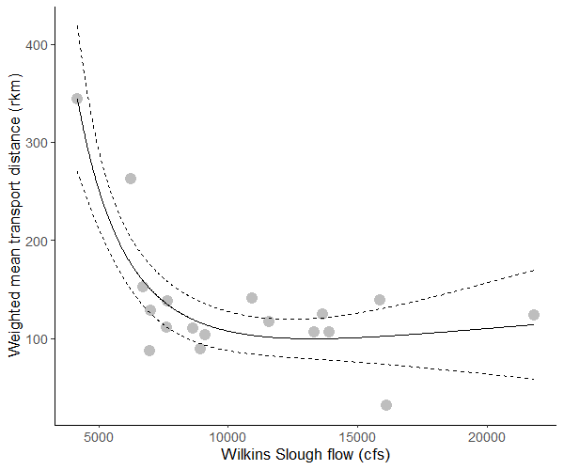
Figure S4. Weighted mean distance between hatcheries and release sites (Sturrock et al. 2019) in relation to Wilkins Slough flow (USGS station number 11390500) for years 2000-2017. The solid line represents predicted distances from a fitted Generalized Additive Model, and the dashed lines represent 95% confidence intervals.
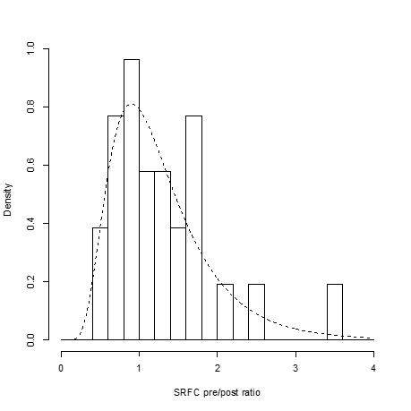
Figure S5. Logged ratio between preseason forecast and postseason estimated abundance for Sacramento River fall Chinook (SRFC). Data were gathered from fishery management documents (PFMC 2021) and Satterthwaite and Shelton (2022). The dashed line represents a fitted lognormal distribution with log-scale mean 0.132 and log-scale standard deviation 0.486.
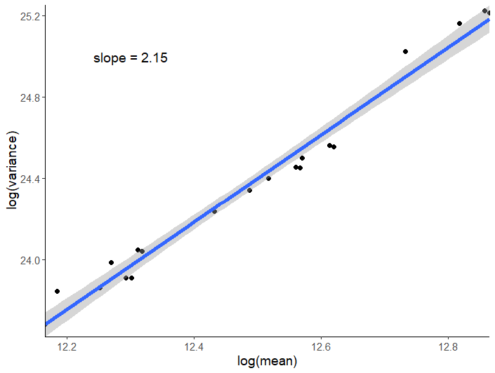
Figure S6. Variance (log scale) in relation to mean (log scale) for spawner escapement. Each point represents the mean and variance for a model scenario (age structure diversity and drought conditions). The linear regression for the log-log plot had a slope = 2.15, thus the coefficients of variation can be used to represent population stability and portfolio effect (Anderson et al. 2013).
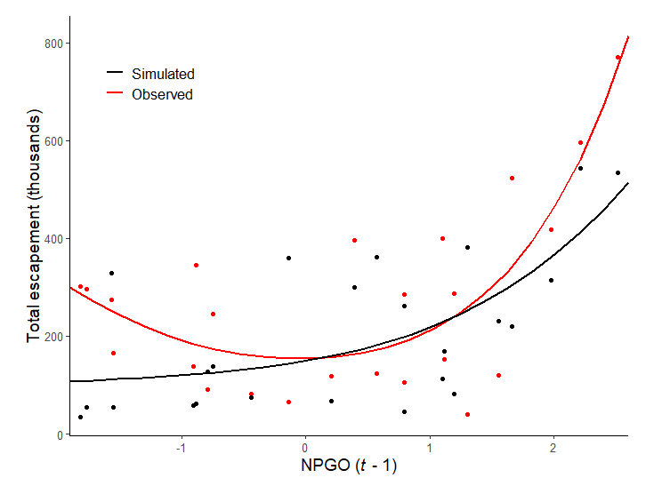
Figure S7. The observed (red) and simulated (black) effect of the North Pacific Gyre Oscillation (NPGO) index on total escapement (lagged for a single year). The relationship was estimated using Generalized Additive Models.
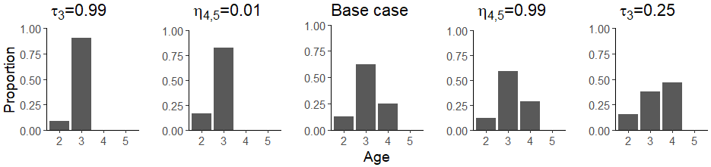
Figure S8. Age composition of spawners for the base case scenario (i.e., contemporary age composition), under alternative maturation rates for age-3 fish (indicated by τ₃), and alternative natural survival rates for fish at ages 4 and 5 (indicated by η_{4,5}). The plots are arranged along a gradient of low (left) to high (right) age structure. The maturation rate and natural survival rate for the base case scenario was τ₃ = 0.5 and η_{4,5} = 0.8, respectively.
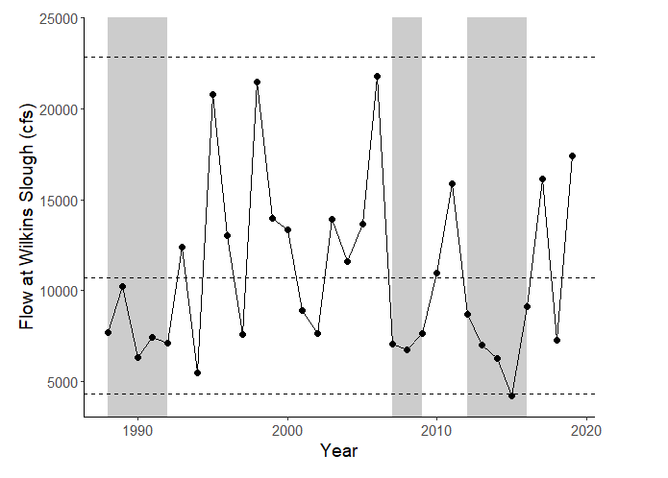
Figure S9. Flow (cfs) at Wilkins Slough (USGS station number 11390500) from 1988-2019. Shaded areas cover notable recent droughts (1988-1992, 2007-2009, 2012-2016; note that the 1988 drought started in 1987 but data were unavailable prior to 1988). Dashed lines represent high (22,872 cfs), historic mean (10,712 cfs), and minimum (4,295) thresholds presented in Michel et al. (2021).
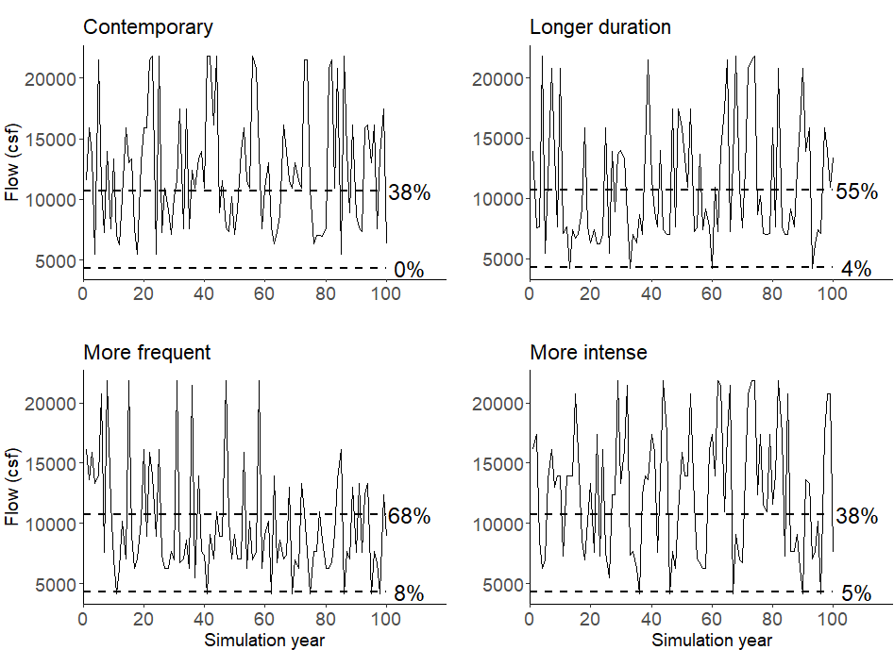
Figure S10. Examples of simulated hydrographs of flow (cfs) for each drought scenario. The ‘Contemporary’ scenario resembles recent flow conditions at Wilkins Slough (USGS station number 11390500), with 3-5 year droughts and time intervals between droughts represented by a Poisson distribution with λ = 12 years. The ‘Longer duration’ scenario was simulated with 3-7 syear droughts, the ‘More frequent’ scenario was simulated with λ = 6 years, and the ‘More intense’ scenario was simulated with increased probability of drawing the lowest flow value. The horizontal dashed lines represent historical mean (10,712 cfs) and minimum flow (4,295; Michel et al., 2021). The figures are annotated with the percentage of years below the historical mean and minimum flow thresholds.
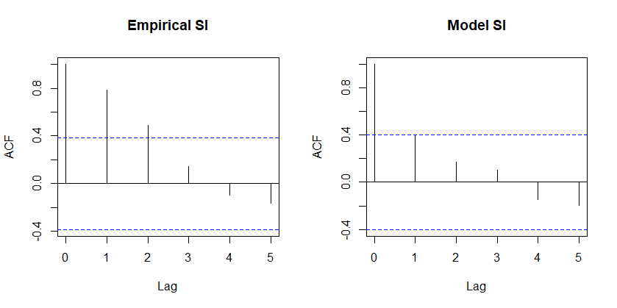
Figure S11. Temporal autocorrelation for log-transformed observed and simulated Sacramento Index (total harvest + total escapement) for the years 1988-2012.
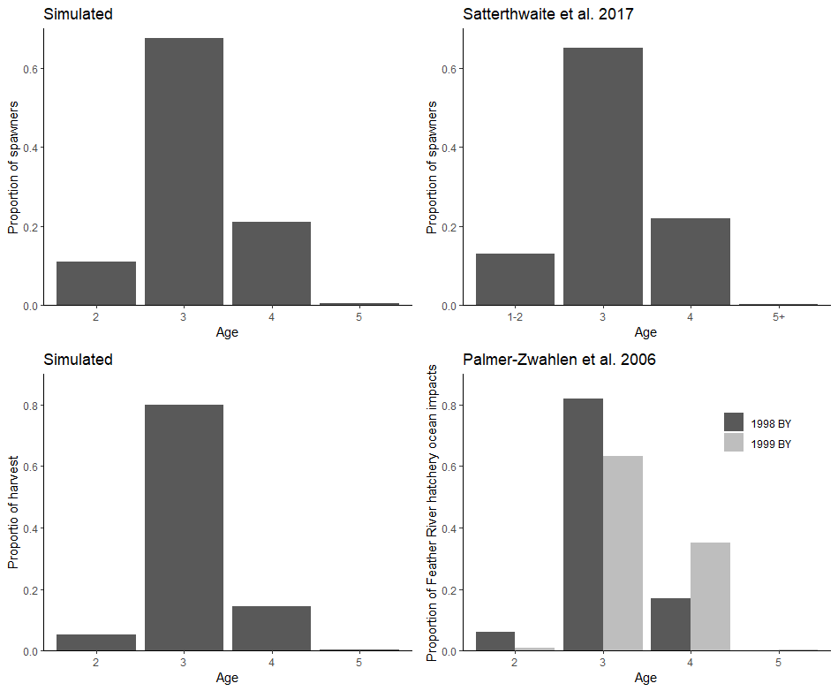
Figure S12. Age composition of spawners (top row) and harvest (bottom row). The figures in the left column represent simulated age compositions and the right column represents observed age composition of Sacramento River fall Chinook (Satterthwaite et al. 2017) and age composition of ocean impacts for Feather River hatchery fall Chinook brood years 1998 and 1999 (Palmer-Zwahlen et al. 2006).
- Sensitivity analyses
To test the robustness of our simulation results, we conducted sensitivity analyses to key model parameters. We tested the sensitivity of our results to the coefficient of variation (CV) of the realized exploitation rate (Eqs. 17-19, Table 1). The base value (CV_{c} = 0.32) was adapted from a model for Sacramento River winter run Chinook salmon (Winship et al. 2013). However, this is higher than values used in other studies and, thus, we ran the simulations with CV_{c} = 0.05. The lower CV represents a scenario where the realized exploitation rate is generally closer to the prescribed exploitation rate from the harvest control rule and lower implementation error (Fig. S5). We also tested the sensitivity of our results to the CV of recruitment stochasticity (CV_{j}; Eq. 4, Table 1). Empirical data was lacking to infer this parameter, and we instead fitted this parameter through minimizing the sum of squared error between observed and simulated total spawner escapement (Eq. 20, Table 1) for the years 1988-2012. The fitted value used in our model (CV_{j} = 0.215) was higher than the posterior mean and median value for winter run Chinook in Winship et al. (2014), thus we ran our simulations with CV_{j} = 0.1, which was the median value in that study. Last, we tested the sensitivity of our results to the mean North Pacific Gyre Oscillation (NPGO) effect on early ocean survival. This value was also fitted by minimizing the sum of squared error and explained a ~40% of the variability in escapement. However, studies have demonstrated that relationships between salmon escapement can exhibit non-stationarity (Litzow et al. 2018, 2019). Thus, we ran the model with lower mean effect of NPGO (ϕ = 0.1) to examine how robust our results are to the strength of NPGO effect on survival.
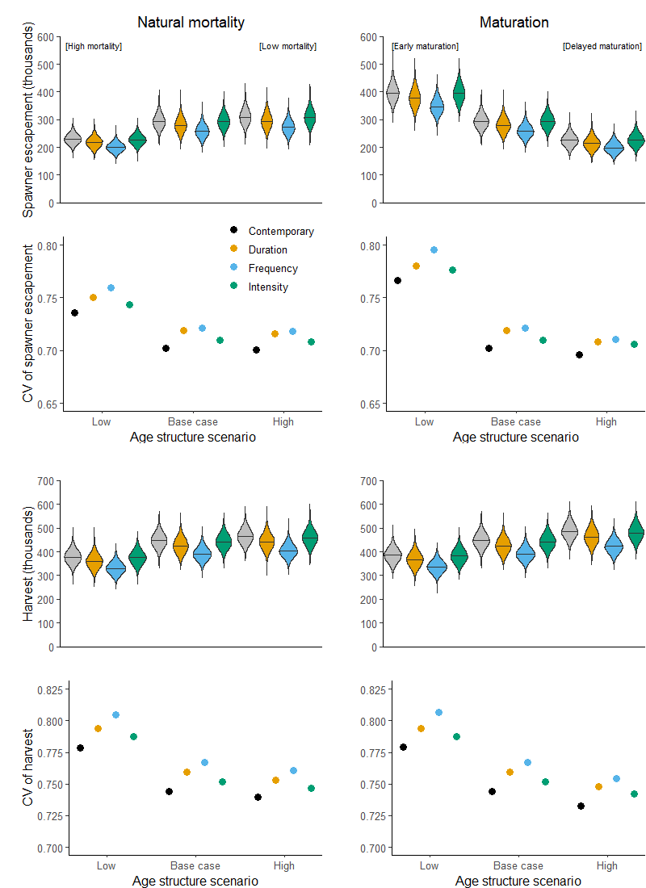
Figure S13. Sensitivity analysis for the coefficient of variation (CV) of realized exploitation rate (CV_{c} = 0.05). Figures show means (horizontal lines in violin plots) and CVs (circles) of spawner escapement and harvest in relation to age structure and drought scenarios (colors). Age structure scenarios altered by natural mortality rates are in the left column and scenarios altered by maturation rates are in the right column.
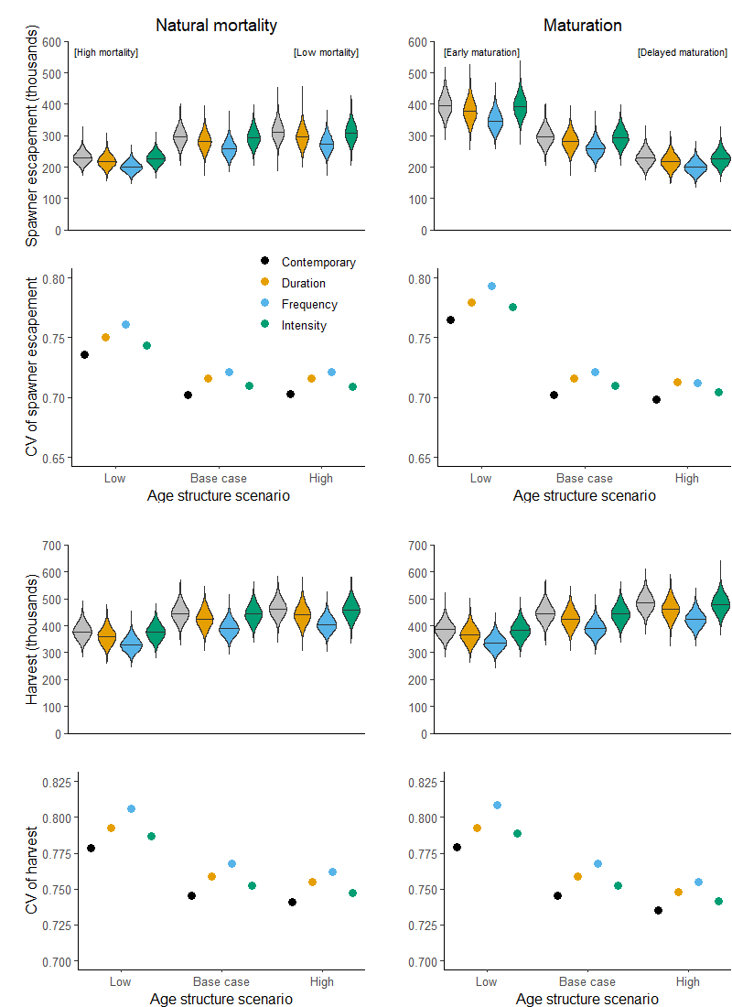
Figure S14. Sensitivity analysis for the coefficient of variation (CV) of recruitment stochasticity (CV_{j} = 0.1). Figures show means (horizontal lines in violin plots) and CVs (circles) of spawner escapement and harvest in relation to age structure and drought scenarios (colors). Age structure scenarios altered by natural mortality rates are in the left column and scenarios altered by maturation rates are in the right column.
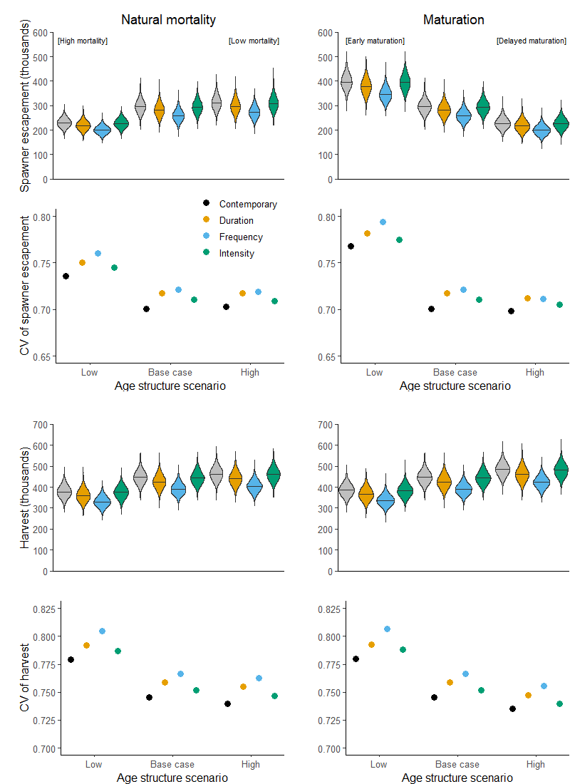
Figure S15. Sensitivity analysis for the mean North Pacific Gyre Oscillation (NPGO) effect on early ocean survival (ϕ = 0.1). Figures show means (horizontal lines in violin plots) and coefficients of variation (CVs; circles) of spawner escapement and harvest in relation to age structure and drought scenarios (colors). Age structure scenarios altered by natural mortality rates are in the left column and scenarios altered by maturation rates are in the right column.
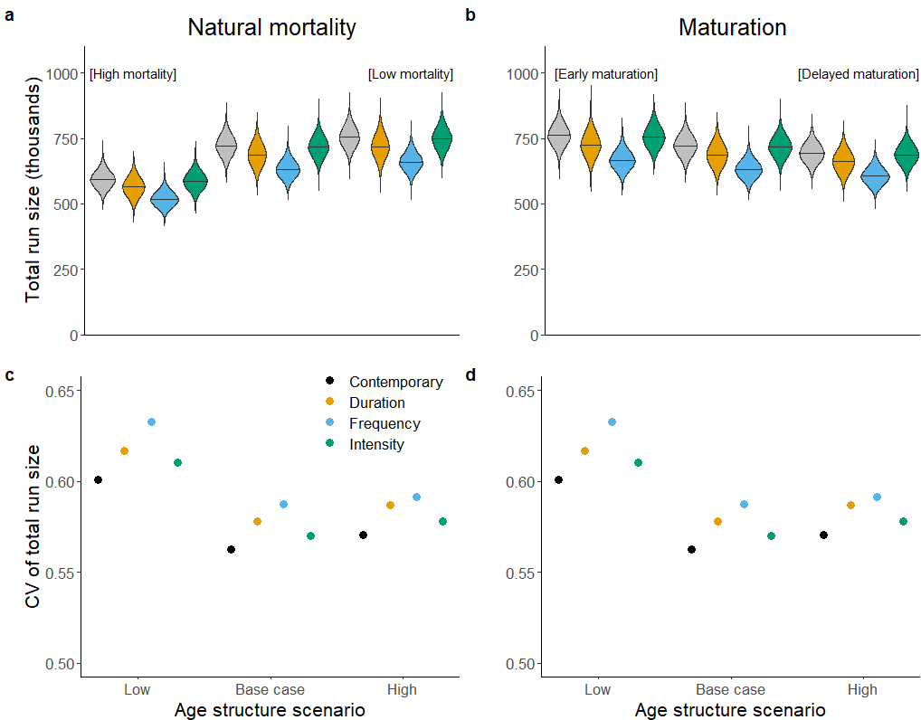
Figure S16. Sensitivity of results when total run size (escapement + harvest) is considered. Figures show the total run size (a and b) and the coefficient of variation in the total run size (CV; c and d) under various age structure and drought scenarios (longer duration, more frequent, and more intense droughts). Age structure scenarios are arranged from lowest (left) to highest (right) diversity and modified by natural mortality rates (a and c) or maturation rates (b and d).
References
Anderson, S.C., Cooper, A.B., and Dulvy, N.K. 2013. Ecological prophets: quantifying metapopulation portfolio effects. Methods Ecol. Evol. 4(10): 971–981. doi:10.1111/2041-210X.12093.
Di Lorenzo, E., Schneider, N., Cobb, K.M., Franks, P.J.S., Chhak, K., Miller, A.J., McWilliams, J.C., Bograd, S.J., Arango, H., Curchitser, E., Powell, T.M., and Rivière, P. 2008. North Pacific Gyre Oscillation links ocean climate and ecosystem change. Geophys. Res. Lett. 35(8): L08607. doi:10.1029/2007GL032838.
Huber, E.R., and Carlson, S.M. 2015. Temporal trends in hatchery releases of fall-run Chinook salmon in California’s Central Valley. San Franc. Estuary Watershed Sci. 13(2).
Litzow, M.A., Ciannelli, L., Cunningham, C.J., Johnson, B., and Puerta, P. 2019. Nonstationary effects of ocean temperature on Pacific salmon productivity. Can. J. Fish. Aquat. Sci. 76(11): 1923–1928. doi:10.1139/cjfas-2019-0120.
Litzow, M.A., Ciannelli, L., Puerta, P., Wettstein, J.J., Rykaczewski, R.R., and Opiekun, M. 2018. Non-stationary climate–salmon relationships in the Gulf of Alaska. Proc. R. Soc. B Biol. Sci. 285(1890): 20181855. doi:10.1098/rspb.2018.1855.
Michel, C.J., Notch, J.J., Cordoleani, F., Ammann, A.J., and Danner, E.M. 2021. Nonlinear survival of imperiled fish informs managed flows in a highly modified river. Ecosphere 12(5): e03498. doi:10.1002/ecs2.3498.
Pacific Fisheries Management Council. 2021. Preseason report I: stock abundance analysis and environmental assessment part 1 for 2021 ocean salmon fishery regulations. Pacific Fishery Management Council, 7700 NE Ambassador Place, Suite 101, Portland, Oregon 97220-1384.
Palmer-Zwahlen, M.L., Grover, A.M., and Duran, J.A. 2006. Feather River Chinook cohort reconstruction brood years 1998 and 1999 fall and spring runs. California Department of Fish and Game, Marine Region, Ocean Salmon Project.
Satterthwaite, W.H., Carlson, S.M., and Criss, A. 2017. Ocean size and corresponding life history diversity among the four run timings of California Central Valley Chinook salmon. Trans. Am. Fish. Soc. 146(4): 594–610. Taylor & Francis.
Satterthwaite, William.H., and Shelton, A.O. 2022. Methods for assessing and responding to bias and uncertainty in U.S. West Coast salmon abundance forecasts. Fish. Res. 257: 106502. doi:10.1016/j.fishres.2022.106502.
Sturrock, A.M., Satterthwaite, W.H., Cervantes‐Yoshida, K.M., Huber, E.R., Sturrock, H.J.W., Nusslé, S., and Carlson, S.M. 2019. Eight decades of hatchery salmon releases in the California Central Valley: factors influencing straying and resilience. Fisheries 44(9): 433–444. doi:10.1002/fsh.10267.
Winship, A.J., O’Farrell, M.R., and Mohr, M.S. 2013. Management strategy evaluation applied to the conservation of an endangered population subject to incidental take. Biol. Conserv. 158: 155–166. doi:10.1016/j.biocon.2012.08.031.
Winship, A.J., O’Farrell, M.R., and Mohr, M.S. 2014. Fishery and hatchery effects on an endangered salmon population with low productivity. Trans. Am. Fish. Soc. 143(4): 957–971. doi:10.1080/00028487.2014.892532.

