Supplementary Material

Supplemental Tables
Supplementary Table 1. Summary of life history parameter values used in category 1 stocks through 2018.
Stock | M | k | M/k | Linf | Lmat | Lmat/Linf | SigmaR
Aurora rockfish | 0.04 | 0.09 | 0.38 | 30.77 | 25.54 | 0.83 | 0.50
Black rockfish (CA) | 0.18 | 0.15 | 1.19 | 54.54 | 43.69 | 0.80 | 0.50
Black rockfish (WA) | 0.16 | 0.14 | 1.19 | 53.91 | 43.69 | 0.81 | 0.50
Bocaccio | 0.18 | 0.23 | 0.79 | 67.34 | 37.70 | 0.56 | 1.00
Cabezon (ORS) | 0.25 | 0.19 | 1.31 | 66.11 | 43.70 | 0.66 | 0.50
Cabezon (NCA) | 0.25 | 0.15 | 1.67 | 60.19 | 34.60 | 0.58 | 0.50
Cabezon (SCA) | 0.25 | 0.13 | 1.98 | 64.00 | 34.60 | 0.54 | 0.70
California Scorpionfish | 0.24 | 0.29 | 0.81 | 31.89 | 18.00 | 0.57 | 0.60
Canary rockfish | 0.09 | 0.13 | 0.68 | 60.04 | 40.50 | 0.68 | 0.50
Chilipepper | 0.16 | 0.20 | 0.82 | 47.30 | 24.40 | 0.52 | 1.00
Darkblotched rockfish | 0.05 | 0.20 | 0.27 | 42.66 | 34.59 | 0.81 | 0.75
Dover sole | 0.12 | 0.15 | 0.78 | 47.79 | 35.00 | 0.73 | 0.35
Kelp greenling | 0.36 | 0.26 | 1.38 | 36.44 | 29.34 | 0.81 | 0.65
Lingcod (N) | 0.26 | 0.13 | 2.00 | 110.00 | 56.70 | 0.52 | 0.55
Lingcod (S) | 0.26 | 0.13 | 2.00 | 93.56 | 52.30 | 0.56 | 0.75
Petrale sole | 0.16 | 0.13 | 1.17 | 54.30 | 33.10 | 0.61 | 0.40
Pacific ocean perch | 0.05 | 0.17 | 0.32 | 41.60 | 32.10 | 0.77 | 0.70
Sablefish | 0.08 | 0.34 | 0.24 | 63.97 | 58.00 | 0.91 | 1.10
Splitnose rockfish | 0.05 | 0.16 | 0.31 | 29.62 | 21.84 | 0.74 | 1.00
Widow rockfish | 0.16 | 0.20 | 0.79 | 50.36 | 29.68 | 0.59 | 0.60
Yellowtail rockfish (N) | 0.17 | 0.14 | 1.25 | 53.58 | 42.49 | 0.79 | 0.50
Yelloweye rockfish | 0.04 | 0.07 | 0.68 | 63.45 | 42.07 | 0.66 | 0.50

Supplementary Table 2. Number of model runs that did not converge out of 100 simulation replicates with bias-adjusted recruitment, based on the criteria that the maximum final gradient must be less than 1.0 and the estimated log(R0) less than 12.
Length data scenario |  | Life history scenario
Sample size | Number of years | Short-lived, slow-growing |  | Short-lived, fast-growing |  | Long-lived, slow-growing |  | Long-lived, fast-growing
SigmaR |  | 0.8 | 0.4 | 0.8 | 0.4 | 0.8 | 0.4 | 0.8 | 0.4
N = 1000  (perfectly specified) | 100 | 0 | 0 | 0 | 0 | 0 | 0 | 0 | 0
N = 200 | 75 | 0 | 0 | 0 | 0 | 0 | 0 | 0 | 0
N = 200 | 20 | 0 | 0 | 0 | 0 | 0 | 0 | 0 | 0
N = 200 | 10 | 0 | 0 | 0 | 0 | 0 | 0 | 0 | 0
N = 200 | 5 | 0 | 0 | 0 | 0 | 0 | 0 | 0 | 0
N = 200 | 1 | 4 | 0 | 5 | 1 | 1 | 0 | 3 | 0
N = 50 | 75 | 0 | 0 | 0 | 0 | 0 | 0 | 0 | 0
N = 50 | 20 | 0 | 0 | 0 | 0 | 0 | 0 | 0 | 0
N = 50 | 10 | 0 | 0 | 0 | 0 | 0 | 0 | 0 | 0
N = 50 | 5 | 1 | 0 | 3 | 0 | 0 | 0 | 0 | 0
N = 50 | 1 | 5 | 7 | 13 | 11 | 6 | 5 | 3 | 1
Decline from 200 samples (year < 87) to 50 samples (year > 87) | 20 | 0 | 0 | 0 | 0 | 0 | 0 | 0 | 0

Supplementary Table 3. Median relative error (i.e., bias) of the final year fraction unfished spawning output across 100 simulation replicates by life history type and length data scenario with recruitment standard deviation = 0.4 with bias-adjusted recruitment. Cells are shaded green for bias less than 10%, yellow less than 20%, and red greater than 20%.
Length data scenario |  | Life history scenario
Sample size | Number of years |  | Shorter-lived, slower-growing | Shorter-lived, faster-growing | Longer-lived, slower-growing | Longer-lived, fast-growing
N = 1000 (perfectly specified) | 100 |  | 0.0051 | -0.0075 | -0.0068 | -0.0076
N = 200 | 75 |  | -0.0456 | -0.0869 | -0.0578 | 0.0006
N = 200 | 20 |  | 0.0130 | -0.0190 | -0.0640 | 0.0187
N = 200 | 10 |  | -0.0339 | -0.0099 | -0.1702 | -0.0271
N = 200 | 5 |  | -0.0799 | -0.0716 | -0.1918 | 0.0125
N = 200 | 1 |  | 0.0478 | -0.0309 | -0.5793 | -0.2070
N = 50 | 75 |  | 0.0808 | 0.0228 | 0.1048 | 0.0641
N = 50 | 20 |  | 0.0232 | 0.0233 | 0.0198 | -0.0297
N = 50 | 10 |  | 0.0797 | 0.0268 | 0.0127 | -0.0987
N = 50 | 5 |  | 0.1307 | 0.0543 | 0.0963 | -0.0326
N = 50 | 1 |  | -0.3265 | 0.3011 | 0.1777 | 0.2565
Decline from 200 samples (years < 87) to 50 samples (year > 87) | 20 |  | 0.0660 | -0.0336 | 0.0535 | -0.0084

Supplementary Table 4. Median relative error (i.e., bias) of the final year fraction unfished spawning output across 100 simulation replicates by life history type and length data scenario with recruitment standard deviation = 0.8 with bias-adjusted recruitment. Cells are shaded green for bias less than 10%, yellow less than 20%, and red greater than 20%.
Length data scenario |  | Life history scenario
Sample size | Number of years | Short-lived, slow-growing | Short-lived, fast-growing | Long-lived, slow-growing | Long-lived, fast-growing
N = 1000 (perfectly specified) | 100 | 0.0093 | 0.0259 | -0.0339 | -0.0185
N = 200 | 75 | -0.1325 | -0.1159 | -0.1540 | -0.0140
N = 200 | 20 | -0.0043 | 0.0484 | 0.0239 | 0.0621
N = 200 | 10 | 0.0366 | 0.0748 | -0.0777 | 0.0682
N = 200 | 5 | -0.0564 | 0.0580 | -0.1563 | 0.0668
N = 200 | 1 | -0.1057 | -0.1499 | -0.0811 | -0.1724
N = 50 | 75 | 0.0446 | 0.1264 | 0.1563 | 0.0876
N = 50 | 20 | 0.1044 | 0.1727 | 0.1914 | 0.1199
N = 50 | 10 | 0.1758 | 0.3507 | 0.1396 | 0.1237
N = 50 | 5 | 0.1718 | 0.2410 | 0.1607 | 0.1622
N = 50 | 1 | -0.0281 | 0.0217 | 0.1579 | 0.1203
Decline from 200 samples (years < 87) to 50 samples (year > 87) | 20 | 0.0813 | -0.0563 | 0.1563 | -0.0362

Supplementary Table 5. Median absolute relative error (i.e., error) of the final year fraction unfished spawning output across 100 simulation replicates by life history type and length data scenario with recruitment standard deviation = 0.4 with bias-adjusted recruitment. Cells are shaded green for precision less than 20%, yellow less than 30%, and red greater than 30%.
Length data scenario |  | Life history scenario
Sample size | Number of years |  | Short-lived, slow-growing | Short-lived, fast-growing | Long-lived, slow-growing | Long-lived, fast-growing
N = 1000 (perfectly specified) | 100 |  | 0.0896 | 0.1045 | 0.0988 | 0.0934
N = 200 | 75 |  | 0.1357 | 0.1388 | 0.1042 | 0.1072
N = 200 | 20 |  | 0.1328 | 0.1425 | 0.1251 | 0.1054
N = 200 | 10 |  | 0.1509 | 0.1232 | 0.2163 | 0.0946
N = 200 | 5 |  | 0.2256 | 0.1411 | 0.2414 | 0.1259
N = 200 | 1 |  | 0.3284 | 0.1889 | 0.6608 | 0.3079
N = 50 | 75 |  | 0.1822 | 0.1434 | 0.1309 | 0.1384
N = 50 | 20 |  | 0.1916 | 0.1476 | 0.1380 | 0.1374
N = 50 | 10 |  | 0.1603 | 0.1478 | 0.1538 | 0.1977
N = 50 | 5 |  | 0.2282 | 0.1706 | 0.1968 | 0.2244
N = 50 | 1 |  | 0.5321 | 0.4176 | 0.4013 | 0.3904
Decline from 200 samples (years < 87) to 50 samples (year > 87) | 20 |  | 0.1409 | 0.1661 | 0.1309 | 0.1327

Supplementary Table 6. Median absolute relative error (i.e., error) of the final year fraction unfished spawning output across 100 simulation replicates by life history type and length data scenario with recruitment standard deviation = 0.8 with bias-adjusted recruitment. Cells are shaded green for precision less than 20%, yellow less than 30%, and red greater than 30%.
Length data scenario |  | Life history scenario
Sample size | Number of years |  | Short-lived, slow-growing | Short-lived, fast-growing | Long-lived, slow-growing | Long-lived, fast-growing
N = 1000 (perfectly specified) | 100 |  | 0.1418 | 0.1914 | 0.1644 | 0.1735
N = 200 | 75 |  | 0.2409 | 0.2554 | 0.2136 | 0.2262
N = 200 | 20 |  | 0.2262 | 0.2330 | 0.2173 | 0.2011
N = 200 | 10 |  | 0.2117 | 0.2372 | 0.2546 | 0.2395
N = 200 | 5 |  | 0.2887 | 0.2402 | 0.3739 | 0.3185
N = 200 | 1 |  | 0.4543 | 0.4185 | 0.6416 | 0.4665
N = 50 | 75 |  | 0.2400 | 0.2726 | 0.2687 | 0.2621
N = 50 | 20 |  | 0.3066 | 0.3161 | 0.2888 | 0.2663
N = 50 | 10 |  | 0.3075 | 0.4043 | 0.2536 | 0.3471
N = 50 | 5 |  | 0.3467 | 0.3578 | 0.3858 | 0.4088
N = 50 | 1 |  | 0.4903 | 0.4114 | 0.4619 | 0.4717
Decline from 200 samples (years < 87) to 50 samples (year > 87) | 20 |  | 0.2564 | 0.3780 | 0.2188 | 0.2626

Supplemental Figures
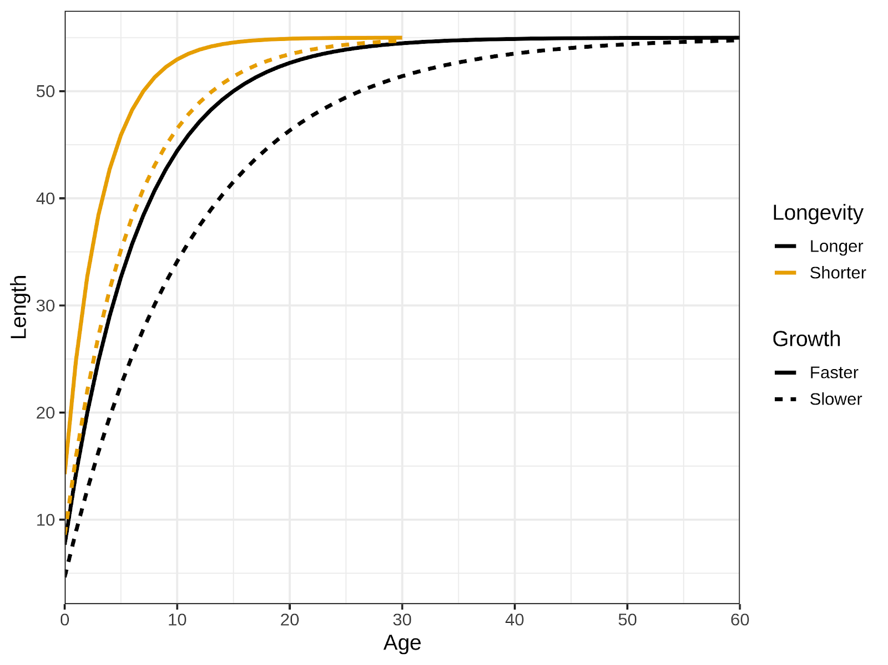
Supplementary Figure 1. Length-at-age for each of the four life history types, varying in their longevity and growth rate, either reaching their maximum size at 50% (faster growth) or 90% (slower growth) of their maximum age (short = 30 years, long = 60 years).
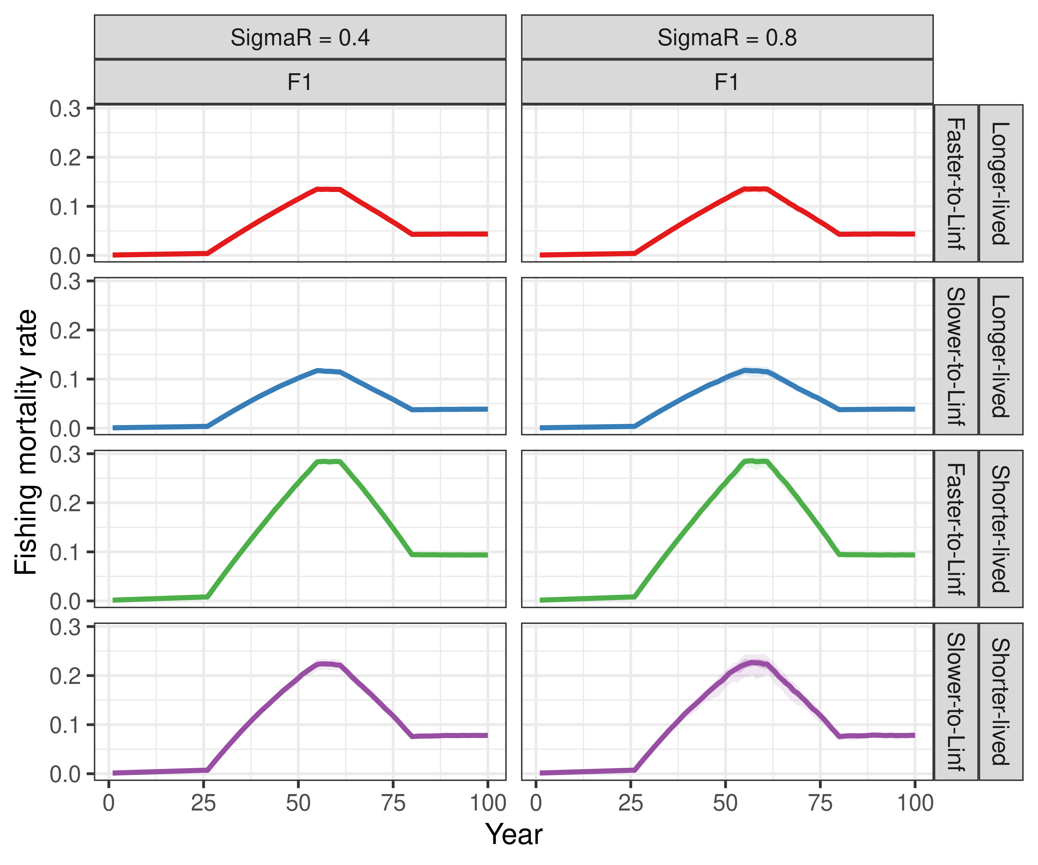
Supplementary Figure 2. Comparison of the F trajectories for each life history type based on the F_{MSY} for each life history type (Table 1) and a shared pattern of F/F_{MSY} for each recruitment scenario. For the shorter-lived, slower-growing life history type there is some variation in the input F at its highest point for some simulation replicates where the full catch could not be taken – this is shown as the 90th percentiles via shading.
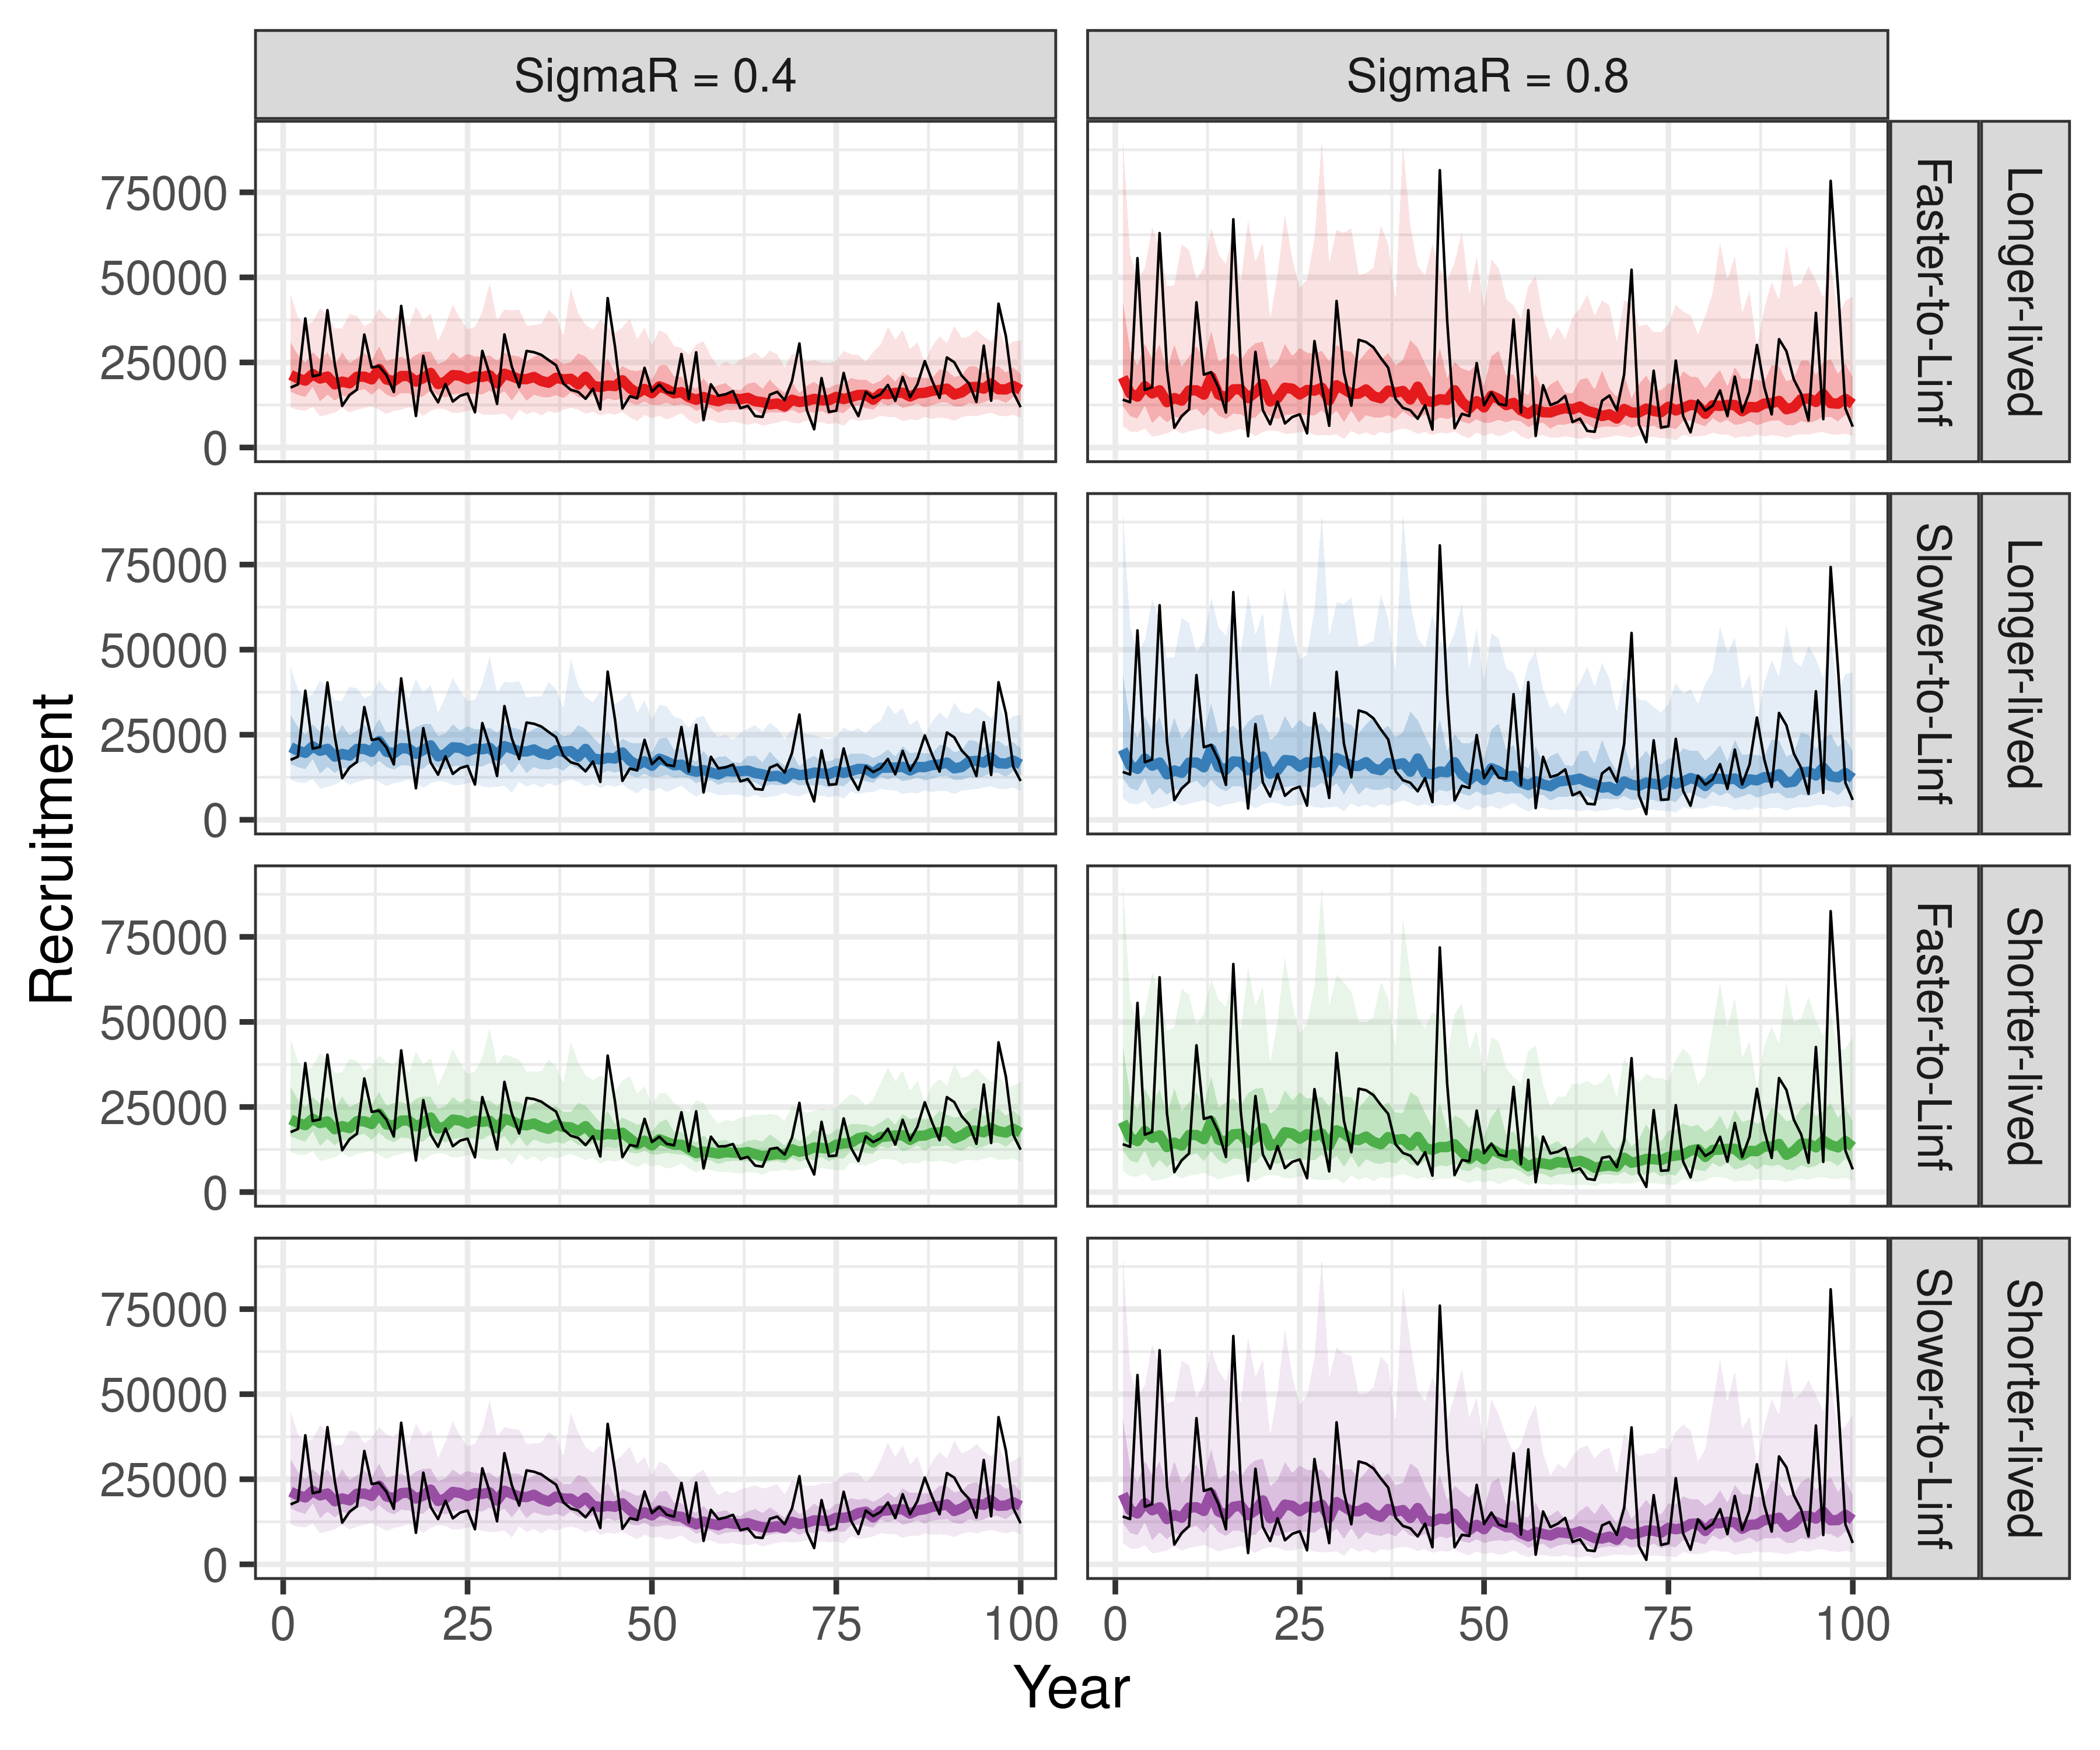
Supplementary Figure 3. Comparison of the median, 50th quantiles, and 90th quantiles of recruitment with sigma R = 0.4 vs. 0.8 across 100 simulation replicates for each life history scenario. The single black lines show a single simulation replicate of recruitment.
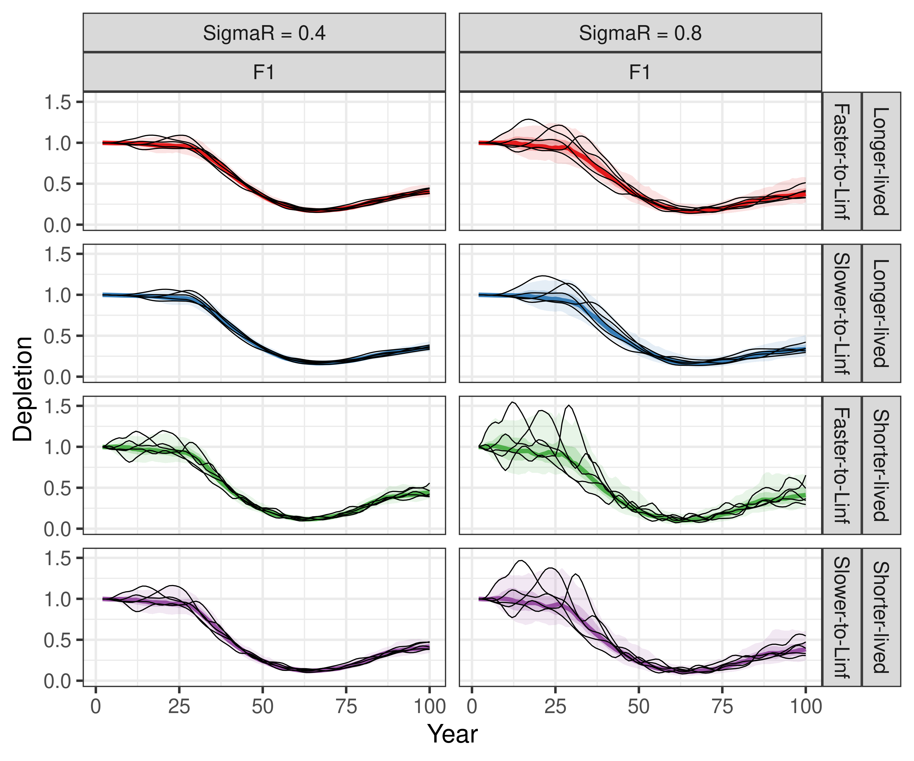
Supplementary Figure 4. Comparison of the median, 50th quantiles, and 90th quantiles of fraction unfished spawning output with sigma R = 0.4 vs. 0.8 across 100 simulation replicates for each life history scenario. The single black lines show a single simulation replicate of the fraction unfished.
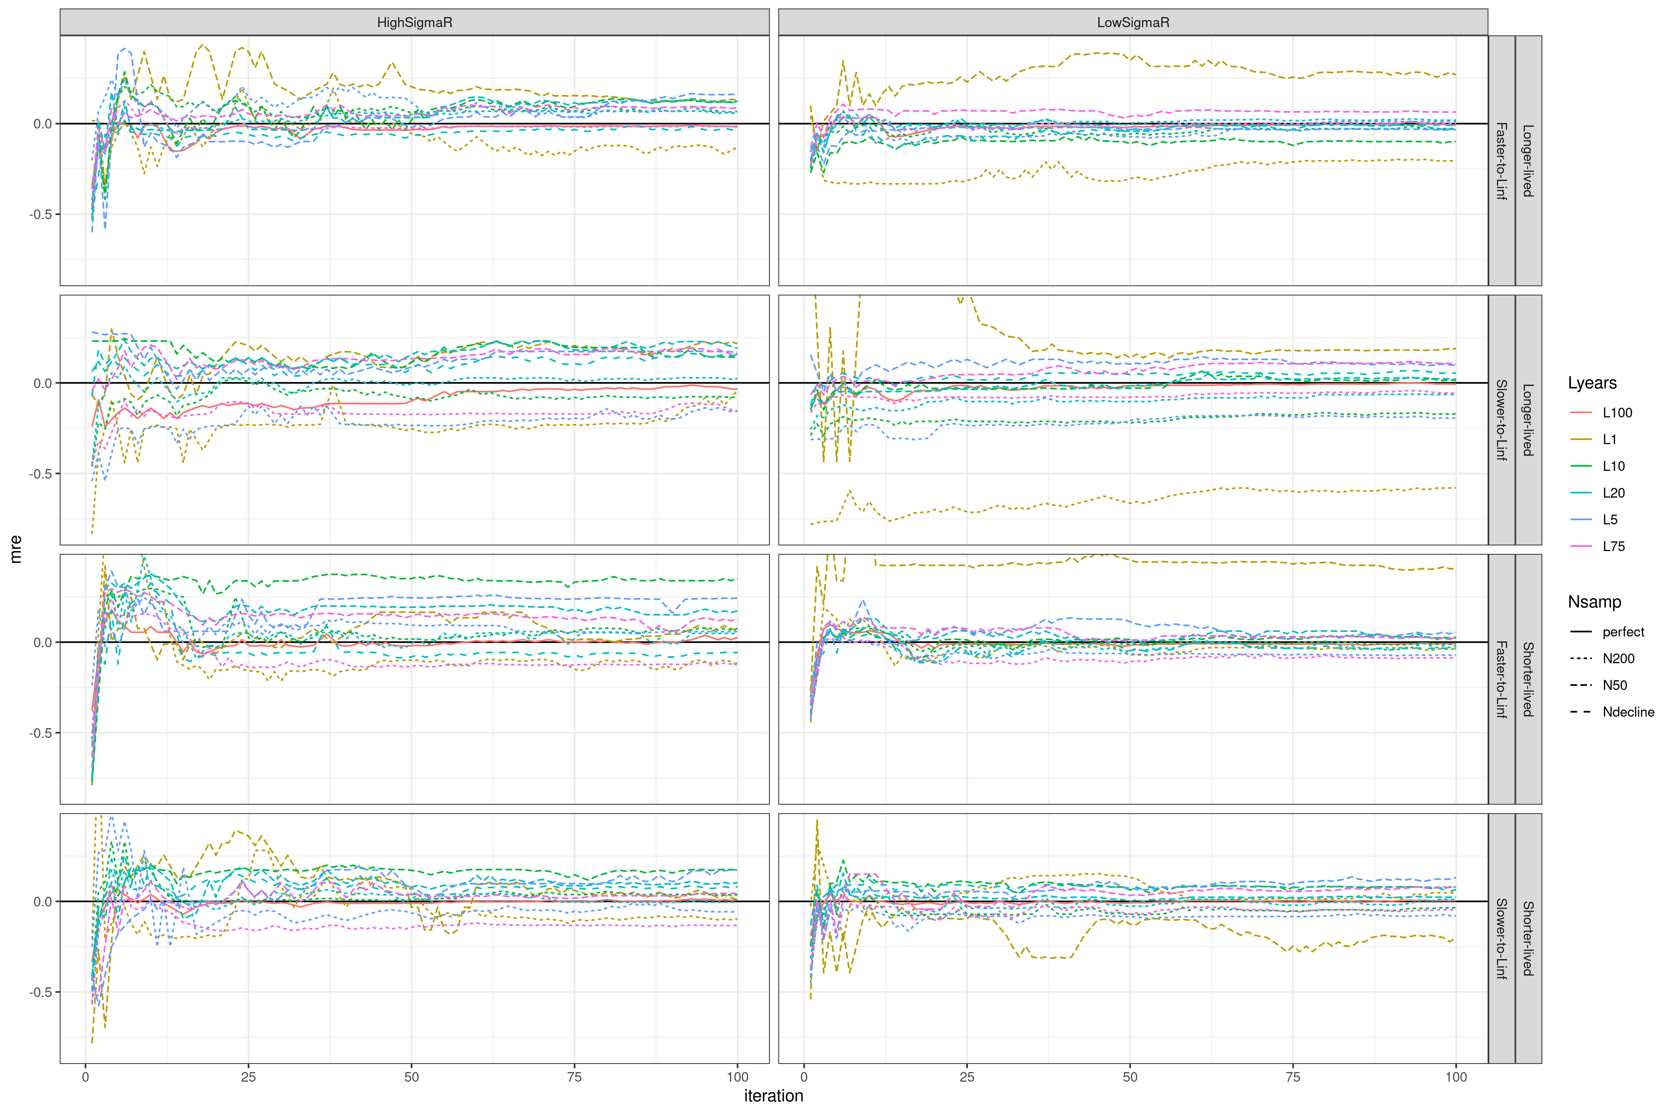
Supplementary Figure 5. Median relative error (MRE, i.e. bias) with increasing simulation replicates (i.e. iteration), where 100 simulation replicates would be the final estimated bias in the simulation study, across life history, recruitment variability, sample size (Nsamp), and number of years of length data (Lyears) scenarios. The MRE generally asymptotes by 100 simulation replicates, indicating that 100 simulation replicates was enough to accurately represent bias.

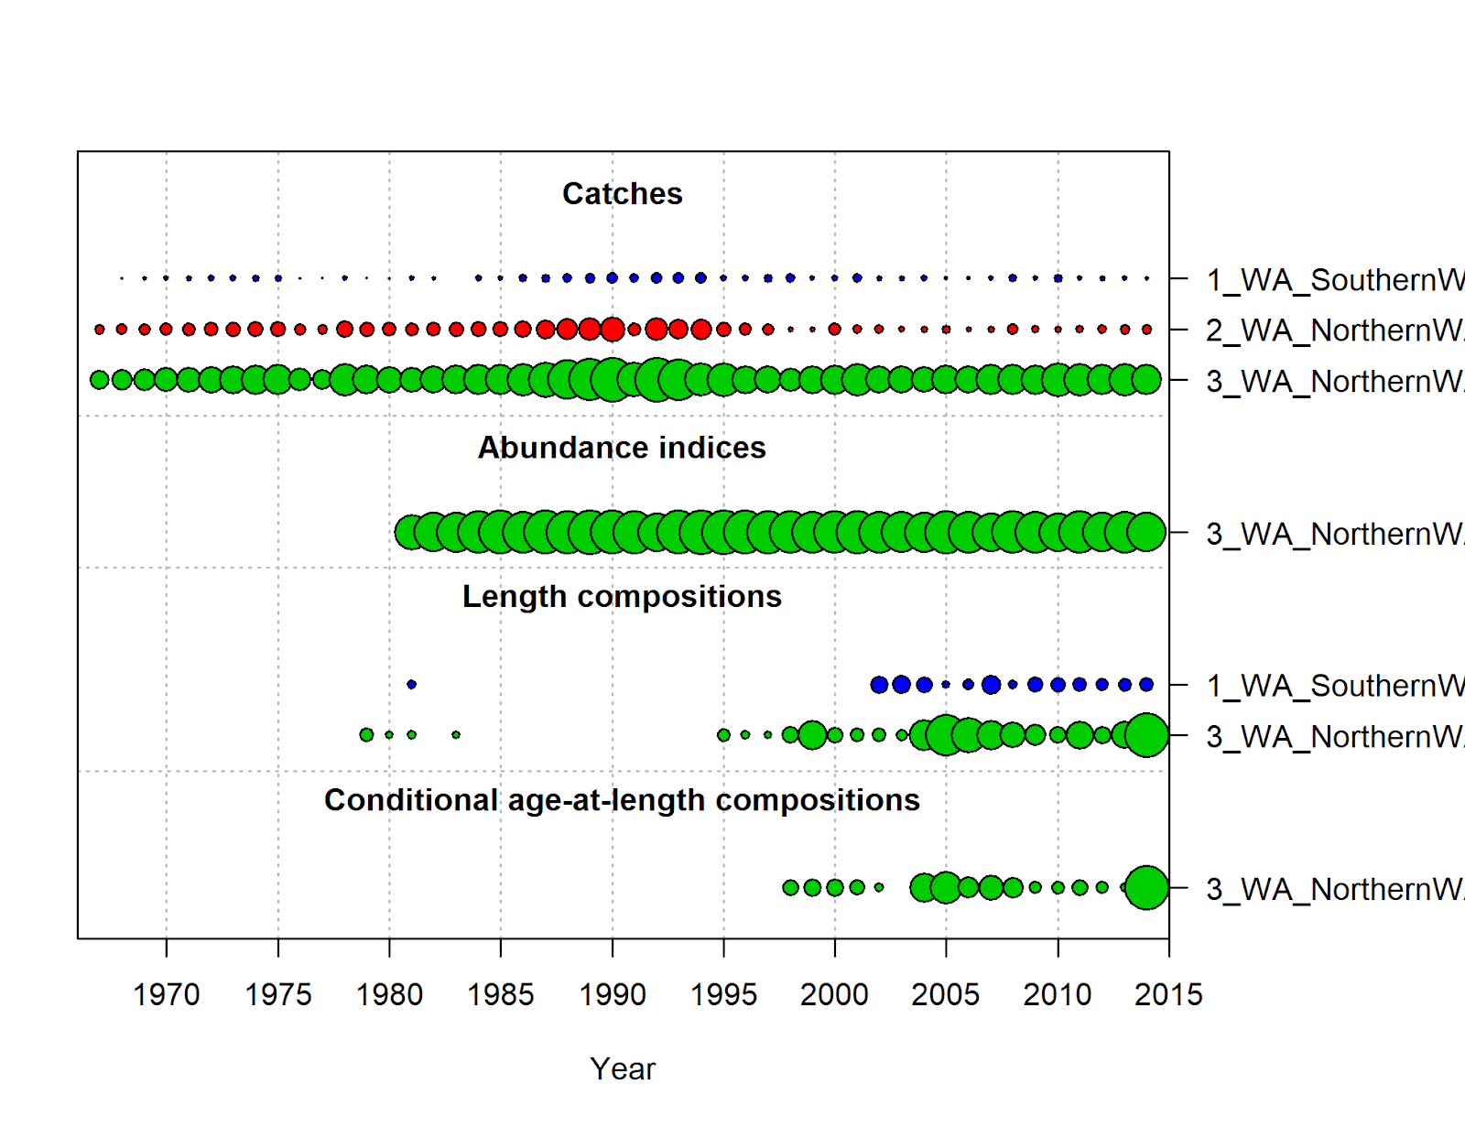

Supplementary Figure 6. Summary of the data type, length of data time series, and quantity for China rockfish (North). The size of the bubble by year is based on the sample size (e.g., larger bubbles indicate higher sample sizes). The bubble size for the indices is equal to the inverse of the mean standard error for the survey.

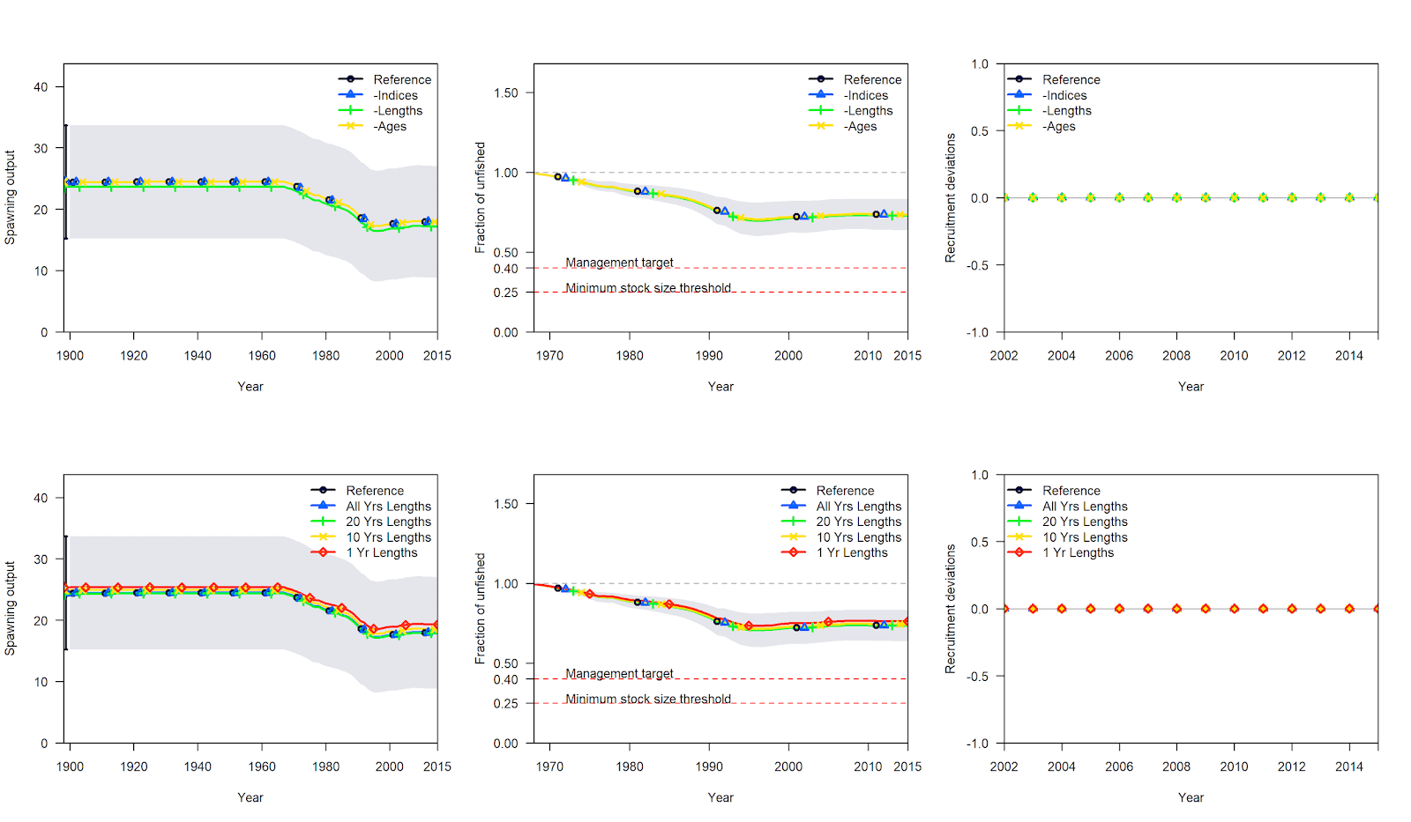
Supplementary Figure 7. Comparison of model estimates of spawning output, the fraction unfished spawning output, and annual recruitment deviations (not estimated in the model) relative to the reference model (black) for China rockfish. The top row are comparisons between the reference model and when all indices (blue), all lengths (green), or all ages (yellow) are removed. The bottom row are comparisons between the reference model and when only catches and all lengths (blue), 20 years of lengths (green), 10 years of length (yellow), or only 1 year of lengths (red) are used in the model.

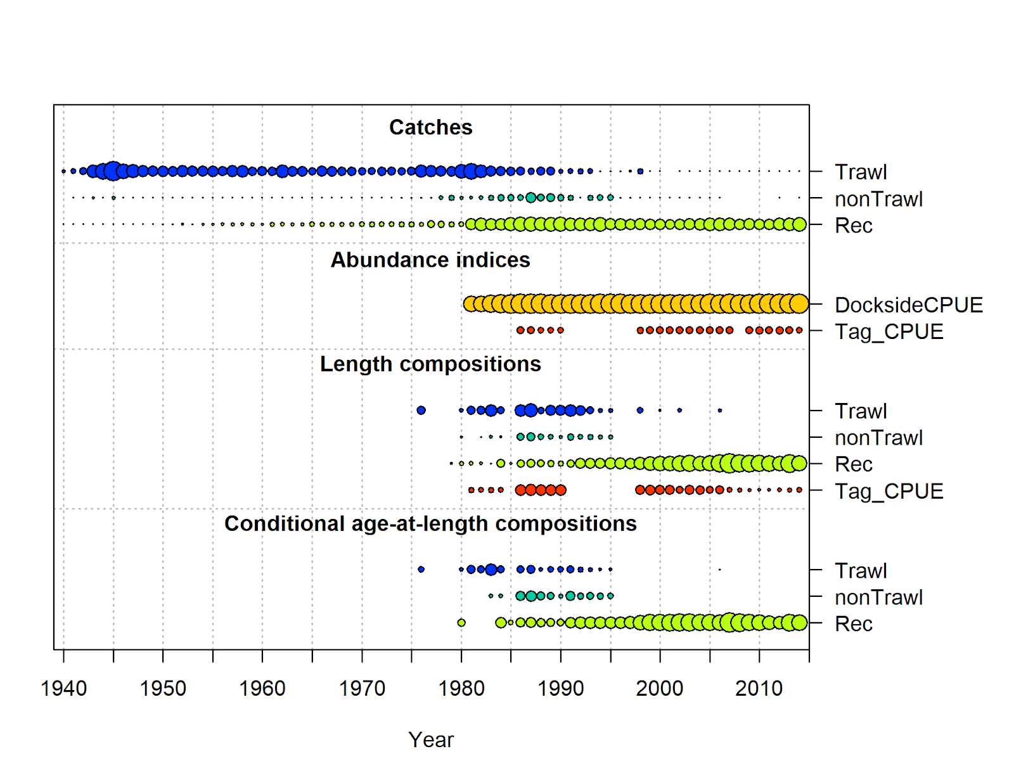FigSupplementary Figure 8. Summary of the data type, length of data time series, and quantity for black rockfish (WA). The size of the bubble by year is based on the sample size (e.g., larger bubbles indicate higher sample sizes). The bubble size for the indices is equal to the inverse of the mean standard error for the survey.

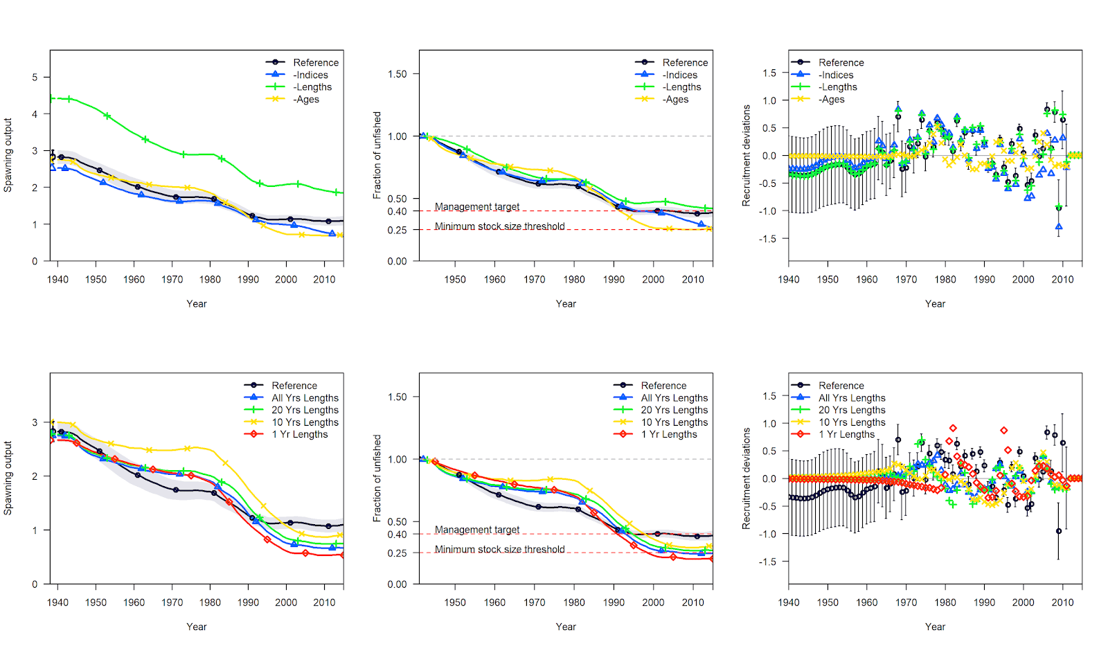
Supplementary Figure 9. Comparison of model estimates of spawning output, the fraction unfished spawning output, and annual recruitment deviations relative to the reference model (black) for black rockfish. The top row are comparisons between the reference model and when all indices (blue), all lengths (green), or all ages (yellow) are removed. The bottom row are comparisons between the reference model and when only catches and all lengths (blue), 20 years of lengths (green), 10 years of length (yellow), or only 1 year of lengths (red) are used in the model.

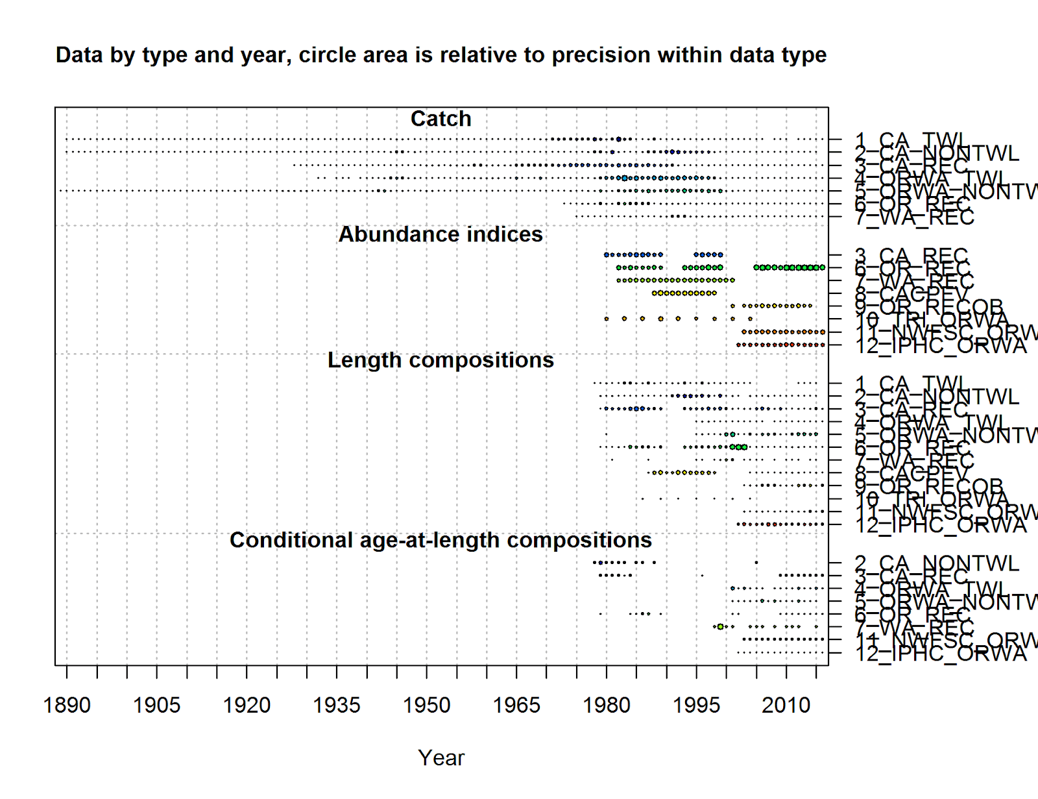
Supplementary Figure 10. Summary of the data type, length of data time series, and quantity for yelloweye rockfish. The size of the bubble by year is based on the sample size (e.g., larger bubbles indicate higher sample sizes). The bubble size for the indices is equal to the inverse of the mean standard error for the survey.

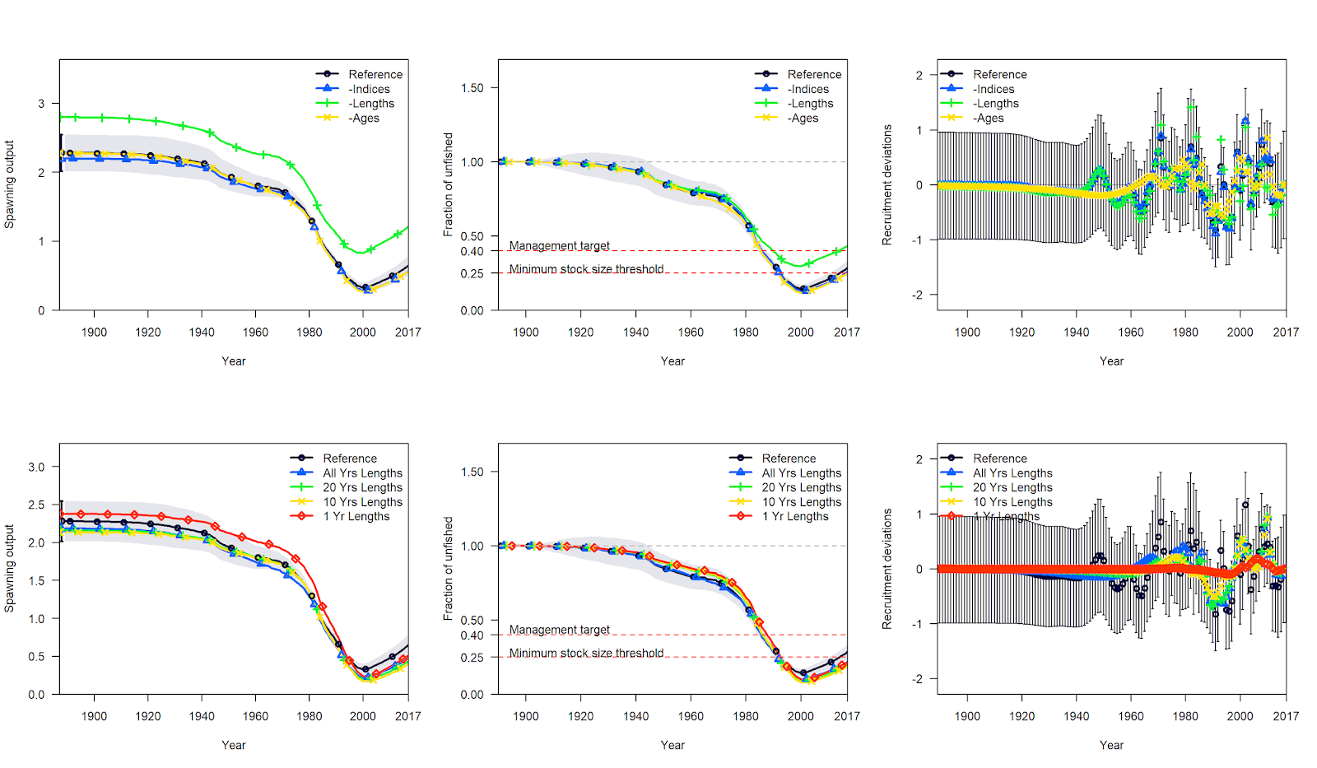
Supplementary Figure 11. Comparison of model estimates of spawning output, the fraction unfished spawning output, and annual recruitment deviations relative to the reference model (black) for yelloweye rockfish. The top row are comparisons between the reference model and when all indices (blue), all lengths (green), or all ages (yellow) are removed. The bottom row are comparisons between the reference model and when only catches and all lengths (blue), 20 years of lengths (green), 10 years of length (yellow), or only 1 year of lengths (red) are used in the model.

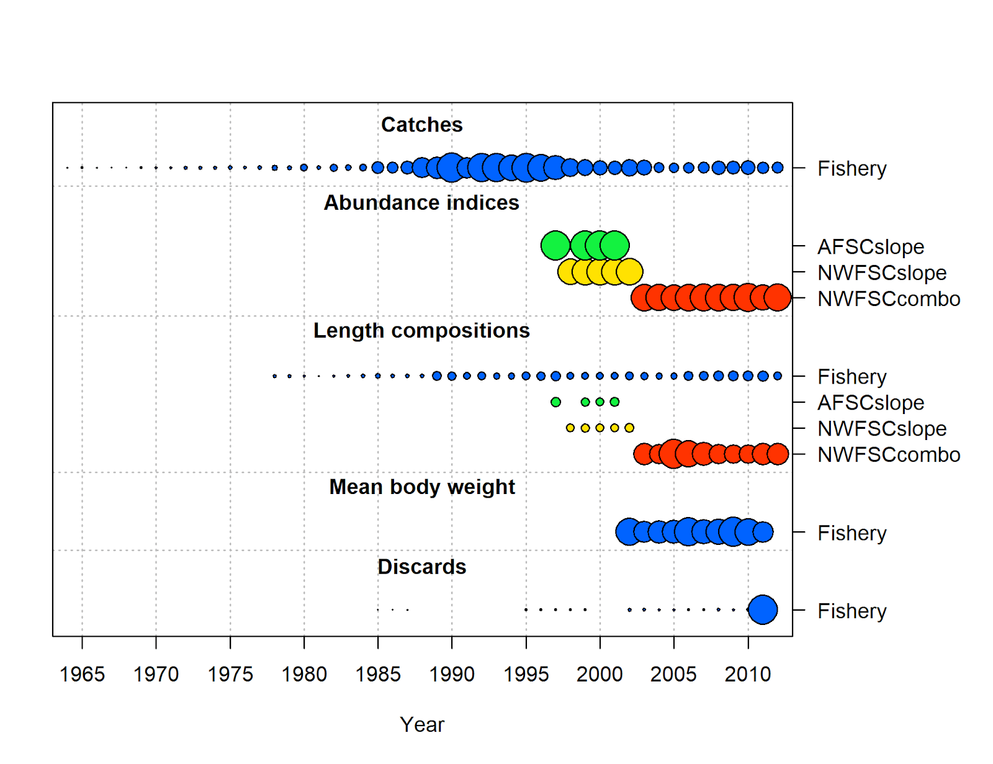
Supplementary Figure 12. Summary of the data type, length of data time series, and quantity for longspine thornyhead. The size of the bubble by year is based on the sample size (e.g., larger bubbles indicate higher sample sizes). The bubble size for the indices is equal to the inverse of the mean standard error for the survey.

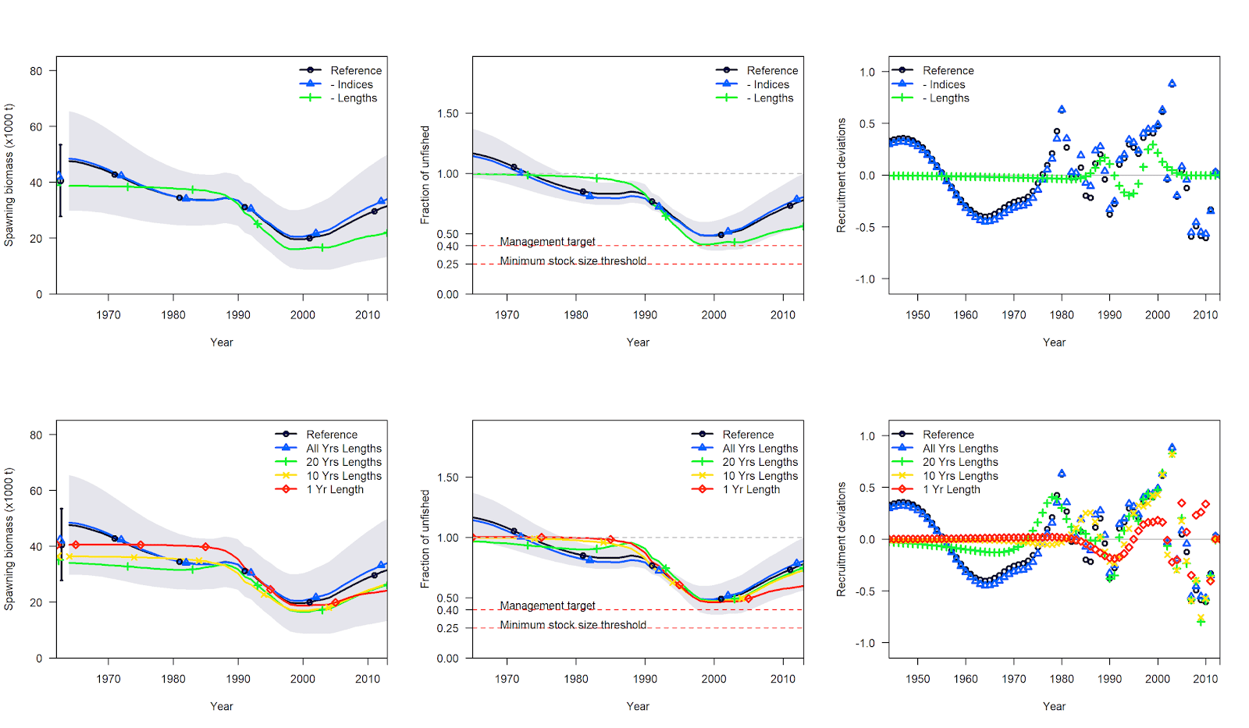
Supplementary Figure 13. Comparison of model estimates of spawning output, the fraction unfished spawning output, and annual recruitment deviations relative to the reference model (black) for longspine thornyhead. The top row are comparisons between the reference model and when all indices (blue) or all lengths (green) are removed. The bottom row are comparisons between the reference model and when only catches and all lengths (blue), 20 years of lengths (green), 10 years of length (yellow), or only 1 year of lengths (red) are used in the model.

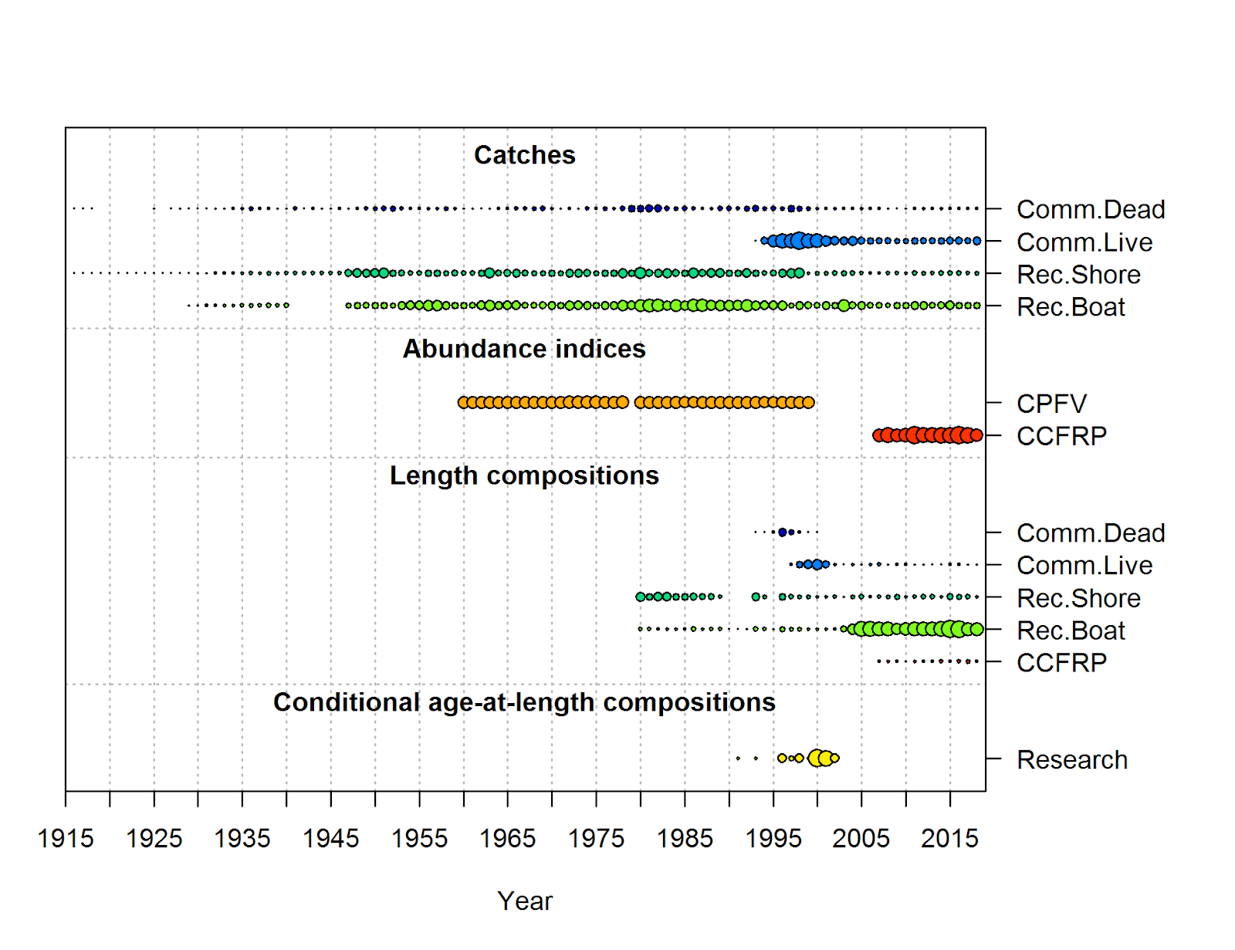
Supplementary Figure 14. Summary of the data type, length of data time series, and quantity for cabezon (NCS). The size of the bubble by year is based on the sample size (e.g., larger bubbles indicate higher sample sizes). The bubble size for the indices is equal to the inverse of the mean standard error for the survey.

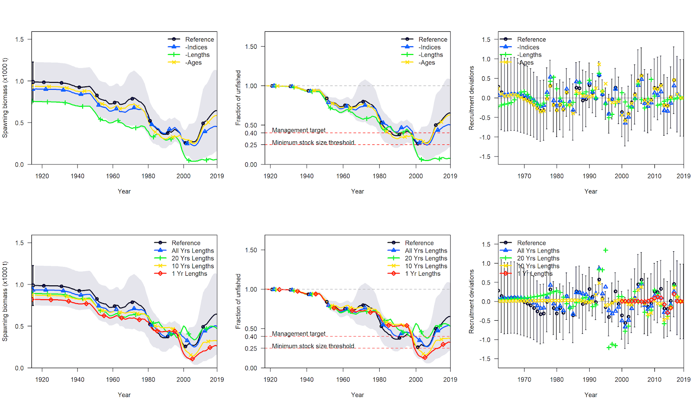
Supplementary Figure 15. Comparison of model estimates of spawning output, the fraction unfished spawning output, and annual recruitment deviations relative to the reference model (black) for cabezon (NCS). The top row are comparisons between the reference model and when all indices (blue), all lengths (green), or all ages (yellow) are removed. The bottom row are comparisons between the reference model and when only catches and all lengths (blue), 20 years of lengths (green), 10 years of length (yellow), or only 1 year of lengths (red) are used in the model.

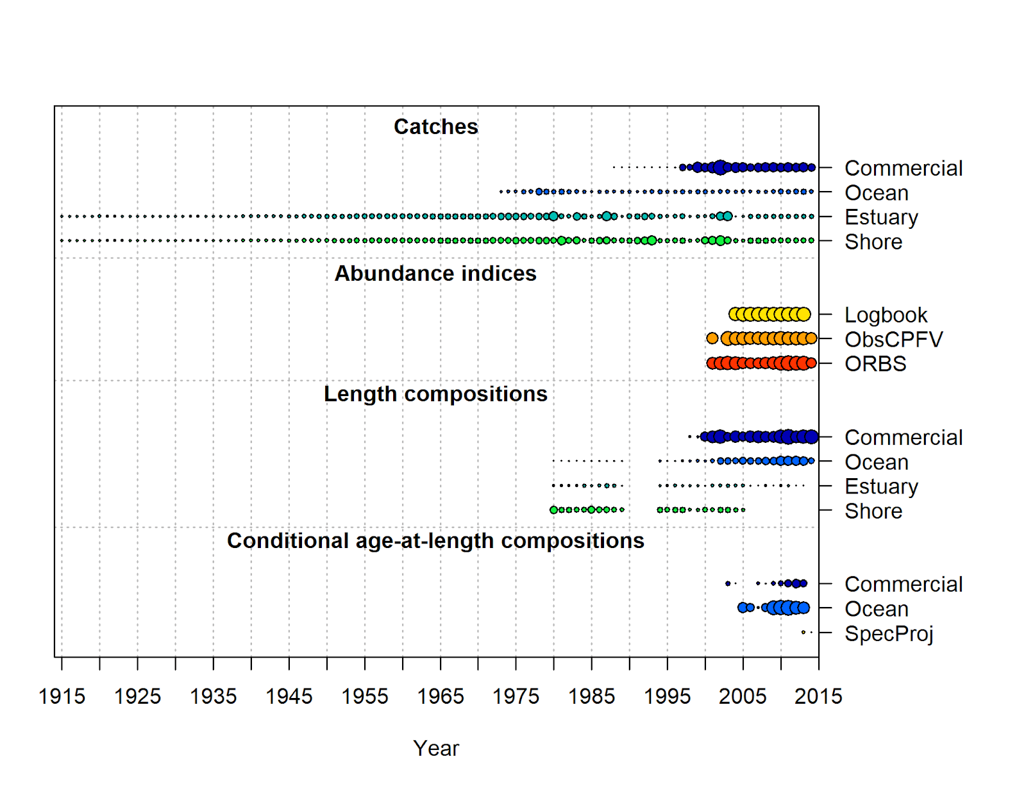

Supplementary Figure 16. Summary of the data type, length of data time series, and quantity for kelp greenling. The size of the bubble by year is based on the sample size (e.g., larger bubbles indicate higher sample sizes). The bubble size for the indices is equal to the inverse of the mean standard error for the survey.

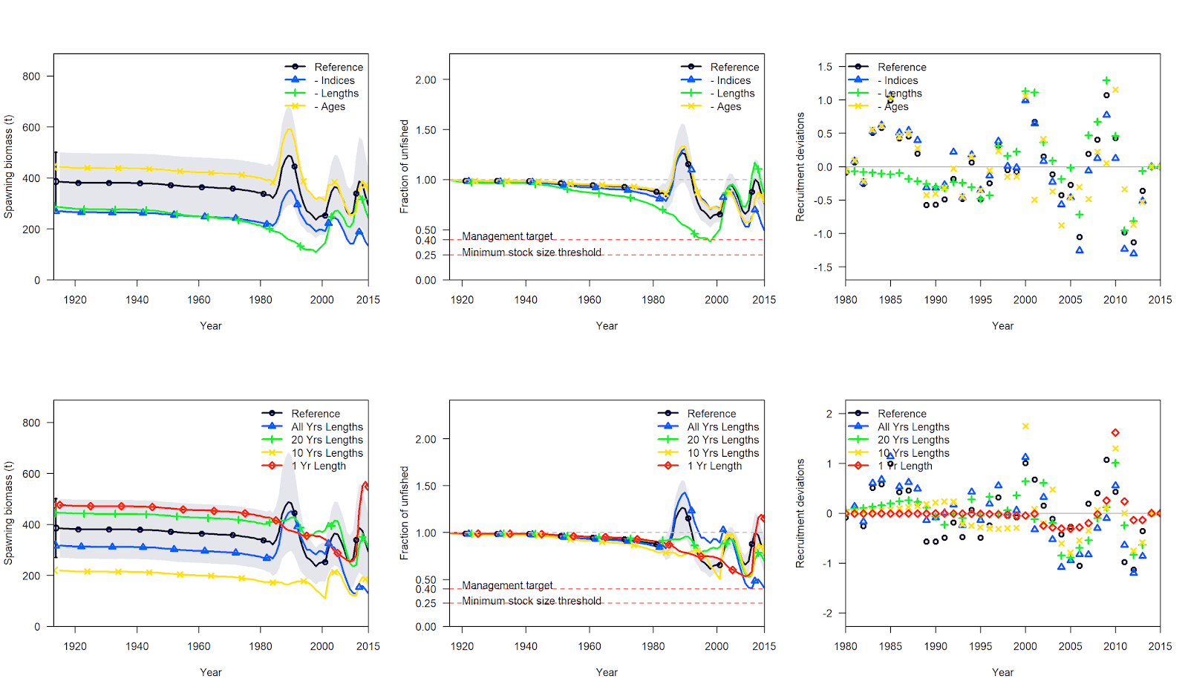
Supplementary Figure 17. Comparison of model estimates of spawning output, the fraction unfished spawning output, and annual recruitment deviations relative to the reference model (black) for kelp greenling. The top row are comparisons between the reference model and when all indices (blue), all lengths (green), or all ages (yellow) are removed. The bottom row are comparisons between the reference model and when only catches and all lengths (blue), 20 years of lengths (green), 10 years of length (yellow), or only 1 year of lengths (red) are used in the model.

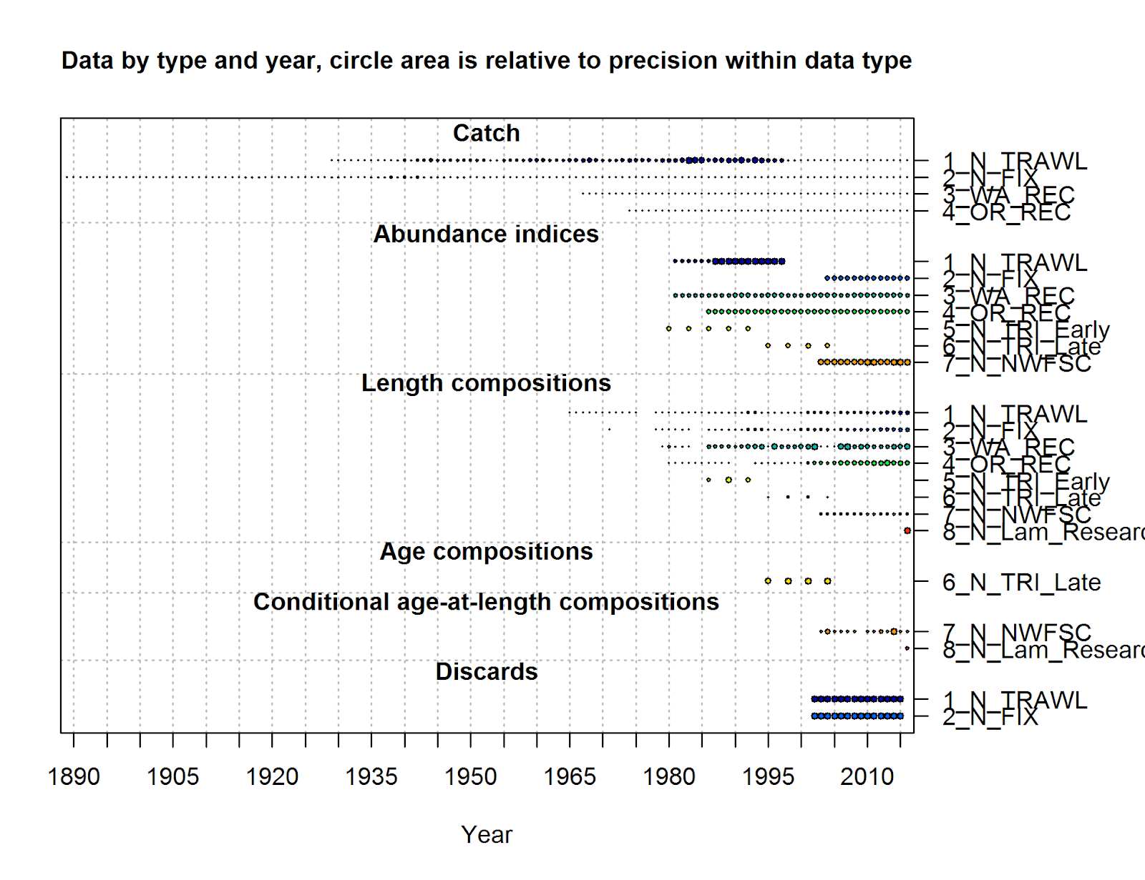

Supplementary Figure 18. Summary of the data type, length of data time series, and quantity for lingcod (North). The size of the bubble by year is based on the sample size (e.g., larger bubbles indicate higher sample sizes). The bubble size for the indices is equal to the inverse of the mean standard error for the survey.

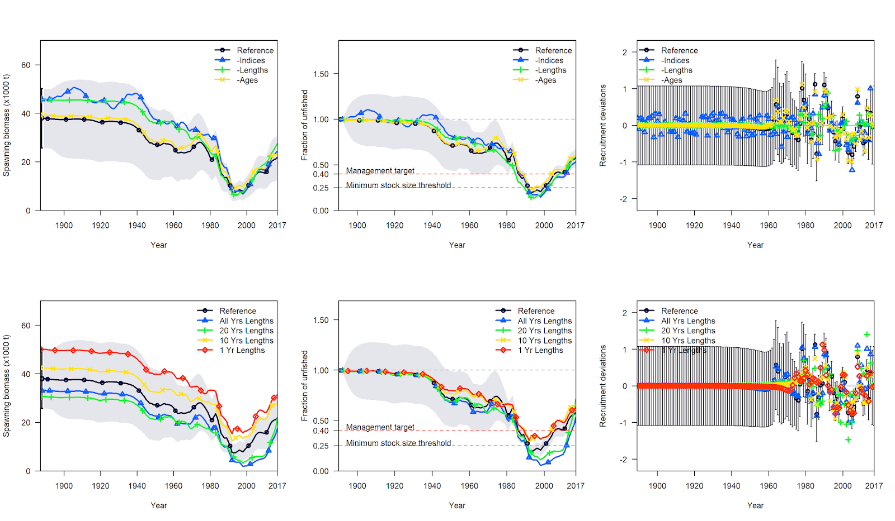
Supplementary Figure 19. Comparison of model estimates of spawning output, the fraction unfished spawning output, and annual recruitment deviations relative to the reference model (black) for lingcod (North). The top row are comparisons between the reference model and when all indices (blue), all lengths (green), or all ages (yellow) are removed. The bottom row are comparisons between the reference model and when only catches and all lengths (blue), 20 years of lengths (green), 10 years of length (yellow), or only 1 year of lengths (red) are used in the model.

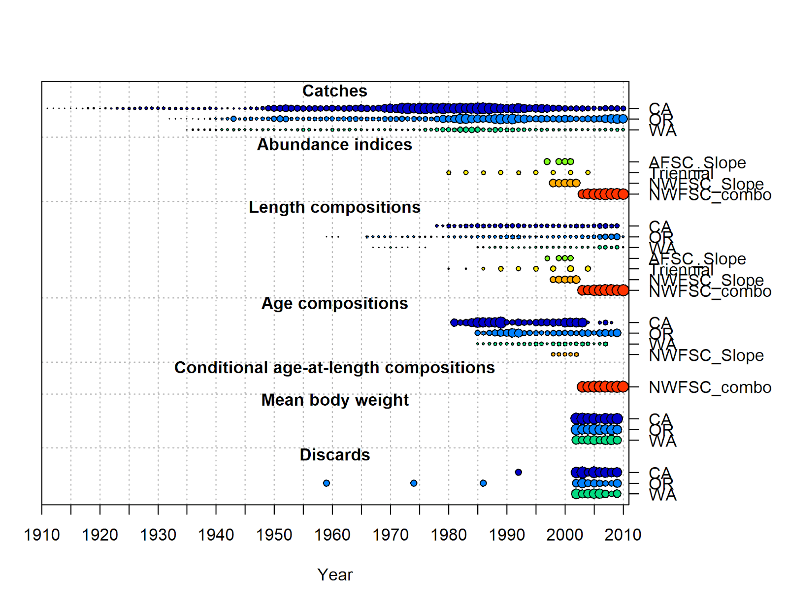
Supplementary Figure 20. Summary of the data type, length of data time series, and quantity for Dover sole. The size of the bubble by year is based on the sample size (e.g., larger bubbles indicate higher sample sizes). The bubble size for the indices is equal to the inverse of the mean standard error for the survey.

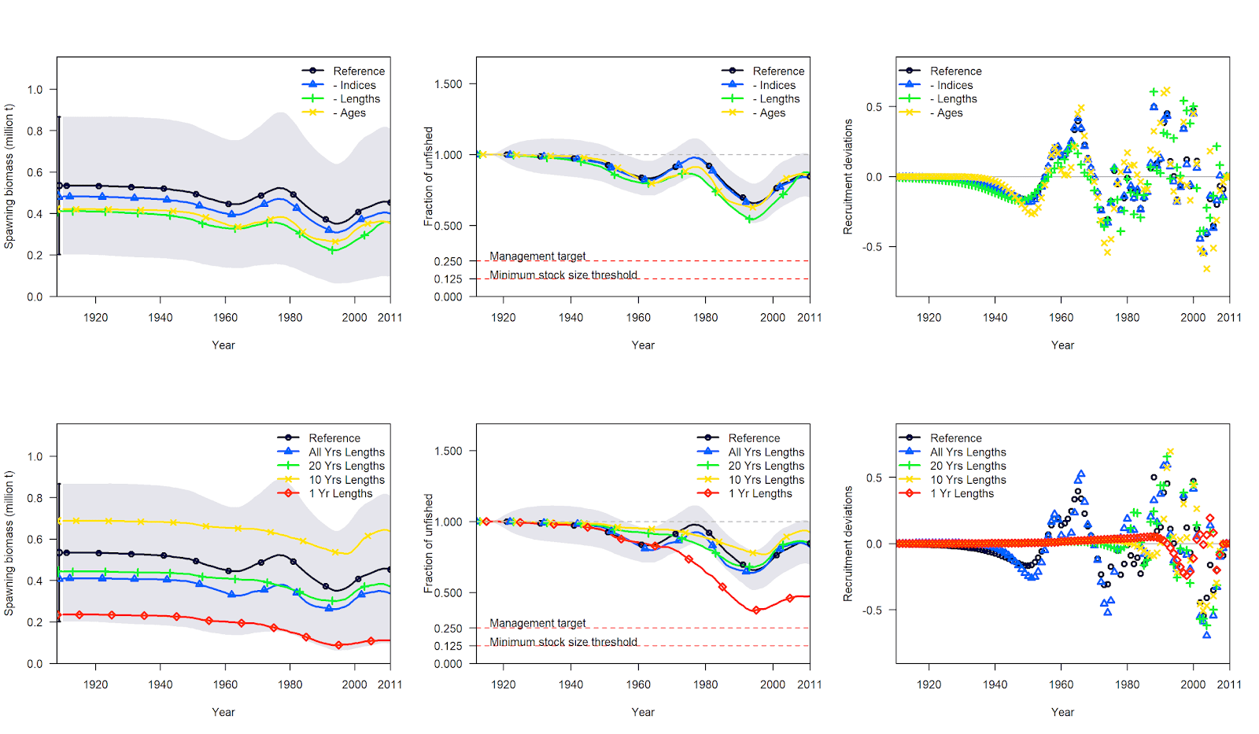

Supplementary Figure 21. Comparison of model estimates of spawning output, the fraction unfished spawning output, and annual recruitment deviations relative to the reference model (black) for Dover sole. The top row are comparisons between the reference model and when all indices (blue), all lengths (green), or all ages (yellow) are removed. The bottom row are comparisons between the reference model and when only catches and all lengths (blue), 20 years of lengths (green), 10 years of length (yellow), or only 1 year of lengths (red) are used in the model.

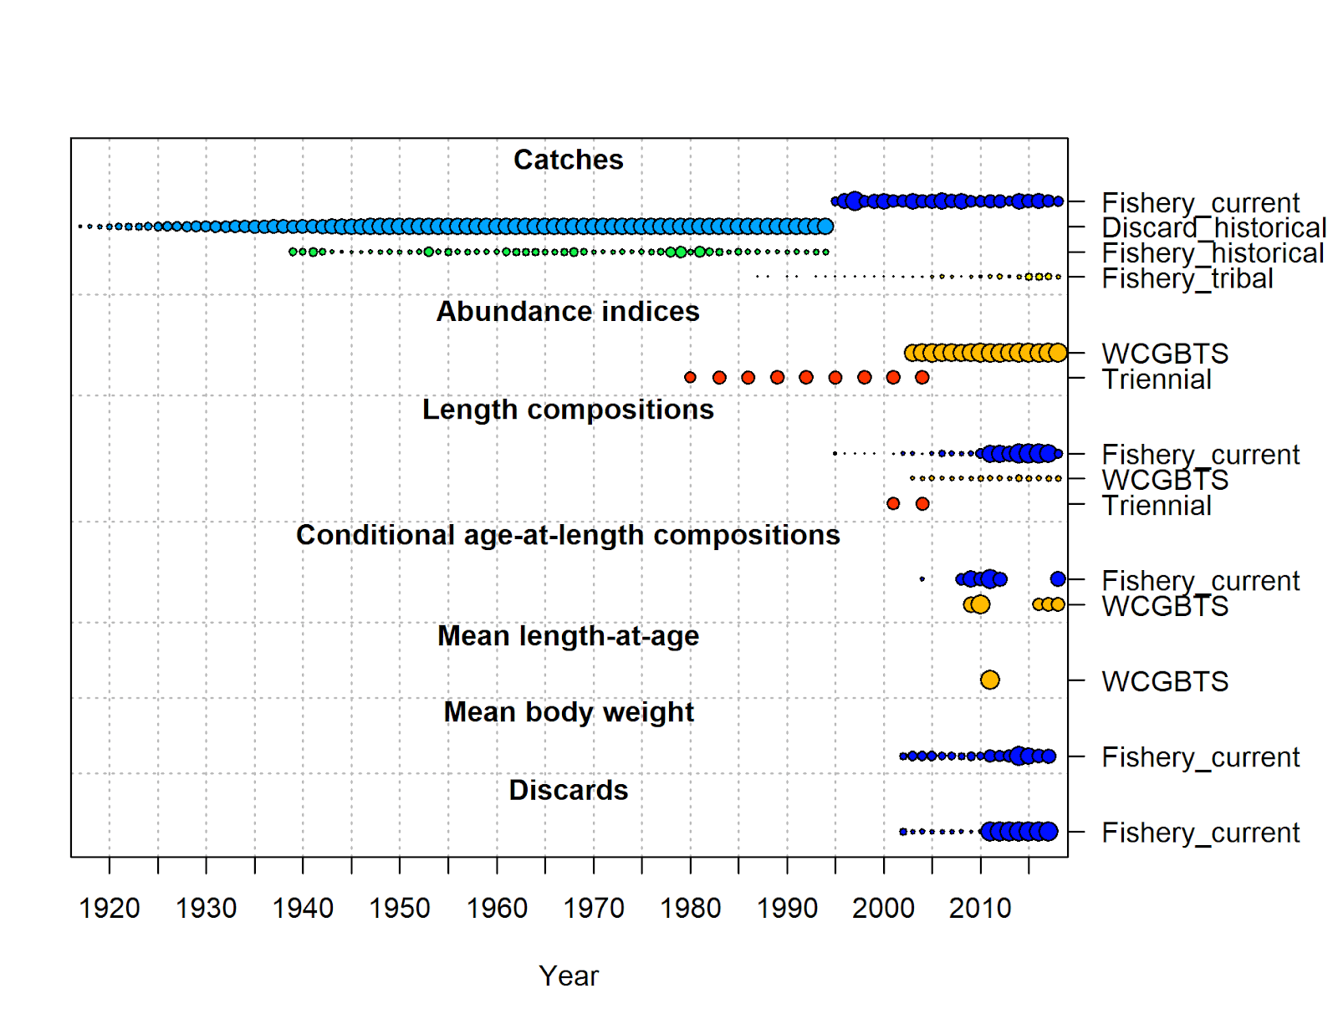
Supplementary Figure 22. Summary of the data type, length of data time series, and quantity for big skate. The size of the bubble by year is based on the sample size (e.g., larger bubbles indicate higher sample sizes). The bubble size for the indices is equal to the inverse of the mean standard error for the survey.

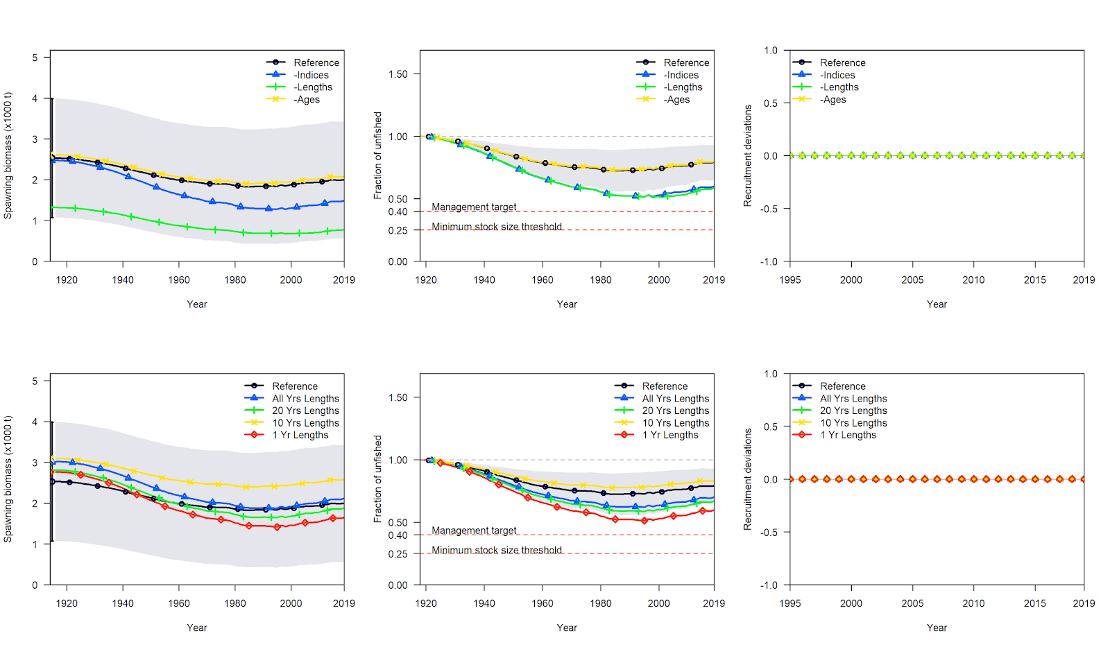
Supplementary Figure 23. Comparison of model estimates of spawning output, the fraction unfished spawning output, and annual recruitment deviations (not estimated in the model) relative to the reference model (black) for big skate. The top row are comparisons between the reference model and when all indices (blue), all lengths (green), or all ages (yellow) are removed. The bottom row are comparisons between the reference model and when only catches and all lengths (blue), 20 years of lengths (green), 10 years of length (yellow), or only 1 year of lengths (red) are used in the model.

Flow chart for SS-CL
- Prepare catch data
  - Catch treated as known. Use total mortality (landings + dead discards).
- Prepare length composition
  - Determine length bins and frequency within bins across years. More than 10 years of data (with reasonable sample sizes) is recommended. Otherwise it is a category 3 assessment.
  - This can be done for as many fleets as needed, but use the parsimony principle to define fleets, as model convergence may be more difficult with more fleets.
  - Female, male and unknown data can be used.
  - Determine effective sample sizes following standard protocol.
  - Combine length data from landings and discards (or reasonable assumptions for the latter if no data) appropriately.
- Define life history parameters
  - Natural Mortality: define using estimators (e.g., Hamel method (must include as a sensitivity at least, if an estimate of longevity/maximum age is available), Natural Mortality Tool). Fix to central tendency (median value) and retain uncertainty for sensitivity analyses.
  - Growth parameters. Externally fit the von Bertalanffy growth function and use point estimates to fix in model. Choose a fixed valued for CV at length. Retain uncertainty for sensitivity analyses.
  - Steepness defined either through meta-analysis or expert opinion. Retain uncertainty for sensitivity analyses.
  - Recruitment variability also defined through meta-analysis or expert opinion. Retain uncertainty for sensitivity analyses.
  - Life history parameters will generally be pre-specified but consideration could be given to estimating these parameters (see Section 1.5.3).
- Parameter estimation
  - Estimate R₀, recruitment deviations and selectivity parameters.
  - Selectivity can be logistic, dome-shaped, or whatever form in chosen in SS.
  - Bias correction to recruitment deviations can subsequently be applied.
- Model weighting
  - Consider weighting the length compositions if multiple fleets.
- Model convergence
  - Length-only models may take additional jittering to find convergence and avoid local likelihood minima.
  - Check model fits to length compositions.
  - Determine whether selectivity shapes make sense.
  - Review other parameters estimates for bounds and poor estimation (and whether they are reasonable).
- Characterize uncertainty
  - Likelihood profile over, at minimum, M, L₂ (preferably parameterized as L∞, though can also make the transformation for reporting) and k (retain correlation structure if possible), CV at length, and h.
  - Sensitivity analysis should be conducted, either based on likelihood profile information or identified model specification.
  - Ensemble modeling to quantify model specification error would be useful. This would need further discussion on how best to approach it.
  - Calculate the Hessian matrix for standard deviations (frequentist inference) or run MCMC (Bayesian inference) to quantify characterize parameter uncertainty.
- Model diagnostics
  - Examine model fits to data, visually and using residual patterns
  - Likelihood profiling over key parameters such as R₀
  - Retrospective analysis

