Supplementary Tables

Table S1. Sampling effort for the study of nesting Chelonia mydas on Trindade Island. Monitoring season, months, and total days, number of measured turtles, and number of turtles with CCL ≤ 108 cm.
Monitoring Season | Monitoring Months | Days Monitored | No. Females Measured | No. marked turtles w/  CCL ≤ 108 cm
1985/1986 | Feb-Apr | 53 | 379 | 58
1989/1990 | Mar | 4 | 61 | 9
1991/1992 | Jan-May | 128 | 449 | 56
1993/1994 | Apr-Jul | 197 | 74 | 20
1994/1995 | Oct-Oct | 344 | 416 | 80
1995/1996 | Oct-Jun | 247 | 448 | 82
1996/1997 | Feb-Feb | 61 | 228 | 34
1997/1998 | Jan-Feb | 40 | 20 | 3
1998/1999 | Dec-Feb | 60 | 355 | 64
1999/2000 | Dec-Apr | 121 | 284 | 55
2001/2002 | Feb-Mar | 13 | 61 | 13
2002/2003 | Feb | 3 | 30 | 3
2006/2007 | Dec-Jul | 189 | 257 | 111
2007/2008 | No Data | No Data | 10 | 0
2008/2009 | Dec-Jun | 210 | 312 | 96
2009/2010 | Dec-Jun | 213 | 343 | 154
2010/2011 | Dec-May | 60 | 458 | 181
2011/2012 | Nov-Jun | 180 | 251 | 86
2012/2013 | Nov-May | 183 | 516 | 238
2013/2014 | Apr-Jul | 105 | 20 | 5
2014/2015 | Dec-Jun | 182 | 381 | 202
2015/2016 | Dec-Apr | 180 | 152 | 58
2016/2017 | Dec-Apr | 181 | 625 | 325

Table S2. Mean, minimum, and maximum CCL of turtles that laid eggs in Trindade for each breeding season.
Year | Mean CCL | SD | Min. CCL | Max. CCL
1985/1986 | 115.8 | 5.4 | 100 | 134
1989/1990 | 115.0 | 5.6 | 103 | 130
1991/1992 | 116.9 | 5.7 | 101 | 143
1993/1994 | 113.0 | 4.4 | 103 | 128
1994/1995 | 114.9 | 5.2 | 95 | 142
1995/1996 | 115.7 | 5.6 | 102 | 132
1996/1997 | 116.5 | 6.0 | 102 | 143
1997/1998 | 116.0 | 4.7 | 105 | 124
1998/1999 | 115.6 | 5.5 | 99 | 137
1999/2000 | 115.7 | 5.9 | 101 | 141
2001/2002 | 114.3 | 5.7 | 99 | 132
2002/2003 | 116.2 | 5.6 | 104 | 127
2006/2007 | 112.3 | 6.7 | 98 | 133
2007/2008 | 115.7 | 4.8 | 109 | 124
2008/2009 | 113.5 | 5.8 | 97 | 131
2009/2010 | 111.9 | 6.4 | 94 | 129
2010/2011 | 112.2 | 6.2 | 96 | 132
2011/2012 | 112.7 | 5.9 | 98 | 134
2012/2013 | 111.0 | 6.1 | 92 | 132
2013/2014 | 112.4 | 4.6 | 99 | 119
2014/2015 | 110.6 | 6.1 | 94 | 132
2015/2016 | 111.5 | 5.9 | 96 | 126
2016/2017 | 110.3 | 6.5 | 89 | 130

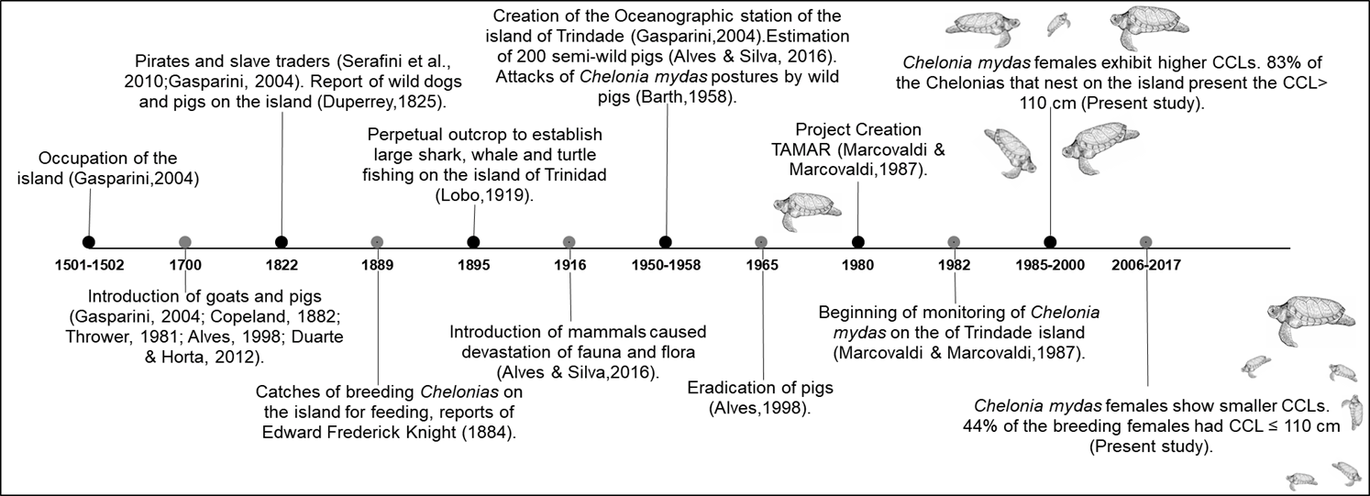
Figure S1. Chronology of anthropogenic influences and impacts on Trindade Island fauna. Timeline entries indicate the most relevant events of occupation, use, and introduction of invasive species at Trindade Island.

Script CCL ~ Year

#Packages
library(mgcv)
library(ggplot2)
library(ggthemes)
#Females
data=read.csv2("recrut.csv", dec=",")
head(data)
View(data)
#Constuction in GAM
gam_j = gam(ccl ~ s(ano, k=10),
family=scat(link="identity"),
method = "REML", data=data)
#Construction of predicted values
x_new = seq(0, max(data$ano), length.out = 100)
y_pred = predict(gam_j, data.frame(ano = x_new))
#Construction of predicted values
par(mfrow = c(2,2))
gam.check(gam_j)
#Model evaluation
anova.gam(gam_j)
summary(gam_j)
#Graphic
ggplot(data, aes(ano, ccl)) + theme_base()+ geom_point() +
labs(y = 'CCL mean (cm)',x = 'Years') +
geom_smooth(method= 'gam', formula = y ~s(x)) +
geom_point(data = data, aes(y = ccl),
colour = 'black', size = 3)

Script Annual Somatic Growth Rate
dados=read.csv2("crescimento.csv", dec=".")
head(dados)
View(dados)
#Models
mnull=glm(rate~1, family = quasipoisson, data = dados)
model1=glm(rate~ccl+time, family = quasipoisson, data=dados)
model2=glm(rate~ccl, family = quasipoisson, data=dados)
model3=glm(rate~time, family = quasipoisson, data=dados)
#Testing
Anova (mnull, model1,model2, model3, test="F")
mnull=glm(rate~1, family = quasipoisson, data = dados)
anova(mnull, test="F")
#Summary
summary(mnull)
# Effect size
-exp()

