Supplementary Material

Year | Jan. | Feb. | March | April | May | June | July | Aug. | Sept. | Oct. | Nov. | Dec. | Total (n)
2000 |  |  |  |  |  | 8 |  |  |  |  |  |  | 8
2002 |  |  |  |  |  | 8 |  |  |  |  |  |  | 8
2003 |  |  |  |  |  | 15 |  |  |  |  |  |  | 15
2004 | 4 | 14 |  |  |  | 15 |  |  |  |  |  |  | 33
2005 |  | 5 |  |  |  |  | 1 |  |  |  |  |  | 6
2006 |  |  |  |  |  | 2 | 5 | 8 | 12 |  |  |  | 27
2007 |  |  |  |  | 15 | 28 | 4 | 34 |  |  |  |  | 81
2008 |  |  |  |  |  | 2 | 1 | 8 |  |  |  |  | 11
2009 |  |  |  |  |  | 10 |  |  |  |  |  |  | 10
2011 |  |  |  |  | 35 | 53 |  |  |  |  |  |  | 88
2012 |  | 17 | 77 | 52 | 67 | 80 | 52 | 64 | 35 | 44 | 20 | 7 | 515
2013 | 17 | 27 | 37 | 24 | 40 | 46 | 61 | 57 | 10 | 20 |  |  | 339
2014 | 1 | 36 | 16 | 38 | 30 | 51 | 50 | 49 | 49 | 54 | 36 | 11 | 421
2015 |  |  |  |  | 4 | 20 |  |  |  |  |  |  | 24
2016 |  |  |  |  | 6 | 17 | 27 | 20 | 7 | 17 | 15 | 21 | 130
2017 |  |  |  |  | 4 | 39 | 63 | 29 | 25 | 22 | 13 |  | 195
Total (n) | 22 | 99 | 130 | 114 | 201 | 394 | 264 | 269 | 138 | 157 | 84 | 39 | 1911
Supplementary Table 1. Monthly total numbers of yellowfin tuna gonads (ovaries and testes combined) sampled from the northcentral Gulf of Mexico during 2000-2017.

CFL mm | Jan. | Feb. | Mar. | Apr. | May | June | July | Aug. | Sept. | Oct. | Nov. | Dec. | Total (n)
400-500 |  |  |  |  |  |  |  |  |  |  | 1 |  | 1
600-700 |  |  |  |  |  |  |  |  |  |  | 1 |  | 1
700-800 | 2 | 1 | 2 | 3 | 2 | 2 | 4 |  |  | 2 | 4 | 7 | 29
800-900 | 4 | 8 | 15 | 9 | 9 | 3 | 2 |  | 1 |  |  | 2 | 53
900-1000 | 1 |  | 5 | 8 | 19 | 15 | 10 | 2 | 2 | 1 | 1 |  | 64
1000-1100 |  | 1 | 2 |  | 1 | 13 | 20 | 6 | 3 | 7 |  | 1 | 54
1100-1200 |  |  | 3 |  |  | 1 | 1 | 3 | 1 | 6 | 4 |  | 19
1200-1300 |  | 1 | 3 |  |  |  | 2 |  |  | 1 |  |  | 7
1300-1400 |  | 1 |  |  |  |  |  |  |  |  | 1 |  | 2
Total (n) | 7 | 12 | 30 | 20 | 31 | 34 | 39 | 11 | 7 | 17 | 12 | 10 | 230
Supplementary Table 2. Monthly total numbers of yellowfin tuna females assigned to the immature reproductive phase in each 100 mm length range. CFL- curved fork length.

Supplementary Table 3. Summary of the logistic regression coefficients (± SE) and associated L₅₀ and L₉₅ estimates for female yellowfin tuna in the northcentral GOM for the functional maturity threshold (V1/V2) for peak spawning months (May-August) and non-peak spawning months (September-April). Corresponding 95% lower and upper confidence intervals are in italics. n- number of mature females in each maturity threshold; corresponding 95% lower and upper confidence intervals are in italics.
Seasonality | Mature (n) | α (±SE) | β (±SE) | L_{50 (mm)} | L_{95 (mm)}
Peak Spawning | 436 | -22.25 | 0.02 | 1070 | 1211
 |  | ±1.99 | ±0.002 | 1058-1082 | 1185-1237
Non-Peak Spawning | 317 | -30.31 | 0.03 | 1077 | 1182
 |  | ±4.08 | ±0.003 | 1061-1093 | 1156-1208

Supplementary Table 4. Summary of AIC analyses resulting from the series of logistic generalized linear models with maturity as a function of seasonality (Season) and curved fork length (CFL) at functional (V1/V2) 50% maturity as predictors for female yellowfin tuna in the northcentral COM. K-the number of parameters in each model, Full- a full model (seasonality, length, and the interaction (*) as a predictor), Reduced-reduced model (the full model with no interaction), and Null-a null model (only CFL as a predictor).
Model | K | AIC | ΔAIC | AIC Wt.
Null: Maturity ~ CFL | 2 | 536.05 | 0 | 0.45
Full: Maturity~ CFL * Season | 4 | 536.42 | 0.37 | 0.38
Reduced: Maturity ~ CFL + Season | 3 | 538.04 | 1.99 | 0.17

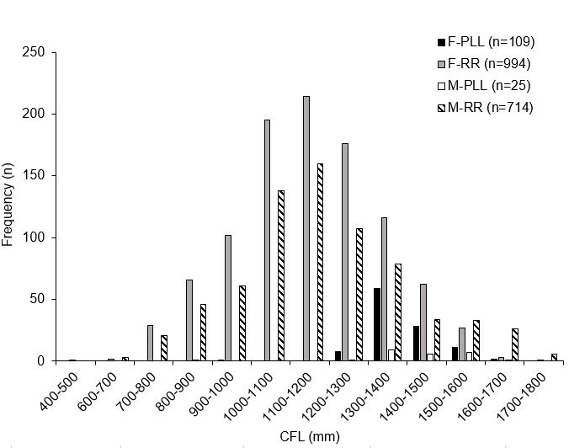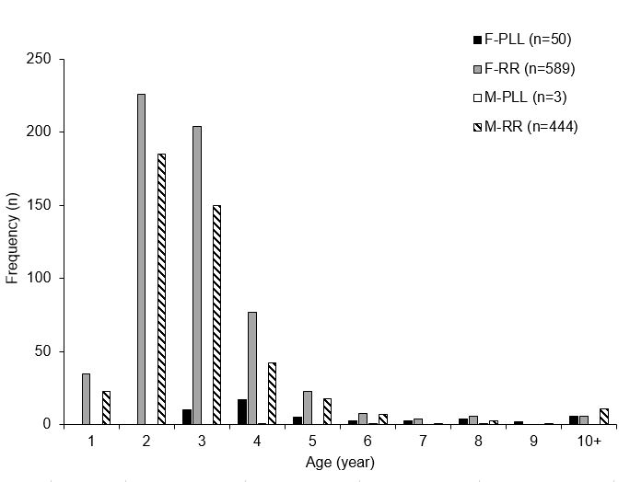
B
A
Supplementary Figure 1. Frequency distributions for female (F) and male (M) yellowfin tuna caught in the northcentral GOM by pelagic longline (PLL) and rod and reel (RR) A) Length frequency in curved fork length (CFL), and B) Age frequency in years.
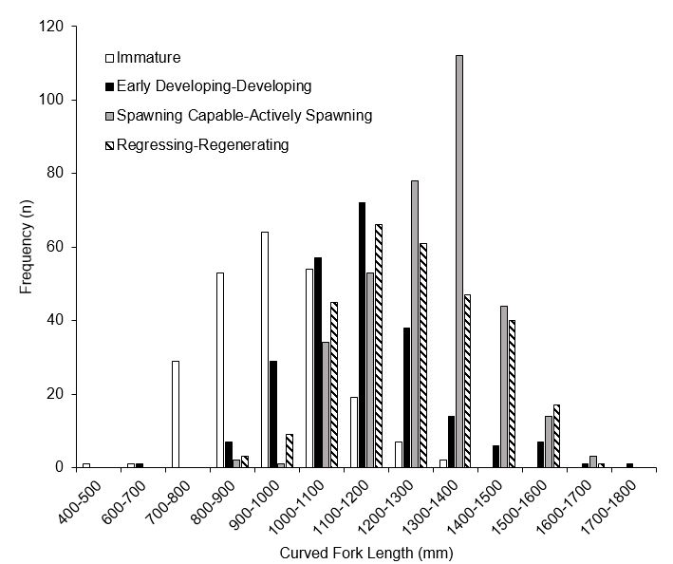
Supplementary Figure 2. The length frequency distribution of female yellowfin tuna (n=1093) landed in the northcentral GOM assigned to reproductive phases.

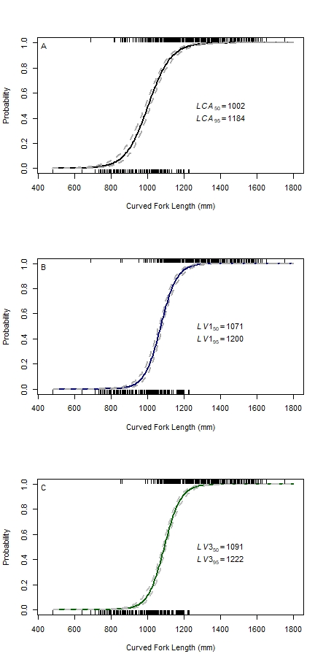
Supplementary Figure 3. Female yellowfin tuna maturity ogives calculated using varying maturity thresholds from individuals landed from 2000 – 2017 from the northcentral Gulf of Mexico for all capture months (n=1099). A) CA= cortical alveolar oocytes [physiological maturity], B) V1= primary or secondary vitellogenic oocytes [functional maturity], C) V3= ovaries containing tertiary vitellogenic oocytes [spawning maturity]). The black tick marks on each graph represent observed immature fish (bottom axis) and mature fish (top axis). The gray dashed lines surrounding each predicted ogive represent the 95% confidence limits. The predicted L₅₀ and L₉₅ estimates from each logistic regression are displayed on the graph.

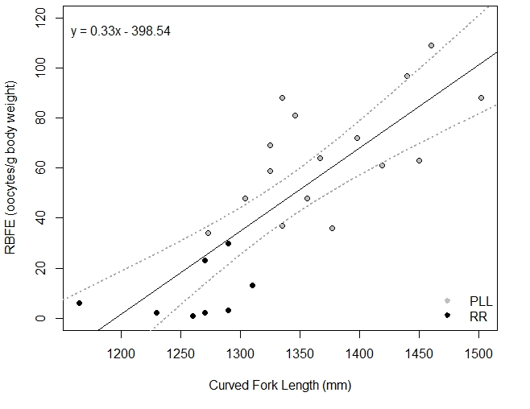
Supplementary Figure 4. Relative batch fecundity estimates (RBFE, oocytes per gram of estimated body weight) as a linear function to curved fork length of yellowfin tuna captured in the northcentral Gulf of Mexico (n=24; P<0.001). Fish separated by capture method; RR=rod and reel (black circles), PLL=pelagic longline (gray circles). The gray dashed lines represent the 95% confidence limits.

