Supplemental Tables and Figures

Supplemental Tables
Table S1. Dungeness crab domoic acid contamination monitoring and management program design¹ in California, Oregon, and Washington before the 2020-21 and 2015-16 seasons (2015-16 season values are provided in parentheses if different from the 2020-21 season).

Dimension | California | Oregon | Washington
Action threshold (ppm) | >30 ppm in viscera  >20 ppm in meat | ≥ 30 ppm in viscera  ≥ 20 ppm in meat | ≥ 30 ppm in viscera  ≥ 20 ppm in meat
Detection limit (ppm) | 2.5 ppm | 1.0 ppm | 1.0 ppm
# of crabs per site | 6 crabs | 6 crabs | 6 crabs
# of sampling sites | 17 sites | 12 sites  (5 sites in 2015) | 4 sites  (2 sites in 2015)
# of management zones | 8 coastal zones  (none in 2015) | 12 coastal zones  (none in 2015) | 4 coastal/3 inland zones
Management actions | Area closure, evisceration order  (area closure only in 2015) | Area closure, evisceration order  (area closure only in 2015) | Area closure, evisceration order  (area closure only in 2015)

¹ See Table S2 for more information on the management of commercial and recreational Dungeness crab fisheries in California, Oregon, and Washington.
Table S2. “3S” management (sex-size-season) of commercial and recreational Dungeness crab fishing in California, Oregon, and Washington.

State | Open | Close | Min. size (in) | Daily bag limit | Season notes
Commercial
Washington | Dec 1 | Sep 15 | 6.25" | Males only | Summer season (Jul 1-Sep 1): 2500-lb trip limit, potential closures, more testing
Oregon (bay) | Sep 1 | Dec 31 | 6.25" | Males only | No weekends or holidays, not in December if adjacent ocean area is closed
Oregon (ocean) | Dec 1 | Aug 14 | 6.25" | Males only
California (northern) | Dec 1 | Jul 15 | 6.25" | Males only
California (central) | Nov 15 | Jun 30 | 6.25" | Males only
Recreational
Washington | Year round | ---- | 6.25" | 5 males
Oregon (bay) | Year round | ---- | 5.75" | 12 males
Oregon (ocean) | Dec 1 | Oct 15 | 5.75" | 12 males
California (northern) | Early Nov | Jul 30 | 5.75" | 10 males/females | First Saturday in November
California (central) | Early Nov | Jun 30 | 5.75" | 10 males/females | First Saturday in November

Table S3. Sources of news releases describing closures, advisories, and other management actions related to biotoxin contamination on the U.S. West Coast.

State | Type | Years | Link
PSMFC | Dungeness crab | 2004-present | http://www.psmfc.org/crab/
WA | Dungeness Crab | 2009-present | https://wdfw.wa.gov/fishing/commercial/crab/coastal/letters-notices
OR | ODFW news releases | 2010-present | https://www.dfw.state.or.us/news/2021/index.asp
OR | ODA news releases | 2016-present | https://odanews.wpengine.com/tag/shellfish/
CA | CDFW news releases | 2015-present | https://cdfwmarine.wordpress.com/2020/
CA | CDPH shellfish advisories | 2014-present | https://www.cdph.ca.gov/Programs/OPA/Pages/Shellfish-Advisories.aspx

Table S4. A guide to interpreting the results of the power analysis.
​​
Category | Notation | Interpretation | Implication
False negative (Type II error) | β | Tests clean but is actually contaminated | Opened riskily - a public health threat
True positive (Power) | 1 - β | Tests contaminated and is actually contaminated | Closed correctly
False positive (Type I error) | α | Tests contaminated but is actually clean | Closed unnecessarily - a burden on fishers
True negative | 1 - α | Tests clean and is actually clean | Opened correctly

¹ Negative test = clean test; Positive test = contaminated test
² Clean = <1 in 6 crabs above the action level; Contaminated = ≥1 in 6 crabs above the action level
Table S5. Range of plausible values for the key characteristics used to construct the simulated early- and mid-season contamination events.*

 | Early season contamination event |  |  |  | Mid-season contamination event
Scenario | Lat. Span | Initial intensity | N. Duration | S. Duration | Day of peak | Lat. of peak | Peak intensity | Peak size | Duration
Small | 1-1.5° | 0.6-0.8 | 25-50 days | 0.3-0.6 of north | Day 75-250 | 42.5-45.5°N | 0.4-0.6 | 1-1.5° | 10-40 days
Medium | 2-2.5° | 0.7-0.9 | 50-75 day | 0.3-0.6 of north | Day 100-250 | 42.5-45.5°N | 0.5-0.7 | 1-2.5° | 10-50 days
Large | 4° | 0.8-1.0 | 75-125 days | 0.3-0.6 of north | Day 150-250 | 42.5-45.5°N | 0.6-0.8 | 1-3.5° | 10-60 days

* Lat = latitudinal/latitude; N = northern; S= southern; intensity = proportion of crabs contaminated above the 30-ppm action level; southern duration = a proportion of the northern duration
Table S6. Latitudinal density of domoic acid monitoring sites for Dungeness crab by state.

State | Lat. range | Lat. height | 2015-16 site density | 2020-21 site density
Washington | 46.25° - 48.43°N | 2.18° | 2 sites, 1 per 1.09°N | 4 sites, 1 per 0.55°N
Oregon | 42.00° - 46.25°N | 4.25° | 5 sites, 1 per 0.85°N | 12 sites, 1 per 0.35°N
California | 35.00° - 42.00°N | 7.00° | 17 sites, 1 per 0.41°N | 17 sites, 1 per 0.41°N

Supplemental Figures
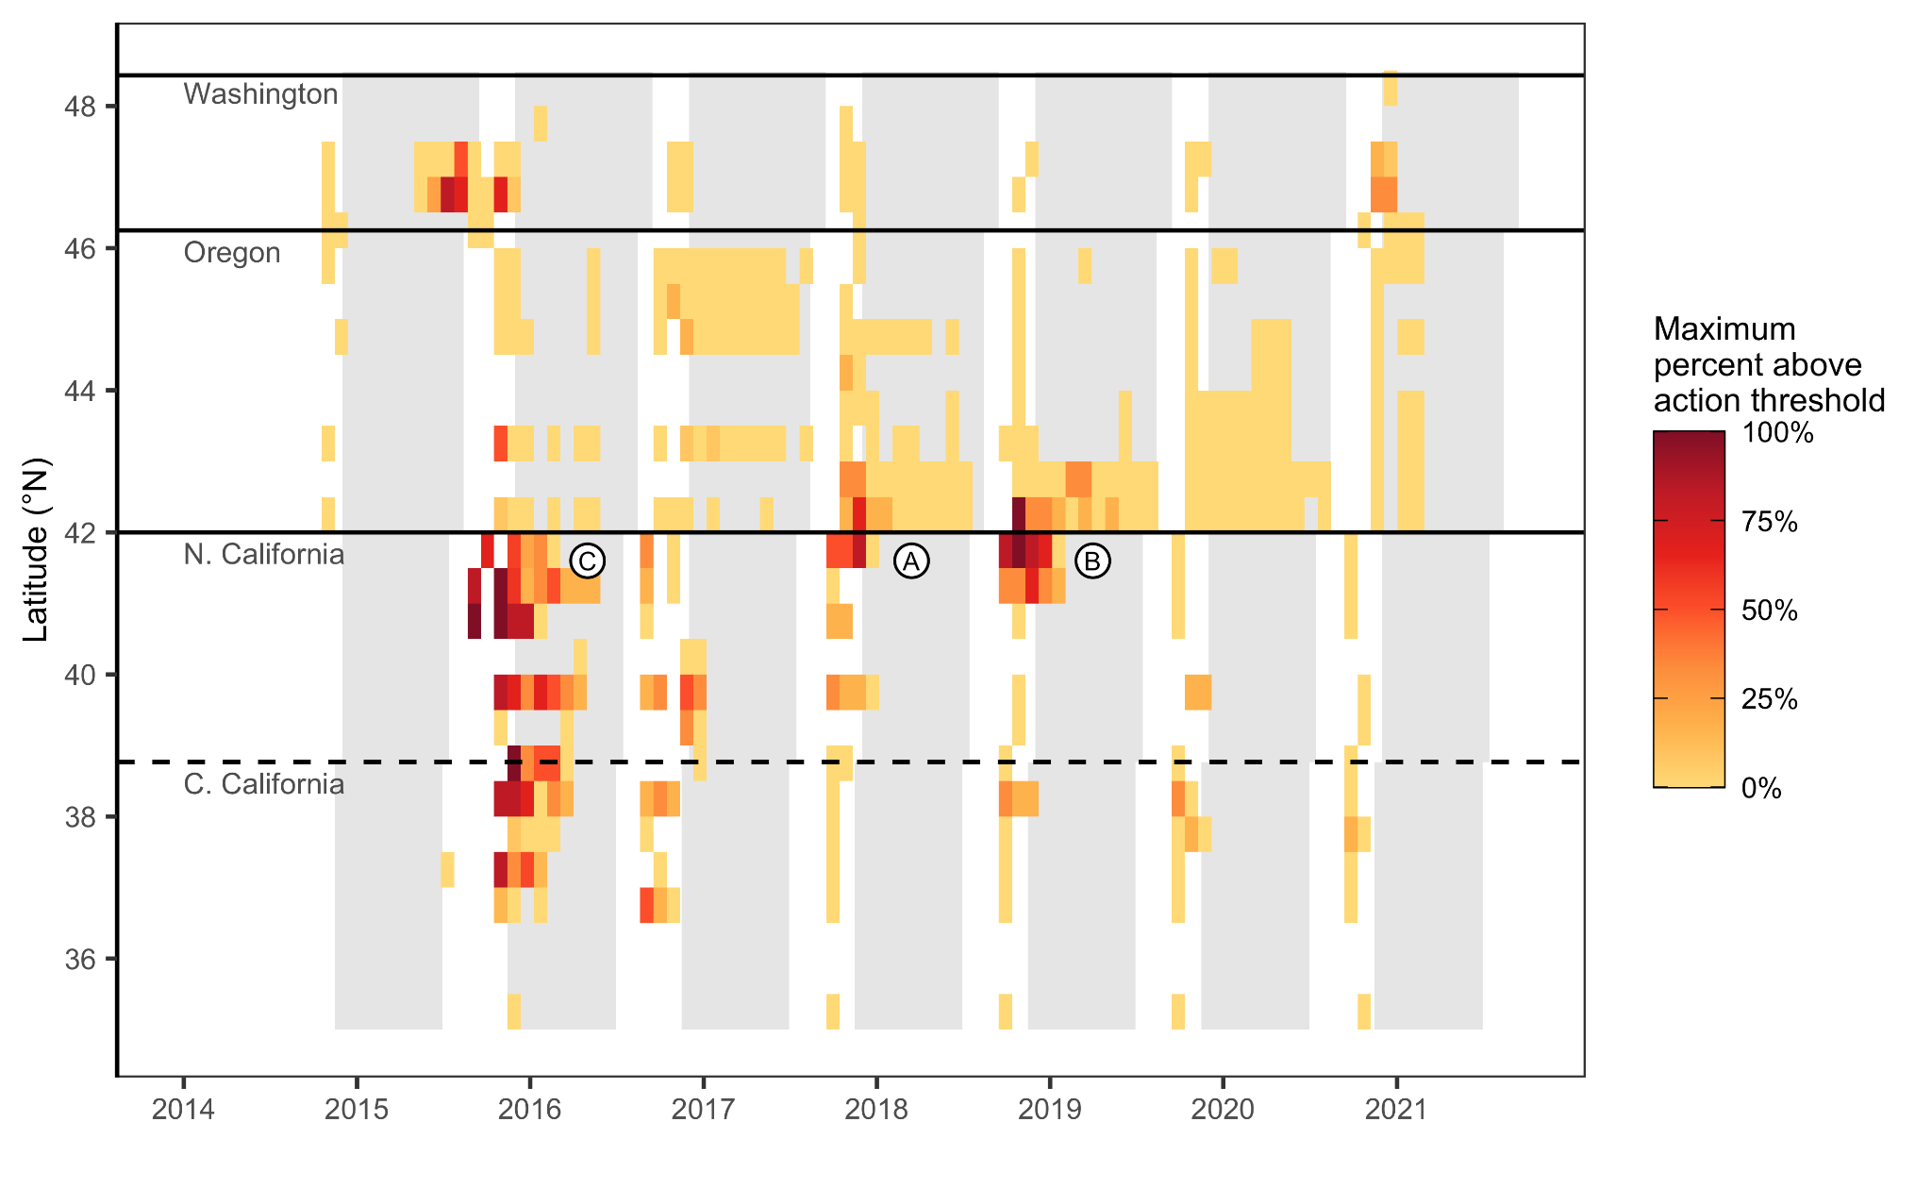Figure S1. The maximum proportion of crabs contaminated above the 30-ppm action level in surveys falling with 0.5° latitude and 4 week intervals along the West Coast from 2014-2021. The (A) small, (B) medium, and (C) large contamination scenarios are modeled after the labeled historical contamination events.

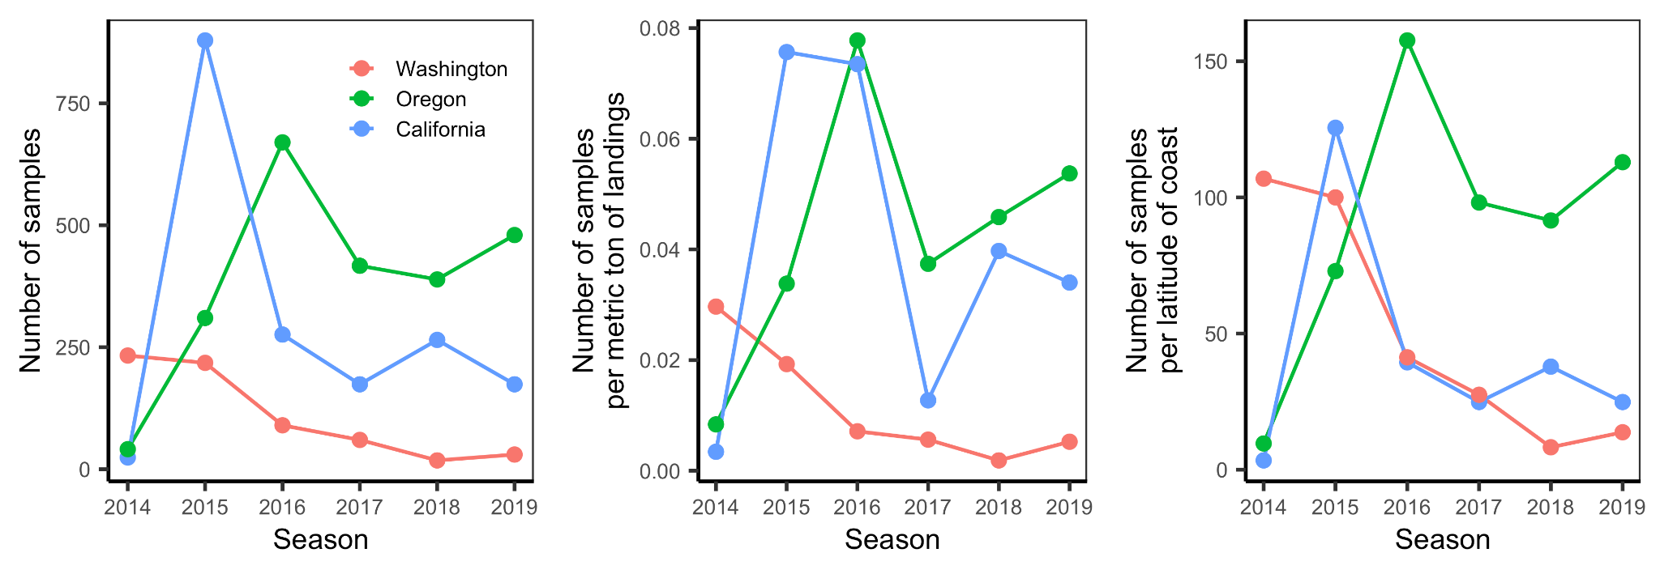Figure S2. Number and density of Dungeness crab domoic acid samples by state and season. The season labels on the x-axis indicate the years during which seasons begin (e.g., 2014 indicates the 2014-15 commercial fishing season).

