Appendix A. Supplemental Materials: Cytochrome c oxidase subunit I gene (COI) DNA Barcoding
The 5’ end of the mitochondrial Cytochrome c oxidase subunit I gene (COI; i.e., the DNA barcode gene, ~650 base pairs (bp)) was sequenced from all individuals included in the final filtered SNP datasets (Diaphus dumerilli, N = 42; Lepidophanes guentheri, N = 44; Ceratoscopelus warmingii, N = 87). Genomic DNA extraction, polymerase chain amplification (PCR), and Sanger Sequencing was performed for most samples (n = 151) by the Canadian Centre for DNA Barcoding (CCDB) (Steinke and Hanner, 2010) and deposited in the Barcode of Life Data System (BOLD, http://www.boldsystems.org). An additional three D. dumerilii (Set 1) and 15 C. warmingii (Set 2) samples were DNA barcoded in-house (see amplification reaction, thermal cycling, and sequencing conditions below, Table S1 and Table S2).
Table S1. PCR conditions for amplification of the mitochondrial Cytochrome c oxidase subunit I gene for three D. dumerilii samples.
Reactant [conc] | Volume (µL)
dH₂0 | 34.3
dNTP [10mM] | 8.0
10X Buffer | 5.0
Forward primer [10µM] | 1.25
Reverse primer [10µM] | 1.25
HotStar Taq Polymerase | 0.2
Template DNA | 1.0

The COI gene of three D. dumerilii individuals (MX0640-5, MX0640-6, DPND 3294) were amplified in a final volume of 50-µL, per the reaction conditions outlined in Table S1 (Forward primer: 5’-TCAACCAACCACAAAGACATTGGCAC-3’; Reverse primer: 5’-TAGACTTCTGGGTGGCCAAAGAATCA-3’; Ward et al., 2005) and with the following thermal profile: 15 minute (min) denaturation at 95°C, followed by 35 cycles of 94°C for 1 min, 50°C for 1 min, and 72°C for 2 min, with a final extension of at 72°C for 5 min. Following amplification, electrophoresis of PCR products was performed using a 1.2% TBE agarose gel to check for successful amplification and proper sizing of resultant amplicons. Following amplification, PCR products were purified in-house using QIAquick PCR purification Kits (Qiagen Inc.) or sent to GENEWIZ, Inc. (South Plainfield, NJ) for enzymatic PCR clean-up. All resultant products were sequenced by GENEWIZ using BigDye Terminator v3.1 cycle sequencing reactions on an ABI 3730xl. Sequences were checked for errors and trimmed using the program CLC Sequence Viewer 8.0 (http://www.qiagenbioinformatics.com/).
Table S2. PCR conditions for amplification of the mitochondrial Cytochrome c oxidase subunit I gene for 15 C. warmingii samples.
Reactant [conc] | Volume (µL)
dH₂0 | 10.2
100X BSA | 0.1
MgCL₂ [25mM] | 2.0
dNTP [10mM] | 1.5
5X GoTaq Green PCR buffer | 4.0
Forward primer [10µM] | 0.5
Reverse primer [10µM] | 0.5
GoTaq Green Polymerase | 0.2
Template DNA | 1.0
The COI gene of 15 C. warmingii individuals (RIE 0129, RIE 0198, RIE 0607, RIE 0616, RIE 0629, RIE 0630, RIE 0631, RIE 0632, RIE 0666, RIE 0667, RIE 0669, RIE 0714, RIE 0759, RIE 0768, RIE 0801) were amplified in a final volume of 20-µL, per the reaction conditions outlined in Table S2 (Forward primer: 5’-TTCTCCACCAACCACAARGAYATYGG-3’; Reverse primer: 5’-CACCTCAGGGTGTCCGAARAATCARAA-3’) and with the following thermal profile: 2 min denaturation at 94°C, followed by 30 cycles of 94°C for 1 min, 50°C for 1 min, and 72°C for 1 min, with a final extension of at 72°C for 5 min. Following amplification, electrophoresis of PCR products was performed using a 1% TBE agarose gel to check for successful amplification and proper sizing of resultant amplicons. PCR clean-up was performed using a standard PEG protocol. Purified PCR products were double-strand sequenced using the BigDye Terminator v3.1 cycle sequencing kit (Applied Biosystems, Inc), followed by sequencing on a ABI 3730 at the Yale Keck School of Medicine. Sequences were checked for errors and trimmed using the program Sequencher 5.1.

Table S3. Diaphus dumerillii specimen identification number (#), NCBI GenBank Accession Number (#), and DNA sequence length in base pairs (bp) of the mitochondrial Cytochrome c oxidase subunit I gene.
Specimen ID # | GenBank Accession # | Length (bp)
MX0609_1 | MN621521 | 652
MX0609_2 | MN621515 | 652
MX0609_3 | MN621531 | 652
MX0611_1 | MN621518 | 652
MX0611_4 | MN621532 | 652
MX0611_5 | MN621517 | 652
MX0613_1 | MN621511 | 652
MX0619_2 | MN621530 | 652
MX0636_2 | MN621525 | 652
MX0640_1 | MN621513 | 652
MX0640_2 | MN621533 | 652
MX0640_3 | MN621527 | 610
MX0640_5 | MN621512 | 626
MX0640_6 | MN621524 | 626
RIE_1027 | MN621516 | 652
RIE_1028 | MN621535 | 652
RIE_1029 | MN621514 | 652
RIE_1030 | MN621528 | 652
RIE_1031 | MN621529 | 652
RIE_109 | MN621509 | 650
RIE_110 | MN621534 | 652
RIE_111 | MN621510 | 652
RIE_112 | MN621522 | 652
RIE_587 | MF041178 | 652
RIE_608 | MF041514 | 652
RIE_711 | MF041495 | 652
RIE_664 | MF041263 | 652
RIE_808 | MN621520 | 652
RIE_995 | MN621519 | 652
DPND_2571 | MG856556 | 652
DPND_2572 | MG856739 | 652
DPND_3294 | MN621526 | 622
DPND_3297 | MG856395 | 640
DPND_3333 | MG856741 | 652
DPND_3334 | MG856780 | 652
DPND_3335 | MG856695 | 652
DPND_3336 | MG856627 | 652
DPND_3337 | MG856769 | 652
DPND_3382 | MG856536 | 652
DPND_3383 | MG856602 | 652
DPND_3464 | MG856534 | 652
DPND_3532 | MG856870 | 652

Table S4. Lepidophanes guentheri specimen identification number (#), NCBI GenBank Accession Number (#), and DNA sequence length in base pairs (bp) of the mitochondrial Cytochrome c oxidase subunit I gene.
Specimen ID # | GenBank Accession # | Length (bp)
MX0614_1 | MN621492 | 652
MX0614_2 | MN621489 | 651
MX0617_4 | MN621503 | 652
MX0631_1 | MN621494 | 652
MX0631_2 | MN621485 | 652
MX0631_3 | MN621505 | 631
MX0631_4 | MN621487 | 652
MX0631_5 | MN621491 | 648
MX0649_1 | MN621501 | 652
MX0654_1 | MN621499 | 652
MX0659_1 | MN621484 | 652
MX0659_2 | MN621508 | 652
MX0664_1 | MN621502 | 652
MX0664_2 | MN621486 | 652
MX0664_3 | MN621490 | 652
MX0696_1 | MN621506 | 652
MX0696_2 | MN621507 | 652
MX0697_1 | MN621496 | 652
RIE_227 | MF041063 | 652
RIE_228 | MF041427 | 652
RIE_250 | MF040975 | 652
RIE_318 | MF041403 | 652
RIE_319 | MF041575 | 652
RIE_320 | MF041473 | 641
RIE_321 | MF041278 | 652
RIE_565 | MF041483 | 652
RIE_600 | MF041508 | 643
RIE_601 | MF041103 | 652
RIE_640 | MN621488 | 652
RIE_641 | MN621495 | 652
RIE_710 | MN621493 | 652
DPND_3414 | MG856460 | 652
DPND_3415 | MG856724 | 652
DPND_3416 | MG856793 | 652
DPND_3417 | MG856902 | 652
DPND_3418 | MG856784 | 652
DPND_3419 | MG856773 | 652
DPND_3420 | MG856591 | 652
DPND_3421 | MG856683 | 652
DPND_3535 | MG856436 | 652
DPND_3561 | MG856443 | 652
DPND_3562 | MG856607 | 652
DPND_3563 | MG856652 | 652
DPND_3726 | MG856524 | 652

Table S5. Ceratoscopelus warmingii specimen identification number (#), NCBI GenBank Accession Number (#), and DNA sequence length in base pairs (bp), and field identification (ID; if different than the specimen ID) of the mitochondrial gene Cytochrome c oxidase subunit I gene.
Specimen ID # | GenBank Accession # | Length (bp) | Additional Field ID
BS_400 | MN621545 | 652 | P14-400
BS_401 | MN621543 | 652 | P14-401
BS_402 | MN621595 | 645 | P14-402
BS_403 | MN621589 | 652 | P14-403
BS_404 | MN621602 | 652 | P14-404
BS_405 | MN621597 | 652 | P14-405
BS_406 | MN621569 | 652 | P14-406
BS_411 | MN621605 | 652 | P14-411
BS_414 | MN621577 | 652 | P14-414
BS_415 | MN621549 | 652 | P14-415
BS_416 | MN621572 | 652 | P14-416
BS_417 | MN621598 | 652 | P14-417
BS_418 | MN621586 | 652 | P14-418
BS_420 | MN621564 | 652 | P14-420
BS_423 | MN621587 | 652 | P14-423
BS_424 | MN621551 | 652 | P14-424
BS_426 | MN621580 | 621 | P14-426
BS_429 | MN621568 | 652 | P14-429
BS_430 | MN621596 | 652 | P14-430
BS_431 | MN621600 | 652 | P14-431
BS_434 | MN621556 | 652 | P14-434
BS_435 | MN621609 | 652 | P14-435
DPND_3863 | MG856440 | 652 | N/A
DPND_3879 | MG856757 | 652 | N/A
DPND_3881 | MG856691 | 652 | N/A
DPND_3918 | MG856728 | 652 | N/A
DPND_4027 | MG856654 | 652 | N/A
DPND_4028 | MG856862 | 652 | N/A
DPND_4070 | MG856847 | 652 | N/A
DPND_4071 | MG856637 | 652 | N/A
DPND_4072 | MG856830 | 652 | N/A
DPND_4073 | MG856822 | 652 | N/A
DPND_4074 | MG856473 | 652 | N/A
DPND_4089 | MG856467 | 652 | N/A
DPND_4090 | MG856850 | 652 | N/A
DPND_4095 | MG856833 | 652 | N/A
DPND_4164 | MG856576 | 652 | N/A
DPND_4165 | MG856493 | 652 | N/A
DPND_4171 | MG856538 | 652 | N/A
DPND_4217 | MG856422 | 652 | N/A
DPND_4260 | MG856873 | 652 | N/A
DPND_4261 | MG856854 | 652 | N/A
DPND_4262 | MG856686 | 652 | N/A
DPND_4288 | MG856514 | 652 | N/A
DPND_4289 | MG856441 | 652 | N/A
DPND_4290 | MG856727 | 652 | N/A
PS_036 | MN621604 | 652 | PS0036
PS_041 | MN621608 | 652 | MX0579-01
PS_042 | MN621607 | 652 | MX0579-02
PS_043 | MN621566 | 652 | MX0581-01
PS_045 | MN621555 | 652 | MX0581-03
PS_049 | MN621599 | 652 | MX0583-01
PS_050 | MN621573 | 652 | MX0583-02
PS_051 | MN621576 | 652 | MX0583-03
PS_052 | MN621588 | 652 | MX0583-04
PS_053 | MN621550 | 652 | MX0583-05
PS_055 | MN621557 | 652 | MX0580-01
PS_056 | MN621552 | 652 | MX0580-02
PS_057 | MN621547 | 652 | MX0580-03
PS_058 | MN621546 | 652 | MX0580-04
PS_059 | MN621553 | 652 | MX0580-05
PS_060 | MN621565 | 652 | MX0580-06
PS_061 | MN621562 | 652 | MX0580-07
PS_062 | MN621592 | 652 | MX0580-08
PS_063 | MN621571 | 652 | MX0580-09
PS_064 | MN621584 | 652 | MX0580-10
PS_065 | MN621575 | 652 | MX0580-11
PS_066 | MN621601 | 652 | MX0580-12
RIE_1020 | MN621603 | 652 | N/A
RIE_1021 | MN621559 | 652 | N/A
RIE_1022 | MN621544 | 652 | N/A
RIE_129 | MN621561 | 663 | N/A
RIE_198 | MN621583 | 597 | N/A
RIE_496 | MN621606 | 652 | N/A
RIE_607 | MN621563 | 597 | N/A
RIE_616 | MN621574 | 597 | N/A
RIE_629 | MN621539 | 597 | N/A
RIE_630 | MN621567 | 597 | N/A
RIE_631 | MN621591 | 663 | N/A
RIE_632 | MN621582 | 597 | N/A
RIE_666 | MN621593 | 597 | N/A
RIE_667 | MN621540 | 597 | N/A
RIE_669 | MN621585 | 597 | N/A
RIE_759 | MN621558 | 663 | N/A
RIE_768 | MN621579 | 663 | N/A
RIE_801 | MN621554 | 663 | N/A
RIE_933 | MN621581 | 652 | N/A

Appendix B. Supplemental Materials: Single Nucleotide Polymorphism Results

Fig. S1. Plot of Admixture’s cross-validation error values for K = 1-5 for: (A) 42 samples of Diaphus dumerilii collected from the Gulf of Mexico during three temporal periods (2011, 2015, and 2016) and genotyped at 2577 SNPs; (B) 44 samples of Lepidophanes guentheri collected from the Gulf of Mexico during three temporal periods (2011, 2015, and 2016) and genotyped at 3462 SNPs; (C) 65 samples of Ceratoscopelus warmingii collected from the Gulf of Mexico during three temporal periods (2011, 2015, and 2016) and genotyped at 1804 SNPs; (D) 87 total samples of C. warmingii collected from the Gulf of Mexico (N = 65) and from Bear Seamount, western North Atlantic (2014; N = 22) genotyped at 1804 SNPs (Cwar-SNP-all).

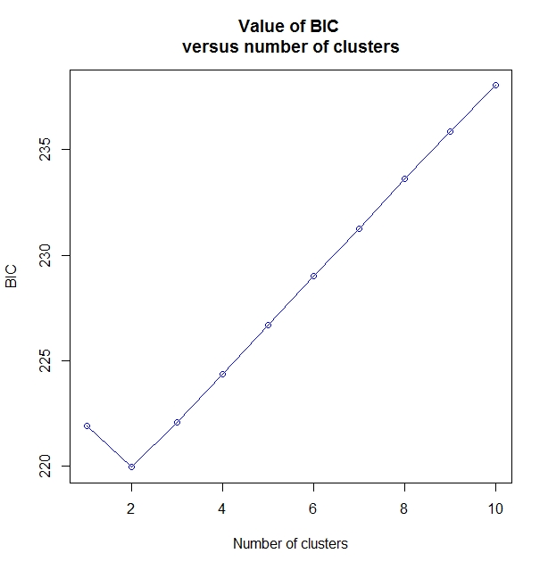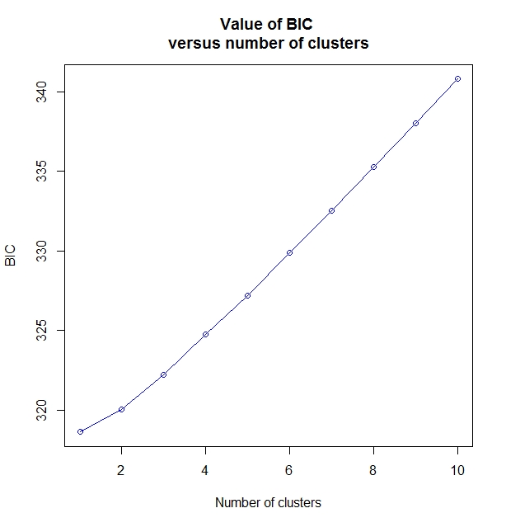
(B) L. guentheri
(A) D. dumerilii

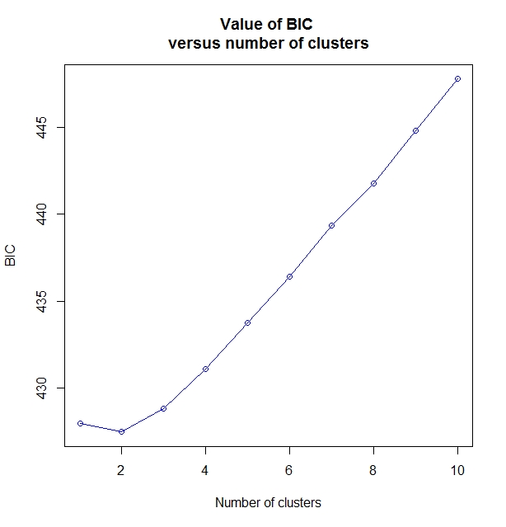
(C) C. warmingii (GOM & Bear)
(C) C. warmingii (GOM-only)

Fig. S2. Plot of the Bayesian Information Criterion (BIC) vs. number of clusters (K) of: (A) 42 samples of Diaphus dumerilii collected from the Gulf of Mexico (GOM) during three temporal periods (2011, 2015, and 2016) and genotyped at 2577 SNPs; (B) 44 samples of Lepidophanes guentheri collected from the GOM during 2011, 2015, and 2016 and genotyped at 3462 SNPs; (C) 65 samples of Ceratoscopelus warmingii collected from the GOM during 2011, 2015, and 2016 and genotyped at 1804 SNPs; and (D) 87 total samples of C. warmingii collected from the GOM (N = 65) and Bear Seamount, western North Atlantic (N = 22) and genotyped at 1804 SNPs (Cwar-SNP-all).

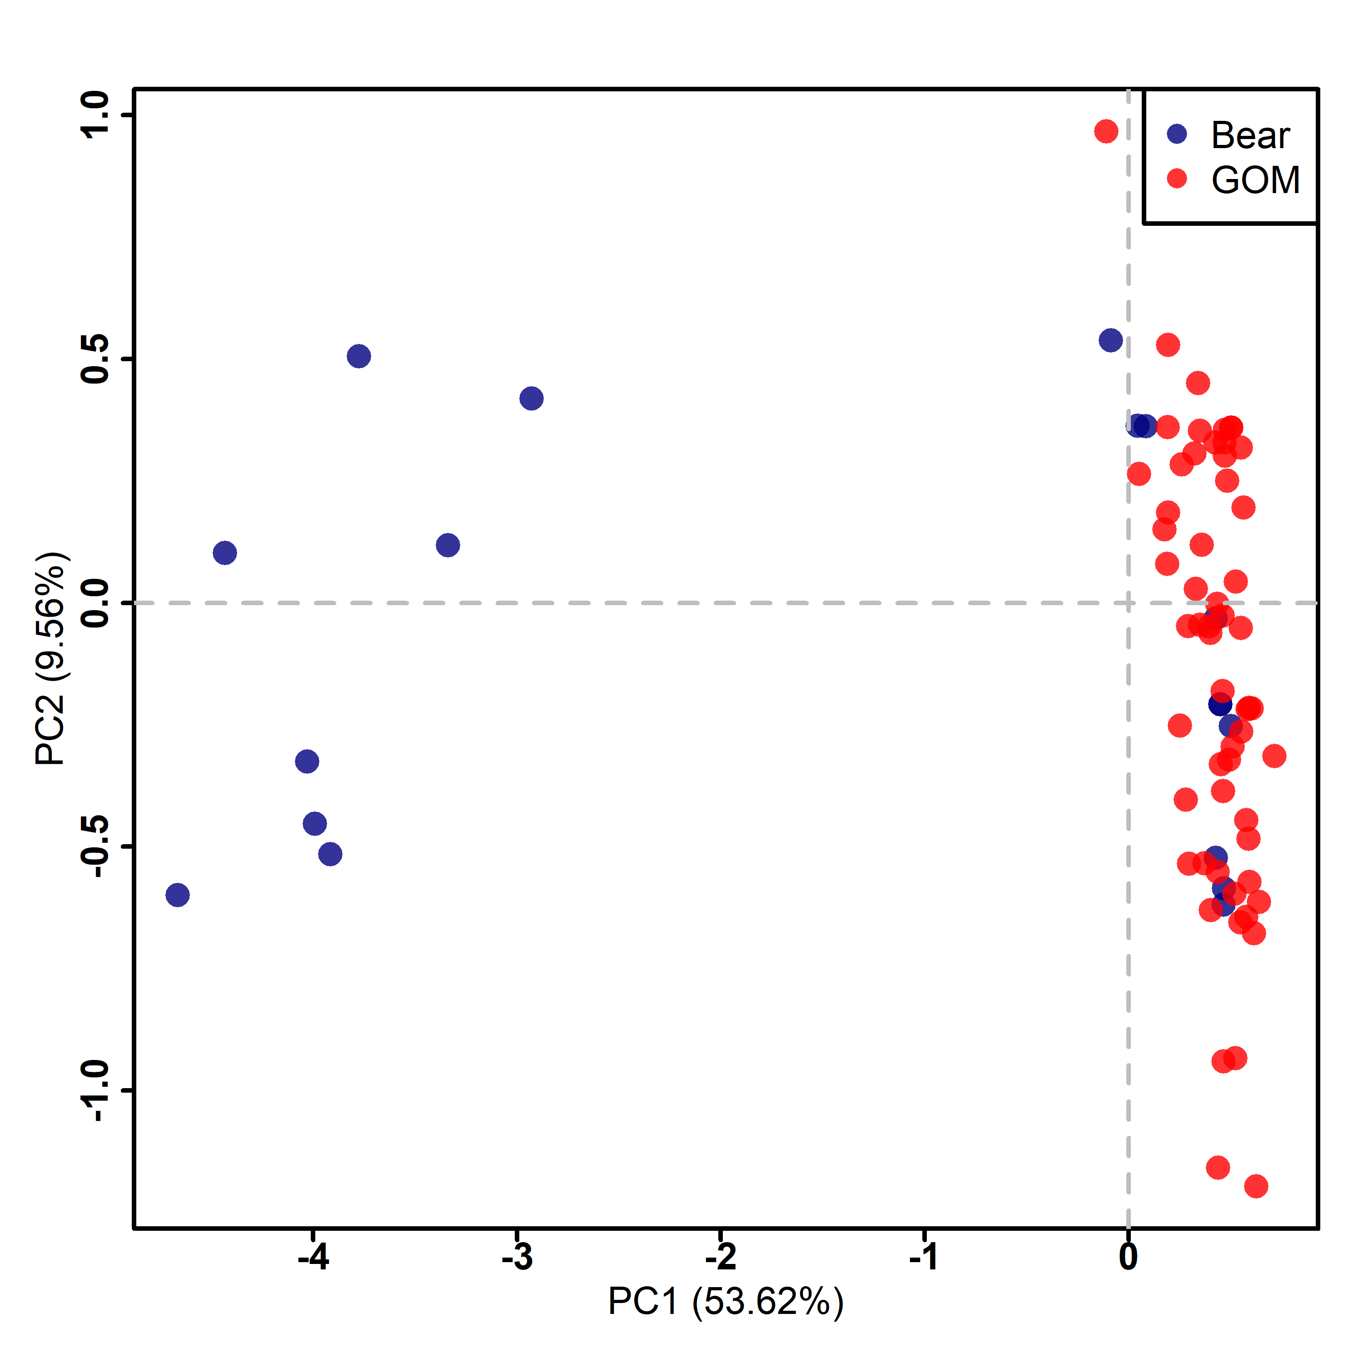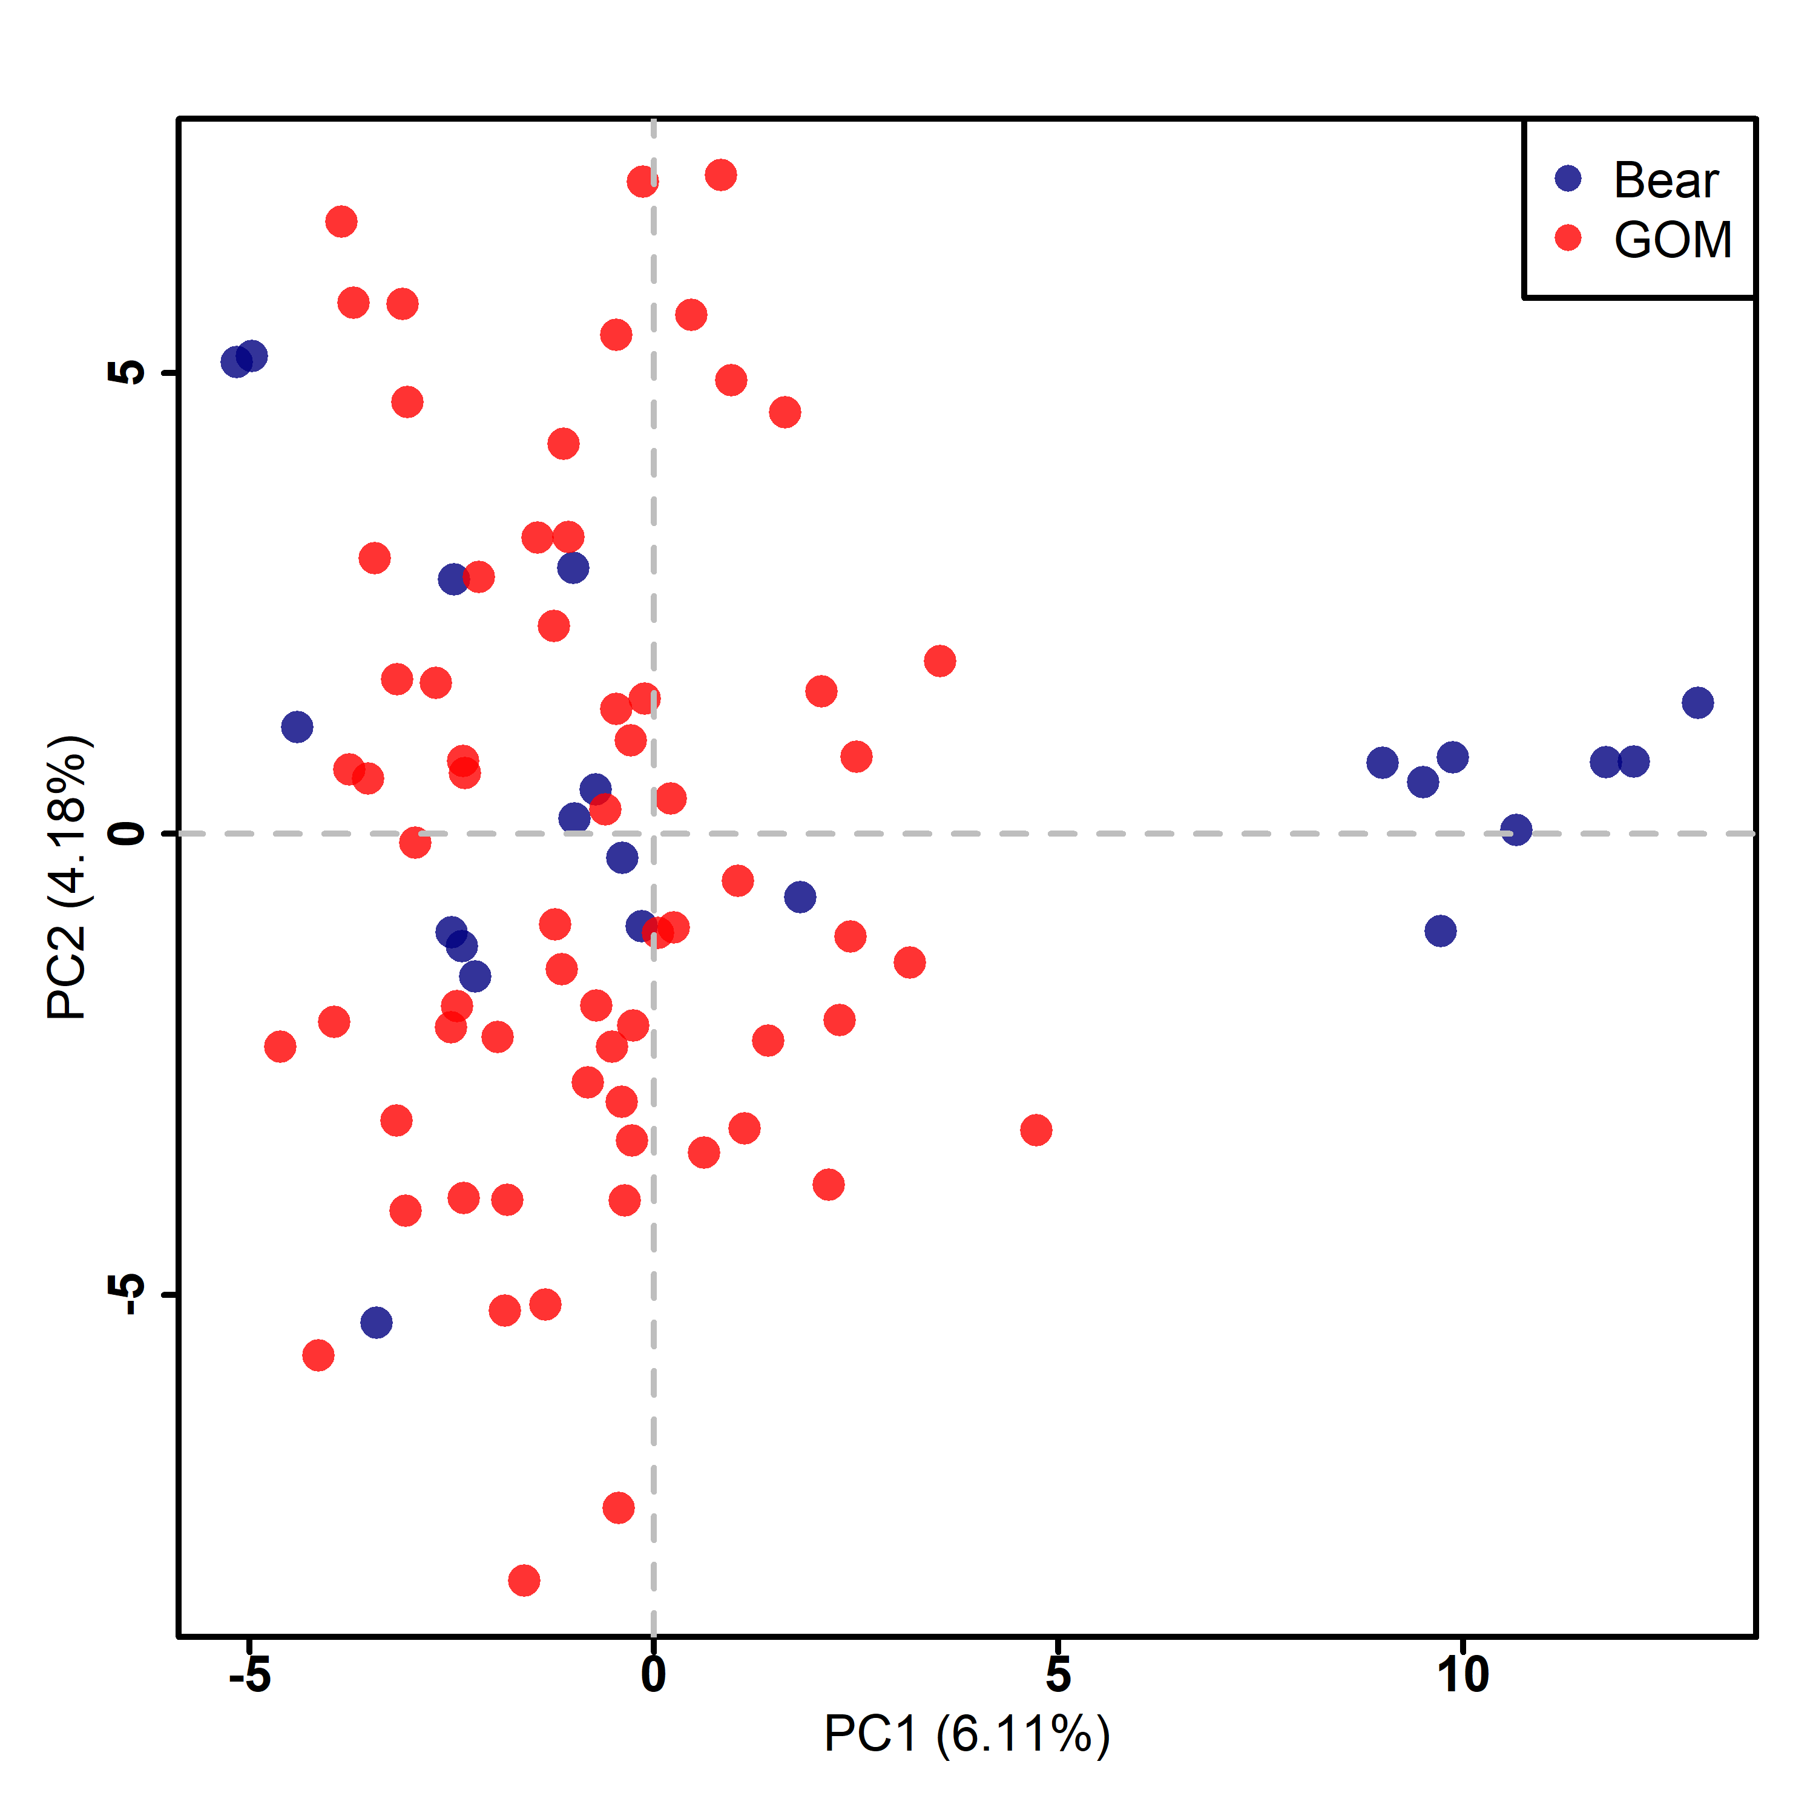
(B) C. warmingii (1784 SNPs)
(A) C. warmingii (20 SNPs)

Fig. S3. Biplot displaying the first two principal components (x-axis = component 1, y-axis = component 2) of a Principal Component Analysis of Ceratoscopelus warmingii samples collected from the GOM (N = 65; red circles) and Bear Seamount, Western North Atlantic (N = 22; blue circles) at (A) 20 candidate outlier SNPs (Cwar-SNP-outlier), and (B)1784 putatively neutral SNPs (Cwar-SNP-neutral).
Abbreviations: GOM: Gulf of Mexico; Bear: Bear Seamount, western North Atlantic.

References
Steinke, D., and Hanner, R. (2010) The FISH-BOL collaborators’ protocol. Mitochondrial DNA, 21(S2):1-5.
Ward, R.D., Zemlak, T.S., Innes, B.H., Last, P.R., Hebert, P.D. (2005) DNA barcoding Australia’s fish species. Philosophical Transactions of The Royal Society B Biological Sciences, 360(1462): 1847-1857.

