SUPPLEMENTARY MATERIALS

APPENDIX A: Figures

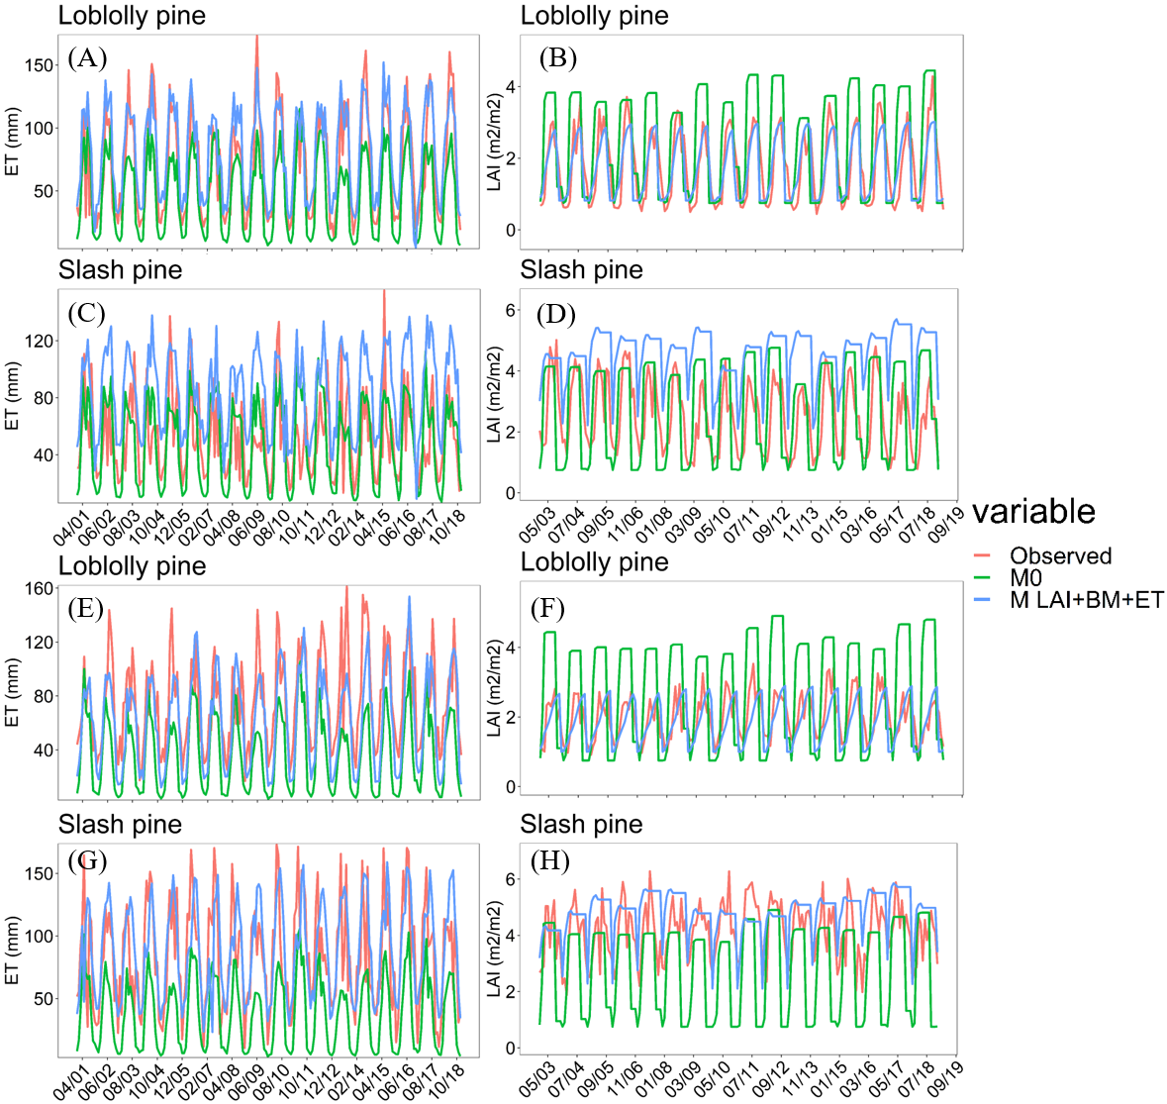
Figure S1. Simulated ET and LAI for loblolly and slash pine versus MODIS estimates at Upatoi Creek watershed (Figures A to D) and Upper Santa Fe River watershed (Figures E to H) under M_{0 and} M_{LAI+BM+ET model} configurations.

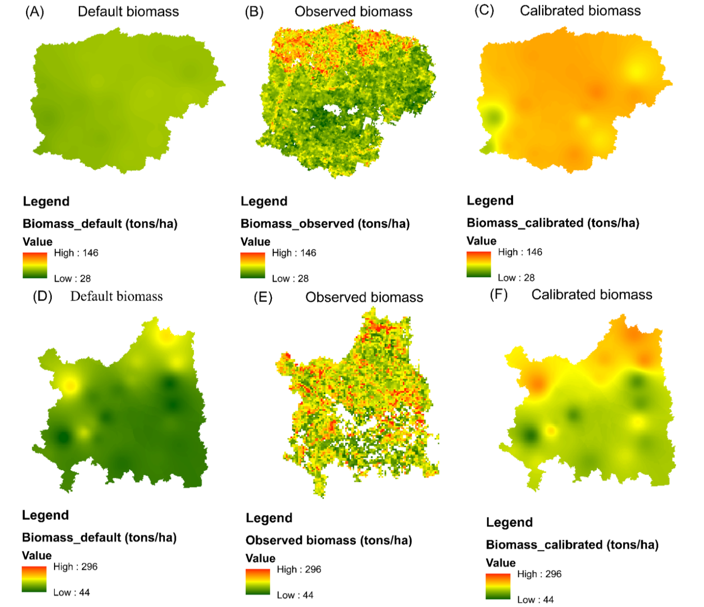
Figure S2. Simulated total forest biomass versus USDA Forest Service forest biomass product estimates at Upatoi Creek (Figures A to C) and Upper Santa Fe River watershed (Figures D to F) under M_{0 and} M_{LAI+BM+ET model} configurations. (A-D) Biomass simulated by SWAT using default parameters in the plant database, (B-E) Observed biomass for the Upatoi Creek watershed derived from USDA Forest Service forest biomass, (C-F) Biomass simulated by SWAT using calibrated plant-related parameters.

Figure S3. Comparison of simulated mean annual baseflow and ET under different model setup configurations against estimated baseflow and ET at Upatoi Creek and Upper Santa Fe River watersheds. Observed baseflow and watershed-wide ET are estimated via baseflow separation tool and MODIS ET data, respectively

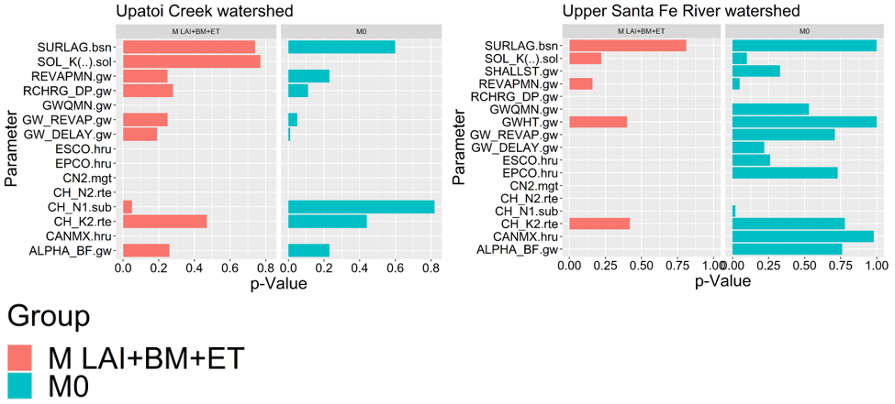
Figure S4. Sensitivity of streamflow parameters under traditional and multi-facet calibration schemes at Upatoi Creek and Upper Santa Fe River watersheds. P-values < 0.05 denote parameters with high sensitivity.

APPENDIX B: Tables

Table S1. Summary of the selected IHA and EFC parameters and their respective ecosystem influences.
IHA Parameter Group | Hydrologic Parameters | Ecosystem Influences
1. Magnitude and duration of annual extreme water conditions  (10 parameters) | Annual minima, 1-day mean; Annual minima, 3-day means; Annual minima, 7-day means; Annual minima, 30-day means; Annual minima, 90-day means; Annual maxima, 1-day mean; Annual maxima, 3-day means; Annual maxima, 7-day means; Annual maxima, 30-day means; Annual maxima, 90-day means | - Balance of competitive, ruderal, and stress- tolerant organisms  - Creation of sites for plant colonization  - Structuring of aquatic ecosystems by abiotic vs. biotic factors  - Structuring of river channel morphology and physical habitat conditions  - Soil moisture stress in plants Dehydration in animals  - Anaerobic stress in plants  - Volume of nutrient exchanges between rivers and floodplains  - Duration of stressful conditions such as low oxygen and concentrated chemicals in aquatic environments  - Distribution of plant communities in lakes, ponds, floodplains  - Duration of high flows for waste disposal, aeration of spawning beds in channel sediments
2. Environmental Flow Components (EFCs) Parameters – Monthly low flows  (12 parameters) | Mean values of low flows during each calendar month | - Provide adequate habitat for aquatic organisms  - Maintain suitable water temperatures, dissolved oxygen, and water chemistry  - Maintain water table levels in floodplain, soil moisture for plants  - Provide drinking water for terrestrial animals  - Keep fish and amphibian eggs suspended  - Enable fish to move to feeding and spawning areas  - Support hyporheic organisms (living in saturated sediments)

Table S2. Model performance before and after calibration of monthly LAI and ET in SWAT. Values between parenthesis () represent model’s performance under its default settings
 | Upper Santa Fe |  | Upatoi Creek
 | Loblolly pine | Slash pine | Loblolly pine | Slash pine
Monthly LAI
R2 | 0.48 (0.29) | 0.21 (0.25) | 0.66 (0.42) | 0.2 (0.27)
NSE | 0.32 (-5) | -0.37 (-3) | 0.65 (-0.74) | -3.1 (-0.56)
PBIAS % | 7 (-38) | -16 (33) | 3.9 (-38) | -82.4 (-8.2)
RMSE | 0.52 (1.55) | 1.15 (2) | 0.58 (1.3) | 2.3 (1.4)
Monthly ET
R2 | 0.65 (0.57) | 0.45 (0.6) | 0.75 (0.68) | 0.34 (0.33)
NSE | 0.46 (-0.66) | 0.38 (-0.60) | 0.65 (0.43) | -1.5 (0)
PBIAS | 17.5 (50) | -6.5 (55) | -17.8 (29.3) | -66 (3.9)
RMSE | 24.9 (43.55) | 31.90 (52.2) | 23.36 (29.9) | 42 (26.4)

Table S3. Calibrated model parameters, their respective initial range and best fitted values under traditional and multivariable calibration approaches at Upatoi Creek and Upper Santa Fe River watersheds.
Parameter | Initial range | Best parameter value
 |  | Upatoi Creek |  | Upper Santa Fe
 |  | M₀ | M_{LAI+BM+ET} | M₀ | M_{LAI+BM+ET}
r__CN2.mgt | -0.3-0.1 | -0.166963 | -0.028276 | -0.087033 | 0.001072
V__ALPHA_BF.gw | 0.01-0.2 | 0.141159 | 0.176099 | 0.105335 | 0.112806
r__GW_DELAY.gw | -0.3-0.3 | 0.000271 | -0.306779 | 0.039278 | -0.119104
r__GW_REVAP.gw | -0.3-0.3 | 0.336196 | 0.400228 | 1.329347 | 6.278326
r__SOL_K().sol | -0.3-0.3 | 0.545236 | 0.446698 | -0.094449 | 0.124502
v__RCHRG_DP.gw | 0-1 | 0.462241 | 0.373301 | 0.403537 | 0.145733
V__SURLAG.bsn | 1-24 | 3.822869 | 15.131299 | 18.912979 | 12.507653
R__CH_N1.sub | 0.1-1 | 0.58338 | 0.539291 | 1.017428 | 1.216417
v__CH_N2.rte | -0.01-0.3 | 0.293692 | 0.403082 | 0.171482 | 0.365554
r__CH_K2.rte | 0.1-0.5 | 0.356586 | 0.076447 | 0.392475 | 0.246932
r__GWQMN.gw | -0.5-4 | 0.819083 | 0.475702 | 5.067966 | 0.549191
r__REVAPMN.gw | -0.5-0.5 | -0.290221 | 0.012907 | -0.823312 | -0.676632
v__ESCO.hru | 0-1 | 0.18564 | 0.815-0.82* | 0.070324 | 0.82-0.86*
v__EPCO.hru | 0-1 | 0.475542 | 0.38-0.48* | 0.972392 | 0.38-0.48*
v__CANMX.hru | 0-5 | 3.768076 | 0.596-0.94* | 4.944259 | 0.52-0.94*

Appendix C: Supporting materials
  - Improvements in forest dynamics

  - Upatoi Creek watershed (UCW)
Although SWAT was run for the 1998-2018 period, the analysis of simulated forest processes discussed here is limited to the period 2001-2018 for ET and 2003-2018 for LAI, because of MODIS data availability.
As shown in Fig. 3, both LAI and ET predictions for loblolly pine improved significantly under M_{LAI+BM+ET}. The default SWAT parameterization largely overestimated the annual maximum LAI in comparison to MODIS. According to MODIS estimates, the average monthly LAI from 2003 to 2018 at UCW was 1.78 m²/m². In the simulation with M₀, the predicted average monthly LAI was 2.45 m²/m², while M_{LAI+BM+ET} simulated an average monthly LAI of 1.71 m²/m². The superior model performance under M_{LAI+BM+ET} is supported by the statistical measures shown in Table 4. As can be seen in Fig. 3, M₀ missed most of MODIS ET peaks, which were captured in the M_{LAI+BM+ET} model configuration. The better goodness of fit between M_{LAI+BM+ET} and MODIS ET is demonstrated in Table 4 by higher NSE and R² values. The model’s inability to capture ET peaks with the M₀ model configuration translated into 30% underestimation of ET. On the other hand, M_{LAI+BM+ET} overestimated ET by 18% during 2001-2018. Although significant, this overestimation is within the uncertainty margin of 20% associated with the MODIS ET product, as reported by Mu et al. (2013).
Simulated LAI and ET for slash pine failed to accurately match MODIS estimates (Fig. 3 and Table 4). These results are not alarming since slash pine cover less than 0.1% of the UCW, representing an area of only 70 hectares. Furthermore, this may indicate that the slash pine parameterization developed in FL is not suited for slash pine trees growing in GA. This finding should not come as a surprise given the substantial geographic distance between the plantation field where slash pine was calibrated and the UCW. The significant model overestimation of ET with the M_{LAI+BM+ET} model configuration is most probably a consequence of the LAI overestimation, given the role played by LAI in ET estimation. Another likely cause of the poor model performance of ET in M_{LAI+BM+ET} is the value of maximum stomatal conductance (GSI) calibrated at the field-scale site in FL, which may be too high for slash pine trees occurring in GA.
We compared simulated forest biomass with USDA’s Forest Service forest biomass product. To that end, we averaged simulated forest biomass in M₀ and M_{LAI+BM+ET} for each subbasin. The subbasin level averaged biomass values were interpolated to the watershed area using Inverse Distance Weighting (IDW) interpolation method in ArcMap to allow for a more spatially discretized comparison against the gridded 250 meters resolution biomass product. The results are shown in Fig. 4. Under M₀, the average annual simulated biomass during 1998-2018 was 64 ± 4 (average ± one standard deviation) tons/ha, while M_{LAI+BM+ET} predicted an average of 104 ± 13 tons/ha during the same period. USDA reported average biomass of 64 ± 15 tons/ha. Although the average biomass predicted by M₀ matched USDA’s values, M₀ failed to reach biomass values larger than 70 tons/ha. In contrast, the maximum biomass predicted by M_{LAI+BM+ET} reached values up to 121 tons/ha, closer to 146 tons/ha of maximum biomass from USDA forest biomass data. The spatial distribution pattern of simulated biomass is similar in M₀ and M_{LAI+BM+ET}, although M_{LAI+BM+ET} showed better agreement with USDA biomass data in the northwestern portion of the watershed. In this area, which is heavily covered by loblolly pine (Fig. 2A), M₀ tended to underestimate biomass.
  - Upper Santa Fe River watershed
It is visually clear that M_{LAI+BM+ET} outperformed M₀ in capturing LAI seasonality for loblolly pine (Fig. 3). The goodness of fit measured by R² and NSE and shown in Table 4 demonstrates the benefits of M_{LAI+BM+ET} in comparison to M₀. The evident model overestimation in M₀ is evidenced by PBIAS values of 38%, which has improved to 7% in M_{LAI+BM+ET}. Monthly ET for loblolly pine was significantly underestimated in M₀ compared with MODIS reference time-series (Fig. 3). With the default parameterization, the average annual ET was 448 ± 58 mm during 2001-2018, which was significantly lower than MODIS estimates of 897 ± 88 mm. In the simulation with the improved model parameterization, the average annual ET increased to 740 ± mm, representing a 40% increase compared with the default model. Monthly ET simulated by M_{LAI+BM+ET} was underestimated by 17.5%, which is lower than the 50% of underestimation with M₀. The good agreement between simulated monthly ET in M_{LAI+BM+ET} and MODIS ET is statistically supported by the higher NSE and R² and lower RMSE values, as shown in Table 4.
Slash pine also had the LAI dynamics largely improved in M_{LAI+BM+ET}. This can be visually seen in Fig. 3, where M_{LAI+BM+ET} reproduces the annual growth cycle captured by MODIS reasonably well. Moreover, the annual LAI peaks estimated by MODIS are better represented in M_{LAI+BM+ET} than in M₀, although even with the M_{LAI+BM+ET} model configuration SWAT could not accurately capture the bimodal LAI seasonality shown in MODIS data. This issue was also reported by Zhang et al. (2020) and is most probably attributable to SWAT’s impossibility of simulating more than one growth cycle per year under the Heat Unit theory. The average annual ET estimated by M₀ in the period 2001-2018 was 453 ± 57 mm, much lower than the average MODIS ET for the same period (999 ± 86 mm). The improved parameterization increased ET estimates by 58% compared with M₀, resulting in an annual average ET of 1,060 ± 65 mm (7% higher than MODIS). The average annual ET simulated by the improved model was in good accordance with the ET range of 754-1168 mm/year at slash pine plantations in Florida reported by McLaughlin et al. (2013). Although the R² value deteriorated in M_{LAI+BM+ET} compared to M₀ for slash pine, other statistical measures improved for M_{LAI+BM+ET} in comparison to M₀ (Table 4).
Finally, the simulated biomass also improved in M_{LAI+BM+ET} compared to M₀, based on USDA reported biomass reference data (Fig. 4). The average annual forest biomass simulated in M₀ was 92 ± 45 tons/ha, which is significantly lower than the USDA reported average of 120 ± 37 tons/ha. The M_{LAI+BM+ET} model configuration increased annual average biomass estimates by 40% compared with M₀, resulting in 153 ± 50 tons/ha of biomass during 1998-2018. The improved model parameterization also ameliorated the spatial pattern of forest biomass, especially in the central portion of the watershed, where M₀ substantially underestimated biomass accumulation. Previous studies reported similar findings (Yang et al., 2018; Yang and Zhang, 2016), revealing that the default SWAT model presents some shortcomings in simulating tree biomass.

