Geophysical Research Letters
Supporting Information for

Trends in Global Tropical Cyclone Activity: 1990–2021

Philip J. Klotzbach¹, Kimberly M. Wood^{2*}, Carl J. Schreck III³, Steven G. Bowen⁴, Christina M. Patricola⁵, and Michael M. Bell¹
¹Department of Atmospheric Science, Colorado State University, Fort Collins, CO, USA.
²Department of Geosciences, Mississippi State University, Mississippi State, MS, USA.
³Cooperative Institute for Satellite Earth System Studies (CISESS), North Carolina State University, Asheville, NC, USA.
⁴Aon, Chicago, IL, USA.
⁵Department of Geological and Atmospheric Sciences, Iowa State University, Ames, IA, USA.

*Klotzbach and Wood contributed equally to this work

Contents of this file

Figures S1–S3
Tables S1–S4
Introduction
This supporting information includes three additional figures and four additional tables. Figure S1 displays global rapid intensity change events at a 30-kt threshold from 1990–2021. Figure S2 displays per-decade linear trends for various large-scale atmospheric and oceanic fields during January–March. Figure S3 displays per-decade linear trends for various large-scale atmospheric and oceanic fields during August–October. Table S1 displays average values of various TC indices from 1990–2021. Table S2 displays linear per-decade trends for these TC indices from 1990–2021. Table S3 displays correlations between Accumulated Cyclone Energy and the ENSO Longitude Index. Table S4 displays correlations between 50-kt RI events and the ENSO Longitude Index.

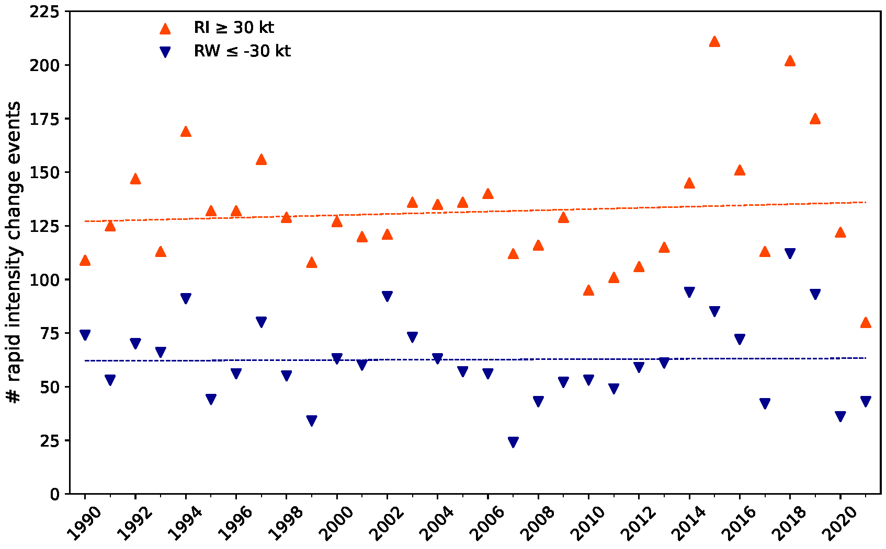
Figure S1. Global rapid intensity change events for the 30-kt RI and -30-kt RW thresholds.
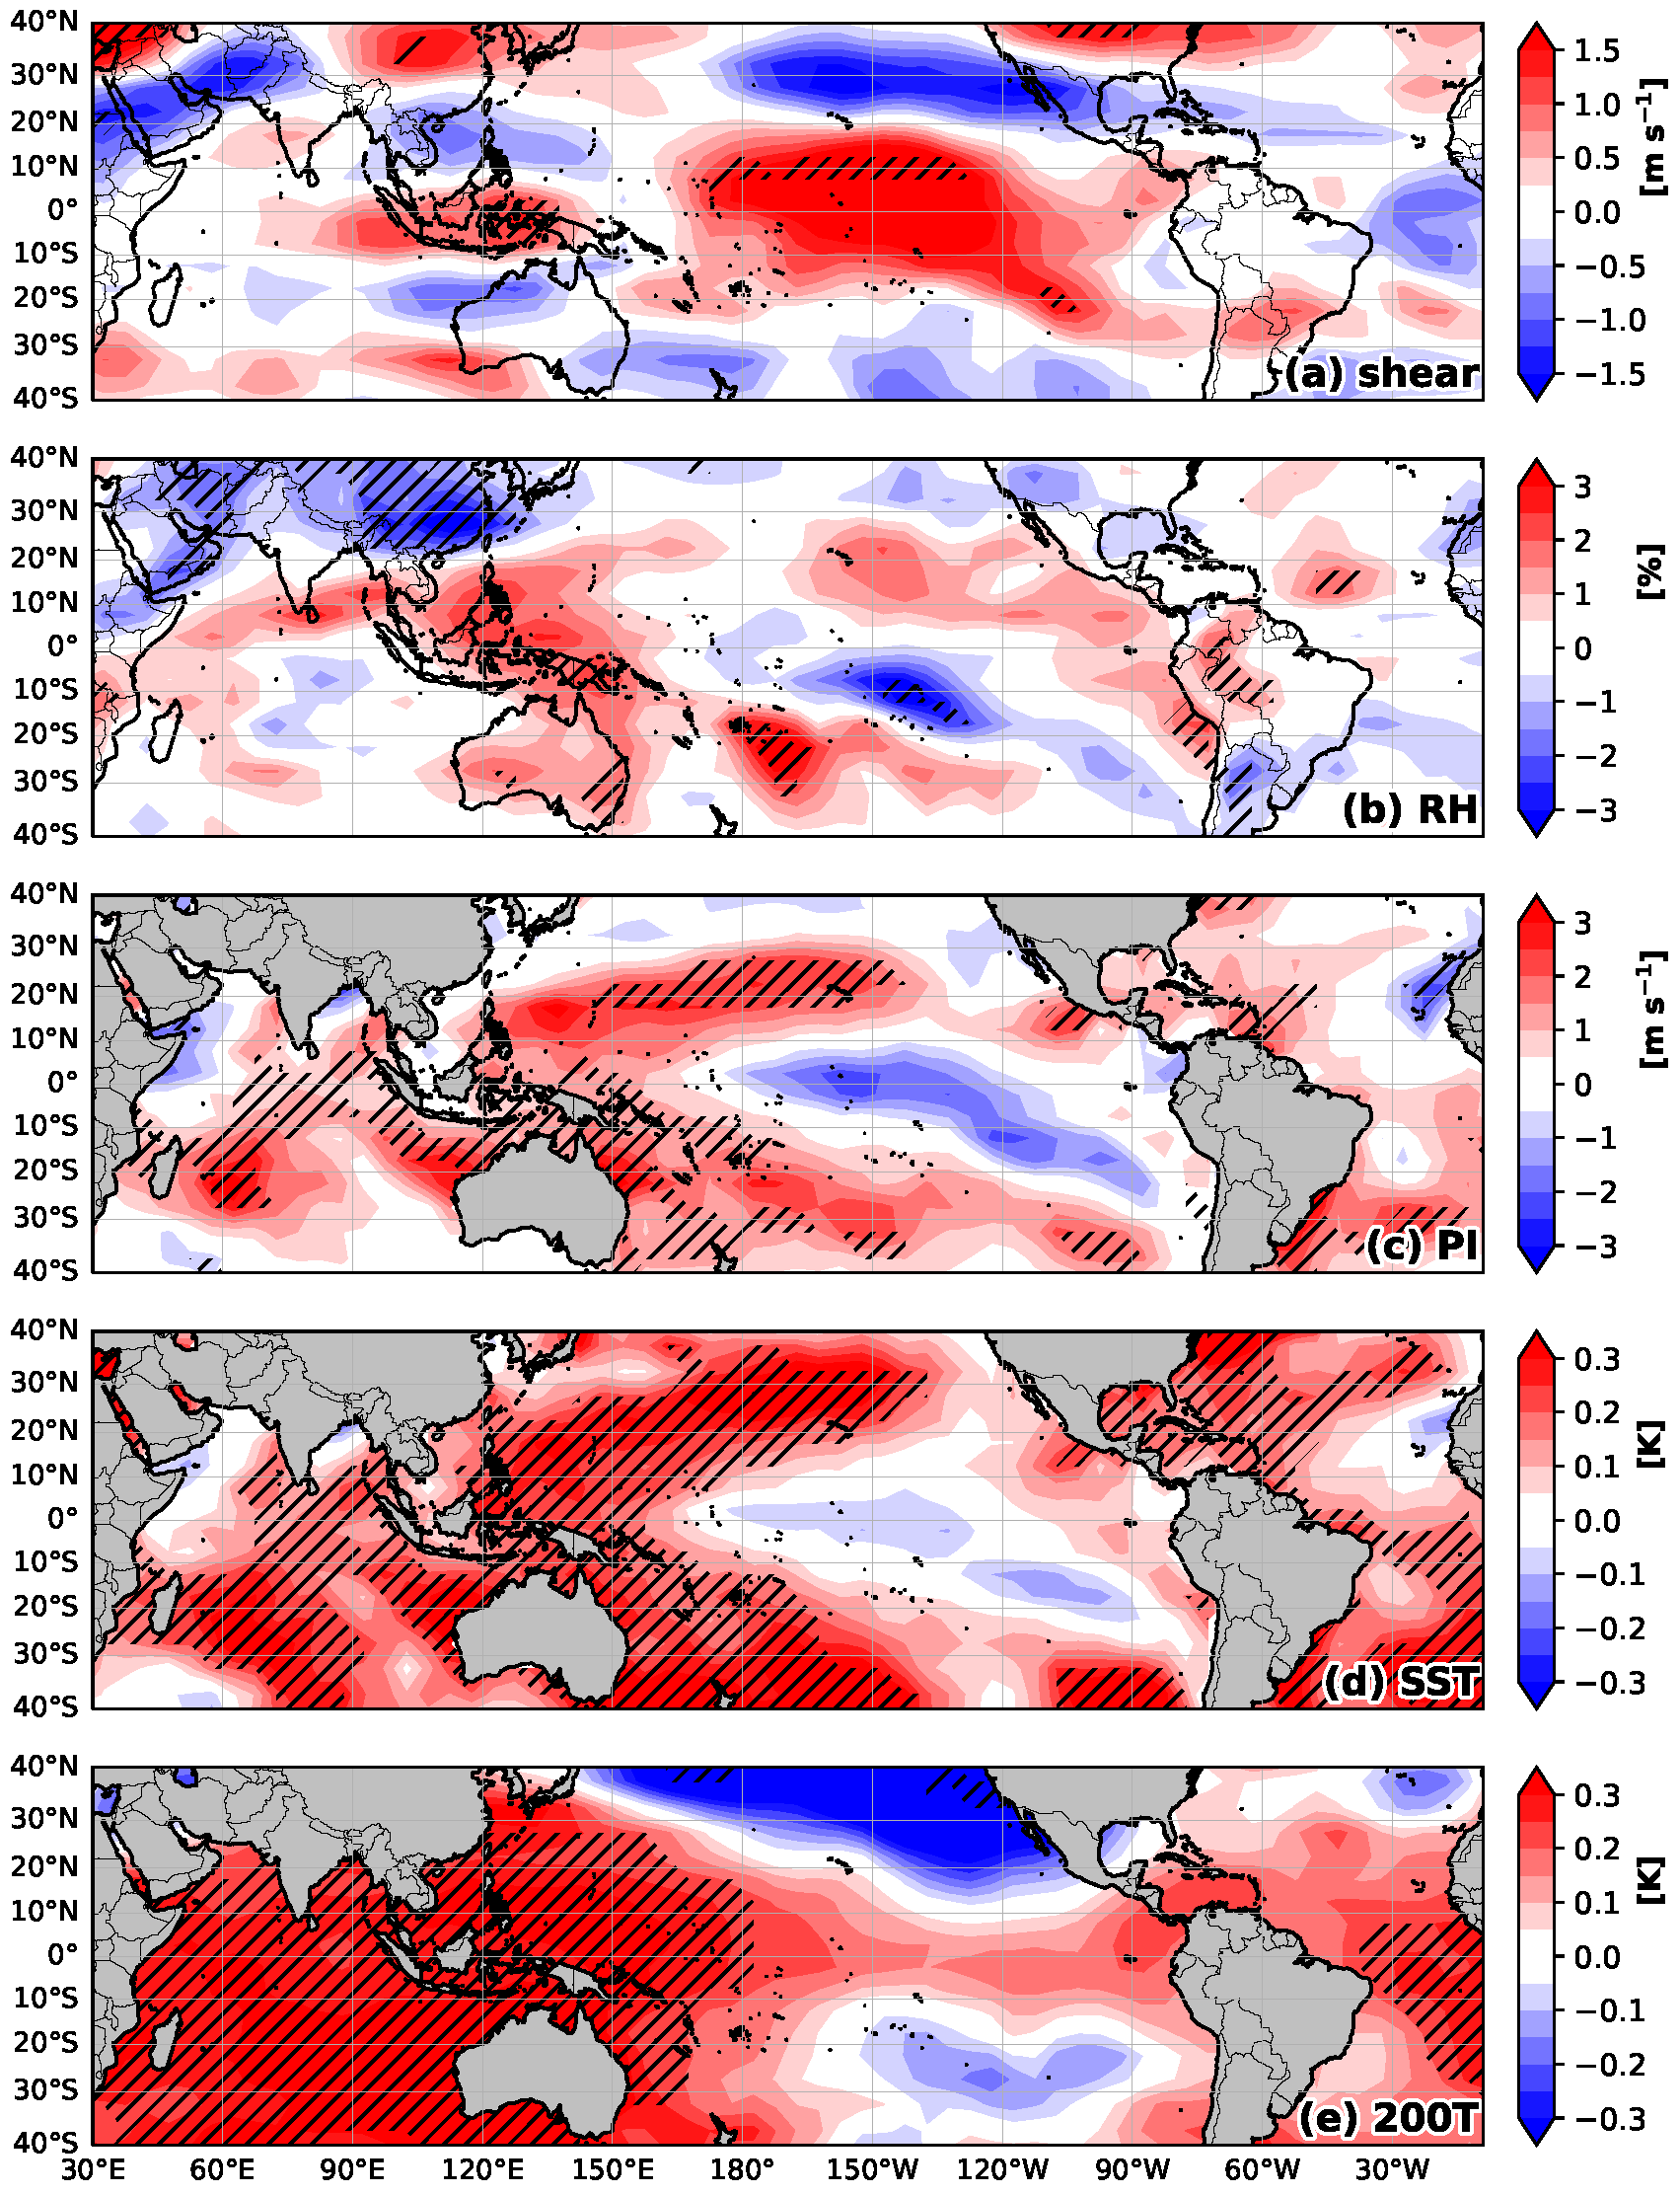
Figure S2. As in Fig. 5a–e but for January–March.

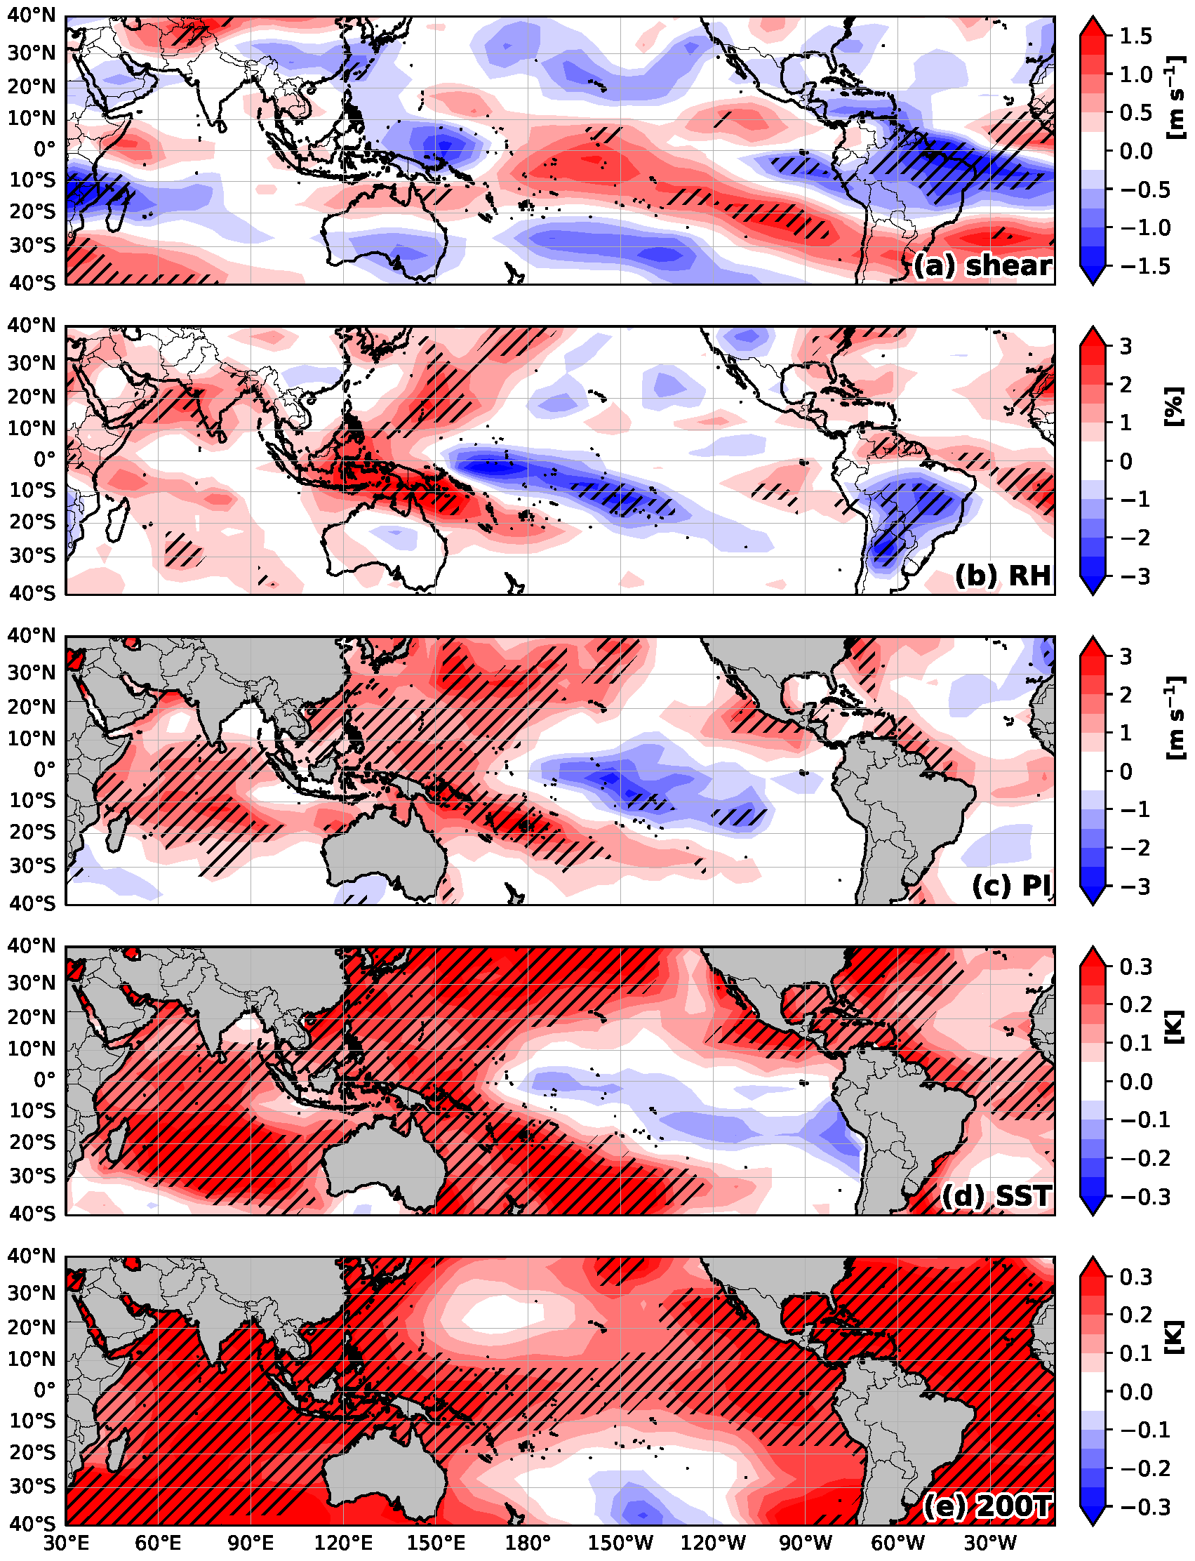

Figure S3. As in Fig. 5a–e but for August–October.
Table S1. Average annual values for several TC metrics globally, for six individual TC basins and for the Northern and Southern Hemisphere during 1990–2021. The percentage of global TC activity generated in each basin or hemisphere is listed in parentheses. Individual TC basin or hemisphere values may not add up to exactly the hemisphere or global total due to rounding.
TC Metric | Globe | North Atlantic | Eastern North Pacific | Western North Pacific | North Indian | South Indian | South Pacific | Northern Hemisphere | Southern Hemisphere
Named Storms | 87.3 | 14.6 (17%) | 16.8 (19%) | 25.6 (29%) | 5.2 (6%) | 15.8 (18%) | 9.3  (11%) | 62.2  (71%) | 25.1  (29%)
Named Storms <=2 Days | 21.3 | 3.9 (18%) | 4.4 (21%) | 5.0 (23%) | 2.0 (9%) | 3.3 (15%) | 2.8 (13%) | 15.3  (72%) | 6.0  (28%)
Named Storms >2 Days | 66.0 | 10.7 (16%) | 12.4 (19%) | 20.6 (31%) | 3.2 (5%) | 12.5 (19%) | 6.6 (10%) | 46.9  (71%) | 19.1  (29%)
Named Storm Days | 409.1 | 69.8 (17%) | 74.1 (18%) | 133.4 (33%) | 16.6 (4%) | 76.7 (19%) | 38.4 (9%) | 293.9  (72%) | 115.1  (28%)
Hurricanes | 47.7 | 7.2 (15%) | 9.0 (19%) | 16.0 (34%) | 2.1 (4%) | 8.7 (18%) | 4.6 (10%) | 34.3  (72%) | 13.3  (28%)
Hurricane Days | 168.3 | 27.0 (16%) | 29.1 (17%) | 64.7 (38%) | 4.4 (3%) | 28.5 (17%) | 14.5 (9%) | 125.2  (74%) | 43.0  (26%)
Major Hurricanes | 25.3 | 3.2 (13%) | 4.6 (18%) | 9.1 (36%) | 1.1 (4%) | 4.9 (19%) | 2.4 (9%) | 17.9  (71%) | 7.3  (29%)
Major Hurricane Days | 57.9 | 7.3 (13%) | 9.7 (17%) | 24.8 (43%) | 1.5 (3%) | 9.8 (17%) | 4.7 (8%) | 43.4  (75%) | 14.5  (25%)
Cat. 4–5 Hurricanes | 18.2 | 1.9 (10%) | 3.3 (18%) | 7.4 (41%) | 0.7 (4%) | 3.3 (18%) | 1.6 (9%) | 13.3  (73%) | 4.9  (27%)
Cat. 4–5 Hurricane % | 38% | 27% | 36% | 47% | 32% | 38% | 34% | 39% | 37%
Cat. 4–5 Days | 32.2 | 3.9 (12%) | 4.6 (14%) | 15.7 (49%) | 0.8 (2%) | 4.9 (15%) | 2.4 (7%) | 25.0  (78%) | 7.2  (22%)
ACE (10⁴ kt²) | 783 | 123 (16%) | 136 (17%) | 297 (38%) | 25 (3%) | 135 (17%) | 68 (9%) | 580  (74%) | 203  (26%)
30-kt RI Events | 126.6 | 15.3 (12%) | 24.2 (19%) | 46.6 (37%) | 4.8 (4%) | 23.5 (19%) | 12.3 (10%) | 90.8  (72%) | 35.8  (28%)
50-kt RI Events | 24.9 | 2.4 (10%) | 5.2 (21%) | 9.7 (39%) | 0.9 (4%) | 4.5 (18%) | 2.3 (9%) | 18.2  (73%) | 6.7  (27%)

30-kt RW Events | 62.7 | 3.7  (6%) | 19.3 (31%) | 16.0 (26%) | 1.0 (2%) | 15.2 (24%) | 7.6 (12%) | 39.9  (64%) | 22.7  (36%)
50-kt RW Events | 7.0 | 0.3  (4%) | 2.0 (29%) | 1.8 (26%) | 0.0 (0%) | 1.9 (27%) | 1.0 (14%) | 4.1  (59%) | 2.9  (41%)
Damage (Billions USD) | 64.3 | 40.0 (62%) | 1.0  (2%) | 18.3 (28%) | 4.0 (6%) | 0.3 (<1%) | 0.6 (1%) | 63.4  (99%) | 1.0  (1%)

Table S2. As in Table S1 but for per-decade linear trends. Category 4–5 hurricane percentage linear trends are not displayed for the North Indian Ocean due to limited per-year hurricane formations. Trends significant at the 10% level are highlighted in bold-face. Individual TC basin or hemisphere values may not add up to exactly the hemisphere or global total due to rounding.
TC Metric | Globe | North Atlantic | Eastern North Pacific | Western North Pacific | North Indian | South Indian | South Pacific | Northern Hemisphere | Southern Hemisphere
Named Storms | 1.4 | 2.9 | 1.2 | -1.7 | 0.2 | -0.7 | -0.4 | 2.6 | -1.2
Named Storms <=2 Days | 3.4 | 1.1 | 1.6 | 0.5 | 0.0 | -0.3 | 0.5 | 3.2 | 0.2
Named Storms >2 Days | -2.0 | 1.8 | -0.4 | -2.2 | 0.2 | -0.4 | -1.0 | -0.6 | -1.4
Named Storm Days | -26.4 | 9.1 | -1.9 | -22.1 | 1.4 | -8.0 | -5.0 | -13.5 | -13.0
Hurricanes | -2.3 | 0.6 | -0.2 | -2.1 | 0.4 | -0.5 | -0.5 | -1.3 | -1.0
Hurricane Days | -20.9 | 0.7 | -3.6 | -13.0 | 1.4 | -4.2 | -2.3 | -14.4 | -6.5
Major Hurricanes | 0.1 | 0.6 | -0.1 | -0.4 | -0.3 | -0.2 | -0.1 | 0.4 | -0.3
Major Hurricane Days | -4.6 | 1.4 | -1.3 | -3.7 | 0.4 | -0.8 | -0.6 | -3.2 | -1.4
Cat. 4–5 Hurricanes | 0.5 | 0.5 | 0.1 | -0.2 | 0.1 | 0.1 | 0.0 | 0.4 | 0.0
Cat. 4–5 Hurricane % | 2% | 5% | 2% | 4% | --- | 2% | 2% | 2% | 3%
Cat. 4–5 Days | -2.4 | 0.7 | -0.7 | -2.1 | 0.2 | -0.4 | -0.1 | -1.9 | -0.5
ACE | -65 | 15 | -12 | -47 | 5 | -16 | -9 | -40 | -25
30-kt RI Events | 3.0 | 3.0 | 0.5 | -0.8 | 1.0 | -0.3 | -0.4 | 3.8 | -0.8
50-kt RI Events | 5.6 | 0.6 | 0.4 | 2.5 | 0.5 | 1.4 | 0.1 | 4.0 | 1.5

30-kt RW Events | 0.4 | 0.7 | -0.4 | -0.6 | 1.2 | 0.3 | -0.7 | 0.8 | -0.4
50-kt RW Events | 0.9 | 0.1 | 0.3 | 0.2 | 0.0 | 0.6 | -0.3 | 0.5 | 0.4
Damage (Billions USD) | 27.3 | 21.7 | -0.1 | 2.7 | 2.5 | 0.2 | 0.2 | 26.8 | 0.5

Table S3. Correlations between ACE for individual TC basins as well as the Northern Hemisphere, Southern Hemisphere and globe and the ENSO Longitude Index for January–March, August–October and the annual average. Correlations significant at the 10% level are highlighted in bold-face.
ENSO Longitude Index Averaging Period | Globe | North Atlantic | Eastern North Pacific | Western North Pacific | North Indian | South Indian | South Pacific | Northern Hemisphere | Southern Hemisphere
January–March | 0.21 | 0.12 | 0.21 | -0.03 | 0.10 | -0.15 | 0.66 | 0.15 | 0.33
August–October | 0.60 | -0.51 | 0.47 | 0.76 | -0.01 | 0.18 | 0.29 | 0.62 | 0.36
Annual | 0.62 | -0.31 | 0.54 | 0.54 | 0.07 | 0.03 | 0.74 | 0.58 | 0.54

Table S4. Correlations between 50-kt RI events for individual TC basins as well as the Northern Hemisphere, Southern Hemisphere and globe and the ENSO Longitude Index for January–March, August–October and the annual average. Correlations significant at the 10% level are highlighted in bold-face.
ENSO Longitude Index Averaging Period | Globe | North Atlantic | Eastern North Pacific | Western North Pacific | North Indian | South Indian | South Pacific | Northern Hemisphere | Southern Hemisphere
January–March | 0.01 | -0.09 | -0.04 | 0.00 | -0.18 | 0.03 | 0.27 | -0.10 | 0.18
August–October | 0.44 | -0.41 | 0.72 | 0.30 | -0.21 | 0.30 | -0.03 | 0.48 | 0.23
Annual | 0.28 | -0.36 | 0.48 | 0.15 | -0.32 | 0.20 | 0.19 | 0.22 | 0.27

