Supplemental Figures and Tables
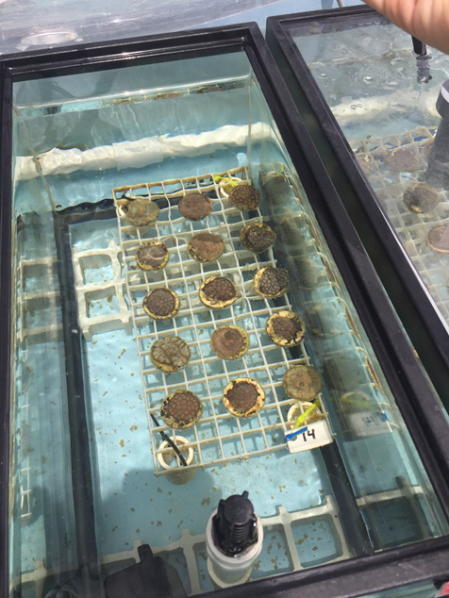
Figure S1. Experimental tank setup within Mote Marine Lab’s Climate and Acidification Ocean Simulator (CAOS) system. Replicate fragments of 3 genotypes of Pseudodiploria clivosa and 12 genotypes of Orbicella faveolata (n = 15 per treatment tank) .

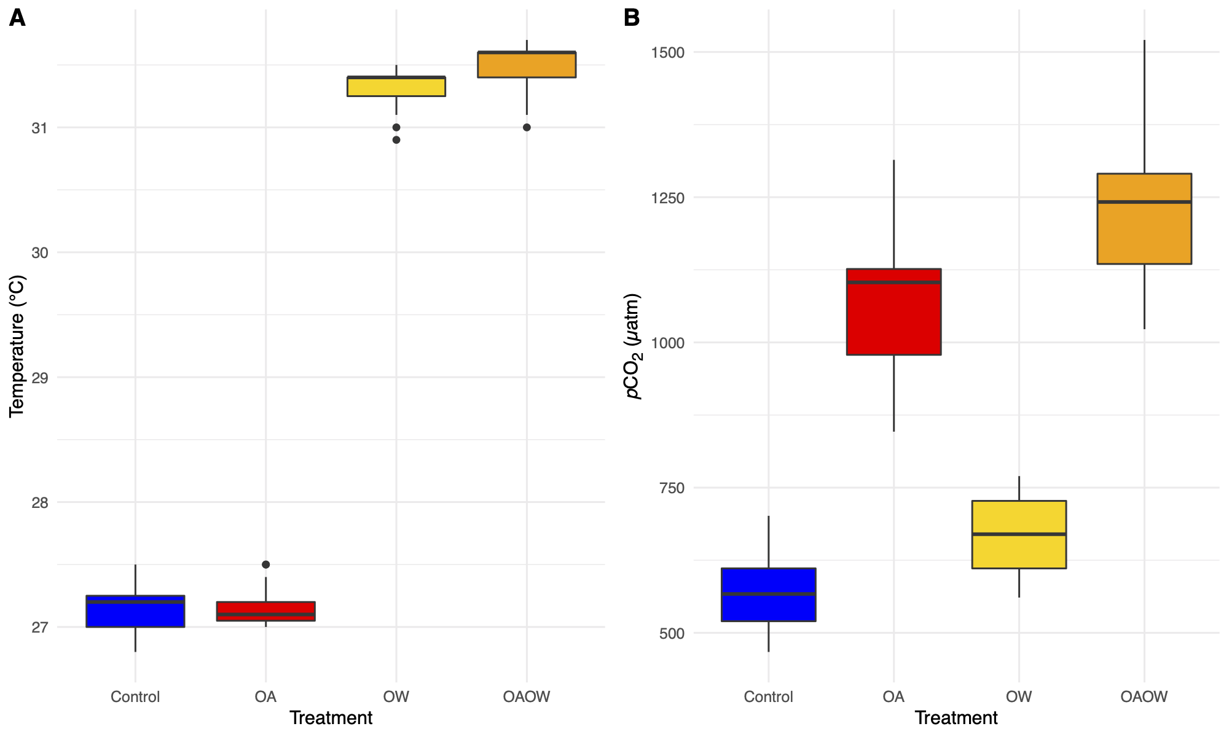
a
c
b
d
a
a
b
c
Figure S2. Boxplots showing the median, quartiles, and 1.5 interquartile range of (A) temperature and (B) pCO₂ across all treatments (x-axis). Different letters denote significant differences within each parameter (Tukey p<0.05).

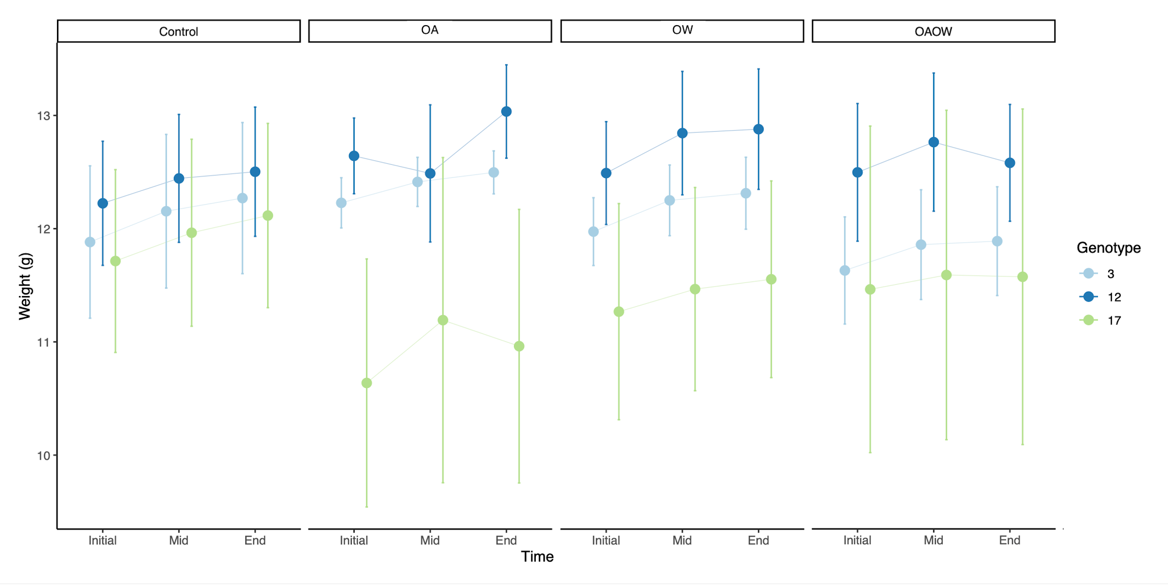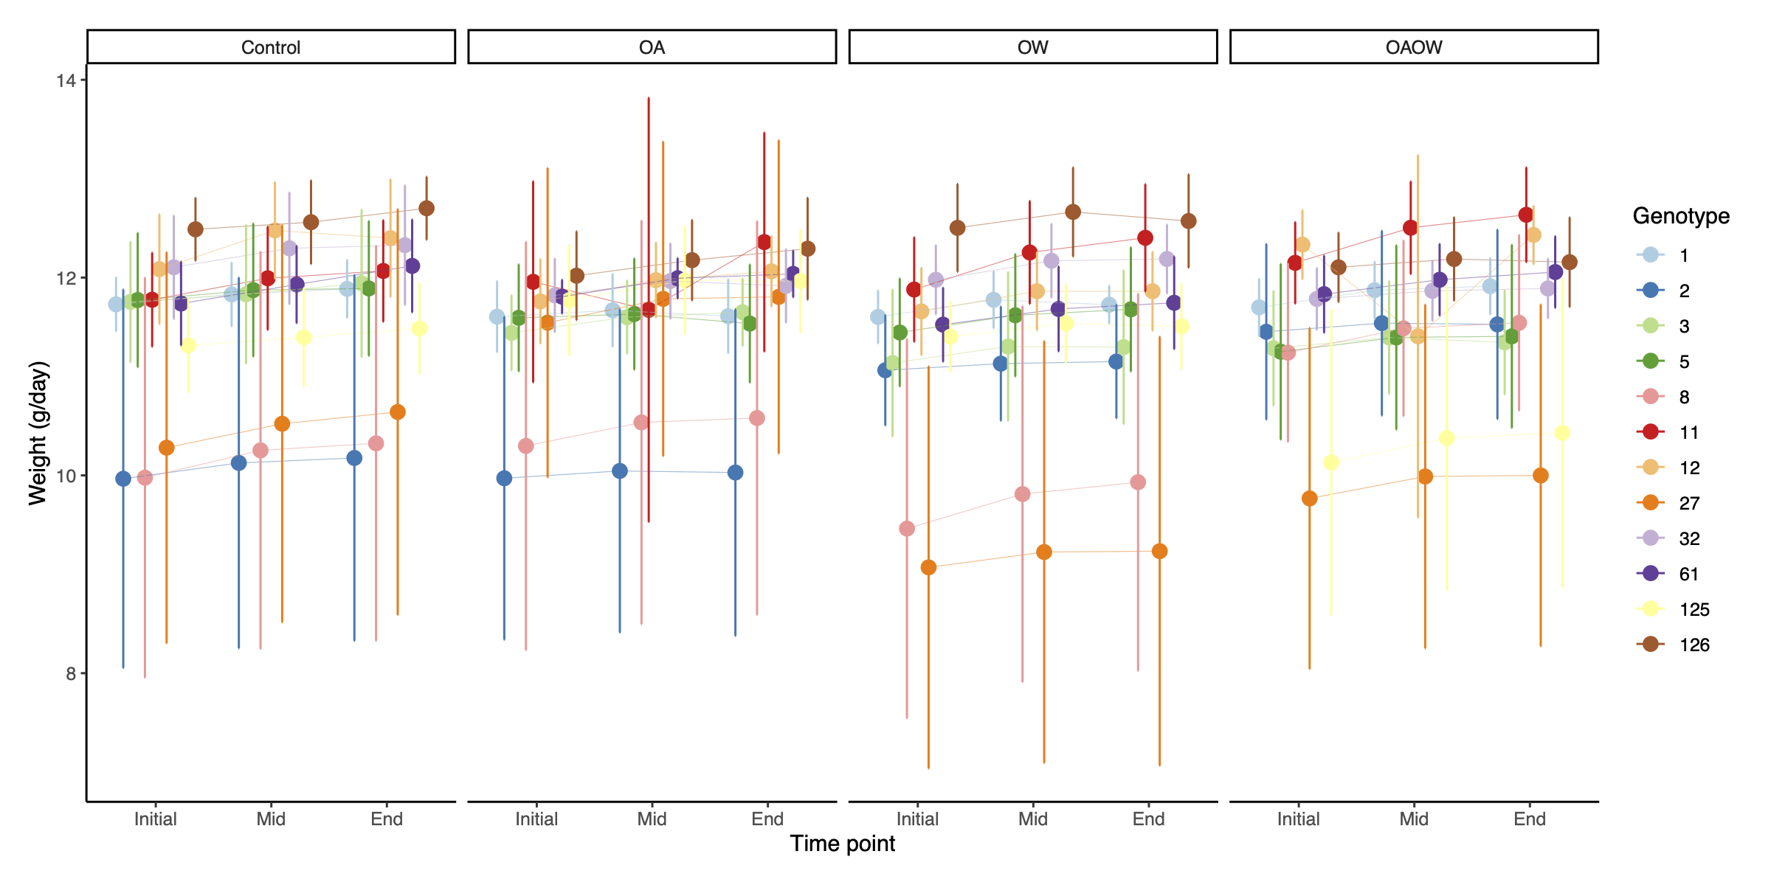
A
B
Figure S3. Mean coral growth (grams dry weight) throughout the experimental period for each genotype of (A) P. clivosa and (B) O. faveolata. ‘Initial’ represents prior to treatment exposures began, ‘Mid’ represents one month at treatment, and ‘Final’ represents two months of treatment. Panels are faceted by treatment (Control, OA, OW, OAOW). Symbols are colored by genotype and represent means ± 95% confidence intervals (n=5-6 per treatment).

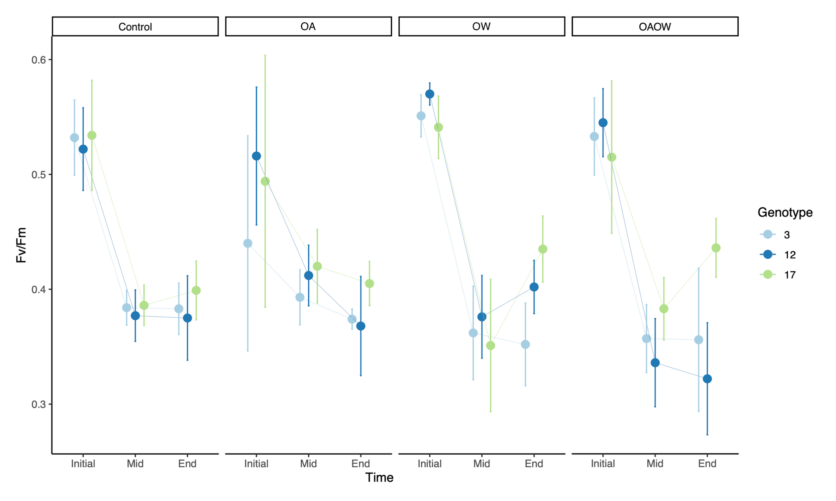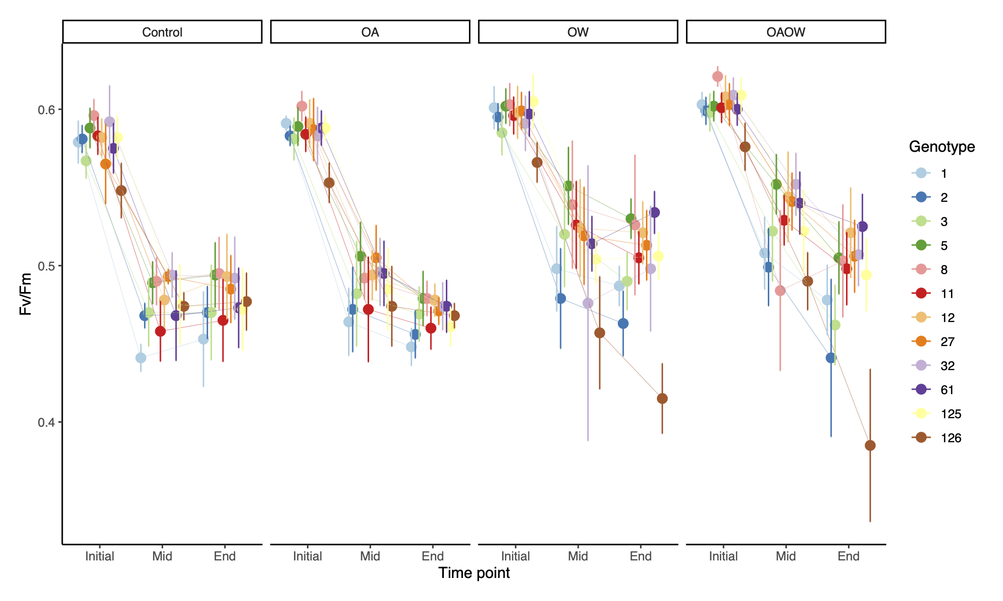
A
B
Figure S4. Mean Fv/Fm throughout the experimental period for each genotype of (A) P. clivosa and (B) O. faveolata. Panels are faceted by treatment (Control, OA, OW, OAOW). Symbols are colored by genotype and represent means ± 95% confidence intervals (n=5-6 per treatment).
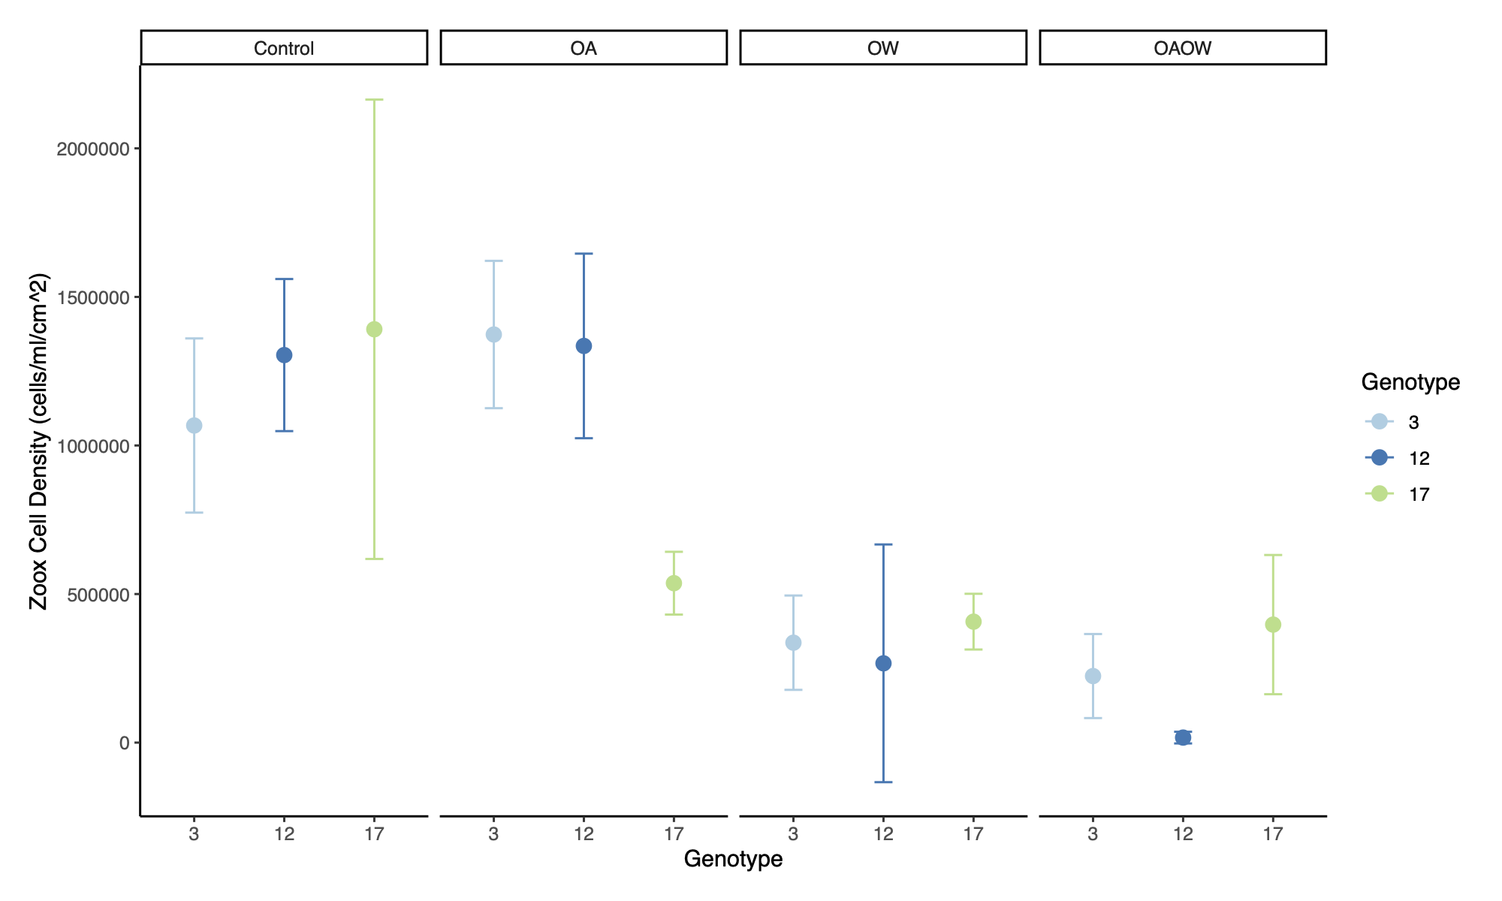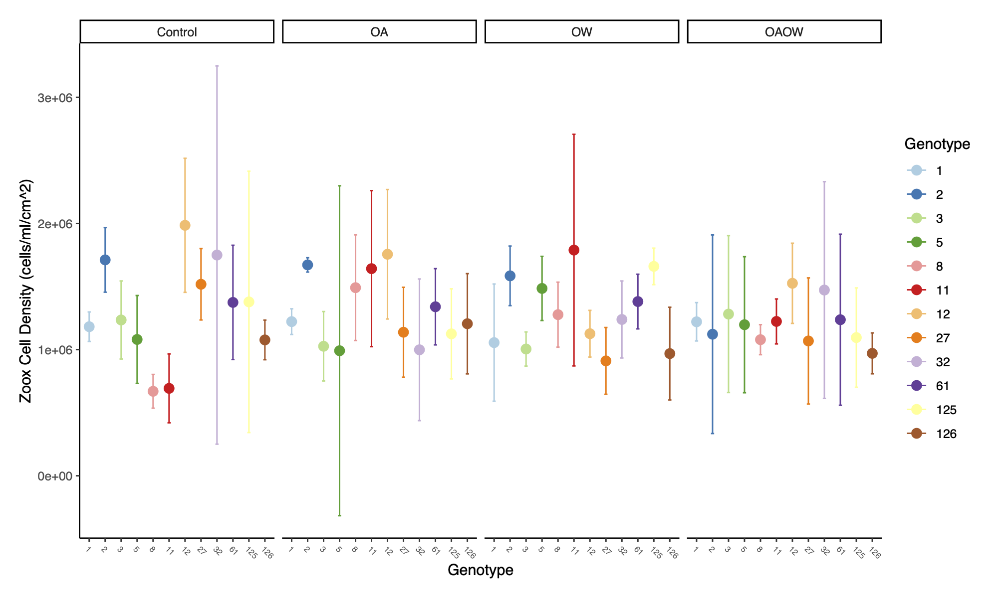
A
B
Figure S5. Mean algal symbiont cellular density (cells ml⁻¹ cm⁻²) throughout the experimental period for each genotype of (A) P. clivosa and (B) O. faveolata. Panels are faceted by treatment (Control, OA, OW, OAOW). Symbols are colored by genotype and represent means ± 95% confidence intervals (n=5-6 per treatment).
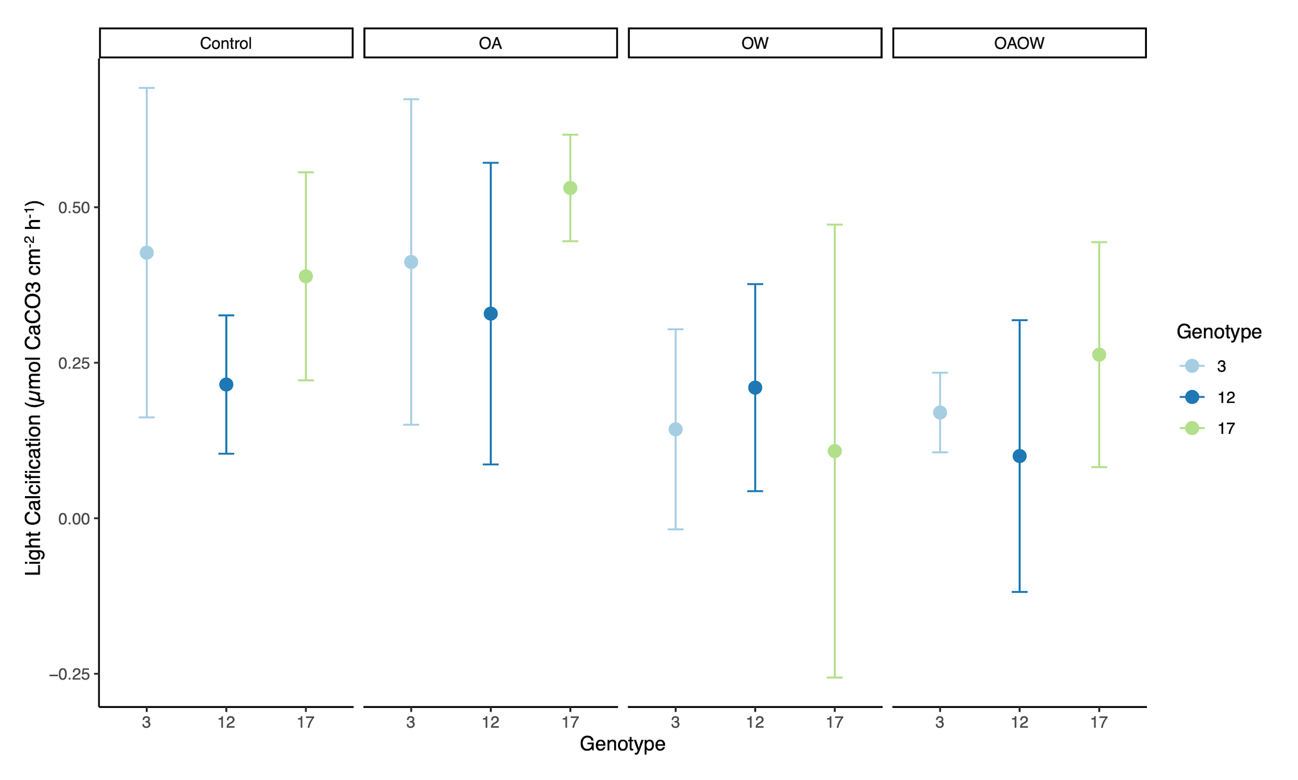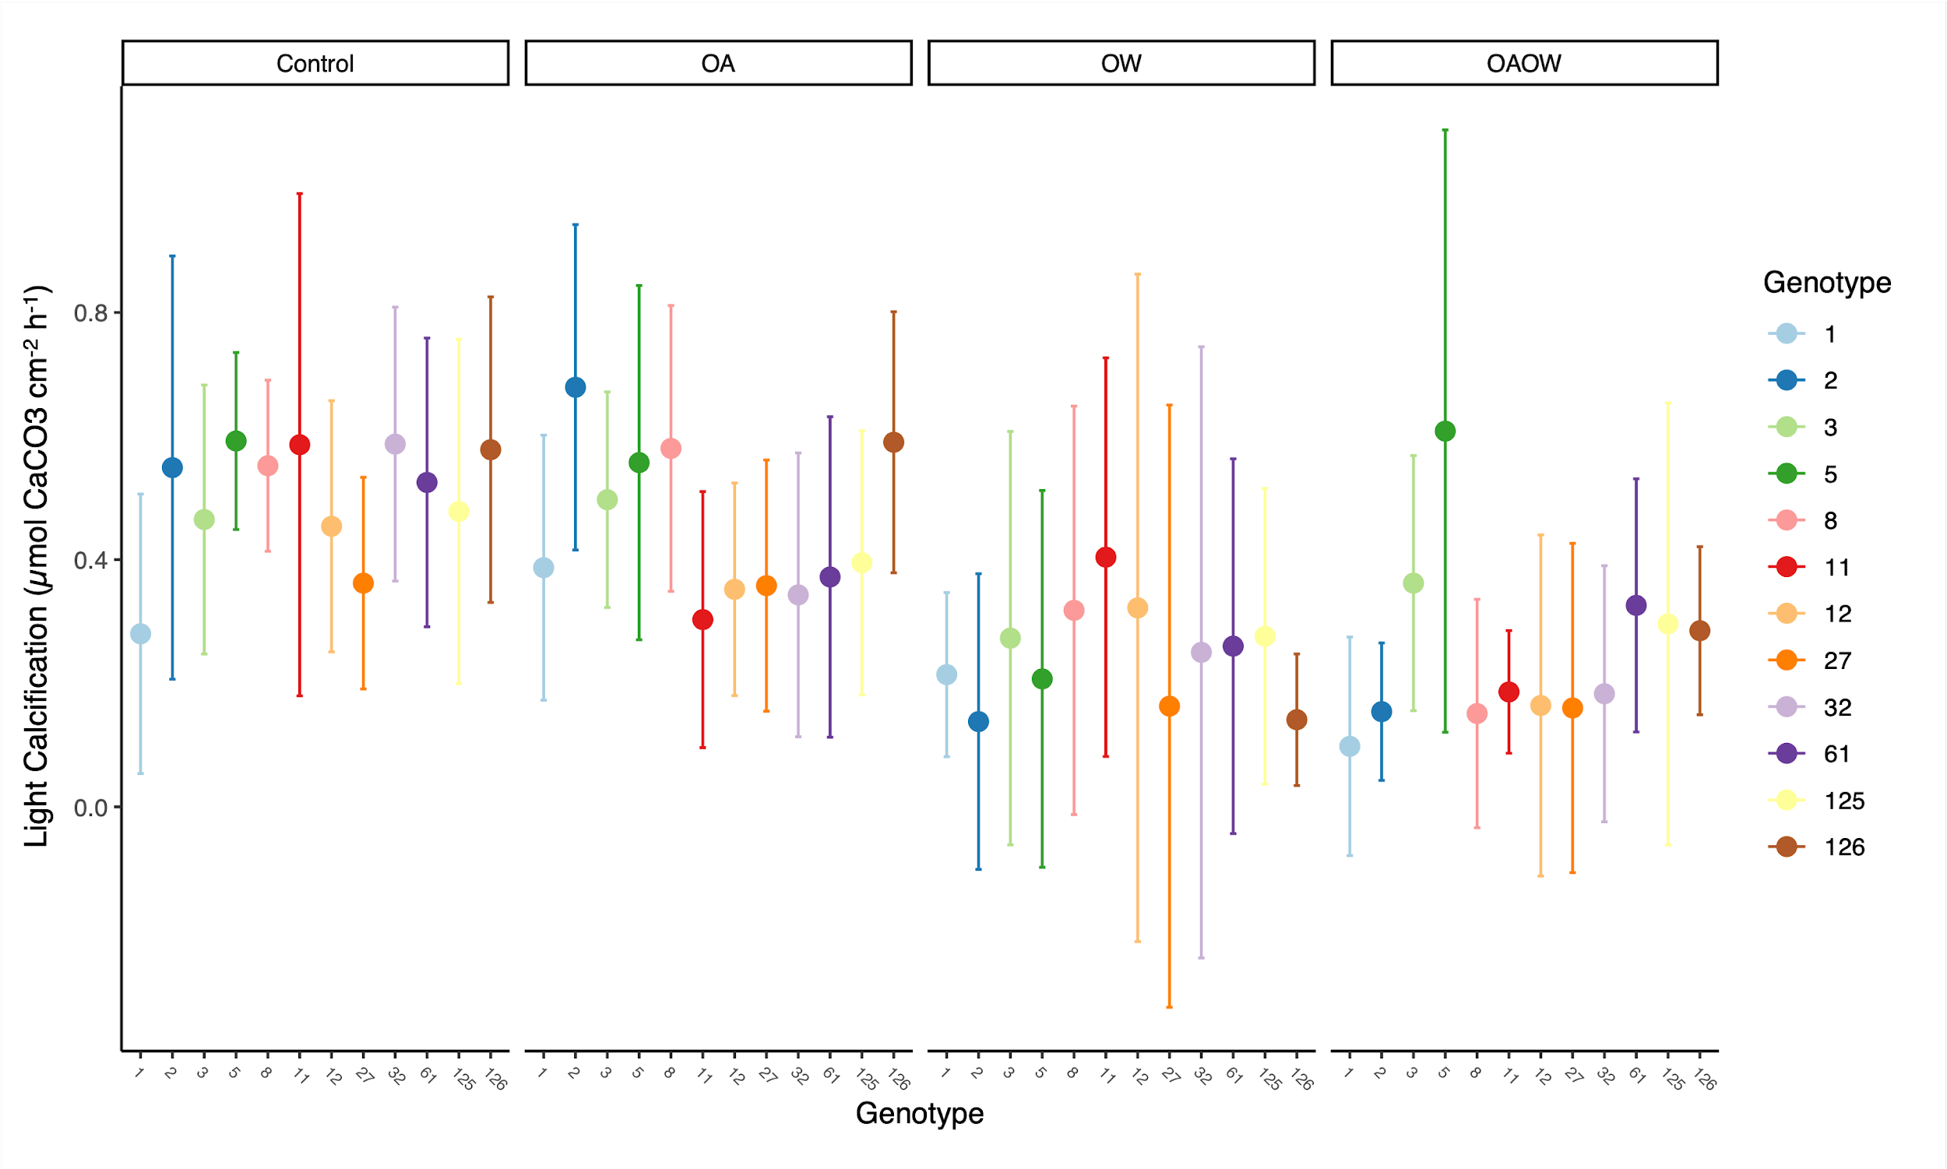
A
B
Figure S6. Mean light calcification (µmol CaCO₃ cm⁻² h⁻¹) throughout the experimental period for each genotype of (A) P. clivosa and (B) O. faveolata. Panels are faceted by treatment (Control, OA, OW, OAOW). Symbols are colored by genotype and represent means ± 95% confidence intervals (n=5-6 per treatment).

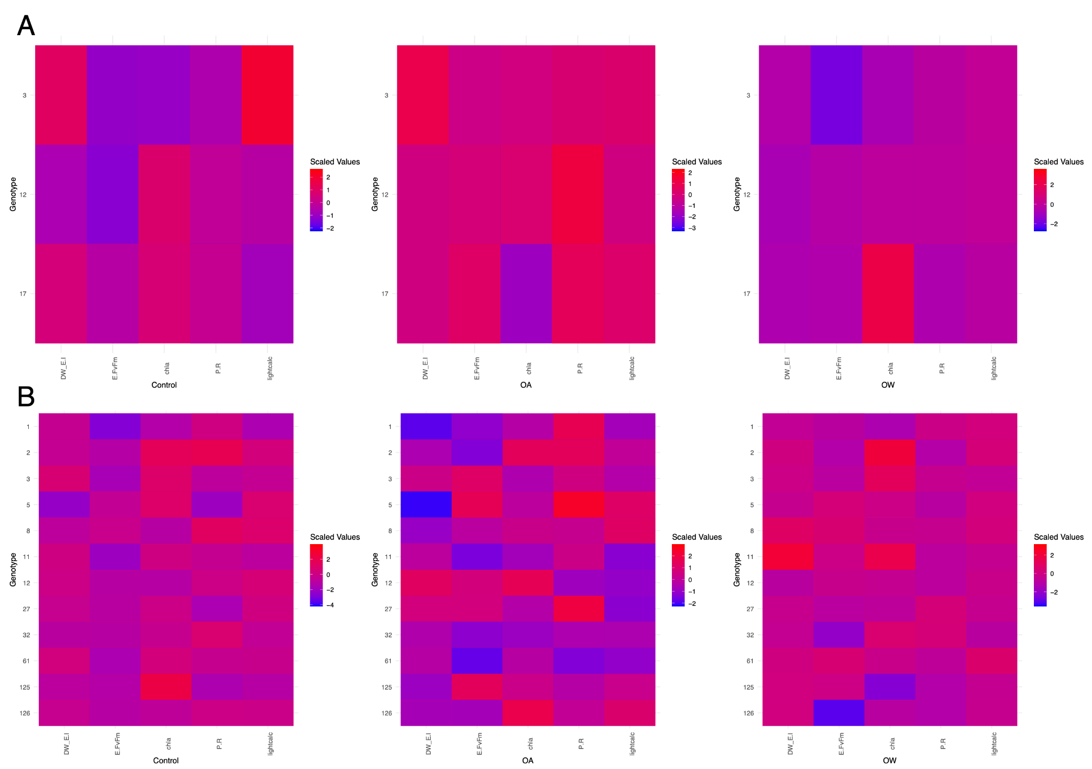
Figure S7. Heatmaps of scaled mean physiological trait values (x-axis) for each genotype (y-axis) of (A) P. clivosa and (B) O. faveolata under the each treatment (Control=left, OA=middle, OW=right), where red indicates higher values (= higher performance) and blue are lower values (= lower performance). Each trait is scaled independently before collating into each final heatmap.

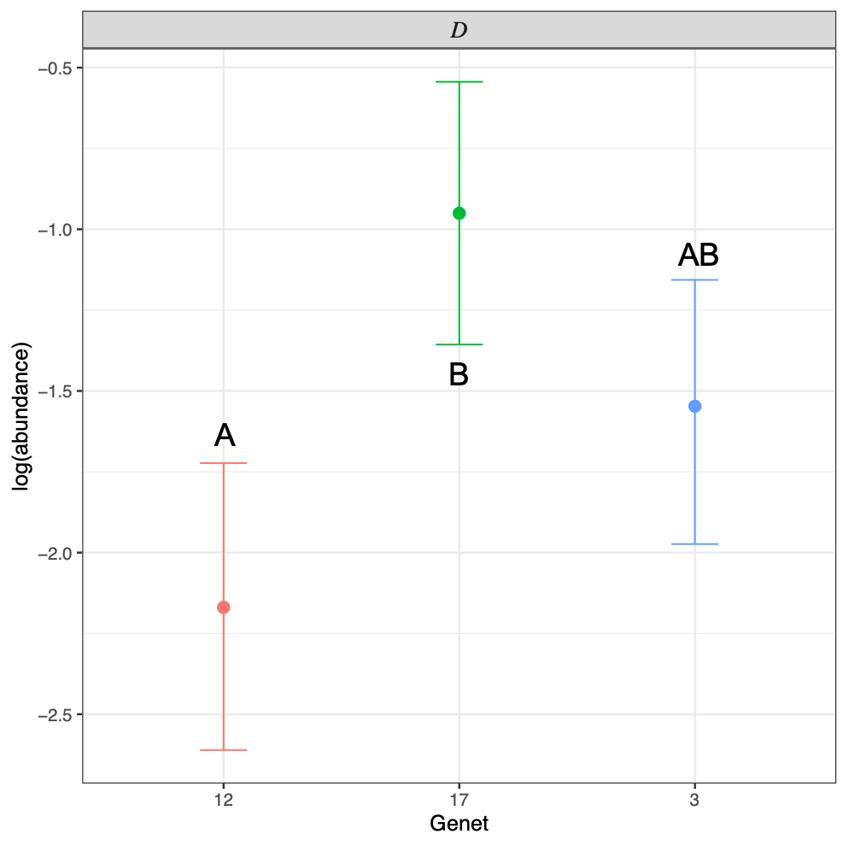
Figure S8. Significantly differentially represented Symbiodiniaceae Durusdinium spp. zOTU (zero-radius Operational Taxonomic Unit) log abundance for each genotype of P. clivosa. Different letters denote significant differences in Durusdinium abundance across genotype (MCMCp < 0.05).

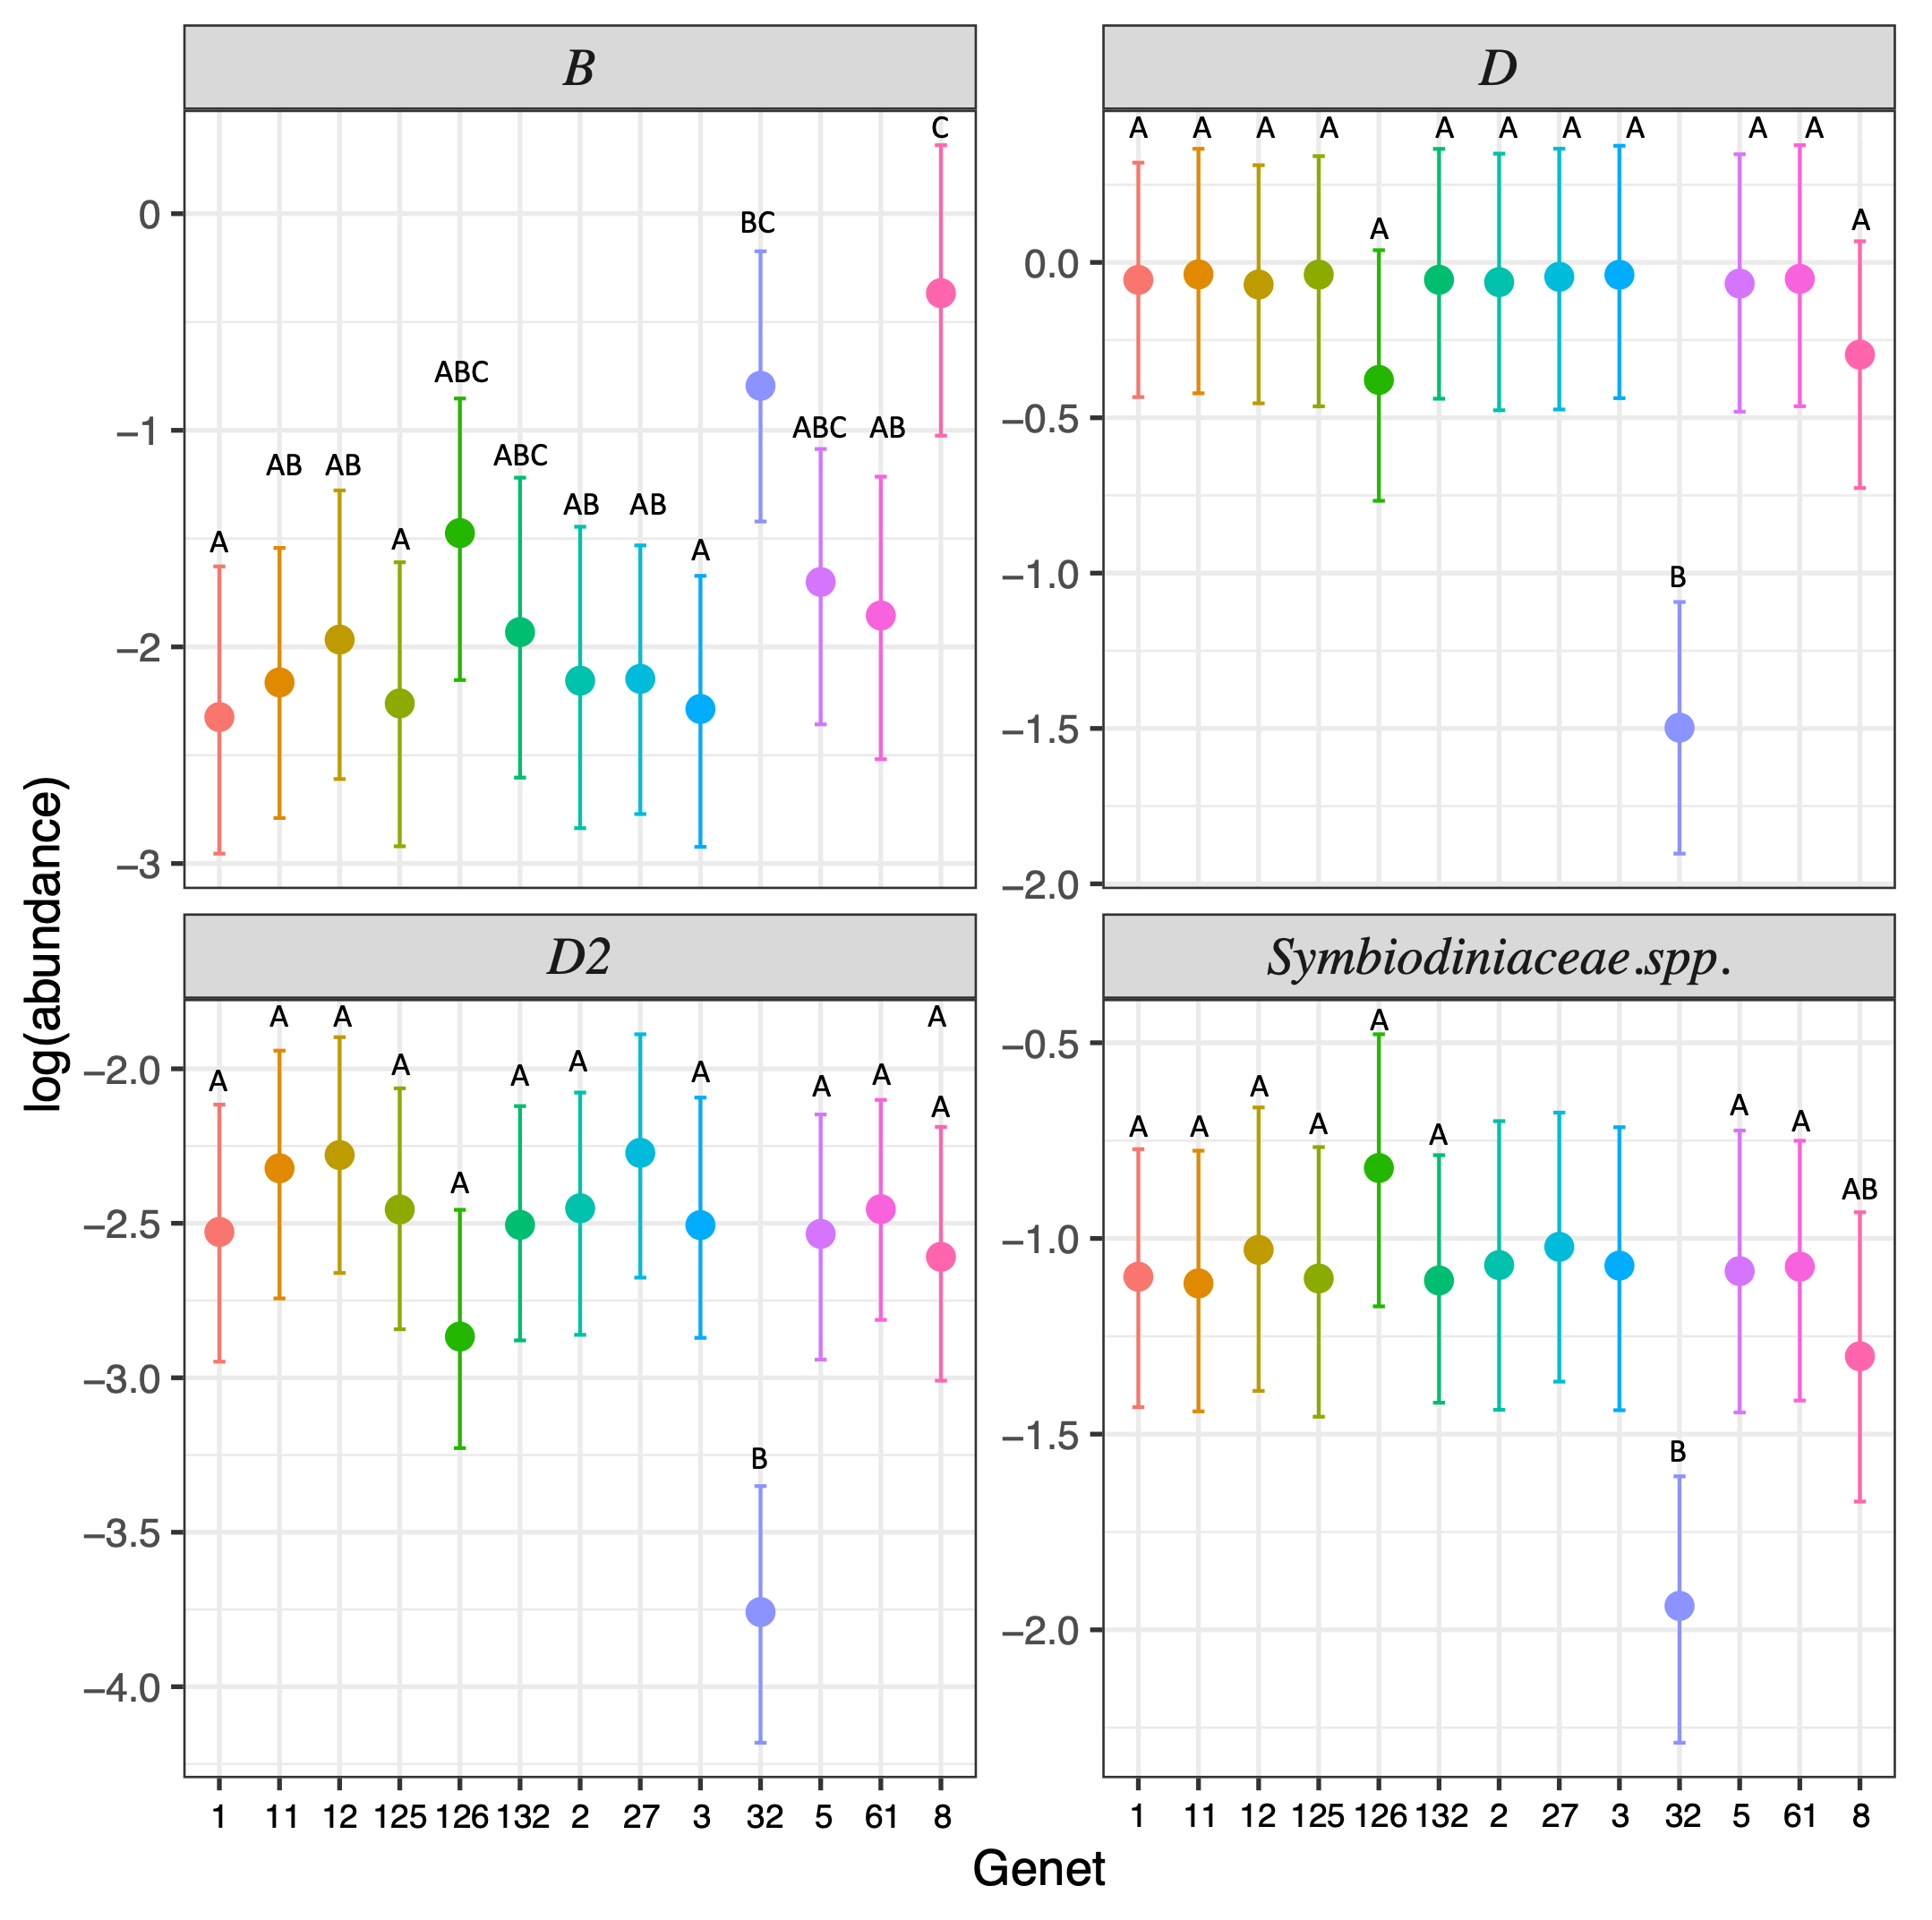
A A A
A

Figure S9. Significantly differentially represented Symbiodiniaceae haplotype zOTU (zero-radius Operational Taxonomic Unit) log abundance for each genotype of O. faveolata. Panels are faceted by zOTU ITS2 type (B=Breviolum, D=Durusdinium, D2=Durusdinium type D2, Symbiodiniaceae spp.). Different letters denote significant differences in abundance across genotype within each zOTU type (MCMCp < 0.05).

Supplemental Tables
Table S1. Hourly conditions of MML’s O. faveolata restoration raceway during the rearing period prior to the two-month experimental exposure within MML’s CAOS raceways.

Time | Temperature (°C) | Salinity (ppt) | DO (mg/L) | pHTOTAL
8:53 | 26.0 | 37.5 | 6.81 | 7.709
9:59 | 26.9 | 37.5 | 6.52 | 7.760
10:59 | 27.4 | 37.6 | 6.87 | 7.784
12:45 | 27.7 | 37.5 | 6.21 | 7.725
14:04 | 27.6 | 37.5 | 6.09 | 7.713
15:01 | 27.6 | 36.2 | 6.28 | 7.721
16:00 | 27.4 | 37.6 | 6.12 | 7.715
17:35 | 26.8 | 37.6 | 5.80 | 7.675

