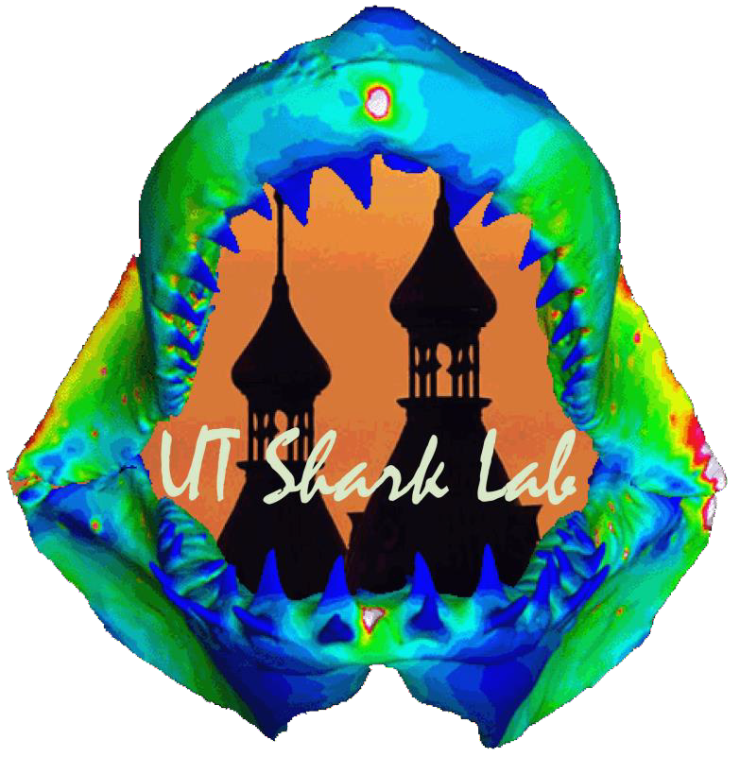
The Jaw Biomechanics of Cookiecutter Sharks’ Specialized Feeding Ecology
Kevin Travis¹, Mark Grace², Jonathan Ford³, Summer Decker³, Dan Huber¹
1The University of Tampa; ²National Oceanic and Atmospheric Administration; ³University of South Florida Morsani College of Medicine

Abstract
The purpose of this study was to understand the wide range of prey capture mechanisms that Chondrichthyans display within their ecological niches. The cookiecutter sharks (Isistius spp.) exemplify this variety through their unique feeding morphology and behavior; a row of teeth fused into a continuous blade and longitudinal body rotation removes plugs of flesh from large fishes or cetaceans. In this study, we examined a) the effects of this fused tooth morphology on lower jaw mechanics, and b) jaw mechanics during the application of bite force and subsequent longitudinal twisting of the body of Isistius brasiliensis. Jaw models were created through CT reconstruction and Finite Element Analysis was used to observe the stress and strain patterns. We predict a) that the fused tooth pattern will stabilize the jaws, therefore reducing strain and creating a more effective bite, and b) that the jaw morphology is uniquely suited for longitudinal twisting. This tooth-based reinforcement and unique jaw morphology allow these sharks to efficiently gouge flesh from large prey species giving them a unique ecological niche within pelagic environments.

Introduction
Methods

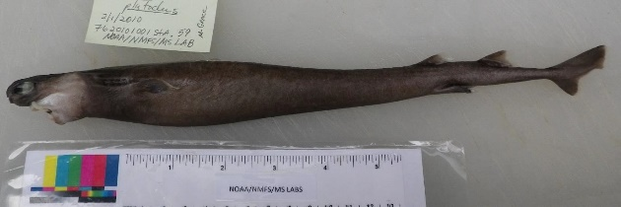
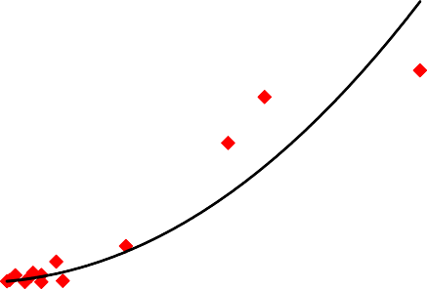
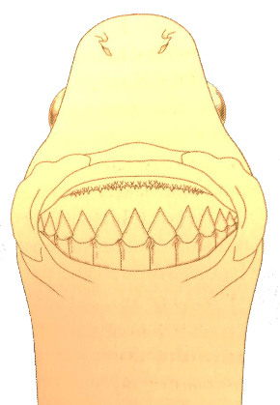
Results
3500
- Computational Modeling
  - Bite force estimates
    - I. plutodus = 11 N
  - Torque force estimates
    - I. plutodus = 11 N
  - Finite Element Analysis: ComSol software (COMSOL, Burlington, MA)
    - Bite simulations (Jaw, Jaw +
3000

2500

2000

1500

1000

500
y = 0.0096x^{2.0945}
R² = 0.75542
0
0
100
200
300
400
500
Total Length (cm)
Functional Teeth, Jaw + Functional
Figure 3 – Relationship between shark bite force and
Teeth + Replacement Teeth) total length (Habegger et al. 2012)
o Torque simulations (Jaw, Jaw +
Functional Teeth, Jaw + Functional Teeth + Replacement Teeth)
- Specimen (Isistius plutodus)
  - Collected: NOAA/NMFS 2010 Marine Mammal Survey
o 31.3 cm, 87.9 g
Figure 2 – Isistius plutodus specimen and illustration of tooth morphology.

- Virtual Reconstruction
  - CT Scanning (Lightspeed VCT 64 slice scanner, GE, Fairfield, CT)
  - CT reconstruction: Amira 5.1 software (FEI, Hillsborough, OR)
  - Surface Optimization: 3-Matic software (Materialise, Plymouth, MI)
Bite Stress (MPa)
Jaw Only | Jaw + Functional Teeth | Jaw + Functional Teeth + Replacement Teeth

Table 1. Average Stress and Strain Energy Values for Bite and Torque Forces
 |  | von Mises Stress (MPa) |  |  | Strain Energy (J)
I. plutodus |  | Jaw | Jaw + FT | Jaw + FT  + RT | Jaw | Jaw + FT | Jaw + FT  + RT
 | Bite | 2.25 | 2.22 | 1.82 | 9.99E-04 | 6.85E-04 | 5.14E-04
 | Torque | 0.51 | 1.52 | 1.03 | 3.77E-04 | 6.30E-04 | 1.43E-04
Discussion
Bite Force (N)

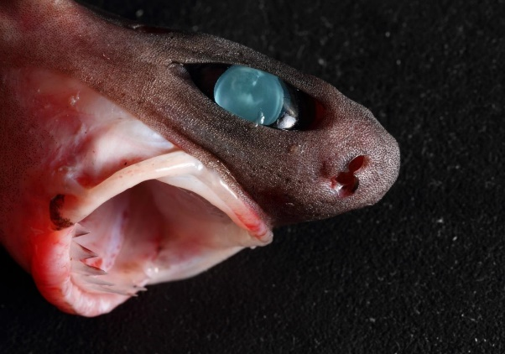
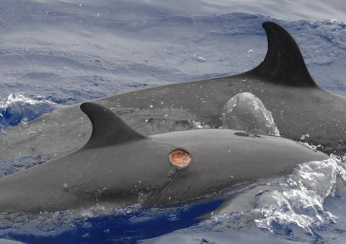
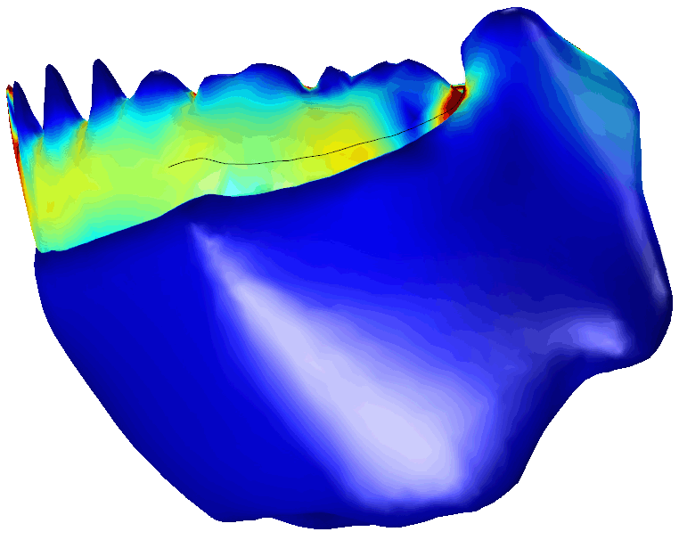
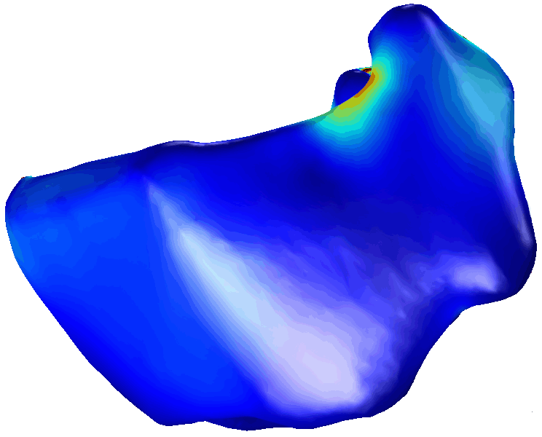
0 10
Shark feeding is relatively under-studied despite the range of feeding
mechanisms and ecologies present in this basal group of jawed fishes, and the notoriety of mega-carnivorous sharks. Compared to bony fishes’ approximately 63 jaw bones, sharks have retained a simplistic feeding mechanism of only 10 cartilaginous elements. However, they have evolved great functional diversity in only 400+ species by adapting to a wide range of ecological niches. This array of feeding ecologies is a result of specialized feeding structures such as teeth. Shark teeth are adapted to allow bite forces to be focused onto prey in specific ways (e.g. seizing/grasping, tearing, cutting, crushing, grinding) (Motta and Huber, 2004).
The squaliform sharks (~85 spp.) exhibit the most diverse and derived dentition of all elasmobranchs and have adapted to a variety of benthic and pelagic niches (Adnet and Cappetta, 2001). Among the squaliforms, cookiecutter sharks (Isistius spp.) have one of the most highly specialized feeding morphologies and ecologies. They migrate into shallower waters at night where they remove circular plugs of flesh from a variety of pelagic fishes and mammals (Papastamatiou et. al, 2010) (Fig. 1). Their feeding apparatus consist of a reduced upper jaw and voluminous lower jaw used for attaching to prey and scooping out flesh, respectively. Although most other sharks have serially-replaced, individual teeth, cookiecutters have evolved rows of fused teeth which function
Figure 1 – The cookiecutter’s unique
as a continuous saw blade to excise the flesh
plug while the body is longitudinally rotated around the bite point (Shirai and Nakaya 1992).
feeding mechanism (upper) and
trademark bite wound (lower).
In this study, we test how lower jaw mechanics of a cookiecutter sharksare
affected by a) fused tooth morphology and b) longitudinal body twisting. Stress and strain energy in the lower jaw was determined by computationally simulating bite and torque forces. We predicted that:
H₁: the fused tooth pattern stabilizes the jaws, creating a more effective bite
H₂: the jaw morphology is uniquely suited for longitudinal twisting
H₁: the fused tooth pattern stabilizes the jaws, creating a more effective bite The bite force simulations showed a reduction of stress with the addition of teeth on the jaw models. In addition, the strain energy density was reduced by
31% with the addition of functional teeth and by 49% with the addition of functional and replacement teeth. This reduced stress and strain energy supports the idea that teeth improve the mechanical integrity and efficiency of the jaws.

Alternatively, the torque force simulations produced greater stress on the jaw models thereby reducing the mechanical integrity. Strain energy increased by 67% with the addition of functional teeth, but was subsequently reduced by 164% with the addition of functional and replacement teeth. Overall, the teeth may create stress concentrations during body twisting, but but the presence of both sets of teeth improves mechanical efficiency.

H₂: the jaw morphology is uniquely suited for longitudinal twisting
For each character state, the torque simulation had lower stress and lower strain energy, supporting the hypothesis that the unique tooth and jaw morphology improves the mechanical integrity and efficiency of the feeding mechanism during longitudinal body twisting behavior as compared to typical biting.

Future Directions
We will be more thoroughly investigating the effect of the uniquely fused tooth pattern of I. plutodus by comparing the current models to those in which the teeth have been virtually disarticulated.

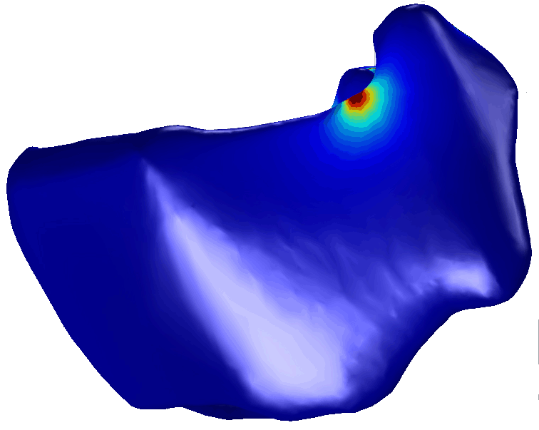
0 10
20 Literature Cited

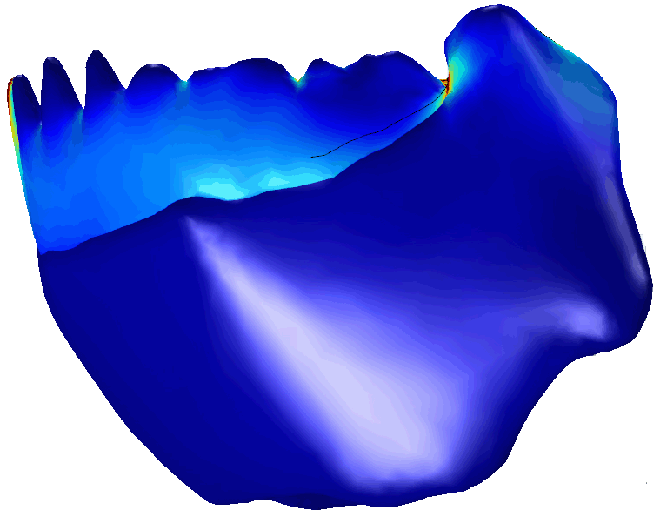
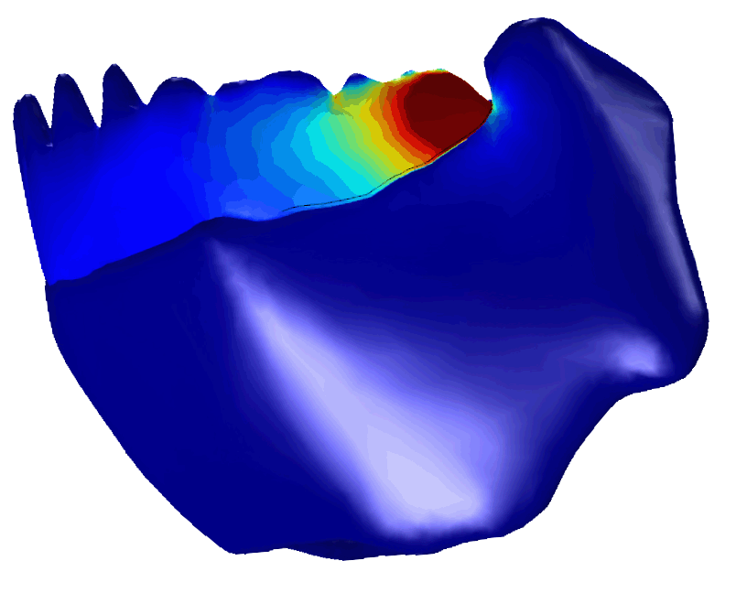
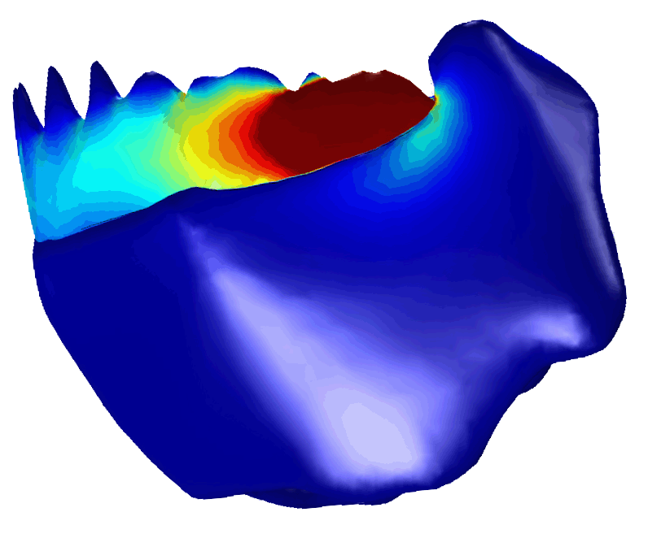
Acknowledgements
We would like to thank the National Oceanic and Atmospheric Administration for providing access to the I. plutodus specimen, the University of South Florida Morsani College of Medicine for CT scanning, and The University of Tampa for providing logistical support.
Adnet, S. and H. Cappetta. 2001. A palaeontological and phylogenetical analysis of the squaliform sharks (Chondrichthyes: Squaliformes) based on dental characters. Lethaia. 34: 234–248.
Motta P. J. and Huber D. (2004) Prey capture behavior and feeding mechanisms of elasmobranchs. In: Carrier JC, Musick JA, Heithaus MR (eds). Biology of Sharks and Their Relatives. CRC Press, New York, pp 165–202.
Papastamatiou, Y. P., Wetherbee, B. M., O'Sullivan, J., Goodmanlowe, G. D., & Lowe, C. G. (2010). Foraging ecology of cookiecutter sharks (Isistius brasiliensis) on pelagic fishes in Hawaii, inferred from prey bite wounds. Environmental Biology of Fish, 88(4): 361-368.
Shirai S, Nakaya K. 1992. Functional morphology of the feeding apparatus of the cookie-cutter shark, Isistius brasiliensis (Elasmobranchii, Dalatiinae). Zoological Science. 9: 811– 821.
Torque Stress
Jaw Only | Jaw + Functional Teeth | Jaw + Functional Teeth + Replacement Teeth

20

