Supplementary Material

Supplementary Tables
Supplementary Table 1. Abiotic variables (Mean ± SE) measured during the early (May–June) and late (August–September) summer months 2018.
Abiotic parameter | Time | Laguna Madre, TX | Corpus Christi Bay, TX | Chandeleur Islands, LA | Cedar Key, FL | Charlotte Harbor, FL
Salinity (ppt) | Early  Late | 36.8 ± 0.06  37.1 ± 0.13 | 33.9 ± 0.16  34.9 ± 0.14 | 16.2 ± 0.49  27.6 ± 0.27 | 28.3 ± 0.59  25.1 ± 0.70 | 22.6 ± 1.22  19.9 ± 0.96
Temperature (⁰C) | Early  Late | 28.1 ± 0.20  29.7 ± 0.38 | 27.0 ± 0.15  30.2 ± 0.20 | 29.8 ± 0.55  30.8 ± 0.25 | 29.7 ± 0.16  30.1 ± 0.52 | 30.1 ± 0.22  31.8 ± 0.29
Dissolved Oxygen (mg L⁻¹) | Early  Late | 8.4 ± 0.43  6.1 ± 0.47 | 6.2 ± 0.32  11.8 ± 0.46 | 9.5 ± 0.58  8.9 ± 0.38 | 7.6 ± 0.30  6.8 ± 0.35 | 6.3 ± 0.24  7.7 ± 1.50

Supplementary Table 2. Comparisons of small benthic communities across algae weight class. One‐way PERMANOVA pairwise test results comparing communities across averaged algae weight classes for the full dataset and a subset of the data, holding seagrass percent cover and canopy height constant. Significant effects of algae class were found when comparing no algae to all other algae class, with some variation found at the intermediate algae concentrations. In this dataset, “0” indicates no algae was present in the sled sample, “1” indicates 1-300 g of algae, “2” represents 301-500 g of algae, “3” represents 501 – 1000 g of algae, and “4” represents samples containing over 1001 g of algae.
Full dataset
Algae class comparisons | T | P(perm) | Permutations
0, 1 | 1.73 | 0.009 | 998
0, 2 | 1.94 | 0.001 | 999
0, 3 | 2.32 | 0.001 | 997
0, 4 | 2.72 | 0.001 | 999
1, 2 | 1.16 | 0.232 | 998
1, 3 | 1.32 | 0.102 | 999
1, 4 | 2.07 | 0.002 | 999
2, 3 | 0.89 | 0.598 | 997
2, 4 | 1.68 | 0.018 | 998
3, 4 | 1.39 | 0.061 | 999
Subset
Algae class comparisons | T | P(perm) | Permutations
0, 1 | 1.79 | 0.004 | 999
0, 2 | 1.81 | 0.009 | 997
0, 3 | 1.62 | 0.022 | 999
0, 4 | 1.66 | 0.011 | 999
1, 2 | 1.18 | 0.21 | 999
1, 3 | 1.08 | 0.30 | 998
1, 4 | 1.14 | 0.23 | 999
2, 3 | 1.48 | 0.04 | 999
2, 4 | 1.71 | 0.01 | 999
3, 4 | 0.85 | 0.63 | 979
Bold values are indicative of significant comparisons at α=0.1

Supplementary Table 3. General linear regression models for taxon-specific length comparisons across algae weight classes during May 2018.
Full dataset
Species group | SS | df | F ratio | Prob > F
Hippolytidae | 0.06 | 1 | 0.03 | 0.8723
Other nonpenaeid shrimp | 0.65 | 1 | 0.04 | 0.8419
Penaeid shrimp | 13.97 | 1 | 0.09 | 0.7679
Goby | 126.43 | 1 | 1.34 | 0.2505
Pipefish | 266.75 | 1 | 0.43 | 0.5131
Pinfish | 105.07 | 1 | 0.90 | 0.3464

Supplementary Table 4. Average total length (mm) ± SE for species contributing to over 70% of the dissimilarity in the Gulf wide dataset based on SIMPER analysis across algae weight class 0 to 4 during the May 2018 sled sampling. Hippolytidae, other nonpenaeid shrimp, penaeid shrimp, gobies, pipefish, and pinfish were grouped together and their average abundance and length was calculated across all regions in which the animal was present in the algae.
Classification
 | 0 |  | 1 |  | 2 |  | 3 |  | 4
Hippolytidae |  | 9.2 ± 0.3 |  | 9.5 ± 0.3 |  | 10.0 ± 0.3 |  | 9.8 ± 0.3 |  | 9.5 ± 0.4
Nonpenaeid shrimp |  | 17.3 ± 0.9 |  | 18.9 ± 0.8 |  | 17.6 ± 0.8 |  | 18.3 ± 0.8 |  | 17.7 ± 0.5
Penaeid shrimp |  | 35.9 ± 5 |  | 27.4 ± 2.3 |  | 26.9 ± 2.9 |  | 23.8 ± 2.3 |  | 27.1 ± 3.4
Goby |  | 24.8 ± 3.4 |  | 32.4 ± 2.1 |  | 28.0 ± 2.8 |  | 25.6 ± 2.1 |  | 26.3 ± 2.7
Pipefish |  | 96.6 ± 9.1 |  | 93.9 ± 5.3 |  | 98.5 ± 5.9 |  | 85.6 ± 10.0 |  | 89.2 ± 6.5
Pinfish |  | 51.2 ± 2.7 |  | 44.3 ± 1.8 |  | 40.3 ± 2.1 |  | 43.3 ± 2.7 |  | 50.9 ± 2.8

Supplementary Figures
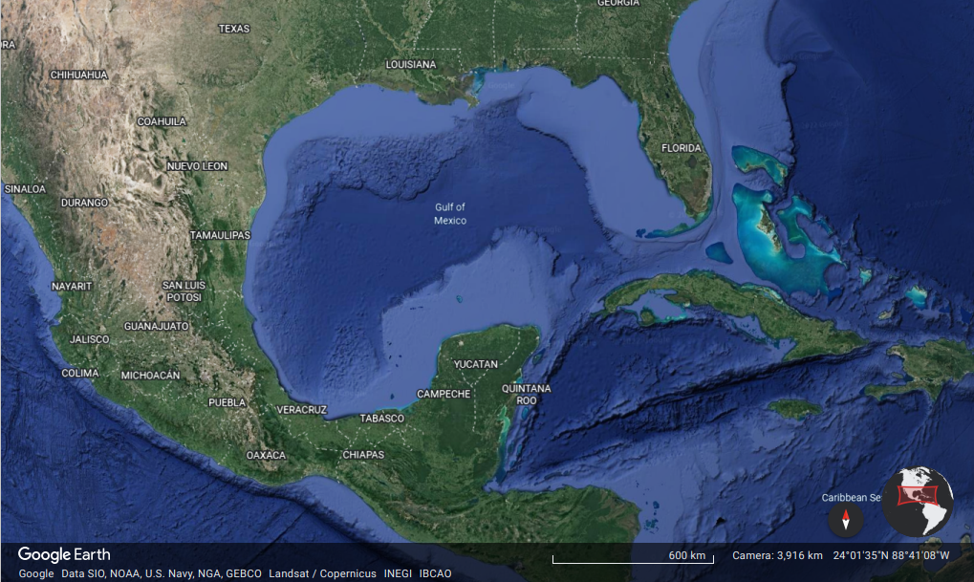
CH (n=25)
CK (n=25)
LA (n=20)
LM (n=20)
CB (n=20)

Supplementary Figure 1. Location of the 5 study estuaries (stars) throughout the northern Gulf of Mexico. 465 Regions include Laguna Madre, TX (LM), Corpus Christi Bay, TX (CB), the northern extent of 466 the Chandeleur Islands (LA), Cedar Key, FL (CK), and Charlotte Harbor, FL (CH). n represents 467 the number of sites that were sampled within each estuary during the early and late summer 468 2018. Map data © 2022 Google.

Supplementary Figure 2. Scatterplots comparing Hippolytidae shrimp abundances to drift macroalgae biomass, while accounting for seagrass cover in Corpus Christi Bay, TX (A), Charlotte Harbor, FL (B), Cedar Key, FL (C), Chandeleur Island, LA (D) and Laguna Madre, TX (E). Abundance measurements were collected from the epibenthic sled pull, which covered a 10 m² area. Only samples with greater than 75% turtle grass cover and canopy heights of 200 – 400 mm were used in this analysis.

Supplementary Figure 3. Scatterplots comparing other nonpenaeid shrimp abundances to drift macroalgae biomass, while accounting for seagrass cover in Corpus Christi Bay, TX (A), Charlotte Harbor, FL (B), Cedar Key, FL (C), Chandeleur Island, LA (D) and Laguna Madre, TX (E). Abundance measurements were collected from the epibenthic sled pull, which covered a 10 m² area. Only samples with greater than 75% turtle grass cover and canopy heights of 200 – 400 mm were used in this analysis.

