Supplemental materials of:

Potential effect of low-rise, downcast artificial lights on nocturnally migrating land birds
Sergio A. Cabrera-Cruz¹, Ronald P. Larkin², Maren E. Gimpel³, James G. Gruber³, Theodore J. Zenzal^{4,5}, Jeffrey J. Buler¹

¹ Department of Entomology and Wildlife Ecology, University of Delaware, Delaware, USA
² Illinois Natural History Survey, Prairie Research Institute, University of Illinois, Champaign, IL, USA
³ Foreman’s Branch Bird Observatory, Washington College, Chestertown, MD, USA
⁴ U.S. Geological Survey Wetland and Aquatic Research Center, Lafayette, LA, USA
⁵ School of Biological, Environmental, and Earth Sciences, University of Southern Mississippi, Hattiesburg, MS, USA

Supplementary Table 1. Environmental variables from EnvDATA used to annotate flight trajectories. Details obtained during data download.
Variable | Description | Unit | Interpolation
NCEP NARR 3D U Wind | Velocity of the east-west (zonal) component of wind. Positive values indicate west to east flow. Direction is relative to true north. | m/s | Bilinear  Z-Dimension: interpolated to animal height
NCEP NARR 3D V Wind | Velocity of the north-south (meridional) component of wind. Positive values indicate south to north flow. Direction is relative to true north. | m/s | Bilinear  Z-Dimension: interpolated to animal heigh
NCEP NARR FLX U Wind | Wind at 30m above ground
NCEP NARR FLX V Wind | Wind at 30m above ground
NCEP NARR SFC Visibility at Surface |  | m | bilinear
ASTER ASTGTM2 Elevation | Ground elevation above mean sea level | m | bilinear
NCEP NARR SFC Temperature at Surface | Air temperature. | K | bilinear
ECMWF Interim Full Daily SFC Total Cloud Cover | The proportion of the model grid cell covered by cloud. Calculated for the total atmospheric column from cloud occurring at all model levels. | (0-1) | bilinear
NCEP NARR FLX Dew Point Temperature at 2 m above Ground | The temperature at which the air will be saturated with water, given the current moisture content and pressure of the air. At the dew point temperature, relative humidity is 100 percent. | K | No data values: NaN (interpolated)  Interpolation: bilinear

We converted air temperature and dew point temperature to estimate the height of the cloud base (in meters): (https://www.faa.gov/regulations_policies/handbooks_manuals/aviation/phak/media/14_phak_ch12.pdf):
“The relationship between dew point and temperature defines the concept of relative humidity. The dew point, given in degrees, is the temperature at which the air can hold no more moisture. When the temperature of the air is reduced to the dew point, the air is completely saturated and moisture begins to condense out of the air in the form of fog, dew, frost, clouds, rain, or snow.
As moist, unstable air rises, clouds often form at the altitude where temperature and dew point reach the same value. When lifted, unsaturated air cools at a rate of 5.4 °F per 1,000 feet and the dew point temperature decreases at a rate of 1 °F per 1,000 feet. This results in a convergence of temperature and dew point at a rate of 4.4°F. Apply the convergence rate to the reported temperature and dew point to determine the height of the cloud base.”

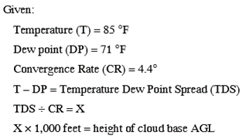

Supplementary Table 2. Number of paths with change points, and number of change points identified when our lights were on and off by season with the top three quantiles of directional change. Top: change points in XY (horizontal plane); bottom: change points in height (vertical plane).
Horizontal plane

 |  | Number of paths with change points
 |  | Spring |  | Autumn
Quantile | Paths with change points | On | Off | On | Off
90% | 715 | 206 | 308 | 117 | 84
95% | 573 | 175 | 247 | 89 | 62
99% | 242 | 73 | 97 | 42 | 30

Vertical plane

 |  | Number of paths with change points
 |  | Spring |  | Autumn
Quantile | Paths with change points | On | Off | On | Off
90% | 721 | 192 | 266 | 145 | 118
95% | 579 | 163 | 218 | 108 | 90
99% | 196 | 55 | 78 | 35 | 28

Supplementary Table 3. Analysis of variance for proximity of paths with and without horizontal change points to experimental lights in spring, by quantile.
Quantile | Source | DF | Sum of squares | Mean Squares | F | p
90% | Change points | 1 | 4.16 | 4.16 | 3.08 | 0.080
 | Lights | 1 | 7.61 | 7.61 | 5.64 | 0.018
 | Change points X Lights | 1 | 0.40 | 0.40 | 0.30 | 0.584
 | Error | 503 | 679.25 | 1.35
95% | Change points | 1 | 0.06 | 0.06 | 0.05 | 0.829
 | Lights | 1 | 8.47 | 8.47 | 6.24 | 0.013
 | Change points X Lights | 1 | 0.00 | 0.00 | 0.00 | 0.980
 | Error | 503 | 682.90 | 1.36
99% | Change points | 1 | 3.67 | 3.67 | 2.72 | 0.100
 | Lights | 1 | 9.03 | 9.03 | 6.69 | 0.010
 | Change points X Lights | 1 | 0.03 | 0.03 | 0.02 | 0.890
 | Error | 503 | 678.70 | 1.35

Supplementary Table 4. Analysis of variance for proximity of paths with and without horizontal change points to experimental lights in autumn, by quantile.
Quantile | Source | DF | Sum of squares | Mean Squares | F | p
90% | Change points | 1 | 0.01 | 0.01 | 0.01 | 0.930
 | Lights | 1 | 0.93 | 0.93 | 0.61 | 0.436
 | Change points X Lights | 1 | 0.65 | 0.65 | 0.42 | 0.515
 | Error | 578 | 887.08 | 1.53
95% | Change points | 1 | 1.91 | 1.91 | 1.25 | 0.264
 | Lights | 1 | 0.93 | 0.93 | 0.61 | 0.436
 | Change points X Lights | 1 | 0.04 | 0.04 | 0.03 | 0.870
 | Error | 578 | 885.79 | 1.53
99% | Change points | 1 | 8.44 | 8.44 | 5.55 | 0.018
 | Lights | 1 | 0.82 | 0.82 | 0.54 | 0.462
 | Change points X Lights | 1 | 1.14 | 1.14 | 0.75 | 0.386
 | Error | 578 | 878.28 | 1.52

Supplementary Table 5. Analysis of variance for proximity of paths with and without vertical change points to experimental lights in spring, by quantile.
Quantile | Source | DF | Sum of squares | Mean Squares | F | p
90% | Change points | 1 | 4.82 | 4.82 | 3.42 | 0.065
 | Lights | 1 | 8.71 | 8.71 | 6.18 | 0.013
 | Change points X Lights | 1 | 0.00 | 0.00 | 0.00 | 0.953
 | Error | 346 | 487.91 | 1.41
95% | Change points | 1 | 0.49 | 0.49 | 0.35 | 0.556
 | Lights | 1 | 9.46 | 9.46 | 6.66 | 0.010
 | Change points X Lights | 1 | 0.18 | 0.18 | 0.12 | 0.724
 | Error | 346 | 491.32 | 1.42
99% | Change points | 1 | 1.24 | 1.24 | 0.88 | 0.348
 | Lights | 1 | 9.75 | 9.75 | 6.94 | 0.009
 | Change points X Lights | 1 | 4.34 | 4.34 | 3.09 | 0.080
 | Error | 346 | 486.12 | 1.40

Supplementary Table 6. Analysis of variance for proximity of paths with and without vertical change points to experimental lights in autumn, by quantile.
Quantile | Source | DF | Sum of squares | Mean Squares | F | p
90% | Change points | 1 | 0.24 | 0.24 | 0.16 | 0.691
 | Lights | 1 | 0.59 | 0.59 | 0.39 | 0.535
 | Change points X Lights | 1 | 4.02 | 4.02 | 2.61 | 0.106
 | Error | 507 | 778.80 | 1.54
95% | Change points | 1 | 0.02 | 0.02 | 0.01 | 0.905
 | Lights | 1 | 0.57 | 0.57 | 0.37 | 0.542
 | Change points X Lights | 1 | 1.36 | 1.36 | 0.88 | 0.347
 | Error | 507 | 781.70 | 1.54
99% | Change points | 1 | 4.16 | 4.16 | 2.71 | 0.100
 | Lights | 1 | 0.59 | 0.59 | 0.39 | 0.534
 | Change points X Lights | 1 | 1.33 | 1.33 | 0.87 | 0.353
 | Error | 507 | 777.58 | 1.53

Supplementary Table 7. Analysis of variance for difference of distance of change- and non-change points to our experimental lights in the horizontal plane (change- minus non-change points) by season and lights treatment, by quantile.
Quantile | Source | DF | Sum of squares | Mean Squares | F | p
90% | Season | 1 | 614680.8 | 614680.8 | 3.3 | 0.069
 | Lights | 1 | 62076.2 | 62076.2 | 0.3 | 0.563
 | Season X Lights | 1 | 1452.1 | 1452.1 | 0.0 | 0.929
 | Error | 711 | 131634304.9 | 185139.7
95% | Season | 1 | 625807.4 | 625807.4 | 3.6 | 0.057
 | Lights | 1 | 262724.2 | 262724.2 | 1.5 | 0.217
 | Season X Lights | 1 | 8969.0 | 8969.0 | 0.1 | 0.820
 | Error | 569 | 98059362.7 | 172336.3
99% | Season | 1 | 10900.4 | 10900.4 | 0.1 | 0.815
 | Lights | 1 | 83497.2 | 83497.2 | 0.4 | 0.518
 | Season X Lights | 1 | 74017.3 | 74017.3 | 0.4 | 0.543
 | Error | 238 | 47432420.6 | 199295.9

Supplementary Table 8. Analysis of variance for difference of distance of change- and non-change points to our experimental lights in the vertical plane (change- minus non-change points) by season and lights treatment, by quantile.
Quantile | Source | DF | Sum of squares | Mean Squares | F | p
90% | Season | 1 | 69128.1 | 69128.1 | 0.4 | 0.537
 | Lights | 1 | 211238.8 | 211238.8 | 1.2 | 0.281
 | Season X Lights | 1 | 224418.4 | 224418.4 | 1.2 | 0.267
 | Error | 717 | 130135473.8 | 181500.0
95% | Season | 1 | 138759.9 | 138759.9 | 0.9 | 0.354
 | Lights | 1 | 144.7 | 144.7 | 0.0 | 0.976
 | Season X Lights | 1 | 35818.8 | 35818.8 | 0.2 | 0.637
 | Error | 575 | 92605571.5 | 161053.2
99% | Season | 1 | 2969.9 | 2969.9 | 0.0 | 0.888
 | Lights | 1 | 130470.4 | 130470.4 | 0.9 | 0.352
 | Season X Lights | 1 | 558333.9 | 558333.9 | 3.7 | 0.055
 | Error | 192 | 28815223.0 | 150079.3

Supplementary Table 9. Posterior mean values, standard errors (SE) and 80% credible intervals of binomial generalized linear model of change point occurrence in the horizontal plane of movement in relation to season and lights treatment, for three quantiles of directional change. n_eff: A measure of effective sample size. Rhat: Potential scale reduction factor (at convergence, Rhat = 1; Sturtz et al. 2005).
Model parameters
90% quantile | Mean | SD | 10% | 50% | 90% | n_eff | Rhat
Intercept | 2.31 | 0.19 | 2.07 | 2.30 | 2.55 | 3920.52 | 1.00
Season (spring) | -2.91 | 0.23 | -3.22 | -2.91 | -2.62 | 4031.90 | 1.00
Lights (on) | -0.58 | 0.26 | -0.91 | -0.57 | -0.24 | 4090.74 | 1.00
Spring X Lights on | 0.92 | 0.32 | 0.51 | 0.92 | 1.33 | 3858.07 | 1.00
95% quantile | Mean | SD | 10% | 50% | 90% | n_eff | Rhat
Intercept | 0.99 | 0.12 | 0.83 | 0.99 | 1.15 | 5762.56 | 1.00
Season (spring) | -2.04 | 0.19 | -2.28 | -2.04 | -1.79 | 5409.94 | 1.00
Lights (on) | -0.04 | 0.19 | -0.28 | -0.04 | 0.20 | 5256.26 | 1.00
Spring X Lights on | 0.38 | 0.27 | 0.03 | 0.38 | 0.73 | 4825.67 | 1.00
99% quantile | Mean | SD | 10% | 50% | 90% | n_eff | Rhat
Intercept | -0.92 | 0.12 | -1.07 | -0.92 | -0.77 | 5133.63 | 1.00
Season (spring) | -1.03 | 0.23 | -1.33 | -1.03 | -0.74 | 4617.04 | 1.00
Lights (on) | 0.07 | 0.18 | -0.17 | 0.07 | 0.30 | 4840.96 | 1.00
Spring X Lights on | 0.19 | 0.32 | -0.21 | 0.19 | 0.59 | 4306.62 | 1.00

Supplementary Table 10. Posterior mean values, standard errors (SE) and 80% credible intervals of binomial generalized linear model of change point occurrence in the vertical plane of movement in relation to season and lights treatment, for three quantiles of directional change. n_eff: A measure of effective sample size. Rhat: Potential scale reduction factor (at convergence, Rhat = 1; Sturtz et al. 2005).
Model parameters
90% quantile | Mean | SD | 10% | 50% | 90% | n_eff | Rhat
Intercept | 2.13 | 0.19 | 1.89 | 2.12 | 2.37 | 5120.81 | 1.00
Season (spring) | -1.18 | 0.25 | -1.51 | -1.18 | -0.86 | 4847.71 | 1.00
Lights (on) | 0.10 | 0.30 | -0.27 | 0.10 | 0.49 | 4651.01 | 1.00
Spring X Lights on | 0.21 | 0.38 | -0.28 | 0.22 | 0.71 | 4324.51 | 1.00
90% quantile | Mean | SD | 10% | 50% | 90% | n_eff | Rhat
Intercept | 1.01 | 0.13 | 0.84 | 1.01 | 1.18 | 5543.41 | 1.00
Season (spring) | -0.81 | 0.20 | -1.07 | -0.81 | -0.55 | 4994.64 | 1.00
Lights (on) | 0.18 | 0.21 | -0.10 | 0.18 | 0.44 | 4802.82 | 1.00
Spring X Lights on | -0.05 | 0.30 | -0.43 | -0.05 | 0.34 | 4253.65 | 1.00
90% quantile | Mean | SD | 10% | 50% | 90% | n_eff | Rhat
Intercept | -1.04 | 0.13 | -1.21 | -1.04 | -0.87 | 5408.80 | 1.00
Season (spring) | -0.55 | 0.25 | -0.88 | -0.55 | -0.24 | 4414.66 | 1.00
Lights (on) | -0.02 | 0.20 | -0.29 | -0.02 | 0.23 | 5131.82 | 1.00
Spring X Lights on | 0.14 | 0.35 | -0.31 | 0.14 | 0.59 | 4257.96 | 1.00

Supplementary Table 11. Average probability of each reaction type in the horizontal plane of movement by season and quantile.
 |  |  | Probability
Season | Quantile | Reaction | Off | On
Spring | 90% | Towards | 0.09 | 0.09
 |  | Ascend | 0.49 | 0.55
 |  | Away | 0.07 | 0.09
 |  | Descend | 0.35 | 0.27
 |  | Neutral | 0 | 0
 | 95% | Towards | 0.12 | 0.12
 |  | Ascend | 0.49 | 0.57
 |  | Away | 0.09 | 0.1
 |  | Descend | 0.3 | 0.21
 | 99% | Towards | 0.19 | 0.2
 |  | Ascend | 0.48 | 0.53
 |  | Away | 0.15 | 0.16
 |  | Descend | 0.18 | 0.11
Autumn | 90% | Towards | 0.07 | 0.06
 |  | Ascend | 0.57 | 0.63
 |  | Away | 0.05 | 0.04
 |  | Descend | 0.3 | 0.27
 |  | Neutral | 0 | 0
 | 95% | Towards | 0.09 | 0.07
 |  | Ascend | 0.56 | 0.62
 |  | Away | 0.08 | 0.06
 |  | Descend | 0.27 | 0.26
 |  | Neutral | 0 | 0
 | 99% | Towards | 0.11 | 0.08
 |  | Ascend | 0.46 | 0.48
 |  | Away | 0.14 | 0.14
 |  | Descend | 0.29 | 0.29

Supplementary Table 12. Regression statistics of the multinomial model of reactions in the horizontal plane in autumn compared to a baseline of reactions towards the lights and to the lights-off treatment, by quantile. Top panel shows the coefficients of the model in the form of log odds, bottom panel shows p-values derived from z-tests (see main text).
Coefficients
Quantile | Predictor | Intercept | Lights on | Slant range
90% | Ascend | 0.049 | 0.295 | 2.004
 | Away | -1.033 | -0.142 | 0.911
 | Descend | 0.79 | 0.049 | 0.791
 | Neutral | -8.249 | 7.318 | -8.914
95% | Ascend | 0.032 | 0.401 | 1.779
 | Away | -0.709 | -0.037 | 0.698
 | Descend | 0.659 | 0.221 | 0.586
 | Neutral | -5.721 | 3.675 | -5.499
99% | Ascend | -0.604 | 0.394 | 1.975
 | Away | -0.839 | 0.333 | 1.194
 | Descend | -0.142 | 0.342 | 1.212
p-values
Quantile | Predictor | Intercept | Lights on | Slant range
90% | Ascend | 0.742 | 0.011 | 0
 | Away | 0 | 0.412 | 0.002
 | Descend | 0 | 0.673 | 0
 | Neutral | 0.725 | 0.754 | 0.163
95% | Ascend | 0.875 | 0.013 | 0
 | Away | 0.009 | 0.868 | 0.047
 | Descend | 0.001 | 0.179 | 0.032
 | Neutral | 0.327 | 0.502 | 0.425
99% | Ascend | 0.193 | 0.29 | 0.001
 | Away | 0.114 | 0.437 | 0.071
 | Descend | 0.759 | 0.361 | 0.042

Supplementary Table 13. Regression statistics of the multinomial model of reactions in the horizontal plane in spring compared to a baseline of reactions towards the lights and to the lights-off treatment, by quantile. Top panel shows the coefficients of the model in the form of log odds, bottom panel shows p-values derived from z-tests (see main text).
Coefficients
Quantile | Predictor | Intercept | Lights on | Slant range
90% | Ascend | 0.878 | 0.144 | 0.486
 | Away | -1.144 | 0.287 | 0.54
 | Descend | 1.986 | -0.26 | -0.477
 | Neutral | -3.015 | -6.665 | -0.14
95% | Ascend | 0.947 | 0.2 | 0.261
 | Away | -0.862 | 0.217 | 0.313
 | Descend | 2.107 | -0.346 | -0.873
99% | Ascend | 1.058 | 0.021 | -0.071
 | Away | 0.215 | -0.062 | -0.253
 | Descend | 1.445 | -0.669 | -1.025
p-values
Quantile | Predictor | Intercept | Lights on | Slant range
90% | Ascend | 0 | 0.417 | 0.001
 | Away | 0 | 0.248 | 0.006
 | Descend | 0 | 0.154 | 0.002
 | Neutral | 0.04 | 0.659 | 0.902
95% | Ascend | 0.001 | 0.394 | 0.14
 | Away | 0.032 | 0.506 | 0.192
 | Descend | 0 | 0.167 | 0
99% | Ascend | 0.034 | 0.963 | 0.8
 | Away | 0.729 | 0.911 | 0.481
 | Descend | 0.016 | 0.228 | 0.012

Supplementary Table 14. Average probability of each reaction type in the vertical plane of movement by season and quantile.
 |  |  | Probability
Season | Quantile | Reaction | Off | On
Spring | 90% | Neutral | 0.02 | 0.02
 |  | Ascend | 0.51 | 0.53
 |  | Descend | 0.47 | 0.45
 | 95% | Neutral | 0.01 | 0.02
 |  | Ascend | 0.48 | 0.54
 |  | Descend | 0.5 | 0.44
 | 99% | Neutral | 0 | 0.02
 |  | Ascend | 0.44 | 0.44
 |  | Descend | 0.56 | 0.54
Autumn | 90% | Neutral | 0.02 | 0.02
 |  | Ascend | 0.46 | 0.49
 |  | Descend | 0.52 | 0.48
 | 95% | Neutral | 0.02 | 0.02
 |  | Ascend | 0.44 | 0.47
 |  | Descend | 0.54 | 0.51
 | 99% | Neutral | 0.02 | 0.02
 |  | Ascend | 0.48 | 0.49
 |  | Descend | 0.51 | 0.49

Supplementary Table 15. Regression statistics of the multinomial model of reactions in the vertical plane in spring compared to a baseline of neutral reactions to lights and to the lights-off treatment, by quantile. Top panel shows the coefficients of the model in the form of log odds, bottom panel shows p-values derived from z-tests (see main text).
Coefficients
Quantile | Predictor | Intercept | Lights on | Flight altitude
90% | Climb | 3.329 | -0.173 | 0
 | Descend | 3.997 | -0.269 | -0.001
95% | Climb | 3.471 | -0.214 | 0
 | Descend | 4.075 | -0.453 | -0.001
99% | Climb | 10.445 | -7.021 | -0.001
 | Descend | 10.354 | -7.075 | 0
p-values
Quantile | Predictor | Intercept | Lights on | Flight altitude
90% | Ascend | 0 | 0.488 | 0.701
 | Descend | 0 | 0.281 | 0.122
95% | Ascend | 0 | 0.56 | 0.97
 | Descend | 0 | 0.217 | 0.346
99% | Ascend | 0 | 0 | 0.858
 | Descend | 0 | 0 | 0.972

Supplementary Table 16. Regression statistics of the multinomial model of reactions in the vertical plane in autumn compared to a baseline of neutral reactions to lights and to the lights-off treatment, by quantile. Top panel shows the coefficients of the model in the form of log odds, bottom panel shows p-values derived from z-tests (see main text).
Coefficients
Quantile | Predictor | Intercept | Lights on | Flight altitude
90% | Climb | 2.788 | -0.181 | 0.001
 | Descend | 3.501 | -0.317 | -0.001
95% | Climb | 2.589 | 0.023 | 0.002
 | Descend | 3.205 | -0.099 | 0.001
99% | Climb | 1.887 | -0.23 | 0.005
 | Descend | 2.607 | -0.294 | 0.003
p-values
Quantile | Predictor | Intercept | Lights on | Flight altitude
90% | Ascend | 0 | 0.335 | 0.406
 | Descend | 0 | 0.089 | 0.595
95% | Ascend | 0 | 0.937 | 0.195
 | Descend | 0 | 0.731 | 0.519
99% | Ascend | 0.038 | 0.699 | 0.188
 | Descend | 0.004 | 0.619 | 0.421

Supplementary Table 17. Posterior mean values, standard errors (SE) and 80% credible intervals of binomial generalized linear model of change points in the horizontal plane of movement in relation to listed predictors in spring migration season, for three quantiles of directional change. n_eff: A measure of effective sample size. Rhat: Potential scale reduction factor (at convergence, Rhat = 1; Sturtz et al. 2005).
Model parameters
90% quantile | Mean | SD | 10% | 50% | 90% | n_eff | Rhat
Intercept | -0.03 | 0.15 | -0.22 | -0.03 | 0.15 | 5944 | 1.00
Distance to lights | -0.23 | 0.12 | -0.37 | -0.23 | -0.08 | 6414 | 1.00
Flight altitude | -0.03 | 0.11 | -0.18 | -0.03 | 0.11 | 7038 | 1.00
Dist to structures | 0.07 | 0.11 | -0.07 | 0.07 | 0.21 | 7220 | 1.00
Minutes to sunrise | 0.03 | 0.11 | -0.11 | 0.03 | 0.17 | 6106 | 1.00
Height difference | 0.06 | 0.11 | -0.08 | 0.06 | 0.20 | 7155 | 1.00
Wind support | -0.35 | 0.14 | -0.53 | -0.34 | -0.16 | 5737 | 1.00
Cross wind | 0.15 | 0.12 | 0.00 | 0.15 | 0.31 | 6528 | 1.00
Visibility | -0.10 | 0.15 | -0.29 | -0.10 | 0.09 | 5684 | 1.00
Cloud cover | -0.30 | 0.28 | -0.67 | -0.30 | 0.06 | 5279 | 1.00
Base cloud height | 0.13 | 0.14 | -0.05 | 0.13 | 0.31 | 5613 | 1.00
Moon illumination | 0.21 | 0.19 | -0.04 | 0.21 | 0.46 | 5291 | 1.00
Distance to structures X Visibility | -0.21 | 0.11 | -0.35 | -0.21 | -0.07 | 6971 | 1.00
Distance to lights X Visibility | -0.10 | 0.15 | -0.29 | -0.10 | 0.09 | 6327 | 1.00
Distance to lights X Cloud cover | -0.14 | 0.15 | -0.33 | -0.13 | 0.06 | 7071 | 1.00
Cloud cover X Moon illumination | 0.02 | 0.27 | -0.32 | 0.02 | 0.37 | 5347 | 1.00
95% quantile | Mean | SD | 10% | 50% | 90% | n_eff | Rhat
Intercept | 0.00 | 0.16 | -0.21 | 0.00 | 0.20 | 6131 | 1.00
Distance to lights | -0.21 | 0.12 | -0.37 | -0.21 | -0.05 | 6802 | 1.00
Flight altitude | 0.02 | 0.12 | -0.13 | 0.02 | 0.18 | 6618 | 1.00
Dist to structures | 0.06 | 0.12 | -0.10 | 0.06 | 0.21 | 6711 | 1.00
Minutes to sunrise | 0.03 | 0.12 | -0.13 | 0.03 | 0.18 | 6024 | 1.00
Height difference | 0.03 | 0.12 | -0.12 | 0.03 | 0.19 | 6960 | 1.00
Wind support | -0.14 | 0.15 | -0.33 | -0.14 | 0.06 | 6056 | 1.00
Cross wind | 0.21 | 0.13 | 0.03 | 0.21 | 0.38 | 6638 | 1.00
Visibility | -0.08 | 0.16 | -0.29 | -0.08 | 0.12 | 6168 | 1.00
Cloud cover | -0.21 | 0.29 | -0.59 | -0.21 | 0.17 | 5459 | 1.00
Base cloud height | 0.05 | 0.14 | -0.14 | 0.05 | 0.23 | 6389 | 1.00
Moon illumination | 0.12 | 0.21 | -0.15 | 0.12 | 0.38 | 5254 | 1.00
Distance to structures X Visibility | -0.10 | 0.11 | -0.24 | -0.10 | 0.05 | 7187 | 1.00
Distance to lights X Visibility | -0.12 | 0.16 | -0.33 | -0.12 | 0.09 | 6466 | 1.00
Distance to lights X Cloud cover | -0.05 | 0.16 | -0.26 | -0.05 | 0.16 | 6223 | 1.00
Cloud cover X Moon illumination | 0.00 | 0.29 | -0.37 | 0.00 | 0.36 | 5799 | 1.00
99% quantile | Mean | SD | 10% | 50% | 90% | n_eff | Rhat
Intercept | -0.03 | 0.31 | -0.42 | -0.03 | 0.37 | 5672 | 1.00
Distance to lights | 0.09 | 0.20 | -0.16 | 0.09 | 0.35 | 7283 | 1.00
Flight altitude | -0.19 | 0.21 | -0.45 | -0.19 | 0.07 | 6965 | 1.00
Dist to structures | -0.30 | 0.20 | -0.55 | -0.29 | -0.04 | 6855 | 1.00
Minutes to sunrise | 0.02 | 0.20 | -0.24 | 0.02 | 0.28 | 7172 | 1.00
Height difference | 0.08 | 0.20 | -0.18 | 0.08 | 0.34 | 7115 | 1.00
Wind support | -0.33 | 0.25 | -0.65 | -0.32 | -0.01 | 5743 | 1.00
Cross wind | 0.44 | 0.23 | 0.16 | 0.44 | 0.74 | 6629 | 1.00
Visibility | -0.13 | 0.27 | -0.47 | -0.12 | 0.21 | 6214 | 1.00
Cloud cover | -0.37 | 0.52 | -1.04 | -0.36 | 0.29 | 5693 | 1.00
Base cloud height | -0.02 | 0.25 | -0.34 | -0.02 | 0.30 | 5716 | 1.00
Moon illumination | 0.30 | 0.40 | -0.20 | 0.30 | 0.80 | 5329 | 1.00
Distance to structures X Visibility | -0.14 | 0.19 | -0.38 | -0.14 | 0.10 | 7211 | 1.00
Distance to lights X Visibility | 0.28 | 0.33 | -0.14 | 0.28 | 0.71 | 5913 | 1.00
Distance to lights X Cloud cover | 0.13 | 0.36 | -0.33 | 0.12 | 0.59 | 6325 | 1.00
Cloud cover X Moon illumination | 0.01 | 0.53 | -0.66 | 0.02 | 0.67 | 5372 | 1.00

Supplementary Table 18. Posterior mean values, standard errors (SE) and 80% credible intervals of binomial generalized linear models of change points in the horizontal plane of movement in relation to listed predictors in autumn migration season, for three quantiles of directional change. n_eff: A measure of effective sample size. Rhat: Potential scale reduction factor (at convergence, Rhat = 1; Sturtz et al. 2005).
Model parameters
90% quantile | Mean | SD | 10% | 50% | 90% | n_eff | Rhat
Intercept | -0.03 | 0.15 | -0.22 | -0.03 | 0.17 | 6639 | 1.00
Distance to lights | 0.02 | 0.18 | -0.21 | 0.02 | 0.25 | 6777 | 1.00
Flight altitude | 0.05 | 0.20 | -0.20 | 0.05 | 0.30 | 7216 | 1.00
Dist to structures | -0.12 | 0.15 | -0.31 | -0.13 | 0.06 | 6509 | 1.00
Minutes to sunrise | 0.01 | 0.14 | -0.18 | 0.01 | 0.19 | 7256 | 1.00
Height difference | 0.01 | 0.15 | -0.19 | 0.01 | 0.21 | 6563 | 1.00
Wind support | -0.11 | 0.18 | -0.35 | -0.11 | 0.12 | 7441 | 1.00
Cross wind | 0.04 | 0.15 | -0.15 | 0.04 | 0.24 | 6229 | 1.00
Visibility | -0.04 | 0.23 | -0.33 | -0.04 | 0.25 | 6479 | 1.00
Cloud cover | -0.02 | 0.17 | -0.24 | -0.02 | 0.19 | 6837 | 1.00
Base cloud height | 0.00 | 0.24 | -0.31 | 0.00 | 0.29 | 6893 | 1.00
Moon illumination | 0.05 | 0.22 | -0.23 | 0.05 | 0.33 | 6739 | 1.00
Distance to structures X Visibility | -0.09 | 0.16 | -0.29 | -0.09 | 0.11 | 6886 | 1.00
Distance to lights X Visibility | -0.07 | 0.21 | -0.33 | -0.07 | 0.19 | 6804 | 1.00
Distance to lights X Cloud cover | 0.10 | 0.17 | -0.12 | 0.10 | 0.31 | 6869 | 1.00
Cloud cover X Moon illumination | 0.06 | 0.19 | -0.18 | 0.06 | 0.29 | 6439 | 1.00
95% quantile | Mean | SD | 10% | 50% | 90% | n_eff | Rhat
Intercept | 0.06 | 0.18 | -0.16 | 0.06 | 0.29 | 7127 | 1.00
Distance to lights | 0.08 | 0.21 | -0.18 | 0.08 | 0.34 | 6445 | 1.00
Flight altitude | -0.06 | 0.26 | -0.40 | -0.06 | 0.26 | 6610 | 1.00
Dist to structures | -0.17 | 0.17 | -0.39 | -0.17 | 0.06 | 6837 | 1.00
Minutes to sunrise | 0.07 | 0.18 | -0.16 | 0.07 | 0.30 | 6846 | 1.00
Height difference | 0.05 | 0.18 | -0.18 | 0.05 | 0.28 | 5835 | 1.00
Wind support | -0.27 | 0.23 | -0.56 | -0.27 | 0.01 | 6304 | 1.00
Cross wind | -0.06 | 0.19 | -0.31 | -0.06 | 0.17 | 6397 | 1.00
Visibility | -0.05 | 0.26 | -0.38 | -0.05 | 0.28 | 6762 | 1.00
Cloud cover | -0.11 | 0.26 | -0.44 | -0.11 | 0.23 | 5553 | 1.00
Base cloud height | -0.17 | 0.36 | -0.65 | -0.16 | 0.28 | 5740 | 1.00
Moon illumination | -0.15 | 0.28 | -0.51 | -0.15 | 0.20 | 6496 | 1.00
Distance to structures X Visibility | -0.03 | 0.17 | -0.25 | -0.03 | 0.18 | 6691 | 1.00
Distance to lights X Visibility | -0.11 | 0.22 | -0.39 | -0.10 | 0.17 | 6733 | 1.00
Distance to lights X Cloud cover | -0.29 | 0.20 | -0.54 | -0.28 | -0.03 | 6902 | 1.00
Cloud cover X Moon illumination | 0.08 | 0.27 | -0.26 | 0.08 | 0.43 | 5687 | 1.00
99% quantile | Mean | SD | 10% | 50% | 90% | n_eff | Rhat
Intercept | 0.01 | 0.30 | -0.37 | 0.01 | 0.39 | 6399 | 1.00
Distance to lights | 0.19 | 0.40 | -0.31 | 0.20 | 0.70 | 6711 | 1.00
Flight altitude | 0.04 | 0.38 | -0.45 | 0.04 | 0.53 | 6538 | 1.00
Dist to structures | 0.40 | 0.31 | 0.01 | 0.39 | 0.80 | 6676 | 1.00
Minutes to sunrise | 0.31 | 0.32 | -0.11 | 0.31 | 0.72 | 6308 | 1.00
Height difference | 0.13 | 0.31 | -0.26 | 0.13 | 0.53 | 6693 | 1.00
Wind support | -0.31 | 0.39 | -0.82 | -0.30 | 0.19 | 6265 | 1.00
Cross wind | -0.08 | 0.37 | -0.56 | -0.08 | 0.40 | 6604 | 1.00
Visibility | 0.40 | 0.69 | -0.48 | 0.39 | 1.27 | 6364 | 1.00
Cloud cover | -0.72 | 0.66 | -1.57 | -0.70 | 0.11 | 5135 | 1.00
Base cloud height | -0.87 | 0.70 | -1.77 | -0.88 | 0.01 | 5655 | 1.00
Moon illumination | -0.36 | 0.50 | -0.99 | -0.36 | 0.30 | 6190 | 1.00
Distance to structures X Visibility | -0.90 | 0.51 | -1.57 | -0.83 | -0.31 | 5340 | 1.00
Distance to lights X Visibility | -0.55 | 0.47 | -1.15 | -0.54 | 0.03 | 6349 | 1.00
Distance to lights X Cloud cover | 0.27 | 0.37 | -0.20 | 0.27 | 0.73 | 7172 | 1.00
Cloud cover X Moon illumination | 0.66 | 0.55 | -0.04 | 0.66 | 1.36 | 5620 | 1.00

Supplementary Table 19. Posterior mean values, standard errors (SE) and 80% credible intervals of binomial generalized linear models of change points in the vertical plane of movement in relation to listed predictors in spring migration season, for three quantiles of directional change. n_eff: A measure of effective sample size. Rhat: Potential scale reduction factor (at convergence, Rhat = 1; Sturtz et al. 2005).
Model parameters
90% quantile | Mean | SD | 10% | 50% | 90% | n_eff | Rhat
Intercept | 0.06 | 0.15 | -0.13 | 0.06 | 0.26 | 6146 | 1.00
Distance to lights | -0.30 | 0.12 | -0.45 | -0.29 | -0.15 | 6052 | 1.00
Flight altitude | 0.05 | 0.13 | -0.11 | 0.05 | 0.22 | 6244 | 1.00
Dist to structures | -0.13 | 0.11 | -0.27 | -0.13 | 0.01 | 7016 | 1.00
Minutes to sunrise | 0.01 | 0.12 | -0.14 | 0.01 | 0.16 | 6429 | 1.00
Height difference | 0.04 | 0.11 | -0.10 | 0.05 | 0.19 | 7168 | 1.00
Wind support | -0.12 | 0.17 | -0.34 | -0.12 | 0.10 | 5841 | 1.00
Cross wind | 0.05 | 0.12 | -0.12 | 0.05 | 0.21 | 6354 | 1.00
Visibility | -0.04 | 0.15 | -0.24 | -0.03 | 0.16 | 6023 | 1.00
Cloud cover | 0.03 | 0.31 | -0.37 | 0.02 | 0.42 | 4512 | 1.00
Base cloud height | 0.07 | 0.16 | -0.13 | 0.07 | 0.28 | 5961 | 1.00
Moon illumination | -0.05 | 0.19 | -0.30 | -0.05 | 0.20 | 4760 | 1.00
Distance to structures X Visibility | -0.02 | 0.10 | -0.16 | -0.02 | 0.11 | 7275 | 1.00
Distance to lights X Visibility | -0.24 | 0.16 | -0.44 | -0.24 | -0.04 | 6257 | 1.00
Distance to lights X Cloud cover | -0.22 | 0.17 | -0.44 | -0.23 | -0.01 | 6111 | 1.00
Cloud cover X Moon illumination | -0.16 | 0.33 | -0.58 | -0.16 | 0.26 | 5102 | 1.00
95% quantile | Mean | SD | 10% | 50% | 90% | n_eff | Rhat
Intercept | 0.02 | 0.17 | -0.20 | 0.02 | 0.24 | 7025 | 1.00
Distance to lights | -0.40 | 0.13 | -0.57 | -0.40 | -0.24 | 6827 | 1.00
Flight altitude | 0.04 | 0.13 | -0.13 | 0.04 | 0.21 | 6858 | 1.00
Dist to structures | -0.09 | 0.13 | -0.25 | -0.09 | 0.08 | 7093 | 1.00
Minutes to sunrise | -0.04 | 0.13 | -0.20 | -0.04 | 0.13 | 6920 | 1.00
Height difference | 0.01 | 0.13 | -0.15 | 0.01 | 0.17 | 6968 | 1.00
Wind support | 0.04 | 0.17 | -0.18 | 0.05 | 0.27 | 7018 | 1.00
Cross wind | -0.15 | 0.13 | -0.32 | -0.15 | 0.01 | 6972 | 1.00
Visibility | 0.07 | 0.16 | -0.13 | 0.07 | 0.28 | 7001 | 1.00
Cloud cover | 0.20 | 0.32 | -0.22 | 0.20 | 0.61 | 6206 | 1.00
Base cloud height | -0.01 | 0.18 | -0.24 | -0.01 | 0.21 | 6632 | 1.00
Moon illumination | -0.16 | 0.21 | -0.42 | -0.16 | 0.10 | 6164 | 1.00
Distance to structures X Visibility | -0.06 | 0.11 | -0.21 | -0.06 | 0.08 | 7040 | 1.00
Distance to lights X Visibility | 0.02 | 0.18 | -0.21 | 0.02 | 0.24 | 7236 | 1.00
Distance to lights X Cloud cover | 0.02 | 0.18 | -0.21 | 0.02 | 0.25 | 7152 | 1.00
Cloud cover X Moon illumination | -0.09 | 0.34 | -0.52 | -0.09 | 0.35 | 6242 | 1.00
99% quantile | Mean | SD | 10% | 50% | 90% | n_eff | Rhat
Intercept | 0.02 | 0.37 | -0.47 | 0.02 | 0.49 | 5907 | 1.00
Distance to lights | -0.53 | 0.25 | -0.86 | -0.53 | -0.22 | 6561 | 1.00
Flight altitude | 0.11 | 0.31 | -0.29 | 0.11 | 0.51 | 6635 | 1.00
Dist to structures | -0.06 | 0.23 | -0.35 | -0.06 | 0.24 | 6852 | 1.00
Minutes to sunrise | 0.06 | 0.25 | -0.26 | 0.06 | 0.38 | 6717 | 1.00
Height difference | 0.03 | 0.23 | -0.26 | 0.04 | 0.32 | 7304 | 1.00
Wind support | -0.06 | 0.44 | -0.63 | -0.06 | 0.51 | 6125 | 1.00
Cross wind | 0.14 | 0.27 | -0.20 | 0.14 | 0.49 | 6287 | 1.00
Visibility | -0.02 | 0.35 | -0.47 | -0.03 | 0.42 | 5962 | 1.00
Cloud cover | -0.04 | 0.91 | -1.21 | -0.04 | 1.11 | 5181 | 1.00
Base cloud height | -0.04 | 0.37 | -0.52 | -0.03 | 0.43 | 6184 | 1.00
Moon illumination | 0.00 | 0.41 | -0.52 | 0.00 | 0.53 | 5518 | 1.00
Distance to structures X Visibility | -0.31 | 0.21 | -0.59 | -0.30 | -0.04 | 6898 | 1.00
Distance to lights X Visibility | -0.17 | 0.38 | -0.65 | -0.17 | 0.31 | 5965 | 1.00
Distance to lights X Cloud cover | -0.10 | 0.37 | -0.57 | -0.10 | 0.35 | 6580 | 1.00
Cloud cover X Moon illumination | -0.05 | 0.83 | -1.10 | -0.06 | 1.02 | 5537 | 1.00

Supplementary Table 20. Posterior mean values, standard errors (SE) and 80% credible intervals of binomial generalized linear models of change points in the vertical plane of movement in relation to listed predictors in autumn migration season, for three quantiles of directional change. n_eff: A measure of effective sample size. Rhat: Potential scale reduction factor (at convergence, Rhat = 1; Sturtz et al. 2005).
Model parameters
90% quantile | Mean | SD | 10% | 50% | 90% | n_eff | Rhat
Intercept | -0.01 | 0.14 | -0.19 | -0.01 | 0.17 | 6603 | 1.00
Distance to lights | -0.23 | 0.15 | -0.42 | -0.23 | -0.04 | 6246 | 1.00
Flight altitude | 0.11 | 0.16 | -0.09 | 0.11 | 0.31 | 6136 | 1.00
Dist to structures | -0.12 | 0.13 | -0.29 | -0.12 | 0.05 | 6443 | 1.00
Minutes to sunrise | 0.03 | 0.14 | -0.15 | 0.03 | 0.20 | 7005 | 1.00
Height difference | 0.01 | 0.15 | -0.18 | 0.00 | 0.19 | 7070 | 1.00
Wind support | -0.10 | 0.16 | -0.31 | -0.11 | 0.10 | 6373 | 1.00
Cross wind | -0.06 | 0.14 | -0.24 | -0.06 | 0.11 | 6836 | 1.00
Visibility | -0.13 | 0.29 | -0.50 | -0.13 | 0.24 | 4307 | 1.00
Cloud cover | -0.05 | 0.16 | -0.25 | -0.05 | 0.15 | 5844 | 1.00
Base cloud height | 0.13 | 0.25 | -0.19 | 0.13 | 0.46 | 4914 | 1.00
Moon illumination | 0.12 | 0.29 | -0.26 | 0.12 | 0.49 | 4183 | 1.00
Distance to structures X Visibility | -0.07 | 0.14 | -0.24 | -0.07 | 0.10 | 6899 | 1.00
Distance to lights X Visibility | 0.11 | 0.15 | -0.09 | 0.10 | 0.30 | 5390 | 1.00
Distance to lights X Cloud cover | 0.01 | 0.15 | -0.18 | 0.01 | 0.20 | 5430 | 1.00
Cloud cover X Moon illumination | -0.11 | 0.20 | -0.36 | -0.11 | 0.14 | 6563 | 1.00
95% quantile | Mean | SD | 10% | 50% | 90% | n_eff | Rhat
Intercept | -0.04 | 0.16 | -0.25 | -0.04 | 0.16 | 7183 | 1.00
Distance to lights | -0.41 | 0.18 | -0.64 | -0.42 | -0.19 | 6451 | 1.00
Flight altitude | 0.01 | 0.18 | -0.23 | 0.01 | 0.24 | 6776 | 1.00
Dist to structures | -0.08 | 0.15 | -0.28 | -0.08 | 0.12 | 6546 | 1.00
Minutes to sunrise | 0.00 | 0.16 | -0.21 | 0.00 | 0.20 | 6453 | 1.00
Height difference | -0.09 | 0.18 | -0.31 | -0.09 | 0.14 | 7097 | 1.00
Wind support | 0.04 | 0.20 | -0.21 | 0.04 | 0.29 | 6784 | 1.00
Cross wind | -0.02 | 0.16 | -0.23 | -0.02 | 0.19 | 7343 | 1.00
Visibility | -0.15 | 0.33 | -0.58 | -0.16 | 0.27 | 4820 | 1.00
Cloud cover | 0.00 | 0.18 | -0.23 | 0.00 | 0.23 | 5939 | 1.00
Base cloud height | 0.13 | 0.28 | -0.23 | 0.13 | 0.49 | 5399 | 1.00
Moon illumination | 0.11 | 0.33 | -0.31 | 0.11 | 0.52 | 4761 | 1.00
Distance to structures X Visibility | -0.08 | 0.15 | -0.26 | -0.08 | 0.11 | 7023 | 1.00
Distance to lights X Visibility | 0.16 | 0.19 | -0.09 | 0.16 | 0.41 | 5367 | 1.00
Distance to lights X Cloud cover | 0.22 | 0.18 | -0.01 | 0.22 | 0.45 | 5514 | 1.00
Cloud cover X Moon illumination | -0.06 | 0.23 | -0.35 | -0.06 | 0.23 | 6537 | 1.00
99% quantile | Mean | SD | 10% | 50% | 90% | n_eff | Rhat
Intercept | -0.29 | 0.37 | -0.77 | -0.29 | 0.17 | 6327 | 1.00
Distance to lights | -0.41 | 0.46 | -1.00 | -0.40 | 0.17 | 6718 | 1.00
Flight altitude | -0.01 | 0.44 | -0.56 | -0.01 | 0.55 | 6556 | 1.00
Dist to structures | -0.01 | 0.31 | -0.40 | -0.01 | 0.39 | 6847 | 1.00
Minutes to sunrise | -0.26 | 0.35 | -0.71 | -0.25 | 0.18 | 6731 | 1.00
Height difference | 0.06 | 0.38 | -0.42 | 0.07 | 0.55 | 6789 | 1.00
Wind support | 0.16 | 0.53 | -0.52 | 0.16 | 0.84 | 6571 | 1.00
Cross wind | 0.14 | 0.51 | -0.51 | 0.14 | 0.79 | 5413 | 1.00
Visibility | -0.77 | 0.66 | -1.61 | -0.77 | 0.06 | 5640 | 1.00
Cloud cover | -0.01 | 0.51 | -0.67 | 0.00 | 0.63 | 5868 | 1.00
Base cloud height | 0.41 | 0.69 | -0.48 | 0.41 | 1.29 | 6076 | 1.00
Moon illumination | 0.84 | 0.67 | 0.00 | 0.83 | 1.69 | 5934 | 1.00
Distance to structures X Visibility | -0.09 | 0.38 | -0.57 | -0.09 | 0.39 | 6297 | 1.00
Distance to lights X Visibility | 0.61 | 0.54 | -0.07 | 0.59 | 1.31 | 6325 | 1.00
Distance to lights X Cloud cover | 1.12 | 0.47 | 0.53 | 1.11 | 1.72 | 6559 | 1.00
Cloud cover X Moon illumination | 0.25 | 0.55 | -0.45 | 0.25 | 0.95 | 6116 | 1.00

Supplementary Table 21. Captures in mist nets at each of our site by season.
Season | Autumn 2016 | Spring 2017 |  |  |  | Autumn 2017
Site | FBBO | FBBO | NB | HG | FBBO |  | NB
Bird-banding effort
Total mist netting days | 52 | 53 | 53 | 43 | 56 |  | 51
Total mist netting hours | 2668 | 2612 | 3816 | 2797 | 3089 |  | 3246
Capture totals
Total captured birds | 2009 | 1657 | 758 | 964 | 1592 |  | 933
Total species | 71 | 63 | 65 | 65 | 76 |  | 62
Total Passerines | 1973 | 1624 | 753 | 952 | 1574 |  | 919
Total Passerine species | 65 | 56 | 62 | 60 | 69 |  | 58
Passerines, new captures only | 983 | 586 | 596 | 763 | 647 |  | 812
Passerines, new, night migrants | 787 | 528 | 535 | 718 | 600 |  | 712
Capture by age of night migrants
Young of the season (HY in autumn, SY in spring) | 583 | 318 | 98 | 241 | 480 |  | 568
Adults (AHY in autumn, ASY in spring) | 203 | 203 | 159 | 2 | 120 |  | 143
Age unknown (unknown or AHY in spring) | 1 | 7 | 278 | 475 | 0 |  | 1

Supplementary Table 22. Analysis of variance for differences in capture rates between lights treatment by season at our study site.
Source | DF | Sum of squares | Mean Squares | F | p
Season | 1 | 0.05 | 0.05 | 1.40 | 0.255
Error | 15 | 0.56 | 0.04

Supplementary Table 23. Analysis of variance for differences in capture rates between lights treatment by season and age group at our study site.
Source | DF | Sum of squares | Mean Squares | F | p
Season | 1 | 0.03 | 0.03 | 2.07 | 0.161
Age group | 1 | 0.02 | 0.02 | 1.57 | 0.221
Season X Age group | 1 | 0.01 | 0.01 | 0.48 | 0.495
Error | 29 | 0.36 | 0.01

Supplementary Table 24. Analysis of variance for differences in capture rates between experimental and control site by light treatment within trial
Source | DF | Sum of squares | Mean Squares | F | p
Site | 1 | 0.01 | 0.01 | 0.62 | 0.439
Season | 1 | 0.03 | 0.03 | 2.25 | 0.148
Site X Season | 1 | 0.00 | 0.00 | 0.27 | 0.608
Error | 22 | 0.31 | 0.01

Supplementary Table 25. Pearson correlation coefficients of distance of change points in the horizontal and vertical planes of movement to our experimental lights and to the tracking radar location in Autumn 2016 (Bluestem farms) by season and for the top three quantiles.
 | XY |  | Height
Quantile | Spring | Autumn | Spring | Autumn
99% | 0.85 | 0.91 | 0.75 | 0.85
95% | 0.78 | 0.88 | 0.77 | 0.81
90% | 0.77 | 0.86 | 0.77 | 0.82

FIGURES

Supplementary Figure 1. Distribution of artificial lights at night (ALAN) within 5km (white circles) from the centroid (white dots) of our experimental (FBBO = Foreman Branch Bird-banding Observatory) and control sites in eastern Maryland, also showing the Chesapeake Bay in blue. Intensity of ALAN (white pixels on black background) is common to all figure panels, and is based on radiance values around Harford Glen. ALAN data collected by the Luojia 1-01 satellite on July 11, 2018, available at http://59.175.109.173:8888/app/login_en.html.
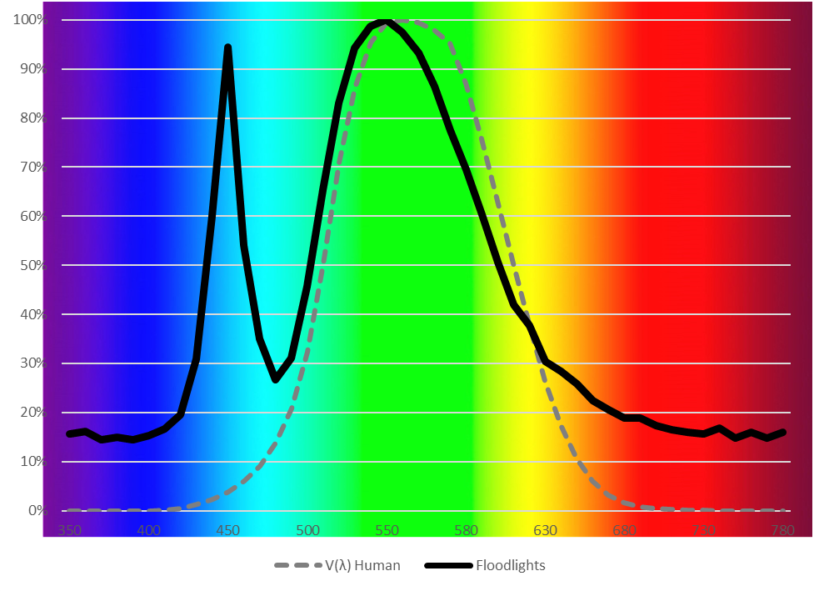

Supplementary Figure 2. Spectral composition of our experimental floodlights (continuous black line) in relation to the spectrum of human color vision (dashed gray line).

Supplementary Figure 3. Two examples of flight paths before (left) and after (right) smoothing with the function ‘TrajSmoothSG’ from the R package ‘trajr’ (McLean and Volponi 2018). Smoothed tracks also show change points (red), and location of our experimental plot (black dot). Notice how smoothing did not remove the potential behavioral reaction (change point identified in red), but reduced the overall jaggedness along the path, minimizing the probability of identifying spurious change points.

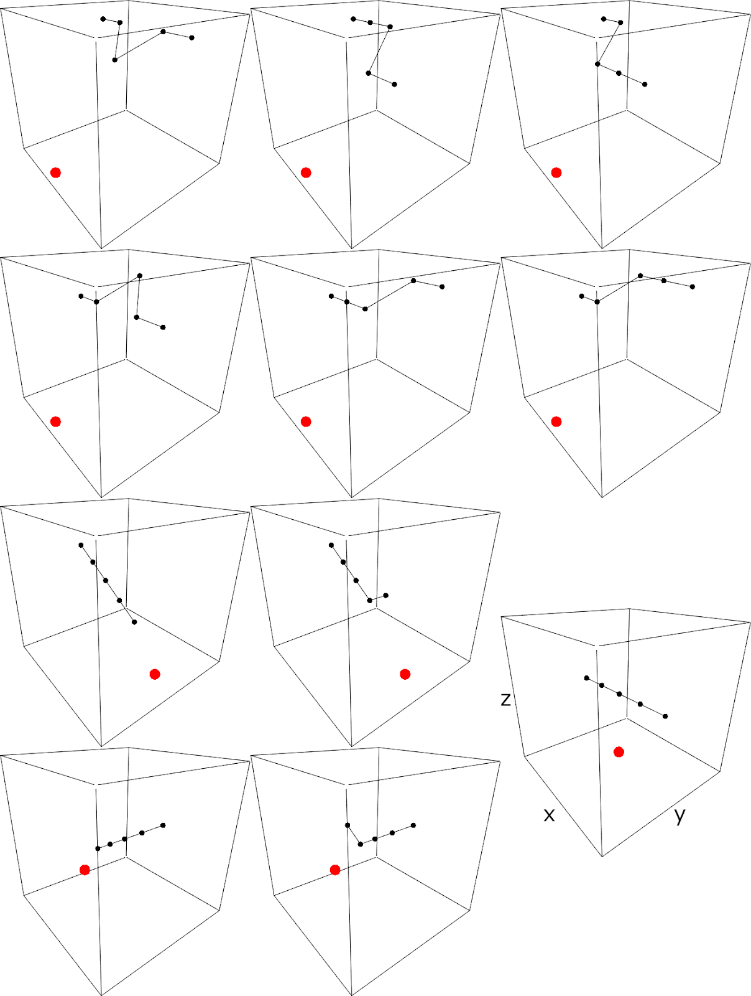

Supplementary Figure 4. Three-dimensional representation of flight paths (lines connected with dots) where the three points in the middle represent the steps of real paths used to categorize potential reactions of targets to lights (red dot), in the horizontal plane of movement. In all panels, paths move from left to right, change points are the third step (mid-point), and the immediate neighbors represent neighboring steps 3 locations away that we compared the change point to. Top three rows represent reactions towards lights; panels in second row represent reactions away. Third and fourth row represent descending and climbing reactions respectively, and panel centered to their right is a neutral change point (i.e. no discernible change in slant range of change point to lights in relation to its neighbors).

Supplementary Figure 5. Path (black line; black dot indicating starting point) with change point (circled in red). We categorized the reaction associated to this change point because our experimental lights were located to the side of the change point and path. We did not categorize reactions when lights were behind or ahead of change points (in relation to the main direction of movement of the path; gray areas in in this example). Experimental lights during the night of this particular example (April 25, 2016) were turned off.

Supplementary Figure 6. Examples of flight paths with severe irregularities (top) and patterned up-and-down oscillations (bottom), which we discarded from analysis of change points in the horizontal and vertical planes of movement respectively. X, Y, and Z-axes represent Longitude, Latitude, and Altitude respectively, with the latter scaled between zero and one.

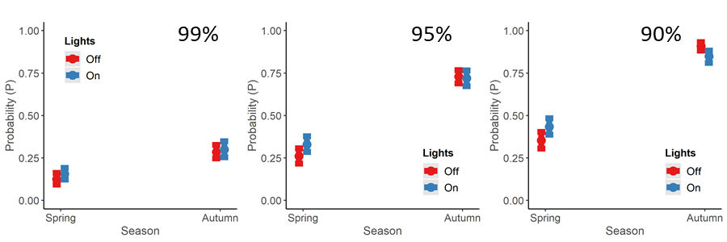

Supplementary Figure 7. Probability of change points in XY when our lights were on and off, in spring and autumn, for the top three quantiles of magnitude of directional change tested (see main text).

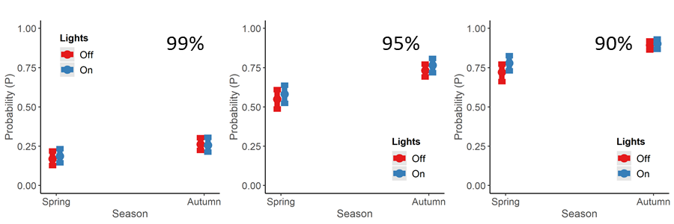

Supplementary Figure 8. Probability of change points in vertical (altitudes) when our lights were on and off, in spring and autumn, for the top three quantiles of magnitude of directional change tested (see main text).

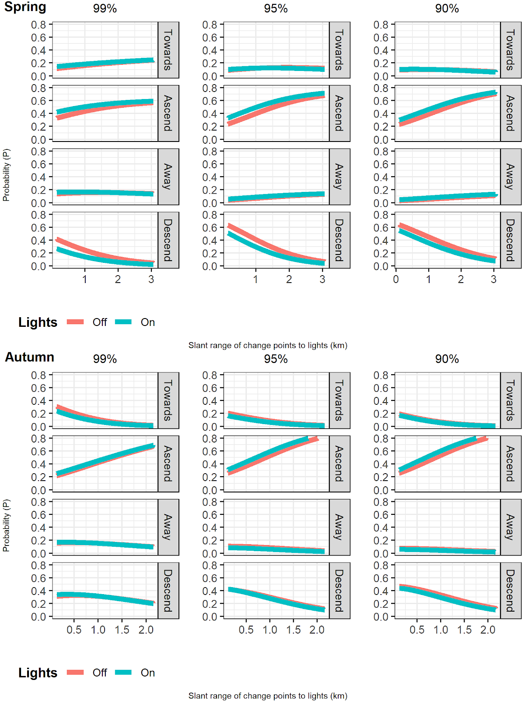

Supplementary Figure 9. Probability of reactions in the horizontal plane in relation to slant range of change points to our experimental lights.
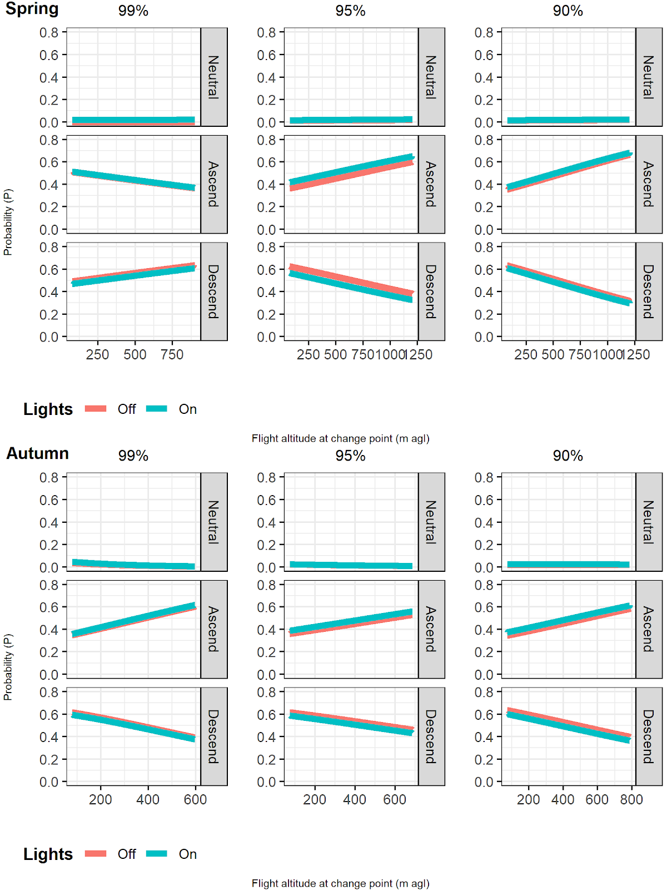

Supplementary Figure 10. Probability of reactions in the vertical plane in relation to flight altitudes of change points above ground level.
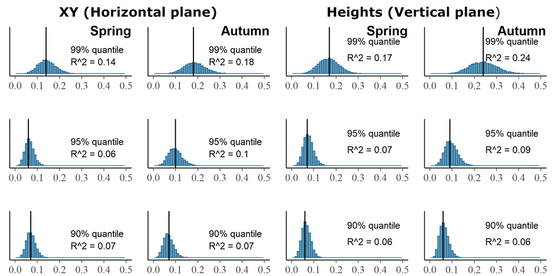

Supplementary Figure 11. Median variance explained (R²; vertical black line) by each of our seasonal models of probability of behavioral reactions in the horizontal (left) and vertical planes of movement in relation to multiple environmental predictors, by quantile of directional changes.

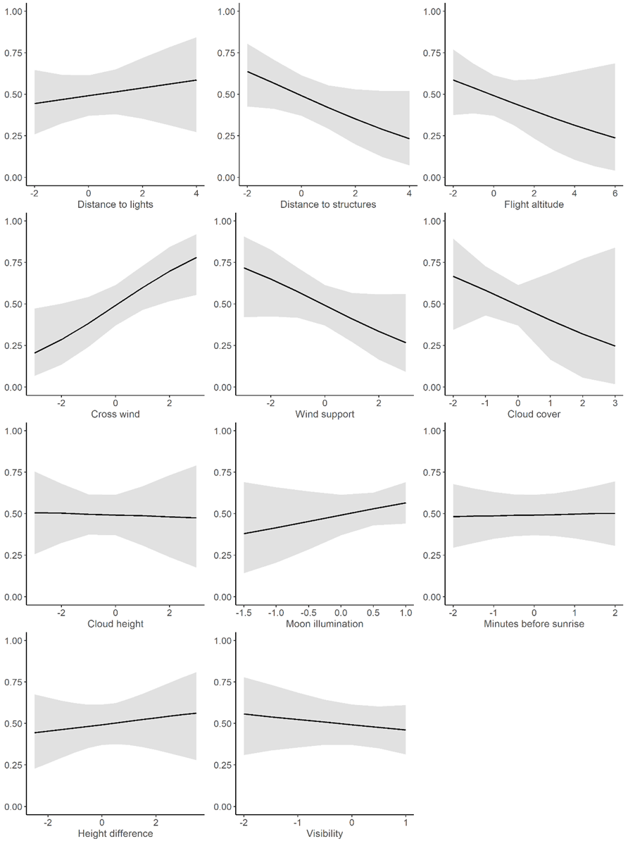

Supplementary Figure 12. Single-predictor plots of probability of occurrence (Y-axes) of change points or behavioral reactions of night-migrating birds in the horizontal plane of movement and in relation to multiple predictors in spring (standardized parameters, X-axes). Probabilities in relation to change points of the 99% quantile (see text). Gray polygons = 95% credible intervals.

Supplementary Figure 13. Probability of occurrence (Y-axes) of change points or behavioral reactions of night-migrating birds in the horizontal plane of movement and in relation to the interaction between different predictors in spring. Probabilities in relation to change points of the 99% quantile (see text).

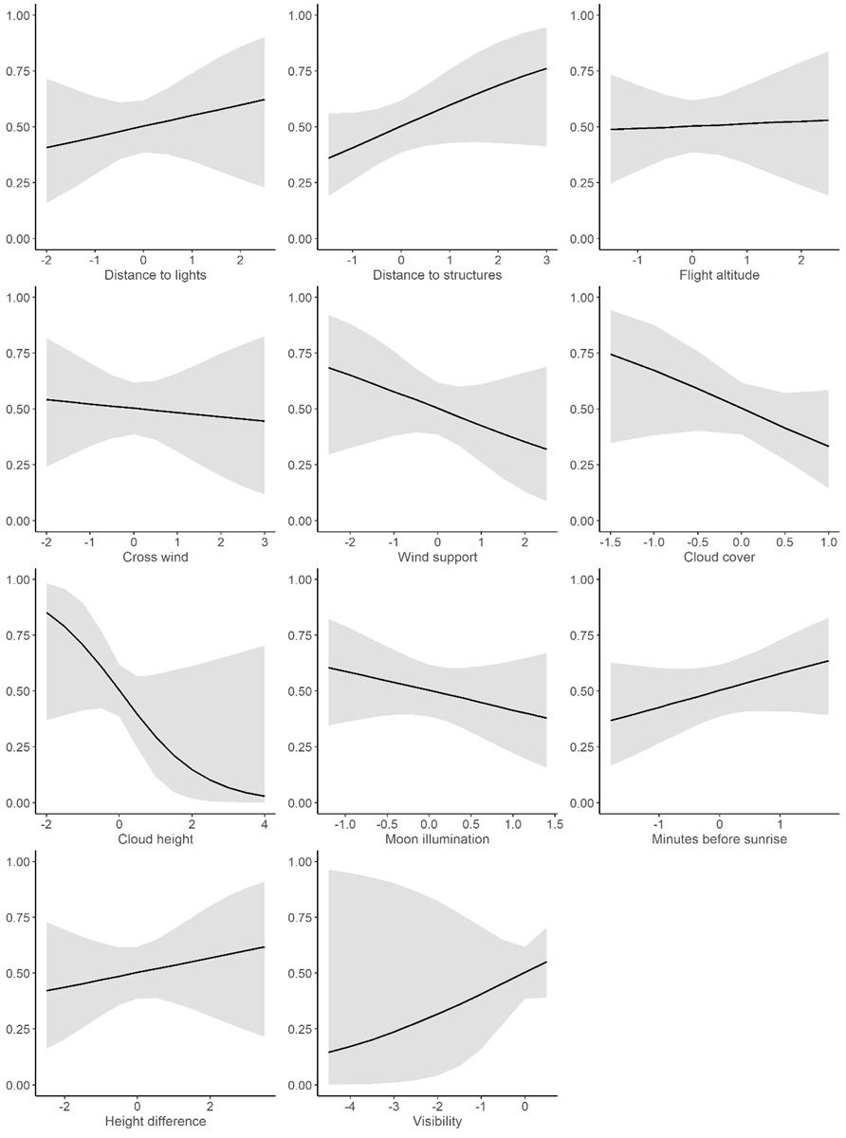

Supplementary Figure 14. Single-predictor plots of probability of occurrence (Y-axes) of change points or behavioral reactions of night-migrating birds in the horizontal plane of movement and in relation to multiple predictors in autumn (standardized parameters, X-axes). Probabilities in relation to change points of the 99% quantile (see text). Gray polygons = 95% credible intervals.

Supplementary Figure 15. Probability of occurrence (Y-axes) of change points or behavioral reactions of night-migrating birds in the horizontal plane of movement and in relation to the interaction between different predictors in autumn. Probabilities in relation to change points of the 99% quantile (see text).

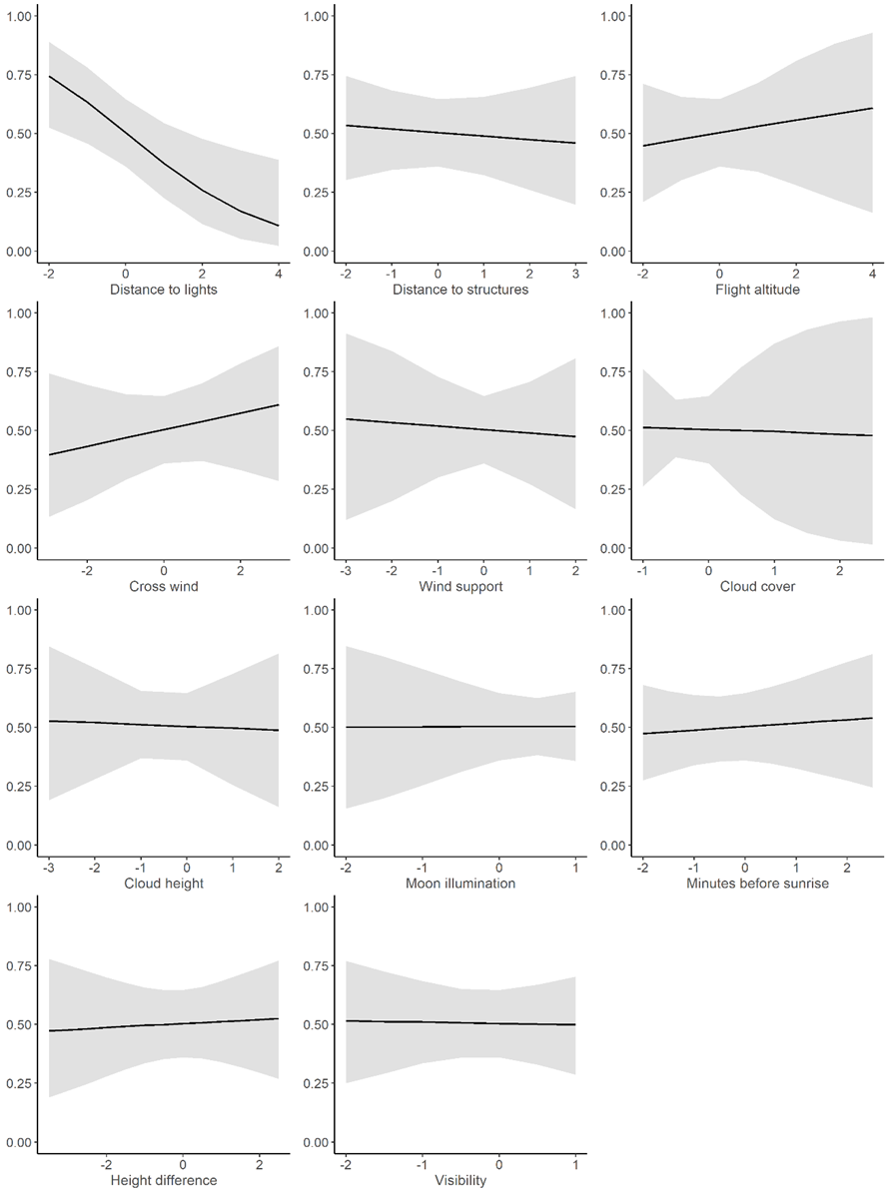

Supplementary Figure 16. Single-predictor plots of probability of occurrence (Y-axes) of change points or behavioral reactions of night-migrating birds in the vertical plane of movement and in relation to multiple predictors in spring (standardized parameters, X-axes). Probabilities in relation to change points of the 99% quantile (see text). Gray polygons = 95% credible intervals.
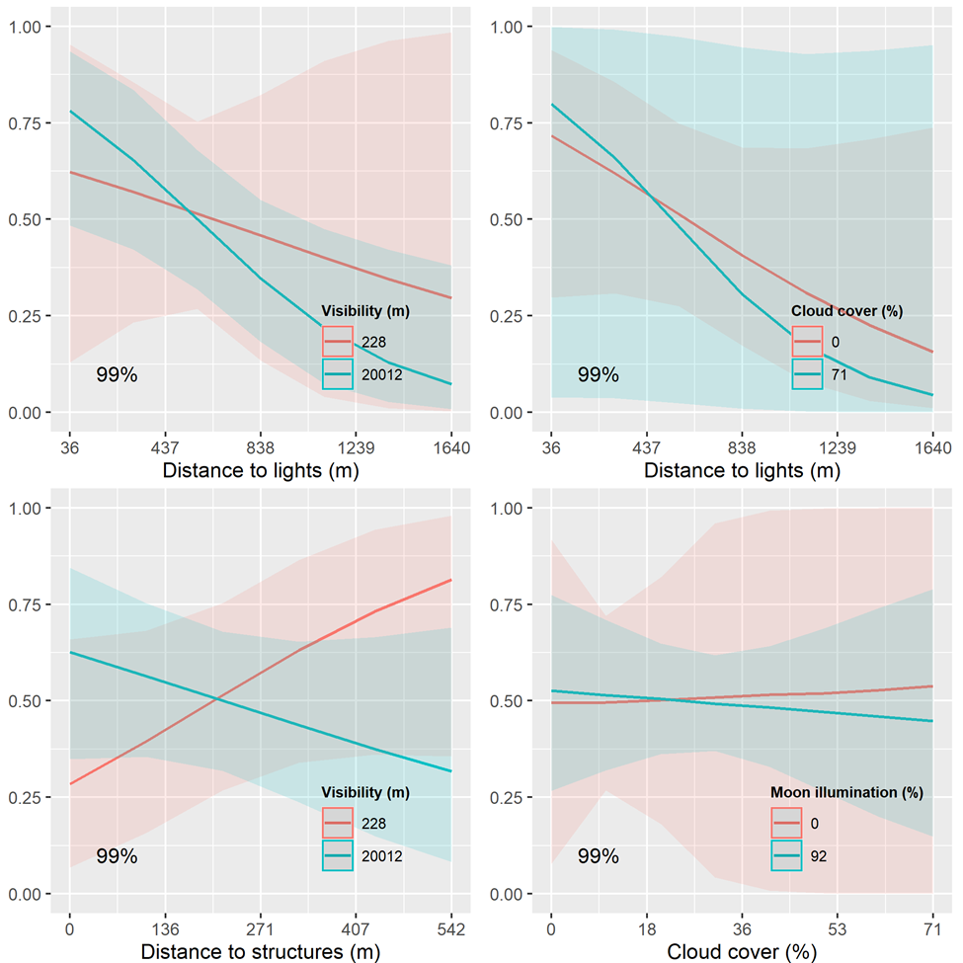

Supplementary Figure 17. Probability of occurrence (Y-axes) of change points or behavioral reactions of night-migrating birds in the vertical plane of movement and in relation to the interaction between different predictors in spring. Probabilities in relation to change points of the 99% quantile (see text).

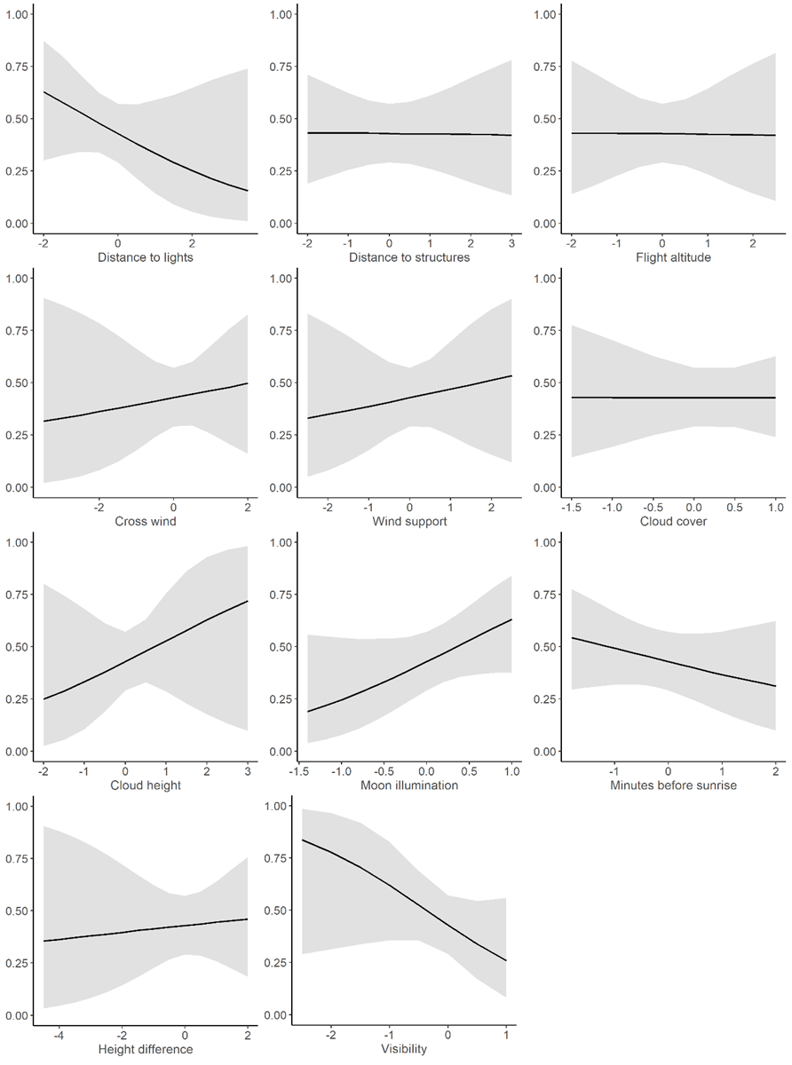

Supplementary Figure 18. Single-predictor plots of probability of occurrence (Y-axes) of change points or behavioral reactions of night-migrating birds in the vertical plane of movement and in relation to multiple predictors in autumn (standardized parameters, X-axes). Probabilities in relation to change points of the 99% quantile (see text). Gray polygons = 95% credible intervals.
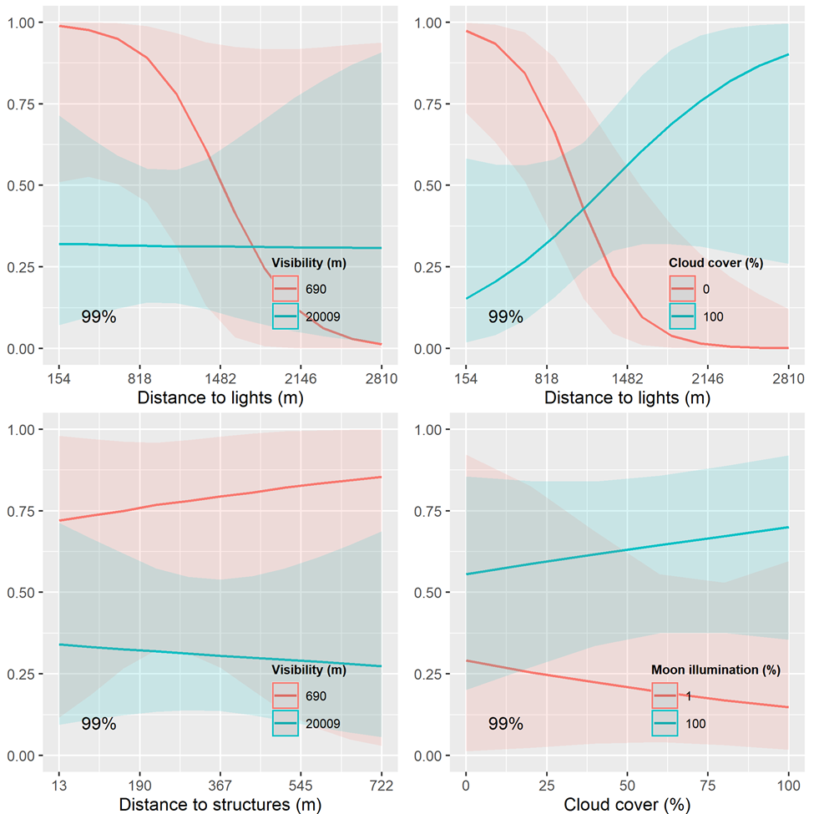

Supplementary Figure 19. Probability of occurrence (Y-axes) of change points or behavioral reactions of night-migrating birds in the vertical plane of movement and in relation to the interaction between different predictors in autumn. Probabilities in relation to change points of the 99% quantile (see text).

Literature cited
McLean DJ, Volponi MAS. 2018. trajr: An R package for characterisation of animal trajectories. Ethology 124:440–48.
Sturtz S, Ligges U, Gelman A. 2005. R2WinBUGS: A package for running WinBUGS from R. Journal of Statistical Software 12:1–16.

