**Sorption of Representative Organic Contaminants on Microplastics****: Effects of Chemical Physicochemical Properties, Particle Size, and Biofilm Presence**

Wenxuan Cui1, Robert C. Hale2, Yichao Huang1, Fengli Zhou,3 Yan Wu4, Xiaolin Liang,1 Liu, Yang,1 Hongli Tan1,5*, Da Chen1

1School of Environment, Guangdong Key Laboratory of Environmental Pollution and Health, Jinan University, Guangzhou, 510632, China

2Department of Aquatic Health Sciences, Virginia Institute of Marine Science, William & Mary, Gloucester Point, VA, 23011, USA

3Research Center of Harmful Algae and Marine Biology, Jinan University, Guangzhou, 510632, China

4School of Geographic Sciences, East China Normal University, Shanghai, 200241, China

5State Key Laboratory of Environmental and Biological Analysis, Hong Kong Baptist University, Hong Kong SAR, 999077, China

Number of pages: 7

Number of figures:2

Number of tables: 1

**\*Corresponding author: Hongli Tan**

**E-mail:** honglitan@hkbu.edu.hk

**INSTRUMENTAL ANALYSIS**

Determination of PBDEs and PCBs was conducted on a 7890B gas chromatograph interfaced with a 5977A mass spectrometer in electron capture negative ionization (ECNI) or electron impact (EI) mode (Agilent Technologies, Palo Alto, CA, USA). For the determination of PBDEs, the GC was equiped with a 15 m DB-5HT column (0.35 mm i.d., 0.1 μm, J&W Scientific, Folsom, CA) , an injector operated in pulsed-splitless mode (held at 240 °C). The initial column temperature was held at 50 °C for 4 min and then ramped to 300 °C at 10 °C/min (held for 15 min). Identification and quantification of PBDE congeners was achieved via selected ion monitoring (SIM) of characteristic ions in electron capture negative ionization (ECNI) mode (Table S1). For the determination of PCBs, the GC wa equiped with a 30 m HP-5MS column (0.25 mm i.d., 0.25 μm, J&W Scientific, Agilent Technologies). The GC injector was operated in spitless mode and held at 260 °C. Initial oven temperature was held at 110 °C for 1 min and then ramped to 200 °C at 10 °C/min, then to 250 °C at 4 °C/min, finally to 290 °C/min at 8 °C/min (held for 8 min). The heated transfer line temperature and quadrupole temperature were set as 280 °C and 150 °C, respectively. Identification and quantification of PCBs congeners was achieved in EI mode.

Determination of labeled OPFRs was conducted on an Agilent 1260 HPLC coupled to a 3200 Q Trap triple quadrupole mass spectrometry (AB Sciex; Toronto, Canada). The HPLC was equipped with Kinetex EVO C18 column (2.1 mm × 100 mm, 5 μm particle size; Phenomenex, Torrance, CA, USA). The mobile phase consisted of methanol (A) and water (B), both spiked with 0.1% formic acid (v/v), and a flow rate of 200 μL/min was used. The gradient was programmed as: 5% B ramped to 70% B in 3 min (linear); ramped to 80% B in 12 min (linear); followed by a linear increase to 95% B in 3 min (held for 12 min) and then a change to 5% B in 1 min (held for 15 min). The MS was equipped with a TurboIonSpray® electrospray ionization (ESI) probe, and operated in the multiple reaction monitoring (MRM) mode (Table S1).

Determination of α-HBCDD was also achieved using an Agilent high-performance liquid chromatograph (HPLC; Agilent Technologies) equipped with a Waters Xterra® phenyl column (2.1 mm × 100 mm, 3.5 μm particle size, Waters, MA, USA). The mobile phase consisted of methanol (A) and water (B). The mobile phase flow rate was the same as that of OPFR. The HPLC was interfaced with a 3200 Q Trap® triple quadrupole/linear ion trap MS equipped with a TurboIonSpray® ESI probe, and operated in MRM mode for quantitative determination. The ions monitored were *m*/*z* 640.6 → 78.9 (80.9) for the α-HBCDD (Table S1).

**QUALITY AUSSURANCE AND CONTROL**

To ensure data quality, quality assurance and control (QA/QC) procedures were undertaken, which included the evaluation of background contamination in laboratory procedural blanks, the recoveries of target analytes in spiking experiments, and the recoveries of surrogate standards in authentic samples. A laboratory procedural blank was processed along with every batch of 10 samples. The procedural blanks contained no quantifiable analytes. The target analytes were spiked into sodium sulfate or water and processed using the method aforementioned. The mean (± standard deviation) recoveries of individual analytes from sodium sulfate spiking analysis ranged from 63.1 ± 10.2% to 96.3 ± 11.5% in five replicates. The recoveries of analytes from water analysis ranged from 67.5 ± 11.6% to 101.5 ± 9.5% in five replicates. Average recoveries of surrogate standards for analytes in authentic samples of microplastics and water ranged from 69.9 ± 8.5% to 91.3 ± 11.8% and 79.4 ± 10.6% to 112.3 ± 6.7%, respectively.

**Table S1.** Summary of the selected ion monitoring (SIM) ions or multiple reaction monitoring (MRM) ion pairs, and limit of quantification (LOQ) of chemicals for sorption experiments.

|  |  |  |  |  |
| --- | --- | --- | --- | --- |
| Analyzes | Full name | Instrumentation | SIM/MRM Ions | LOQ (ng) |
| *PCBs* |  |  |  |  |
| PCB-3 | 4-Chlorobiphenyl | GC-MS-EI | 188/190 | 0.2 |
| PCB-3 | 2,3-Dichlorobiphenyl | GC-MS-EI | 222/224 | 0.2 |
| PCB-28 | 2,4,4'-Trichlorobiphenyl | GC-MS-EI | 256/258 | 0.2 |
| PCB-74 | 2,4,4',5-Tetrachlorobiphenyl | GC-MS-EI | 292/290 | 0.2 |
| PCB-118 | 2,3',4,4',5-Pentachlorobiphenyl | GC-MS-EI | 326/328 | 0.2 |
| PCB-138 | 2,2',3,4,4',5'-Hexachlorobiphenyl | GC-MS-EI | 358/360 | 0.2 |
| PCB-180 | 2,2',3,4,4',5,5'-Heptachlorobiphenyl | GC-MS-EI | 394/396 | 0.2 |
| PCB-203 | 2,2',3,4,4',5,5',6-Octachlorobiphenyl | GC-MS-EI | 428/430 | 0.2 |
| PCB-206 | 2,2',3,3',4,4',5,5',6-Nonachlorobiphenyl | GC-MS-EI | 464/466 | 0.2 |
| PCB-209 | Decachlorobiphenyl | GC-MS-EI | 496/498 | 0.4 |
| *PBDEs* |  |  |  |  |
| BDE-3 | 4-Bromodiphenyl ether | GC-MS-ECNI | 79/81 | 0.2 |
| BDE-15 | 4,4'-Dibromodiphenyl ether | GC-MS-ECNI | 79/81 | 0.2 |
| BDE-28 | 2,4,4'-Tribromodiphenyl ether | GC-MS-ECNI | 79/81 | 0.2 |
| BDE-47 | 2,2',4,4'-Tetrabromodiphenyl ether | GC-MS-ECNI | 79/81 | 0.2 |
| BDE-85 | 2,2',3,4,4'-Pentabromodiphenyl ether | GC-MS-ECNI | 79/81 | 0.4 |
| BDE-99 | 2,2',4,4',5-Pentabromodiphenyl ether | GC-MS-ECNI | 79/81 | 0.4 |
| BDE153 | 2,2',4,4',5,5'-Hexabromodiphenyl ether | GC-MS-ECNI | 79/81 | 0.6 |
| BDE183 | 2,2',3,4,4',5',6-Heptabromodiphenyl ether | GC-MS-ECNI | 79/81 | 0.8 |
| BDE208 | 2,2',3,3',4,5,5',6,6'-Nonabromodiphenyl ether | GC-MS-ECNI | 79/81 | 0.8 |
| BDE209 | Decabromodiphenyl ether | GC-MS-ECNI | 487/489 | 1.0 |
| *OPFRs* |  |  |  |  |
| d12-TCEP | Tris(2-chloroethyl)phosphate-d12 | LC-MS/MS | 284.9/62.9 284.9/99 | 0.05 |
| d15-TDCPP | Tris(1,3-dichloro-2-propyl) phosphate-d15 | LC-MS/MS | 430.9/99 430.9/81 | 0.3 |
| d27-TBP | Tri-n-butyl phosphate-d27 | LC-MS/MS | 267.1/98.9 267.1/80.9 | 0.05 |
| d15-TPP | Triphenyl phosphate-d15 | LC-MS/MS | 327.1/77.1 327.1/152.1 | 0.1 |
| M6-TBEP | Tris(2-butoxy-[13C2]-ethyl)phosphate | LC-MS/MS | 225.1/98.9 225.1/80.9 | 0.1 |
| α-HBCDD | α-hexabromocyclododecane | LC-MS/MS | 640.8/79  640.8/81 | 0.05 |
| *Surrogate or internal standards* | | | | |
| F-BDE69 | 4’-Fluoro-2,3’,4,6-tetrabromodiphenyl ether | GC-MS-ECNI | 79/81 |  |
| F-BDE160 | 4’-Fluoro-2,3,3’,4,5,6-hexabromodiphenyl ether | GC-MS-ECNI | 79/81 |  |
| 4PC-BDE208 | 2,2’,3,3’,4,5,5’,6,6’-Nonabromo-4’-chlorodiphenyl ether | GC-MS-ECNI | 487/489 |  |
| PCB-30 | 2,4,6-Trichlorobiphenyl | GC-MS-EI | 258/256 |  |
| PCB-65 | 2,3,5,6-Tetrachlorobiphenyl |  | 292/290 |  |
| PCB-204 | 2,2',3,4,4',5,6,6'-Octachlorobiphenyl | GC-MS-EI | 430/428 |  |
| MTPP | 13C18-Triphenyl phosphate | LC-MS/MS | 345.3/83 |  |
| F-BDE154 | 3'-Fluoro-2,2',4,4',5,6'-hexabromodiphenyl ether | GC-MS-EI | 79/81 |  |
| DCDE | Decachlorodiphenyl ether | GC-MS-ECNI | 444/442 |  |
| Coumaphos-d10 | Coumaphos-d10 | LC-MS/MS | 373/228 |  |

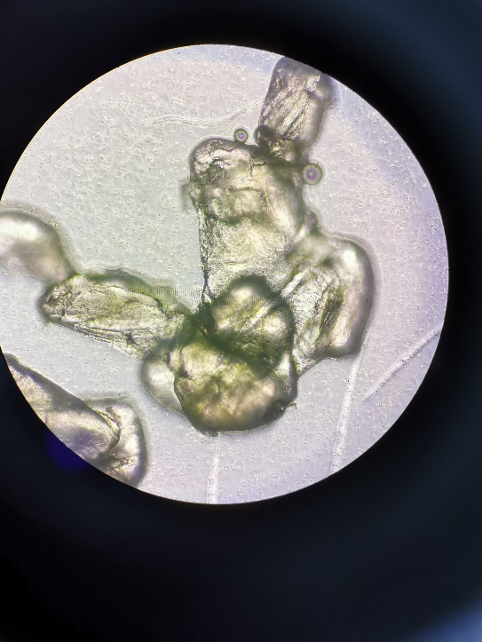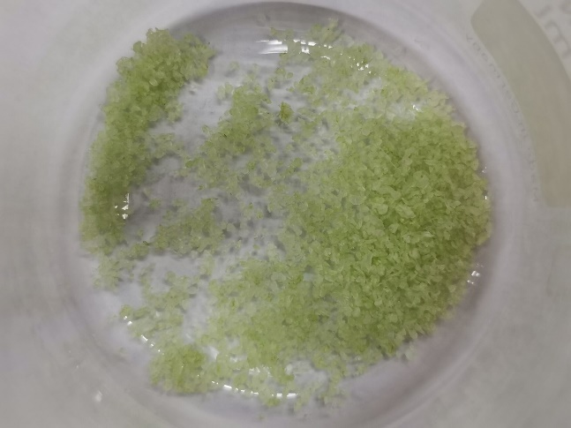

**Fig. S1.** Images of HDPE polymer particles (300-1000 μm) with the presence of biofilm after washing with seawater (left: original image; right: 40X under the microscope).



**Fig. S2.** Changes of chemical residues of PBDEs, PCBs, α-HBCDD and OPFRs in water along with time.