
Geophysical Research Letters
Supporting Information for
Using timing of ice retreat to predict timing of fall freeze-up in the Arctic
Julienne Stroeve^{1,2}, Alexander Crawford¹, and Sharon Stammerjohn³
¹National Snow and Ice Data Center (NSIDC), Cooperative Institute for Research in Environmental Sciences (CIRES), University of Colorado, Boulder, CO USA
²University College London, Centre for Polar Observation and Modelling (CPOM), London, United Kingdom
³Institute for Arctic and Alpine Research (INSTAAR), Cooperative Institute for Research in Environmental Sciences (CIRES), University of Colorado, Boulder, CO USA

Contents of this file

Figures S1 to S10
Tables S1 to S4

Introduction
This supplemental section includes additional figures and tables to support discussion in the main document.

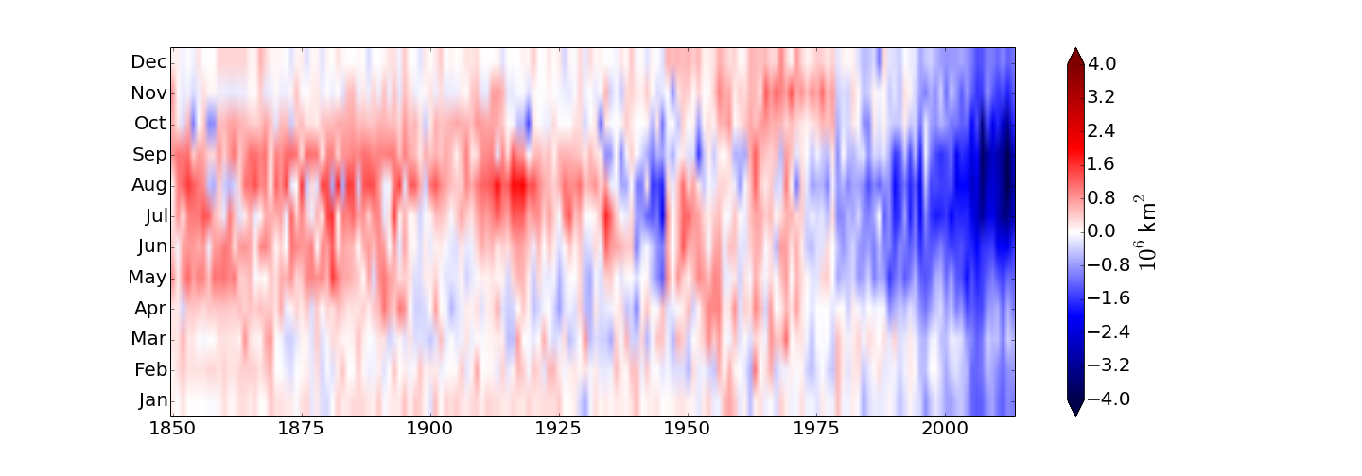
Figure S1. Sea ice extent anomalies from 1850 to 2013, based on a newly released historical sea ice data set [Walsh et al., 2015].

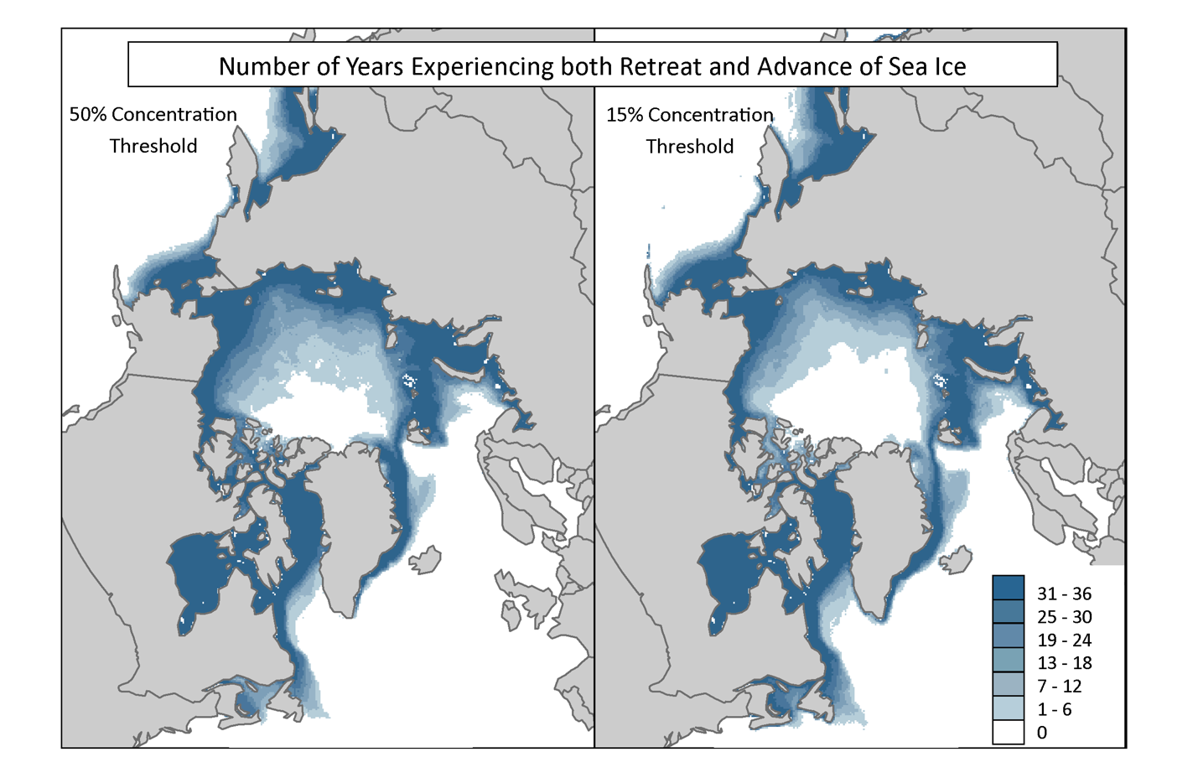Figure S2. Number of years each pixel experiences both retreat and advance of sea ice as a function of sea ice concentration threshold.

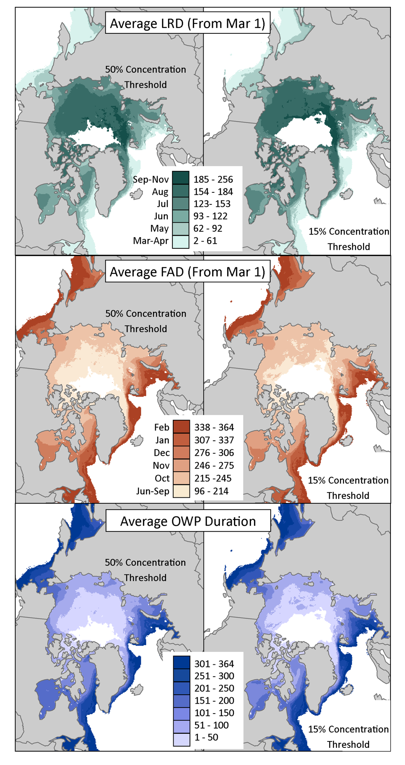
Figure S3. Climatological mean date of last retreat (LRD) of sea ice (top), first advance date (FAD) (middle) and open water period (OWP) (bottom) as a function of two sea ice concentration thresholds: 50% (left) and 15% (right).

Figure S4. Long-term trends (day/year) in date of last retreat (LRD), first advance (FAD) and open water period (OWP) sea ice as a function of two sea ice concentration thresholds: 50% (left) and 15% (right). Trends are only shown for pixels that have at least 20 years of valid data. Stippling is used to identify pixels with trends statistically significant at the 95% confidence level.

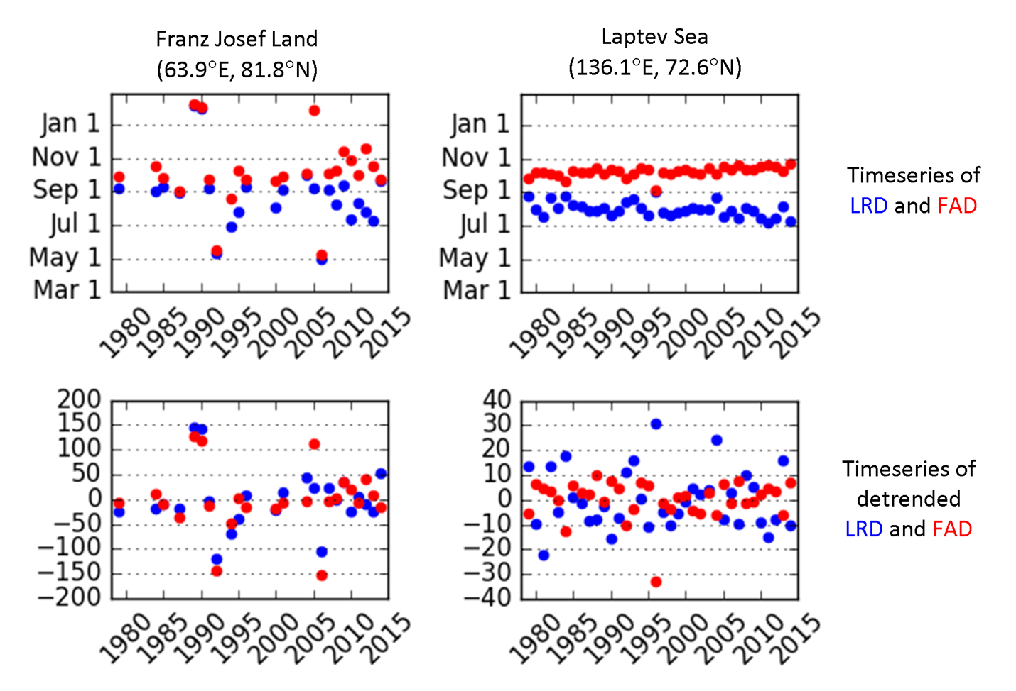
Figure S5. Time-series of last retreat date and first advance date for two locations, one near Franz Josef Land and the other near the Laptev Sea. Detrended values are shown in the bottom two plots.

Figure S6. Correlation between last retreat day and first advance day for a 15% sea ice concentration threshold for 4 different decades: 1980-1989, 1990-1999, 2000-2009 and 2005-2014. Stippling is used to identify pixels with trends statistically significant at the 95% confidence level.

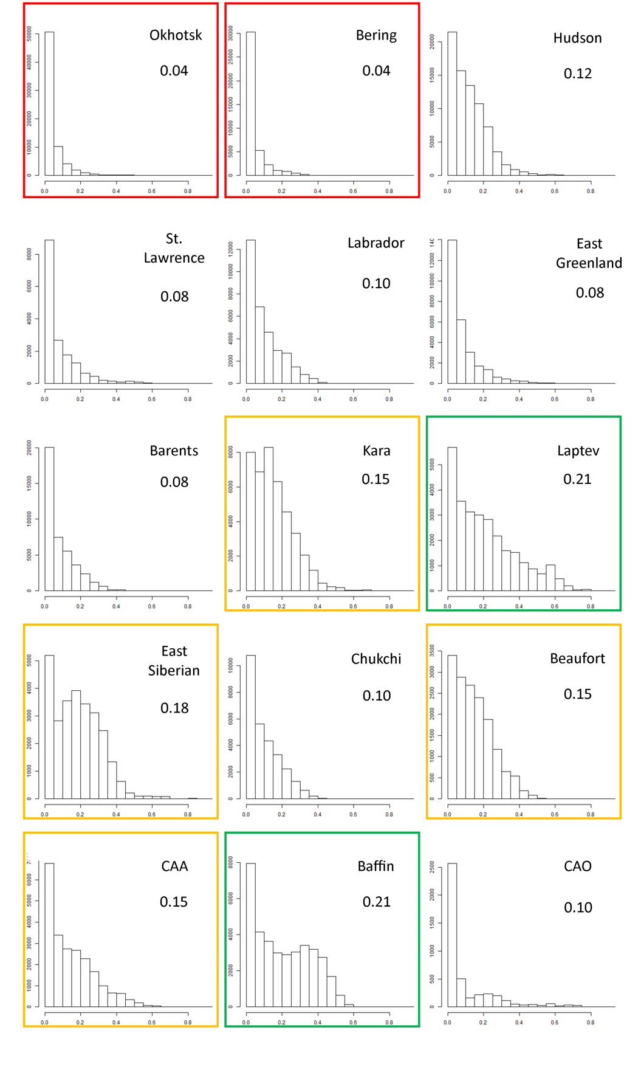
Figure S7. Histograms of predictive skill as a function of region (with mean predictive skill noted). Regions highlighted in green show the highest predictive skill (mean ≥ 0.20), followed by regions outlined in yellow (mean ≥ 0.15). Regions with the lowest predictive skill are outlined in red (mean < 0.05). All years and pixels are included as observations for the histograms.
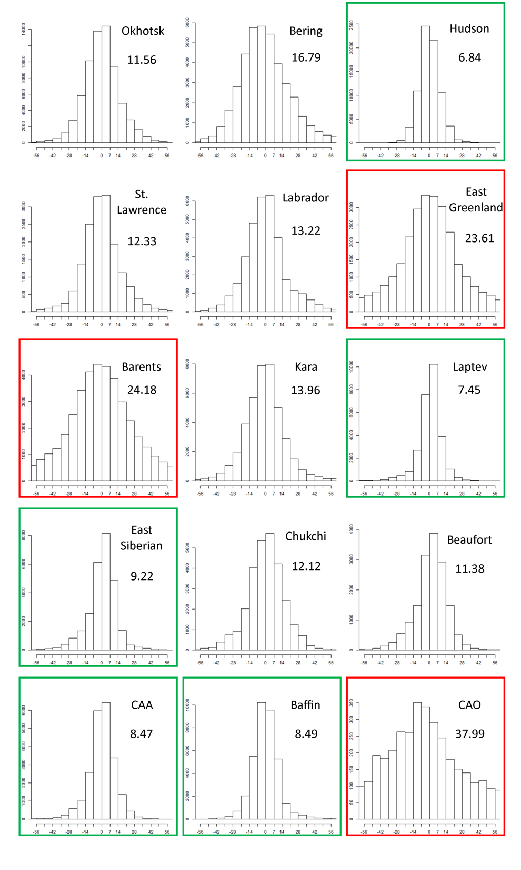
Figure S8. Histogram of residuals as a function of region (with mean residual magnitude noted). Regions higlighted in green have a mean residual magnitude less than 10 days, and regions highlighted in red have a mean residual magnitude greater than 20 days. All years and pixels are included as observations for the histograms.
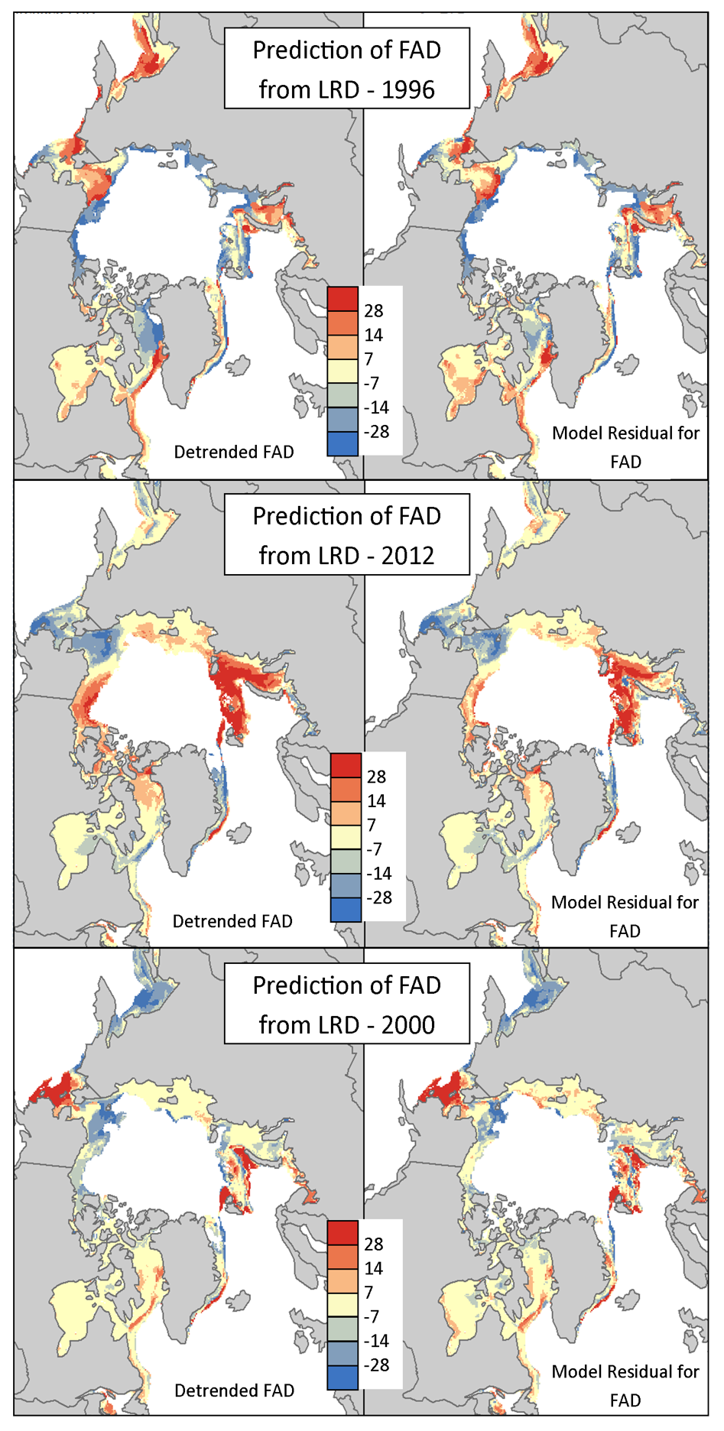
Figure S9. Detrended first advance day (FAD: left) and model residual error (in days; right) for 1996 (top), 2012 (middle) and 2000 (bottom).
Figure S10. Correlations between the detrended 1979-2014 time series of continuous melt onset and last retreat day of sea ice using a concentration threshold of 15%. Correlations were only calculated for grid cells experiencing at least 20 years with a cycle of sea ice retreat and advance. Stippling is shown for correlations that are significant at the 95% confidence level.

Region | MO | LRD  50% SIC | FAD  50% SIC | OWP  50% SIC | LRD  15% SIC | FAD  15% SIC | OWP  15% SIC
Okhotsk | -0.60 | -0.32 | +0.53 | +0.85 | -0.33 | +0.46 | +0.80
Bering | -0.18 | +0.19 | +0.04 | -0.16 | +0.06 | +0.07 | +0.01
Hudson | -0.46 | -0.46 | +0.51 | +0.97 | -0.63 | +0.54 | +1.17
St. Lawrence | -0.56 | -0.18 | +0.40 | +0.58 | -0.18 | +0.49 | +0.67
Labrador | -0.66 | -0.67 | +0.84 | +1.51 | -0.85 | +0.93 | +1.78
E. Greenland | -0.47 | -0.55 | +0.62 | +1.17 | -1.06 | +0.94 | +2.00
Barents | -1.40 | -1.31 | +1.69 | +3.00 | -1.58 | +1.77 | +3.35
Kara | -0.68 | -0.97 | +1.22 | +2.19 | -1.11 | +1.02 | +2.13
Laptev | -0.40 | -0.83 | +0.73 | +1.56 | -0.86 | +0.70 | +1.56
E. Siberian | -0.08 | -0.55 | +0.97 | +1.52 | -0.49 | +0.87 | +1.36
Chukchi | -0.28 | -0.81 | +1.00 | +1.82 | -0.83 | +0.94 | +1.77
Beaufort | -0.32 | -0.60 | +0.82 | +1.41 | -0.70 | +0.73 | +1.43
CAA | -0.24 | -0.38 | +0.53 | +0.91 | -0.32 | +0.46 | +0.78
Baffin | -0.87 | -0.70 | +0.78 | +1.48 | -0.81 | +0.71 | +1.52
Central Arctic | +0.02 | -1.05 | +1.82 | +2.88 | -1.16 | +1.82 | +2.99
Table S1. Regional trends (1979-2014) in surface melt onset (MO), last sea ice retreat day (FRD), first sea ice advance date (FAD) and open water season (OWP). Note in computing trends we require at least 20 years of valid data. Data are first area-weighted averaged before computing the regional trends. Trends are shown in days per year.

Region | 1980-1989 | 1990-1999 | 2000-2009 | 2005-2014
Okhotsk | 0.00 | -0.13 | -0.11 | 0.03
Bering | 0.01 | -0.14 | -0.22 | -0.06
Hudson | -0.23 | -0.37 | -0.26 | -0.25
St. Lawrence | -0.20 | -0.15 | -0.14 | -0.20
Labrador | -0.31 | -0.33 | -0.13 | -0.20
East Greenland | -0.11 | -0.19 | -0.17 | -0.09
Barents | -0.25 | -0.22 | -0.26 | -0.07
Kara | -0.25 | -0.40 | -0.14 | -0.42
Laptev | -0.18 | -0.47 | -0.37 | -0.38
East Siberian | -0.19 | -0.40 | -0.54 | -0.39
Chukchi | -0.21 | -0.25 | -0.29 | -0.17
Beaufort | -0.20 | -0.55 | -0.21 | -0.07
CAA | -0.17 | -0.13 | -0.31 | -0.36
CAO | -0.04 | 0.17 | 0.03 | -0.10
Baffin | -0.45 | -0.31 | -0.26 | -0.33
Table S2. Average correlation of detrended LRD and FAD by region for various decades. LRD and FAD are calculated using a concentration threshold of 15%.

Region | 1980-1989 | 1990-1999 | 2000-2009 | 2005-2014
Okhotsk | -0.02 | -0.15 | -0.07 | 0.00
Bering | 0.01 | -0.06 | -0.21 | -0.05
Hudson | -0.24 | -0.40 | -0.29 | -0.26
St. Lawrence | -0.21 | -0.10 | -0.22 | -0.31
Labrador | -0.29 | -0.38 | -0.17 | -0.21
East Greenland | -0.07 | -0.18 | -0.20 | -0.10
Barents | -0.24 | -0.23 | -0.24 | -0.07
Kara | -0.18 | -0.37 | -0.18 | -0.38
Laptev | -0.17 | -0.48 | -0.38 | -0.37
East Siberian | -0.18 | -0.42 | -0.55 | -0.39
Chukchi | -0.24 | -0.24 | -0.29 | -0.17
Beaufort | -0.23 | -0.54 | -0.21 | -0.09
CAA | -0.18 | -0.17 | -0.34 | -0.42
CAO | -0.01 | 0.25 | 0.11 | -0.09
Baffin | -0.49 | -0.33 | -0.25 | -0.32
Table S3. Same as Table S2 but using a concentration threshold of 30%.

Region | 1980-1989 | 1990-1999 | 2000-2009 | 2005-2014
Okhotsk | -0.05 | -0.12 | -0.12 | -0.06
Bering | +0.01 | 0.00 | -0.18 | +0.01
Hudson | -0.21 | -0.35 | -0.28 | -0.27
St. Lawrence | -0.15 | -0.10 | -0.21 | -0.40
Labrador | -0.26 | -0.39 | -0.15 | -0.16
East Greenland | -0.08 | -0.12 | -0.17 | -0.05
Barents | -0.24 | -0.23 | -0.16 | -0.07
Kara | -0.13 | -0.31 | -0.18 | -0.31
Laptev | -0.14 | -0.45 | -0.43 | -0.38
East Siberian | -0.18 | -0.38 | -0.53 | -0.40
Chukchi | -0.14 | -0.25 | -0.25 | -0.14
Beaufort | -0.16 | -0.46 | -0.17 | -0.12
CAA | -0.16 | -0.16 | -0.16 | -0.40
CAO | +0.06 | +0.31 | +0.11 | -0.05
Baffin | -0.47 | -0.30 | -0.24 | -0.29
Table S4. Same as Table S2 but using a concentration threshold of 50%.

References
Walsh, J. E., W. L. Chapman, and F. Fetterer (2015), Gridded monthly sea ice extent and concentration, 1850 onward, version 1, [indicate subset used], NSIDC: National Snow and Ice Data Center, Boulder, Colo., [Available at 10.7265/N5833PZ5, (Date Accessed)].

