Supporting Information for
Pronounced Increases in Nitrogen Emissions and Deposition due to the Historic 2020 Wildfires in the Western U.S.

Patrick Campbell, Daniel Tong, Rick Saylor, Yunyao Li, Siqi Ma, Xiaoyang Zhang, Shobha Kondragunta, & Fangjun Li

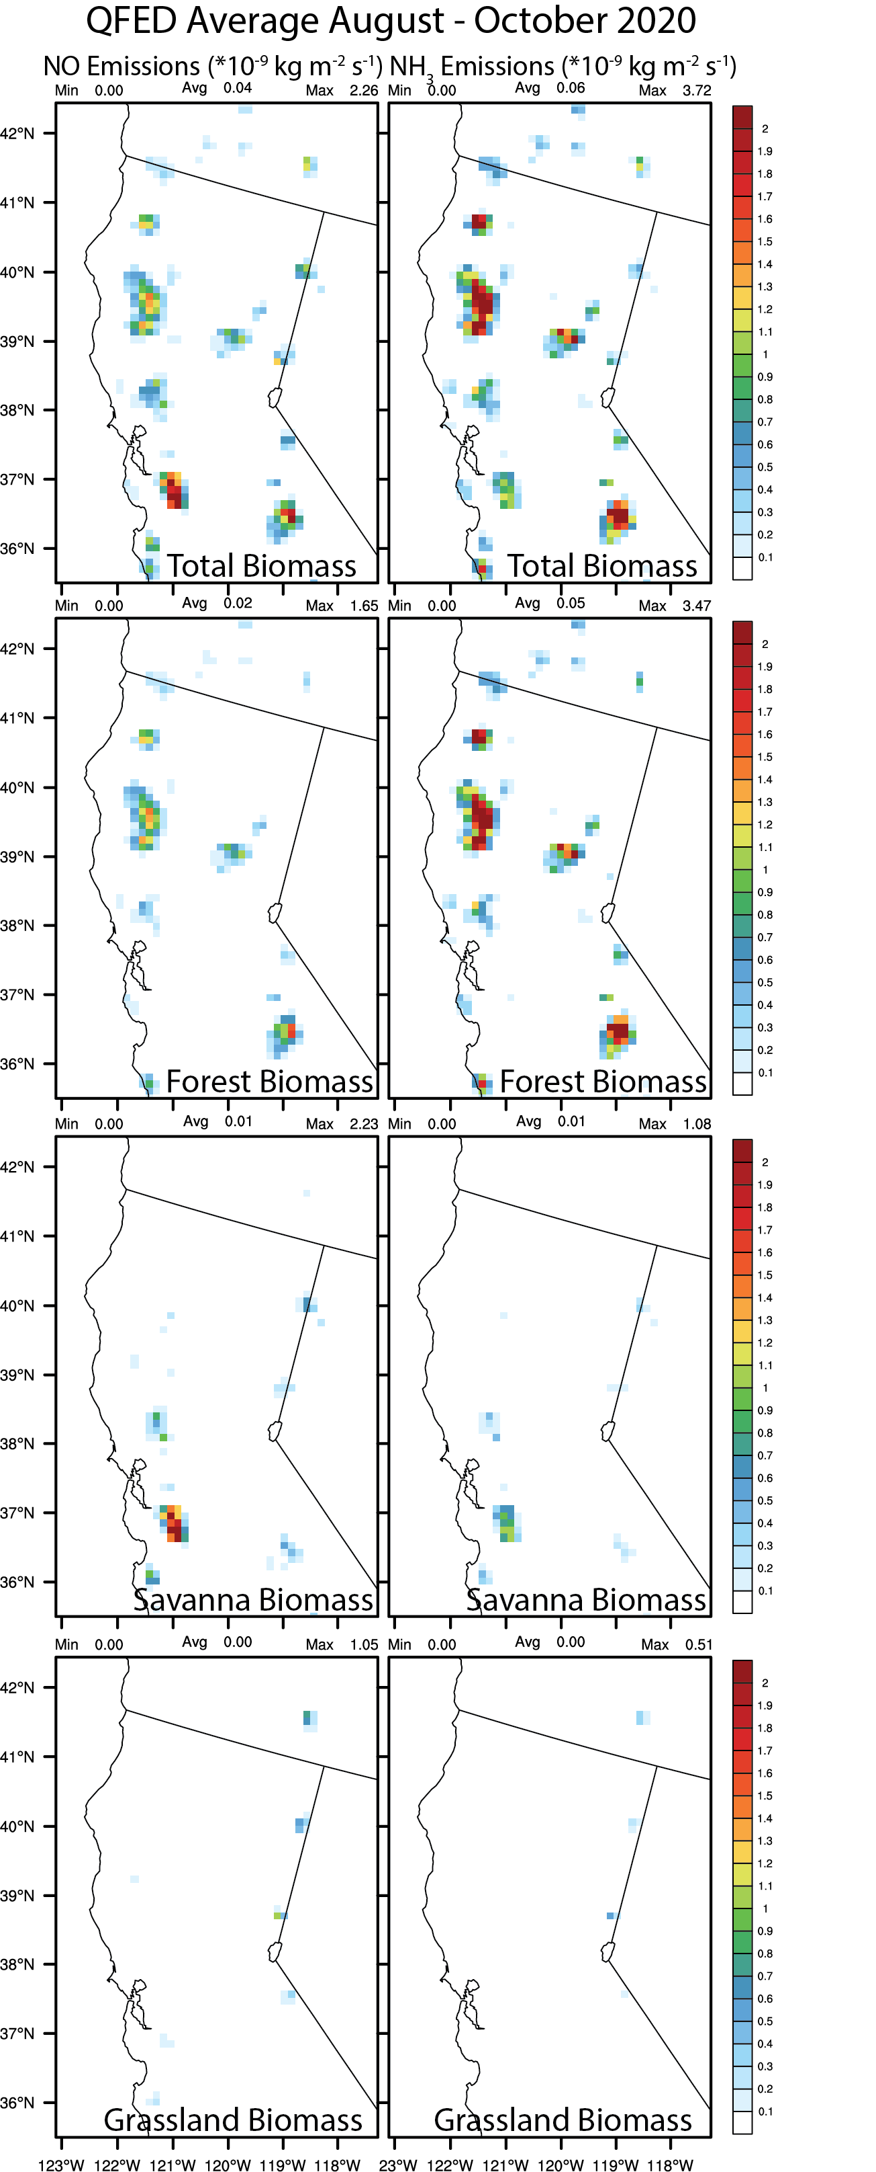 |  | Figure S1. Analysis of the spatial distribution of average August - October 2020 QFED NO (left) and NH₃ (right) emissions for the total biomass and different QFED biomass types in California.
East U.S. (< 100° W) | West U.S. (> 100° W)
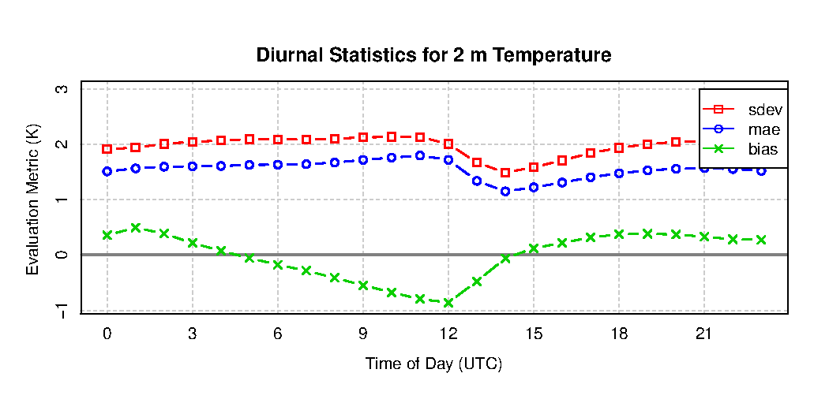 | 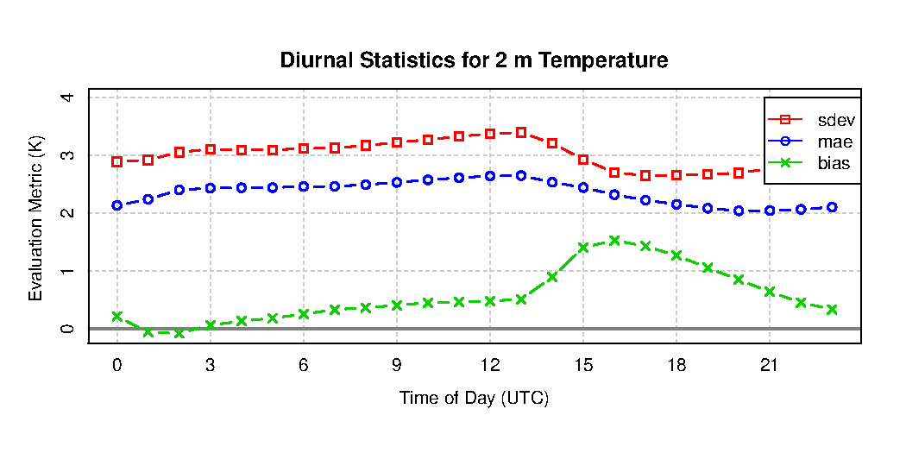
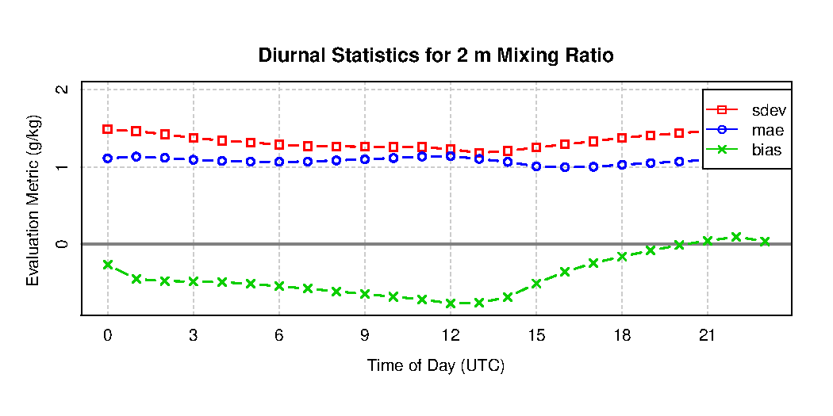 | 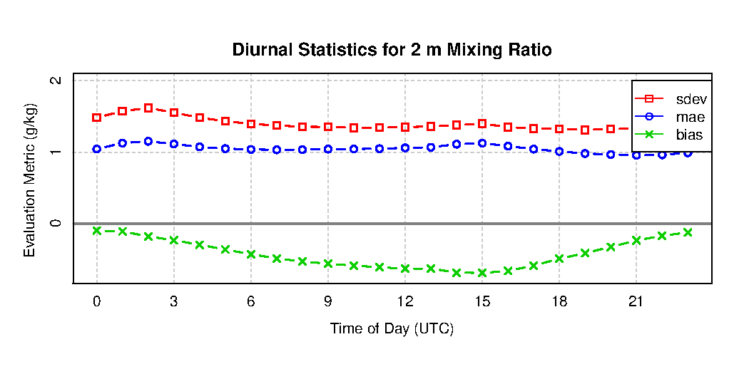
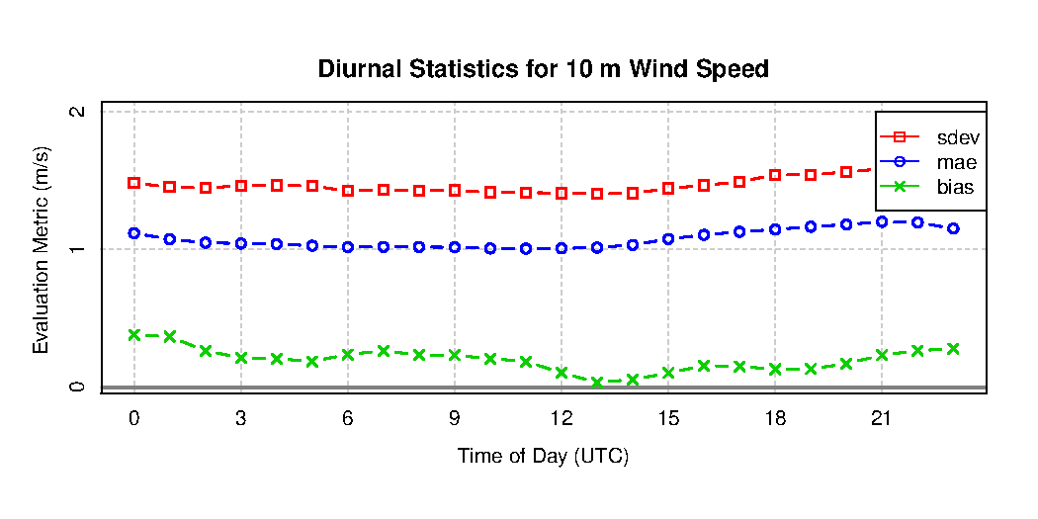 | 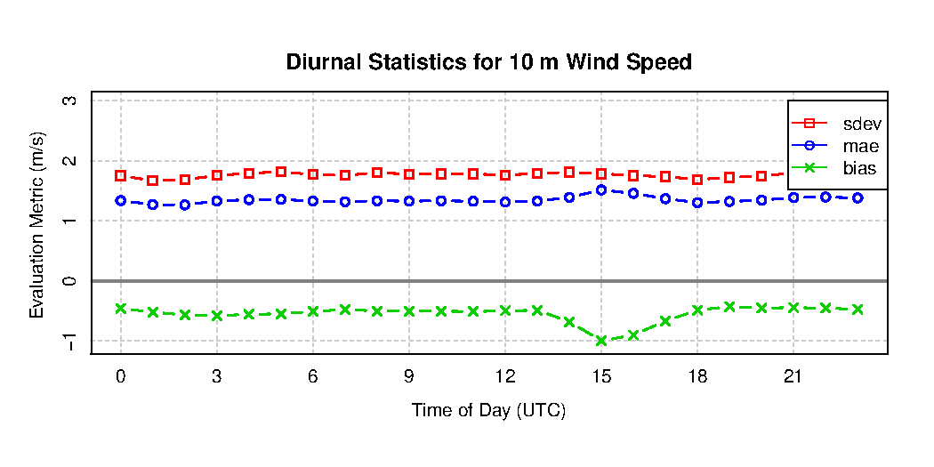
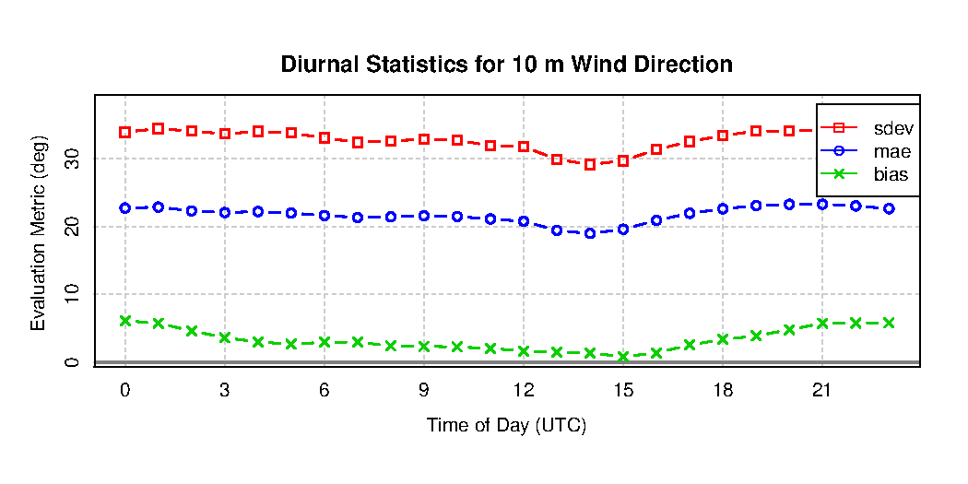 | 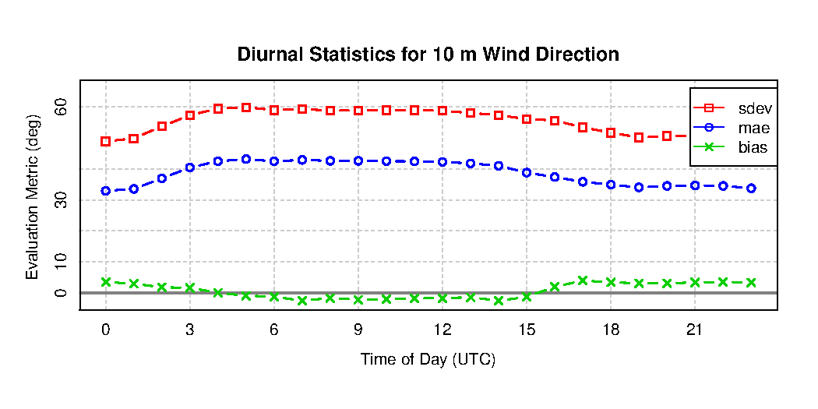

Figure S2. Evaluation of the GMU-WFS predicted September 2020 2-m temperature (row 1), 2-m water vapor mixing ratio (row 2), 10-m wind speed (row 3), and 10-m wind direction (row 4). The statistical metrics include the mean standard deviation (sdev), absolute error (mae) and bias against the MADIS/METAR network for the East (left) and West U.S. (right) regions.

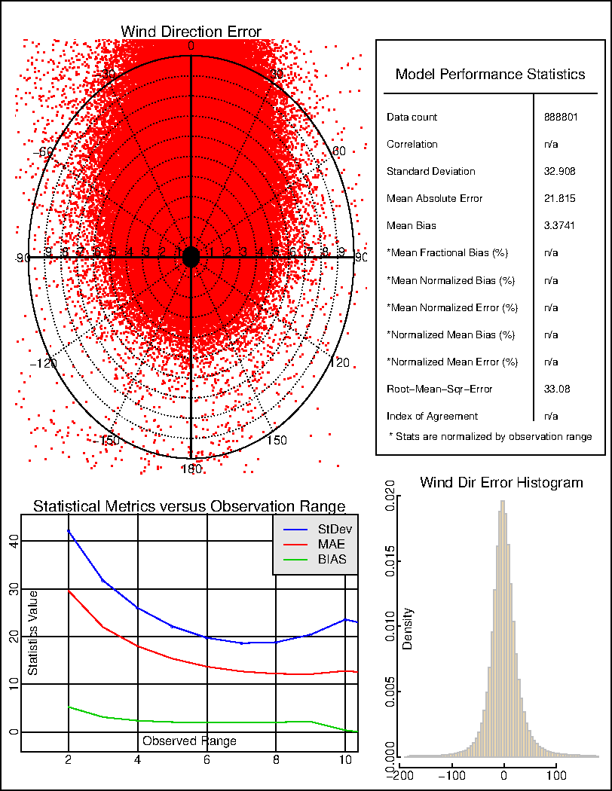
Figure S3a. September 2020 average statistical summary plots for the GMU-WFS simulated 10-m wind direction for the East U.S. (< 100° W) region.

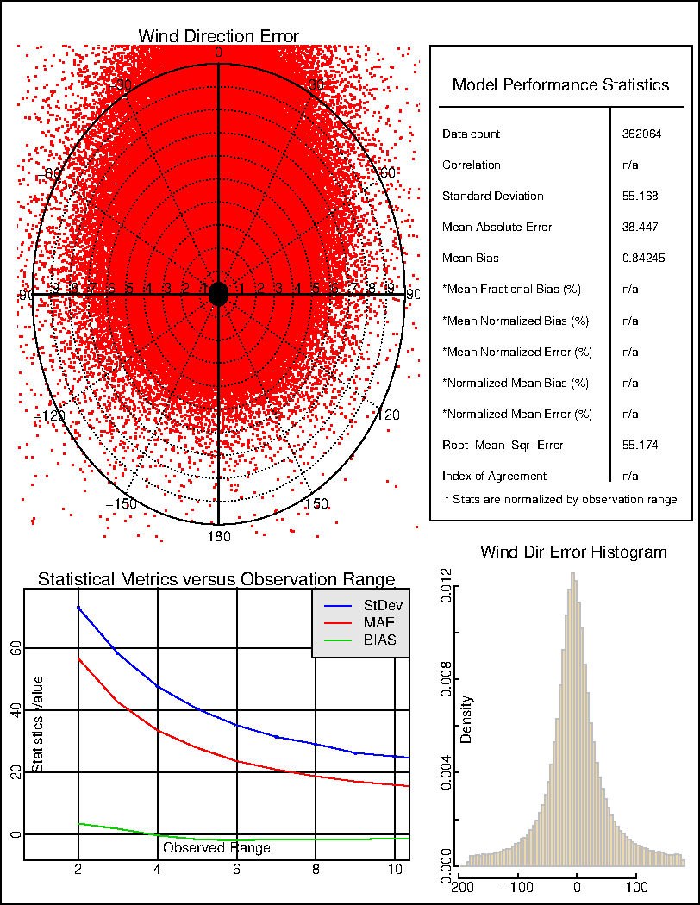
Figure S3b. Same as in Figure S3a, but for the West U.S. (> 100° W) region.

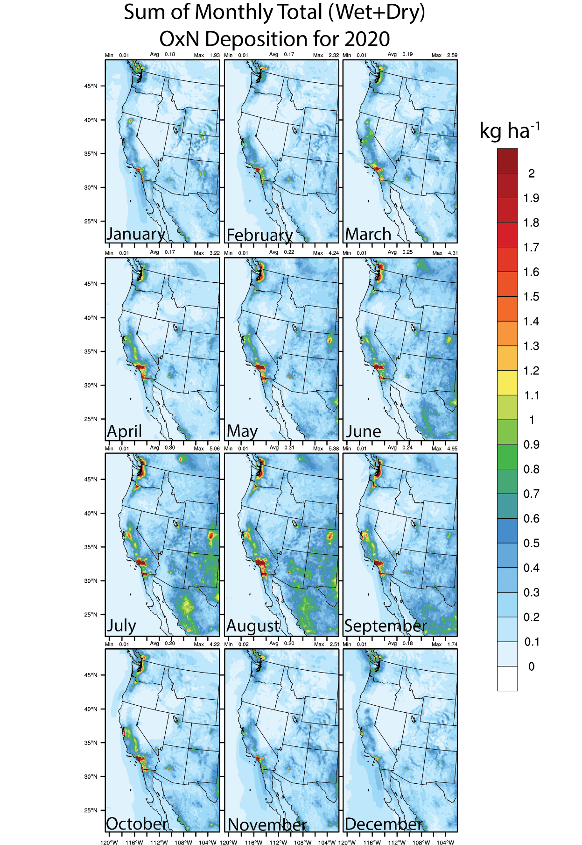
Figure S4a. Sum of monthly 2020 total (wet and dry) deposition (kg ha⁻¹) for the NOF GMU-WFS simulated OxN.

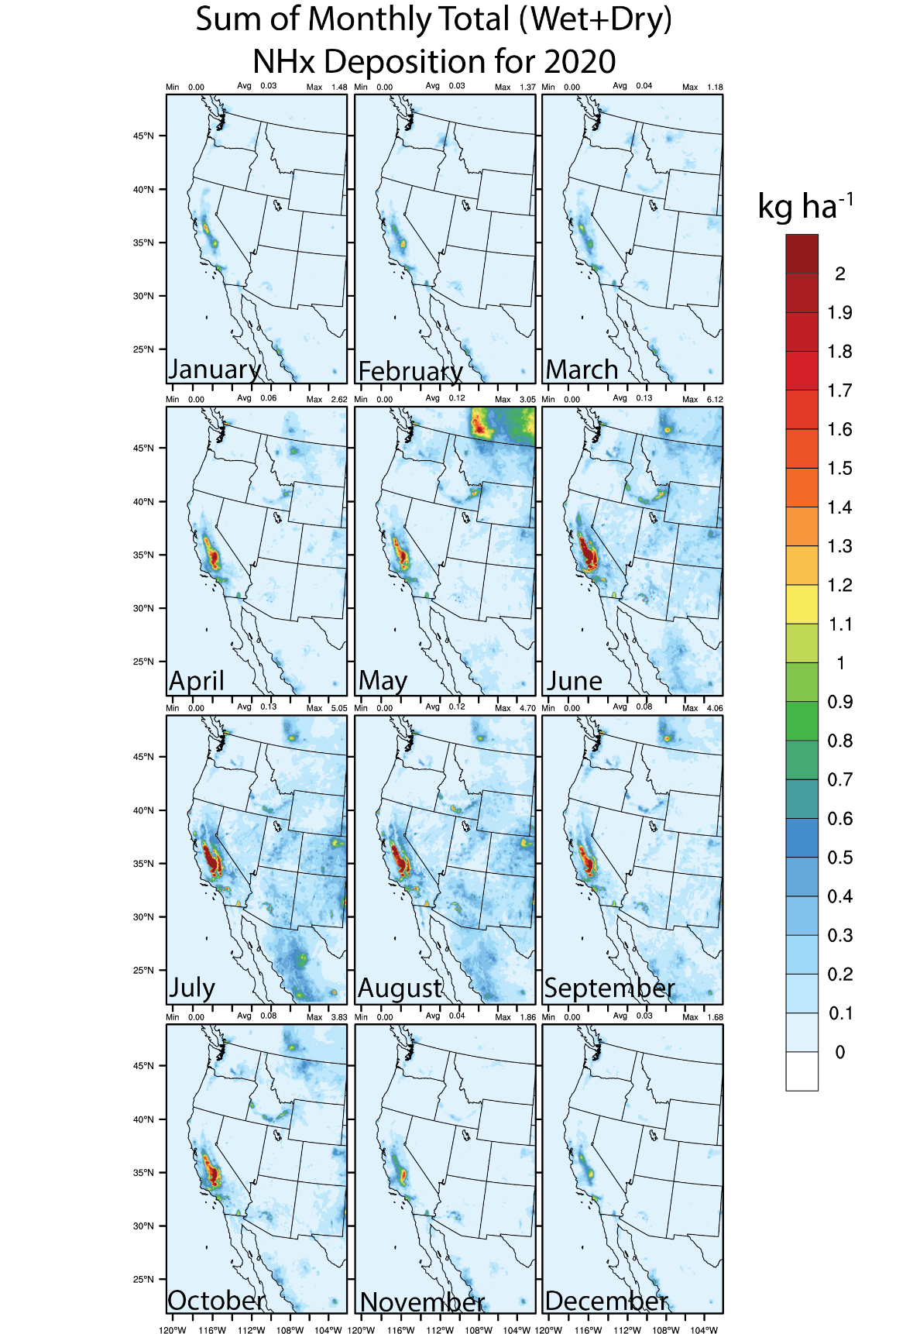
Figure S4b. Same as in Figure S4a, but for total NHx deposition.

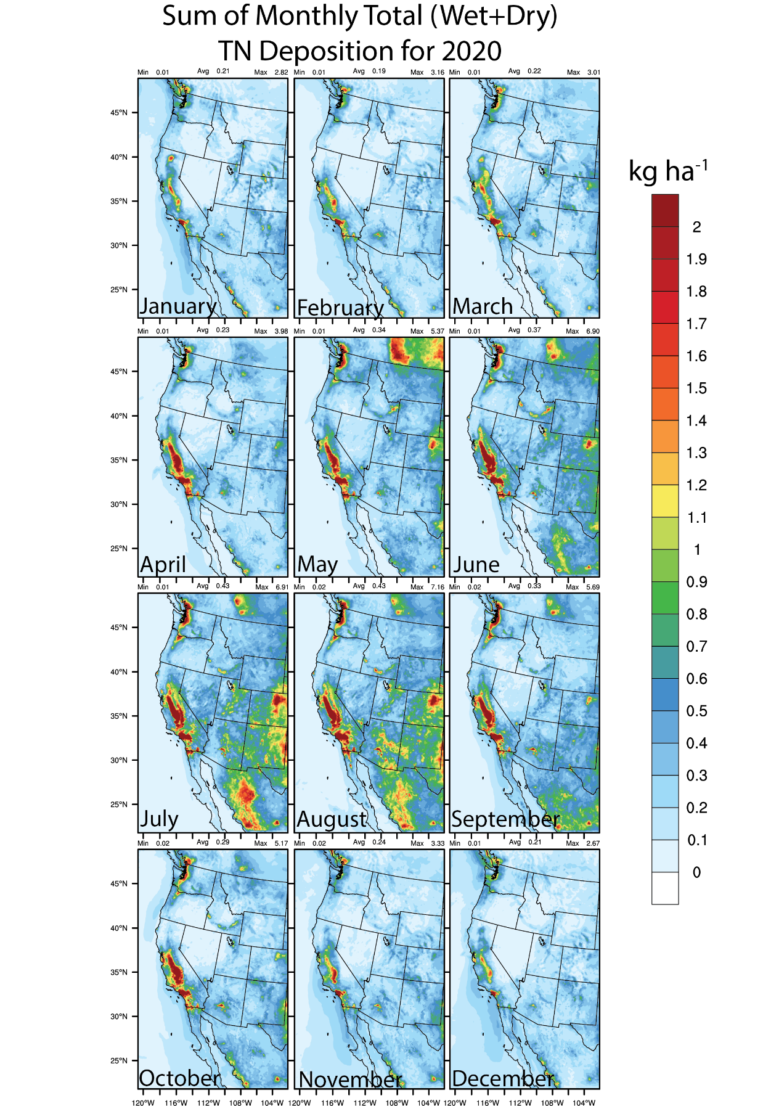
Figure S4c. Same as in Figure S4a, but for total TN (OxN+NHx) deposition.

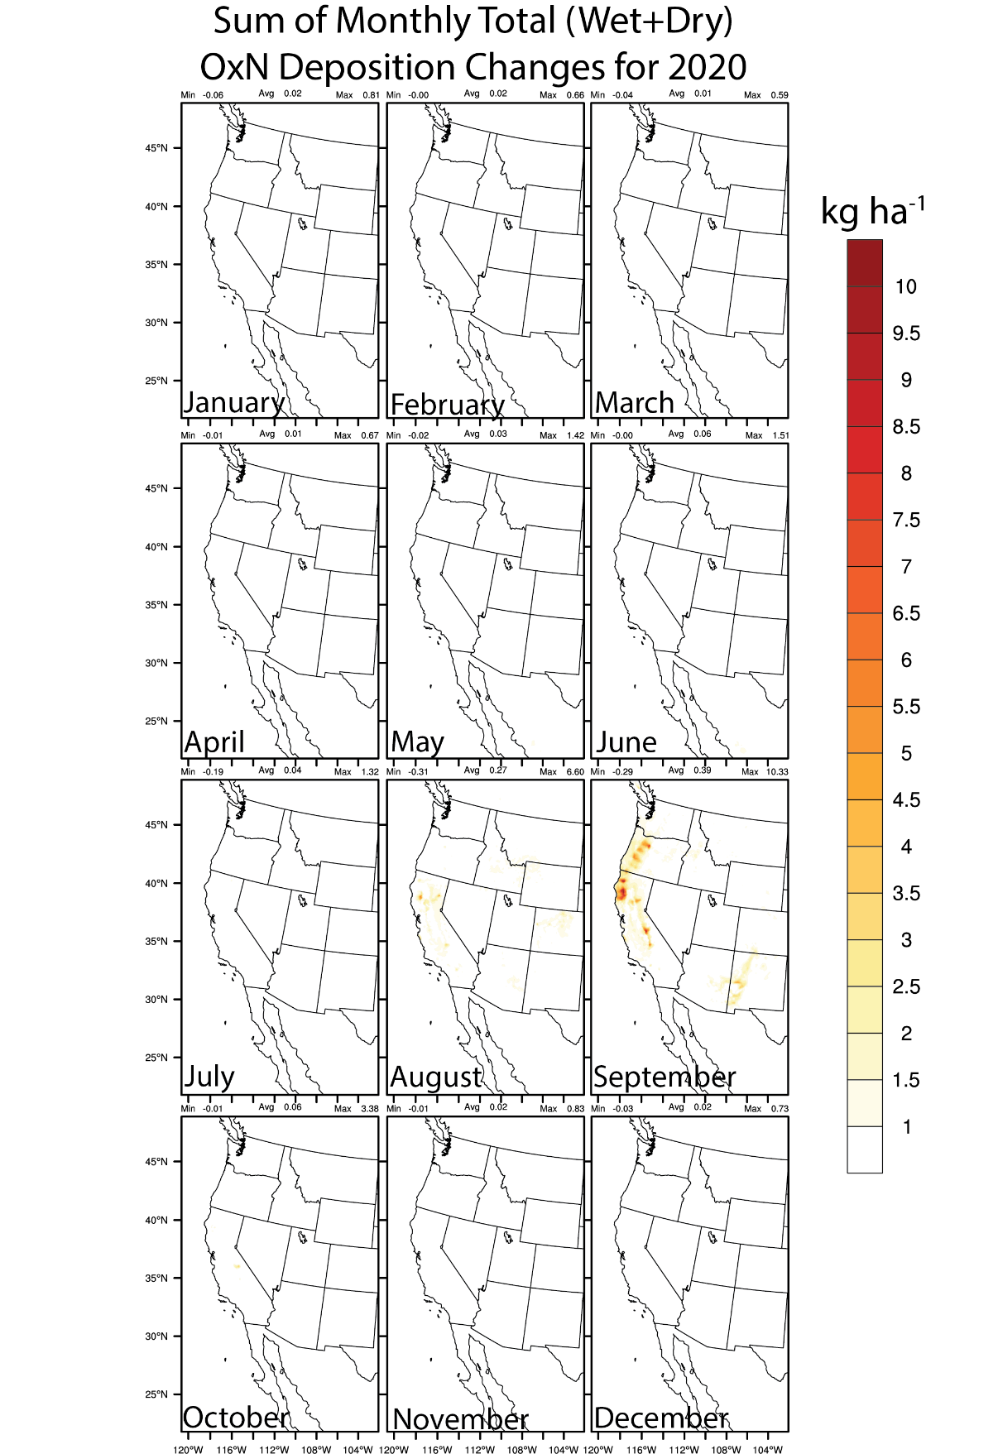
Figure S4d. Same as in Figure S4a, but for total ALLF-NOF OxN deposition.

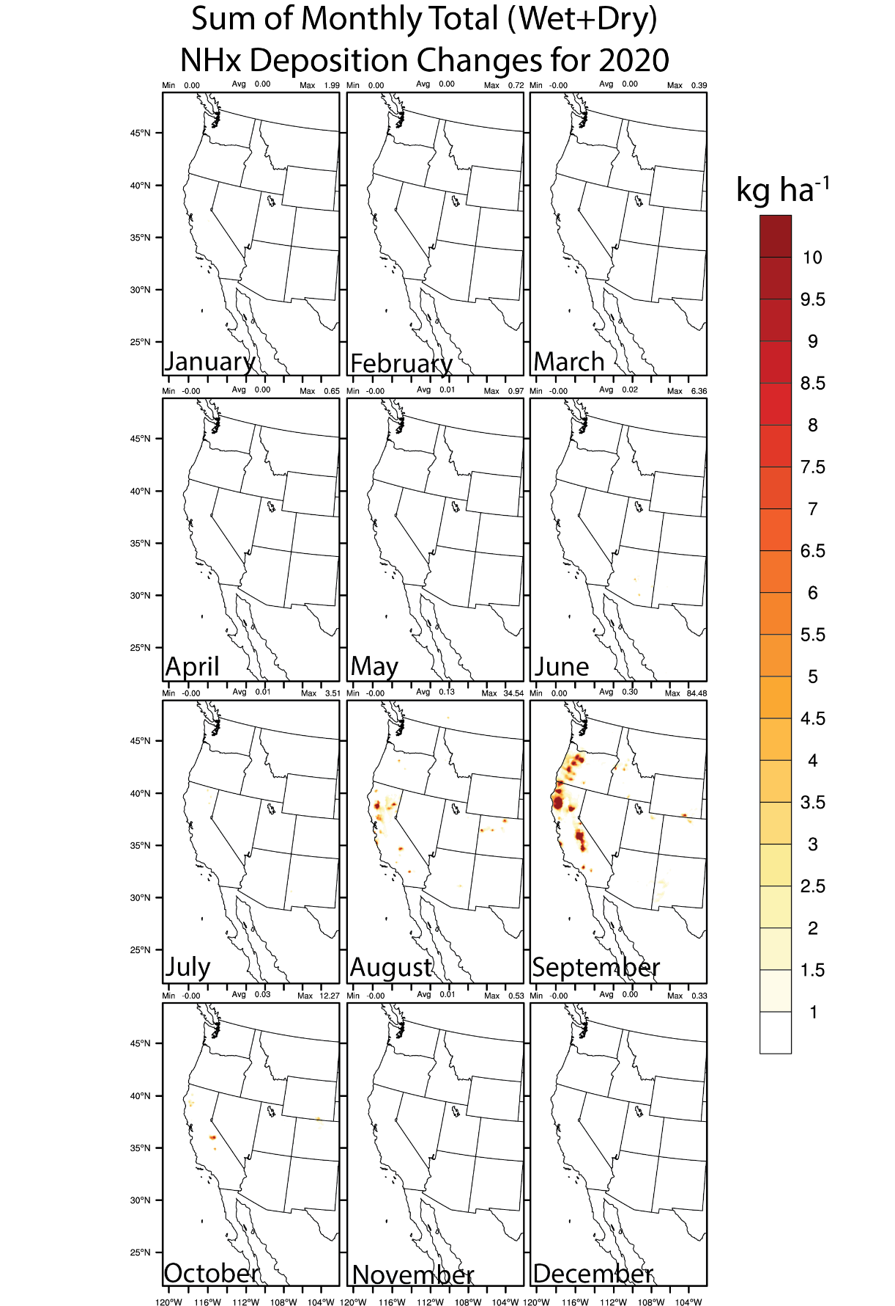
Figure S4e. Same as in Figure S4a, but for total ALLF-NOF NHx deposition.

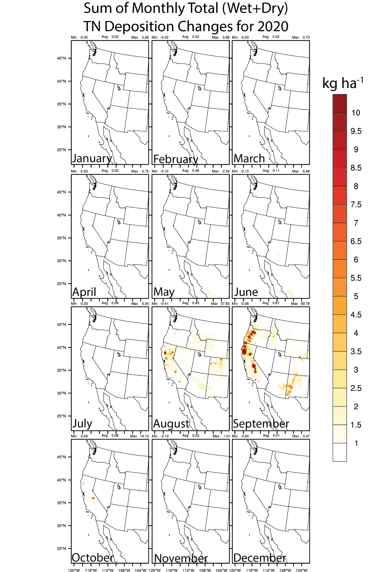
Figure S4f. Same as in Figure S4a, but for total ALLF-NOF TN (OxN+NHx) deposition.

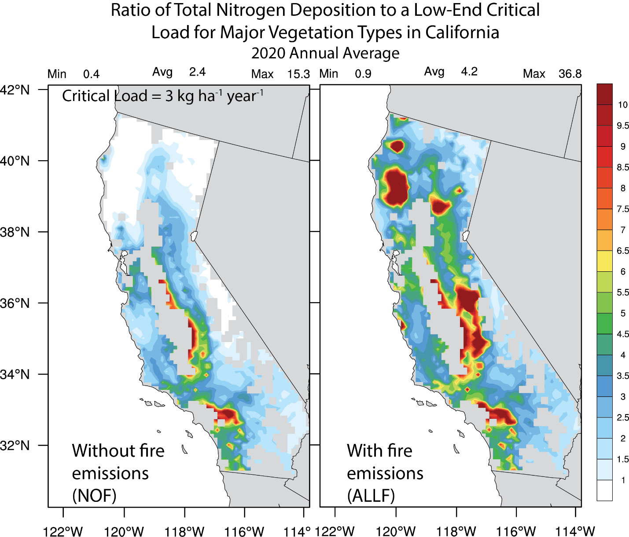
Figure S5. 2020 annual average ratio of the total (wet+dry) nitrogen (TN=OxN+NHx) species deposition (kg ha⁻¹ year⁻¹) to a low-end Critical Load (CL) ~ 3 kg ha⁻¹ year⁻¹ for the NOF (left) and ALLF (right) cases. Data within the state of California is shown, and is further masked by the model dominant landuse types that represent a total of 8 major vegetation types including deciduous broadleaf forest, deciduous needle leaf forest, evergreen broadleaf, evergreen needleleaf, other mixed forest, grasslands, shrublands, and savanna from the USGS 24-category land use data used in the simulation. Note that the color scale includes shading (other than white) only for those levels above the low-end, above which can result in adverse N deposition effects on lichen communities found in California mixed conifer forests and some scrub species (see Fenn et al., 2008 and Table 7.2 in Bytnerowicz et al., 2016).

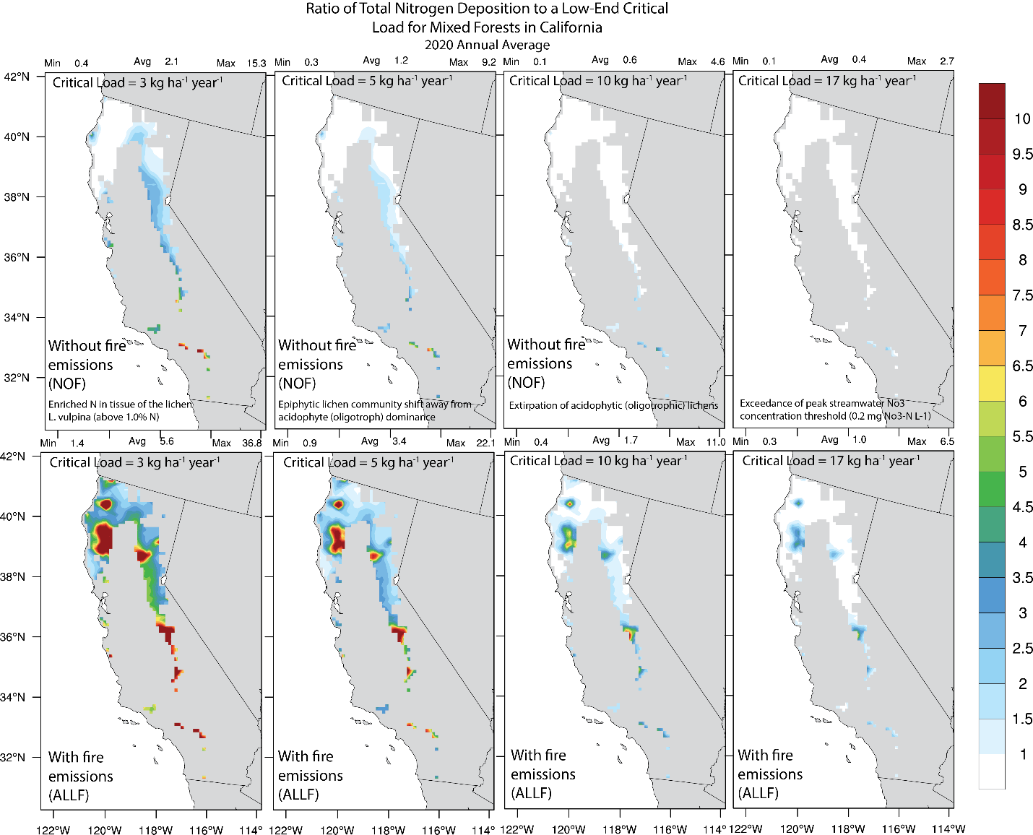
Figure S6. Same as in Figure S5, but for the mixed forest vegetation type only across different CLs based on Table 7.2 in Bytnerowicz et al. (2016). The description of the response variables for CL determination are also shown in top panels for each CL, and are taken directly from Table 7.2 in Bytnerowicz et al. (2016).

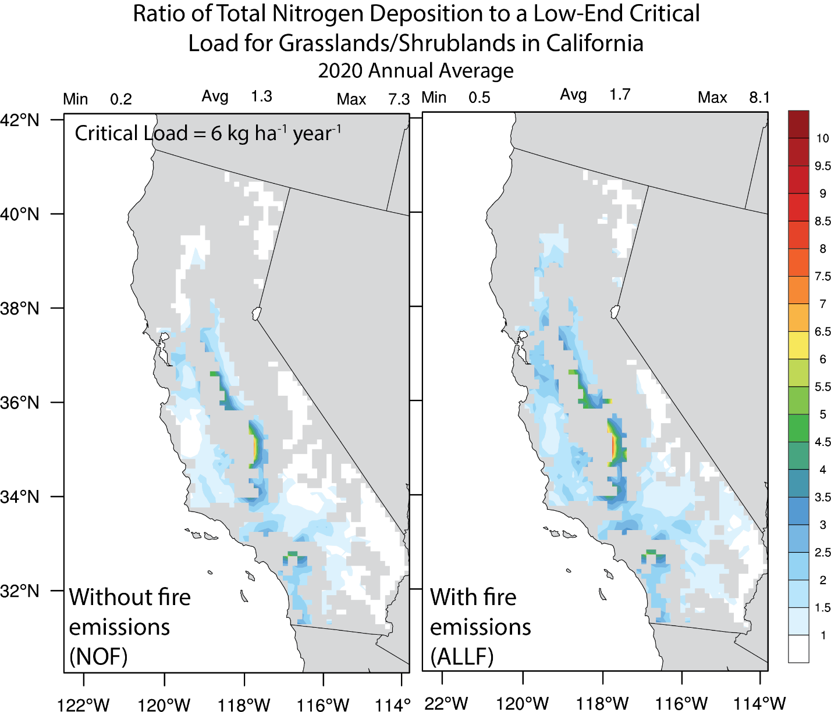
Figure S7. Same as in Figure S5, but for the grassland/shrubland vegetation type only, which is associated with a CL ~ 6 kg ha⁻¹ year⁻¹ (from Table 7.2 in Bytnerowicz et al., 2016).

Table S1. Total January – December 2020 NO_{x} and NH₃ GBBEPx and NEIC2016v1 emissions (in Tg) for CONUS and western U.S. (> 102 °W).
 | NO_{x} (Tg) |  | NH₃ (Tg)
 | NEIC2016v1 | GBBEPx | NEIC2016v1 | GBBEPx
January 2020
CONUS | 10.5 | 0.37 | 0.10 | 0.01
Western U.S. | 2.5 | 0.12 | 0.03 | 0.01
February 2020
CONUS | 9.6 | 0.33 | 0.10 | 0.02
Western U.S. | 2.2 | 0.10 | 0.04 | 0.01
March 2020
CONUS | 10.3 | 0.83 | 0.19 | 0.03
Western U.S. | 2.5 | 0.11 | 0.05 | 0.004
April 2020
CONUS | 10.0 | 0.83 | 0.28 | 0.03
Western U.S. | 2.4 | 0.10 | 0.09 | 0.005
May 2020
CONUS | 10.7 | 0.66 | 0.56 | 0.03
Western U.S. | 2.6 | 0.25 | 0.16 | 0.01
June 2020
CONUS | 10.6 | 0.97 | 0.58 | 0.05
Western U.S. | 2.6 | 0.64 | 0.15 | 0.03
July 2020
CONUS | 11.3 | 0.37 | 0.55 | 0.02
Western U.S. | 2.8 | 0.23 | 0.15 | 0.01
August 2020
CONUS | 11.3 | 2.9 | 0.60 | 0.16
Western U.S. | 2.8 | 2.6 | 0.14 | 0.14
September 2020
CONUS | 10.2 | 11.8 | 0.38 | 0.48
Western U.S. | 2.5 | 11.6 | 0.10 | 0.48
October 2020
CONUS | 11.0 | 1.7 | 0.37 | 0.07
Western U.S. | 2.6 | 1.4 | 0.10 | 0.06
November 2020
CONUS | 9.9 | 0.65 | 0.16 | 0.02
Western U.S. | 2.4 | 0.29 | 0.05 | 0.01
December 2020
CONUS | 10.9 | 0.32 | 0.14 | 0.01
Western U.S. | 2.6 | 0.14 | 0.03 | 0.005

