**Supplementary Figures and Tables**

**Table S1. Environmental conditions present at Buck Island or Black Point reefs**

|  |  |  |
| --- | --- | --- |
| **Reef** | **Buck Island** | **Black Point** |
| Lat (dd) | 18.27883 | 18.34450 |
| Lon (dd) | −64.89833 | −64.98595 |
| Depth (m) | 14.1 | 5.2 |
| Temperature (°C) | 26.88 | 26.98 |
| Salinity | 35.98 | 36.04 |
| Dissolved Oxygen (% sat.) | 102.5 | 105.0 |
| pH | 7.98 | 8.09 |
| Turbidity (NTU) | −0.05 | 0.12 |

**Table S2. Summary statistics of sequencing reads produced by three sequencing runs on the Illumina iSeq 100 System, outlined by sample type.**

|  |  |  |  |  |
| --- | --- | --- | --- | --- |
| **Sample Type** | **Average** | **Standard Deviation** | **Minimum** | **Maximum** |
| Seawater (n = 51) | 96,933 | 10,218 | 68,527 | 119,141 |
| Coral (n = 49) | 99,177 | 14,511 | 60,105 | 128,036 |
| Syringe Method Control (n = 9) | 96,290 | 7,542 | 85,728 | 113,293 |
| DNA Extraction Control (n = 6) | 19,418 | 11,672 | 1,908 | 34,118 |
| PCR Negative Control (n = 3) | 9,930 | 904 | 8,928 | 10,683 |
| Mock Community (n = 3) | 74,735 | 12,494 | 61,401 | 86,172 |

**Table S3. Summary of coral species featuring significant enrichment (FDR corrected p-value < 0.05) of SCTLD bioindicator ASVs in disease lesion (DD) compared to healthy coral (HH and HD combined)**. White cells indicate no significant difference in the relative abundance of the ASV between healthy and diseased corals. Differential abundance of ASVs was calculated using the beta-binomial regression model of the R-package *corncob* and ASVs were considered significant at an FDR corrected p-value <0.05.

|  |  |  |  |  |  |
| --- | --- | --- | --- | --- | --- |
| **Family, Genus** | **ASV ID** | ***Colpophyllia***  ***natans*** | ***Montastraea cavernosa*** | ***Orbicella franksi*** | ***Meandrina meandrites*** |
| Arcobacteraceae, *Arcobacter* | 21 |  |  |  |  |
| Arcobacteraceae, *Arcobacter* | 48 |  |  |  |  |
| Arcobacteraceae, *Arcobacter* | 101 |  |  |  |  |
| Arcobacteraceae, *Arcobacter* | 263 |  |  |  |  |
| Arcobacteraceae, *Arcobacter* | 1012 |  |  |  |  |
| Desulfovibrionaceae, *Desulfovibrio* | 185 |  |  |  |  |
| Desulfovibrionaceae, *Halodesulfovibrio* | 13 |  |  |  |  |
| Family_XII, *Fusibacter* | 44 |  |  |  |  |
| Family_XII, *Fusibacter* | 135 |  |  |  |  |
| Family_XII, *Fusibacter* | 275 |  |  |  |  |
| Flavobacteriaceae, *Wenyingzhuangia* | 126 |  |  |  |  |
| Lachnospiraceae, *Vallitalea* | 130 |  |  |  |  |
| Marinifilaceae, *Marinifilum* | 39 |  |  |  |  |
| Peptostreptococcaceae, *Tepidibacter* | 36 |  |  |  |  |
| Prolixibacteraceae, *Roseimarinus* | 26 |  |  |  |  |
| Pseudoalteromonadacea, *Algicola* | 52 |  |  |  |  |
| Rhizobiaceae, *Cohaesibacter* | 226 |  |  |  |  |
| Rhodobacteraceae, *Shimia* | 60 |  |  |  |  |
| Rhodobacteraceae, *Thalassobius* | 111 |  |  |  |  |
| Rhodobacteraceae, unclassified | 34 |  |  |  |  |
| Vibrionaceae, *Vibrio* | 20 |  |  |  |  |
| Vibrionaceae, *Vibrio* | 25 |  |  |  |  |
| Vibrionaceae, *Vibrio* | 54 |  |  |  |  |
| Vibrionaceae, *Vibrio* | 67 |  |  |  |  |
| Vibrionaceae, *Vibrio* | 96 |  |  |  |  |



**Fig. S1.** **Principal coordinates analysis (PCoA) of Bray-Curtis dissimilarity between all coral and seawater samples**. Seawater (gray outline) and coral (black outline) samples are shaped by the coral species, *C. natans* (circle), *M. cavernosa* (square), *O. franksi* (up triangle), and *M. meandrites* (down triangle). Colors indicate health condition where DD = SCTLD lesion sample, HD = healthy sample on diseased colony, HH = healthy sample from apparently healthy colony.



**Fig. S2.** **Principal coordinates analysis (PCoA) of Bray-Curtis dissimilarity between all coral samples from *C. natans* and *M. cavernosa*.** Outline color denotes whether the corals originated from the Black Point or Buck Island reef. Samples are shaped by the coral species, *C. natans* (circle), *M. cavernosa* (square). Colors indicate health condition where DD = SCTLD lesion sample, HD = healthy sample on diseased colony, HH = healthy sample from apparently healthy colony.



**Fig. S3**. **Principal coordinates analysis (PCoA) of Bray-Curtis dissimilarity within healthy coral samples only**. Outline color denotes whether the corals originated from the Black Point or Buck Island reef. Fill color represents whether the healthy sample was from a diseased colony (HD, green) or apparently healthy colony (HH, purple). Shape denotes the following coral species: *C. natans* (circle), *M. cavernosa* (square), *O. franksi* (up triangle), and *M. meandrites* (down triangle).



**Fig. S4**. **Boxplots denoting range in Bray-Curtis Dissimilarity values within healthy (HH = purple and HD = green) and diseased (DD = orange) coral microbiomes**. Difference between healthy and diseased Bray-Curtis dissimilarity values is significant by independent Mann-Whitney U Test (p < 0.001).

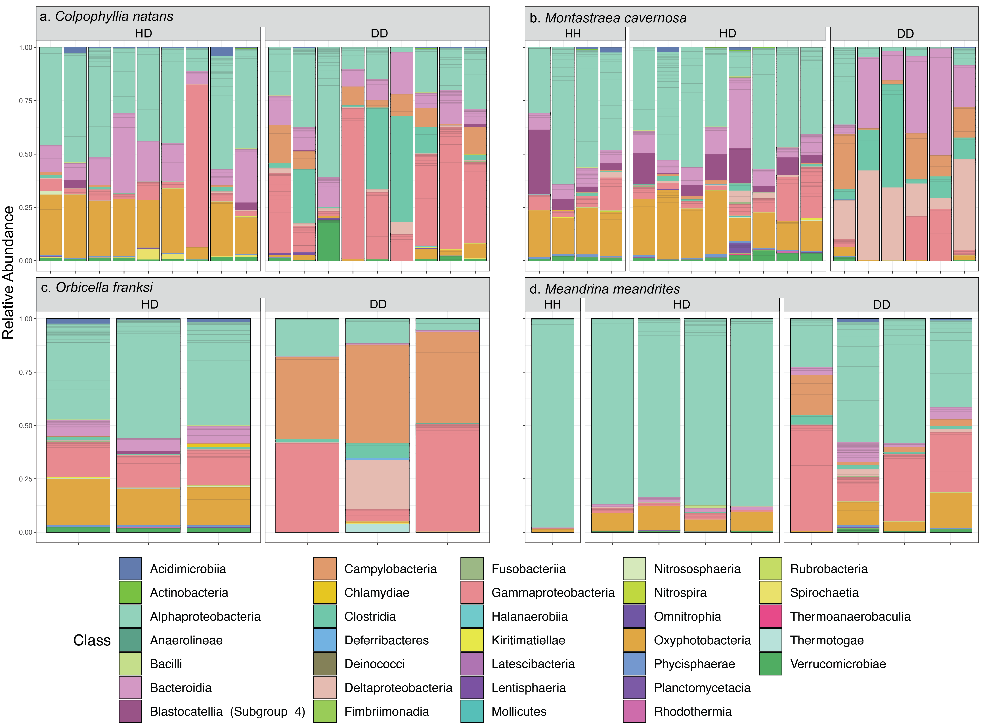

**Fig. S5. Stacked bar chart of microbial relative abundances within corals in (a) *C. natans*, (b) *M. cavernosa*, (c) *O. franksi*, and (d) *M. meandrites***. Stacked bar charts are organized by coral health condition (HH = healthy sample from a healthy colony, HD = Apparently healthy sample from a diseased colony, DD = Disease lesion).



**Fig. S6. Significantly differentially abundant ASVs between diseased and healthy coral in *Colpophyllia natans****.* Positive coefficients indicate ASV relative abundance was enriched in diseased coral relative to healthy coral. Points are labeled by genera and ASV number, and colored by Family.



**Fig. S7. Significantly differentially abundant ASVs between diseased and healthy coral in *Montastraea cavernosa****.* Positive coefficients indicate ASV relative abundance was enriched in diseased relative to healthy coral. Points are labeled by genera and ASV number, and colored by Family.



**Fig. S8. Significantly differentially abundant ASVs between diseased and healthy coral in *Orbicella franksi****.* Positive coefficients indicate ASV relative abundance was enriched in diseased relative to healthy coral. Points are labeled by genera and ASV number, and colored by Family.



**Fig. S9. Significantly differentially abundant ASVs between diseased and healthy coral in *Meandrina meandrites****.* Positive coefficients indicate ASV relative abundance was enriched in diseased relative to healthy coral. Points are labeled by genera and ASV number, and colored by Family.

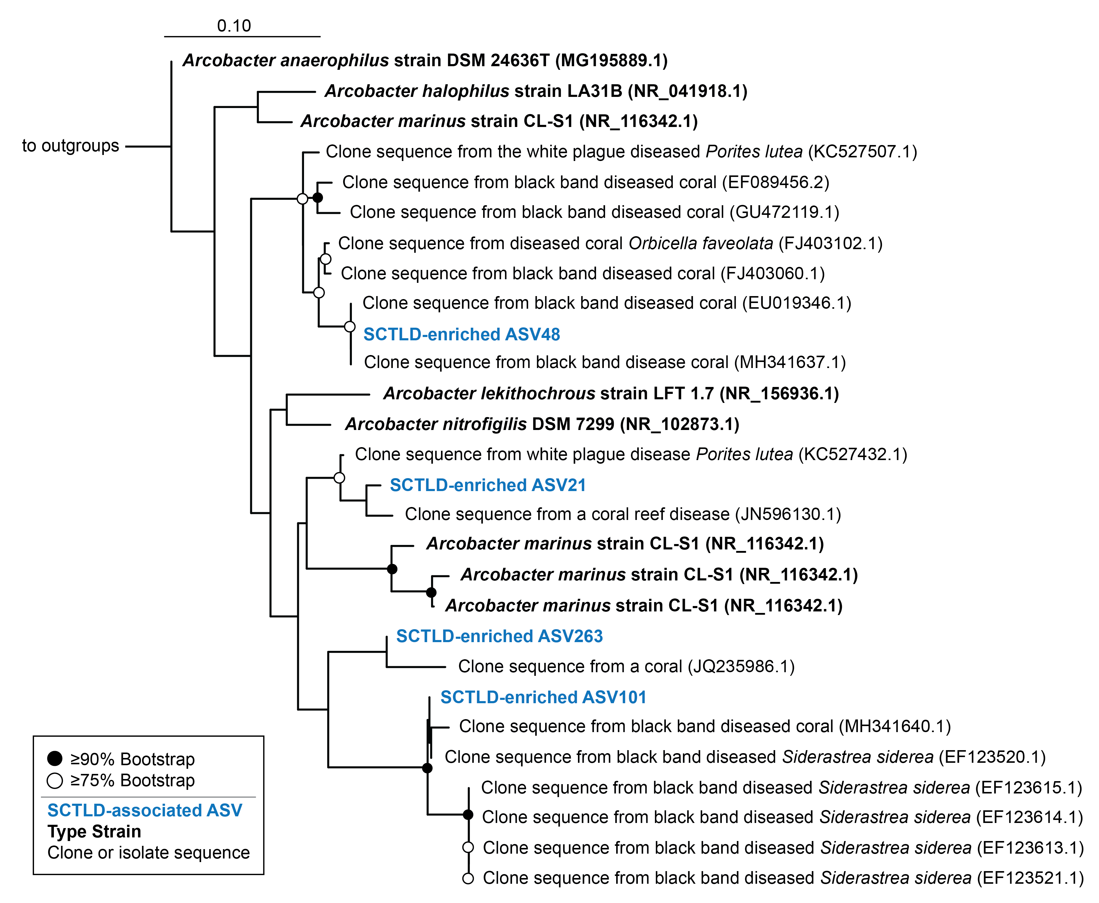

**Fig. S10. Bioindicator ASVs from the genus *Arcobacter* closely related to isolates and clone sequences from diseased corals.** Reference phylogenetic tree was produced using RAxML rapid bootstrapping with an automatic bootstrapping approach to produce the highest-scoring maximum likelihood tree using only longer-length sequences (black). SCTLD-associated ASVs (blue) identified by differential abundance analysis or by previous studies were added to the tree using the Evolutionary Placement Algorithm in RAxML. Colors represent qualitative information about the sequences as follows: Blue = SCTLD-associated ASVs from the present study, black bold = bacterial type strains, black = clone or bacterial isolate/strain sequences. GenBank accession numbers are located in parentheses following each taxa label. Circles at node represent bootstrap values of ≥ 90% (filled-in circle) or ≥ 75% (empty circle). Bar indicates 10% sequence divergence. Tree was rooted using the 16S rRNA gene of *Streptococcus mutans* strain ATCC 25175 (NR_115733.1).

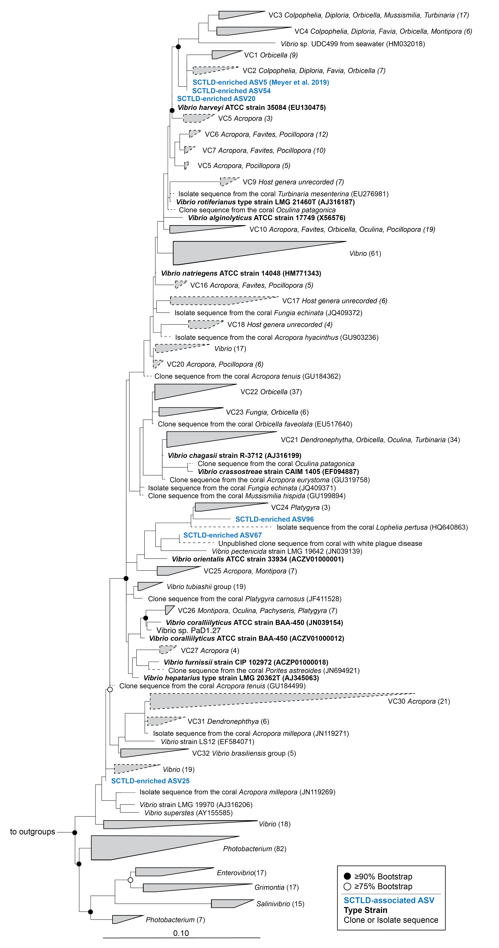

**Fig. S11. Bioindicator *Vibrio* ASVs from the present study and a recent study related to *Vibrio* pathogens, type strains, and sequences obtained from the Coral Microbiome Database.** Maximum likelihood and bootstrapped phylogenetic tree was produced using RAxML based on long (>1200 bp) sequences only, with the shorter coral associated sequences (dashed lines) and SCLTD-associated sequences (blue text) added using the Quick-add Parsimony tool in ARB. Colors represent qualitative information about the sequences as follows: Blue = SCTLD-associated ASVs from the present or previous study (Meyer *et al.*, 2019), Black bold = bacterial type strains, Black = clone or bacterial isolate/strain sequences. GenBank accession numbers are located in parentheses following each taxa label, when available. Circles at node represent bootstrap values of ≥ 90% (filled-in circle) or ≥ 75% (empty circle). Bar indicates 10% sequence divergence. Tree was rooted with *Thalassospira xianhensis* (EU017546) and *Thalassospira tepidiphila* (AB265822).

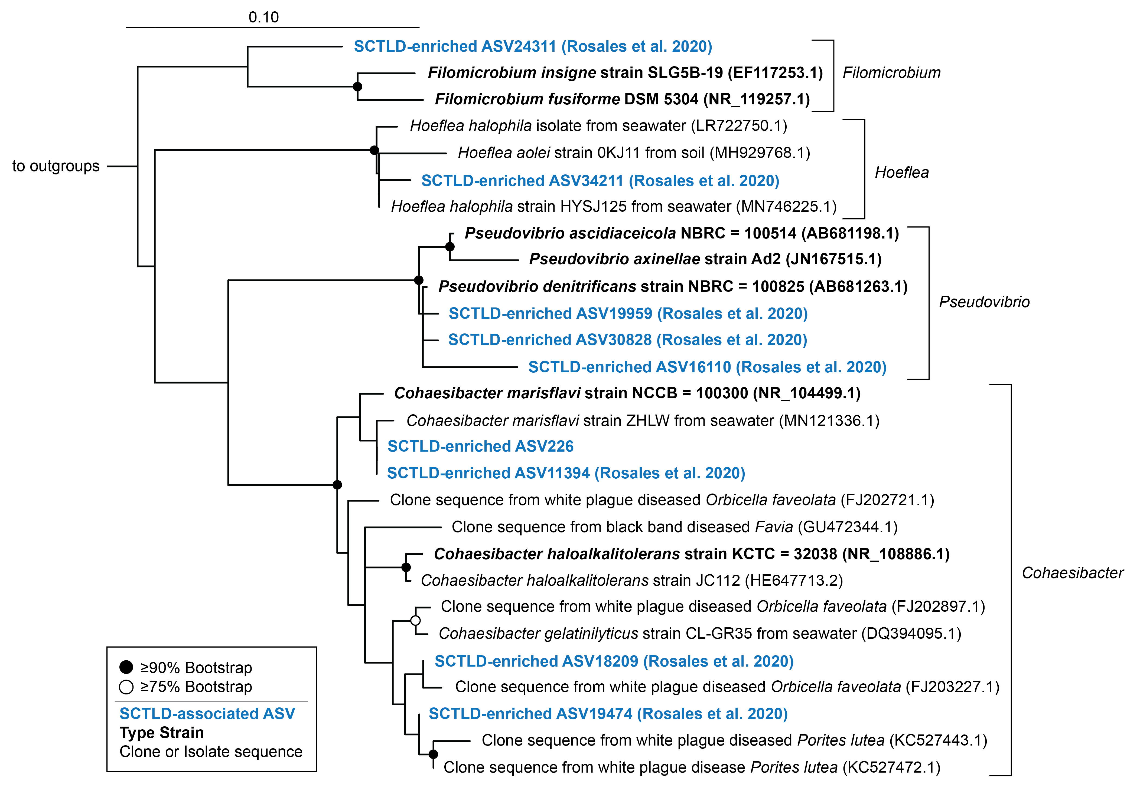

**Fig. S12. One SCTLD bioindicator Rhizobiaceae ASV from the present study and several from a previous study related to other Rhizobiaceae sequences associated with corals and coral diseases.** Reference phylogenetic tree was produced using RAxML rapid bootstrapping with an automatic bootstrapping approach to produce the highest-scoring maximum likelihood tree using only longer-length sequences (black). SCTLD-associated ASVs (blue) identified by differential abundance analysis or in a previous study (Rosales *et al.*, 2020) were added to the tree using the Evolutionary Placement Algorithm in RAxML. Colors represent qualitative information about the sequences as follows: Blue = SCTLD-associated ASVs from the present or a previous study (Rosales *et al.*, 2020), Black bold = bacterial type strains, Black = clone or bacterial isolate/strain sequences. GenBank accession numbers are located in parentheses following each taxa label. Circles at node represent bootstrap values of ≥ 90% (filled-in circle) or ≥ 75% (empty circle). Bar indicates 10% sequence divergence. Tree was rooted using the 16S rRNA gene of *Streptococcus mutans* strain ATCC 25175 (NR_115733.1).

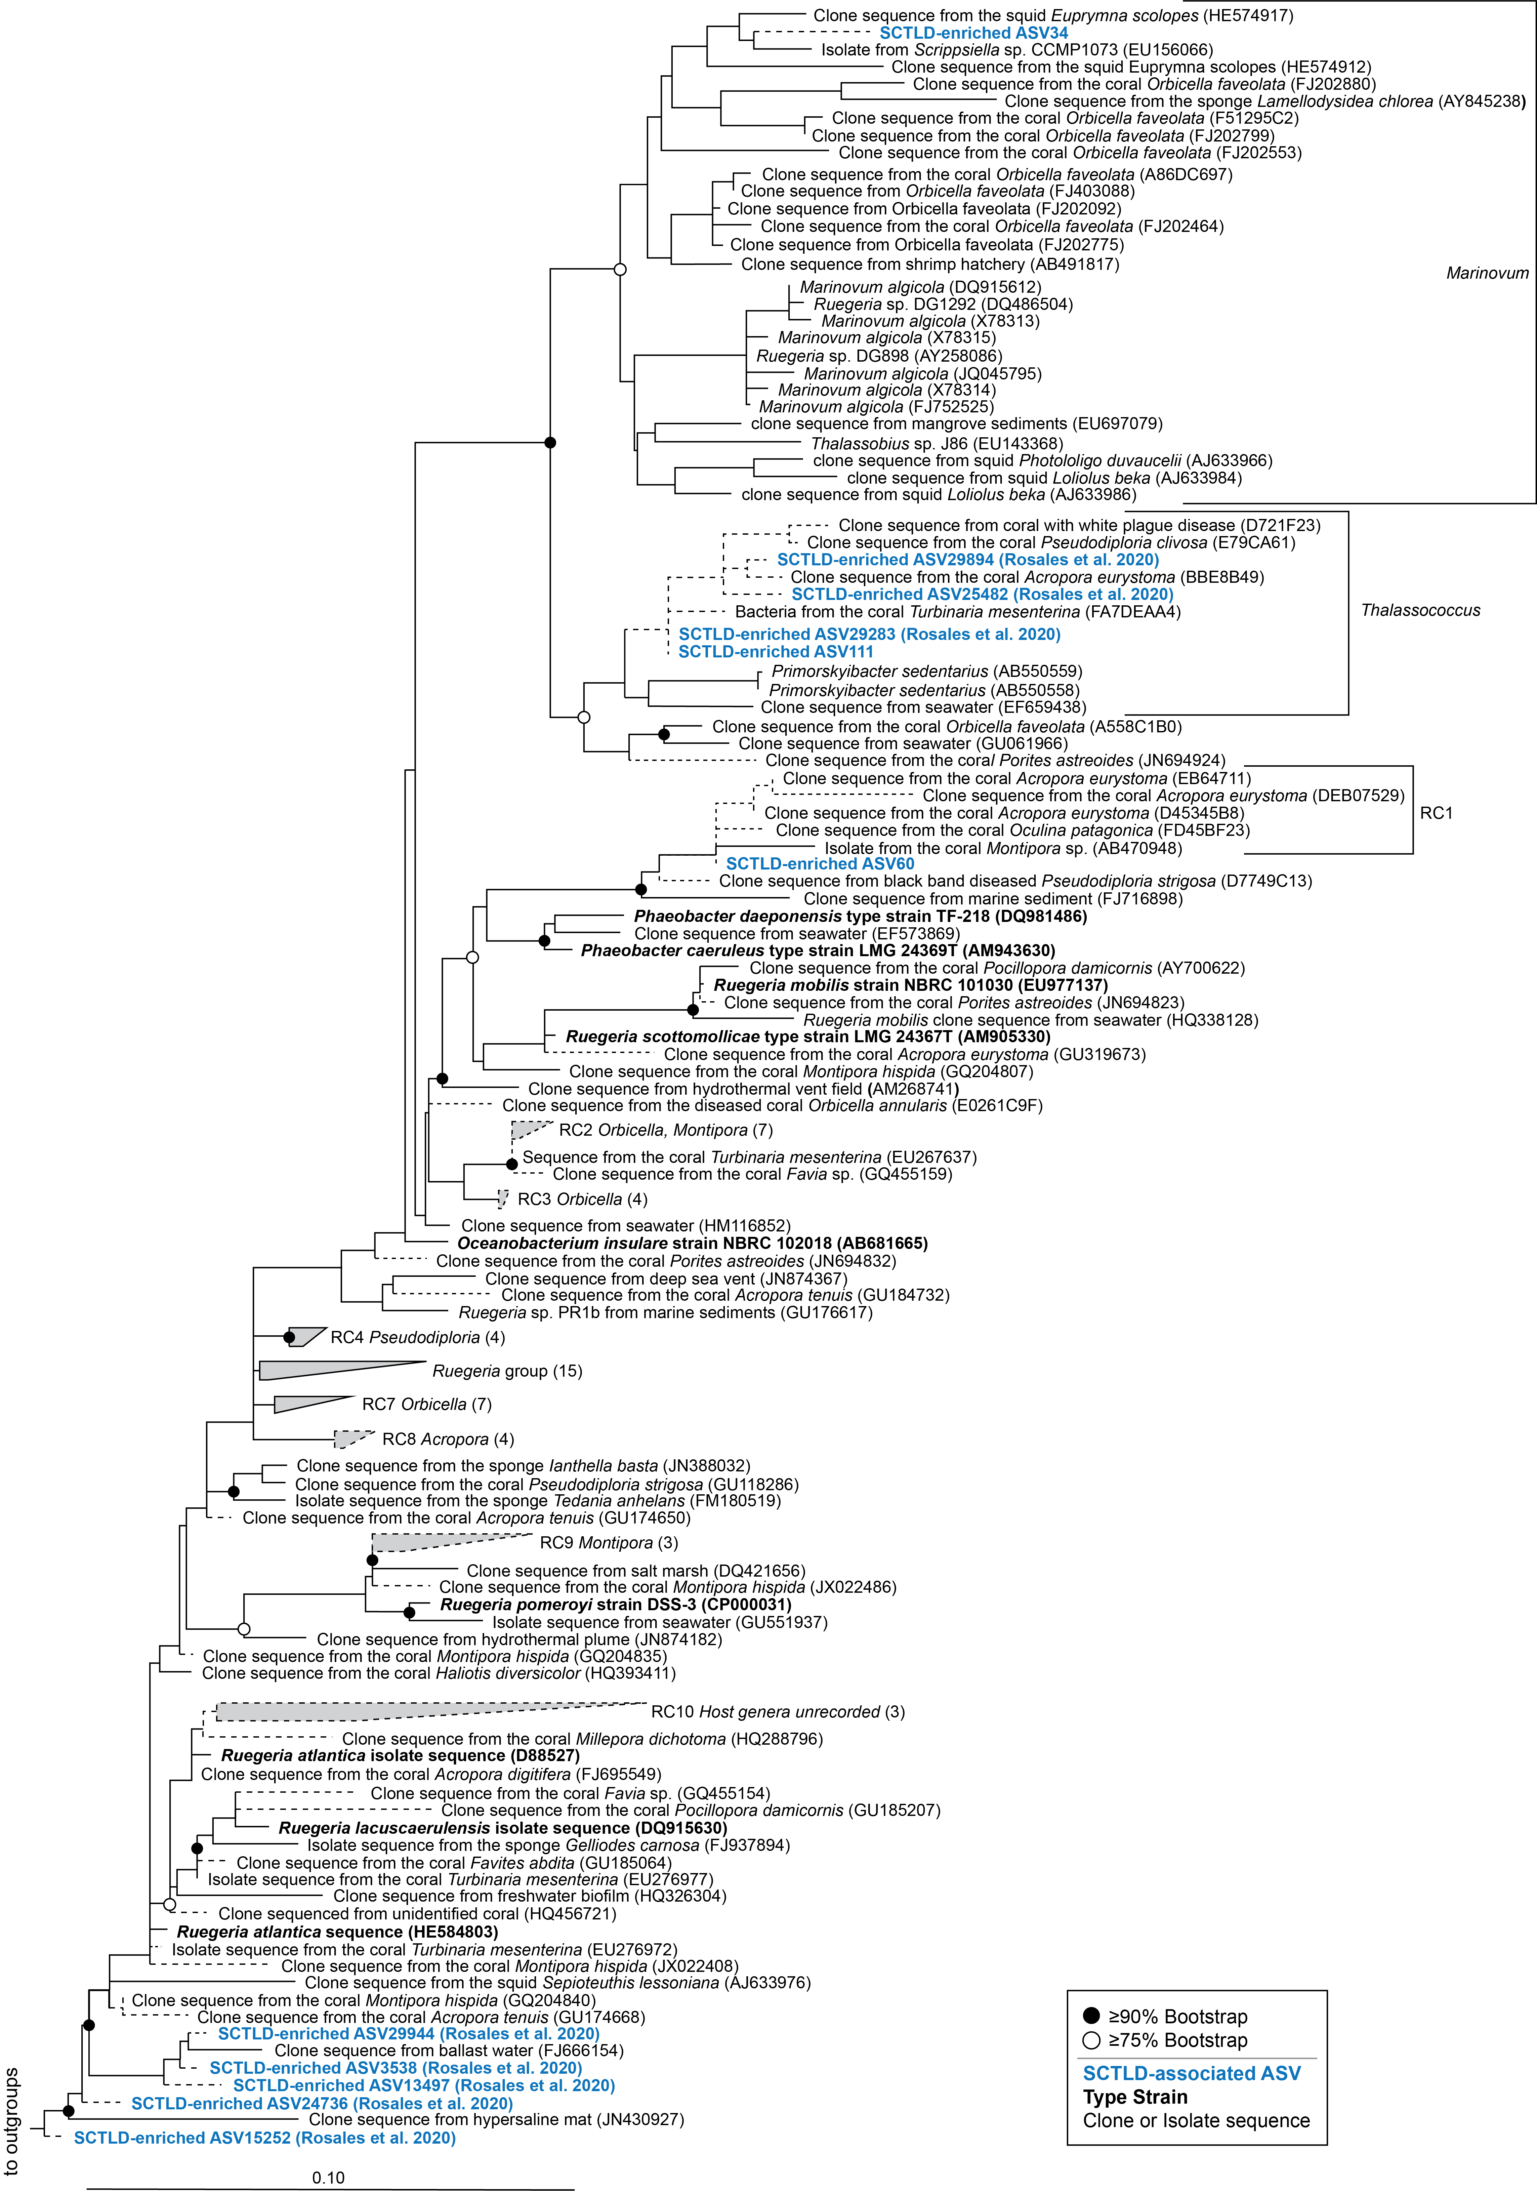

**Fig. S13. Two SCTLD bioindicator Rhodobacteraceae ASVs from the present study and several from a previous study related to sequences from the Coral Microbiome Database encompassing several genera within the Rhodobacteraceae Family.** Maximum likelihood and bootstrapped phylogenetic tree was produced using RAxML based on long (>1200 bp) sequences only, with the shorter coral associated sequences (dashed lines) and SCLTD-associated sequences (blue text) added using the Quick-add Parsimony tool in ARB. Colors represent qualitative information about the sequences as follows: Blue = SCTLD-associated ASVs from the present or a previous study (Rosales *et al.*, 2020), Black bold = bacterial type strains, Black = clone or bacterial isolate/strain sequences. GenBank accession numbers are located in parentheses following each taxa label, when available. Circles at node represent bootstrap values of ≥ 90% (filled-in circle) or ≥ 75% (empty circle). Bar indicates 10% sequence divergence. Tree was rooted with *Alteromonas* (AACY023784545) and *Methylophilaceae* (HM856564 and EU795249).