New Zealand southern right whale (Eubalaena australis; Tohorā nō Aotearoa) behavioural phenology, demographic composition, and habitat use in Port Ross, Auckland Islands over three decades: 1998-2021

Supplementary Material

Table S1: Drone survey summary information. Grid refers to grid shown in Figure S1.

Grid | Date | Number of southern right whales (Eubalaena australis) photographed
1 | 7 August 2020 | 2
2 | 3 August 2020 | 10
4 | 15 August 2020 | 7
5 | 15 August 2020 | 0
14 | 16 August 2020 | 0
17 | 16 August 2020 | 27

Table S2: Summary of southern right whale (Eubalaena australis) pre-approach behaviour by group size and category for the 1998 and 2020/21 surveys. The 1998 data is from Patenaude and Baker (2001). Shown are the percentage of groups observed with each behaviour and total number of groups in that category (N).

 |  |  |  |  | 1998 (%) |  |  |  |  |  |  |  |  |  |  | 2020/21 (%)
Groups with cow-calf pairs
Group size | Log |  | Travel |  |  | Social |  | Play |  | N |  | Log |  | Travel |  |  | Social |  | Mill |  | N
2 | 64 |  | 36 |  |  | - |  | 0 |  | 67 |  | 40 |  | 36 |  |  | - |  | 24 |  | 247
3+ | 50 |  | 13 |  |  | 38 |  | 0 |  | 16 |  | 27 |  | 27 |  |  | 35 |  | 12 |  | 26
Groups without cow-calf pairs
1 |  | 60 |  | 29 |  |  | - |  | 11 |  | 90 |  | 66 |  | 15 |  |  | - |  | 19 |  | 110
2 |  | 29 |  | 21 |  |  | 45 |  | 5 |  | 82 |  | 34 |  | 18 |  |  | 49 |  | 0 |  | 68
3+ |  | 14 |  | 4 |  |  | 83 |  | 0 |  | 103 |  | 14 |  | 4 |  |  | 79 |  | 2 |  | 97

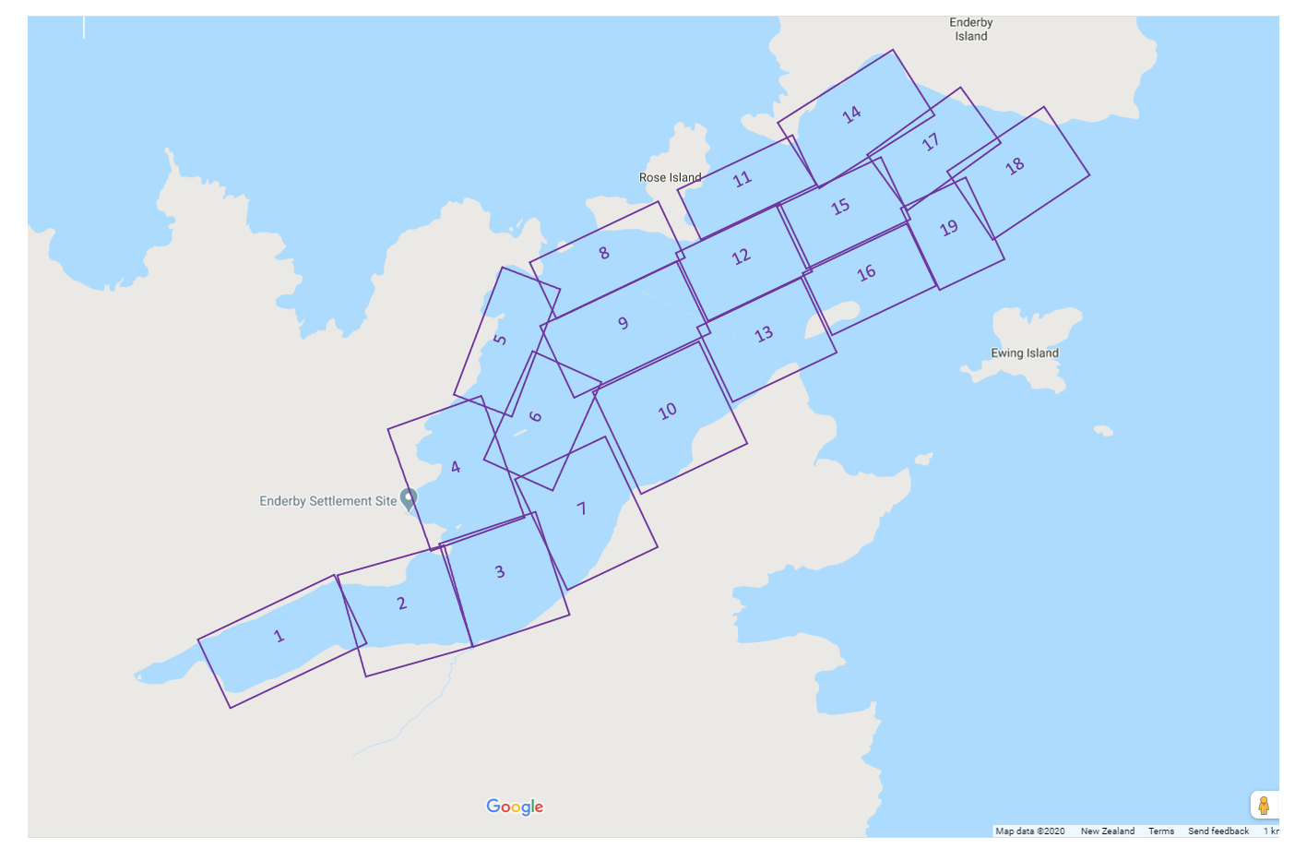

Fig. S1: Map of drone-based survey grids

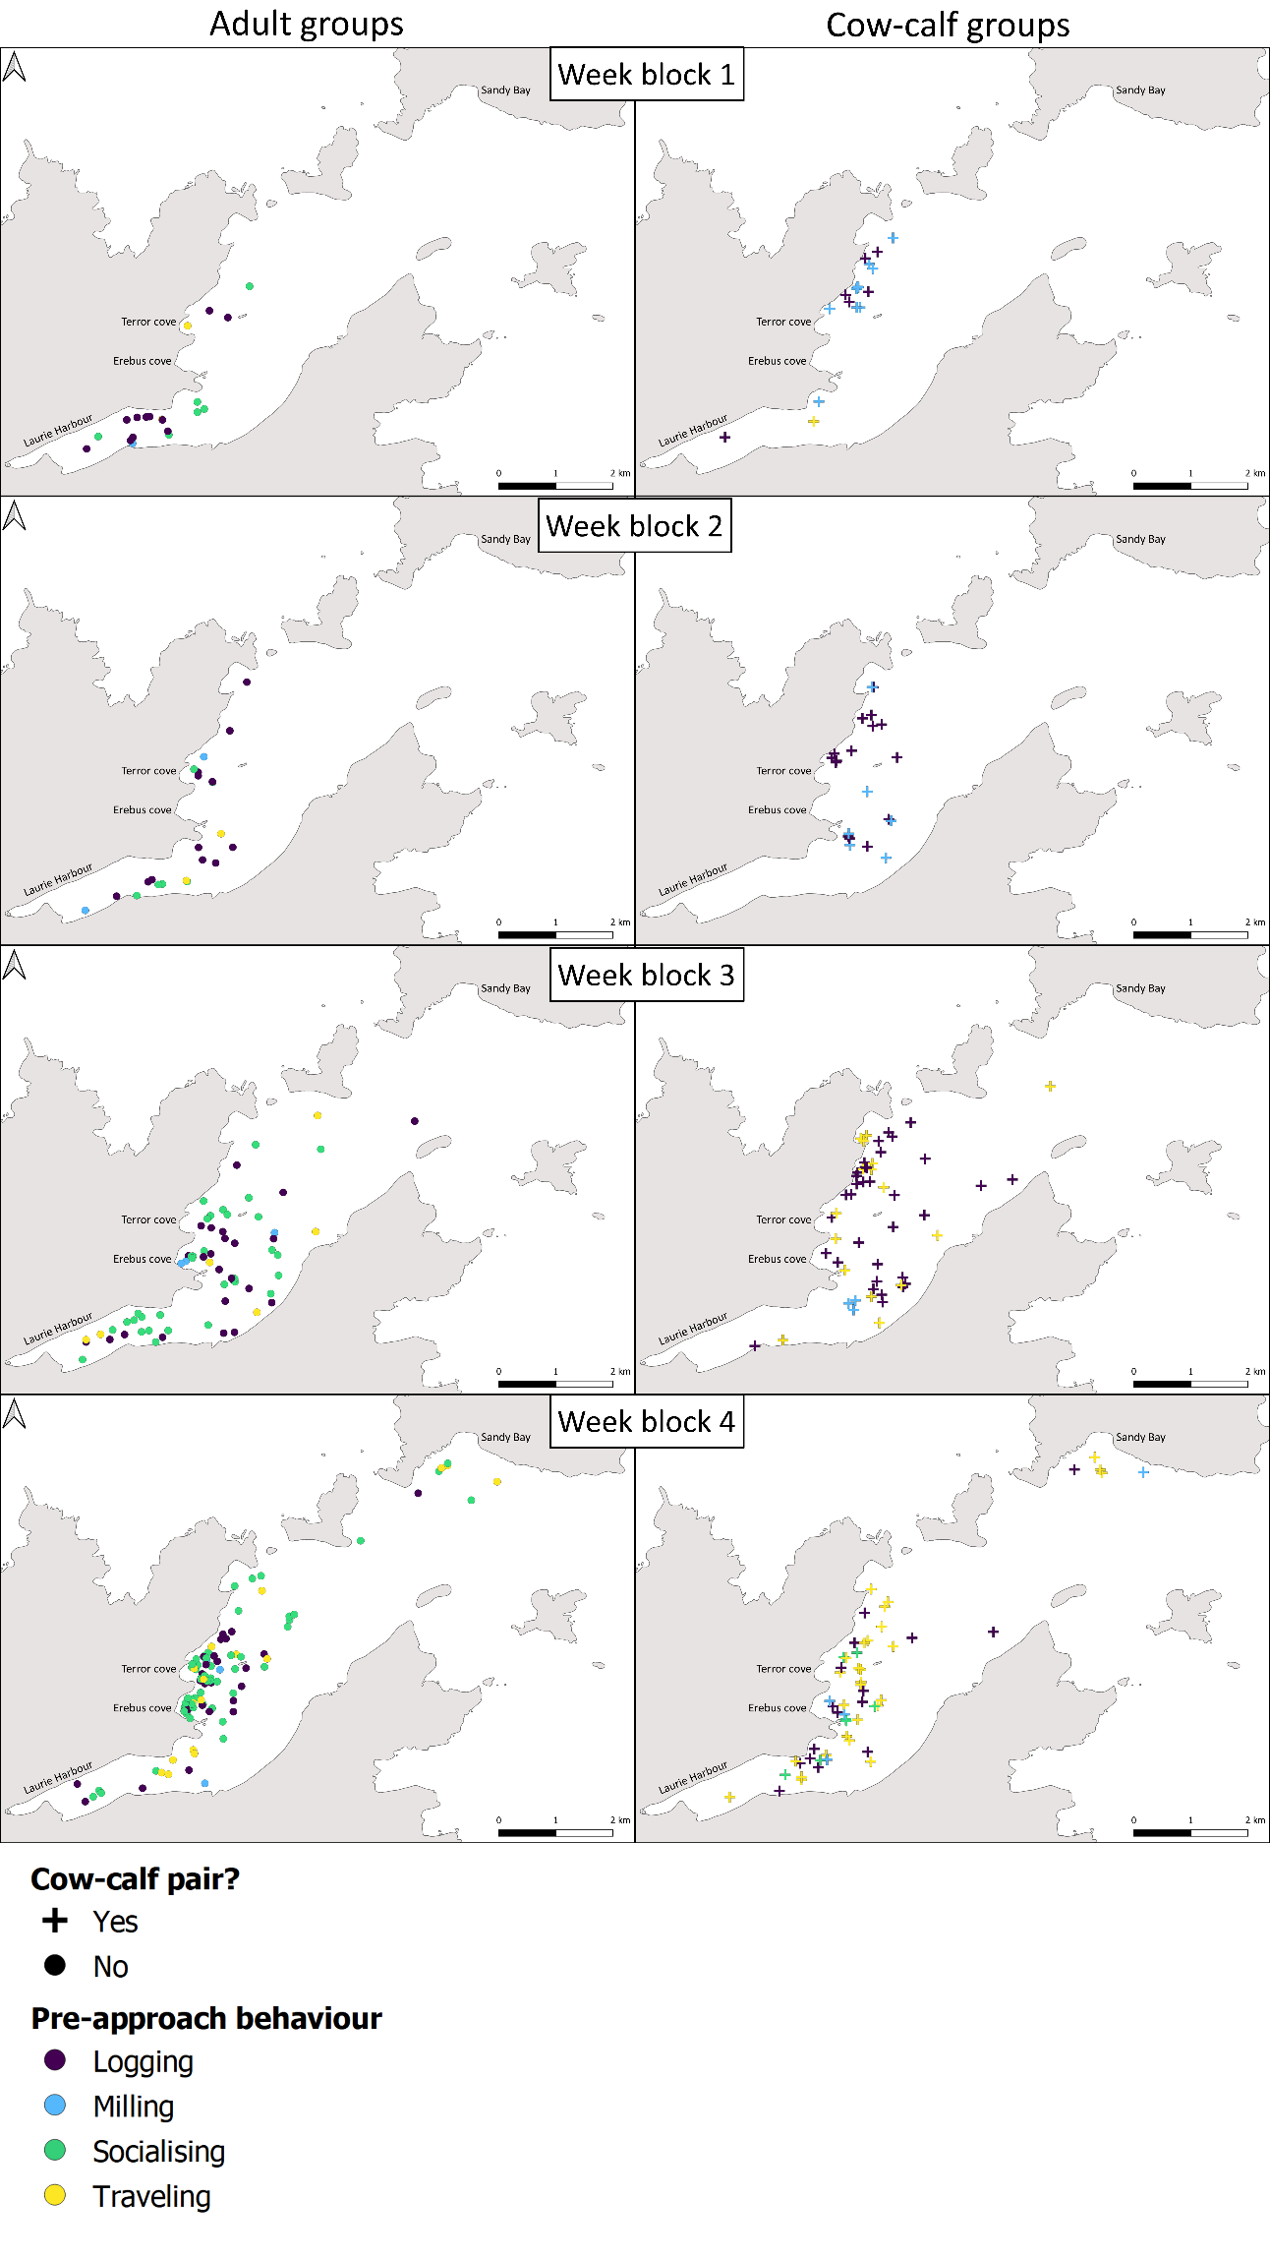
Figure S2: Location of encounters with southern right whales (Eubalaena australis) during the 2020 and 2021 field seasons plotted by weekly blocks 1-4. Left- and right-hand column shows position of encounters of groups containing only adults, and groups containing cow-calf pairs, respectively.

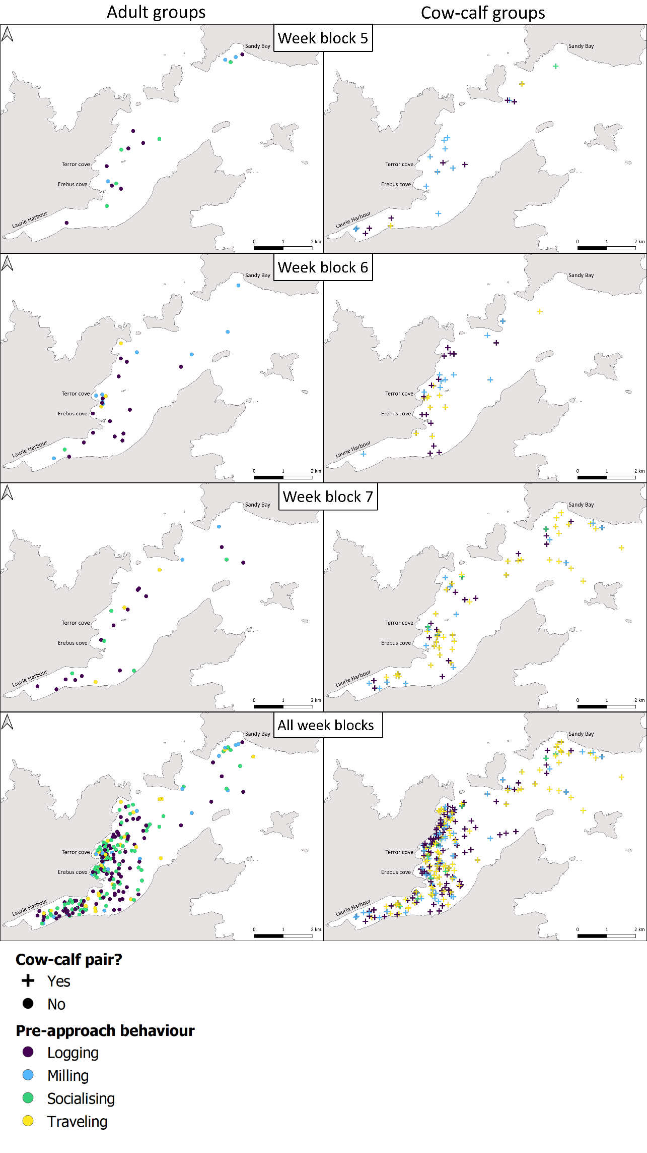
Figure S2 continued: Location of encounters with southern right whales (Eubalaena australis) during the 2020 and 2021 field seasons plotted by weekly blocks 5-7, and for all weeks in the 2020-2021 seasons combined. Left- and right-hand column shows position of encounters of groups containing only adults, and groups containing cow-calf pairs, respectively

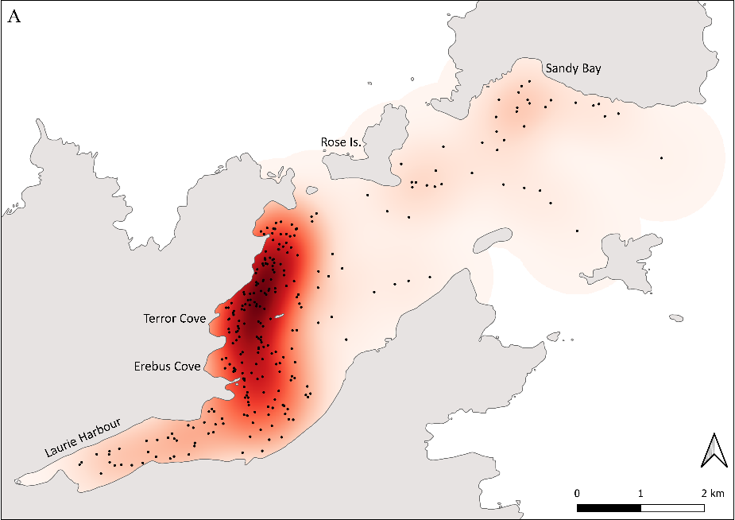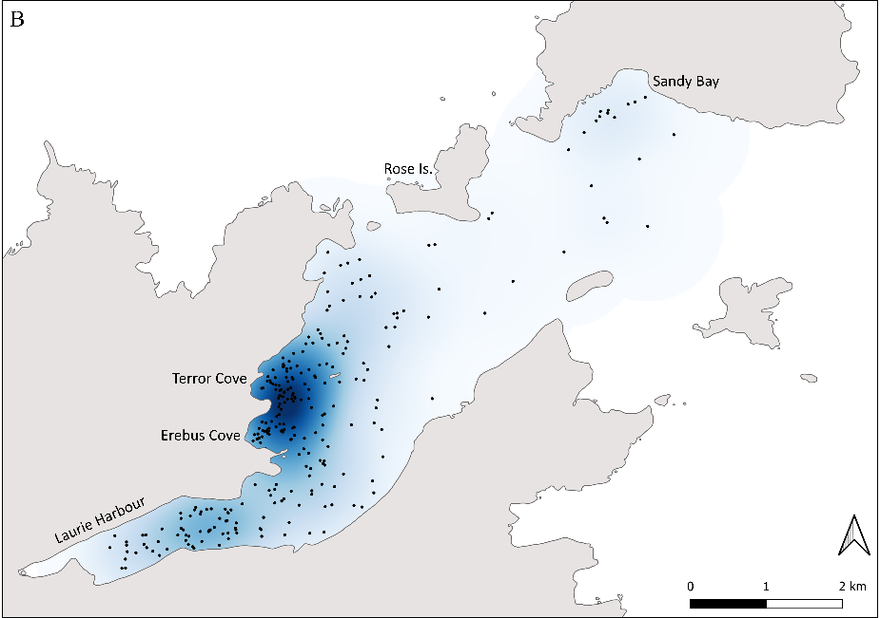
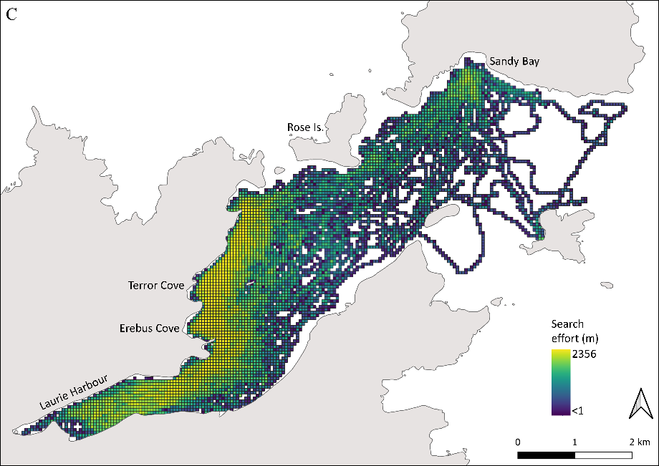
Figure S3: raw kernel density estimates overlaid with encounter locations (points) for groups (A) with and (B) without southern right whale (Eubalaena australis) cow-calves. Darker colours denote higher kernel density estimates. (C) search effort as distance travelled (in m) in 50x50m grid cells. Note that the kernel density extent is not exactly same for cow-calf and non-cow-calf groups due to the locations of those group encounters

