Supplemental Material

Effort allocation strata with sampled and non-sampled inlets shown in white and dark grey, respectively. The MWB stratum is comprised of the 26 colored sub-strata and planned tracklines are shown in black.

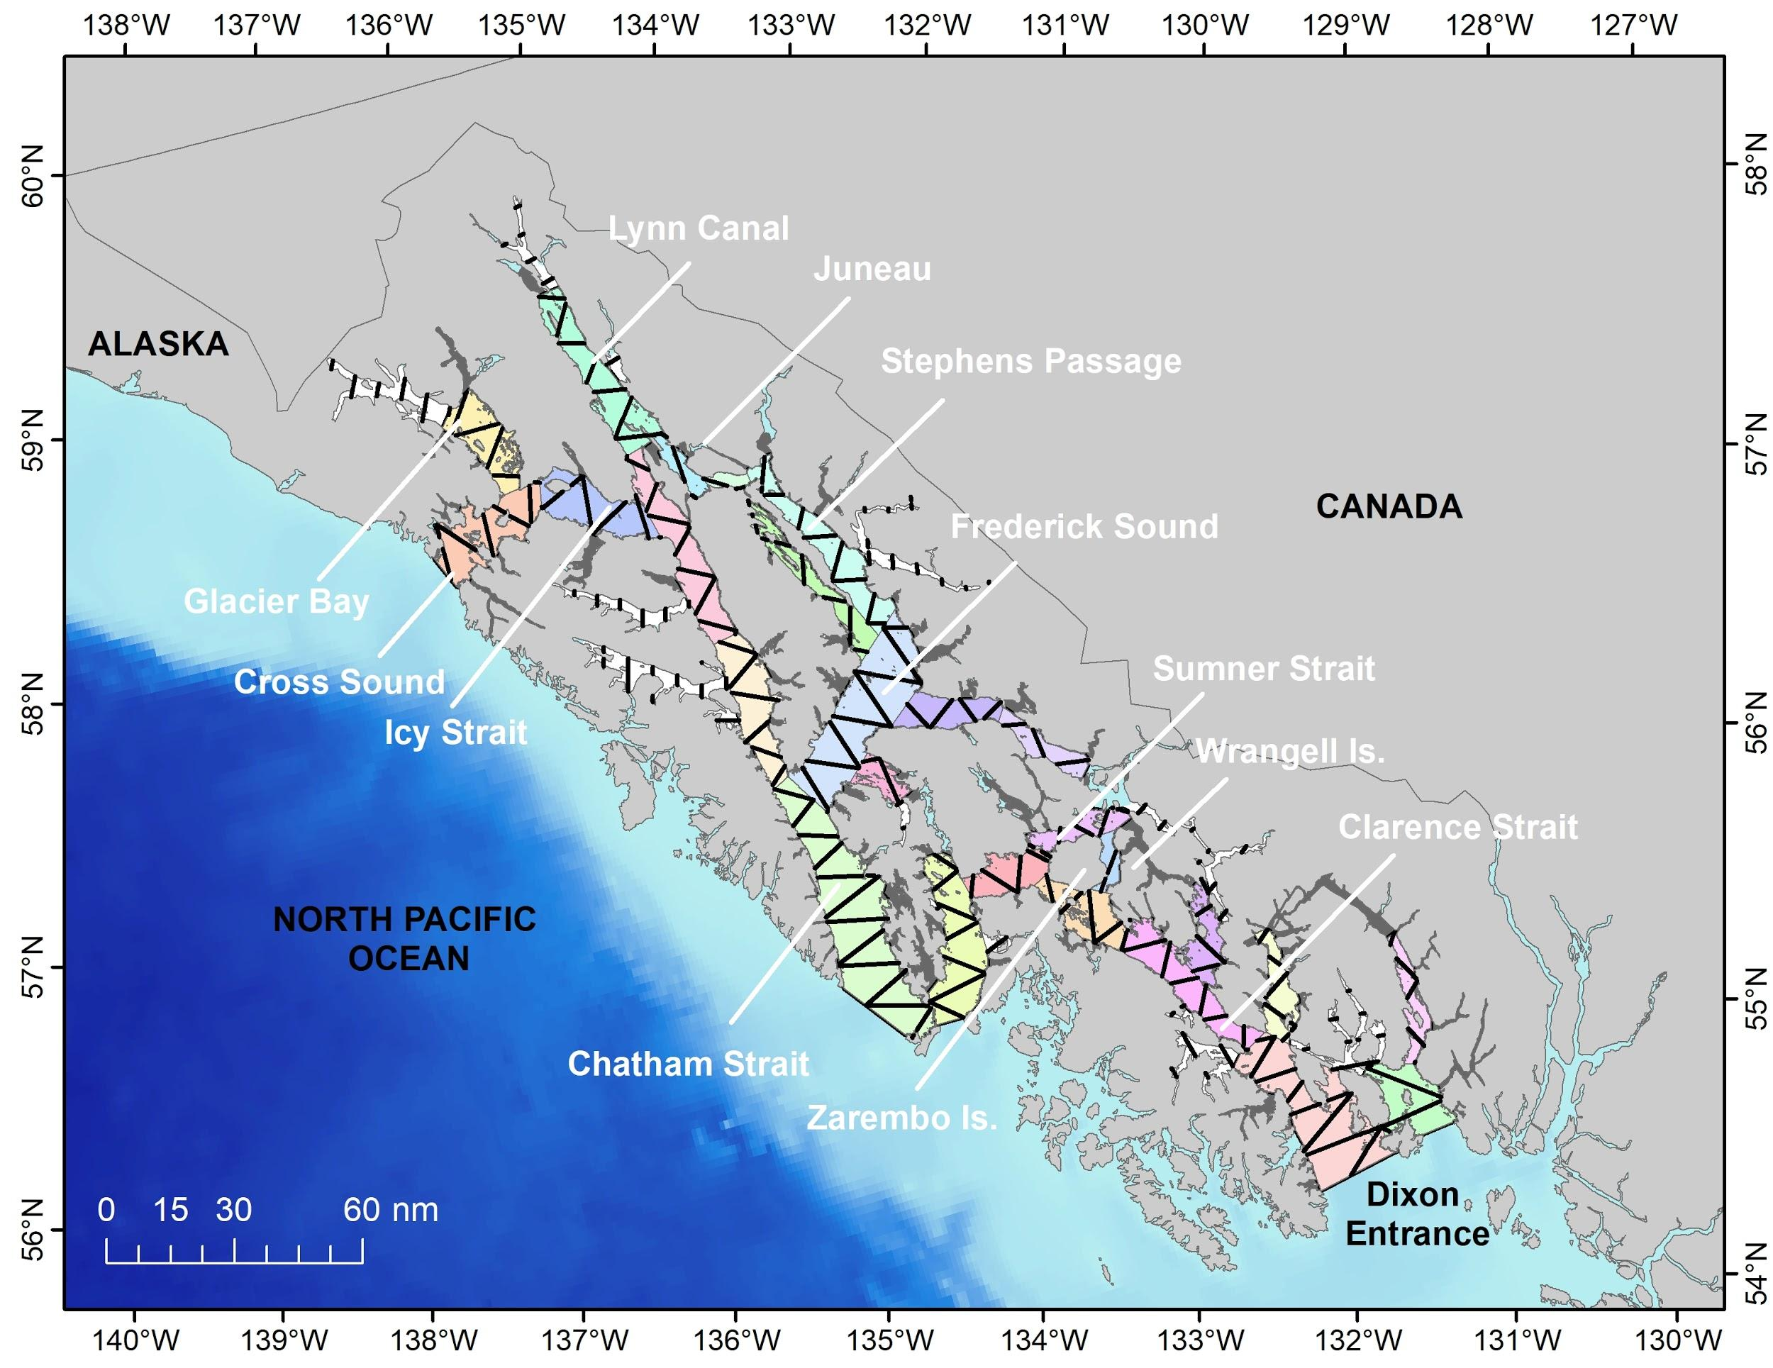

Example of a detection probability model fit to harbor porpoise perpendicular distance data. This model includes observer, weather conditions and Beaufort category as covariates. The dots represent the detection probability of each individual sighting while the line represents the average detection probability.

Bootstrap Estimates of Parameters of Interest – Abundance of Harbor Porpoise in SEAK in 2019.

 | Area: "wide inlets" northern DIP
 | Covered Area | Effort (km) | number of porpoise groups | encounter rate |  | mean group size |  | density of groups (uncorrected for g[0]) |  | number of individuals |  | density of individuals (uncorrected for g[0])
Median | 219.3 | 73.1 | 2.00 | 0.025 |  | 1.00 |  | 0.017 |  | 2.00 |  | 0.017
Mean | 221.6 | 73.9 | 1.96 | 0.026 |  | 0.89 |  | 0.018 |  | 1.96 |  | 0.018
SE | 36.4 | 12.1 | 1.30 | 0.017 |  | 0.32 |  | 0.011 |  | 1.30 |  | 0.011
CV | 0.2 | 0.2 | 0.66 | 0.637 |  | 0.36 |  | 0.645 |  | 0.66 |  | 0.645
Min | 138.3 | 46.1 | 0.00 | 0.000 |  | 0.00 |  | 0.000 |  | 0.00 |  | 0.000
Max | 387.9 | 129.3 | 7.00 | 0.100 |  | 1.00 |  | 0.068 |  | 7.00 |  | 0.068
LCL | 160.4 | 53.5 | 0.00 | 0.000 |  | 0.00 |  | 0.000 |  | 0.00 |  | 0.000
UCL | 297.6 | 99.2 | 5.00 | 0.062 |  | 1.00 |  | 0.042 |  | 5.00 |  | 0.042

 | Area: "narrow inlets" northern DIP
 | Covered Area | Effort (km) | number of porpoise groups |  | encounter rate |  |  | mean group size |  |  | density of groups (uncorrected for g[0]) |  | number of individuals |  | density of individuals (uncorrected for g[0])
Median | 212.5 | 126.0 |  | 5.00 |  | 0.038 |  |  | 1.17 |  | 0.022 |  | 6.00 |  |  | 0.027
Mean | 213.8 | 128.2 |  | 5.16 |  | 0.043 |  |  | 1.26 |  | 0.026 |  | 6.15 |  |  | 0.031
SE | 42.5 | 24.5 |  | 3.04 |  | 0.029 |  |  | 0.29 |  | 0.018 |  | 3.32 |  |  | 0.020
CV | 0.2 | 0.2 |  | 0.59 |  | 0.673 |  |  | 0.23 |  | 0.696 |  | 0.54 |  |  | 0.654
Min | 114.6 | 70.4 |  | 0.00 |  | 0.000 |  |  | 1.00 |  | 0.000 |  | 0.00 |  |  | 0.000
Max | 377.3 | 236.0 |  | 16.00 |  | 0.176 |  |  | 2.00 |  | 0.128 |  | 17.00 |  |  | 0.136
LCL | 138.8 | 86.6 |  | 0.00 |  | 0.000 |  |  | 1.00 |  | 0.000 |  | 0.00 |  |  | 0.000
UCL | 302.0 | 178.0 |  | 12.00 |  | 0.112 |  |  | 2.00 |  | 0.071 |  | 14.00 |  |  | 0.082

 | Area: MWB northern DIP
 | Covered Area | Effort (km) | number of porpoise groups |  |  | encounter rate |  |  | mean group size |  |  | density of groups (uncorrected for g[0]) |  | number of individuals |  | density of individuals (uncorrected for g[0])
Median | 2748.8 | 916.3 |  | 51.00 |  |  | 0.056 |  |  | 1.51 |  | 0.041 |  | 78.00 |  |  | 0.062
Mean | 2755.6 | 918.5 |  | 52.43 |  |  | 0.057 |  |  | 1.51 |  | 0.042 |  | 79.63 |  |  | 0.064
SE | 176.0 | 58.7 |  | 11.60 |  |  | 0.013 |  |  | 0.14 |  | 0.011 |  | 18.09 |  |  | 0.018
CV | 0.1 | 0.1 |  | 0.22 |  |  | 0.226 |  |  | 0.09 |  | 0.260 |  | 0.23 |  |  | 0.274
Min | 2201.7 | 733.9 |  | 21.00 |  |  | 0.024 |  |  | 1.13 |  | 0.013 |  | 34.00 |  |  | 0.021
Max | 3465.4 | 1155.1 |  | 97.00 |  |  | 0.109 |  |  | 2.04 |  | 0.088 |  | 154.00 |  |  | 0.136
LCL | 2437.6 | 812.5 |  | 33.00 |  |  | 0.035 |  |  | 1.26 |  | 0.024 |  | 47.98 |  |  | 0.036
UCL | 3106.2 | 1035.4 |  | 77.00 |  |  | 0.084 |  |  | 1.80 |  | 0.065 |  | 119.00 |  |  | 0.102

 | Area: MWB southern DIP
 | Covered Area | Effort (km) | number of groups |  |  | encounter rate |  |  | mean group size |  |  | density of groups (uncorrected for g[0]) |  | number of individuals |  | density of individuals (uncorrected for g[0])
Median | 1094.0 | 364.7 |  | 26 |  |  | 0.071 |  |  | 1.52 |  | 0.047 |  | 39.0 |  |  | 0.071
Mean | 1092.0 | 364.0 |  | 27 |  |  | 0.073 |  |  | 1.52 |  | 0.049 |  | 40.4 |  |  | 0.074
SE | 95.2 | 31.7 |  | 8 |  |  | 0.023 |  |  | 0.14 |  | 0.016 |  | 12.6 |  |  | 0.027
CV | 0.1 | 0.1 |  | 0 |  |  | 0.308 |  |  | 0.09 |  | 0.337 |  | 0.3 |  |  | 0.359
Min | 797.9 | 266.0 |  | 3 |  |  | 0.008 |  |  | 1.00 |  | 0.006 |  | 3.0 |  |  | 0.006
Max | 1363.5 | 454.5 |  | 56 |  |  | 0.164 |  |  | 1.95 |  | 0.146 |  | 91.0 |  |  | 0.225
LCL | 906.7 | 302.2 |  | 12 |  |  | 0.035 |  |  | 1.23 |  | 0.023 |  | 18.0 |  |  | 0.031
UCL | 1273.0 | 424.3 |  | 43 |  |  | 0.122 |  |  | 1.79 |  | 0.086 |  | 67.0 |  |  | 0.136

Bootstrap estimates of g(0) – Abundance of Harbor Porpoise in SEAK in 2019.

g(0) estimates (D_X = Beaufort-specific density, g0-X rel = relative g0, Eff_BX = Beaufort-specific effort, where X = Beaufort states 0-3)
 | D_0 | D_1 | D_2 | D_3 | g0-0 rel | g0-1 rel | g0-2 rel | g0-3 rel | Eff_B0 | Eff_B1 | Eff_B2 | Eff_B3 | Average_g0
median | 0.209 | 0.116 | 0.057 | 0.051 | 1 | 0.56 | 0.28 | 0.25 | 361 | 350 | 376 | 310 | 0.53
mean | 0.213 | 0.117 | 0.058 | 0.052 | 1 | 0.57 | 0.28 | 0.25 | 362 | 353 | 376 | 314 | 0.53
SE | 0.039 | 0.012 | 0.008 | 0.016 | NA | 0.11 | 0.07 | 0.09 | 52 | 48 | 44 | 52 | 0.06
CV | 0.182 | 0.105 | 0.146 | 0.298 | NA | 0.20 | 0.23 | 0.35 | 0.14 | 0.14 | 0.12 | 0.16 | 0.11
LCL | 0.149 | 0.095 | 0.043 | 0.024 | 1 | 0.38 | 0.17 | 0.11 | 268 | 265 | 293 | 218 | 0.43
UCL | 0.299 | 0.143 | 0.075 | 0.084 | 1 | 0.82 | 0.42 | 0.46 | 467 | 453 | 462 | 418 | 0.65
SE = Standard Error, CV = coefficient of variation, LCL = 95% lower confidence limit, UCL = 95% upper confidence limit
Mathematical Formulation of Methods

1. Detection probability
The model to estimate detection probability assumed the following form (Marques and Buckland, 2003):

${\hat{P}}_{j}=\int_{0}^{W}{g(x,z|\hat{β})\frac{1}{W}dx}$ (eq. 1)

Where:
- ${\hat{P}}_{j}$ is the probability of detecting sighting j within the strip of half width W,
- x is the perpendicular distance,
- z is set of covariates (e.g., sea state, group size),
- $\hat{β}$ is the vector of estimated covariate coefficients.

The detection function $g(x,z|\hat{β})$ corresponded to a half normal model.

For Conventional Distance Sampling (CDS), the detection probability ($\hat{P}$) is a special case of eq (1), is estimated only as a function of distance from the trackline (no other covariates are considered) and is therefore constant (Borchers and Burnham, 2004).

2. Method specific density estimates
In this study, a combination of line transect and strip transect methods were used to estimate density in the different regions surveyed. Estimation of parameters of interest is described below for each method separately.

2.1 Line transect
Density of groups using line transect methods were computed as follows:

For MCDS models (Marques and Buckland, 2003), the density of groups (g) and individuals (i), uncorrected for g(0), is given by:

${\hat{D}}_{g,k,r}^{u}=\frac{\sum_{j=1}^{n}{\frac{1}{{\hat{P}}_{j,k,r}}}}{2L_{k,r}W}$ (eq. 2)

${\hat{D}}_{i,k,r}^{u}=\frac{\sum_{j=1}^{n}{\frac{s_{j,k, r}}{{\hat{P}}_{j,k,r}}}}{2L_{k,r}W}$ (eq. 3)

Where:
- ${\hat{D}}_{g,k,r}^{u}$ – is the uncorrected density of groups within the survey strip in stratum “k” (MWB or “wide” inlets) and region “r” (northern or southern DIP).
- ${\hat{D}}_{i,k,r}^{u}$ – is the uncorrected density of individuals within the survey strip in stratum “k” and region “r”.
- $s_{j,k, r}$– is the observed group size for sighting “j” in stratum “k” and region “r”,
- ${\hat{P}}_{j,k,r}$ – is defined in equation 1 above and applied for each of the “j” sighting observed on tracklines in stratum “k” and region “r”,
- L_{k,r}– is the length of trackline surveyed in stratum “k” and region “r”, and
- W – is the effective strip width.

For CDS models, the uncorrected density of groups and individuals is estimated as (Buckland et al., 2001):

${\hat{D}}_{g,k,r}^{u}=\frac{\frac{n_{k,r}}{\hat{P}}}{2L_{k,r}W}$ (eq. 4)

${\hat{D}}_{i,k,r}^{u}={\hat{D}}_{g,k,r}^{u}*{\hat{E}(s)}_{k, r}$ (eq. 5)

Where:
- n_{k,r} – is the number of porpoise groups detected within the survey strip in stratum “k” and region “r”,
- $\hat{P}$ – is the average detection probability computed using CDS methods,
- ${E(s)}_{k,r}$ – is the expected group size in stratum “k” and region “r”.

The expected group size, $(E\left[s\right])$, for CDS and MCDS models were given, respectively, by:

${\hat{E}\left(S\right)}_{k,r}=\frac{\sum_{j=1}^{n}{s_{k,j}}}{n}$ (eq. 6)

${\hat{E}\left(S\right)}_{k,r}= \frac{\sum_{j=1}^{n}{\frac{s_{j, k, r}}{{\hat{P}}_{j,k,r}}}}{\sum_{j=1}^{n}{\frac{1}{{\hat{P}}_{j,k,r}}}}$ (eq. 7)

2.2 Strip transect
Strip transect methods were used to compute density in the “narrow” inlets as it was assumed that all individuals available to be detected within these inlets were seen (see Methods section for details). Density of individuals, uncorrected for g(0), was computed as follows:

$D_{i,k^{'},r}^{u}= \frac{\sum_{m=1}^{M}{{n'}_{m, k^{'},r}}}{\sum_{m=1}^{M}{a_{m, k^{'}, r}}}$ (eq. 8).

Where:
- $D_{i,k^{'},r}^{u}$ – is the density of individuals in stratum “k’ ” (narrow inlet) in region “r” (northern or southern DIP),
- $a_{m, k^{'},r}$ – is the area of narrow inlet “m”, in stratum “k’” in region “r”
- ${n'}_{m, k^{'}, r}$ – is the number of individuals seen in narrow inlet “m”, in stratum “k’” in region “r”
- M_{k’},_{r} – is the total number of narrow inlets in stratum “k’”, in region “r”.

3. Density in the Inlet Stratum
Uncorrected density of individuals in the inlet stratum was estimated as the weighted average of density in the “wide” and “narrow” inlets, as follows:

${\hat{D}}_{i, inlets, r}^{u}= \frac{D_{i,k,r}^{u}+D_{i,k',r}^{u}}{a_{k, r}+ a_{k', r}}$ (eq. 9)
Where:
- ${\hat{D}}_{i, inlets, r}^{u}$ – is the uncorrected density of individuals in the inlet stratum in region “r”,
- $D_{i,k,r}^{u}$- is the density of individuals in the k = “wide” inlets (computed with eqs. 3 or 5),
- $D_{i,k',r}^{u}$- is the density of individuals in the k’ = “narrow” inlets (computed with eq. 8),
- $a_{k, r}$- area of the survey strip within the k = “wide” inlets,
- $a_{k', r}$- area of the sampled k’ = “narrow” inlets.

4. Uncorrected abundance estimation
Uncorrected abundance for each stratum in each region was estimated as as follows:

${\hat{N}}_{MWB, r}^{u}= A_{MWB, r}*{\hat{D}}_{i, MWB, r}^{u}$ (eq. 10)

${\hat{N}}_{inlets, r}^{u}= A_{inlets, r}*{\hat{D}}_{i, inlets, r}^{u}$ (eq. 11)

Where:
- ${\hat{N}}_{MWB, r}^{u}$ – is the uncorrected abundance of individuals in the MWB stratum in region “r”,
- $A_{MWB, r}$ – is the survey region area for stratum MWB in region “r”
- ${\hat{D}}_{i, MWB, r}^{u}$- is the uncorrected density of individuals in the MWB stratum in region “r” (computed with eqs. 3 or 5),
- ${\hat{N}}_{inlets, r}^{u}$ – is the uncorrected abundance of individuals in the I stratum in region “r”,
- $A_{inlets, r}$ – is the survey region area for stratum I in region “r”
- ${\hat{D}}_{i,inlets, r}^{u}$- is the uncorrected density of individuals in the I stratum in region “r” (computed with eq. 9).

Total uncorrected abundance in each region was computed as:

${\hat{N}}_{ r}^{u}= {\hat{N}}_{ MWB, r}^{u}+ {\hat{N}}_{ inlets, r}^{u}$ (eq. 12)

5. Trackline detection probability - g(0)
Detection probability on the trackline was estimated by adapting the method described by Barlow (2015) to estimate density for Beaufort sea states ranging from 0 to 3 using harbor porpoise sighting data collected in Southeast Alaska in 1991-93, 2006-7 and 2010-12 (Dahlheim et al., 2015). Detection probability and density were computed using eqs. 1 and 2, respectively.

Relative g(0) was computed as:

${\hat{g\left(0\right)}}_{B}= \frac{{\hat{D}}_{B}}{{\hat{D}}_{0}}$ (eq. 13)

Where:
${\hat{g\left(0\right)}}_{ B}$ – is the relative g(0) estimate for Beaufort (B) states ranging from 1 to 3 (g(0) for Beaufort 0 is assumed to be 1),
${\hat{D}}_{B}$ – is the estimated density of harbor porpoise in Beaufort (B) state 1-3,
${\hat{D}}_{0}$ – is the estimated density of harbor porpoise in Beaufort state 0.

The average g(0) for the 2019 survey was computed as:

$\hat{g\left(0\right)}= \frac{1}{L}\sum_{B=1}^{3}{{\hat{g(0)}}_{B}*L_{B}}$ (eq. 14)

Where:
- L_{B} – is the survey effort associated with each Beaufort sea state B (0 to 3),
- L – is total survey effort (sum across all Beaufort sea states)

6. Corrected abundance estimation
Overall abundance, corrected for g(0) was computed as:

$\hat{N}= \frac{{\hat{N}}_{r}^{u}}{\hat{g(0)}}$(eq. 15)

Where:
- ${\hat{N}}_{r}$ – is the estimated total abundance corrected for g(0) in region “r”,
- ${\hat{N}}_{r}^{u}$ – is the estimated uncorrected abundance for region “r” (computed using eq. 12)
- $\hat{g(0)}$ – is the estimated average g(0) (computed using eq. 14)

