SUPPLEMENTARY FIGURES

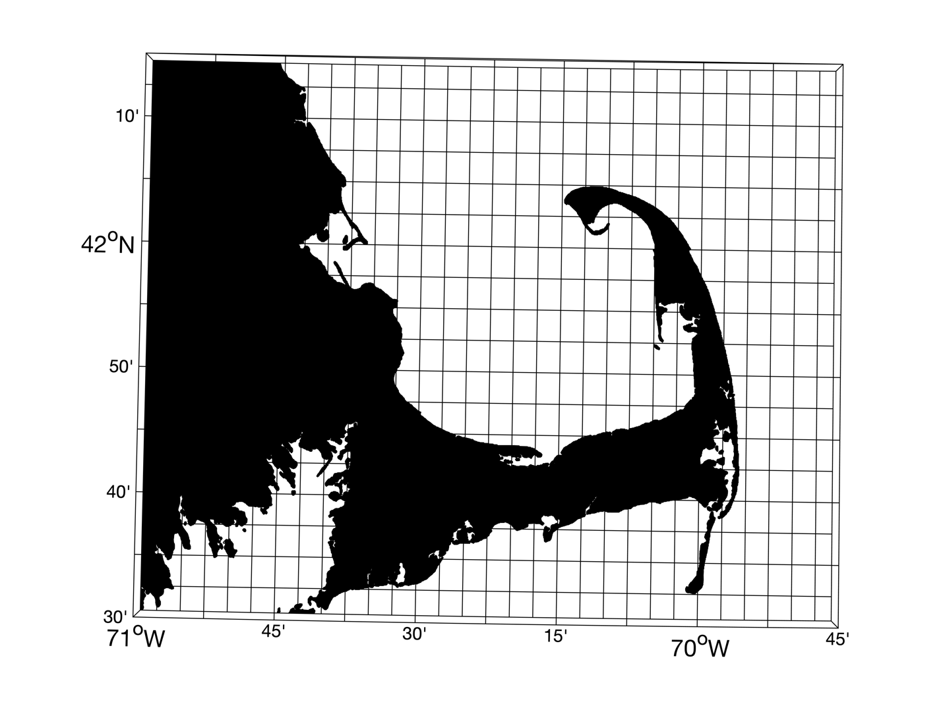
Figure S1. Cape Cod Bay study area with 4.6 km grid cells.
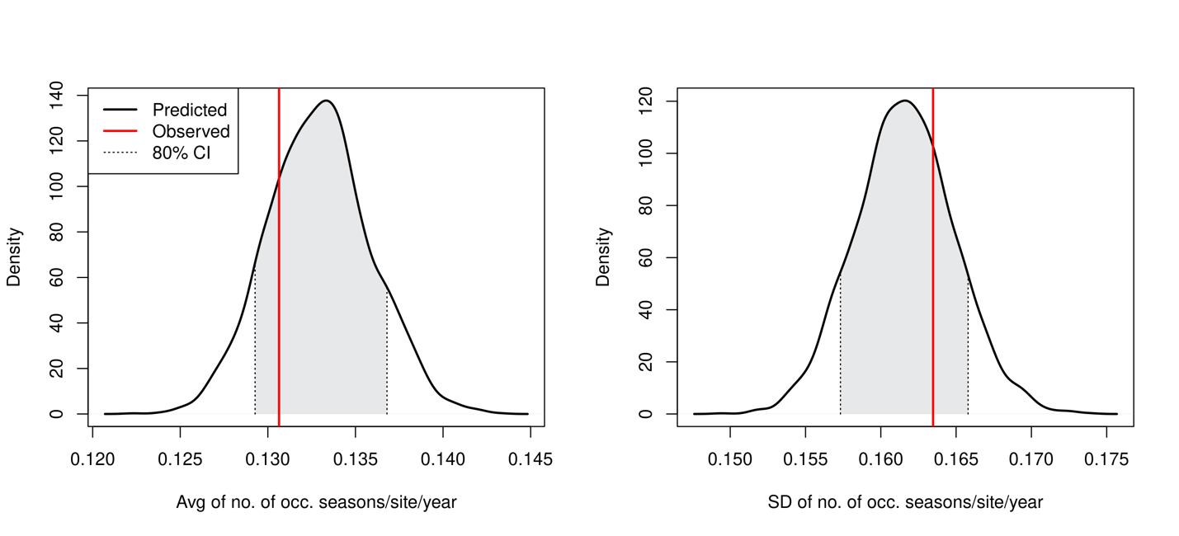Figure S2. Right whale post predictive check

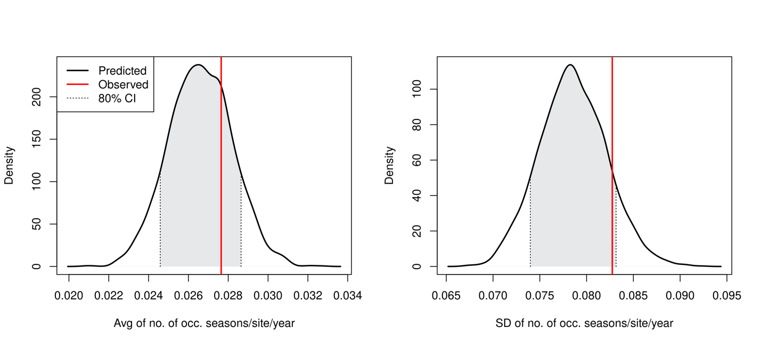
Figure S3. Humpback whale post predictive check

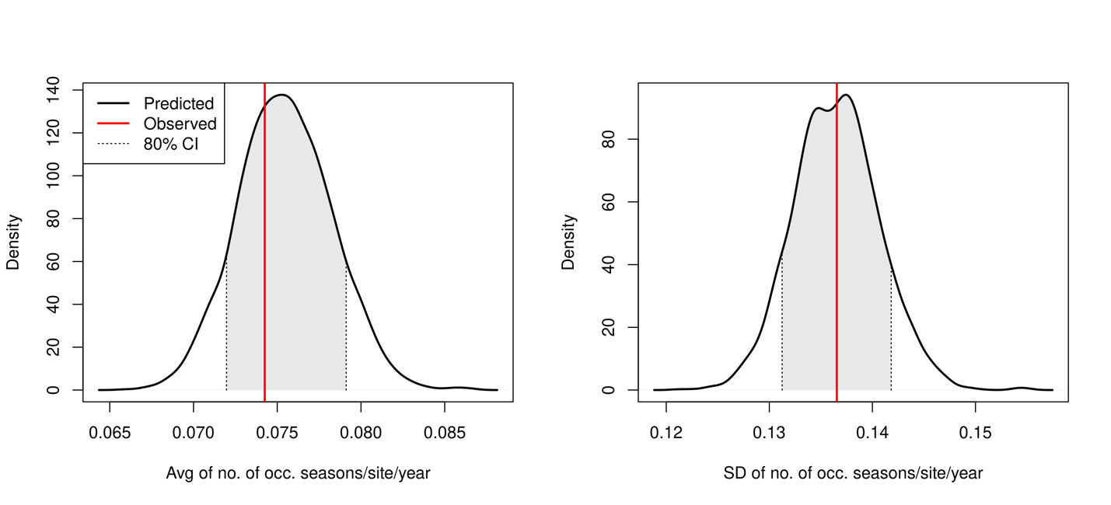
Figure S4. Fin whale post predictive check.

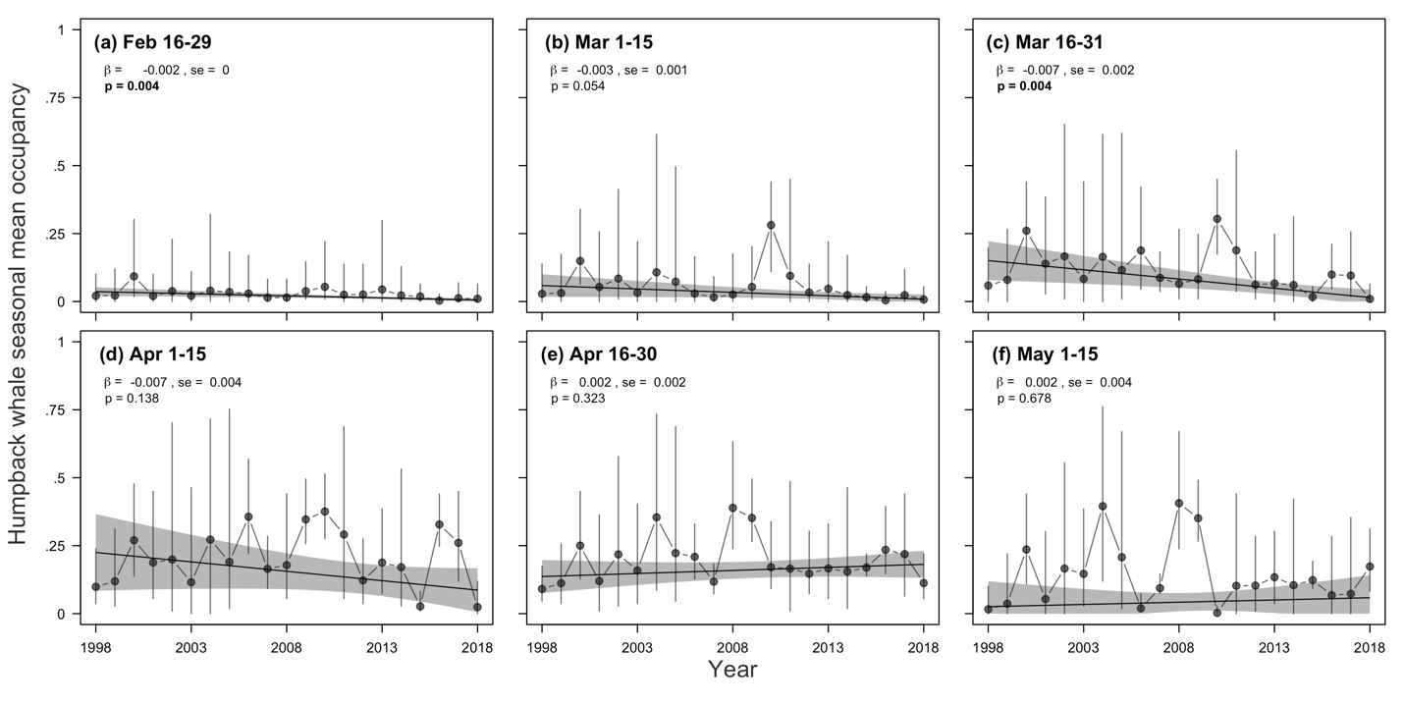
Figure S5: Mean occupancy of humpback whales in Cape Cod Bay from 1998–2018 within half-month sampling periods: 16–29 February (a), 1–15 March (b), 16 – 31 March (c), 1–15 April (d), 16–30 April (e), and 1–15 May (f). Vertical lines show 50% CrIs. Solid and dashed fitted lines are inversely weighted by the variance in each estimate of mean occupancy. Shaded regions represent 95% CIs. Bold p-values indicate statistical significance (p < 0.05).

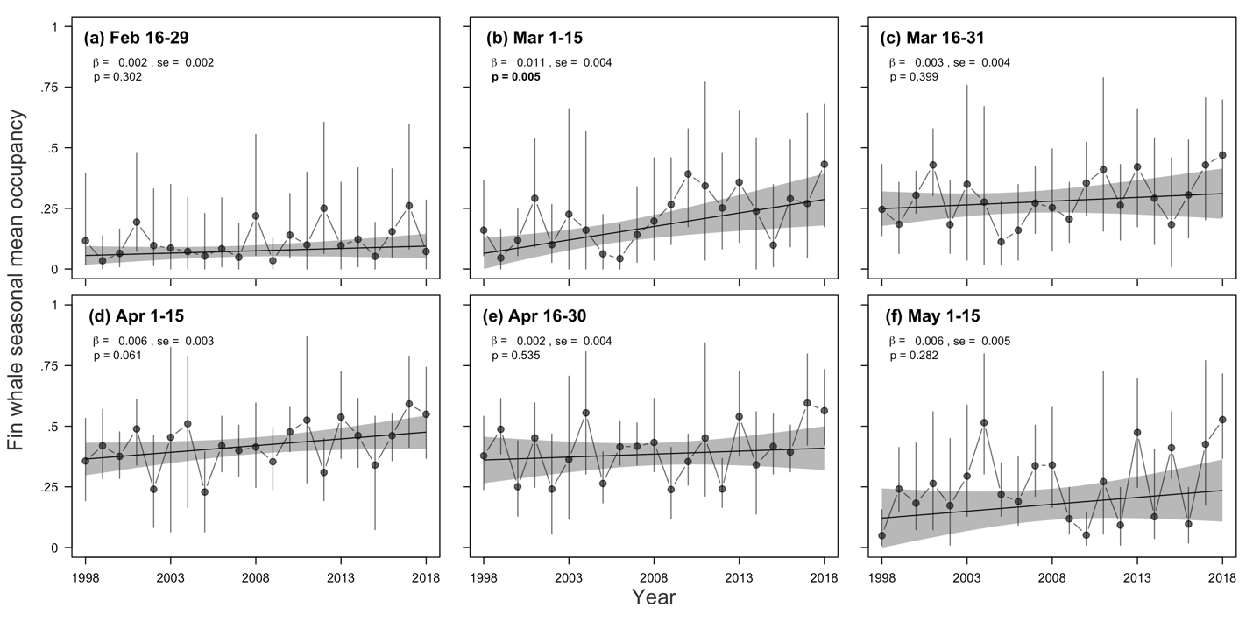
Figure S6: Mean occupancy of fin whales in Cape Cod Bay from 1998–2018 within half-month sampling periods: 16–29 February (a), 1–15 March (b), 16–31 March (c), 1–15 April (d), 16–30 April (e), and 1–15 May (f). Vertical lines show 50% CrIs. Solid and dashed fitted lines are inversely weighted by the variance in each estimate of mean occupancy. Shaded regions represent 95% CIs. Bold p-values indicate statistical significance (p < 0.05).

