Model configuration and data inputs
The stock assessment model for Gulf red grouper included a variety of input data sources (Fig. S1). The selection of 1986 as the start year was based on data availability and quality, and reflects the year in which commercial landings started to be reported at the species level, leading to the most reliable catch estimates (SEDAR 2015). The stock was initialized in a non-equilibrium state with initial conditions approximated by estimating initial fishing mortality rates from initial equilibrium catches (specified as the average landings between 1986 and 1990). Three commercial fishing fleets (longline, vertical line, and trap) and one recreational fleet were modeled, with the majority of landings removed by commercial fisheries. Data for each fishing fleet included: landings, discards, age composition of the landings, length compositions of the discards where available, and catch-per-unit-effort indices of relative abundance. Relative abundance and size data from four fishery-independent surveys were also used in the assessment. The Southeast Area Monitoring and Assessment Program summer groundfish survey captures juvenile and younger adult red grouper, whereas the NMFS/FWRI video, NMFS bottom longline, and FWRI hook-and-line surveys primarily encounter adults (SEDAR 2019).

Age-specific natural mortality for Gulf red grouper was estimated (Lorenzen 2005) using a target natural mortality of 0.14 year⁻¹ (Hoenig 1983) and fixed in the stock assessment model. Total fecundity-at-age for this protogynous hermaphrodite was estimated externally as a function of the proportion female, proportion mature, and batch fecundity and fixed in the stock assessment model. Spawning stock biomass (SSB) was therefore defined in relative number of eggs. A Beverton-Holt stock-recruitment relationship was assumed and steepness (the fraction of virgin recruits produced at 20% of the equilibrium SSB) was fixed at 0.99, with maximum sustainable yield approximated using spawning potential ratio (SPR)-based reference points with a target of 30% (SEDAR 2015). Steepness fixed at 0.99 originated from the Review Panel recommendation of the Benchmark SEDAR 42 Assessment following an uninformative stock recruitment relationship (SEDAR 2015), with this decision enabling projections to assume recent average recruitment by eliminating the dependency of recruitment on spawners. Additional details on steepness and other aspects of model configuration can be obtained in SEDAR (2019).

Assessment model diagnostics for Gulf of Mexico red grouper base model estimating red tide mortality in 2005 and 2014
A range of diagnostics evaluated model performance, model fits to the data, model stability, and uncertainty in model parameters and derived quantities. Model performance was explored by examining residuals of the model fit to each of the input datasets. Correlations between parameters were evaluated to identify highly correlated parameters which could lead to instability. No major issues were evident in the residual patterns, and most parameter estimates appeared reasonable with relatively low CVs (Table S1). A few exceptions were noted for recruitment deviations, particularly for more recent years where CVs ranged between one and two. Given the highly parameterized nature of this model, six parameter pairs were mildly correlated (correlation coefficient > 70%); however, no strong correlations (> 95%) were evident (Table S2).

Starting values of estimated parameters were randomly ‘jittered’ by 10% and the model was refitted 200 times to determine whether a global minimum had been found by the search algorithm. This sensitivity analysis of alternative starting parameter values indicated that all 200 runs landed on the same negative log-likelihood estimate as the assessment model, suggesting a stable model solution under the current model configuration.

Likelihood profiles were developed for key parameters to assess the support of model estimates based on an examination of changes in the log-likelihood for each data component. Likelihood profiles generally revealed minimum total likelihood values that corresponded with the assessment model estimate, although some conflicts between data sources were noted (Fig. S2).
Parametric bootstrap analysis was used to analyze model performance and variance estimation. The assumed error structure was used within the bootstrap to create a new random set of observations using the same variance characteristics as the original data. The model was refitted to each bootstrapped data file and consistency in parameter estimates across bootstrap runs and the assessment model was indicative that the model was performing well and was relatively stable. Five hundred bootstrap runs were carried out and summary statistics were generated to characterize model performance. Parametric bootstrap analysis indicated that the assessment model performed fairly well and was relatively stable, as parameter estimates for the runs fit to the bootstrapped datasets tended to converge towards the same solutions (Fig. S3). Exceptions were noted for the recruitment in the final year of the historical period (2017), which is often poorly estimated given the lack of data informing this value. The bootstrap analysis also revealed some variability in the initial fishing mortality rates for each fishery, although it is important to note that these estimates are largely dependent on the bootstrapped age composition data. It is possible that the bootstrapped dataset is not fully representative of the original dataset (i.e., bootstrapped data may not be as poor as observed, given the early years often have lower sample sizes). Closer inspection of the 2017 harvest rate by fleet showed that the assessment model estimate fell within the 50% confidence intervals (Fig. S3).

A five-year retrospective analysis was conducted which sequentially removed one year of data at a time and allowed for an evaluation of the consistency of model estimates in the final years of the assessment. Results of the retrospective illustrate a fairly consistent trend estimated within the base assessment model. As data are peeled off, the model estimates of spawning biomass and fishing mortality in each successive year do not change by a large margin (and remain within the confidence intervals) and show no pathological trend of over or underestimation (Fig. S4). While some changes in estimated recruitments are evident, this is expected because as years of data are removed, less information is available to inform recruitment in the last few years of the historical assessment period. As additional years of data were removed, the estimates of red tide mortality in 2014 became more uncertain (i.e., higher CV) and were reduced. Data removals of 2017, 2016, and 2015 data led to 2014 red tide estimates of: 0.257 (0.429), 0.232 (0.507), and 0.213 (0.663).

Additional References Not Cited in Main Text:
Hoenig, J.M. 1983. Empirical use of longevity data to estimate natural mortality rates. Fish
Bull. 82: 898-903.
Lorenzen, K. 2005. Population dynamics and potential of fisheries stock enhancement: practical theory for assessment and policy analysis. Philosophical Transactions of the Royal Society of London. Biological Sciences. 360:171-189. doi:10.1098/rstb.2004.1570.

Table S1. List of Stock Synthesis parameters for Gulf of Mexico red grouper base model estimating red tide mortality in 2005 and 2014. The list includes predicted parameter values and their associated standard deviations, lower and upper bounds of the parameters, the prior densities assigned to the parameters as applicable, and phases (negative identifies parameters that were fixed). Parameters designated as fixed were held at their initial values and have no associated range or SD.

Label | Value | Range | SD | CV | Prior | Phase
L_at_Amin_Fem_GP_1 | 5.016 | (1, 40) | 0.685 | 0.137 |  | 3
L_at_Amax_Fem_GP_1 | 79.995 |  |  |  |  | -3
VonBert_K_Fem_GP_1 | 0.121 | (0.05, 0.3) | 0.002 | 0.017 |  | 3
CV_young_Fem_GP_1 | 0.142 |  |  |  |  | -3
CV_old_Fem_GP_1 | 0.164 |  |  |  |  | -3
Wtlen_1_Fem_GP_1 | 5.99E-06 |  |  |  |  | -3
Wtlen_2_Fem_GP_1 | 3.25 |  |  |  |  | -3
Mat50%_Fem_GP_1 | 2.8 |  |  |  |  | -3
Mat_slope_Fem_GP_1 | -1.15 |  |  |  |  | -3
Eggs_scalar_Fem_GP_1 | 4.47E-08 |  |  |  |  | -3
Eggs_exp_len_Fem_GP_1 | 5.48 |  |  |  |  | -3
CohortGrowDev | 1 |  |  |  |  | -1
FracFemale_GP_1 | 1 |  |  |  |  | -99
SR_LN(R0) | 9.925 | (1, 40) | 0.035 | 0.004 |  | 1
SR_BH_steep | 0.99 |  |  |  |  | -1
SR_sigmaR | 0.815 | (0, 2) | 0.111 | 0.136 |  | 5
SR_regime | 0 |  |  |  |  | -1
SR_autocorr | 0 |  |  |  |  | -99
Early_InitAge_6 | 0
Early_InitAge_5 | 0
Early_InitAge_4 | 0
Early_InitAge_3 | 0
Early_InitAge_2 | 0
Early_InitAge_1 | 0
Early_RecrDev_1986 | 0
Early_RecrDev_1987 | 0
Early_RecrDev_1988 | 0
Early_RecrDev_1989 | 0
Early_RecrDev_1990 | 0
Early_RecrDev_1991 | 0
Early_RecrDev_1992 | 0
Main_RecrDev_1993 | 0.315 | (-5, 5) | 0.195 | 0.619 |  | 4
Main_RecrDev_1994 | -0.444 | (-5, 5) | 0.401 | 0.903 |  | 4
Main_RecrDev_1995 | 0.937 | (-5, 5) | 0.147 | 0.157 |  | 4
Main_RecrDev_1996 | -0.592 | (-5, 5) | 0.361 | 0.610 |  | 4
Main_RecrDev_1997 | -1.087 | (-5, 5) | 0.483 | 0.444 |  | 4
Main_RecrDev_1998 | 1.674 | (-5, 5) | 0.118 | 0.070 |  | 4
Main_RecrDev_1999 | -0.543 | (-5, 5) | 0.476 | 0.877 |  | 4
Main_RecrDev_2000 | -0.686 | (-5, 5) | 0.488 | 0.711 |  | 4
Main_RecrDev_2001 | 1.175 | (-5, 5) | 0.170 | 0.145 |  | 4
Main_RecrDev_2002 | -0.84 | (-5, 5) | 0.519 | 0.618 |  | 4
Main_RecrDev_2003 | 0.202 | (-5, 5) | 0.245 | 1.213 |  | 4
Main_RecrDev_2004 | -0.97 | (-5, 5) | 0.519 | 0.535 |  | 4
Main_RecrDev_2005 | 2.047 | (-5, 5) | 0.138 | 0.067 |  | 4

Table S1. Continued List of Stock Synthesis parameters for Gulf of Mexico red grouper.

Label | Value | Range | SD | CV | Prior | Phase
Main_RecrDev_2006 | 0.734 | (-5, 5) | 0.185 | 0.252 |  | 4
Main_RecrDev_2007 | -0.934 | (-5, 5) | 0.480 | 0.514 |  | 4
Main_RecrDev_2008 | -0.271 | (-5, 5) | 0.266 | 0.982 |  | 4
Main_RecrDev_2009 | 0.071 | (-5, 5) | 0.216 | 3.042 |  | 4
Main_RecrDev_2010 | -0.610 | (-5, 5) | 0.333 | 0.546 |  | 4
Main_RecrDev_2011 | -0.135 | (-5, 5) | 0.260 | 1.926 |  | 4
Main_RecrDev_2012 | -0.147 | (-5, 5) | 0.324 | 2.204 |  | 4
Main_RecrDev_2013 | 1.092 | (-5, 5) | 0.223 | 0.204 |  | 4
Main_RecrDev_2014 | 0.252 | (-5, 5) | 0.422 | 1.675 |  | 4
Main_RecrDev_2015 | -0.410 | (-5, 5) | 0.569 | 1.388 |  | 4
Main_RecrDev_2016 | -0.476 | (-5, 5) | 0.725 | 1.523 |  | 4
Main_RecrDev_2017 | -0.354 | (-5, 5) | 0.779 | 2.201 |  | 4
InitF_seas_1_flt_1commHL | 0.129 | (0, 1) | 0.024 | 0.186 |  | 1
InitF_seas_1_flt_2commLL | 0.090 | (0, 1) | 0.018 | 0.200 |  | 1
InitF_seas_1_flt_3commTrap | 0.019 | (0, 1) | 0.004 | 0.211 |  | 1
InitF_seas_1_flt_4Rec | 0.245 | (0, 1) | 0.050 | 0.204 |  | 1
F_fleet_1_YR_1986_s_1 | 0.163 | (0, 8) | 0.018 | 0.110 |  | 1
F_fleet_1_YR_1987_s_1 | 0.140 | (0, 8) | 0.026 | 0.186 |  | 1
F_fleet_1_YR_1988_s_1 | 0.114 | (0, 8) | 0.021 | 0.184 |  | 1
F_fleet_1_YR_1989_s_1 | 0.242 | (0, 8) | 0.042 | 0.174 |  | 1
F_fleet_1_YR_1990_s_1 | 0.265 | (0, 8) | 0.048 | 0.181 |  | 1
F_fleet_1_YR_1991_s_1 | 0.226 | (0, 8) | 0.041 | 0.181 |  | 1
F_fleet_1_YR_1992_s_1 | 0.154 | (0, 8) | 0.028 | 0.182 |  | 1
F_fleet_1_YR_1993_s_1 | 0.107 | (0, 8) | 0.017 | 0.159 |  | 1
F_fleet_1_YR_1994_s_1 | 0.107 | (0, 8) | 0.017 | 0.159 |  | 1
F_fleet_1_YR_1995_s_1 | 0.083 | (0, 8) | 0.014 | 0.169 |  | 1
F_fleet_1_YR_1996_s_1 | 0.076 | (0, 8) | 0.012 | 0.158 |  | 1
F_fleet_1_YR_1997_s_1 | 0.077 | (0, 8) | 0.012 | 0.156 |  | 1
F_fleet_1_YR_1998_s_1 | 0.057 | (0, 8) | 0.009 | 0.158 |  | 1
F_fleet_1_YR_1999_s_1 | 0.082 | (0, 8) | 0.013 | 0.159 |  | 1
F_fleet_1_YR_2000_s_1 | 0.110 | (0, 8) | 0.017 | 0.155 |  | 1
F_fleet_1_YR_2001_s_1 | 0.103 | (0, 8) | 0.016 | 0.155 |  | 1
F_fleet_1_YR_2002_s_1 | 0.104 | (0, 8) | 0.017 | 0.163 |  | 1
F_fleet_1_YR_2003_s_1 | 0.073 | (0, 8) | 0.012 | 0.164 |  | 1
F_fleet_1_YR_2004_s_1 | 0.075 | (0, 8) | 0.013 | 0.173 |  | 1
F_fleet_1_YR_2005_s_1 | 0.078 | (0, 8) | 0.013 | 0.167 |  | 1
F_fleet_1_YR_2006_s_1 | 0.091 | (0, 8) | 0.014 | 0.154 |  | 1
F_fleet_1_YR_2007_s_1 | 0.099 | (0, 8) | 0.016 | 0.162 |  | 1
F_fleet_1_YR_2008_s_1 | 0.109 | (0, 8) | 0.017 | 0.156 |  | 1
F_fleet_1_YR_2009_s_1 | 0.151 | (0, 8) | 0.024 | 0.159 |  | 1
F_fleet_1_YR_2010_s_1 | 0.081 | (0, 8) | 0.013 | 0.160 |  | 1
F_fleet_1_YR_2011_s_1 | 0.085 | (0, 8) | 0.014 | 0.165 |  | 1
F_fleet_1_YR_2012_s_1 | 0.086 | (0, 8) | 0.014 | 0.163 |  | 1
F_fleet_1_YR_2013_s_1 | 0.059 | (0, 8) | 0.010 | 0.169 |  | 1
F_fleet_1_YR_2014_s_1 | 0.082 | (0, 8) | 0.013 | 0.159 |  | 1
F_fleet_1_YR_2015_s_1 | 0.127 | (0, 8) | 0.021 | 0.165 |  | 1
F_fleet_1_YR_2016_s_1 | 0.113 | (0, 8) | 0.020 | 0.177 |  | 1
F_fleet_1_YR_2017_s_1 | 0.095 | (0, 8) | 0.018 | 0.189 |  | 1
F_fleet_2_YR_1986_s_1 | 0.093 | (0, 8) | 0.012 | 0.129 |  | 1
F_fleet_2_YR_1987_s_1 | 0.148 | (0, 8) | 0.028 | 0.189 |  | 1
F_fleet_2_YR_1988_s_1 | 0.087 | (0, 8) | 0.016 | 0.184 |  | 1
F_fleet_2_YR_1989_s_1 | 0.140 | (0, 8) | 0.025 | 0.179 |  | 1
Table S1. Continued List of Stock Synthesis parameters for Gulf of Mexico red grouper.

Label | Value | Range | SD | CV | Prior | Phase
F_fleet_2_YR_1990_s_1 | 0.157 | (0, 8) | 0.030 | 0.191 |  | 1
F_fleet_2_YR_1991_s_1 | 0.208 | (0, 8) | 0.038 | 0.183 |  | 1
F_fleet_2_YR_1992_s_1 | 0.196 | (0, 8) | 0.035 | 0.179 |  | 1
F_fleet_2_YR_1993_s_1 | 0.312 | (0, 8) | 0.049 | 0.157 |  | 1
F_fleet_2_YR_1994_s_1 | 0.240 | (0, 8) | 0.038 | 0.158 |  | 1
F_fleet_2_YR_1995_s_1 | 0.178 | (0, 8) | 0.029 | 0.163 |  | 1
F_fleet_2_YR_1996_s_1 | 0.235 | (0, 8) | 0.037 | 0.157 |  | 1
F_fleet_2_YR_1997_s_1 | 0.226 | (0, 8) | 0.035 | 0.155 |  | 1
F_fleet_2_YR_1998_s_1 | 0.173 | (0, 8) | 0.026 | 0.150 |  | 1
F_fleet_2_YR_1999_s_1 | 0.217 | (0, 8) | 0.032 | 0.147 |  | 1
F_fleet_2_YR_2000_s_1 | 0.172 | (0, 8) | 0.026 | 0.151 |  | 1
F_fleet_2_YR_2001_s_1 | 0.192 | (0, 8) | 0.029 | 0.151 |  | 1
F_fleet_2_YR_2002_s_1 | 0.170 | (0, 8) | 0.027 | 0.159 |  | 1
F_fleet_2_YR_2003_s_1 | 0.153 | (0, 8) | 0.025 | 0.163 |  | 1
F_fleet_2_YR_2004_s_1 | 0.152 | (0, 8) | 0.026 | 0.171 |  | 1
F_fleet_2_YR_2005_s_1 | 0.149 | (0, 8) | 0.025 | 0.168 |  | 1
F_fleet_2_YR_2006_s_1 | 0.171 | (0, 8) | 0.027 | 0.158 |  | 1
F_fleet_2_YR_2007_s_1 | 0.112 | (0, 8) | 0.018 | 0.161 |  | 1
F_fleet_2_YR_2008_s_1 | 0.148 | (0, 8) | 0.023 | 0.155 |  | 1
F_fleet_2_YR_2009_s_1 | 0.053 | (0, 8) | 0.009 | 0.170 |  | 1
F_fleet_2_YR_2010_s_1 | 0.052 | (0, 8) | 0.009 | 0.173 |  | 1
F_fleet_2_YR_2011_s_1 | 0.098 | (0, 8) | 0.016 | 0.163 |  | 1
F_fleet_2_YR_2012_s_1 | 0.093 | (0, 8) | 0.015 | 0.161 |  | 1
F_fleet_2_YR_2013_s_1 | 0.086 | (0, 8) | 0.015 | 0.174 |  | 1
F_fleet_2_YR_2014_s_1 | 0.139 | (0, 8) | 0.023 | 0.165 |  | 1
F_fleet_2_YR_2015_s_1 | 0.144 | (0, 8) | 0.024 | 0.167 |  | 1
F_fleet_2_YR_2016_s_1 | 0.191 | (0, 8) | 0.034 | 0.178 |  | 1
F_fleet_2_YR_2017_s_1 | 0.149 | (0, 8) | 0.029 | 0.195 |  | 1
F_fleet_3_YR_1986_s_1 | 0.028 | (0, 8) | 0.004 | 0.143 |  | 1
F_fleet_3_YR_1987_s_1 | 0.019 | (0, 8) | 0.004 | 0.211 |  | 1
F_fleet_3_YR_1988_s_1 | 0.023 | (0, 8) | 0.005 | 0.217 |  | 1
F_fleet_3_YR_1989_s_1 | 0.028 | (0, 8) | 0.006 | 0.214 |  | 1
F_fleet_3_YR_1990_s_1 | 0.029 | (0, 8) | 0.006 | 0.207 |  | 1
F_fleet_3_YR_1991_s_1 | 0.036 | (0, 8) | 0.007 | 0.194 |  | 1
F_fleet_3_YR_1992_s_1 | 0.047 | (0, 8) | 0.009 | 0.191 |  | 1
F_fleet_3_YR_1993_s_1 | 0.063 | (0, 8) | 0.011 | 0.175 |  | 1
F_fleet_3_YR_1994_s_1 | 0.056 | (0, 8) | 0.010 | 0.179 |  | 1
F_fleet_3_YR_1995_s_1 | 0.075 | (0, 8) | 0.013 | 0.173 |  | 1
F_fleet_3_YR_1996_s_1 | 0.064 | (0, 8) | 0.011 | 0.172 |  | 1
F_fleet_3_YR_1997_s_1 | 0.066 | (0, 8) | 0.011 | 0.167 |  | 1
F_fleet_3_YR_1998_s_1 | 0.018 | (0, 8) | 0.003 | 0.167 |  | 1
F_fleet_3_YR_1999_s_1 | 0.041 | (0, 8) | 0.007 | 0.171 |  | 1
F_fleet_3_YR_2000_s_1 | 0.064 | (0, 8) | 0.011 | 0.172 |  | 1
F_fleet_3_YR_2001_s_1 | 0.046 | (0, 8) | 0.008 | 0.174 |  | 1
F_fleet_3_YR_2002_s_1 | 0.052 | (0, 8) | 0.010 | 0.192 |  | 1
F_fleet_3_YR_2003_s_1 | 0.037 | (0, 8) | 0.007 | 0.189 |  | 1
F_fleet_3_YR_2004_s_1 | 0.031 | (0, 8) | 0.006 | 0.194 |  | 1
F_fleet_3_YR_2005_s_1 | 0.031 | (0, 8) | 0.006 | 0.194 |  | 1
F_fleet_3_YR_2006_s_1 | 0.036 | (0, 8) | 0.006 | 0.167 |  | 1
F_fleet_3_YR_2007_s_1 | 0.001 | (0, 8) | 0 |  |  | 1
F_fleet_3_YR_2011_s_1 | 3.9E-07 | (0, 8) | 0 |  |  | 1
F_fleet_4_YR_1986_s_1 | 0.488 | (0, 8) | 0.049 | 0.100 |  | 1
Table S1. Continued List of Stock Synthesis parameters for Gulf of Mexico red grouper.

Label | Value | Range | SD | CV | Prior | Phase
F_fleet_4_YR_1987_s_1 | 0.173 | (0, 8) | 0.042 | 0.243 |  | 1
F_fleet_4_YR_1988_s_1 | 0.385 | (0, 8) | 0.088 | 0.229 |  | 1
F_fleet_4_YR_1989_s_1 | 0.863 | (0, 8) | 0.168 | 0.195 |  | 1
F_fleet_4_YR_1990_s_1 | 0.586 | (0, 8) | 0.128 | 0.218 |  | 1
F_fleet_4_YR_1991_s_1 | 0.648 | (0, 8) | 0.139 | 0.215 |  | 1
F_fleet_4_YR_1992_s_1 | 0.766 | (0, 8) | 0.165 | 0.215 |  | 1
F_fleet_4_YR_1993_s_1 | 0.558 | (0, 8) | 0.129 | 0.231 |  | 1
F_fleet_4_YR_1994_s_1 | 0.559 | (0, 8) | 0.131 | 0.234 |  | 1
F_fleet_4_YR_1995_s_1 | 0.638 | (0, 8) | 0.149 | 0.234 |  | 1
F_fleet_4_YR_1996_s_1 | 0.172 | (0, 8) | 0.040 | 0.233 |  | 1
F_fleet_4_YR_1997_s_1 | 0.220 | (0, 8) | 0.051 | 0.232 |  | 1
F_fleet_4_YR_1998_s_1 | 0.299 | (0, 8) | 0.068 | 0.227 |  | 1
F_fleet_4_YR_1999_s_1 | 0.579 | (0, 8) | 0.129 | 0.223 |  | 1
F_fleet_4_YR_2000_s_1 | 0.558 | (0, 8) | 0.124 | 0.222 |  | 1
F_fleet_4_YR_2001_s_1 | 0.359 | (0, 8) | 0.083 | 0.231 |  | 1
F_fleet_4_YR_2002_s_1 | 0.378 | (0, 8) | 0.089 | 0.235 |  | 1
F_fleet_4_YR_2003_s_1 | 0.307 | (0, 8) | 0.071 | 0.231 |  | 1
F_fleet_4_YR_2004_s_1 | 0.669 | (0, 8) | 0.158 | 0.236 |  | 1
F_fleet_4_YR_2005_s_1 | 0.325 | (0, 8) | 0.077 | 0.237 |  | 1
F_fleet_4_YR_2006_s_1 | 0.332 | (0, 8) | 0.075 | 0.226 |  | 1
F_fleet_4_YR_2007_s_1 | 0.254 | (0, 8) | 0.058 | 0.228 |  | 1
F_fleet_4_YR_2008_s_1 | 0.427 | (0, 8) | 0.095 | 0.222 |  | 1
F_fleet_4_YR_2009_s_1 | 0.346 | (0, 8) | 0.079 | 0.228 |  | 1
F_fleet_4_YR_2010_s_1 | 0.339 | (0, 8) | 0.077 | 0.227 |  | 1
F_fleet_4_YR_2011_s_1 | 0.292 | (0, 8) | 0.066 | 0.226 |  | 1
F_fleet_4_YR_2012_s_1 | 0.417 | (0, 8) | 0.096 | 0.230 |  | 1
F_fleet_4_YR_2013_s_1 | 0.622 | (0, 8) | 0.150 | 0.241 |  | 1
F_fleet_4_YR_2014_s_1 | 0.840 | (0, 8) | 0.199 | 0.237 |  | 1
F_fleet_4_YR_2015_s_1 | 0.723 | (0, 8) | 0.172 | 0.238 |  | 1
F_fleet_4_YR_2016_s_1 | 0.587 | (0, 8) | 0.149 | 0.254 |  | 1
F_fleet_4_YR_2017_s_1 | 0.410 | (0, 8) | 0.105 | 0.256 |  | 1
F_fleet_5_YR_2005_s_1 | 0.339 | (0, 8) | 0.105 | 0.310 |  | 1
F_fleet_5_YR_2014_s_1 | 0.257 | (0, 8) | 0.110 | 0.428 |  | 1
LnQ_base_commHL(1) | -8.763 |  |  |  |  | -1
LnQ_base_commLL(2) | -8.976 |  |  |  |  | -1
LnQ_base_Rec(4) | -7.132 |  |  |  |  | -1
LnQ_base_SEAMAP_Vid(6) | -8.749 |  |  |  |  | -1
LnQ_base_SEAMAP_GF(7) | -9.869 |  |  |  |  | -1
LnQ_base_NMFS_BLL(8) | -8.644 |  |  |  |  | -1
LnQ_base_CBT_PRSurv(9) | -9.234 |  |  |  |  | -1
LnQ_base_FWRI_RTD(10) | -8.756 |  |  |  |  | -1
Size_DblN_peak_commHL(1) | 55.415 | (10, 85) | 0.346 | 0.006 |  | 2
Size_DblN_top_logit_commHL(1) | -12.059 | (-15, 15) | 1.999 | 0.166 | Normal (-12.059, 2) | 3
Size_DblN_ascend_se_commHL(1) | 5 |  |  |  |  | -3
Size_DblN_descend_se_commHL(1) | 5 |  |  |  |  | -3
Size_DblN_start_logit_commHL(1) | -999 |  |  |  |  | -2
Size_DblN_end_logit_commHL(1) | -999 |  |  |  |  | -4
Retain_L_infl_commHL(1) | 0 |  |  |  |  | -3
Retain_L_width_commHL(1) | 0.25 |  |  |  |  | -3
Retain_L_asymptote_logit_commHL(1) | 10 |  |  |  |  | -3
Retain_L_maleoffset_commHL(1) | 0 |  |  |  |  | -4
Table S1. Continued List of Stock Synthesis parameters for Gulf of Mexico red grouper.

Label | Value | Range | SD | CV | Prior | Phase
DiscMort_L_infl_commHL(1) | -15 |  |  |  |  | -2
DiscMort_L_width_commHL(1) | 1 |  |  |  |  | -4
DiscMort_L_level_old_commHL(1) | 0.19 |  |  |  |  | -2
DiscMort_L_male_offset_commHL(1) | 0 |  |  |  |  | -4
Size_DblN_peak_commLL(2) | 52.461 | (10, 85) | 0.467 | 0.009 |  | 2
Size_DblN_top_logit_commLL(2) | -0.459 | (-15, 15) | 0.155 | 0.338 | Normal (-0.349, 0.15) | 3
Size_DblN_ascend_se_commLL(2) | 5 |  |  |  |  | -3
Size_DblN_descend_se_commLL(2) | 5 |  |  |  |  | -3
Size_DblN_start_logit_commLL(2) | -999 |  |  |  |  | -2
Size_DblN_end_logit_commLL(2) | -999 |  |  |  |  | -4
Retain_L_infl_commLL(2) | 0 |  |  |  |  | -3
Retain_L_width_commLL(2) | 0.25 |  |  |  |  | -3
Retain_L_asymptote_logit_commLL(2) | 10 |  |  |  |  | -3
Retain_L_maleoffset_commLL(2) | 0 |  |  |  |  | -4
DiscMort_L_infl_commLL(2) | -15 |  |  |  |  | -2
DiscMort_L_width_commLL(2) | 1 |  |  |  |  | -4
DiscMort_L_level_old_commLL(2) | 0.415 |  |  |  |  | -2
DiscMort_L_male_offset_commLL(2) | 0 |  |  |  |  | -4
Size_DblN_peak_commTrap(3) | 51.925 | (10, 85) | 0.882 | 0.017 |  | 2
Size_DblN_top_logit_commTrap(3) | -1.213 | (-15, 15) | 0.821 | 0.677 | Normal (-0.9, 1) | 3
Size_DblN_ascend_se_commTrap(3) | 5 |  |  |  |  | -3
Size_DblN_descend_se_commTrap(3) | 5 |  |  |  |  | -3
Size_DblN_start_logit_commTrap(3) | -999 |  |  |  |  | -2
Size_DblN_end_logit_commTrap(3) | -999 |  |  |  |  | -4
Retain_L_infl_commTrap(3) | 0 |  |  |  |  | -3
Retain_L_width_commTrap(3) | 0.25 |  |  |  |  | -3
Retain_L_asymptote_logit_commTrap(3) | 10 |  |  |  |  | -3
Retain_L_maleoffset_commTrap(3) | 0 |  |  |  |  | -4
DiscMort_L_infl_commTrap(3) | -15 |  |  |  |  | -2
DiscMort_L_width_commTrap(3) | 1 |  |  |  |  | -4
DiscMort_L_level_old_commTrap(3) | 0.1 |  |  |  |  | -2
DiscMort_L_male_offset_commTrap(3) | 0 |  |  |  |  | -4
Size_DblN_peak_Rec(4) | 41.268 | (10, 85) | 1.445 | 0.035 | Normal (41.349, 2) | 2
Size_DblN_top_logit_Rec(4) | -2.05 | (-15, 15) | 0.328 | 0.160 | Normal (-1.836, 0.56) | 3
Size_DblN_ascend_se_Rec(4) | 5.01 | (-15, 15) | 0.173 | 0.035 | Normal (5, 0.35) | 3
Size_DblN_descend_se_Rec(4) | 2.864 | (-15, 15) | 0.616 | 0.215 | Normal (3, 0.89) | 3
Size_DblN_start_logit_Rec(4) | -999 |  |  |  |  | -2
Size_DblN_end_logit_Rec(4) | -999 |  |  |  |  | -4
Retain_L_infl_Rec(4) | 43.969 |  |  |  |  | -3
Retain_L_width_Rec(4) | 0.5 |  |  |  |  | -3
Retain_L_asymptote_logit_Rec(4) | 10 |  |  |  |  | -3
Retain_L_maleoffset_Rec(4) | 0 |  |  |  |  | -4
DiscMort_L_infl_Rec(4) | -15 |  |  |  |  | -2
DiscMort_L_width_Rec(4) | 1 |  |  |  |  | -4
DiscMort_L_level_old_Rec(4) | 0.116 |  |  |  |  | -2
DiscMort_L_male_offset_Rec(4) | 0 |  |  |  |  | -4
Size_inflection_SEAMAP_Vid(6) | 43.075 | (0, 85) | 2.193 | 0.051 | Normal (42.537, 3) | 2
Size_95%width_SEAMAP_Vid(6) | 18.676 | (0, 20) | 2.105 | 0.113 |  | 2
Size_DblN_peak_SEAMAP_GF(7) | 24.971 | (10, 30) | 1.773 | 0.071 | Normal (24.732, 2.56) | 2
Size_DblN_top_logit_SEAMAP_GF(7) | -5.204 | (-15, 15) | 1.819 | 0.350 | Normal (-5, 2) | 3
Size_DblN_ascend_se_SEAMAP_GF(7) | 4.571 | (-15, 15) | 0.276 | 0.060 | Normal (5, 1) | 3
Size_DblN_descend_se_SEAMAP_GF(7) | 7.026 | (-15, 15) | 0.307 | 0.044 | Normal (6.986, 0.42) | 3
Table S1. Continued List of Stock Synthesis parameters for Gulf of Mexico red grouper.

Label | Value | Range | SD | CV | Prior | Phase
Size_DblN_start_logit_SEAMAP_GF(7) | -999 |  |  | 0.009 |  | -2
Size_DblN_end_logit_SEAMAP_GF(7) | -999 |  |  |  |  | -2
Size_inflection_NMFS_BLL(8) | 42.625 | (20, 129) | 0.753 | 0.018 | Normal (42.044, 1.04) | 2
Size_95%width_NMFS_BLL(8) | 10.895 | (0, 50) | 0.867 | 0.080 |  | 2
Size_inflection_FWRI_RTD(10) | 34.198 | (20, 60) | 1.029 | 0.030 | Normal (33.853, 1.4) | 2
Size_95%width_FWRI_RTD(10) | 10.751 | (0, 50) | 1.406 | 0.131 |  | 2
minage@sel=1_RedTide(5) | 0.1 |  |  |  |  | -3
maxage@sel=1_RedTide(5) | 21 |  |  |  |  | -3
Retain_L_infl_commHL(1)_BLK2repl_1990 | 48.975 |  |  |  |  | -3
Retain_L_infl_commHL(1)_BLK2repl_2009 | 43.969 |  |  |  |  | -3
Retain_L_width_commHL(1)_BLK2repl_1990 | 1.157 |  |  |  |  | -3
Retain_L_width_commHL(1)_BLK2repl_2009 | 1.355 | (0, 20) | 0.102 | 0.075 |  | 3
Retain_L_asymptote_logit_commHL(1)  _BLK2repl_1990 | 10 |  |  |  |  | -3
Retain_L_asymptote_logit_commHL(1)  _BLK2repl_2009 | 10 |  |  |  |  | -3
Retain_L_infl_commLL(2)_BLK2repl_1990 | 48.975 |  |  |  |  | -3
Retain_L_infl_commLL(2)_BLK2repl_2009 | 43.969 |  |  |  |  | -3
Retain_L_width_commLL(2)_BLK2repl_1990 | 0.742 | (0, 20) | 0.228 | 0.307 |  | 3
Retain_L_width_commLL(2)_BLK2repl_2009 | 1.941 | (0, 20) | 0.17 | 0.088 |  | 3
Retain_L_asymptote_logit_commLL(2)  _BLK2repl_1990 | 10 |  |  |  |  | -3
Retain_L_asymptote_logit_commLL(2)  _BLK2repl_2009 | 10 |  |  |  |  | -3
Retain_L_infl_commTrap(3)_BLK3repl_1990 | 48.975 |  |  |  |  | -3
Retain_L_width_commTrap(3)_BLK3repl_1990 | 0.1 |  |  |  |  | -3
Retain_L_asymptote_logit_commTrap(3)  _BLK3repl_1990 | 10 |  |  |  |  | -3
Retain_L_infl_Rec(4)_BLK1repl_1990 | 48.795 |  |  |  |  | -3
Retain_L_width_Rec(4)_BLK1repl_1990 | 2.865 |  |  |  |  | -3
Retain_L_asymptote_logit_Rec(4)  _BLK1repl_1990 | 1.29 | (-10, 10) | 0.416 | 0.322 |  | 3

Table S2. Summary of moderately correlated (correlation coefficient > 0.7) parameters for the Gulf of Mexico red grouper base model estimating red tide mortality in 2005 and 2014. No correlations exceeded 0.95.

Parameter 1 | Parameter 2 | Correlation
F_fleet_2_YR_1986_s_1 | F_fleet_1_YR_1986_s_1 | 0.770
Main_RecrDev_2005 | Main_RecrDev_2001 | 0.713
Size_95%width_SEAMAP_Vid(6) | Size_inflection_SEAMAP_Vid(6) | 0.710
Size_DblN_ascend_se_Rec(4) | Size_DblN_peak_Rec(4) | 0.805
Size_DblN_ascend_se_SEAMAP_GF(7) | Size_DblN_peak_SEAMAP_GF(7) | 0.808
VonBert_K_Fem_GP_1 | L_at_Amin_Fem_GP_1 | -0.862

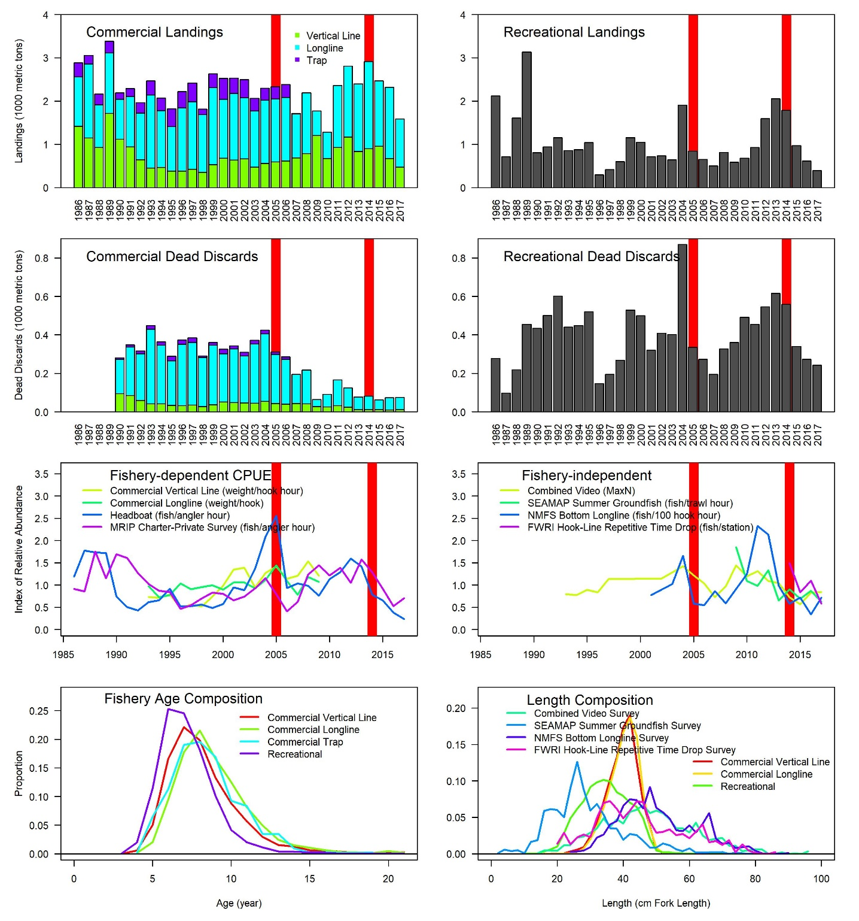
Fig. S1. Data streams used in the stock assessment for Gulf red grouper. Note differences in y-axes between panels. Discards refer to the biomass of dead discards estimated by the assessment model. Age composition derived from the fisheries and length compositions for fishery-independent surveys and fishery discards are shown for all years combined. Thick red vertical lines indicate years where severe red tide events occurred.
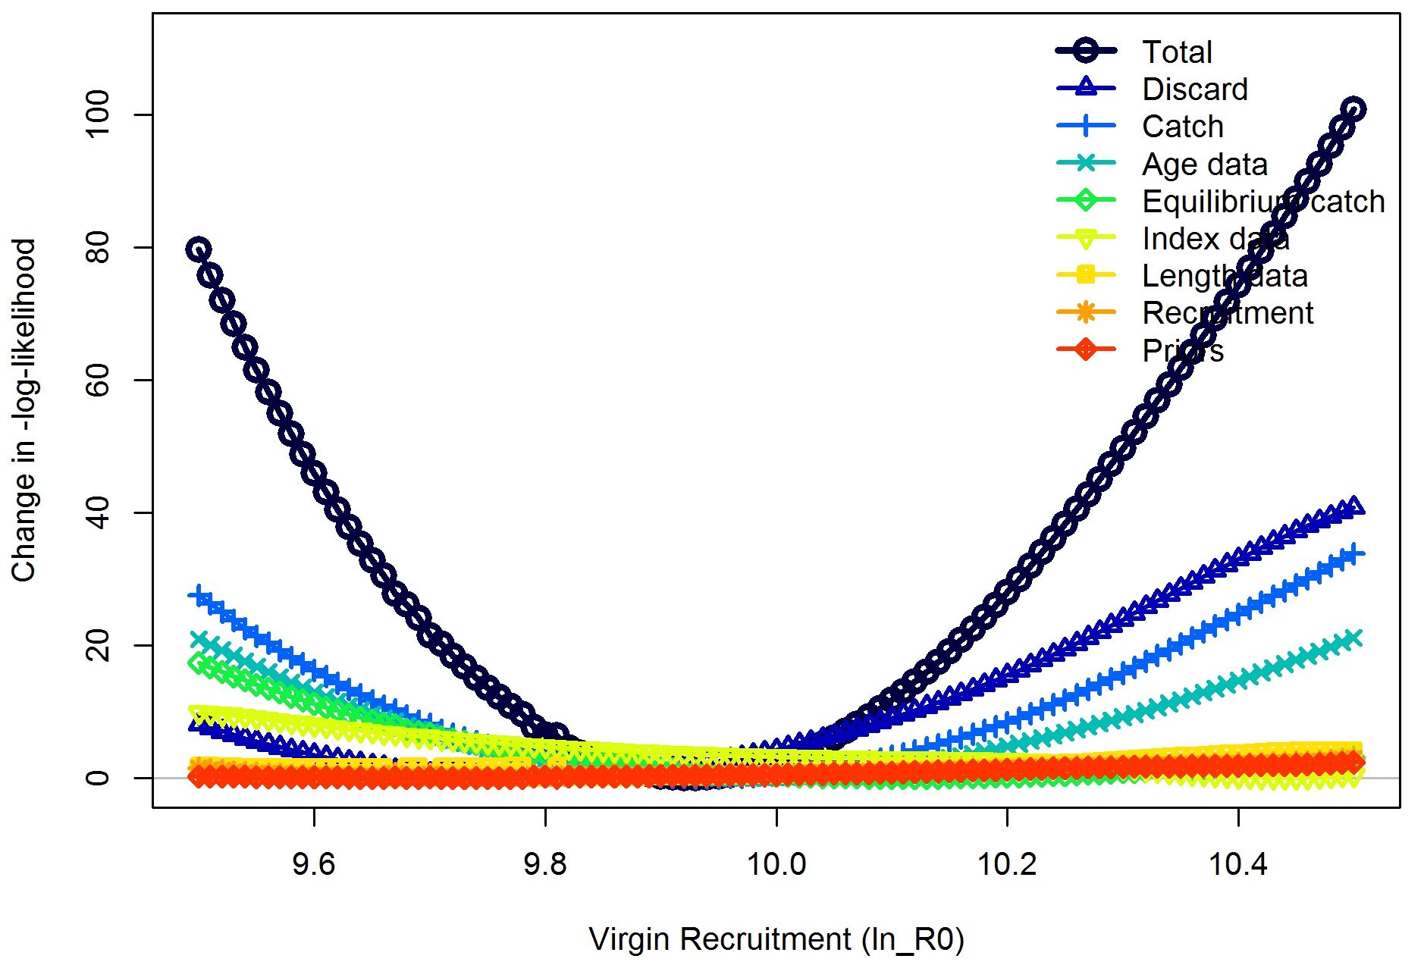
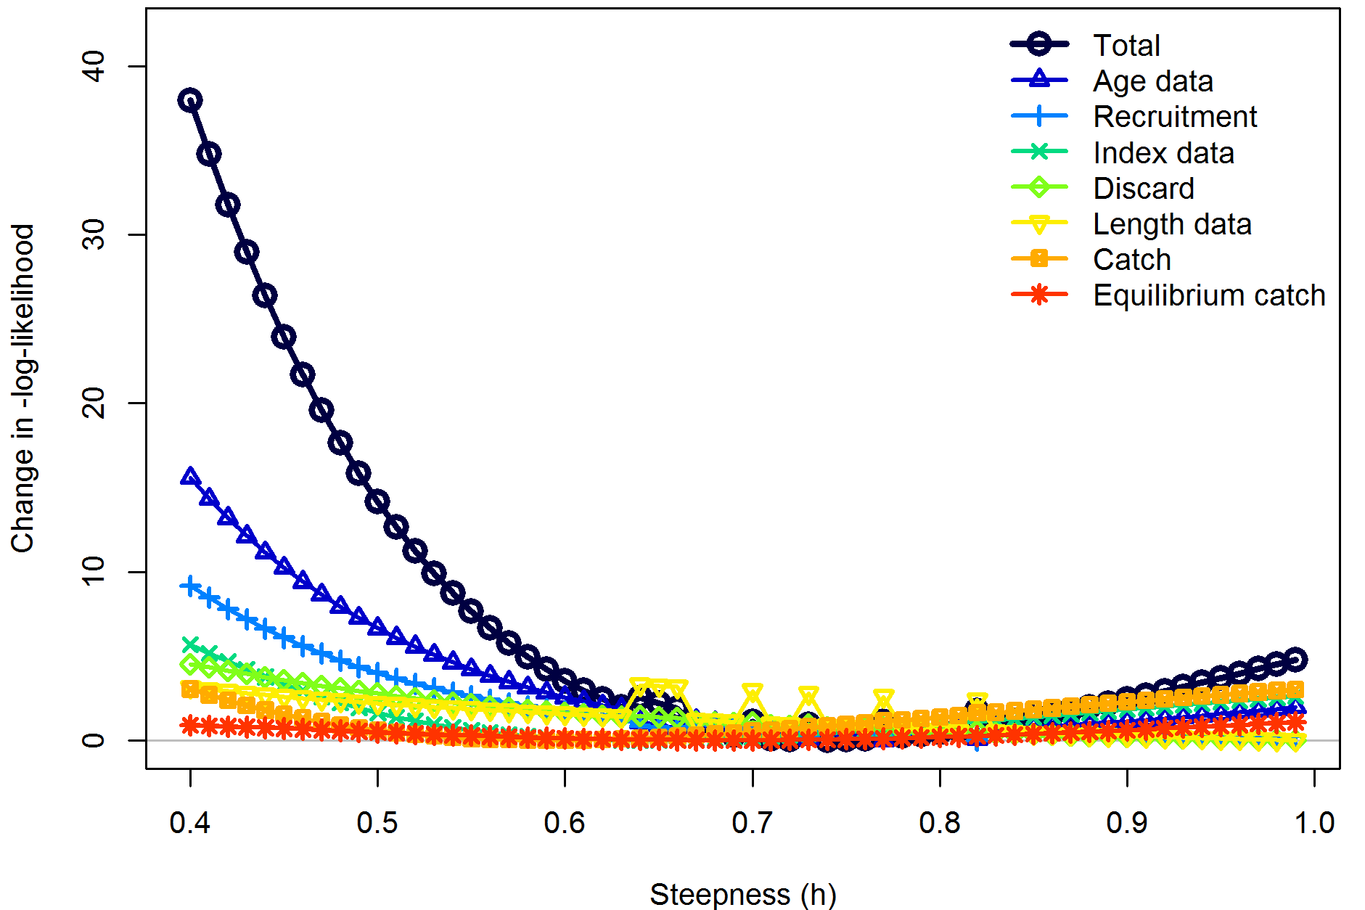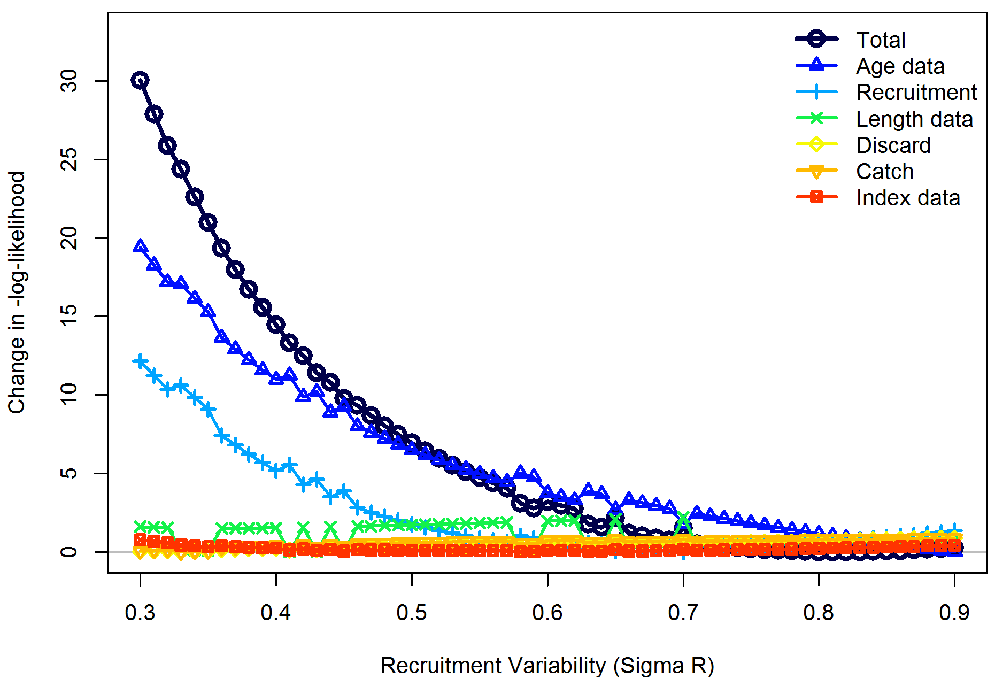
Fig. S2. Profile likelihoods for the virgin recruitment (equilibrium recruitment in the absence of fishing) parameter of the Beverton – Holt stock-recruit function, the steepness parameter, and the recruitment variance parameter for the Gulf of Mexico red grouper base model estimating red tide mortality in 2005 and 2014. Each line represents the change in negative log-likelihood value for each of the data sources fit in the model across the range of fixed values tested in the profile diagnostic run.
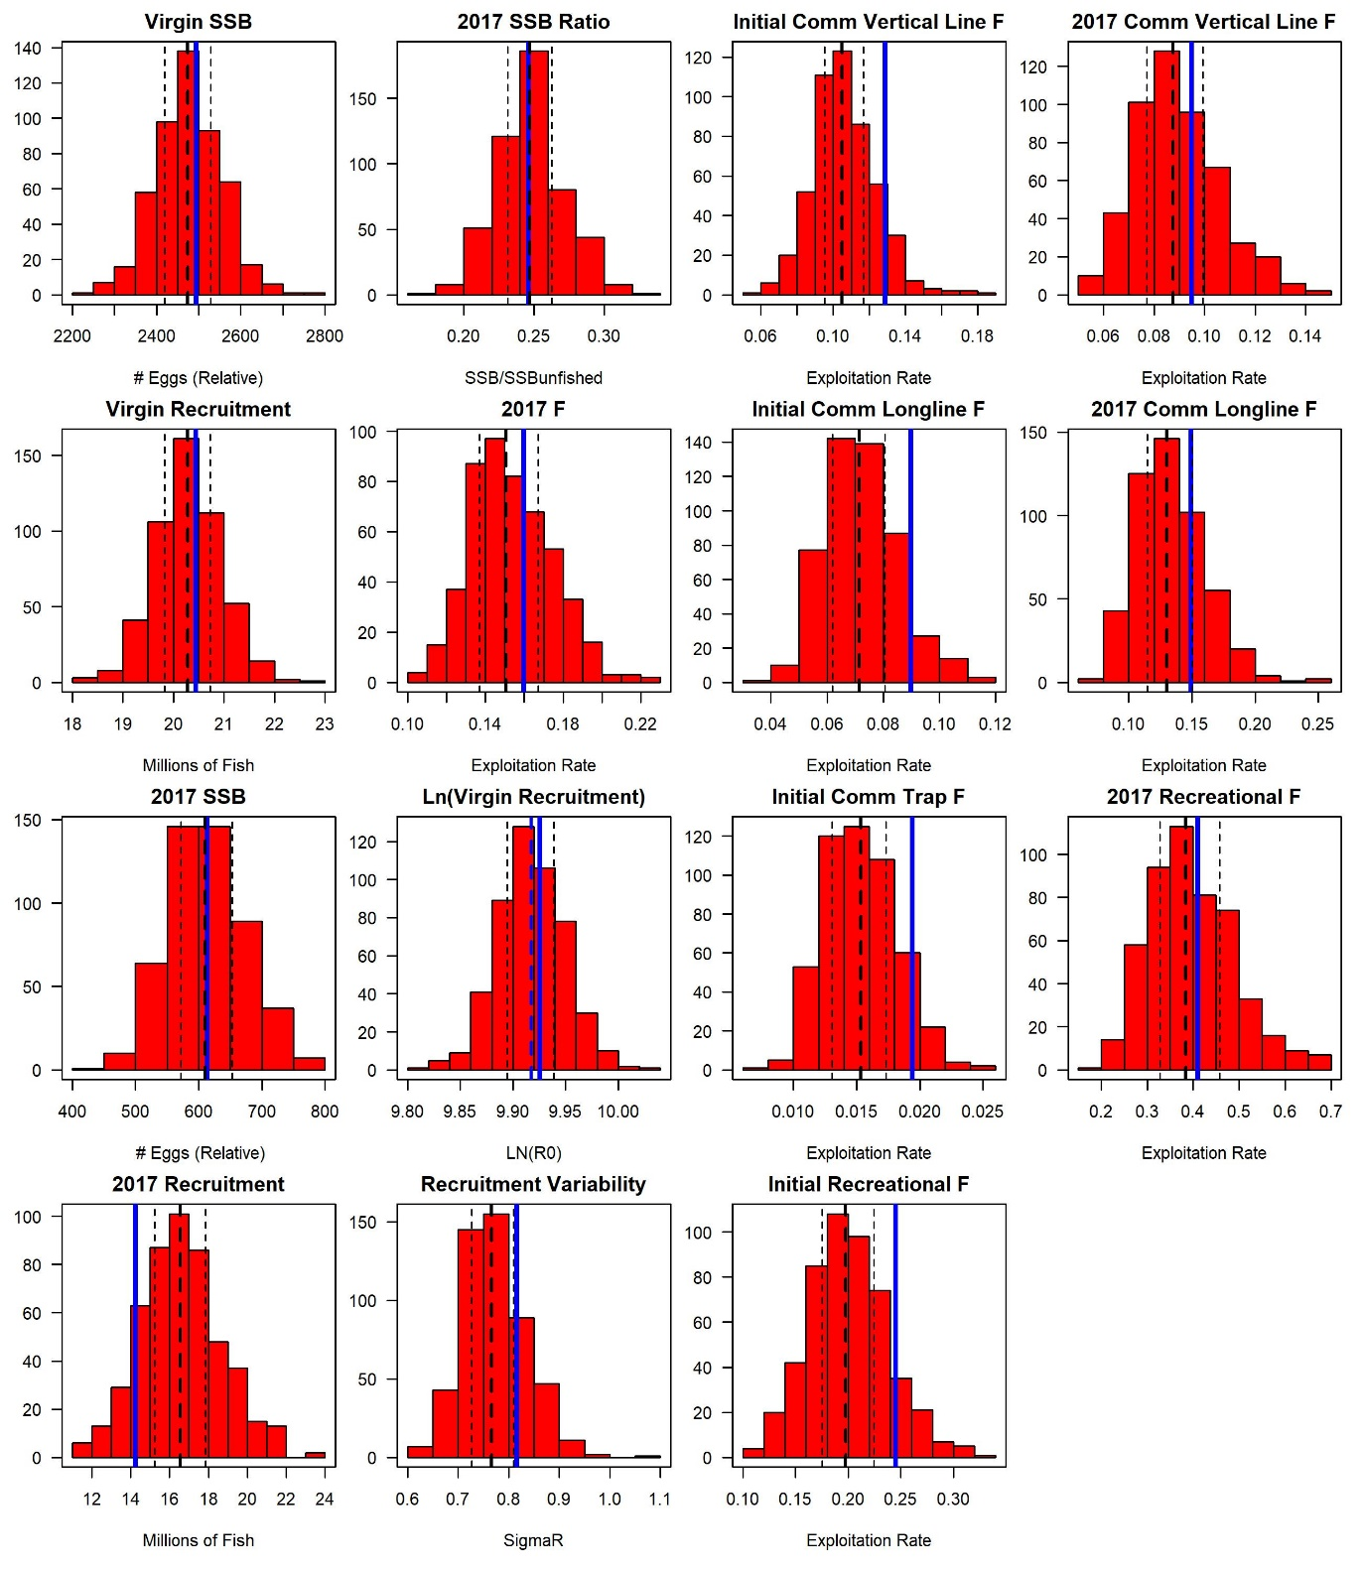
Fig. S3. Histograms of derived quantities and estimated parameters for the 500 bootstrap runs for the Gulf red grouper assessment estimating red tide mortality in 2005 and 2014. The assessment model estimate is indicated by the blue solid vertical line, thin dashed lines represent the 25th and 75th percentiles, and the thick dashed line represents the median. SSB is in relative number of eggs.

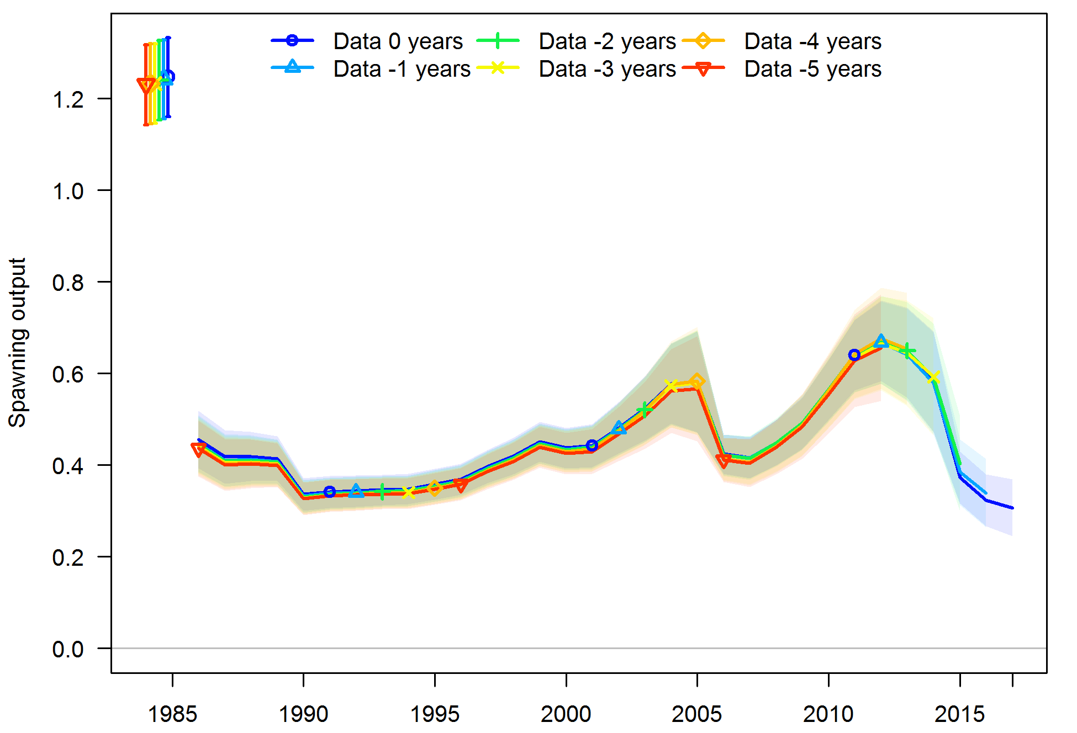
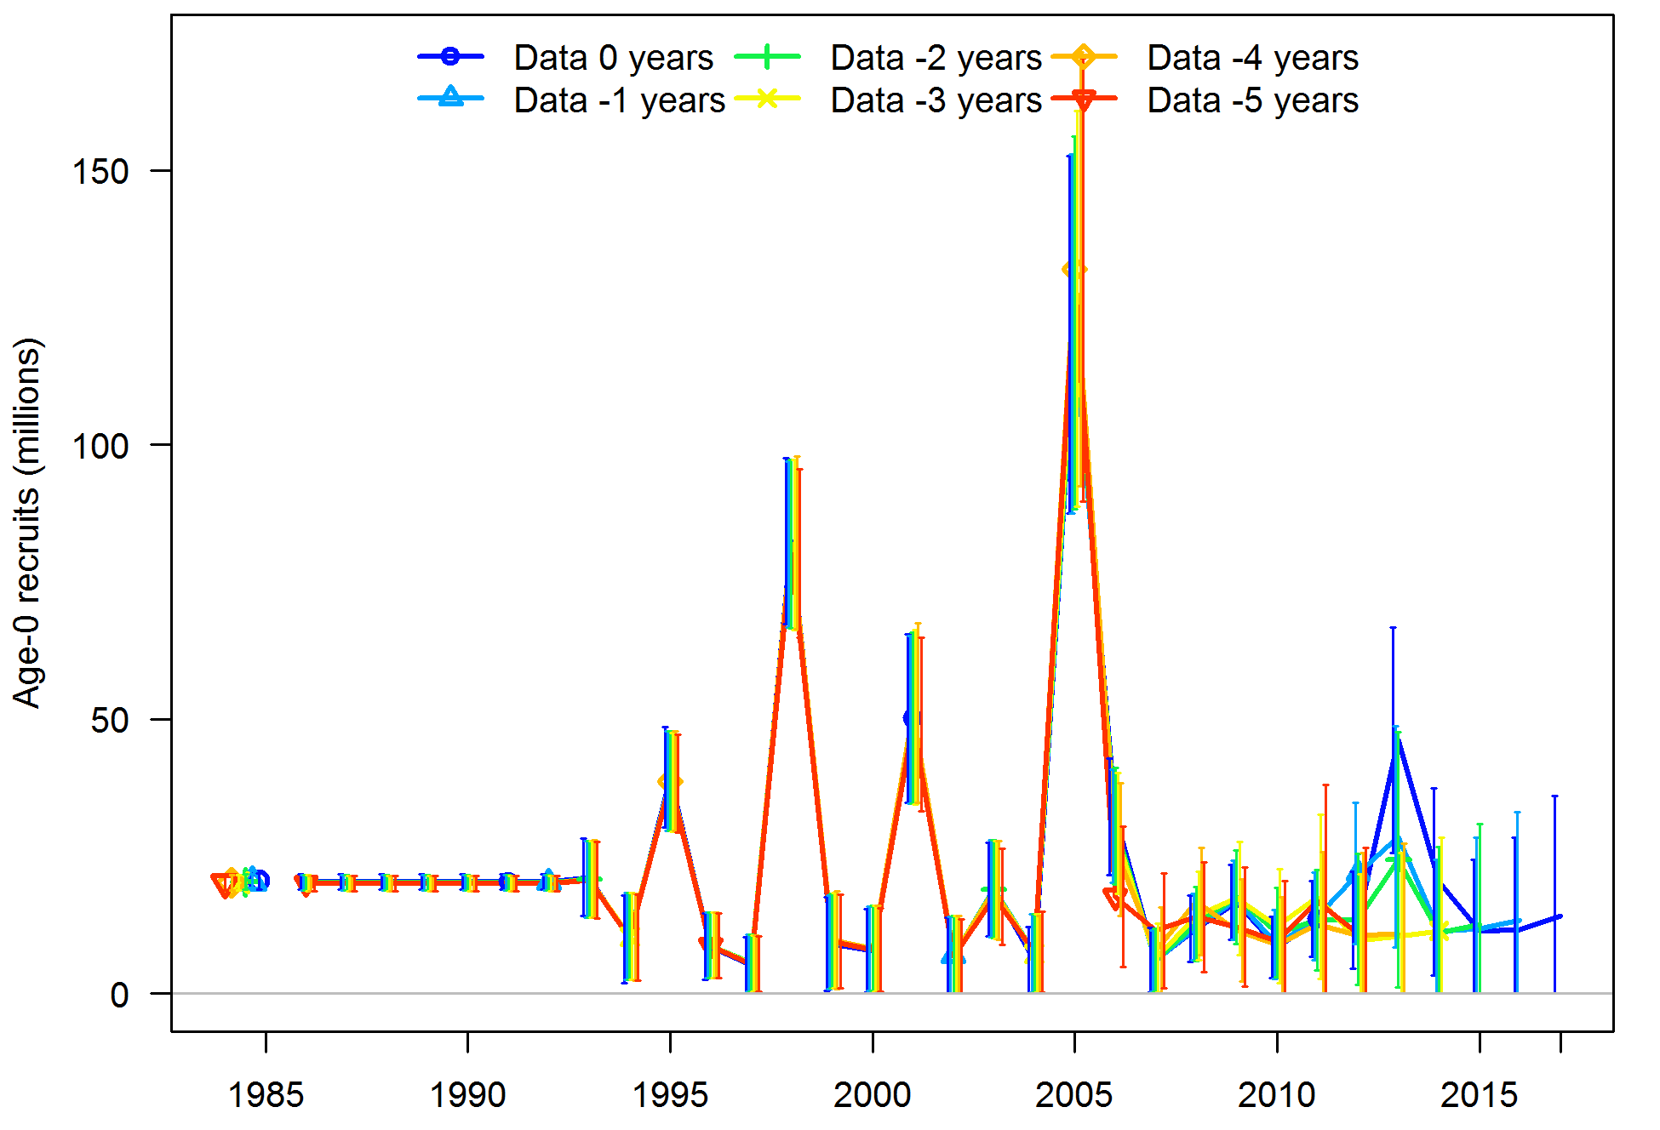
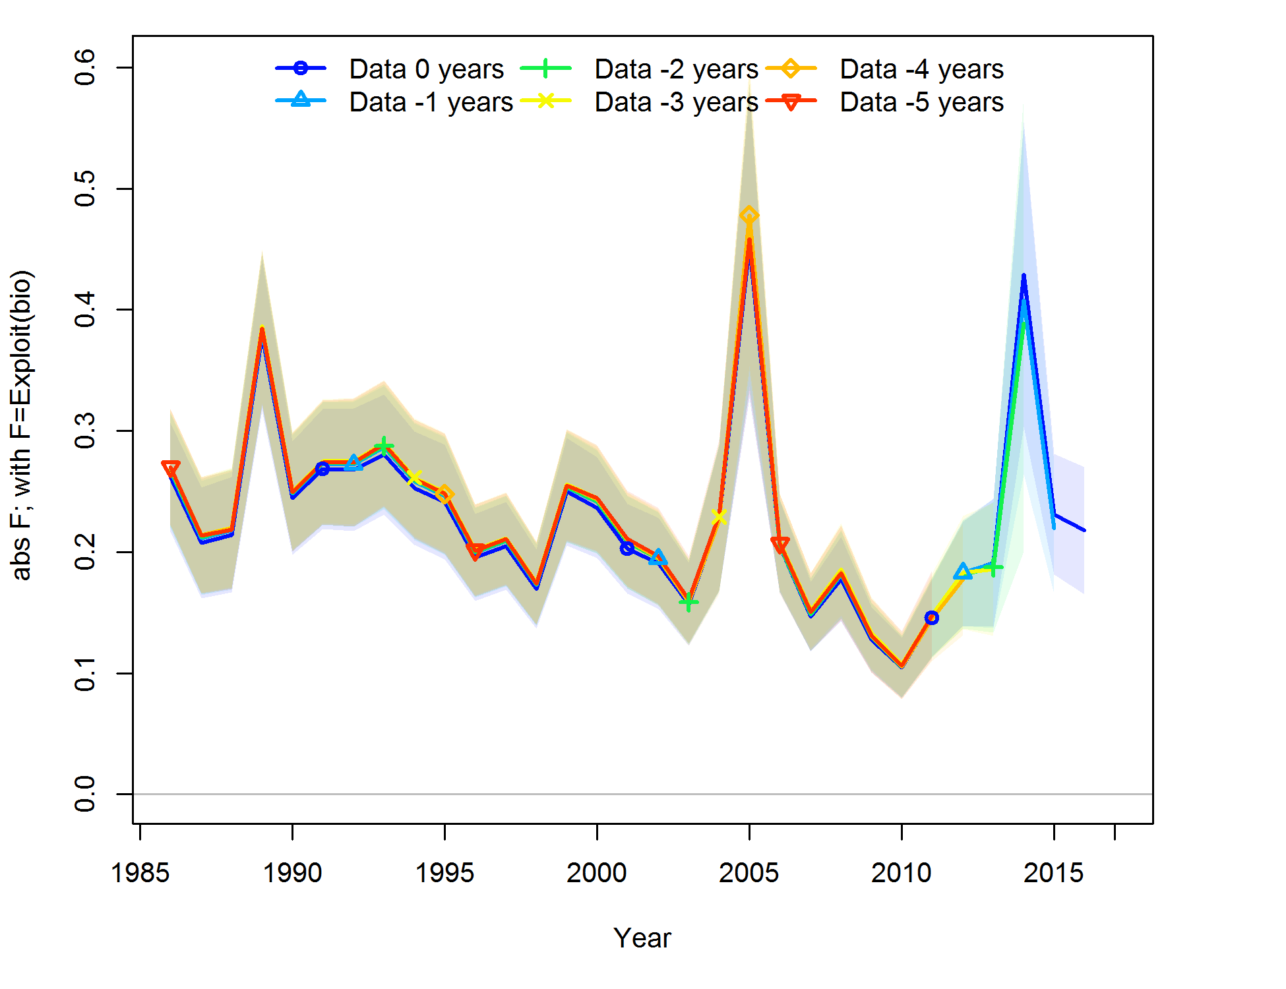

Fig. S4. Results of a five year retrospective analysis for spawning biomass (relative number of eggs; top panel), recruitment (millions of fish; middle panel), and fishing mortality (total biomass killed/total biomass, includes red tide mortality in 2005 and 2014) for the Gulf red grouper assessment. There is no discernible systematic bias, because each data peel is not consistently over or underestimating any of the population quantities.

