Geophysical Research Letters
Supporting Information for
New WMO Certified Megaflash Lightning Extremes
for Flash Distance (709 km) and Duration (16.73 seconds) recorded from Space
[Michael J. Peterson¹,Timothy J. Lang², Eric C. Bruning³,Rachel Albrecht⁴,Richard J. Blakeslee²,Walter A. Lyons⁵, Stéphane Pédeboy⁶, William Rison⁷, Yijun Zhang⁸, Manola Brunet⁹, Randall S. Cerveny^{10*}
¹ISR-2, Los Alamos National Laboratory, Los Alamos, NM USA
²NASA Marshall Space Flight Center, Huntsville, AL USA
³Texas Tech University, Lubbock TX USA
⁴Universidade da São, São Paulo, Brazil
⁵FMA Research, Fort Collins, CO USA
⁶Météorage, Pau France
⁷New Mexico Tech, Socorro, NM USA
⁸Fudan University, Shanghai, China
⁹University Rovira i Virgili, Tarragona Spain & University of East Anglia, Norwich UK
¹⁰Arizona State University, Tempe AZ USA
*Corresponding Author, Randall S. Cervenyemail:cerveny@asu.edu

Contents of this file

Figure S1

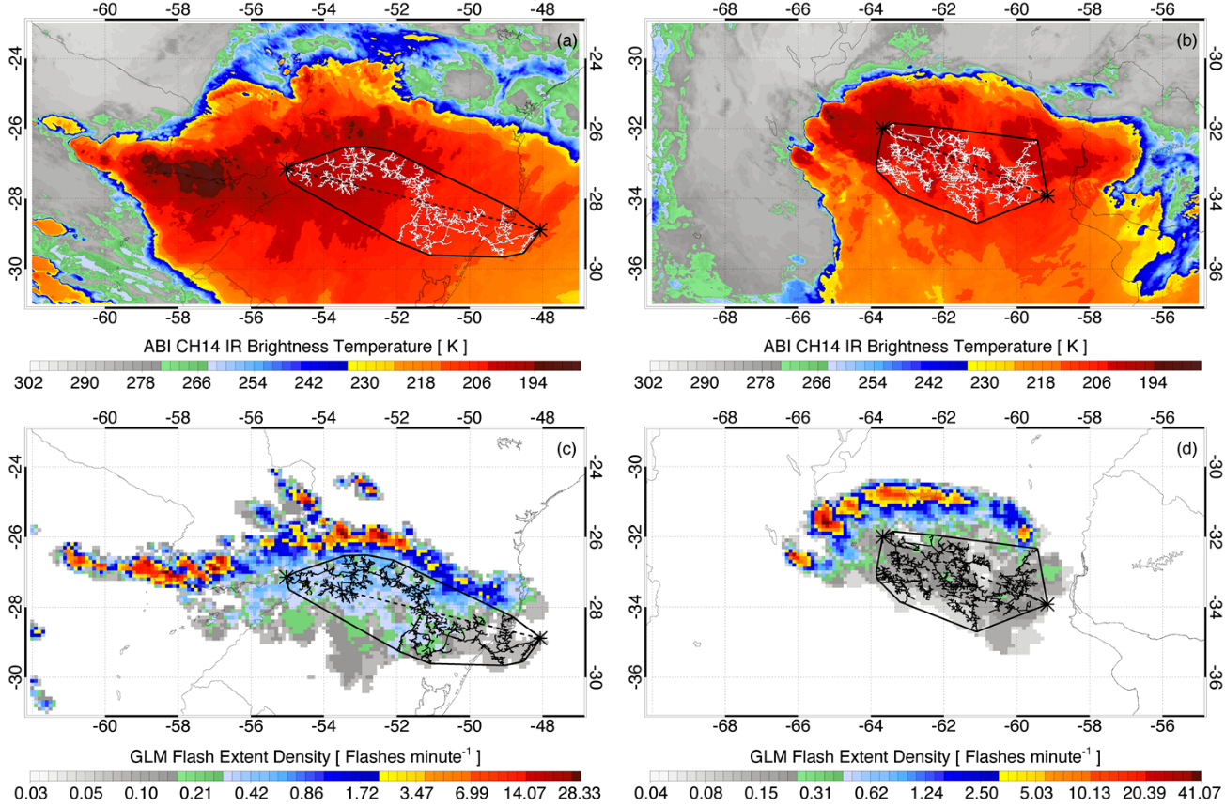<Insert Figure S1>

Figure S1. GOES-16 Advanced Baseline Imager (ABI) Channel 14 (11.2 μm) infrared imagery (top row) and GLM Flash Extent Density (FED) imagery (bottom row) for the MCS thunderstorms that produced the top length (left) and top duration (right) lightning flashes. Incremental flash structure, flash endpoints (asterisk symbols connected by dashed line), and convex hull (solid contour) from Figures 2 and 3 are overlaid to show the scale of each megaflash in the larger thunderstorm

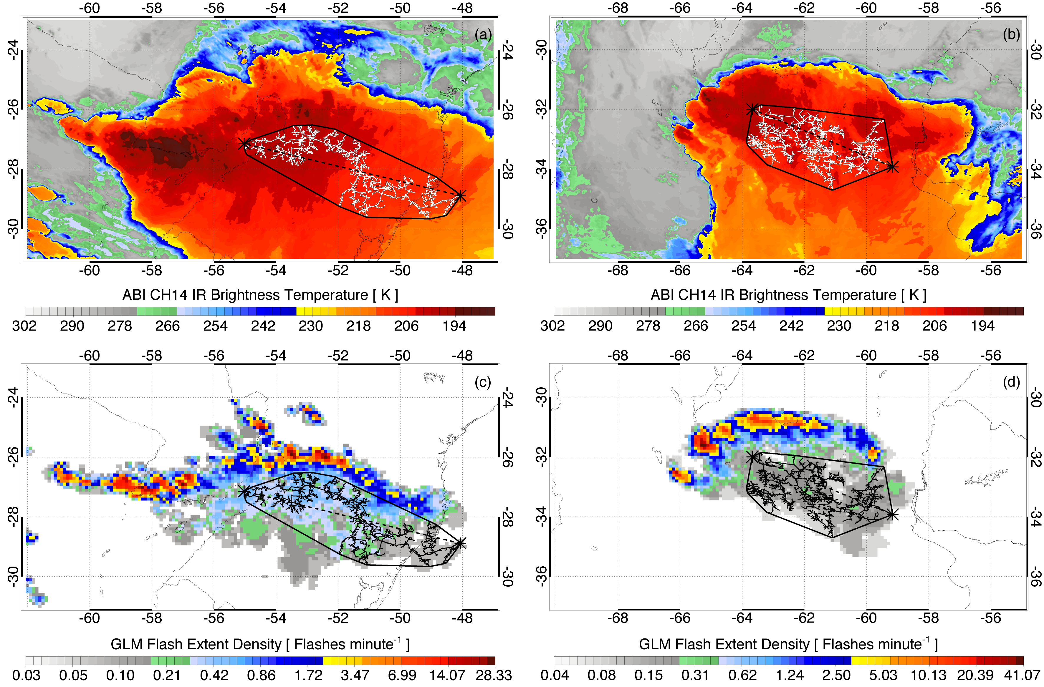
Supplemental Figure. GOES-16 Advanced Baseline Imager (ABI) Channel 14 (11.2 μm) infrared imagery (top row) and GLM Flash Extent Density (FED) imagery (bottom row) for the MCS thunderstorms that produced the top length (left) and top duration (right) lightning flashes. Incremental flash structure, flash endpoints (asterisk symbols connected by dashed line), and convex hull (solid contour) from Figures 2 and 3 are overlaid to show the scale of each megaflash in the larger thunderstorm.

