Supplementary Materials to: Quinn et al., “Modelling the effects of currents and migratory behaviours on the dispersal of Atlantic salmon (Salmo salar) post-smolts in a coastal embayment”

Table S1. Data plotted in Fig. 5 of the main text. Bolded blue and red text indicates behaviour simulations in which values were significantly less or greater than observed, respectively.

Behaviour/Speed | Residence time in Passamaquoddy Bay (days) |  |  | Particles successfully leaving Passamaquoddy Bay in 10 days |  |  |  | Particles exiting via Western Passage
 | Mean | 95 % C.I. |  | Mean |  | 95 % C.I. (%) |  | Mean |  | 95 % C.I. (%)
 |  |  |  | n | % |  |  | n | %
 |  | LCI | UCI |  |  | LCI | UCI |  |  | LCI | UCI
Observed | 4.7 | 4.0 | 4.9 | 45 | 84.9 | 72.4 | 93.3 | 39 | 86.7 | 73.2 | 94.9
Passive | 7.6 | 5.1 | 9.3 | 15 | 28.3 | 16.8 | 42.3 | 2 | 13.3 | 1.7 | 40.5
Negative rheotaxis (with current)
0.5 BL/s | 6.8 | 5.2 | 7.3 | 31 | 58.5 | 44.1 | 71.9 | 5 | 16.1 | 5.5 | 33.7
1.0 BL/s | 5.7 | 4.0 | 6.2 | 28 | 52.8 | 38.6 | 66.7 | 9 | 32.1 | 15.9 | 52.4
1.5 BL/s | 6.0 | 4.4 | 6.7 | 24 | 45.3 | 31.6 | 59.6 | 7 | 29.2 | 12.6 | 51.1
2.0 BL/s | 5.5 | 4.3 | 5.7 | 41 | 77.4 | 63.8 | 87.7 | 16 | 39.0 | 24.2 | 55.5
2.5 BL/s | 4.2 | 3.0 | 4.2 | 50 | 94.3 | 84.3 | 98.8 | 12 | 24.0 | 13.1 | 38.2
3.0 BL/s | 4.1 | 3.2 | 4.2 | 48 | 90.6 | 79.3 | 96.9 | 11 | 22.9 | 12.0 | 37.3
Positive rheotaxis (against current)
0.5 BL/s | 6.4 | 4.3 | 7.5 | 17 | 32.1 | 19.9 | 46.3 | 1 | 5.9 | 0.1 | 28.7
1.0 BL/s | 7.9 | 6.1 | 9.3 | 11 | 20.8 | 10.8 | 34.1 | 0 | 0 | 0 | 28.5
1.5 BL/s | 4.4 | 3.2 | 5.5 | 8 | 15.1 | 6.7 | 27.6 | 0 | 0 | 0 | 36.9
2.0 BL/s | 7.2 | N/A | N/A | 1 | 1.9 | 0 | 10.1 | 0 | 0 | 0 | 97.5
2.5 BL/s | 7.4 | N/A | N/A | 1 | 1.9 | 0 | 10.1 | 0 | 0 | 0 | 97.5
3.0 BL/s | > 10 | N/A | N/A | 0 | 0 | 0 | 6.7 | 0 | 0 | 0 | 0.0
Tide-varying rheotaxis (with current on ebb, against current on flood)
0.5 BL/s | 5.8 | 4.3 | 6.0 | 37 | 69.8 | 55.7 | 81.7 | 7 | 18.9 | 8.0 | 35.2
1.0 BL/s | 4.4 | 3.3 | 4.4 | 50 | 94.3 | 84.3 | 98.8 | 8 | 16.0 | 7.2 | 29.1
1.5 BL/s | 3.7 | 2.8 | 3.8 | 41 | 77.4 | 63.8 | 87.7 | 5 | 12.2 | 4.1 | 26.2
2.0 BL/s | 3.4 | 2.7 | 3.4 | 50 | 94.3 | 84.3 | 98.8 | 6 | 12.0 | 4.5 | 24.3
2.5 BL/s | 2.7 | 2.2 | 2.8 | 53 | 100 | 93.3 | 100.0 | 3 | 5.7 | 1.2 | 15.7
3.0 BL/s | 2.8 | 2.3 | 2.9 | 53 | 100 | 93.3 | 100.0 | 0 | 0.0 | 0.0 | 6.7
Orient toward greater depth
0.5 BL/s | 5.7 | 4.1 | 5.9 | 40 | 75.5 | 61.7 | 86.2 | 15 | 37.5 | 22.7 | 54.2
1.0 BL/s | 6.9 | 5.7 | 7.4 | 30 | 56.6 | 42.3 | 70.2 | 10 | 33.3 | 17.3 | 52.8
1.5 BL/s | > 10 | N/A | N/A | 0 | 0 | 0 | 6.7 | 0 | 0 | 0 | 0
2.0 BL/s | > 10 | N/A | N/A | 0 | 0 | 0 | 6.7 | 0 | 0 | 0 | 0
2.5 BL/s | > 10 | N/A | N/A | 0 | 0 | 0 | 6.7 | 0 | 0 | 0 | 0
3.0 BL/s | > 10 | N/A | N/A | 0 | 0 | 0 | 6.7 | 0 | 0 | 0 | 0
Orient toward higher salinity
0.5 BL/s | 5.4 | 3.9 | 6.0 | 21 | 39.6 | 26.5 | 54.0 | 0 | 0 | 0 | 16.1
1.0 BL/s | 4.2 | 3.2 | 4.5 | 28 | 52.8 | 38.6 | 66.7 | 0 | 0 | 0 | 12.3
1.5 BL/s | 3.4 | 2.9 | 3.8 | 15 | 28.3 | 16.8 | 42.3 | 0 | 0 | 0 | 21.8
2.0 BL/s | 3.2 | 2.2 | 4.4 | 4 | 7.5 | 2.1 | 18.2 | 0 | 0 | 0 | 60.2
2.5 BL/s | 3.1 | 2.9 | 3.3 | 14 | 26.4 | 15.3 | 40.3 | 0 | 0 | 0 | 23.2
3.0 BL/s | 2.7 | 2.0 | 3.3 | 10 | 18.9 | 9.4 | 32.0 | 0 | 0 | 0 | 30.8
Orient toward lower temperature
0.5 BL/s | 5.4 | 3.9 | 6.0 | 21 | 39.6 | 26.5 | 54.0 | 0 | 0 | 0 | 16.1
1.0 BL/s | 7.6 | 5.1 | 10.1 | 8 | 15.1 | 6.7 | 27.6 | 1 | 12.5 | 0.3 | 52.7
1.5 BL/s | 3.2 | 2.8 | 3.5 | 15 | 28.3 | 16.8 | 42.3 | 0 | 0 | 0 | 21.8
2.0 BL/s | 3.4 | 2.9 | 3.8 | 14 | 26.4 | 15.3 | 40.3 | 0 | 0 | 0 | 23.2
2.5 BL/s | 8.7 | N/A | N/A | 1 | 1.9 | 0.0 | 10.1 | 0 | 0 | 0 | 97.5
3.0 BL/s | 8.4 | 7.7 | 9.1 | 4 | 7.5 | 2.1 | 18.2 | 0 | 0 | 0 | 60.2
Swim in random directions
0.5 BL/s | 8.1 | 6.5 | 9.0 | 24 | 45.3 | 31.6 | 59.6 | 2 | 8.3 | 1.0 | 27.0
1.0 BL/s | 7.8 | 5.8 | 9.2 | 15 | 28.3 | 16.8 | 42.3 | 3 | 20.0 | 4.3 | 48.1
1.5 BL/s | 7.7 | 5.8 | 8.8 | 19 | 35.8 | 23.1 | 50.2 | 3 | 15.8 | 3.4 | 39.6
2.0 BL/s | 6.4 | 4.7 | 7.2 | 22 | 41.5 | 28.1 | 55.9 | 7 | 31.8 | 13.9 | 54.9
2.5 BL/s | 6.3 | 4.7 | 6.9 | 25 | 47.2 | 33.3 | 61.4 | 3 | 12.0 | 2.5 | 31.2
3.0 BL/s | 5.3 | 3.8 | 5.7 | 28 | 52.8 | 38.6 | 66.7 | 8 | 28.6 | 13.2 | 48.7
Swim south
0.5 BL/s | 2.9 | 2.1 | 2.9 | 51 | 96.2 | 87.0 | 99.5 | 2 | 3.9 | 0.5 | 13.5
1.0 BL/s | 3.3 | 1.6 | 2.8 | 49 | 92.5 | 81.8 | 97.9 | 1 | 2.0 | 0.1 | 10.9
1.5 BL/s | 1.7 | 1.0 | 1.6 | 47 | 88.7 | 77.0 | 95.7 | 2 | 4.3 | 0.5 | 14.5
2.0 BL/s | 1.4 | 0.8 | 1.3 | 53 | 100 | 93.3 | 100 | 0 | 0 | 0 | 6.7
2.5 BL/s | 3.8 | 2.7 | 5.5 | 49 | 92.5 | 81.8 | 97.9 | 0 | 0 | 0 | 7.3
3.0 BL/s | 1.4 | 1.2 | 1.6 | 26 | 49.1 | 35.1 | 63.2 | 0 | 0 | 0 | 13.2
Swim southwest
0.5 BL/s | 4.6 | 3.0 | 4.6 | 43 | 81.1 | 68.0 | 90.6 | 22 | 51.2 | 35.5 | 66.7
1.0 BL/s | 2.3 | 1.6 | 2.4 | 37 | 69.8 | 55.7 | 81.7 | 12 | 32.4 | 18.0 | 49.8
1.5 BL/s | 2.5 | 1.7 | 3.0 | 14 | 26.4 | 15.3 | 40.3 | 10 | 71.4 | 41.9 | 91.6
2.0 BL/s | 3.2 | 0.3 | 22.0 | 3 | 5.7 | 1.2 | 15.7 | 3 | 100.0 | 29.2 | 100
2.5 BL/s | > 10 | N/A | N/A | 0 | 0 | 0 | 6.7 | 0 | 0 | 0 | 0
3.0 BL/s | > 10 | N/A | N/A | 0 | 0 | 0 | 6.7 | 0 | 0 | 0 | 0
Notes: ‘N/A’ = not applicable, 95 % confidence interval (C.I.) value could not be calculated because n = 0 or 1; LCI and UCI = lower and upper limits of the 95 % C.I., respectively; statistical significance (P < 0.05) was assessed based on the overlap of the 95 % C.I. and means of observed vs. simulated values.

Table S2. Details of the drifter deployments carried out at Magaguadavic River estuary in 2018.

Month | Drifter |  | Release |  | End |  | Time tracked (days)
 | # | Device code | Date | Time (ADT) | Date | Time (ADT)
May | 1 | 0-2512251 | 2018-05-26 | 13:42:00 | 2018-05-28 | 15:40:00 | 2.1
 | 2 | 0-2511295 | 2018-05-26 | 13:42:00 | 2018-05-27 | 18:07:00 | 1.2
 | 3 | 0-2515941 | 2018-05-26 | 13:42:00 | 2018-05-28 | 16:08:00 | 2.1
 | 4 | 0-3132039 | 2018-05-26 | 13:44:00 | 2018-05-28 | 12:22:00 | 1.9
 | 5 | 0-3132043 | 2018-05-26 | 13:45:00 | 2018-05-28 | 12:08:00 | 1.9
June | 1 | 0-3132032 | 2018-06-07 | 09:50:00 | 2018-06-07 | 15:05:00 | 0.2
 | 2 | 0-2511000 | 2018-06-07 | 10:11:00 | 2018-06-11 | 07:18:00 | 3.9
 | 3 | 0-2510987 | 2018-06-07 | 10:11:00 | 2018-06-08 | 12:36:00 | 1.1
 | 4 | 0-3132031 | 2018-06-07 | 10:11:00 | 2018-06-08 | 11:33:00 | 1.1
 | 5 | 0-2512586 | 2018-06-07 | 10:16:00 | 2018-06-08 | 13:21:00 | 1.1

Table S3. The model performance index (PI) values calculated for each simulated behaviour and swim speed combination based on overall mean residence time of particles in Passamaquoddy Bay, percent of particles exiting the bay within 10 days, and percent of exiting particles leaving via Western Passage (see Eq. (2) in the main text). Overall PI values and ranks (1 = best, 49 = worst) are shown in Fig. 10 of the main text. The ranks of the top three behaviours (with the lowest PI values and that did not differ significantly from one another based on analysis of 95 % C.I., P > 0.05) are marked with a ‘*’. The 95 % C.I. and contribution (%) of each model endpoint to the overall PI are also shown.

Behaviour/Speed | Overall PI |  |  | Rank | Contribution to PI (%)
 | Value | 95 % C.I. |  |  | Residence time | Exit success | Western Passage usage
 |  | LCI | UCI
Passive | 1.5 | 1.6 | 1.5 | 34 | 24.7 | 28.8 | 46.5
Negative rheotaxis (with current)
0.5 BL/s | 1.0 | 1.1 | 0.7 | 17 | 20.8 | 10.1 | 69.1
1.0 BL/s | 0.6 | 1.0 | 0.3 | 6 | 7.7 | 24.4 | 67.8
1.5 BL/s | 0.7 | 1.1 | 0.4 | 13 | 10.4 | 29.6 | 59.9
2.0 BL/s | 0.3 | 0.6 | 0.2 | 2* | 8.5 | 2.3 | 89.2
2.5 BL/s | 0.5 | 0.9 | 0.4 | 4 | 2.1 | 2.2 | 95.7
3.0 BL/s | 0.6 | 0.8 | 0.4 | 5 | 2.9 | 0.8 | 96.3
Positive rheotaxis (against current)
0.5 BL/s | 1.4 | 1.6 | 1.0 | 29 | 9.4 | 27.9 | 62.7
1.0 BL/s | 2.0 | 1.8 | 2.0 | 44 | 22.8 | 28 | 49.2
1.5 BL/s | 1.7 | 2.0 | 0.8 | 40 | 0.2 | 40.2 | 59.5
2.0 BL/s | 2.2 | N/A | N/A | 45 | 12.6 | 42.7 | 44.7
2.5 BL/s | 2.3 | N/A | N/A | 46 | 14.4 | 41.8 | 43.7
3.0 BL/s | N/A | N/A | N/A | 49 | N/A | N/A | N/A
Tide-varying rheotaxis (with current on ebb, against current on flood)
0.5 BL/s | 0.7 | 0.9 | 0.4 | 10 | 7.8 | 4.5 | 87.6
1.0 BL/s | 0.7 | 0.9 | 0.5 | 8 | 0.6 | 1.8 | 97.6
1.5 BL/s | 0.8 | 1.1 | 0.5 | 14 | 5.7 | 1.0 | 93.3
2.0 BL/s | 0.8 | 1.1 | 0.6 | 16 | 9.2 | 1.5 | 89.3
2.5 BL/s | 1.1 | 1.3 | 0.9 | 23 | 16.7 | 2.9 | 80.4
3.0 BL/s | 1.2 | 1.3 | 1 | 25 | 13.7 | 2.6 | 83.7
Orient toward greater depth
0.5 BL/s | 0.4 | 0.6 | 0.2 | 3* | 11.9 | 3.2 | 84.8
1.0 BL/s | 0.7 | 0.9 | 0.5 | 11 | 30.9 | 15.7 | 53.5
1.5 BL/s | N/A | N/A | N/A | 49 | N/A | N/A | N/A
2.0 BL/s | N/A | N/A | N/A | 49 | N/A | N/A | N/A
2.5 BL/s | N/A | N/A | N/A | 49 | N/A | N/A | N/A
3.0 BL/s | N/A | N/A | N/A | 49 | N/A | N/A | N/A
Orient toward higher salinity
0.5 BL/s | 1.3 | 1.5 | 0.9 | 26 | 1.7 | 21.8 | 76.5
1.0 BL/s | 1.2 | 1.4 | 0.8 | 24 | 1 | 12.4 | 86.6
1.5 BL/s | 1.5 | 1.8 | 0.8 | 32 | 5 | 29.2 | 65.7
2.0 BL/s | 1.9 | 2.2 | 0.7 | 43 | 5.3 | 43.0 | 51.7
2.5 BL/s | 1.6 | 1.8 | 0.9 | 38 | 7.3 | 29.8 | 62.9
3.0 BL/s | 1.8 | 2.1 | 0.9 | 41 | 10.1 | 33.8 | 56
Orient toward lower temperature
0.5 BL/s | 1.3 | 1.5 | 0.9 | 26 | 1.7 | 21.8 | 76.5
1.0 BL/s | 1.8 | 1.8 | 1.8 | 42 | 21.3 | 37.8 | 40.9
1.5 BL/s | 1.5 | 1.8 | 0.9 | 35 | 6.6 | 28.7 | 64.7
2.0 BL/s | 1.6 | 1.8 | 0.8 | 36 | 4.9 | 30.6 | 64.5
2.5 BL/s | 2.7 | N/A | N/A | 48 | 27 | 35.7 | 37.3
3.0 BL/s | 2.5 | 1.6 | 2.5 | 47 | 25.3 | 33.9 | 40.8
Swim in random directions
0.5 BL/s | 1.6 | 1.4 | 1.6 | 37 | 33.6 | 14.0 | 52.5
1.0 BL/s | 1.5 | 1.6 | 1.4 | 31 | 29.6 | 30.2 | 40.2
1.5 BL/s | 1.4 | 1.5 | 1.2 | 30 | 28.9 | 23.7 | 47.4
2.0 BL/s | 0.8 | 1.2 | 0.5 | 15 | 16.5 | 32.9 | 50.6
2.5 BL/s | 1.1 | 1.3 | 0.7 | 21 | 11 | 18.7 | 70.3
3.0 BL/s | 0.6 | 1.1 | 0.3 | 7 | 2.7 | 23.5 | 73.8
Swim south
0.5 BL/s | 1.1 | 1.3 | 0.9 | 22 | 13.6 | 1.6 | 84.7
1.0 BL/s | 1.1 | 1.4 | 1.0 | 20 | 8.4 | 0.8 | 90.8
1.5 BL/s | 1.3 | 1.6 | 1.1 | 28 | 31.0 | 0.2 | 68.8
2.0 BL/s | 1.5 | 1.7 | 1.4 | 33 | 32.3 | 2.1 | 65.6
2.5 BL/s | 1.0 | 1.2 | 0.9 | 19 | 3.5 | 0.8 | 95.7
3.0 BL/s | 1.7 | 1.9 | 1.2 | 39 | 29.5 | 10.6 | 59.9
Swim southwest
0.5 BL/s | 0.2 | 0.5 | 0.1 | 1* | 0.3 | 1.2 | 98.6
1.0 BL/s | 0.7 | 1.2 | 0.4 | 9 | 38.1 | 4.6 | 57.3
1.5 BL/s | 0.7 | 1.3 | 0.4 | 12 | 30.2 | 65.5 | 4.3
2.0 BL/s | 1.0 | 1.0 | 14.2 | 18 | 10.2 | 87.4 | 2.4
2.5 BL/s | N/A | N/A | N/A | 49 | N/A | N/A | N/A
3.0 BL/s | N/A | N/A | N/A | 49 | N/A | N/A | N/A
Notes: ‘N/A’ = not applicable, if both PI value and 95 % C.I. = N/A this meant that no particles left Passamaquoddy Bay within 10 days so no PI value could be calculated (worst rank = 49), while if only 95 % C.I. = N/A the C.I. value could not be calculated because n = 0 or 1; LCI and UCI = lower and upper limits of the 95 % C.I., respectively; statistical significance was not assessed among all groups beyond the top three, but could be done based on the overlap of the 95 % C.I. and means PI values.

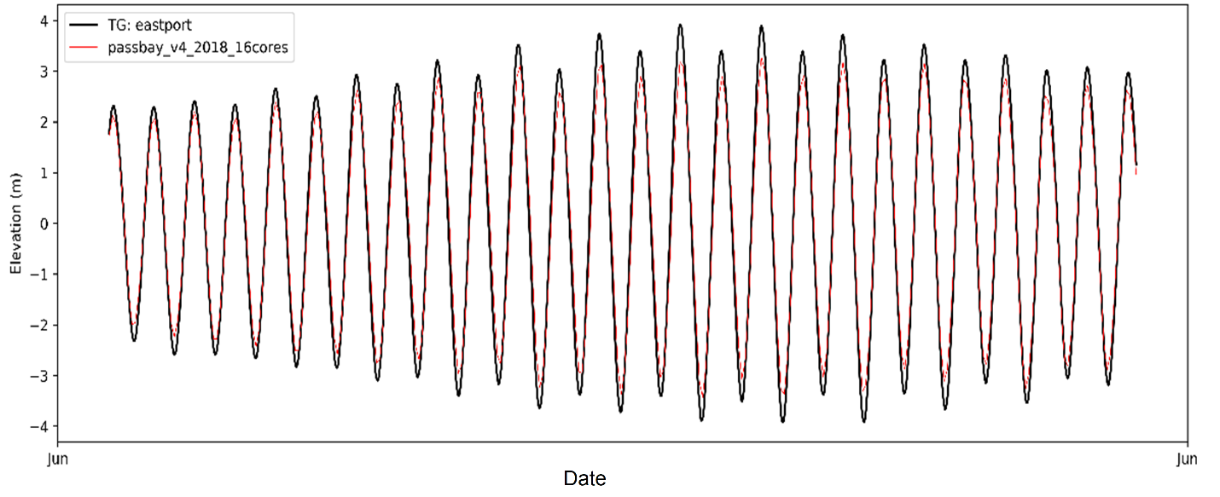
Fig. S1. Comparison of observed (black) and modelled (red) sea-surface height at Eastport, Maine.

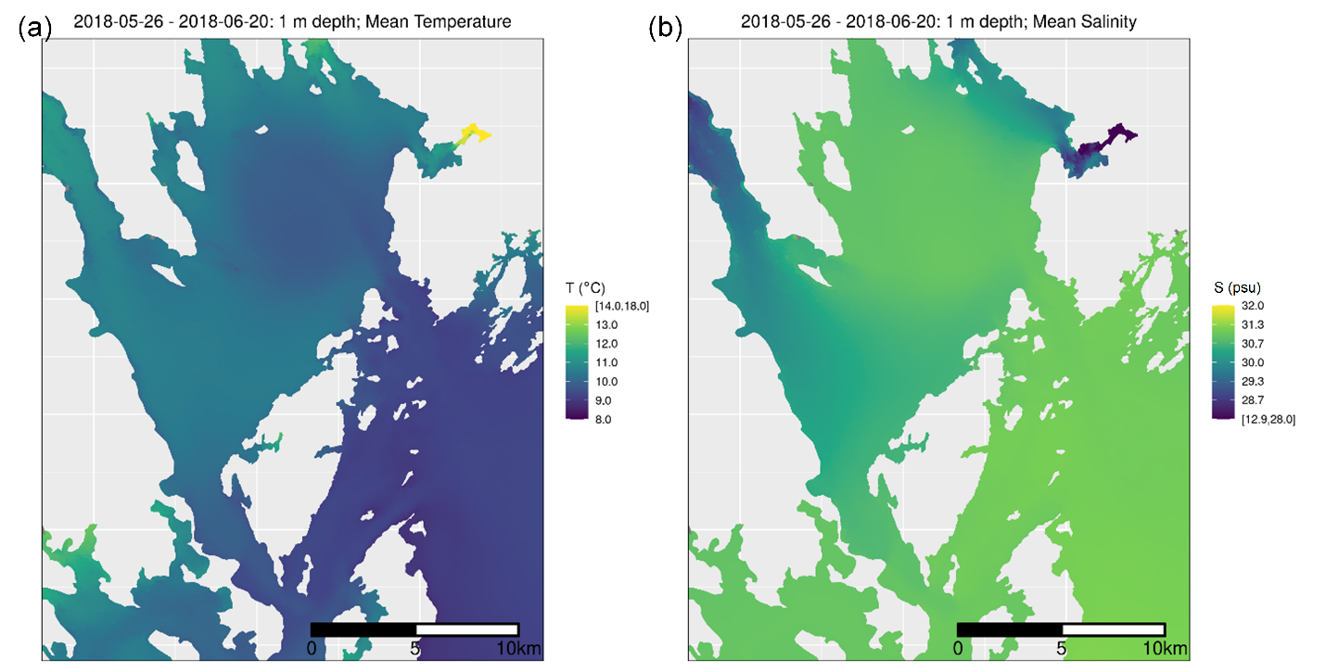

Fig. S2. Mean model temperature (a) and salinity (b) fields interpolated to 1 m below the sea surface and averaged over the period of 25 May to 20 June 2018. Map produced using the ‘coord_quickmap’ function in the R package ‘ggplot’ (Wickam, 2009; R Core Team, 2019) based on FVCOM model mesh coordinates (projection modified from NAD83; Chen et al., 2011).

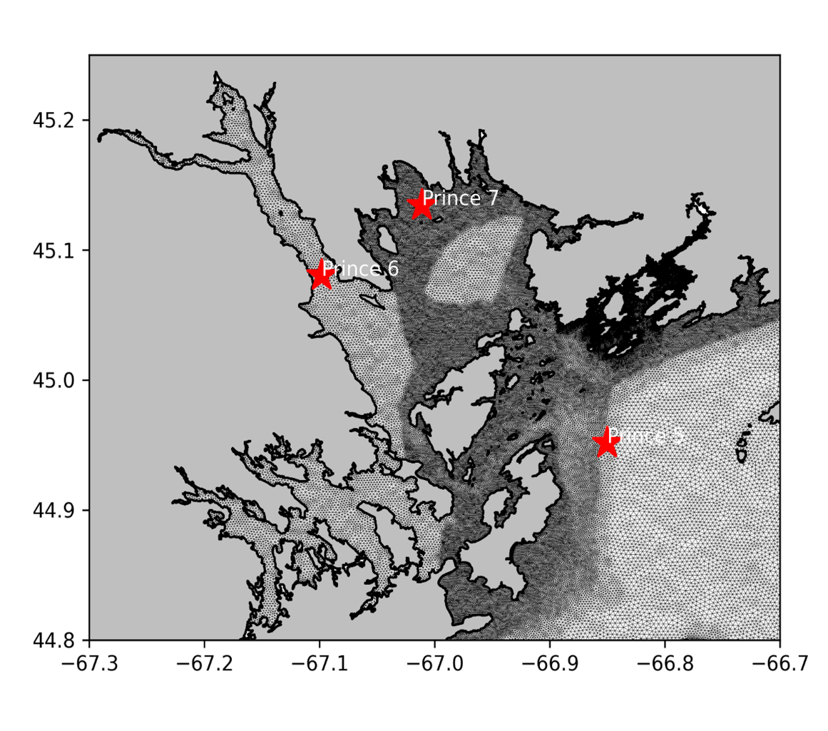
Fig. S3. Location of ‘Prince’ stations in the region where monthly vertical profiles of temperature and salinity data were collected as part of the Atlantic Zone Monitoring Program. Map shows the FVCOM model mesh (Chen et al., 2011) and was created using Python in Matplotlib (latitude and longitudes in the EPSG:4326 - WGS 84 coordinate system).
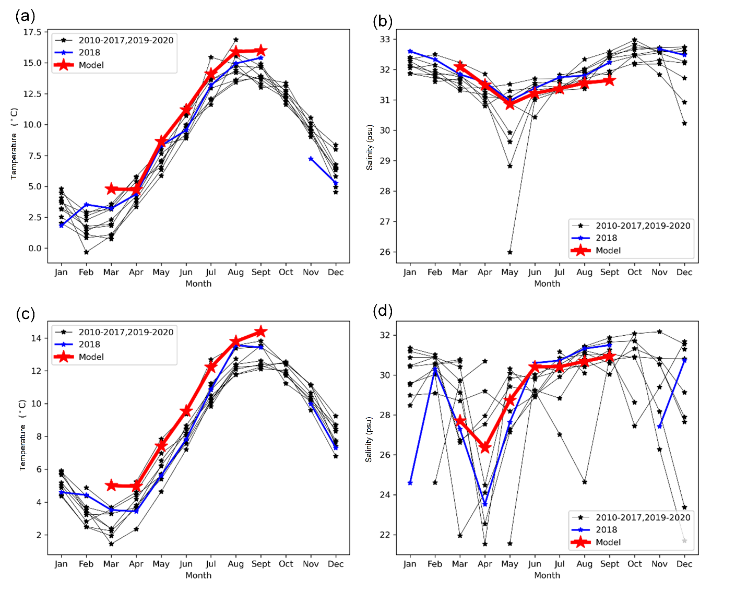
Fig. S4. Comparison of temperature (a, c) and salinity (b, d) between model results (red) and observations in 2018 (blue) at Prince 5 (a, b), located at 66.8500 °W, 44.951667 °N, and Prince 6 (c, d), located at (67.098056 °W, 45.080278 °N (see Fig. S3), at 1 m below the sea surface. Data collected from 2010 to 2020 (black) are also shown.

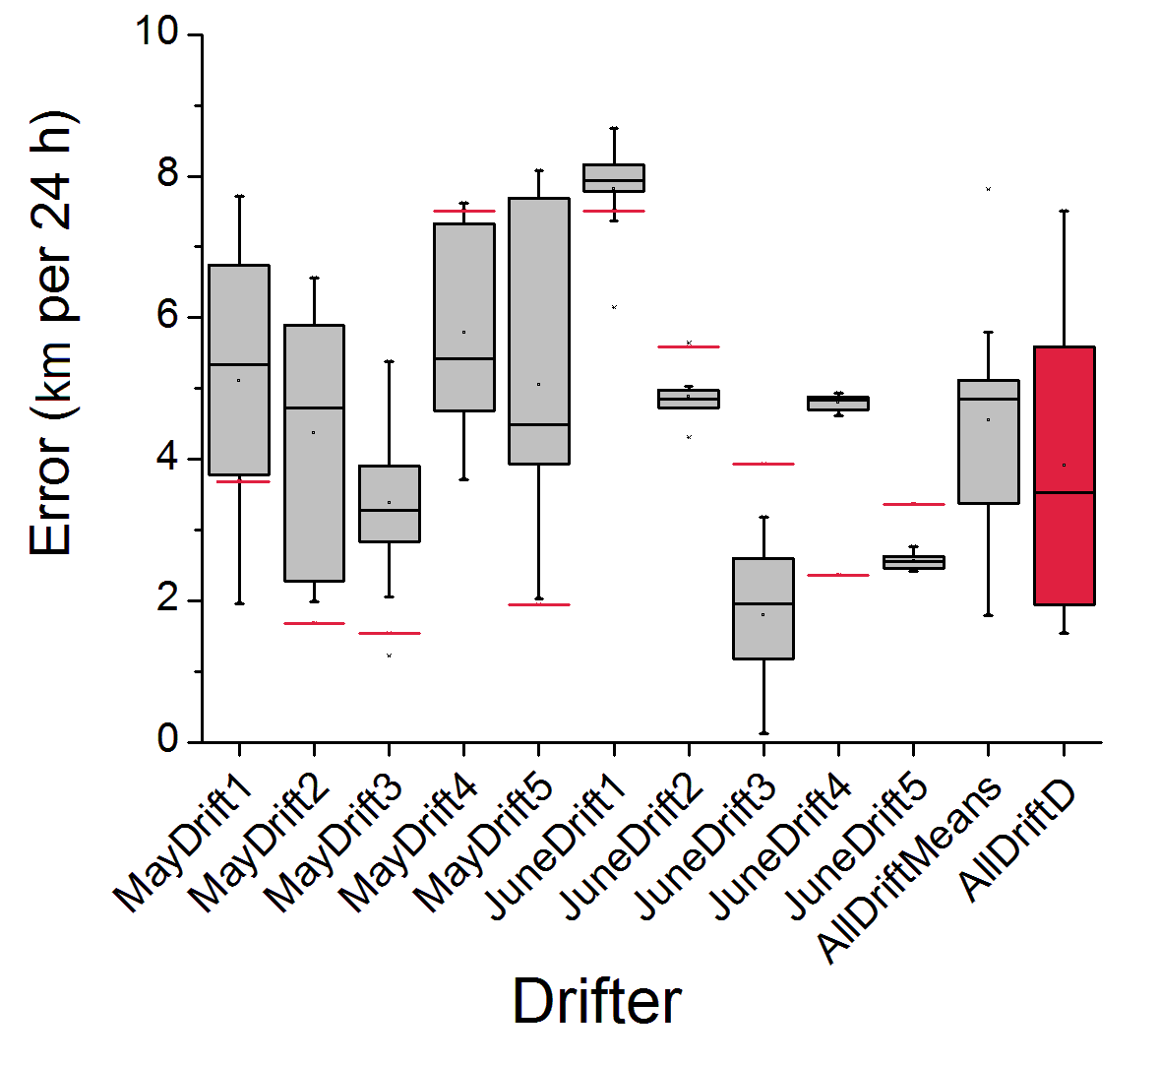

Fig. S5. Model prediction error per 24 h (E_{rr}, in km) in predicting the trajectories of experimental surface drifters. Each gray bar represents the distribution and range of values for the 10 replicate particles representing each drifter in ‘variable’ (with random walk) simulations, as well as the overall distribution of mean values for each ‘variable’ drifter (far right). Red bars represent the values for each particle in ‘deterministic’ (no random walk) simulations, and the red box (‘AllDriftD’) is the distribution of values for all 10 ‘deterministic’ drifter particles (far right). For ‘variable’ simulations, the mean E_{rr} value used in statistical analyses in the main text was calculated for each drifter across all 10 replicate particles, and then an overall mean was calculated by averaging the means of all 10 drifters. For ‘deterministic’ simulations, the mean overall E_{rr} value was calculated by averaging the single value obtained for each drifter/particle.
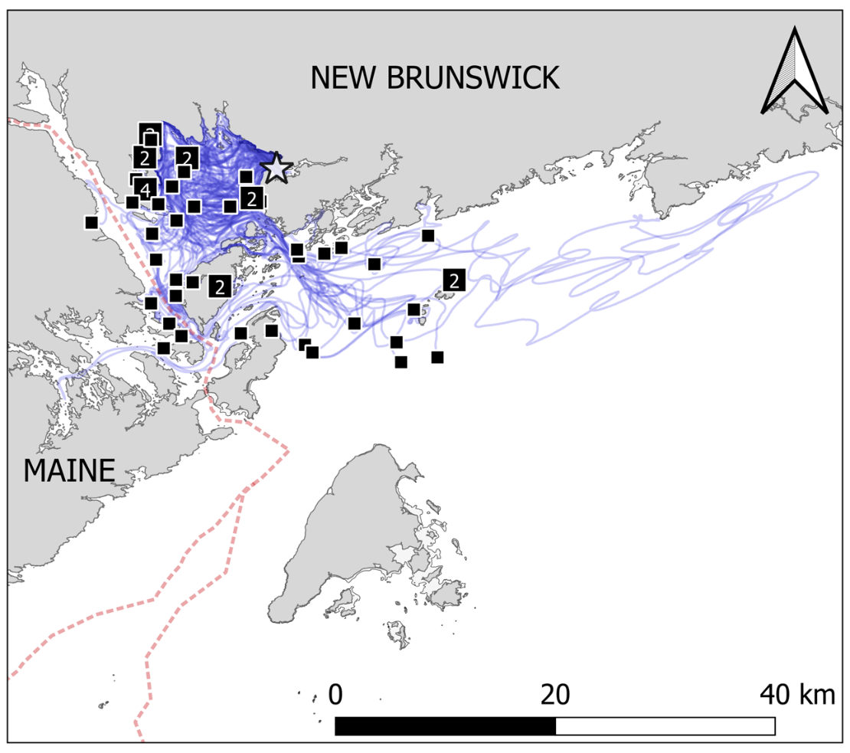

Fig. S6. Full extent of dispersal within 10 days by modelled particles drifting passively (compare Fig. 6 in the main text). Star = release point; squares = particle positions at end of simulation (#s indicate overlap); blue lines = particle tracks. Map produced in QGIS (base map from Greenlaw and McCurdy (2014); coordinate system: EPSG:4326 - WGS 84).

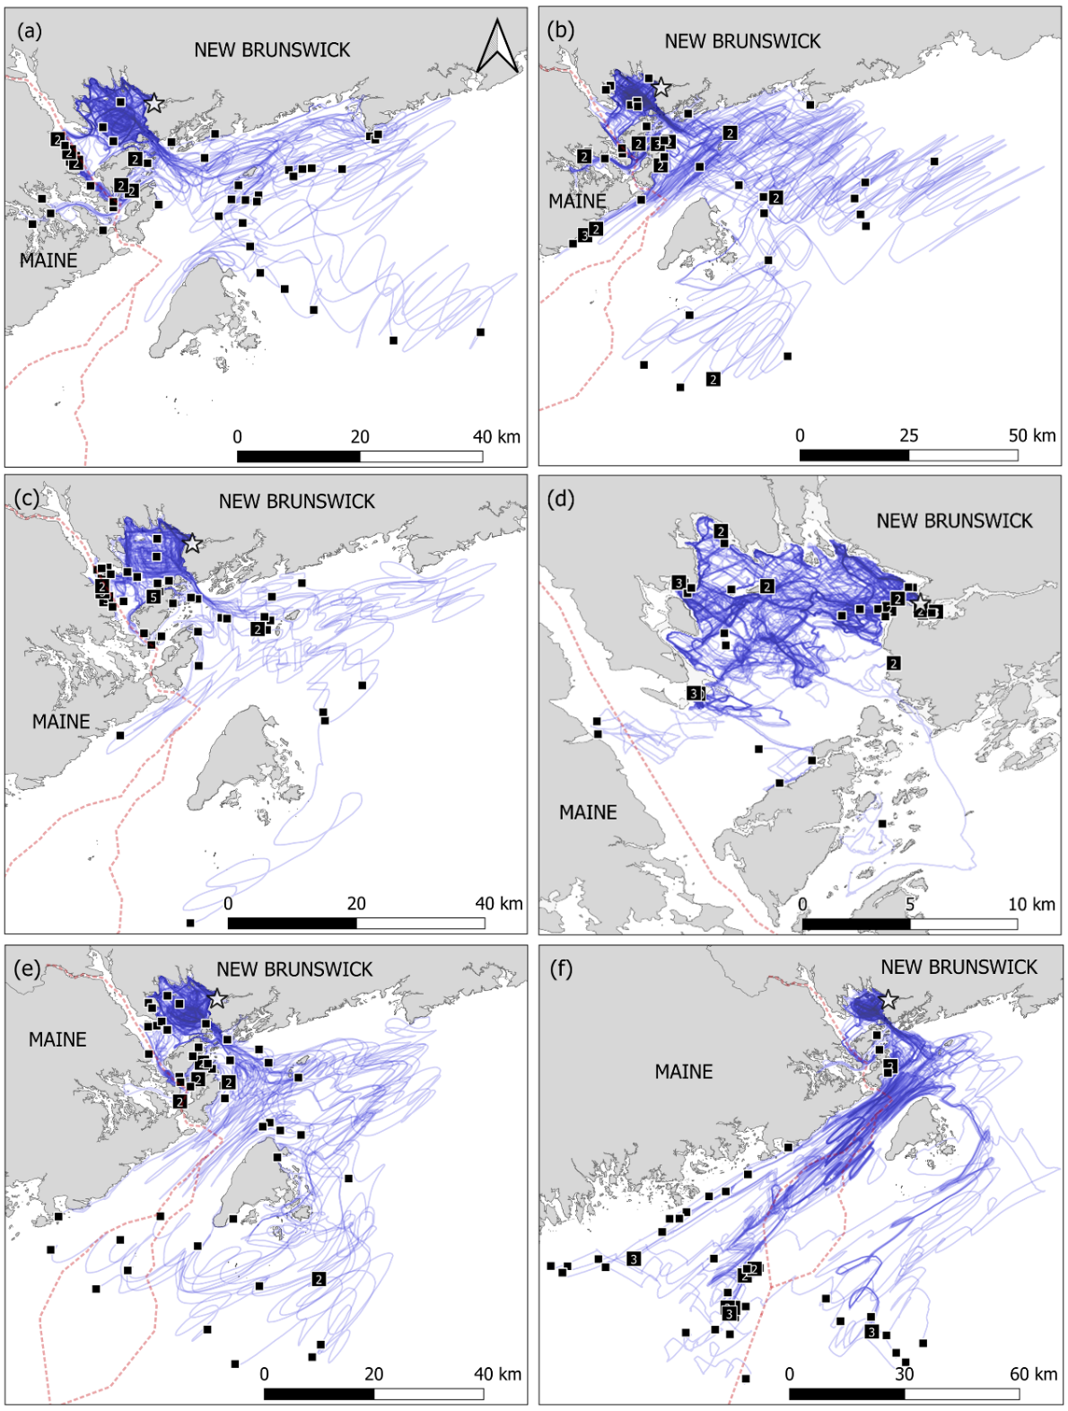
Fig. S7. Full extent of dispersal within 10 days by modelled particles programmed to use current-following behaviours (rheotaxis) (compare Fig. 7 in the main text). Behaviours included: negative rheotaxis (swimming with current) (a, b); positive rheotaxis (swimming against current) (c, d); tide-varying rheotaxis (swimming with current on ebb tide, against current on flood tide) (e, f); with speed = 0.5 BL/s (a, c, e) or speed = 2.0 BL/s (b, d, f). Star = release point; squares = particle positions at end of simulation (#s indicate overlap); blue lines = particle tracks. Map produced in QGIS (base map from Greenlaw and McCurdy (2014); coordinate system: EPSG:4326 - WGS 84).
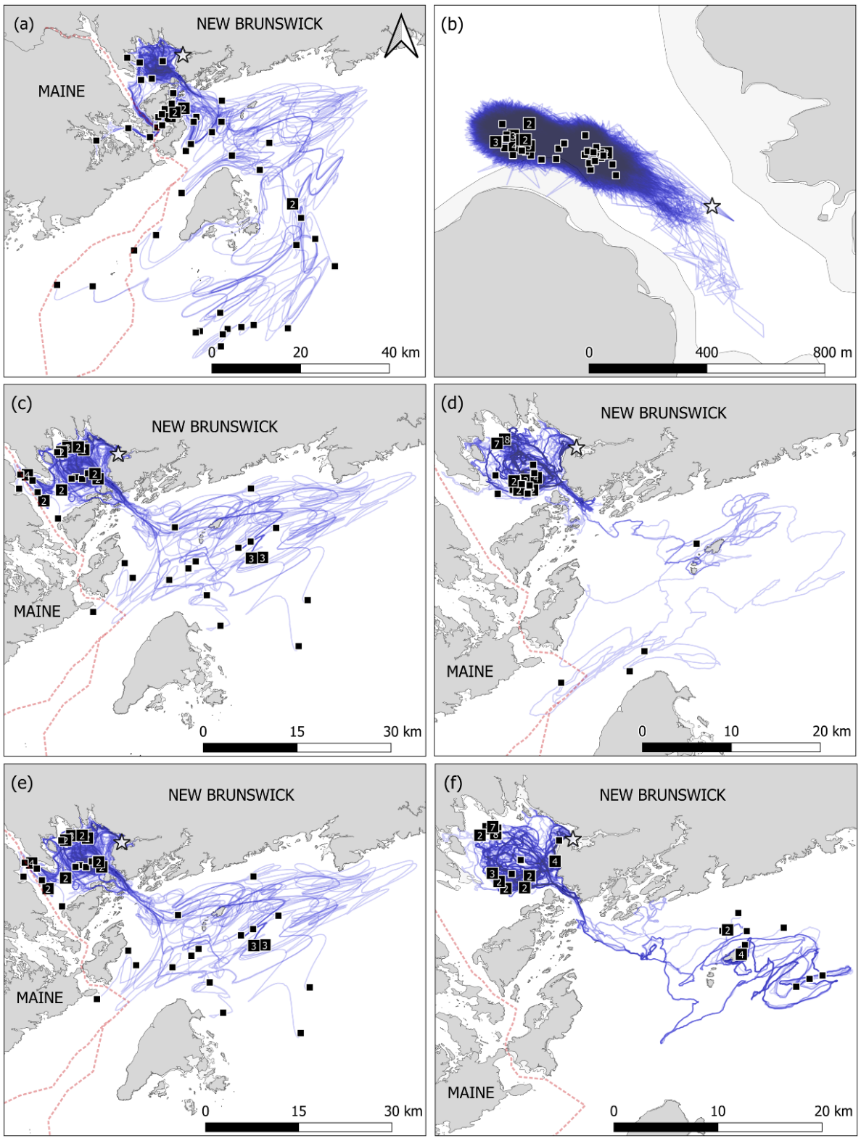
Fig. S8. Full extent of dispersal within 10 days by modelled particles programmed to use orientation behaviours (compare Fig. 8 in the main text). Behaviours included: orientation toward increasing water depth (a, b); orientation toward increasing salinity (halotaxis) (c, d); orientation toward decreasing temperature (thermotaxis) (e, f); with speed = 0.5 BL/s (a, c, e) or speed = 2.0 BL/s (b, d, f). Star = release point; squares = particle positions at end of simulation (#s indicate overlap); blue lines = particle tracks. Note that in (b), all particles remained within the Magaguadavic River Estuary. Map produced in QGIS (base map from Greenlaw and McCurdy (2014); coordinate system: EPSG:4326 - WGS 84).
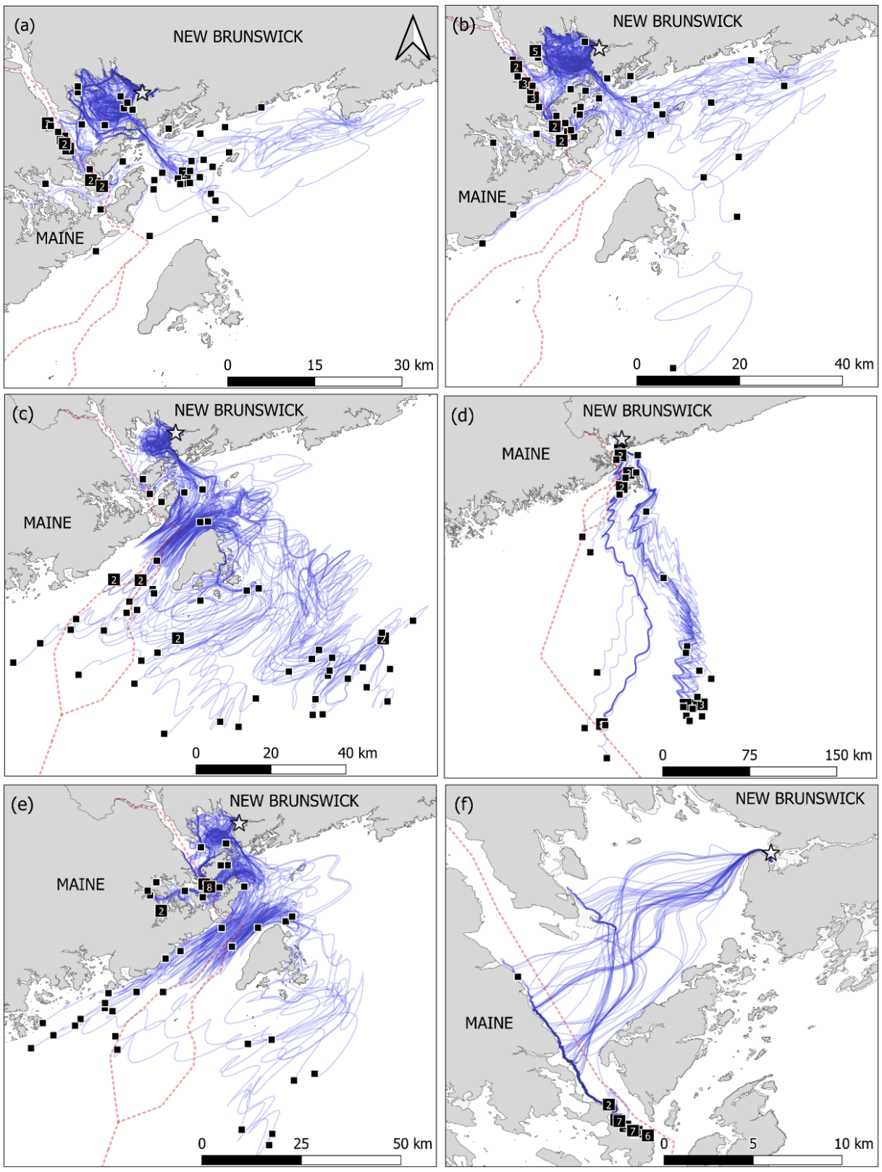
Fig. S9. Full extent of dispersal within 10 days by modelled particles programmed to use directional swimming behaviours (compare Fig. 9 in the main text) as follows: swimming in random directions (a, b); swimming directly south (c, d); swimming southwest (e, f); with speed = 0.5 BL/s (a, c, e) or speed = 2.0 BL/s (b, d, f); results not shown for other swimming directions. Star = release point; squares = particle positions at end of simulation (#s indicate overlap); blue lines = particle tracks. Map produced in QGIS (base map from Greenlaw and McCurdy (2014); coordinate system: EPSG:4326 - WGS 84).

