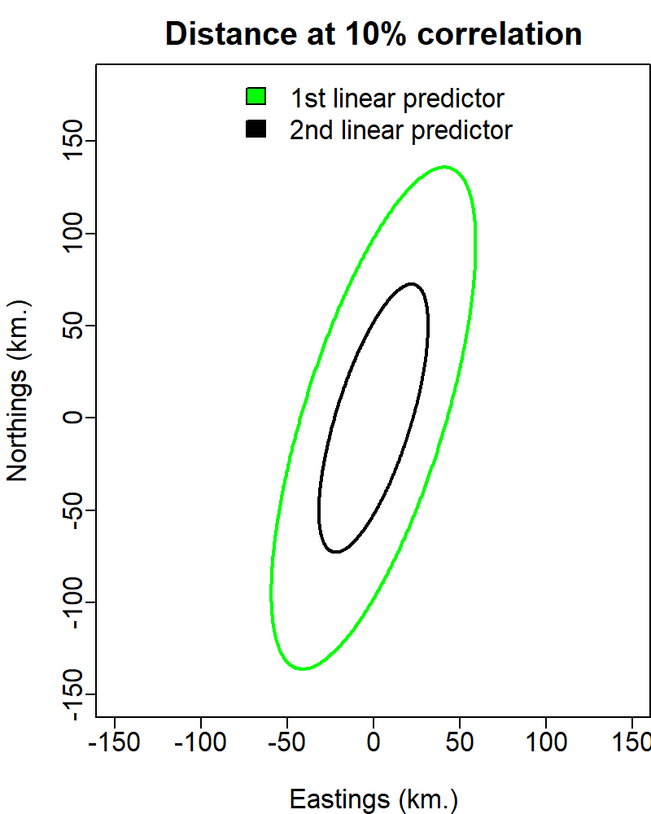
Figure 1: Aniso correlation plot for VAST model investigating spatio-temporal dynamics of bluefin tuna.
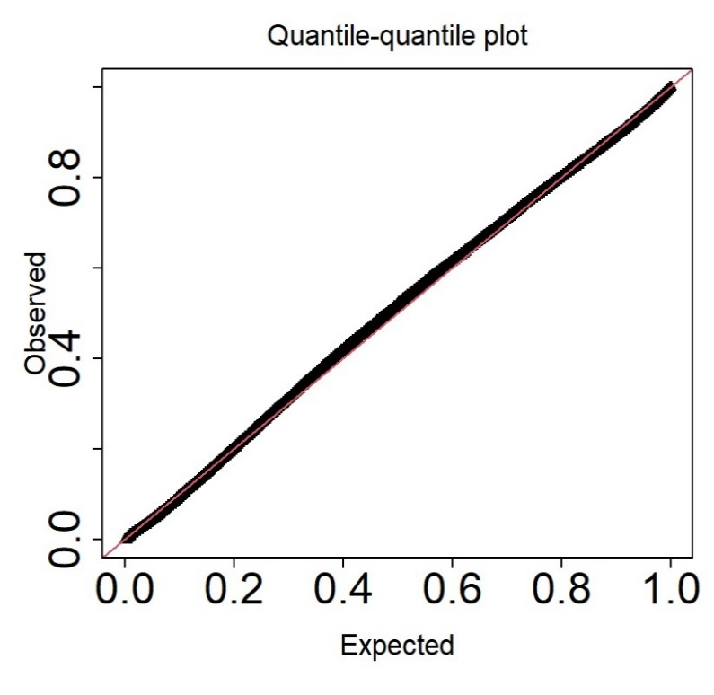
Figure 2: QQ plot for VAST model investigating spatio-temporal dynamics of bluefin tuna.

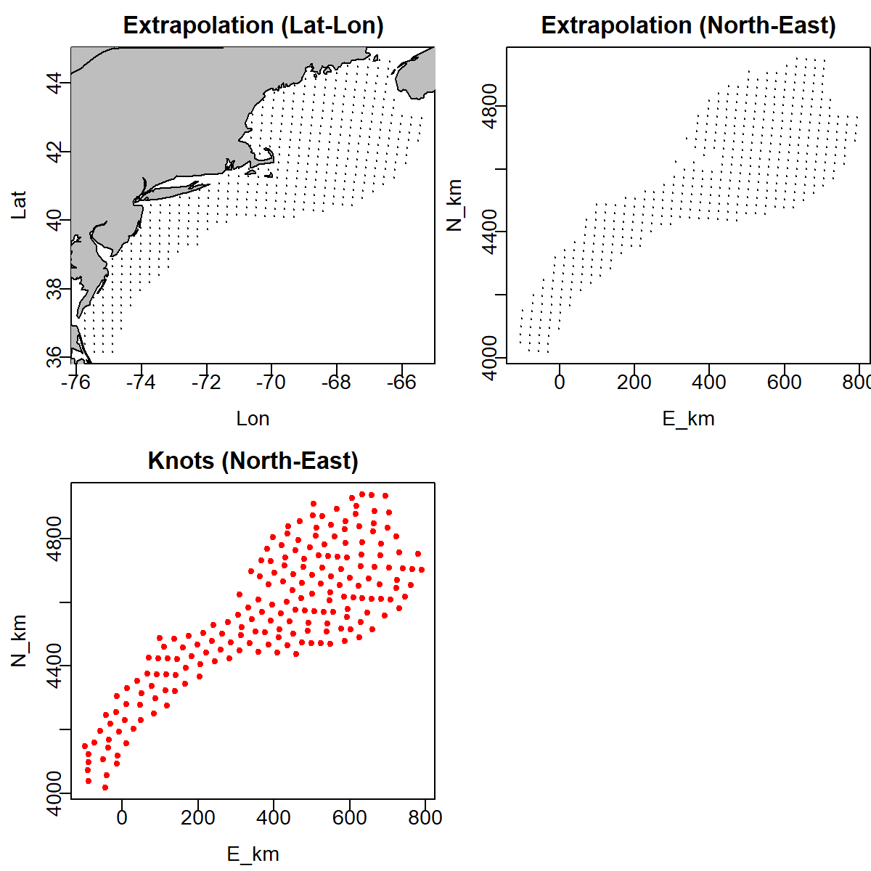
Figure 3: Knots for VAST model investigating spatio-temporal dynamics of bluefin tuna.
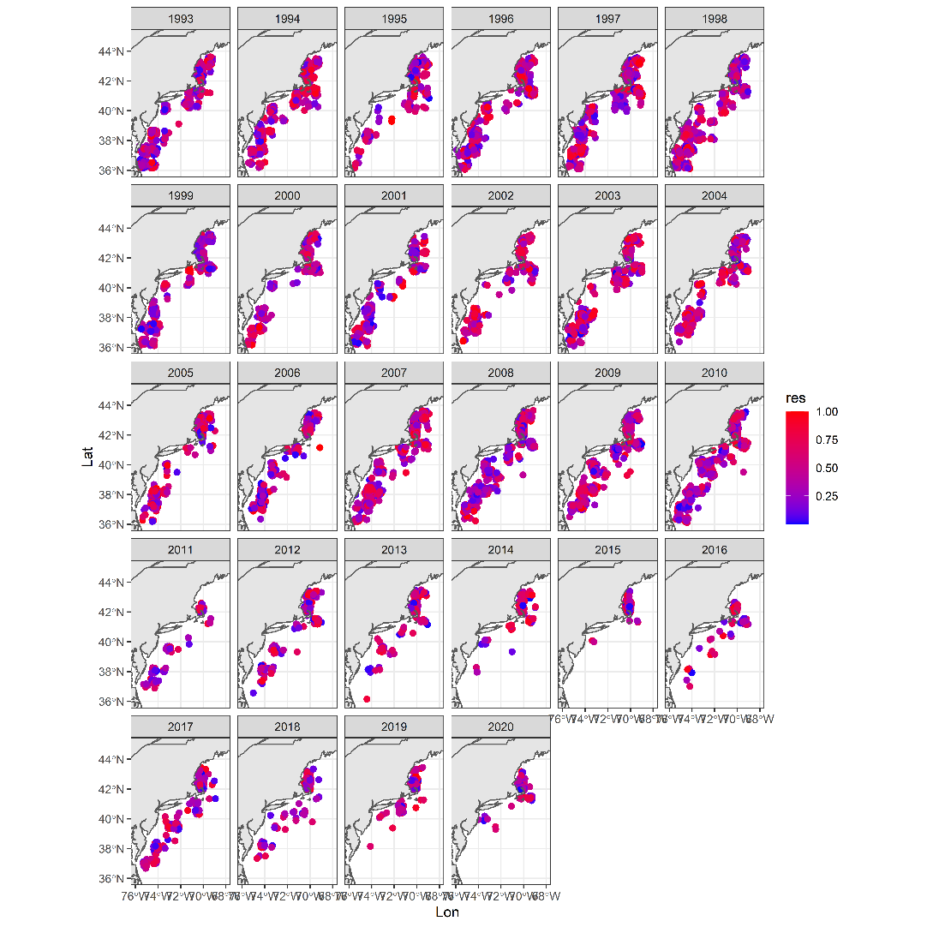
Figure 4: Spatial residuals for VAST model investigating spatio-temporal dynamics of bluefin tuna.
Table 1: For bluefin tuna, the total catch, the total hours spent fishing, total number of lines spent fishing and the average nominal catch per unit effort (CPUE; Catch/Hours) by year.
Year | Catch | Lines | Hours | CPUE
1993 | 2369 | 4342 | 7410 | 0.319703
1994 | 315 | 2297 | 4083 | 0.077149
1995 | 1024 | 3525 | 6831 | 0.149905
1996 | 789 | 2249 | 3430 | 0.230029
1997 | 1266 | 3387 | 5610 | 0.225668
1998 | 1067 | 3649 | 5776 | 0.18473
1999 | 503 | 1626 | 2565 | 0.196101
2000 | 401 | 2488 | 5236 | 0.076585
2001 | 678 | 2838 | 4808 | 0.141015
2002 | 247 | 1659 | 3731 | 0.066202
2003 | 83 | 2410 | 5299 | 0.015663
2004 | 258 | 1250 | 4131.5 | 0.062447
2005 | 133 | 1188 | 3608 | 0.036863
2006 | 48 | 796 | 2064 | 0.023256
2007 | 134 | 1296 | 2649 | 0.050585
2008 | 99 | 1672 | 2944 | 0.033628
2009 | 163 | 1318 | 2853 | 0.057133
2010 | 147 | 1360 | 3369 | 0.043633
2011 | 103 | 1427 | 3979 | 0.025886
2012 | 189 | 2136 | 6343 | 0.029797
2013 | 110 | 1829 | 5802 | 0.018959
2014 | 83 | 1447 | 5108 | 0.016249
2015 | 369 | 2388 | 7501 | 0.049193
2016 | 289 | 2673 | 9104 | 0.031744
2017 | 295 | 2446 | 7390 | 0.039919
2018 | 318 | 2547 | 9371 | 0.033934
2019 | 388 | 2129 | 6756 | 0.05743
2020 | 283 | 1838 | 5025 | 0.056318

Table 2: GVIF scores for covariates explored in VAST runs.
Covariate | GVIF
Month | 5.1
Lines | 1.1
Hours | 1.4
SST | 4.2
Depth | 2.7
AMO | 1.6
Herring Biomass | 1.3
Table 3. Different model runs and the associated figures.

Analyses | Model run | Gradient | Figure
Counterfactual | Gaussian Markov random fields (GMRF) - Density: SST + Depth + AMO + Herring | <0.001 | 4-8
 | Fixed effects - Density: SST + Depth + AMO + Herring | <0.001
 | Fixed effects - no covariates | <0.001 | 9
 | Fixed effects - SST | <0.001
 | Fixed effects - SST + Deph | <0.001
 | Fixed effects - SST + Depth + AMO + Herring | <0.001
CPUE | Select by AIC - Density: SST | <0.001 | 10

