SUPPLEMENTAL INFORMATION

Regional differences in energy allocation of black sea bass (Centropristis striata) along the US Northeast Shelf (36°N - 42°N) and throughout the spawning season
Emily Slesinger^{1*}, Kiernan Bates¹, Mark Wuenschel², and Grace K. Saba¹

TABLES
SI Table 1. The models used in analysis, their distribution family and link functions.

Analysis | Response variable | Model | Distribution family | Link
Compositional | LC (g lipid/g dry weight) | GLM | Beta | Logit
 | ED (kJ/g wet weight) | GLM | Gamma | Inverse
 | TE (kJ) | GLM | Gamma | Log
Seasonal | LTE | GAM | Gamma | Log
 | GTE | GAM | Gamma | Log

SI Table 2. BIC values used to compete the null and regional models. Bold values indicate the lowest BIC and the chosen model

Tissue | Sex | Model | Measurement
 |  |  | LC (g/g DW) | ED (kJ/g WW) | TE (kJ)
Muscle | All | Null | -1554.69 | 262.97 | NA
 |  | Regional | -1540.56 | 215.11 | NA
Liver | F | Null | -225.20 | 652.30 | 1376.39
 |  | Regional | -237.98 | 646.75 | 1364.76
 | M | Null | -195.60 | 446.64 | 1006.90
 |  | Regional | -198.83 | 449.71 | 1004.27
Gonad | F | Null | -549.70 | 485.49 | 1642.10
 |  | Regional | -566.83 | 478.55 | 1628.76
 | M | Null | -518.79 | 129.61 | 996.12
 |  | Regional | -522.34 | 141.43 | 999.10

FIGURES
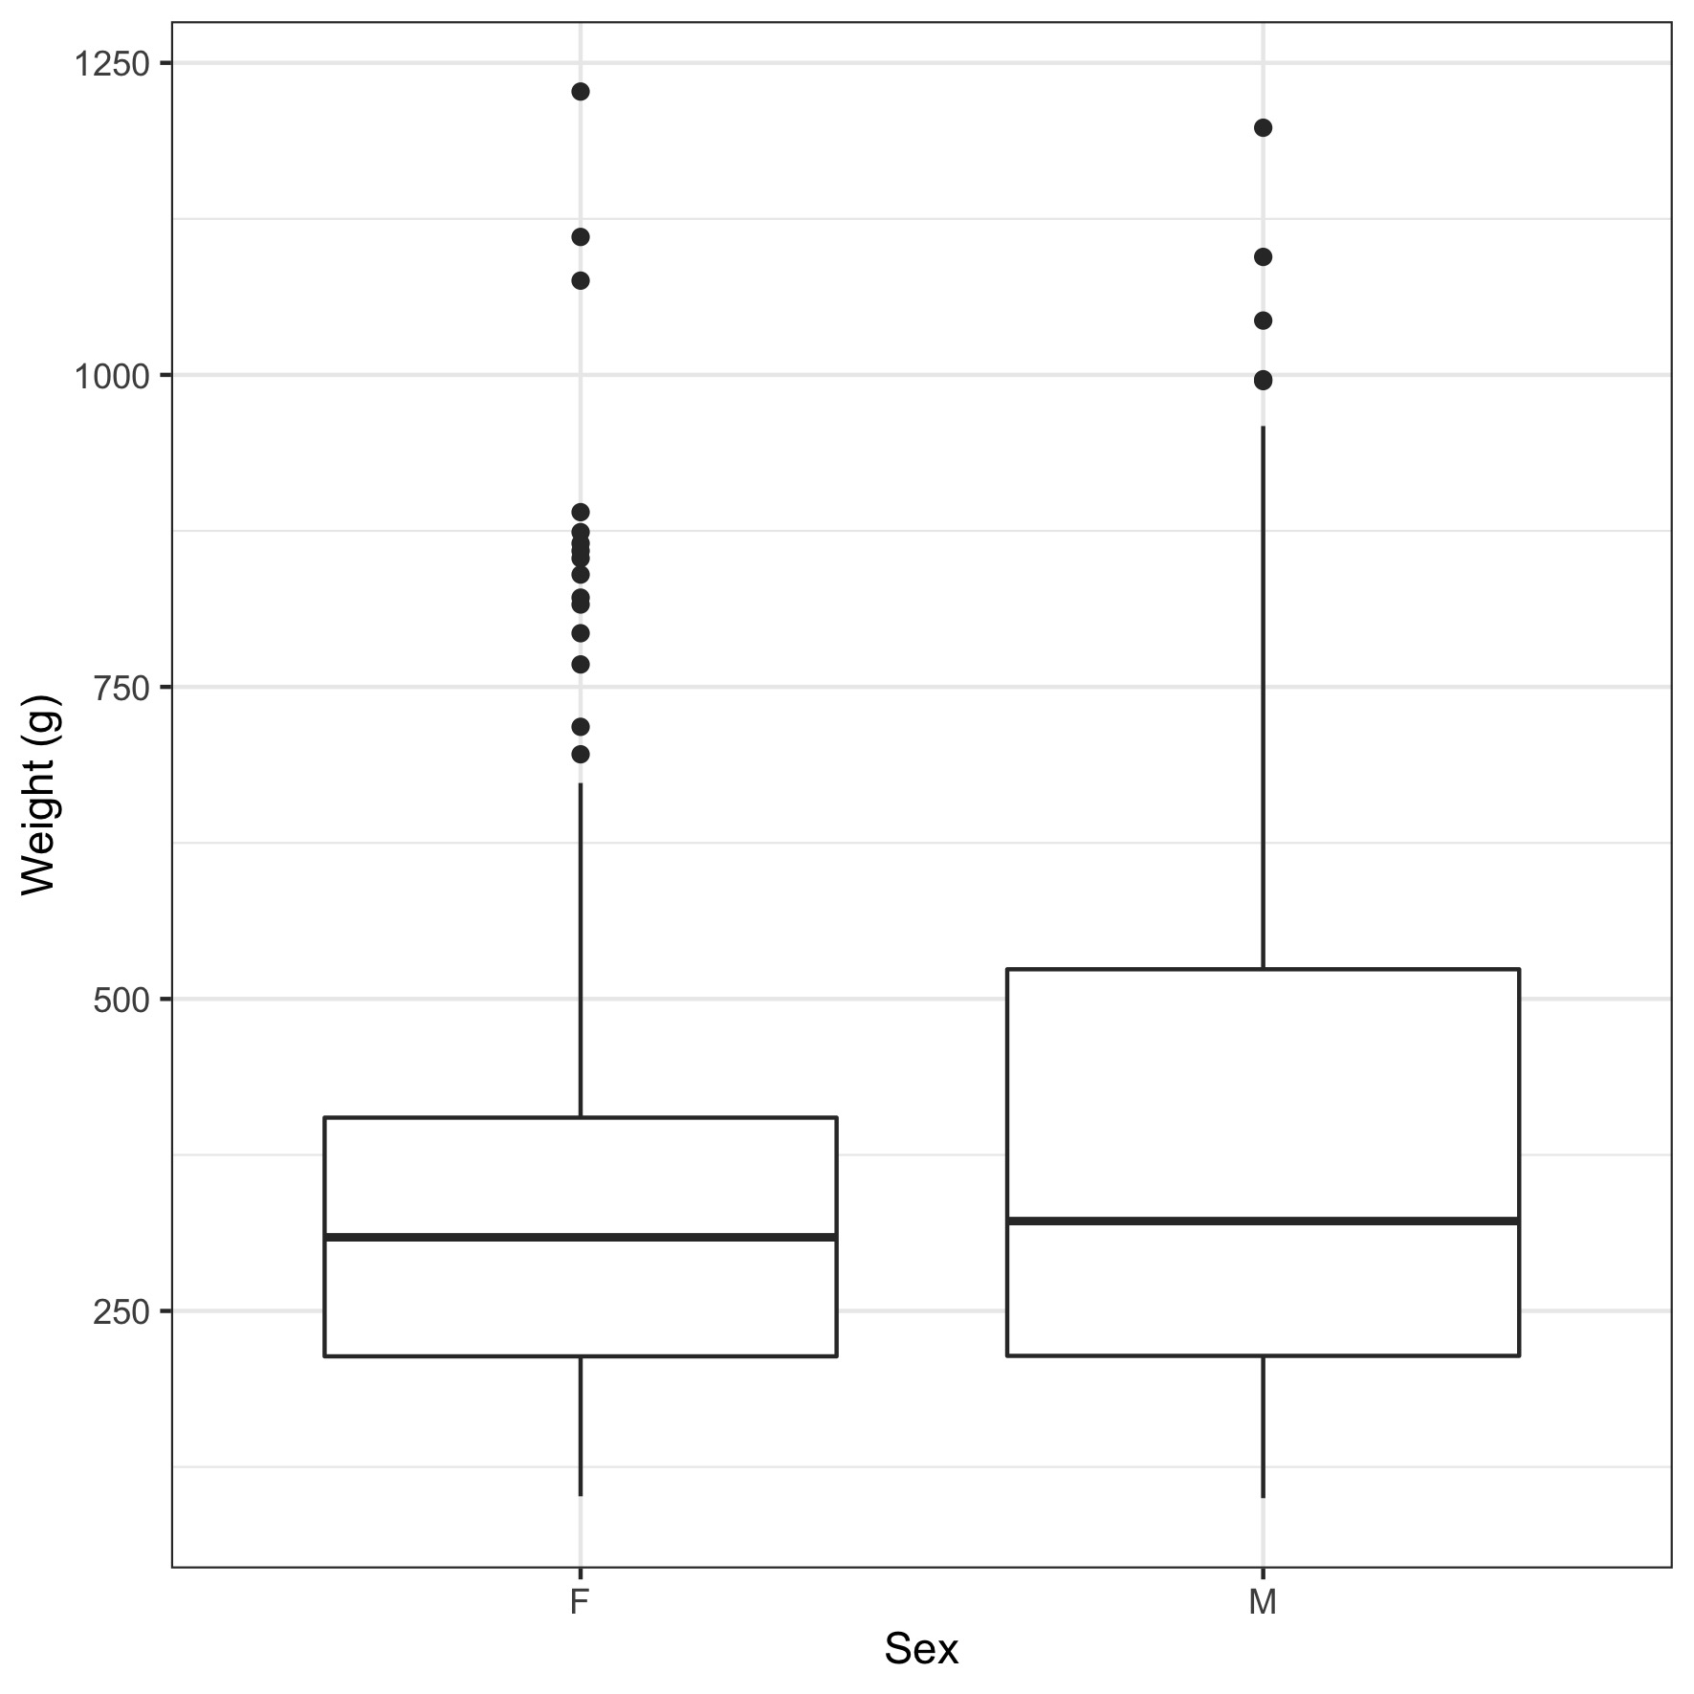
SI Figure 1. The size distribution between female and male fish of individuals used in this study.
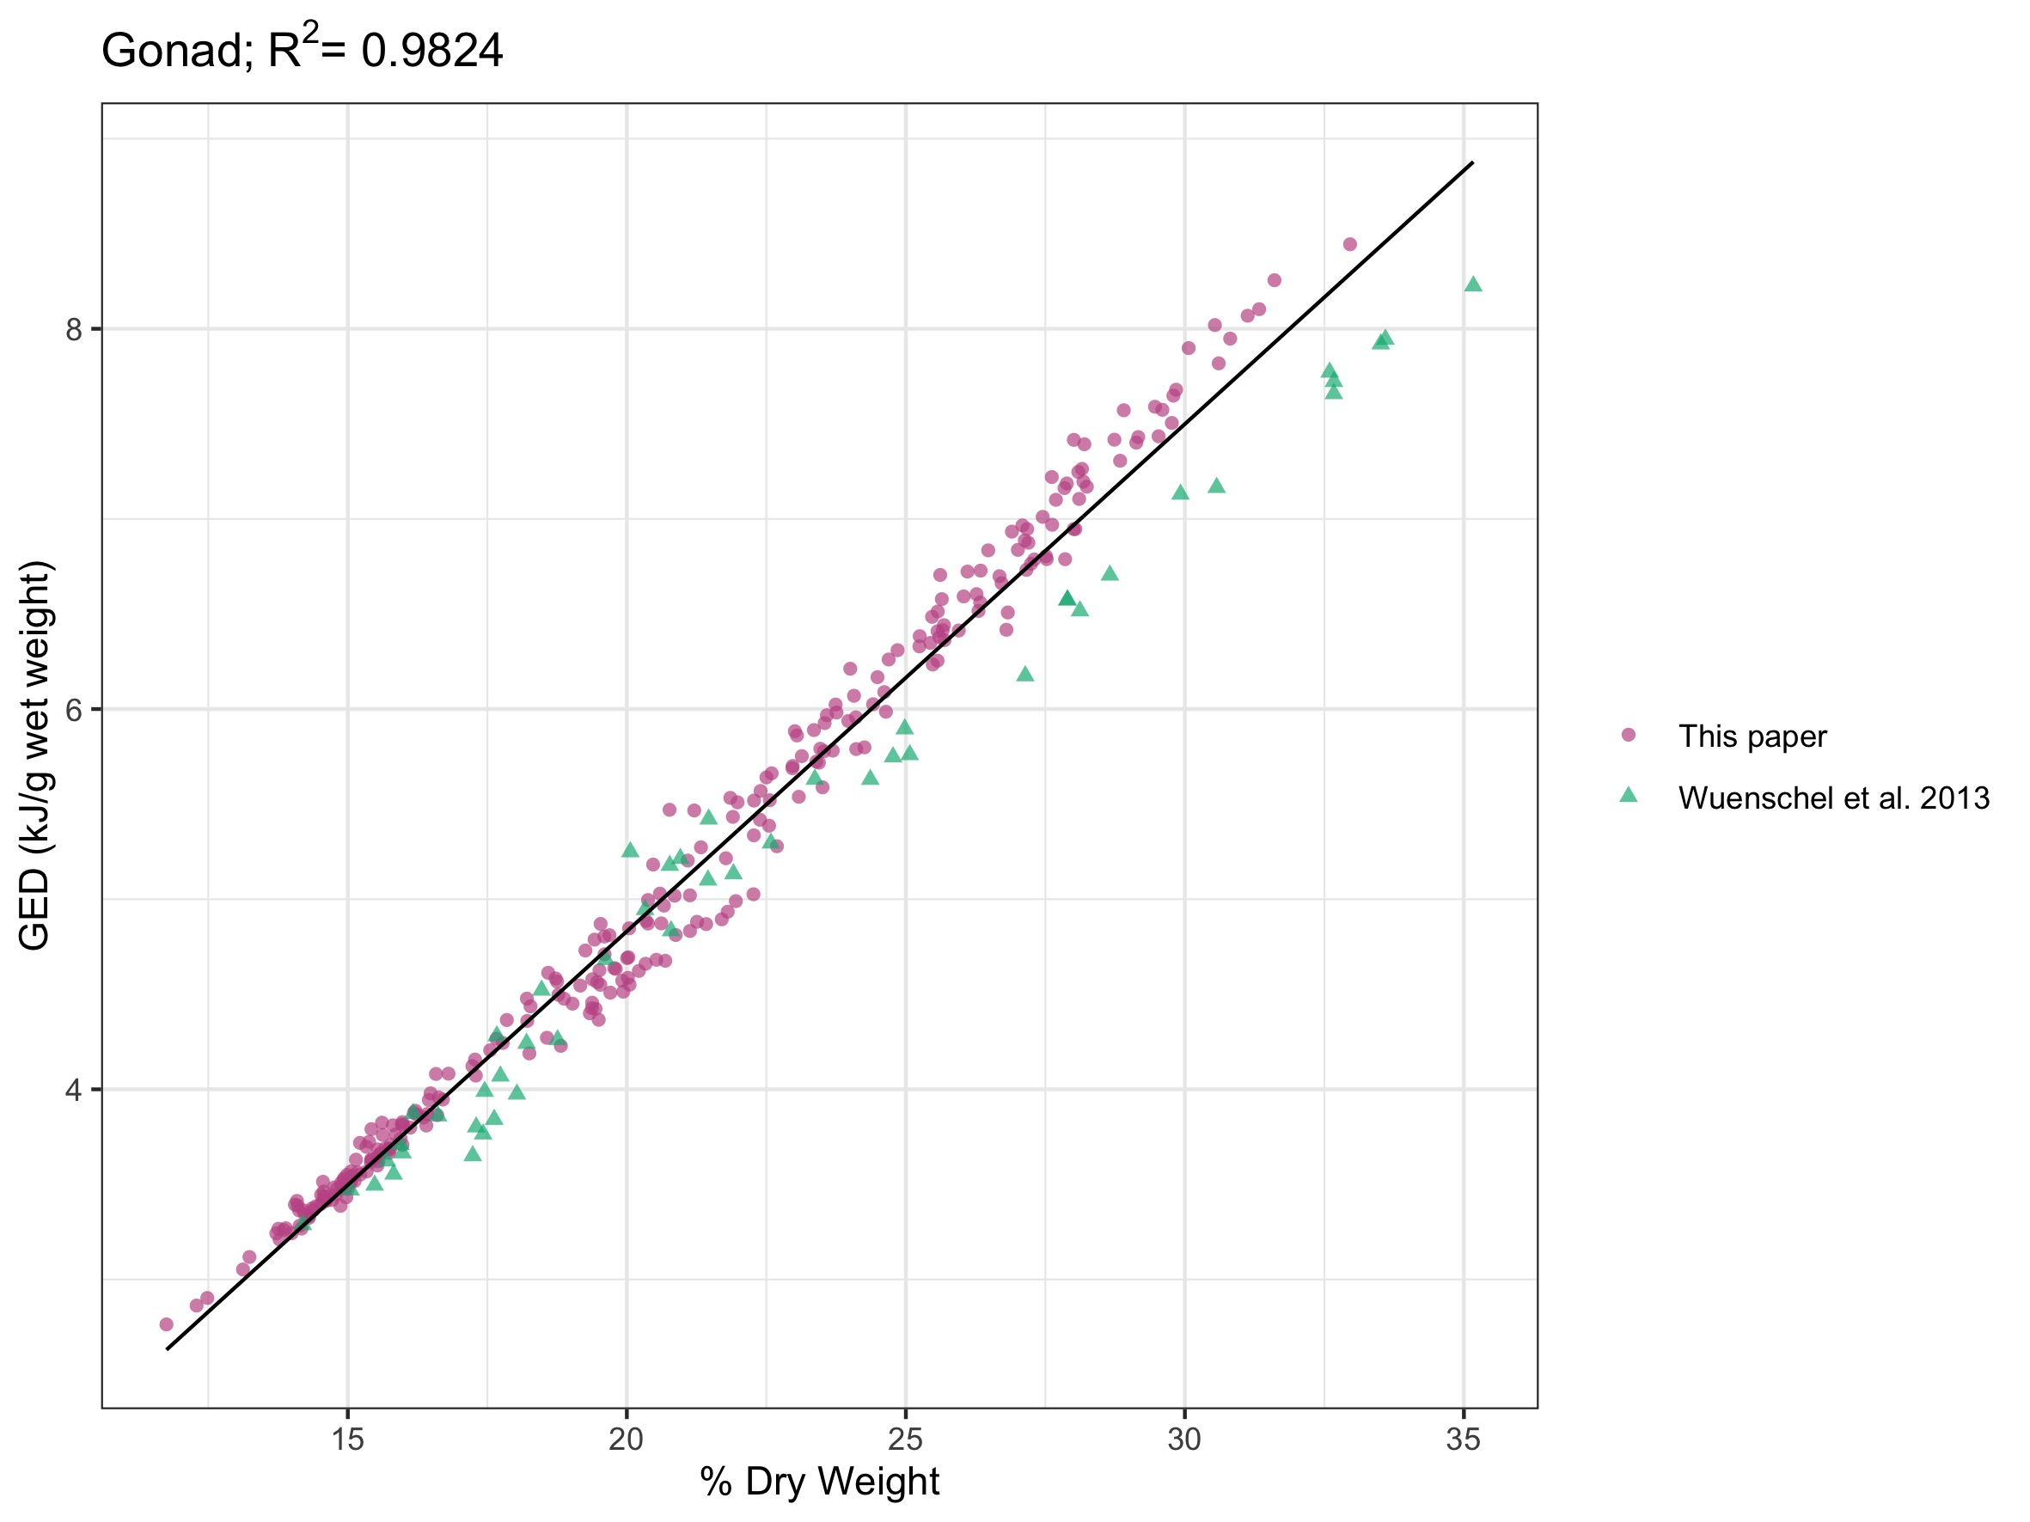
SI Figure 2. Linear trend of gonad % dry weight to GED for this paper and data from Wuenschel et al. 2013 to assess fit of our estimated ED values from those already published for C. striata.
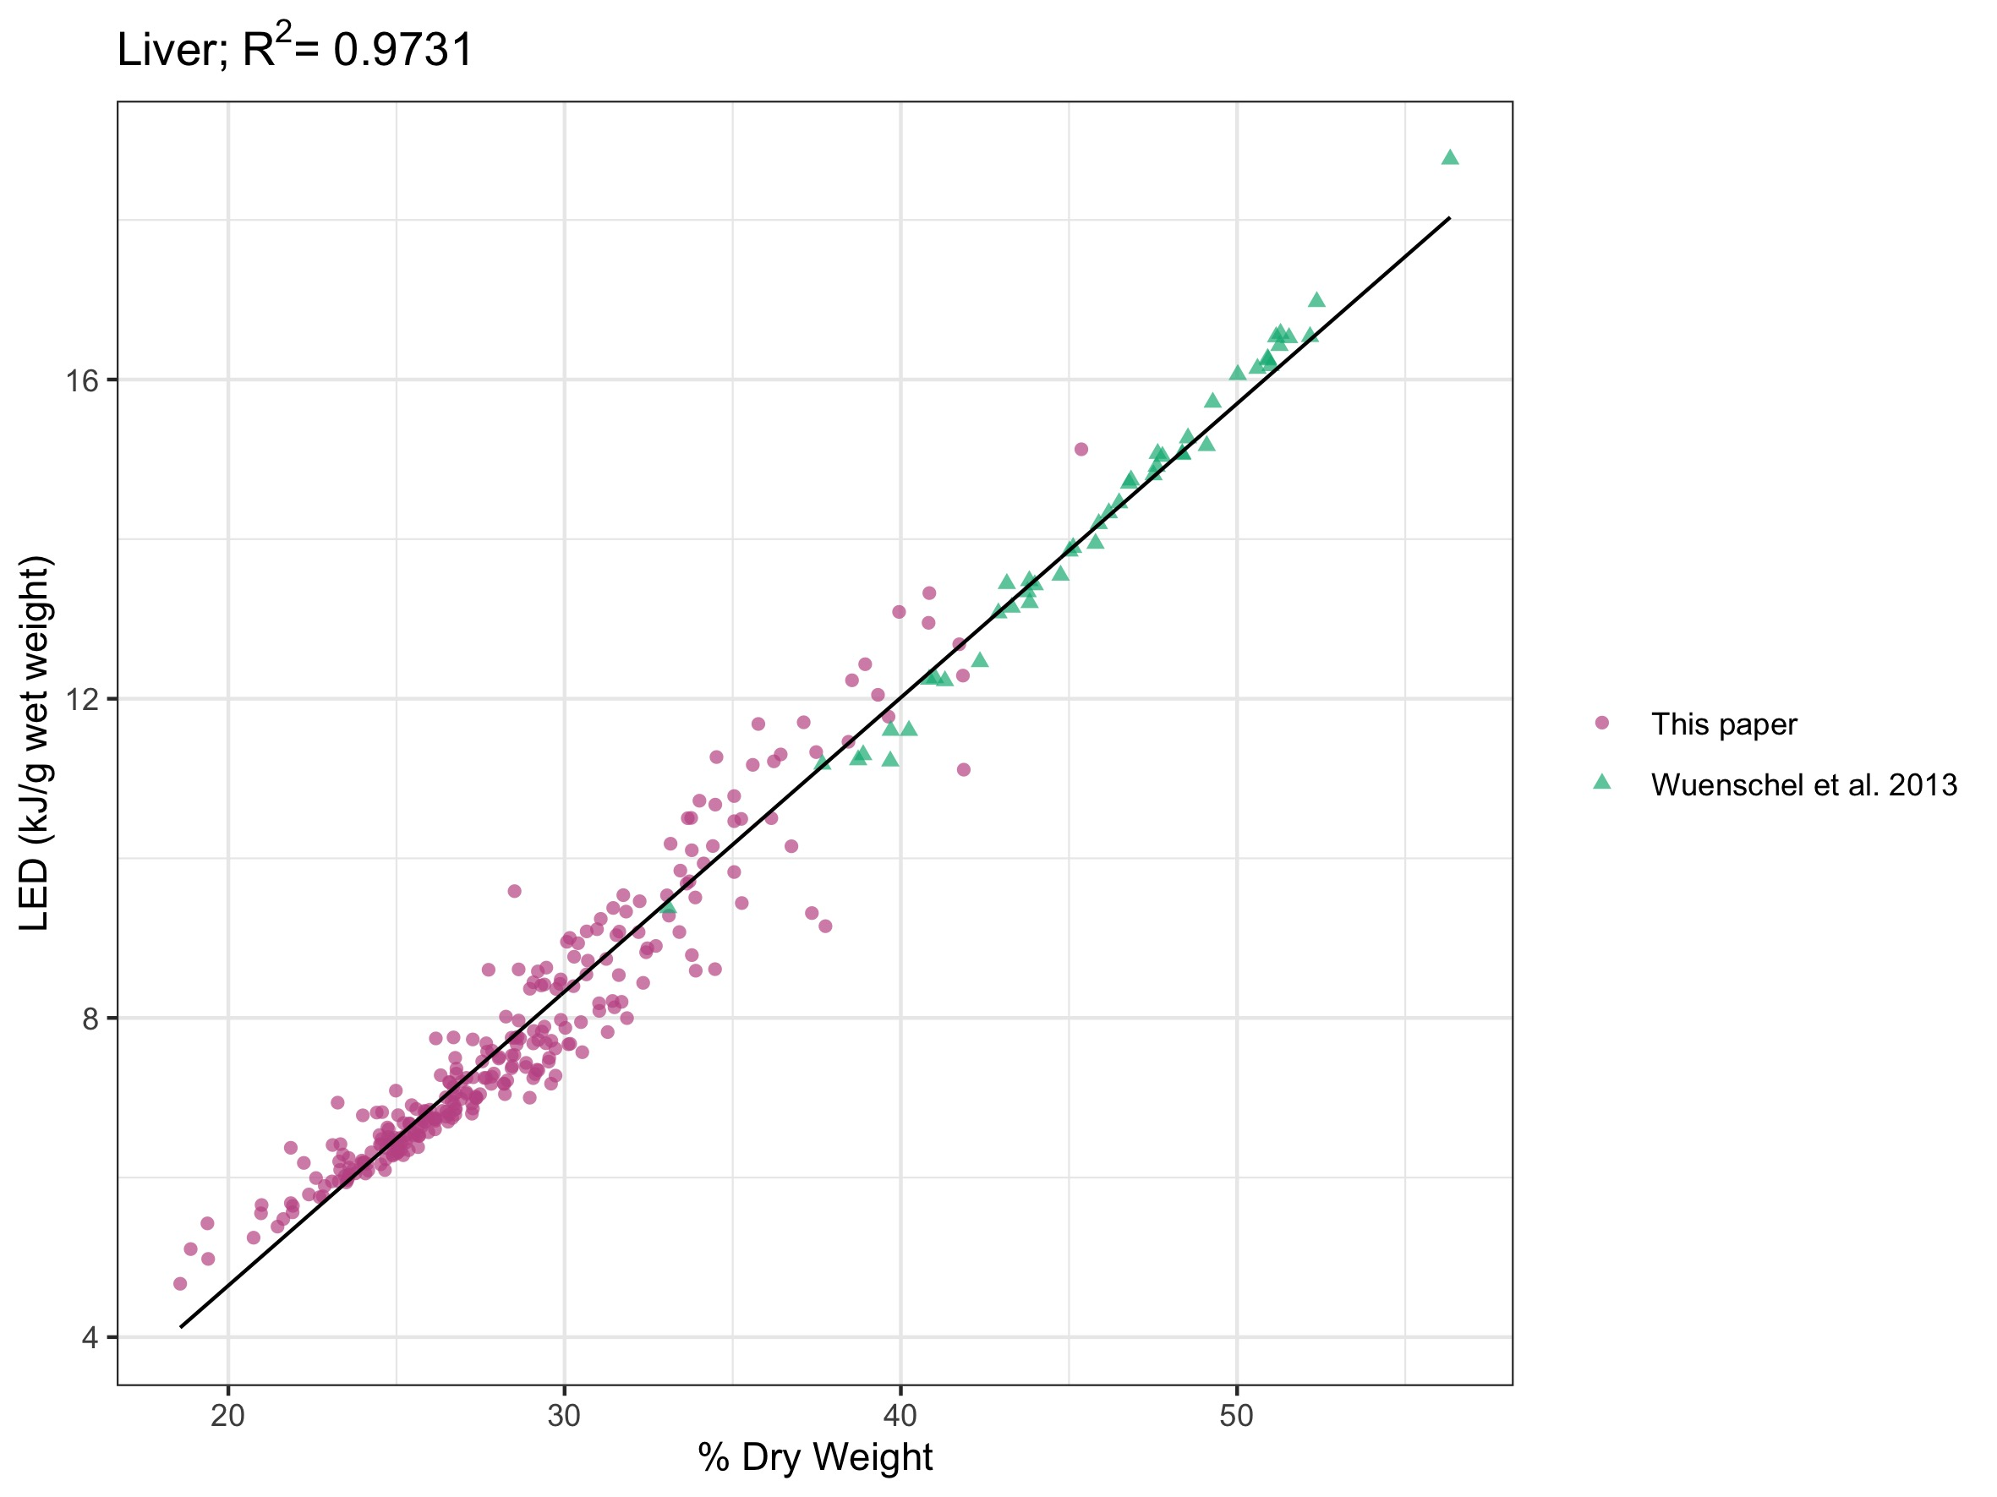
SI Figure 3. Linear trend of liver % dry weight to LED for this paper and data from Wuenschel et al. 2013 to assess fit of our estimated ED values from those already published for C. striata.

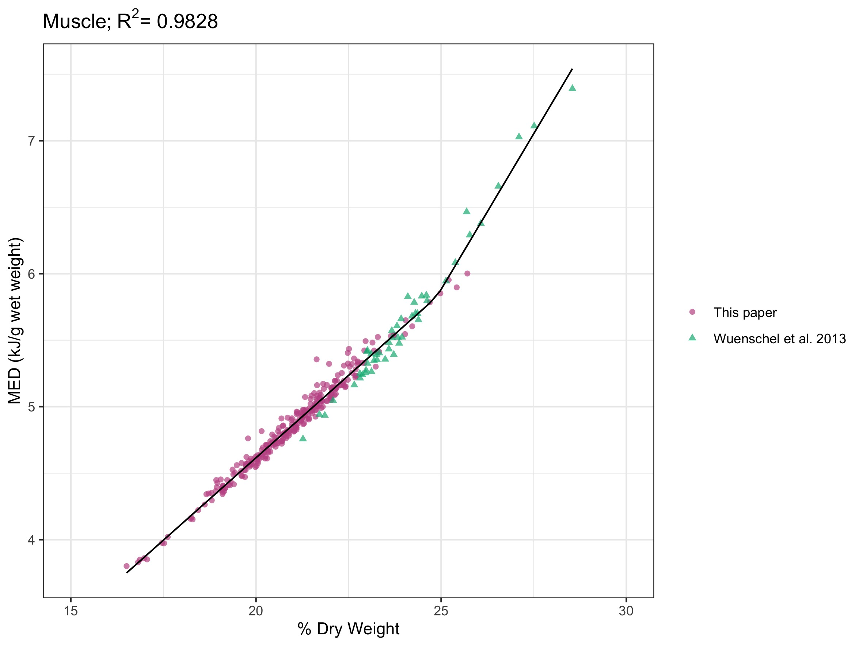
SI Figure 4. Regression of muscle % dry weight to MED, using a broken stick regression, for this paper and data from Wuenschel et al. 2013 to assess fit of our estimated ED values from those already published for C. striata.

