Spatiotemporal characteristics of US floods: Current status and forecast under a future warmer climate
Zhi Li¹, Shang Gao¹, Mengye Chen¹, Jonathan J. Gourley², Yang Hong¹
¹School of Civil Engineering and Environmental Science, University of Oklahoma, Norman, OK, USA;
²NOAA National Severe Storms Laboratory, Norman, 73072, USA
Corresponding to: Dr. Yang Hong (yanghong@ou.edu)

Supplementary Table 1. A list of datasets used in this study.
Dataset name | Fields | Resolution (Spatial/temporal) | URL
Bukovsky divisions | Climate zones | Vector data | http://www.narccap.ucar.edu/contrib/bukovsky/
USGS extreme flow frequency | streamflow | Vector data | https://streamstats.usgs.gov/ss/
Retrospective climate (CTL) | Precipitation, temperature, | 4km/hourly | https://rda.ucar.edu/datasets/ds612.0/
Future climate (PGW) | Precipitation, temperature, | 4km/hourly | https://rda.ucar.edu/datasets/ds612.0/
Hydrography | Digital Elevation Model, Flow Accumulation, Flow Direction | 1km/static | https://doi.org/10.5281/zenodo.4009759
Distributed hydrologic parameters | Water balance parameters and routing parameters | 1km/static | https://doi.org/10.5281/zenodo.4009759

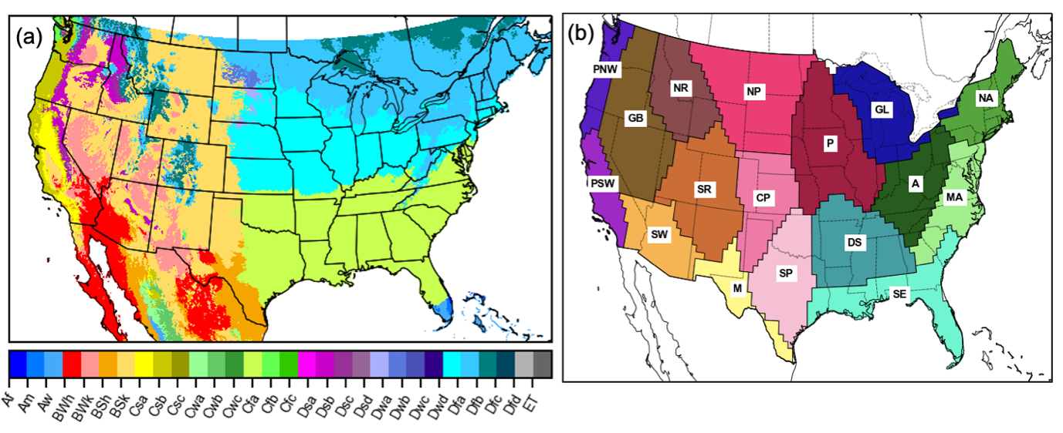
Supplementary Figure 1. Maps of Climate divisions based on (a) Koppen-Geiger and (b) Bukovsky. Symbols in (a) represent: Af – Tropical rainforest; Am – Tropical monsoon; Aw – Tropical savannah; BWh – Arid, desert, hot; BWk – Arid, desert, cold; BSh – Arid, steppe, hot; BSk – Arid, steppe, cold; Csa – Temperate, dry summer, hot summer; Csb – Temperate, dry summer, warm summer; Csc Temperate, dry summer, cold summer; Cwa – Temperate, dry winter, hot summer; Cwb – Temperate, dry winter, warm summer; Cwc – Temperate, dry winter, cold summer; Cfa – Temperate, no dry season, hot summer; Cfb – Temperate, no dry season, warm summer; Cfc – Temperate, no dry season, cold summer; Dsa – Cold, dry summer, hot summer; Dsb – Cold, dry summer, warm summer; Dsc – Cold, dry summer, cold summer; Dsd – Cold, dry summer, very cold winter; Dwa – Cold, dry winter, hot summer; Dwb – Cold, dry winter, warm summer; Dwc – Cold, dry winter, cold summer; Dwd – Cold, dry winter, very cold winter; Dfa – Cold, no dry season, hot summer; Dfb – Cold, no dry season, warm summer; Dfc – Cold, no dry season, cold summer; Dfd – Cold, no dry season, very cold winter; E.T. – Polar, tudra; E.F. – Polar frost. Symbols in (b) represent: PNW – Pacific Northwest; PSW – Pacific Southwest; G.B. – Great Basin; S.W. – Southwest; N.R. – Northern Rockies; S.R. – Southern Rockies; M – Meziquital; N.P. – Northern Plain; C.P. – Central Plain; S.P. – Southern Plain; P – Prairie; D.S. – Deep South; S.E. – Southeast; G.L. – Great Lakes; A – Appalachian; M.A. – Mid-Atlantic; N.A. – North-Atlantic.
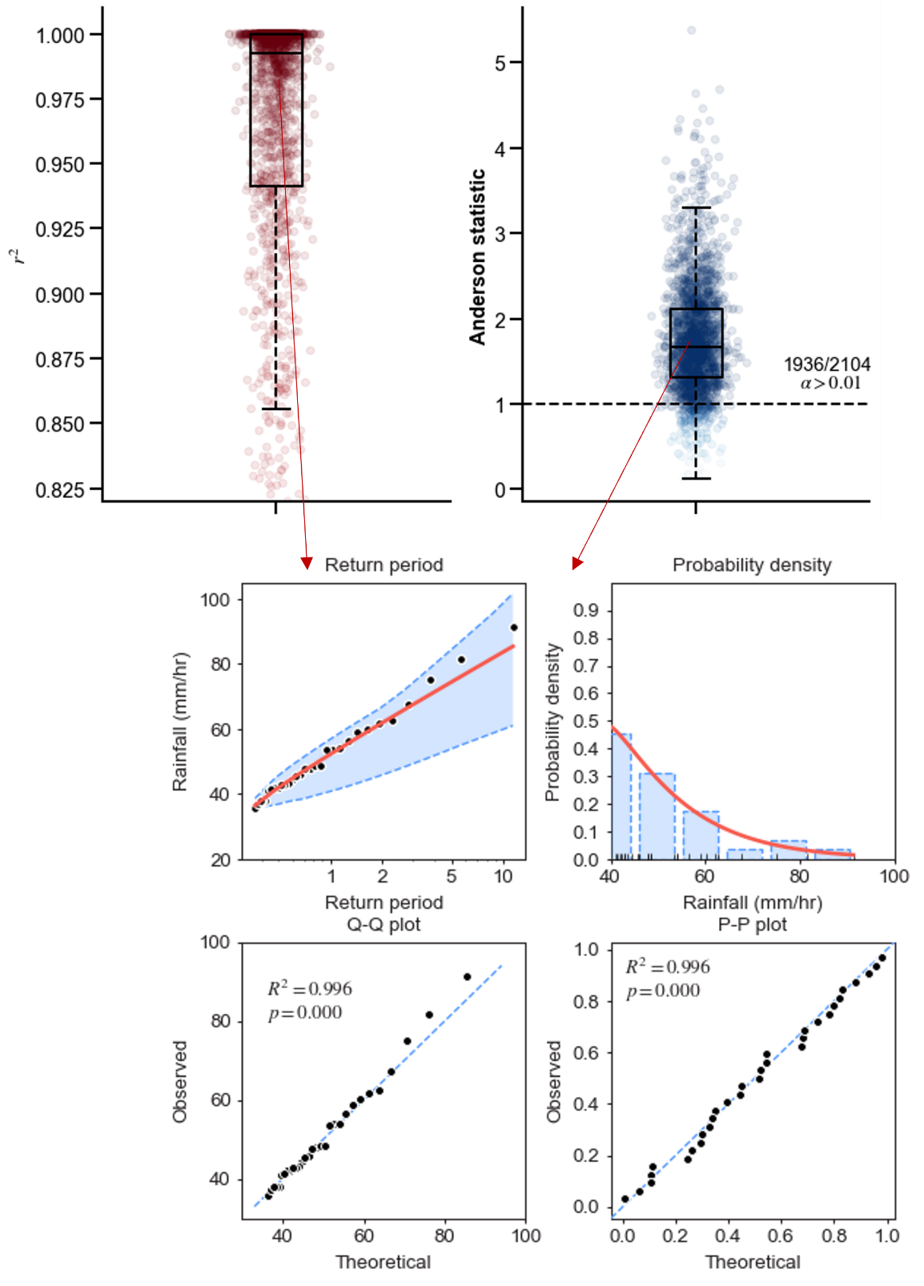
Supplementary Figure 2. Goodness-of-fit test for extreme rainfall (fitted by Gamma distribution) and tested with Anderson-Darling test.
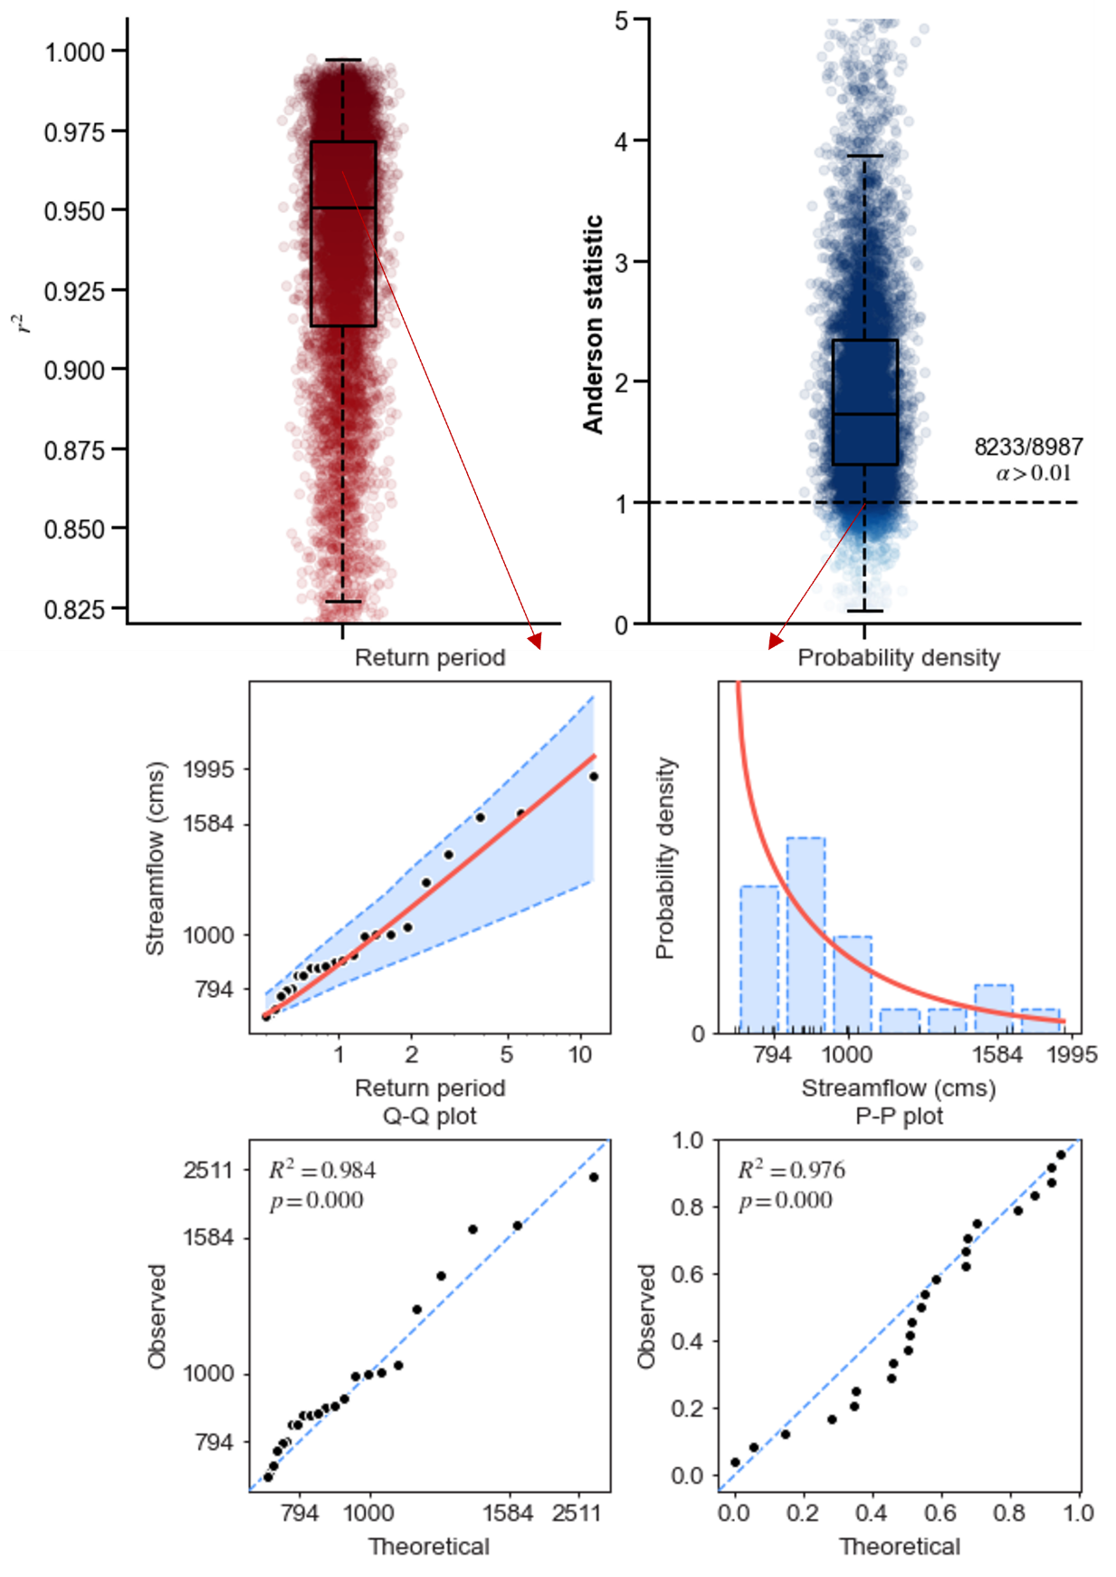
Supplementary Figure 3. Goodness-of-fit test for extreme streamflow (fitted by Log-Pearson type III distribution) and tested with Anderson-Darling test.
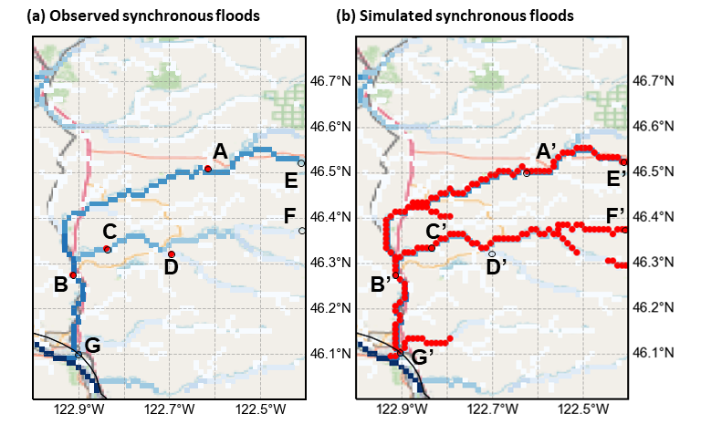
Supplementary Figure 4. Illustration of advantages of simulating flood synchrony by distributed hydrologic models. The red dots are synchronous floods by (a) USGS stream gauges and (b) distributed hydrologic model. The flood event is taken from 2003-02-01, an atmospheric river event contributing to catastrophic flood event in California. Flooded points are overlaid with 1-km flow accumulation image used for hydrologic simulation.

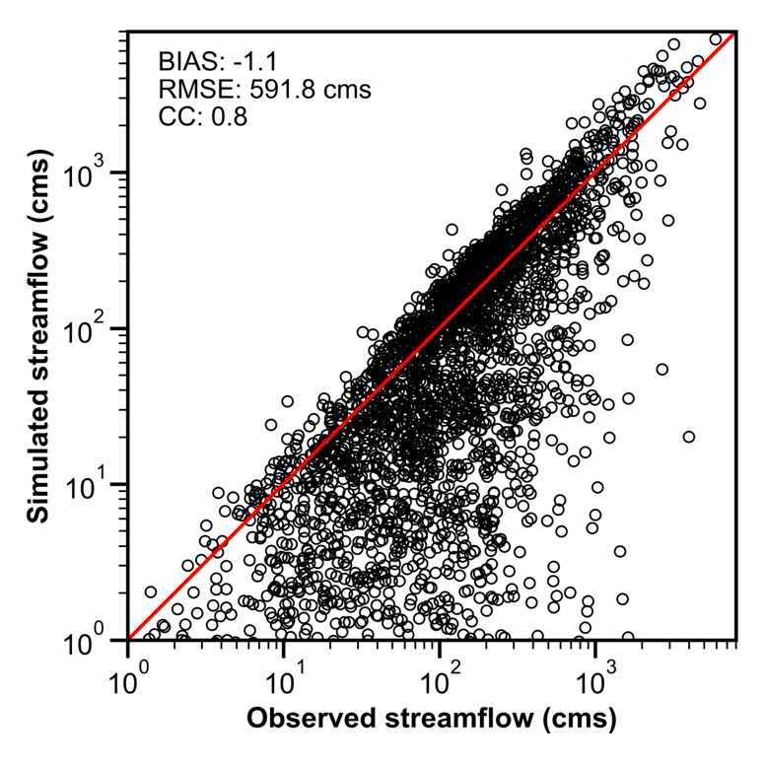
Supplementary Figure 5. Scatter plot of simulated and observed two-year flow. BIAS: relative bias, calculated by summation of simulated streamflow minus summation of observed streamflow and divide by summation of observed. RMSE: Root Mean Square Error. CC: Correlation Coefficient.

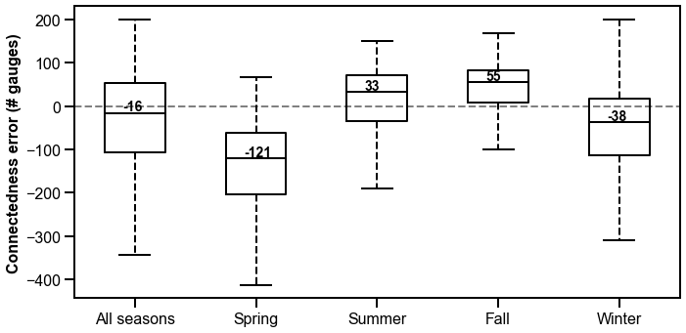
Supplementary Figure 6. Overall and seasonal errors in flood connectedness (simulated minus observed connectedness).

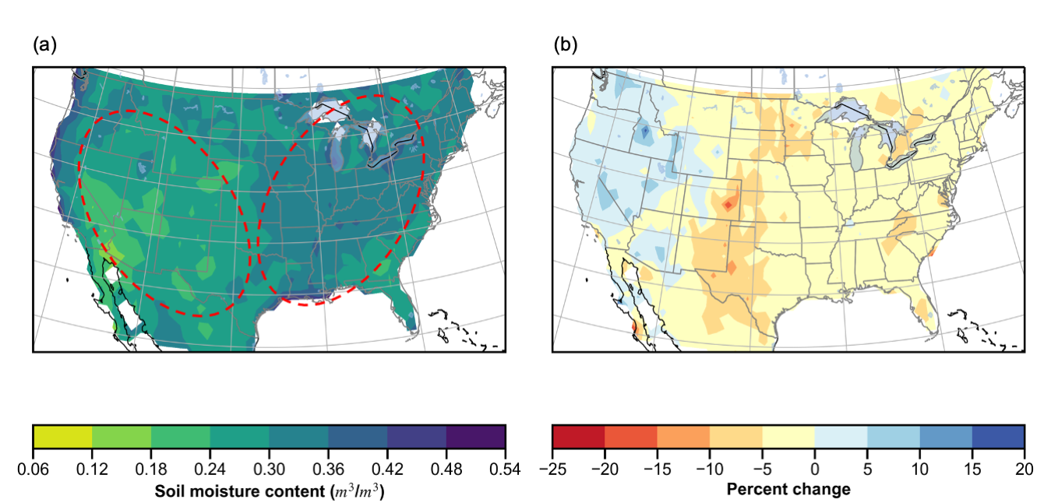
Supplementary Figure 7. Maps of antecedent soil moisture: (a) retrospective simulation (CTL) (b) change by PGW minus CTL. The dashed ovals distinguish high antecedent soil moisture (eastern US) and low antecedent soil moisture (western US).

